Camelia Ungureanu
1816236

Coaching and Mentoring

Executive Summary
Organizations are faced with various changes they need to implement on a daily basis to ensure smooth operation of services. In this regard, they have to come up with a number of measures aimed at ensuring the employees are at par with whatever changes are expected of them. This paper addresses concerns regarding coaching and mentorship on how they would be ideal in the management of the concerns of the employees in as far as changes that need to be implemented. The paper also touches on the practical exercise I undertook to get a feel of the coaching exercise and know how best to address such challenges one would face within a work environment.

Table of Contents

Executive Summary 2
Table of Contents 3
Introduction 4
Findings 5
Evaluation of the similarities and differences between coaching and mentoring 5
Line Managers 7
Change Management 8
Personal Reflection 12
Conclusion 13
References 14

Introduction
Employees are faced daily with different challenges on the daily duties they have to undertake because of varied tasks on a daily basis. Just like any employee in a work place, there must be a job description in place and an itinerary on the activities that will be done for a particular day. On the flipside, there are duties as well responsibilities that may crop in from time to time and in most cases, they are unforeseen circumstances that no employee is usually ready to handle because it seems like an ambush whenever the duties are delegated them yet there is a short deadline to have the duties completed (Jenny Rogers, 2015 p. 23).
This paper has a similar case of an employee faced with such a scenario and goes ahead to seek assistance from her coach. The paper outlines the manner Cami, the coach, guides and assures Amida of her capability in delivering the task at hand that involves pitching a presentation to prospective clients in the organization she works in. This report will also address the differences and similarities between coaching and mentoring.

FINDINGS
- Evaluation of the similarities and differences between coaching and mentoring
Mentoring is a process that involves developing and empowering people in order to encourage them to optimize their individual potential, improve in their performance and develop skills (Cronin, 2022). The different types of mentoring include one on one mentoring which involves a mentor and the individual being mentored (Mercado, 2018). This example of mentoring involves a face-to-face interaction between the two parties thus creating a rapport between them.
Another example is group mentoring whereby a mentor can work with a group of people that can be mentored within a particular period. The schedule for the meeting has to be agreed on by those mentees and the mentored (Kimsey-House, 2012). Scheduling needs to be done because of difficulty in having a regular meeting with a group of people. The relationship in mentoring is also not effectively achieved in this example (Brockbank and McGill, 2006 p 16).
1.2 Training Based Mentoring
Training Based mentoring is also another method used when undertaking mentoring activities. At the start of this model, a mentee gets assigned to a mentor to help in developing relevant skills taught within the program with the main focus being the subject one needs assistance on (Smith, 2016). The program however comes with both advantages and disadvantages that can be realized through the mentoring program. In this method, it is seen as a benefit to both parties involved in the mentoring program (Jenny Rogers, 2015 p. 23).
At the end of the mentoring exercise, the mentee gains new skills (Toll, 2014). This experience gives them the chance to comprehend various expectation of the system so that a mentee can develop a mindset of being capable of handling any duties they are assigned and at the end of the day, they can display competence in their line of work (Murrell, 2016). At the end of the exercise, a mentor feels his or her effort has not gone to waste because they have helped other be better in undertaking their duties and responsibilities thus giving them a sense of fulfilment.
A number of situations that may lead to a serious need for mentorship include instances where an individual has been promoted to a senior position yet he or she feels they are not yet ready, developing skills for technical expertise, organizational change and the development of technical expertise.
1.3 Coaching
Coaching involves working together with clients in a creative and process that helps in inspiring the clients to make good use of their individual potential at a personal and professional level.
The examples of coaching vary based on the kinds of services a client needs. The examples include Adapting behaviour whereby an employee may need coaching in order to adapt to changes that may be introduced within an organization. The moment an employee is assigned a duty completely different from their job description, they are likely to be less confident thus coaching them on boosting their confidence is key in this case.
1.4 Development of Skills
Development of skills is also very vital in coaching an employee because there are job roles that need one to have good communication and presentation skills up their sleeves. Coaching a staff member nominated for this role would thus be ideal to help in ensuring the goals are effectively achieved once the employee has been put through a training program that boost their individual skills.
1.5 Similarities and differences
Coaching and mentoring are both aimed at helping a person be better at what they do. They both involve instilling confidence in an individual and encouraging them to display the same with a lot of confidence and authority being that they have mastered their duties.
The two are also undertaken within a particular timeline an individual may set out that they wish to learn a skill and complete a duty assigned to them within a particular timeline.
The differences are that in coaching, the exercise can be undertaken within a short timeline while in mentorship, the exercise takes longer (Passmore, 2010). Coaching is also more focused on performance especially in undertaking duties while mentorship is focused in development more specifically an individual’s development in their career.
Clutterback’s Approach
Based on clutterback’s approach, the process-based method helps in giving control to clients and ensuring a purposeful conversation. In this regard, mentoring and coaching are deemed effective in this case in that an employee can be coached on how best to manage the organization’s relationship with the clients.
Clutterback’s philosophy-based approach aimed at making it easier for clients to do an activity by themselves directly relates with the coaching and mentoring of staff on hard skills such as customer care that can enable them convince the clients into undertaking a particular activity by themselves.
- Line managers
A line manager has the duty for direct supervision of an employee once duties have been assigned. They must be aware and are in the picture whenever job descriptions are being developed. The line managers also train the junior staff by coaching and mentoring them on what they are likely to interact with in their duties and responsibility and how to go about it. It is mainly done at the point of orientation or during a training exercise when there is any form of introduced or anticipated change impacting on a company’s operation (Hislop et al, 2015 p. 10).
2.1 Benefits of Line Managers
The benefits of line managers are that the employees can easily approach them when faced with a challenge and they can relay their communication with ease and get quick feedback. A drawback could however be that a line manager may side with the management and assume that the employees are aware of what is expected of them in case of changes in operation.
2.3 Necessary Skills
The necessary skills that are important include being adaptable to changing situations, coaching and mentoring skills are also necessary for a line manager to help him or her know how best to motivate or encourage his team to perform as expected of them. The line managers should also be approachable and patient with their juniors since not all of them can learn at a similar pace plus it takes time to learn a new skill.
Resilience is the act of willing to persevere through the challenges one goes through. However, much it puts pressure on them, they are willing to cope with the challenge and make things work.
- Change Management
Change management on the other hand deals with the handling of the difference that tend to arise on the manner duties are handled within an organization. It can also be defined as a way of handling a reverse in the management of organizational processes (Garvey and Stokes, 2014 p. 15).
3.1 Drivers of Change
Emerging drivers of change in the workplace are varied and come in different forms. For instance, the advancement in the level of technology leads to a rise in the development of software that will in the end lead into changing the manner different processes are managed within an organization (Parsloe & Leedham, 2016 p. 7).
The other drivers of change also include new standards of operation in particular industry that would be required of an organization to ensure they properly fit with the requirements of a particular industry. For instance, the government may require that in an organization, all employees must be well-versed with safety management issues to ensure all the employees know what to do in the event of an accident (Parsloe, 2016 p. 24).
Poorly managed change can affect the employees negatively. For instance, employees may seem like strangers in an organization since they will be in need of guidance on how to work with the changes therein. A slight change in the daily routine of an employee can end up altering the process they use in undertaking and subsequently affect their end result negatively.
The workforce can be less demotivated and worried about what would become of their position in an organization if they are not informed of the changes that can be anticipated within an organization at a particular time. As such, the organization stands to lose dearly (Burley and Pomphrey, 2011).
In as much as change is inevitable, there is need for engaging the employees so that they can understand what is required of them. The organization can engage the services of coaches to have them impart the relevant skills they need to have the work done within an organization.
3.2 Importance of Coaching and Mentoring
Coaching and mentoring instils confidence among employees and gives them the urge to carry on with duties assigned to them in as much as there may be challenges that are likely to crop up in future (Garvey et al, 2018 p. 21). The moment the employees are taken through the two exercises, they will be more informed, shaped and ready to undertake whatever duties are assigned to them.
In rare occasions would there be an instance whereby an employee who has gone through coaching and mentoring, may not be willing to take up their duties accordingly. In most cases they are charged up and ready for duty with a clear mindset of being ready to undertake their duties (Cox et al, 2011 p. 27).
Mentorship and coaching are indeed an employee’s best bet at ensuring they can still work with the much confidence they had in the onset of change. It would be therefore wise to have the employees informed of the new changes that will take place beforehand and have them go through a coaching and mentorship exercise as soon as possible (Evans et al, 2015 p. 19).
3.3 More Insight
Management and leadership coaching are practical interventions that can play a critical role in assisting managers and leaders in explaining likely changes that will face their teams, increasing team preparedness, and increasing the overall capability of the organisation. Tools like as mindfulness and meditation, which are commonly used in coaching, are particularly beneficial to people who are going through a transition (Holliday, 2016). The effectiveness of coaching during times of transformation in a company is one of the most important topics that needs to be researched right now. It is primarily utilised during times of company or firm transition to assist management in becoming acclimated to and acquiring the necessary information to carry out their operations in order to achieve the organization's objectives while also overcoming the problems that come with firm change (Front Matter | Biological, Social, and Organizational Components of Success for Women in Academic Science and Engineering: Report of a Workshop | The National Academies Press, n.d.). The coach assists the executives in achieving a smooth transition from one phase of change to the next. It is also concerned with enhancing the efficiency with which the organisation is handled as well as the overall prosperity of the firm. Executive development is the primary objective of coaching. It places a greater emphasis on learning, and as a result, it involves a process in which one must discover problems, figure them out, apply solutions, and then review the results. Coaching becomes more effective when it assists the client in advancing their career and obtaining a transition work position. There are several available models of coaching and Grow model is one of them. The qualitative indicators in the essay are concerned with the empowerment of each directorate on an individual basis. The GROW Model is a coaching paradigm designed to uncover potential and possibilities in discussions, meetings, and everyday leadership (Performance Consultants, n.d.). In this section, the personality and characteristics of an executive are examined. Quality indicators are subjective because they are dependent on the individual. In order to increase one's ability to deal with pressure, one must look in the direction of problem solution, how valuable one will be, and one's ability to maintain self-discipline (Turner, n.d.). When it comes to quantitative measures, they are decided by what can be measured or counted, but qualitative measures are determined by what cannot be measured or counted. Based on the goals and ambitions of the organisation, this can result in an increase in individual productivity inside the organisation. It aids employees in strengthening their reliability and self-competence by providing them with training and resources.
4.Personal Reflection
In order to complete the prescribed workout, I was granted the opportunity to instruct Anita.. She had to deliver a presentation to a group of people with a wide range of backgrounds and experiences. Because of this, she pondered whether the assignment might be handed to someone else because she was unwilling to engage in the exercise. As a result, she found herself in a precarious position, as she knew that completing the exercise would automatically result in a promotion. I was allowed to select how to connect with my customer after we had established a good rapport. Consequently, I was able to give my client a chance to be open and honest with me about what was bothering her in the workplace (Garvey et al, 2018 p. 21). Since we had both gone through a similar situation, I was able to help my coachee see the potential she had, with the only difference being that she was now speaking to a whole new audience (Nigro, 2012). Coaching my student on how to present her work to an audience was a great opportunity for me to give her honest feedback, which helped her avoid a situation where she could be out of touch with her audience (Blackman et al, 2015 p. 24). Because English was a second language for my coachee, she voiced tremendous anxiety about her ability to communicate effectively in English. She was worried that she wouldn't be able to connect with the people she expected to be in the audience. Because she was unfamiliar with PowerPoint presentations and needed help organising PowerPoint decks, she hired a professional who could help her get her message across to her audience. My coacher was dissatisfied because she felt misinformed about the course of events. To put it another way, this was a case of poor communication from the management, which made her feel out of place and inexperienced in dealing with this sort of issue (Hymans, 2014). She was able to go on with the work at hand with ease because to the confidence she earned throughout the coaching exercise that she would succeed in the presentation. Due to her previous experience with PowerPoint presentations, she will be able to complete the exercise with ease.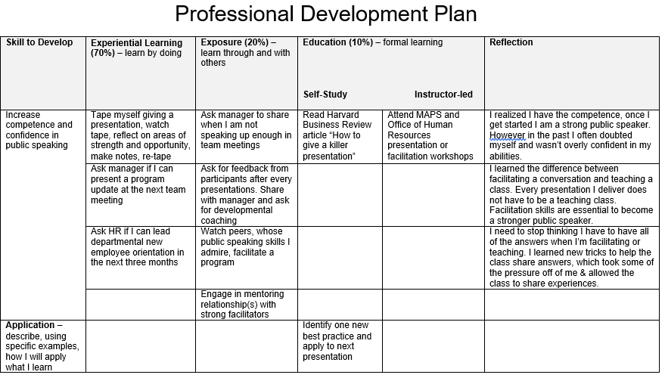
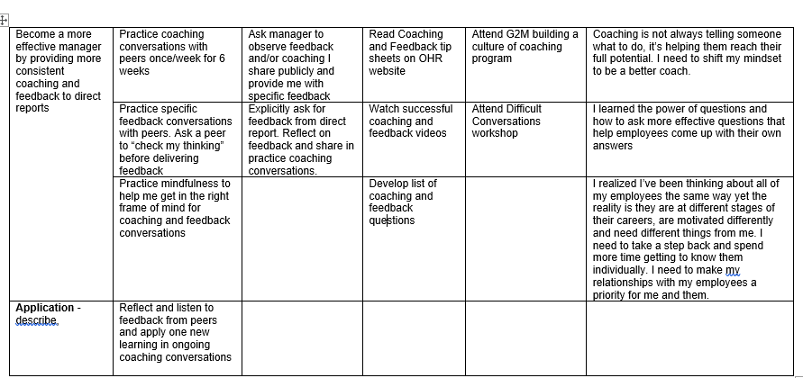

- CONCLUSION
Coaching and mentoring are an important aspect organization should consider when managing their operations. The line managers should be at the front in ensuring this takes place accordingly. The employees play indeed a vital role at ensuring that everything moves according to an organization’s mission as well as vision and it would it would be vital to have all them at par with plans and intended changes.
Furthermore, the line managers should act as a voice to the top management on the issues they face whenever they have to undertake duties using a different method, they may not be well-versed with at the end of the day (Hoppey, 2016). In addition, a junior staff should feel free to consult with a line manager if faced with any challenge regarding undertaking their duties.
The report has provided a detailed approach on how coaching and mentoring is effective in in organizations. It also clearly highlights the position of employees within the organization whenever there are changes to be introduced in the operations of the organization. In as much as the management would wish the changes to take effect, no major progress can be made unless the employees are fully aware on how the entire exercise will be undertaken.

References
Bob Garvey, P. S. D. M., 2018. Coaching and Mentoring: Theory and Practice. Chicago: SAGE Publications.
Brockbank, A. and McGill, I., 2006. Facilitating reflective learning through mentoring & coaching. London: Kogan Page.
2006. Biological, social, and organizational components of success for women in academic science and engineering. Washington, D.C.: National Academies Press.
Blackman, A., Kon, D. and Clutterbuck, D., 2015. Coaching and mentoring in the Asia Pacific.
Burley, S. and Pomphrey, C., 2011. Mentoring and coaching in schools. London: Routledge.
Cox, E., Bachkirova, T. and Clutterbuck, D., 2011. The complete handbook of coaching.
Cronin, Nicola. The Importance of Mentoring in the Workplace | Guider. 2022, https://www.guider-ai.com/blog/why-everyone-needs-mentoring-in-the-workplace.
Eric Parsloe, M. L., 2016. Coaching and Mentoring: Practical Techniques for Developing Learning and Performance. New York: Kogan Page
Evans, K., Hodkinson, P. and Unwin, L., 2015. Working to learn. London, UK: Kogan Page.
Garvey, B. and Stokes, P., 2014. Coaching and mentoring.
‘The GROW Model’. Performance Consultants, https://www.performanceconsultants.com/grow-model. Accessed 3 Mar. 2022.
Hislop, D., Bosua, R. and Helms, R., 2015. Knowledge management in organisations.
Holliday, M., 2016. Coaching, Mentoring, and Managing: A Coach Guidebook. Chicago: Red Wheel'.
Hoppey, D. and Yendol-Hoppey, D., 2016. Outcomes of high-quality clinical practice in
teacher education.
Hymans, M., 2014. Coaching and mentoring staff in schools.
Jenny Rogers, A. G. K. W., 2015. Manager as Coach: The New Way to Get Results. New York: Mc-Graw Hill.
Kimsey-House, H., Kimsey-House, K., Sandahl, P. and Whitworth, L., 2012. Co-active coaching.
Mercado, J., 2018. Personal Flourishing in Organizations. Cham: Springer International Publishing.
Murrell, A., Crosby, F. and Ely, R., 2016. Mentoring dilemmas.
Nigro, N. and Dixon, W., 2012. The Everything Coaching and Mentoring Book.
Passmore, J., 2010. Excellence in coaching. London: Kogan Page.
Smith, R. and Smith, J., 2016. Impact coaching.
Toll, C., 2014. Educational coaching.
Turner, T., Lucas, M. and Whitaker, C., n.d. Peer supervision in coaching and mentoring.
Wilson, C., 2011. Best practice in performance coaching. London: Kogan Page.

