Dylan Samuel (2119913)

Building services assignment

Table of Contents

1.Introduction

2. Transforming a Part L-Compliant Masonry Building to LETI Standards

3. Reducing Thermal Bridging
3.1 Existing Design
3.2 Required Improvements

Improving Airtightness
4.1. Existing Design
4.2. LETI-Aligned Airtightness Strategy
4.3. Benefits and LETI Requirements

5. MVHR Requirement

6.Windows and Doors Current Specification
6.1. Specification for High-Performance Openings
6.2. Functional and Environmental Advantages

7.Costs

8. Conclusion

Introduction
This assignment is about planning and improving the Mechanical, Electrical, and Ventilation (M&E) systems for a new house in Wales. The main aim is to carefully review the current M&E design and suggest necessary changes to meet low-energy building standards. A report will be written to explain and support the choices made for the equipment used in these systems, considering their impact on sustainability, running costs, and the environment over time.

I will look at how the design fits with trends like Net Zero, low-carbon energy, low embodied carbon/energy, and ways to save money both at the start and in the long run. The planned changes aim to improve the building's performance now and ensure the design remains relevant in the future as people worldwide move towards more energy-efficient and environmentally friendly living spaces.

All assumptions made throughout the report will be clearly explained, along with the reasons for each decision, to ensure clarity and give strong support for the suggested changes. The main goal of this review is to provide examples of suitable changes to the building to help it meet both Part L and LETI standards.

Transforming a Part L-Compliant Masonry Building to LETI Standards
The building currently uses masonry construction with PIR insulation and meets the basic requirements of the UK Building Regulations Part L. However, to achieve LETI’s standards focusing on Net Zero energy and Passive House principles, we need some design improvements. LETI encourages buildings to naturally use less energy with a fabric-first approach, targeting space heating needs of less than 15–20 kWh/m²/year. This report examines the current construction and highlights changes needed in four main areas: reducing thermal bridging, improving airtightness, upgrading windows and doors, and installing a mechanical ventilation with heat recovery (MVHR) system. These changes are essential to enhance the building's energy efficiency and align with LETI’s goals for low-energy buildings. By addressing these areas, the building can better conserve energy, reduce costs, and provide a more comfortable environment for its occupants.

Reducing Thermal Bridging

Existing Design
The current building uses taped PIR insulation in the walls, but it doesn't have specific features to stop heat from leaking at key points, like where the walls meet the floor or roof, and around windows. The building is made with strong Forterra Evalast aggregate blocks, but these can still cause heat loss if not properly addressed. Also, since there is no insulation around the edges of the concrete slab, this can lead to heat escaping at the foundation, creating cold spots.

Required Improvements
To comply with LETI guidance and high-performance targets for low-energy buildings, it's crucial to design with a complete and integrated focus on the thermal envelope. The thermal envelope is the key barrier between the building's interior and the outside, and it should be designed to reduce heat transfer and thermal bridging. An important area needing improvement is where the ground floor slab meets the external walls. Currently, the building lacks insulation at the foundation, causing a significant thermal bridge that results in unwanted heat loss and possible condensation on the floor. To fix this, continuous insulation should be installed around the slab edge using materials like extruded polystyrene (XPS), phenolic foam, or cellular glass, which are durable and moisture resistant. These materials have low thermal conductivity and can effectively stop thermal transfer where the building meets the ground.

The UK Building Regulations’ Approved Document Part L (2021) requires accounting for thermal bridging at key areas like floor-to-wall junctions in SAP assessments, either using standard Accredited Construction Details (ACDs) or custom thermal modelling. LETI, however, recommends going beyond these requirements to achieve construction without thermal bridges. LETI suggests aiming for psi ce (Ψ-values) below 0.05 W/m·K, which needs better detailing and choice of materials at all junctions.
The current construction uses Forterra Evalast aggregate blocks in external walls. While strong, these blocks have higher thermal conductivity than newer options. It's better to replace them with low-density, lightweight aggregate blocks or aerated concrete blocks, which have thermal conductivities as low as 0.11 W/m·K. These blocks help reduce thermal bridging, improve U-values, and enhance the building's thermal performance. Using low-conductivity materials is recommended in LETI and Passive House methods for better thermal performance without major structural issues.
Careful consideration is needed on how these materials fit into the wall structure to ensure continuous insulation. This means aligning internal insulation with external wall insulation and avoiding breaks from structural issues or poor work. According to Part L, all details affecting heat loss must be included in the energy model to accurately reflect the building's as-built performance. With these measures, the design will achieve better thermal continuity, lower energy losses, and comply with UK regulations and LETI's goals for low-carbon, resilient buildings.
(HM Government, 2023)

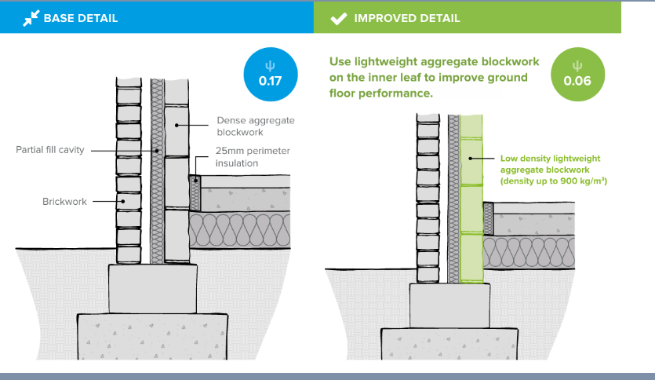

(THERMAL BRIDGING GUIDE An introductory guide to thermal bridging in homes, n.d.)

For windows and doors, it's crucial to use insulated cavity closers and thermal breaks to maintain the building’s temperature and stop heat from escaping. These areas are prone to losing heat since insulation gets interrupted by structural parts like frames and lintels. Without proper attention, these spots can lead to higher U-values, which means more heat loss, and could result in moisture on surfaces and discomfort inside the building.
The role of insulated cavity closers is to both seal off the cavity and keep insulation intact around windows and doors. They need to be installed perfectly to cover the cavity fully and line up with the internal insulation layer, ensuring no gaps are present for heat to escape. It's equally important to have thermal breaks at the points where window and door frames meet walls made of masonry or concrete. These breaks reduce heat transfer through the frames. Using tools like thermally broken fixings, insulated mounting brackets, and frame profiles made from materials that don’t conduct heat well, such as composite timber, uPVC, or aluminium, can be very effective.
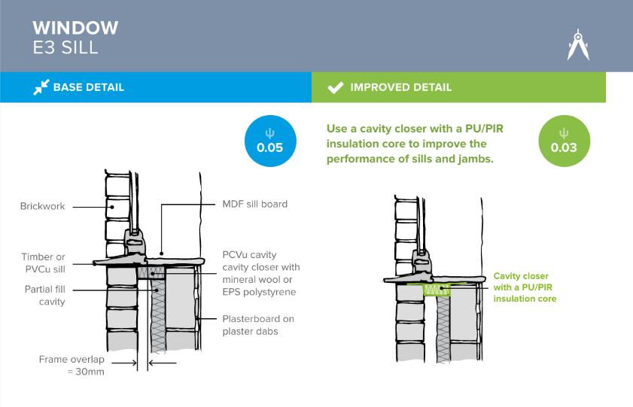

(THERMAL BRIDGING GUIDE An introductory guide to thermal bridging in homes, n.d.)
As shown in the construction detail above, incorporating a cavity closure at the junction significantly enhances thermal performance by reducing the Ψ-value by 0.02 W/m·K. This reduction helps to minimise heat loss through thermal bridging at the interface, contributing to improved overall energy efficiency and thermal comfort within the building Benefits and Compliance.

Improving Airtightness
Existing Design
The existing building plan currently depends on Passive Purple internal vapour control paint to make everything airtight. This paint can help control air leaks when applied correctly, but it can't work alone to achieve LETI standards. To ensure LETI standards are met, there must be measures in place that ensure all areas of the building where penetrations and connections are sealed correctly and to LETI standard.
The UK Building Regulations, specifically Approved Document Part L (2021 edition), set standards to conserve fuel and energy in buildings. For new homes, the maximum air leakage allowed is 8.0 m³/(h·m²) at 50 Pascals. While this is the highest limit, most new homes are built with better airtightness, between 3 and 5 m³/(h·m²). This is important because stricter energy performance requirements need to be met according to the Standard Assessment Procedure (SAP). SAP checks the Dwelling Emission Rate (DER) and Dwelling Primary Energy Rate (DPER) to make sure buildings comply with Part L.

Every new home must pass an air pressure test. A qualified tester, registered with ATTMA (Air Tightness Testing and Measurement Association) or iATS, needs to carry out this test. If only one or two houses are built, the test could be avoided by assuming an air leak rate of 15 m³/(h·m²), but this often means failing SAP requirements.

Homes that aim for low energy or Net Zero performance, such as Passivhaus or LETI standards, require much tighter construction. They should achieve air leakage levels under 1.0 m³/(h·m²), or 0.6 air changes per hour (ACH) at 50 Pascals for Passivhaus. These lower leakage rates reduce energy use and improve comfort for residents. They are also crucial for the successful operation of mechanical ventilation with heat recovery (MVHR) systems. (HM Government, 2023b)
LETI-Aligned Airtightness Strategy
To meet LETI targets, buildings must be highly airtight. LETI requires airtightness to be ≤1.0 cubic meters per hour per square meter at 50 Pascals, much stricter than the Part L standard of 8 cubic meters per hour per square meter. Achieving this requires a clear airtightness strategy.
First, choose an airtight membrane for inside and ensure it is continuous across all joints and connections. This needs careful step-by-step attention. Seal pipes and cables that pass-through walls using special airtight grommets or tapes. Windows and doors must also be sealed to the building with expanding airtight tapes and connectors that work with the membranes.
Air tests should be conducted during and after construction. These checks ensure the building is airtight and help in identifying any issues early before it is to late.
Benefits and LETI Requirements
A high level of airtightness is crucial for MVHR (Mechanical Ventilation with Heat Recovery) systems to function effectively. It prevents air leaks and reduces heat loss. Meeting LETI targets means doing the work with great care and ensuring quality at every step. Better airtightness also minimises drafts, improves noise separation between spaces, and helps maintain good indoor air quality. This is because it lets controlled ventilation strategies do their job properly.
MVHR requirement
When designing a highly airtight building, such as one aiming to meet or exceed the requirements of Part L or achieve low-energy targets like LETI or Passivhaus standards, it becomes essential to incorporate a Mechanical Ventilation with Heat Recovery (MVHR) system. This is because increased airtightness—achieved by reducing air permeability to levels below 3 m³/(h·m²) @ 50 Pa, and especially below 1.0 m³/(h·m²) in ultra-low energy homes—prevents uncontrolled air infiltration and exfiltration. While this minimises heat loss and improves energy efficiency, it also significantly reduces the natural ventilation that would typically occur through small air gaps in the building fabric.
In airtight buildings, the lack of natural air exchange can lead to the accumulation of indoor pollutants such as carbon dioxide (CO₂), volatile organic compounds (VOCs), moisture from cooking and bathing, and other airborne contaminants. Without adequate ventilation, this build-up can lead to poor indoor air quality, increased risk of condensation and mould growth, and can negatively affect occupant health and comfort.
An MVHR system solves this issue by providing a balanced, continuous, and controlled ventilation strategy. It extracts stale, moisture-laden air from rooms like kitchens, bathrooms, and utility areas, while simultaneously supplying fresh, filtered air to living spaces and bedrooms. The key benefit of MVHR is its integrated heat exchanger, which captures heat from the outgoing air and transfers it to the incoming fresh air—typically achieving a thermal efficiency of 85–95%. This allows for year-round ventilation without the significant heat losses associated with traditional extract or trickle vent systems.
Stated within Approved Document Part F of the UK Building Regulations (2021), all ventilation strategies must be designed to ensure adequate indoor air quality. While background ventilation (e.g. trickle vents and intermittent fans) may be acceptable in naturally ventilated homes, it is insufficient in highly airtight buildings. MVHR becomes not just beneficial, but essential, in these cases. It ensures compliance with both Part F and Part L by maintaining fresh air supply while supporting the building’s energy performance. (HM Government, 2021)
Using MVHR (Mechanical Ventilation with Heat Recovery) in airtight homes needs careful planning. You must think about the system's setup and how the ducts are arranged. The ducts should be right sized to cut down on pressure loss. They also need insulation on both the intake and exhaust sides and soundproofing to stop noise from getting through to other rooms within the building. It's crucial to balance the system so it has the correct flow rates, as planned during the design stage. In addition to this, you also need to maintain it regularly to keep it working well for a long duration.

Windows and Doors Current Specification

The current design does not specify glazing types, frame materials, or thermal performance values for windows and doors. Under Part L, compliance can typically be achieved with double-glazing and standard uPVC or aluminium frames. However, these elements represent a weak point in the thermal envelope and are critical in LETI-aligned buildings.

Specification for High-Performance Openings

LETI-compliant windows and doors must meet or exceed triple-glazing standards. Window units should achieve whole-window U-values (Uw) between 0.8 and 1.0 W/m²·K, using thermally broken composite frames (e.g. timber-aluminium or Passive House-certified uPVC) and insulated glazing units (IGUs) with low-emissivity coatings and warm-edge spacers. Glazing should have a g-value between 0.5–0.6 to control solar gain. All openings must be installed using airtight and thermally broken details, with frames recessed into the insulation zone, protected by external reveals or insulated cavity closers.
Functional and Environmental Advantages
High-performance windows and doors play a crucial role in energy-saving buildings. They prevent heat from escaping by using advanced materials like insulated glass and airtight frames. This helps keep indoor surfaces warmer during cold weather, reducing condensation and enhancing comfort. Less condensation means a lower risk of mould and damp issues.
The placement and size of windows are also vital. When windows are well-positioned, especially on south-facing walls, they allow more natural light and harness the sun's heat in winter, a concept known as passive solar heating. This reduces the need for central heating. At the same time, smart design keeps out excess heat in summer, preventing overheating and minimising the need for air conditioning.
While high-performance windows and doors might be more expensive initially, they save energy over time, cut down on heating costs, and enhance the comfort of living or working spaces. These upgrades are also essential to meet energy performance standards set by LETI, which advises that buildings should use no more than 15 to 20 kWh of energy per square meter annually for heating. Achieving these standards is key to building energy-efficient and sustainable structures.

Costs

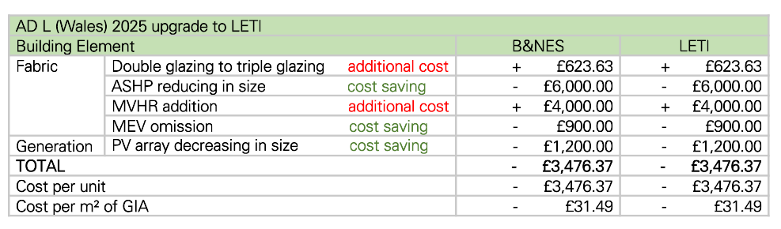(davies, 2025)
A shown in the table above. Upgrading from AD L (Wales) 2025 to the LETI building standard offers a cost-effective way to achieve better energy efficiency and environmentally friendly homes. Surprisingly, the upgrade results in savings of £3,476.37 per unit or £31.49 per square meter, which is unique since upgrades usually tend to cost more. These savings are mainly due to using smaller Air Source Heat Pumps (ASHP) and Photovoltaic (PV) panels, and by not using the Mechanical Extract Ventilation (MEV) system. These changes help reduce initial expenses without losing energy efficiency because the building is constructed with better materials, such as improved insulation and enhanced air tightness, all in line with LETI standards.

However, there are additional expenses involved. Switching to triple-glazed windows costs £623.63 and adding a Mechanical Ventilation with Heat Recovery (MVHR) system costs £4,000.00. Although these require more initial spending, they provide lasting benefits such as better thermal comfort, improved indoor air quality, and reduced heat loss. These are crucial for achieving LETI's goals of low energy usage and net-zero carbon emissions.

The benefits of the upgrade include saving on overall costs, reduced operational expenses, and keeping up with advanced building standards. The drawbacks could involve more complex design processes and the need for construction teams to learn new methods. Overall, the upgrade represents a wise investment, providing both immediate cost savings and long-term benefits for environmental sustainability and building performance.

Conclusion

In conclusion, upgrading the mechanical, electrical, and ventilation (M&E) systems of a Part L-compliant masonry home to meet LETI standards presents a highly beneficial opportunity for improving building performance and long-term sustainability. By adopting a fabric-first approach, reducing thermal bridging, improving airtightness, and integrating high-efficiency components such as triple-glazed windows and an MVHR system, the home can achieve significant reductions in energy use and carbon emissions. While these upgrades do involve added upfront costs for certain elements, these are offset by savings gained from smaller ASHP and PV systems, leading to an overall cost reduction of over £3,400 per unit. More importantly, the improved thermal comfort, better indoor air quality, and alignment with future energy performance targets make the investment worthwhile. These enhancements not only help the home meet LETI's ambitious low-energy goals but also prepare it for a low-carbon future, ensuring long-term value, compliance with evolving regulations, and a healthier living environment for future occupants.

References
- davies, jon (2025). PowerPoint presentation . [online] Sharepoint.com. Available at: https://uowtsd.sharepoint.com/:p:/r/teams/BuildingServices2-IntegrationACBA5017_GRP/_layouts/15/Doc2.aspx?action=edit&sourcedoc=%7Bfd3cec92-ecf0-4628-9ea2-925d839a5724%7D&wdOrigin=TEAMS-WEB.teamsSdk_ns.rwc&wdExp=TEAMS-TREATMENT&wdhostclicktime=1746526450064&web=1 [Accessed 6 May 2025].
- HM Government (2021). Approved Document F: Volume 1 applies to dwellings. [online] Available at: https://assets.publishing.service.gov.uk/media/61deba42d3bf7f054fcc243d/ADF1.pdf.
- HM Government (2023). L Conservation of Fuel and Power the Building Regulations 2010 Volume 1: Dwellings Requirement L1: Conservation of Fuel and Power Requirement L2: On-site Generation of Electricity Regulations: O N L I N E V E R S I O N O N L I N E V E R S I O N. [online] Available at: https://assets.publishing.service.gov.uk/media/662a2e3e55e1582b6ca7e592/Approved_Document_L__Conservation_of_fuel_and_power__Volume_1_Dwellings__2021_edition_incorporating_2023_amendments.pdf.
- THERMAL BRIDGING GUIDE An introductory guide to thermal bridging in homes. (n.d.). Available at: https://greenbuildingencyclopaedia.uk/wp-content/uploads/2016/10/ZCH-ThermalBridgingGuide-Screen_0.pdf.

