

University of Wales Trinity Saint David
School of Engineering
Technical Report: Design of a Soapbox racing vehicle

Written by: Tamzyn Davis, Greig Western, Robin Gillie-Williamson, Oliver Turner, Thomas Crocker, Harley Bates.
Student Numbers: 1804003, 1804348, 1800974, 1805585, 1801936, 1800078

BEng Foundation Motorsport & Automotive Engineering
December 2018
Integrating Project (M3X01506)

Final Report collated and presented by Tamzyn Davis and Greig Western.

1.Abstract
This Assignment was to create a team and design a soapbox racer for the Richards Castle Soapbox Derby held in the UK every year. The team first chose the name Team Brexit as a tongue in cheek nod to the fact that regardless of outcome it seems that the process of Brexit is going downhill. The next port of call was to assign relevant parts of the assignment for each member to be in control of. The assignment presented a challenge to the team due to a wide gap in both age and experience in certain skills in the classroom or workplace, from school leavers to members with 20 years of experience in the workplace. The team managed to come together both in spite of and because of these differences, with each member working to their strengths, and helping each other where necessary. Minuted team meetings at the beginning were both essential and frequent, with ideas and questions being passed freely.
Once the Team had brainstormed all relevant ideas, the final decision was agreed upon and each team went their separate ways to research their own specific areas, using group phone calls where necessary to interact with other members.
The soapbox design is based loosely on a 1950s British Formula 1 race car, to compliment the Brexit name, the materials, structure, chassis and design have all been chosen after looking at several options and choosing a best fit for both performance and cost. This is not an unlimited budget, pie in the sky approach, but a modest, realistic one. The vehicle must be realistically buildable with the equipment and budget available to UWTSD.

Contents
1 Abstract 2
Table of figures 4
2 Introduction 5
3 Background research (Greig Western) 5
4 Meetings (Tamzyn Davis) 5
4.1 Minutes 5
4.2 Gantt Chart 8
5 Design (Robin Williamson-Gillie) 9
5.1 Initial design A 10
5.2 Initial Design B 11
5.3 Initial Design C 12
5.4 Combined Design 13
5.5 Final design 14
6 Materials (Thomas Crocker) 15
6.1 Chassis 15
6.2 Bodywork 15
6.3 Suspension 15
6.4 Wheels 16
6.5 Livery 16
7 Costs (Harley Bates) 16
7.1 Bodywork 16
7.2 Chassis 16
8 Construction (Oliver Turner) 17
8.1 Chassis 17
8.2 Wheels, Tyres and Hubs 18
8.3 Suspension 19
8.4 Steering 20
8.5 Ballast 22
9 Conclusion 23

Table of figures

Figure 1, Serious Soapbox racers (Williams, 2017) 9
Figure 2, Silly soapbox racers (Jordan, 2015) 9
Figure 3, 1960's Formula 1 car (ANON, 2010) 12
Figure 4, spaceframe (engineeringsport, 2014) 17
Figure 5, Crash structure (hotrod, 2008) 18
Figure 6, Hub mounting (Formulagravitycouk, 2019) 19
Figure 7, wishbone attachment (Westfield, 2011) 19
Figure 8, Wishbone bushings (Frosty, 2011) 20
Figure 9, Pinch bolt (mopedscom, 2019) 20
Figure 10, Single pivot point (kartbuildingnet, 2019) 21
Figure 11, Steering system (howstuffworkscom, 2001) 21
Figure 12, Pitman steering (buildyourowngokartcom, 2019) 21
Figure 13, Ackerman (hotrodderscom, 2019) 22

Introduction
This report aims to determine the design for a soapbox vehicle to race at the Richards Castle Soapbox Derby. The decision will be based on several criteria: cost, materials available, workshop facilities available, performance and aesthetics.
This report will explore these factors and marry them to fit the rules and regulations of the derby to ensure the vehicle is both competitive and popular with spectators.

Background research (Greig Western)
Richard’s Castle Soapbox Derby is held annually on Hanway Common, it is an event for gravity powered soap box cars to race against the clock as an amusing aside to raising money for over 50 charities and local causes since 2004. In 2017 it donated an impressive £103,770. This year it will be supporting 3 main charities: ECHO, The Cart Shed and Working Together. As members of the 2018 Foundation year at UWTSD (University of Wales Trinity St David) studying for various engineering degrees, the class was tasked with forming groups of their own choosing, organising themselves into specialist roles within the groups, and coming up with their own designs for a Soapbox car for this event. The team this report follows is known as “Team Brexit”, a rather tongue in cheek reference to the possibility of things going rather downhill after Britain’s exit from the European Union in 2019

Meetings (Tamzyn Davis)
During the project’s duration the team regularly met up to discuss the work individuals had carried out, what was to be completed for the next meeting and to bounce ideas around. To begin with the meetings were sporadic but as time went on, they became more focused and to the point.

Minutes
11/10/2018 @ 13:15pm
Members Present:
Tamzyn Davis – TD – Admin
Greig Western – GW – Project manager
Robin Gillie - RG – Design
Tom Crocker – TC – Materials
Harley Bates – HB – Finance
Ollie Turner – OT – Construction

GW – Welcome, let’s get updated on the project. Is everyone happy with the roles assigned?
RG – Yes, I’ve brought a preliminary drawing to start with.
*Provides copies of drawing to all team members*
TD – TC has taken a picture of a chassis from the workshop for reference.
TC – I’ve also taken notes from our meeting with Paul from the workshop and have made recommendations of materials for construction and finance to use.
OT – I will look at the recommendations and come up with a plan this week for next weeks’ meeting.
GW – Thanks
HB – I will look at the costings once construction and design has come up with the plans.
TD – I will come up with the minutes next week after just watching this time.
GW – No problem, Thanks for coming everyone, let’s keep each other updated on the one drive throughout the week, Next meeting will be Thursday at 1pm in the forum.
Meeting ended 13:30pm

18/10/2018 @ 13:05pm
Members present:
Greig Western – GW – Project manager
Harley Bates – HB – Finance
Tom Crocker – TC – Materials
Ollie Turner – OT – Construction
Robin Gillie – RG – Design
Members Absent:
Tamzyn Davis – TD – Admin
TC – Hello everyone, just as a quick note, I think we should book a room next time.
GW – Good idea, as project manager I will get a room booked for next weeks’ meeting.
ALL - Agreed
GW – Right where are each of you in your tasks?
RW – For the design I have a few ideas I just need to get them on paper, one of the ideas is a cigar shape like an F1 car.
GW – Ok by next week we need OT & RG to have a least 1 design, but more would be appreciated.
TC – I’ll get a strength analysis while they do that.
GW – Ok, goo idea, so work with OT & RG so that between you we have a project design we can give to HB for costing.
ALL – Ok.
GW – Excellent, let’s get to it!
Meeting ended @ 13:30
25/10/2018 @ 13:15pm
Members Present:
Greig Western – GW – Project manager
Tom Crocker – TC – Materials
Ollie Turner – OT – Construction
Robin Gillie – RG – Design
Tamzyn Davis – TD – Admin
Members Absent:
Harley Bates – HB – Finance

GW – Hi Everyone. Has anything been done this week?
RW – I have a drawing with me (shows drawing to group)
TC – The Materials are proving harder than I thought.
GW - Ok, we can have a look together for next meeting.
TC – Thanks.
RW & OT Draw sketches, brainstorming on whiteboard (photos on GW phone)
GW – Okay so now myself and TC will make a list of all available materials suitable for each component, HB will find a unit price for each material and OT will inform the team how much of each material is needed so HB can do the maths, once done TC can procure the materials.
ALL – Agreed
RW – As far as the design is concerned, I have made it British Racing Green with a yellow nose and a union flag with the number 50 for article 50 of Brexit.
TD – are we making 1 or 3 designs?
RW – I have come up with 1 design so far, once this is done, I will make another 2 designs we can work with!
TD – ok.
GW – So, by next meeting we will all need to have made progress across the board. We need the design to be complete and possibly the next two designs as well, we also need a list of materials, their cost and the construction design done for the first car.
ALL – Ok.
GW – Thanks for coming guys, I’ll let everyone know when and where the next meeting is.
Meeting ended @ 13:55

07/11/2018 @ 13:00
Members Present:
Greig Western – GW – Project manager
Tom Crocker – TC – Materials
Ollie Turner – OT – Construction
Robin Gillie – RG – Design
Tamzyn Davis – TD – Admin
Harley Bates – HB – Finance

GW – Hello Everyone. We need to get ourselves ready for the presentation on Friday.
RW – I wasn’t present for that session what presentation?
GW – On Friday we have a 5-10-minute presentation on how far we are as a group and we have to answer a few points he gave us as well.
RW – Ah okay that’s fine then. I have come up with bodywork designs (shows team designs)
GW – now we need construction to look and see what internal systems can fit.
OT - Ill play around and see what fits
GW - Okay so what materials are you going to use
TC - We are looking at using carbon fiber for one design and aluminium as its cheaper for the others
GW - We could use fiberglass
OT - I was thinking about a fiberglass mold for the bodywork, As the materials guy did you have a look at fiberglass and how easy it was to use?
TC – I haven’t yet but I will make that my next research project!
GW – okay and HB have you looked at costings of the first design yet?
HB – I have I just need to finish the write-up.
GW – Have you referenced your research for the cost?
HB – Absolutely.
RW - How can I draw an accurate roll cage design
OT – let me show you (draws example in notebook)
GW – RW please do a final drawing and liaise with OT to turn that drawing into a finished design, then please pass to TC and HB for materials and costing for the final report.
GW – Tomorrow please either bring any designs or research so we are ready to start sorting this presentation, we have the online one-drive page or a group chat for anything to be uploaded to as well.
Meeting ended @ 13:38

Gantt Chart
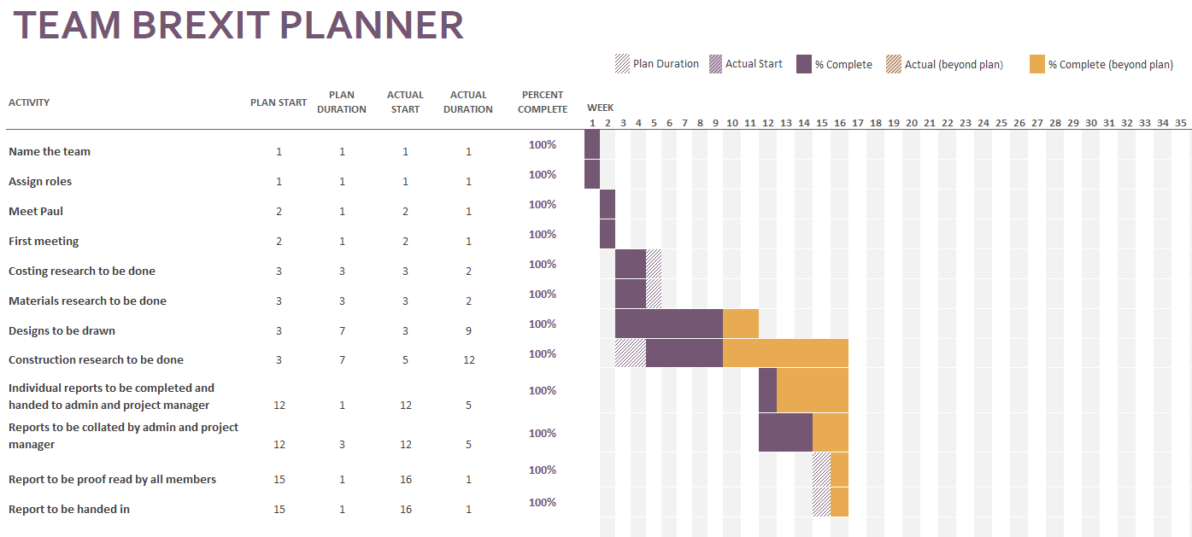

Design (Robin Williamson-Gillie)
Before starting the designs for the car, images of different soap boxes that have previously been raced were looked at, these designs varied from the serious to the bizarre.
For each design this section of the report will talk about the positives and negatives of the idea and what helped to decide what to carry through to the final design.
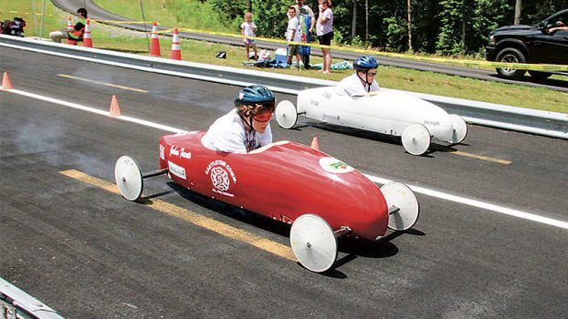

Figure 1, Serious Soapbox racers (Williams, 2017)
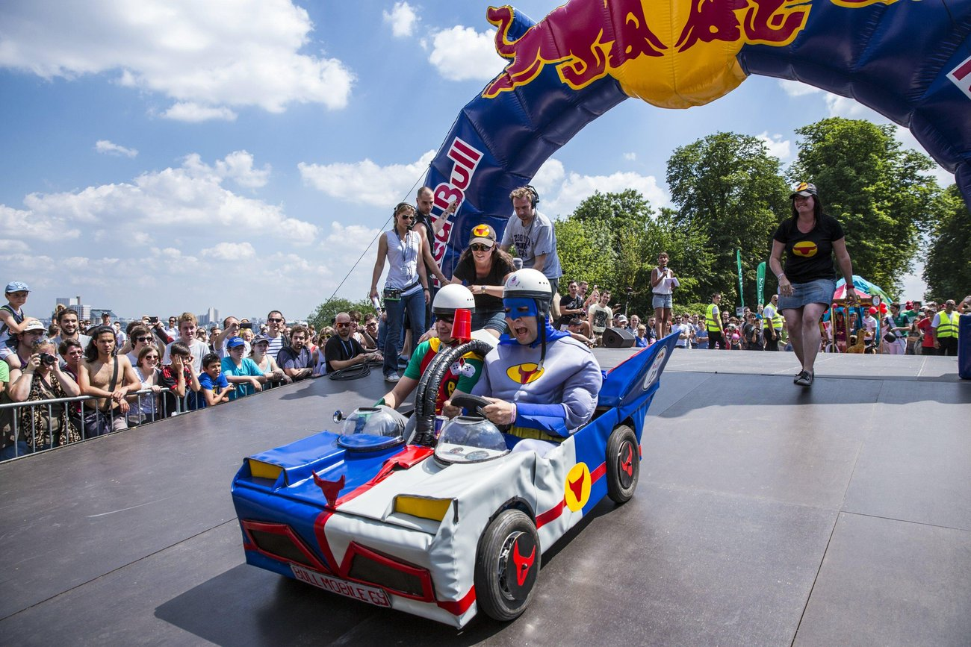

Figure 2, Silly soapbox racers (Jordan, 2015)

Initial design A
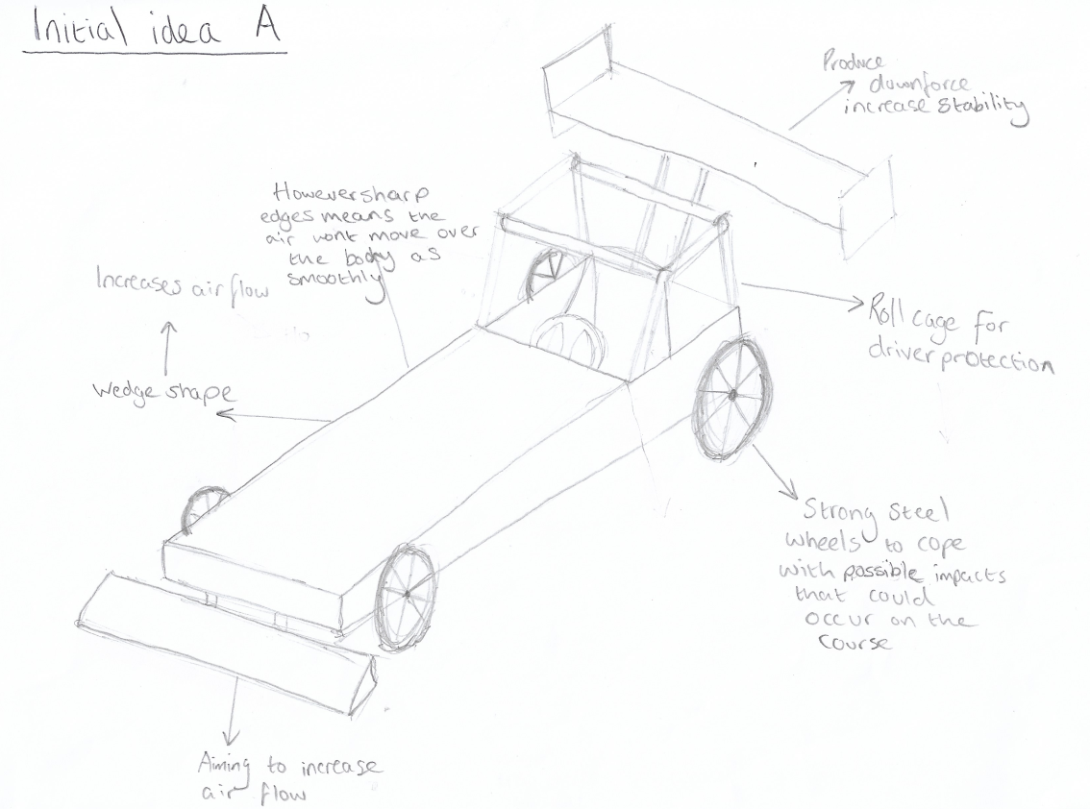

This is the first design that was produced. This was a quick sketch that gave the basis for the other designs. The basis for the first design was drag cars, as they have a huge focus on their aerodynamics to hit higher speeds quickly. One of the strongest aspects of this design is the bodies wedge shape, which allows the air to flow over the vehicle smoothly, however the cockpit design causes a huge irregularity in the shape of the body of the racer which cause there to be a large amount of drag on the vehicle. The rear and front mounted wings on the racer are more for the aesthetic of the vehicle as at the speeds the racer will be moving, they will not cause a much, if any, affect. The affect that will occur from them however, is a large increase in weight, which will reduce the acceleration of the racer.

Initial Design B

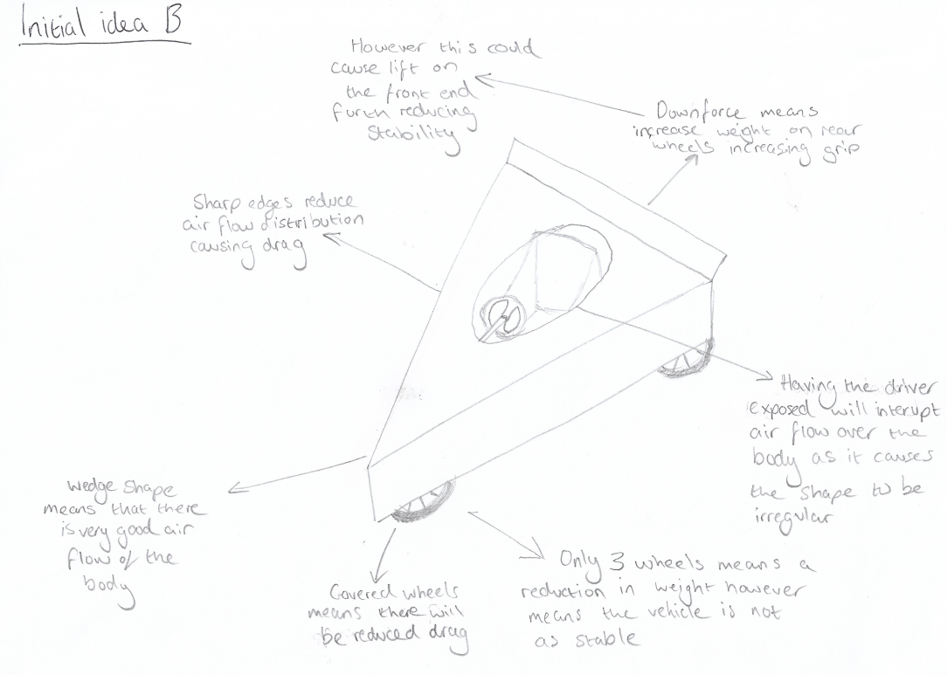

The second design is based of design seen in another soap box event. It took the shape of a cheese wedge, so a similar design was tried. Similar to design A the wedge shape is in use again, it has been made use of it again as it is the best way to get a good solid structure that is also aero dynamic. The simple shape of this design means that there are not many extremities on the bodyshell, this means that the airflow won’t be interrupted, reducing drag. It was also designed so that the driver would sit low in the cockpit of the car so that only the head would be raised above the body, this will cause slight drag, but it was the only way to fit the driver in a shape like this and for them to be able to see. Another advantage this design had is that the wheels are covered, this reduces drag from the wheels which also means that they are protected from any possible collisions that could occur on the course.

Initial Design C
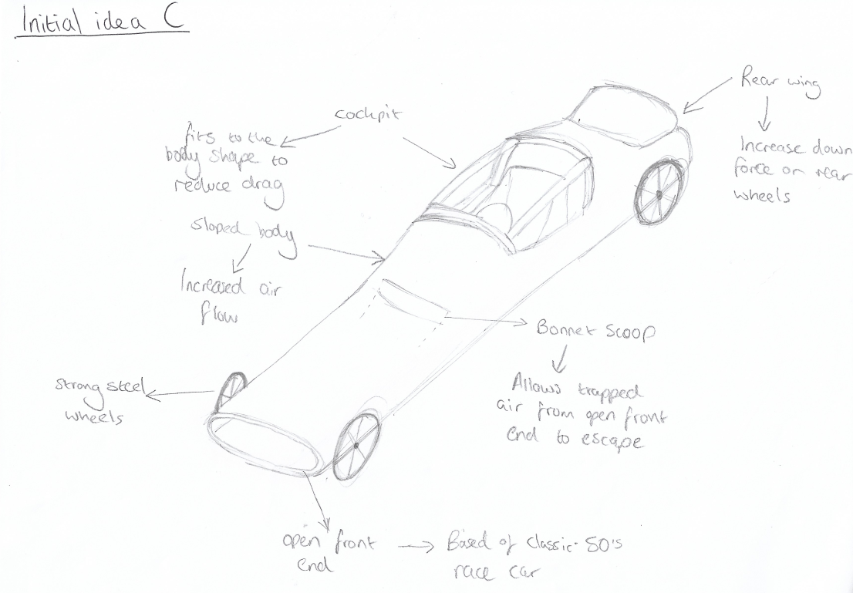

Design C was based on classic formula 1 race cars. One of the big features on these cars was an open front end, which allowed cool air to get to the engine stopping it from overheating. It was included in this design for aesthetic purposes. However, an issue was going to occur due to this added feature, the air would get trapped within the body of the car which would cause huge amounts of drag, to deal with this a bonnet scoop was added to allow the air to pass through the racer and over the cockpit of the car.
A positive aspect is that due to the shape, this design allowed the cockpit to be incorporated within the bodywork mouldings, this means that the driver sits lower in the car and still be able to see. The irregular shape will not cause drag, as the cockpit and the body of the racer are seamless with each other.
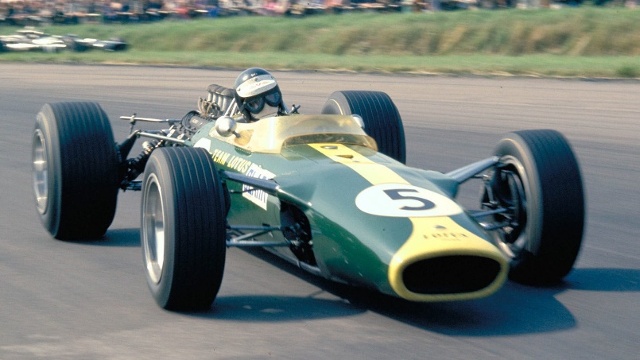

Figure 3, 1960's Formula 1 car (ANON, 2010)

Combined Design
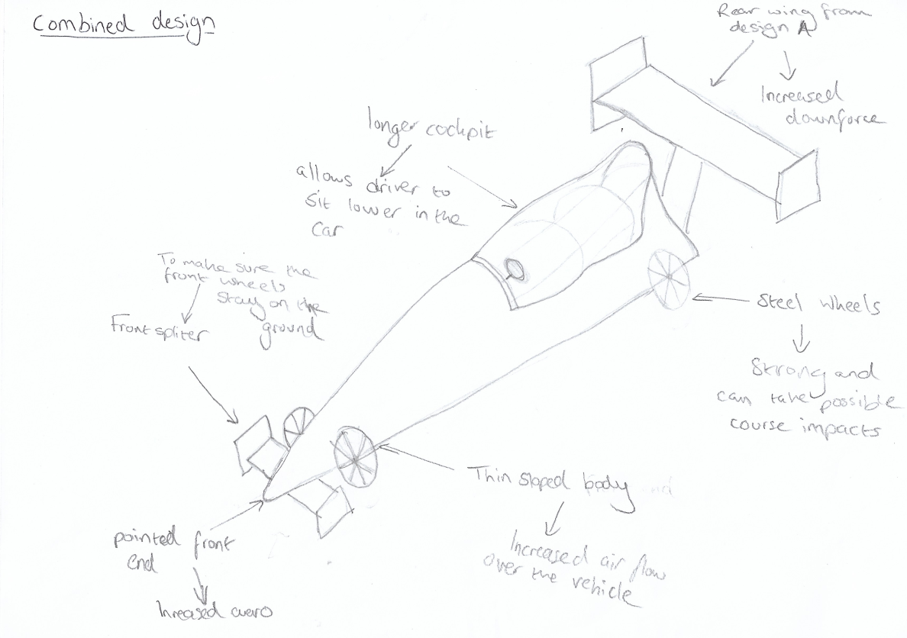

This design is a combination of idea A and idea C, it does not incorporate idea B as the rules and regulations of the Richards castle race state “There must be four wheels, fitted with pneumatic tyres, one on each corner” (Dave Pearce, 2018).
This design combines the body design of idea C with the dragster theme of idea A. A slight change to the body of the design was made, the length was increased, and the front end of the car made narrower. This further increased the aero of the design as the front is shaped to a point, the increased length also meant that the racer would be more stable with the addition of the rear wing and front spoiler from design A, however the structural strength of the racer is not as good due to the larger wheel base. A positive of increasing the length is the weight is better distributed over a larger base, giving better centre of gravity, thereby making the car more stable around the corners.

Final design
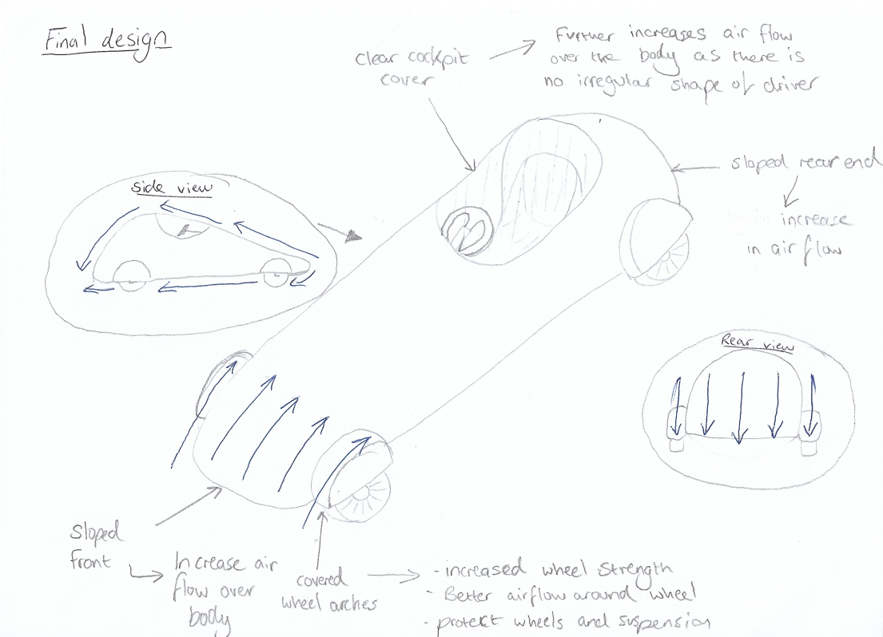

The final design was mainly based on design idea B this is because this was the most efficient design out of all them as it had the best aero dynamics and the best stability, however there some changes made to it.
The first change that was made was wheel arches were added, this creates a magnitude of benefits to the racer. One is that it allows the air to flow smoother over the wheels reducing drag caused by them, it also adds structural integrity and stability to the car as the wheels aren’t as free to moved. It also protects the wheels from any possible impact that could occur on the course.
The second change that was made was the height of the rear of the car was increased and a plastic cover was added to the cockpit of the racer, this means that the driver will have a clear view of where they are driving, while the body stays as one complete shape meaning that there will be no drag from irregularly shaped extremities.
Another change that was made was the open front end from Design B is closed off as this was a feature for aesthetics only and created more drag.

Materials (Thomas Crocker)
Throughout the soapbox, materials play a massive role in the performance of the vehicle. The main areas of the soapbox that require attention from the materials department is the: Bodywork, Chassis, Suspension, Livery and the Braking system. the best possible materials to use would be composites because of their low weight to high strength ratio.

Chassis
The perfect material for a soapbox body needs to be robust enough so that it can withstand all the jumps and bumps that come along with a soapbox derby. The perfect soapbox will sit on a scale between total focus on the raw speed of the vehicle and total focus on the agility of the vehicle. Where the soapbox sits on the scale depends on the layout of the track. Tracks with lots of corners and harder braking zones require a more agile and therefore more lightweight soapbox in order to give the lowest times (Carties, 2013), however, tracks with more straights require a heavier car due to physics (Carties, 2013). The basic principle is that the soapbox needs to have an accelerating force large enough to overcome friction, rolling resistance and wheel inertia. The accelerating force can be worked out using the equation F=mgsinθ where m is the mass of the vehicle, g is acceleration due to gravity and θ is the angle of the incline. From the equation you can note that if the mass of the vehicle increases then so does the accelerating force. This means that a heavier soapbox will overcome these resistive forces a lot easier, therefore accelerating quicker and giving higher v max (Carties, 2013). Looking at an onboard of the Richard’s Castle Track (Soapybox, 2012) it seems to be in the midpoint between a twisty and straight track.
This means that the material needs to be in the midpoint between light and heavy in order to produce the best balance between speed and agility. In a perfect world, the body would be made from carbon fibre due to its lightweight but still robust nature. However, carbon fibre is incredibly expensive and isn’t that easy to work with (Composites, 2016), with this in mind, the most ideal material for our soapbox racer would be steel due to it being robust, lightweight nature as well as being readily available from the workshop and it being pretty cheap.

Bodywork
The workshop at the university has an autoclave facility, which is used in the manufacturing of carbon fibre, this makes carbon fibre a viable but expensive option for the bodywork. The second option is to use fibreglass as it is a lot cheaper but heavier than the carbon fibre option. The third way, which is the cheapest and lightest way to make the bodywork is shrink wrap, however this is by far the least structurally sound option.

Suspension
The ideal suspension system would use steel tubing due to its strength and rigidity, however a soapbox’s suspension does not need to be too extreme because, as much as there is a lot required from the suspension due to the bumpy nature of a soapbox track, the suspension will not be experiencing enough force to require incredibly strong materials. With this in mind, I recommend using steel tubing, preferably oval tubing due to its aerodynamic benefits, with rubber dampers as this could be a cost-effective method of shock absorption.

Wheels
Most soapbox racers use spoked bicycle wheels, however spoked wheels struggle under high side loads and crumple, so in an ideal world the solution to this would be to use mag wheels from BMX bikes. However, mag wheels are incredibly expensive so a much more cost-effective solution, without delving too far into the construction side of things, would be to use normal spoked bicycle wheels and attach metal discs to the spokes in order to reduce the effects of large side loads on the wheels.

Livery
The best, and conveniently, the most ideal livery for the soapbox would be to use vinyl and shrink-wrap it onto the shell of the soapbox. Using vinyl is ideal due to the availability of it in the workshop, its low costs and it aerodynamic benefits.

Costs (Harley Bates)
Carbon Fibre Cloth Fabric 2/2 Twill 1m - £25.80(carbonmods, 2019)
Woven Roving - 1m wide – £2.95(ecfibreglasssuplies, 2019)
Realpack Clear Pallet Stretch Wrap Cling Film 400mm x 250m £7.99 / 250 = £0.31 pm(amazon, 2019)
Brake Caliper and Disc £30(greenpower, 2019)
Brake Cable £2.07(greenpower, 2019)
F24 16"/305 Wheel £70.00 ex VAT ex vat(greenpower, 2019)
Schwalbe AV2 Inner Tube 16" £7.50 ex VAT(greenpower, 2019)
Kenda K193 16" x 1.25" (32-305) Reflective Tyre £25.47 ex VAT(greenpower, 2019)
Mild steel tube 42mm d 3mm thick 100cm £8.10 (greenpower, 2019)

Bodywork
The workshop has an autoclave facility, which is used in the manufacturing of carbon fibre, this makes carbon fibre a viable but expensive option for the bodywork. The second option is to use fibreglass as it is a lot cheaper but heavier than the carbon fibre option, potentially slowing the car down. The third way, which is the cheapest and lightest way to make the bodywork is shrink wrap, however this is by far the least structurally sound option.
The optimal solution here for the purposes of this project is a fibreglass body shell.

Chassis
Mild steel is a strong material, at a fair price, and can be used to make different parts of the Chassis due to the high strength. There are several benefits to using this starting with the fact that it is the most cost effective. Mild steel is the least expensive of the steels because of the amount of carbon in it, this keeps it strong without it costing as much. The next benefit is the fact that it is weldable, which unlike high carbon steel, can be coalesced without much trouble, reducing man hours and electrical costs. Another benefit is, like most metals, mild steel is recyclable so it can be made from other things, rather than having to mine more, which can be very expensive. The final benefit of using the mild steel is that once the car has reached the end of its racing life the whole car itself can be recycled into something else or recycled back into the parts needed for another gravity racer.
The wheels, tyres, inner tubes, brake cables, disks and calipers will be purchased from an education trust named Greenpower. This company will be used because it has been found that these parts work best for the body and style of the car, however, the parts come at a higher price. Furthermore, there are other benefits for using this company, namely the good influence they have on younger children. One of their key aims is to excite young people to take an interest in the STEM (science, technology, engineering and maths) subjects.

Construction (Oliver Turner)

Chassis
The chassis was the first point of concern for the project. This will be the basis that the rest of the components will be based around. It must be strong but light, options considered for this were using bike frames, a go-kart frame, a monocoque or a tubular space frame chassis. Bike frames or a go-kart frame would seriously limit the design capabilities, so these were ruled out. This is because they tend to come in a specific shape which would not be easy to modify/ adapt. An ideal solution would be to use a monocoque construction as they are very adaptable and could be custom made to the shape and specification required, however this would be very complicated and much more expensive. Therefore, it has been ruled out also. A simpler solution whilst maintaining a light weight, strong and very adaptable kart will be to use a bespoke space frame. An example of this is Guy Martin’s downhill speed record vehicle (See figure 4).
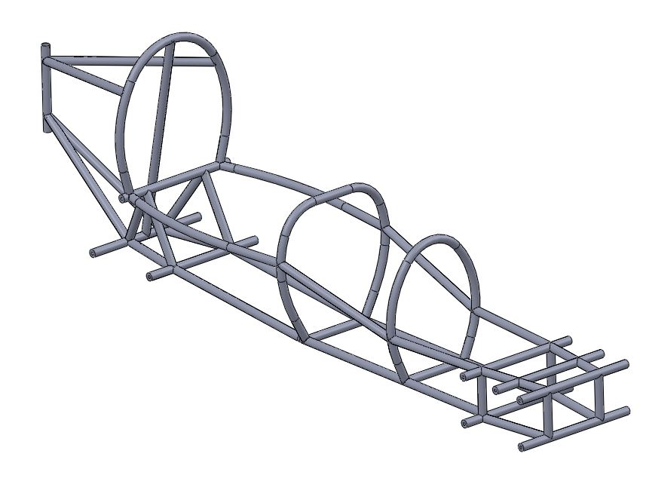
Figure 4, spaceframe (engineeringsport, 2014)
The space frame could be made in house which would be a large benefit on the cost front. It could also be made as simplistic or as complicated as required. If desirable with this method, simple crumple zones could be manufactured into the design to protect the occupant and reduce repair costs. These work by intentionally deforming in a crash to absorb the impact (see figure 5)
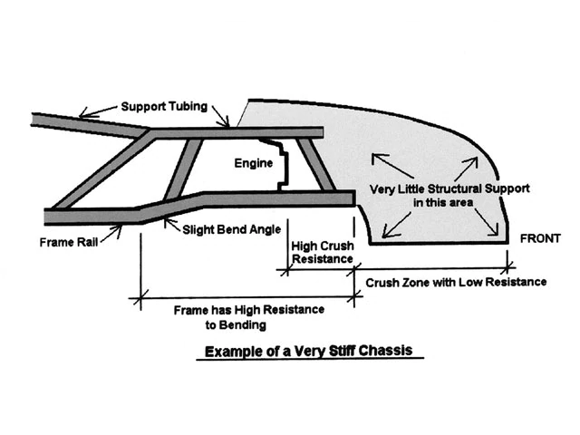
Figure 5, Crash structure (hotrod, 2008)

The space frame will be heavily triangulated for strength, this is explained in an article on Formula1-dictionary.net. (Seas, 2019) including a one-piece roll hoop over the head of the driver to offer roll over protection. Small tabs will be attached to the chassis and will provide bolting points for the body work allowing it to be easily replaced if damaged. A go-kart seat will be attached to the chassis as they are rigid and light.

Wheels, Tyres and Hubs
Richards castle has both fast, straight sections and tight bends. This makes wheel choice particularly important. Smaller, fatter wheels such as go-kart wheels are very good for cornering but have a very high rolling resistance limiting acceleration and top speed. It is suggested by the Scottish Carties (Scottishcartiesorguk, 2019) that the most common choice for all round performance are 20” BMX wheels. This is due to a large range of readily available, cheap tyre choices and strength to withstand large side loads avoiding deformation. If there is any flex in the wheels, they will not be strong enough and will likely eventually buckle. They also stated that wheels larger than 20” are unlikely to be able to withstand the side loading on some corners. According to open research online (Hopetech, 2019), smaller wheels are likely to be lighter, especially the tyres. This would help with acceleration due to the lower moment of inertia. They would also be easier to stop and require smaller brakes. On the flip side, heavier wheels would experience a higher degree of torque from the weight of the vehicle making the larger moment of inertia practically negligible. It is stated that in this circumstance, the moment of inertia does not affect the top speed of the vehicle, although the greater acceleration at the start of the course from smaller and lighter wheels is likely to decrease the time of the run. Plastic spoked wheels are certainly not strong enough and wheels from any children’s bikes are unlikely to be either. Tyre tread will be dependent on weather conditions but will be suited towards the roughness of the course. More tread increases wind resistance and is only needed on rough or wet surfaces. Due to these points, 20” BMX wheels will be used, mounted on hubs with inboard brakes. (Scottishcartiesorguk, 2019).
Strong inboard hubs reduce the risks of buckling. They also allow the use of lightweight reliable disk brakes from a bike as were retro fitted to Guy Martins speed record car (Scottishcartiesorguk, 2019). These are preferable over rim brakes as the mounting brackets or wheels can flex and only a slight amount would be needed to cause the brake to ride on the wheels. As for the hubs, 10mm bicycle stub axles are common but 14mm will be used in this case as they are much stronger and allow the use of stub axles. (Scottishcartiesorguk, 2019)

Suspension
The hubs will be mounted via ball joints, on two wishbones (top and bottom) via an upright (see figure 6).
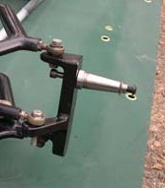
Figure 6, Hub mounting (Formulagravitycouk, 2019)

These will be attached to the chassis via rubber bushings. (see figures 7 and 8)
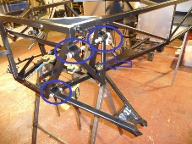
Figure 7, wishbone attachment (Westfield, 2011)
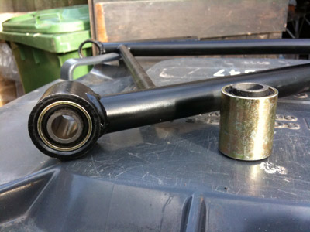
Figure 8, Wishbone bushings (Frosty, 2011)
From the bottom wishbone, there will be a strut angled up to the chassis to maintain the ride height. Rubber mountings will be incorporated into this strut using the same bushings as the wishbones, acting as a form of primitive suspension to absorb vibrations and help eliminate bump steer. The disks will be mounted to the wheels and brackets will hold the calipers firmly to the uprights. These will be either bolted or welded. There will be one disk for each hub. They will be operated by sheathed cables and separately adjustable via pinch bolts (see figure 9).
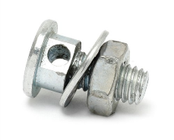

Figure 9, Pinch bolt (mopedscom, 2019)
This is because its crucial to have individual adjustment to change biases, ensuring each side apply the same braking force. If they did not, the kart could be forced to veer to one side or the other losing time, reducing driver confidence or even possibly causing a crash.

Steering
It is important for a downhill racer to be able to go around corners. For driver confidence the vehicle must be stable at speed and will not swerve from side to side or be too unpredictable/ skittish. There are several options to choose from when it comes to steering. The Scottish Carties Association narrows this down to three choices for us (Formulagravitycouk, 2019). The first option is a single pivot point (see figure 10).
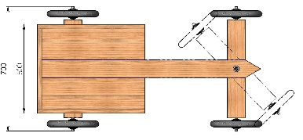
Figure 10, Single pivot point (kartbuildingnet, 2019)
This involves rotating the front axle around a centre point. This could be via rope, feet or some other mechanism. This option has no self-centering and is inherently unstable. For these reasons, although a very cheap solution, it has been ruled out. The other two options are more closely matched. Firstly, the steering rack from a small car. (see figure 11)
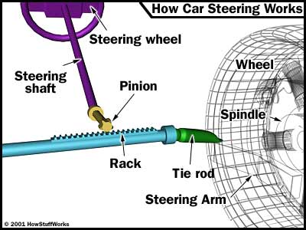
Figure 11, Steering system (howstuffworkscom, 2001)
Or, secondly, using a kart steering system, the pitman arm (see figure 12)
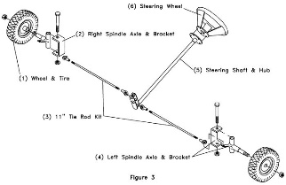

Figure 12, Pitman steering (buildyourowngokartcom, 2019)
The steering rack from a car is a viable solution, unfortunately they often have hundreds of different parts making them more complicated than the kart system. There would also be extra fabrication required to fit the part. The main issue with this option however would be adjusting the steering ratio. The Carties state that to be stable at speed, the vehicle must have a length/width ratio of at least 2:1. This would not be an issue for a conventional steering rack but there is no room for adjustment. For the previous reasons, the chosen steering method will be the Pitman arm from a go-Kart. Kart steering set-ups are very cheap and readily available. Also, as Formula Gravity explain on their website (Datageneticscom, 2019), the steering ratio is simple to adjust. This would also allow for the use of Kart spindles and entailing brackets, providing a clear advantage as it would offset the steering angle allowing Ackerman principles to come into play (see figure 13)
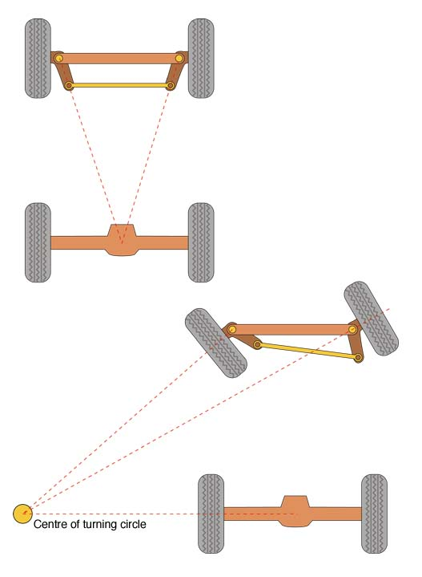
Figure 13, Ackerman (hotrodderscom, 2019)
This allows the wheels to work together under steering, avoiding scrubbing of the outside tyre. Stability and ease of control is also dramatically increased. One more thing suggested from the Scottish Carties association was to limit steering angle to around 10-15 degrees for maximum control, this will be finally decided depending on what steering ratio is achieved. The Carties also suggest the use of a motorcycle steering damper in order to make the steering firmer, helping the driver to avoid unintentional input from vibrations and bumps. One of these will be fitted.

Ballast
A final point to mention, is weight. The programme “Speed with Guy Martin” (Channel4, 2019) employed a simple technique to increase the velocity of a downhill racer by using water bottles to add more weight for each run, the speed increased until Guy broke the record. This shows that a heavier vehicle will be faster on straight sections of track due to the gravitational force dragging it down the slope. This is proven by the formula “V = √ (2(mg sin(θ) / ρCdA)” (Scottishcartiesorguk, 2019). The mass multiplied by the force of gravity has a direct effect on the velocity of the vehicle. The downside to this is potential steering instability, as was exhibited after Guy broke the record. The vehicle was very twitchy and lost control causing him to crash. Enough weight will need to be added to maximize the velocity and acceleration of the vehicle without having too much of an adverse effect on stability or handling.

Conclusion
Since starting this project, the team has grown and learned new skills. The first day was a daunting one in which a new batch of students were given a task of not only completing the task of researching and designing a soap box racer, but also forming new bonds and working as a team. The team has mostly worked well to meet each other in minuted meetings when required and has rallied to each other’s requests of help via group phone calls. There have been some issues with timekeeping and turning in work to get the assignment finalised, but in the end, all work designated has been completed before the due date, this is shown in the GANTT chart.
The Final version of the car will take the form based loosely on a 1950s British formula 1 car, the chassis will be a mild steel, spaceframe chassis design with a fibreglass shell. The vehicle will use 20” bicycle wheels and rubber bushed wishbone suspension along with independently controlled left and right cable operated brake discs for better control. The steering system will be taken from a kart for packaging, cost and ease.

References
amazon, 2019. clear pallet stretch. [Online]
Available at: https://www.amazon.co.uk/realpack-clear-pallet-stretch-cling/dp/B0055R48Z6
ANON, 2010. Jim Clark, Lotus, Brands Hatch, 1967. [Online]
Available at: https://www.racefans.net/2010/12/31/cosworth-considering-kers-supply-in-2013/jimclark_lotus_brandshatch_/
buildyourowngokartcom, 2019. frontsteeringwheelassembly. [Online]
Available at: http://buildyourowngokart.com/oneperson/frontwheelsteeringassembly.php
[Accessed 22 january 2019].
carbonmods, 2019. carbonfibre cloth twill. [Online]
Available at: http://www.carbonmods.co.uk/products/carbon-fibre-cloth-twill-1000mm.aspx
Carties, S., 2013. Soapbox Racer Physics. [Online]
Available at: http://scottishcarties.org.uk/resources/how_to_build_a_soapbox_racer/soapbox_racer_physics
Carties, S., 2013. What's Better - Heavy or Light?. [Online]
Available at: http://scottishcarties.org.uk
Channel4, 2019. Gravityracer. [Online]
Available at: https://www.channel4.com/programmes/speed-with-guy-martin/on-demand/58642-004
[Accessed 06 January 2019].
Composites, P., 2016. working with carbon fiber. [Online]
Available at: http://www.protechcomposites.com/pages/Working-With-Carbon-Fiber.html
Datageneticscom, 2019. index. [Online]
Available at: http://datagenetics.com/blog/december12016/index.html
[Accessed 05 January 2019].
ecfibreglasssuplies, 2019. woven roving. [Online]
Available at: https://ecfibreglasssuplies.co.uk/product/300g-woven-roving-1-mt-wide
engineeringsport, 2014. gravity racer world record design. [Online]
Available at: https://engineeringsport.co.uk/2014/12/01/gravity-racer-worl-record-design/
[Accessed 06 January 2019].
formulagravity, 2019. formulagravity. [Online]
Available at: http://www.formulagravity.co.uk/build.html
[Accessed 24 january 2019].
Formulagravitycouk, 2019. build. [Online]
Available at: http://formulagravity.co.uk/build.html
[Accessed 03 January 2019].
Frosty, 2011. guide to wishbone bushes. [Online]
Available at: https://forum.wscc.co.uk/forum/topic/88643-guide-to-wishbone-bushes/
[Accessed 22 january 2019].
greenpower, 2019. shop. [Online]
Available at: https://www.greenpower.co.uk/shop
Hopetech, 2019. Guy Martin gravity racer. [Online]
Available at: http://www.hopetech.com/guy-martin-gravity-racer
[Accessed 13 January 2019].

hotrod, 2008. stock car safety. [Online]
Available at: http://enthusiastnetwork.s3.amazonaws.com/uploads/sites/21/2008/05/ctrp_0805_09_z-stock_car_safety-chassis_diagram.jpg
[Accessed 12 january 2019].
hotrodderscom, 2019. ackerman suspension geometry. [Online]
Available at: https://www.hotrodders.com/forum/understanding-ackerman-suspension-geometry-227762.html
[Accessed 22 january 2019].
howstuffworkscom, 2001. steering2. [Online]
Available at: https://auto.howstuffworks.com/steering2.htm
[Accessed 12 january 2019].
Jordan, R., 2015. Things You Didn’t Know about Red Bull Soapbox Race. [Online]
Available at: https://www.redbull.com/mea-en/10-things-you-didn%E2%80%99t-know-about-red-bull-soapbox-race
kartbuildingnet, 2019. plans. [Online]
Available at: http://www.kartbuilding.net/wooden go-kart plans/
[Accessed 22 january 2019].
mopedscom, 2019. cable pinch bolt. [Online]
Available at: http://www.1977mopeds.com/cable-pinch-bolt-m6-p/38.htm
[Accessed 22 january 2019].
Scottishcartiesorguk, 2019. mounting. [Online]
Available at: http://scottishcarties.org.uk/resources/construction/wheels/mounting
[Accessed 12 January 2019].
Scottishcartiesorguk, 2019. node372. [Online]
Available at: http://scottishcarties.org.uk/node/372
[Accessed 22 January 2019].
Scottishcartiesorguk, 2019. Steering. [Online]
Available at: http://scottishcarties.org.uk/resources/construction/steering
[Accessed 21 January 2019].
Scottishcartiesorguk, 2019. wheels. [Online]
Available at: http://scottishcarties.org.uk/resources/construction/wheels
[Accessed 12 January 2019].
Seas, 2019. chassis. [Online]
Available at: http://.formula1-dictionary.net/chassis.html
[Accessed 06 January 2019].
Soapybox, 2012. Youtube. [Online]
Available at: https://www.youtube.com/watch?v=3VOXKOnkW24
Westfield, R., 2011. Blog. [Online]
Available at: http://rhetts-westfield.blogspot.com
[Accessed 13 january 2019].
Williams, C., 2017. Old fashioned Soap Box Derby fun coming to Dadeville. [Online]
Available at: https://www.alexcityoutlook.com/2017/07/20/old-fashioned-soap-box-derby-fun-coming-to-dadeville/

