BSc Applied Computing
Fahad ahmed

Databases and Application Development (ACCA50260)
Walter Ernesto Melendez Dominguez (2413597)
Database Design & Implementation
UWTSD | LONDON CAMPUS
2026
Table of Contents

Introduction 2
Database Design 3
Entity-Relationship Diagram (ERD) 3
Design Decisions: Database Normalization 4
Entity Relationships 4
Implementation Documentation 5
Table Creation 5
Constraint Implementation 6
Sample Data Insertion 6
Trigger and Stored Procedure Execution 7
Stored Procedure and Transactional Scenario 8
Transaction Handling for CRUD Operations 8
Practical Use Case 1: INSERT Logic (Patient Registration) 8
Practical Use Case 2: UPDATE and DELETE Logic (Appointment Cancellation) 8
SQL Implementation 9
Performance Tuning Enhancement 10
Indexing Strategy for Performance-Critical Queries 10
Operational Data Handling Benefits 10
Expected Improvements in Speed and Efficiency 10
SQL Implementation 10
Conclusion and Reflection 11
Challenges and Solutions 11
Future Improvements 11
References 12
Part B 13
Develop a database-driven website to present dynamic content. 13

Introduction

The purpose of this report is to document the design, implementation, and optimization of a relational database system tailored for a medical clinic's daily operations. The scenario requires a robust system capable of managing core entities such as departments, doctors, patients, and their respective medical appointments, treatments, and feedback.
As part of applying database concepts to a real-world scenario, this implementation demonstrates the practical importance of data integrity. By setting up strict rules like foreign keys and using transaction handling (COMMIT and ROLLBACK), the system is protected from everyday errors—such as scheduling an appointment for a patient who hasn't been registered yet. Additionally, implementing an automated audit log with triggers and adding secondary indexes to speed up specific searches shows how these database tools are actively used to keep a clinic's administration running smoothly and securely.

Database Design

Entity-Relationship Diagram (ERD)
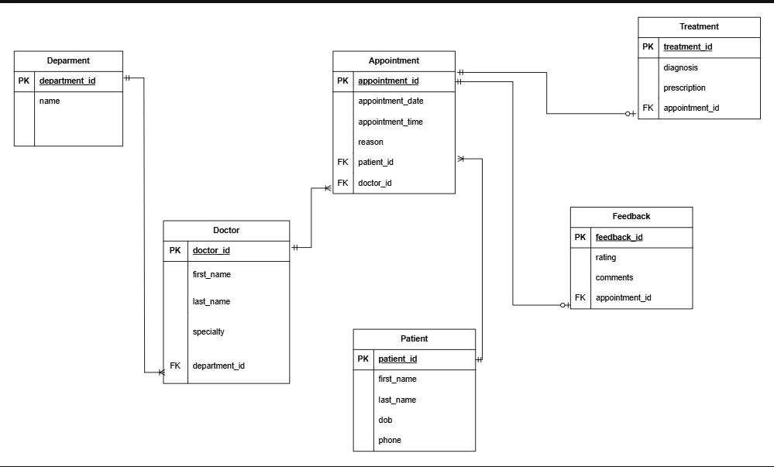
"Figure X: Entity-Relationship Diagram representing the clinic's database architecture”

The Entity-Relationship Diagram (ERD) presented above illustrates the complete logical structure of the medical clinic's database. It maps out the six core entities necessary for daily operations: Department, Doctor, Patient, Appointment, Treatment, and Feedback. The diagram clearly identifies the Primary Keys (PK) used uniquely for record identification and the Foreign Keys (FK) established to maintain referential links between these entities.

Design Decisions: Database Normalization

A critical design decision in this architecture was strictly adhering to the rules of Database Normalization. The database has been normalized up to the Third Normal Form (3NF) to eliminate data redundancy, prevent update anomalies, and ensure a highly efficient structure.
First Normal Form (1NF): The design ensures that every attribute holds atomic (indivisible) values. For example, in the Patient and Doctor tables, the names are split into first_name and last_name rather than a single "full name" column. This allows the clinic to search or sort records specifically by surname without complex string manipulation.
Second Normal Form (2NF): All tables possess a single-column primary key (e.g., appointment_id), and every non-key attribute is fully functionally dependent on that primary key. There are no partial dependencies in the design.
Third Normal Form (3NF): The architecture guarantees that there are no transitive dependencies. For instance, the Doctor table stores the department_id (as a Foreign Key) instead of storing the department's actual name. If a department's name changes (e.g., from "General Medicine" to "General Practice"), the update only needs to happen once in the Department table, preventing data inconsistency across multiple doctor records.

Entity Relationships
The relationships between entities were designed using Crow's Foot notation to clearly define the business logic and cardinality of the clinic's processes:
Department to Doctor (1:N): A One Mandatory to Many Mandatory relationships. A department can employ multiple doctors, but every doctor must be assigned to exactly one department.
Patient to Appointment (1:N): A single patient can schedule multiple appointments over time (Many Mandatory), but each individual appointment record is strictly linked to one specific patient (One Mandatory).
Doctor to Appointment (1:N): Similar to the patient logic, a doctor will oversee multiple appointments, but any given appointment is assigned to one specific attending doctor.
Appointment to Treatment (1:1): A One Mandatory to One Optional relationship. A specific appointment might result in a medical treatment or prescription (diagnosis and medication). However, the optionality (zero or one) reflects that not every consultation will generate a treatment plan.
Appointment to Feedback (1:1): A One Mandatory to One Optional relationship. Patients have the ability to leave a rating and comment after their visit. The relationship is optional because providing feedback is at the patient's discretion and not a mandatory requirement for the appointment to exist.

Implementation Documentation

This section details the physical implementation of the medical clinic's database using MySQL. The implementation process was executed sequentially to respect the relational hierarchy and data dependencies.

Table Creation
The database tables were created using Data Definition Language (DDL). Tables were created in a specific order, starting with independent entities (Department, Patient) followed by dependent entities (Doctor, Appointment) to prevent referencing errors. Standard data types such as VARCHAR, INT, and DATE were selected based on the nature of the clinical data.
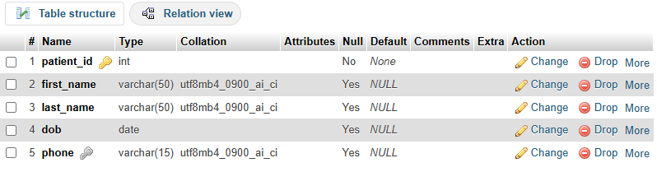

“Figure 2: Screenshot showing the successful creation and structure of the Patient table in phpMyAdmin.”

The following SQL snippet demonstrates the DDL used for this creation:
SQL
CREATE TABLE Patient (
patient_id INT PRIMARY KEY,
first_name VARCHAR(50) NOT NULL,
last_name VARCHAR(50) NOT NULL,
dob DATE NOT NULL,
phone VARCHAR(15)
);

Constraint Implementation
To enforce data integrity, several constraints were actively implemented across the schema. Primary Keys (PK) were designated to ensure entity integrity, while Foreign Keys (FK) were applied to maintain referential integrity. Additionally, domain constraints were utilized, such as a CHECK constraint on the Feedback table to restrict patient ratings strictly to a 1-5 scale, preventing invalid data entry.
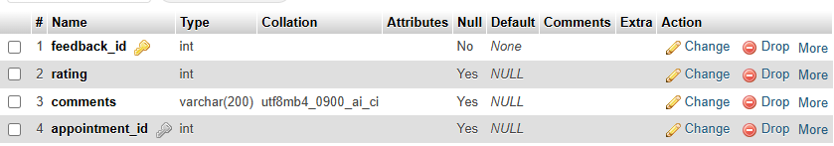
“Figure 3: Screenshot detailing the constraint implementation on the Feedback table.”

SQL
CREATE TABLE Feedback (
feedback_id INT PRIMARY KEY,
rating INT CHECK (rating >= 1 AND rating <= 5),
comments TEXT,
appointment_id INT UNIQUE,
FOREIGN KEY (appointment_id) REFERENCES Appointment(appointment_id)
);

Sample Data Insertion
Following the structural creation, Data Manipulation Language (DML) was employed to populate the database with realistic sample data. This step is crucial to simulate a live operational environment and test the relational connections. The insertion order was strictly managed, ensuring that parent records (e.g., Doctors) existed before child records (e.g., Appointments) were created.

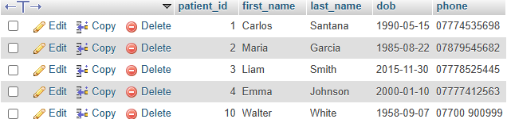
“Figure 4: Screenshot demonstrating the successful insertion of realistic sample data into the Patient table. ”
SQL
INSERT INTO Patient (patient_id, first_name, last_name, dob, phone) VALUES
(1, 'Carlos', 'Santana', '1990-05-15', '07700 900101'),
(2, 'Maria', 'Garcia', '1985-08-22', '07700 900102');

Trigger and Stored Procedure Execution

To validate the automated features of the database, both the auditing trigger and the transactional stored procedure were executed and monitored.
First, the stored procedure RegisterPatientAndAppointment was called using CALL to insert a new patient and book their consultation simultaneously. Second, an UPDATE command was executed on an existing appointment to test the After_Appointment_Update trigger. The system successfully detected the modification and generated an automated entry in the Audit_Log table.

“Figure 5: Screenshot of the Audit_Log table verifying the automated execution of the auditing trigger.”
-- Trigger Execution Testing
UPDATE Appointment SET reason = 'Severe headache' WHERE appointment_id = 1;

Stored Procedure and Transactional Scenario

Transaction Handling for CRUD Operations
To ensure the database maintains strict data integrity during daily operations, Stored Procedures were implemented to handle multi-step Insert, Update, and Delete commands. By wrapping these CRUD (Create, Read, Update, Delete) operations inside a START TRANSACTION block, the system guarantees Atomicity. This means that either all steps in the process succeed (COMMIT), or if a single error occurs, the entire process is undone (ROLLBACK) to prevent database corruption. [1]

Practical Use Case 1: INSERT Logic (Patient Registration)
A common practical scenario in the clinic is welcoming a new patient. The procedure RegisterPatientAndAppointment was designed to simultaneously INSERT the patient’s personal details into the Patient table and INSERT their initial consultation into the Appointment table.
Conditional Rollback and Commit Logic: If the system successfully registers the patient but fails to book the appointment (e.g., due to an invalid doctor ID), an SQLEXCEPTION handler detects the failure and executes a ROLLBACK. This conditional logic ensures that the clinic does not end up with registered patients who have no assigned appointments. If both inserts are valid, a COMMIT saves the changes permanently.

Practical Use Case 2: UPDATE and DELETE Logic (Appointment Cancellation)
Another critical operational scenario is handling patient cancellations. For this, the CancelAppointment procedure was implemented. When a patient cancels, the system performs two actions in one transaction: first, it registers the cancellation in the auditing system (UPDATE to the audit log), and second, it executes a DELETE command to remove the appointment from the active schedule.
Conditional Rollback and Commit Logic: If the database successfully logs the action but encounters a server error or a lock while trying to DELETE the appointment, the ROLLBACK command is triggered. This ensures that the clinic's schedule is not accidentally altered unless the entire cancellation process is fully validated and committed.

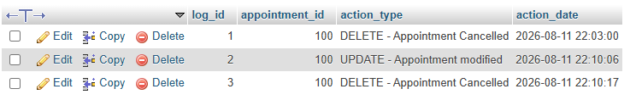
figure 6

SQL Implementation
The following SQL code demonstrates the implementation of these transactional scenarios for Insert, Update, and Delete operations:
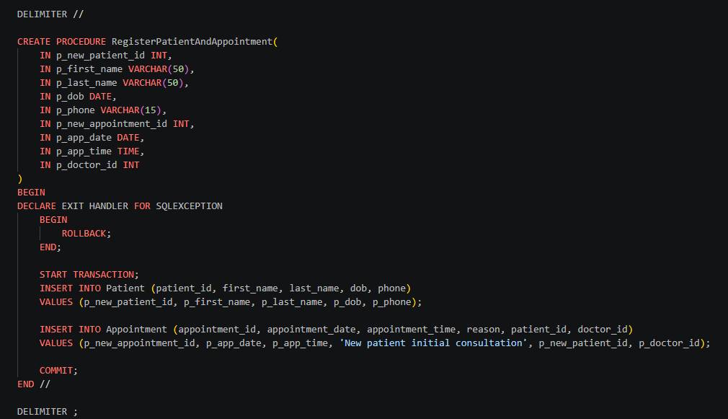
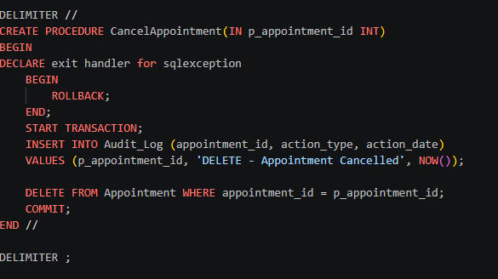

Performance Tuning Enhancement

Indexing Strategy for Performance-Critical Queries

As databases grow over time, retrieving data can become significantly slower if the system must perform a "full table scan" (reading every single row to find a match) [2]. To optimize the system, a secondary indexing strategy was developed focusing on two performance-critical queries that staff execute daily:
- Patient record retrieval via phone number.
- Daily schedule generation via appointment date.

Operational Data Handling Benefits
Proper indexing directly benefits the clinic’s operational data handling by aligning the database structure with actual administrative workflows. For example, receptionists frequently need to identify patients instantly when they call the facility, making the phone column a high-frequency search parameter. Similarly, medical staff constantly filter the Appointment table to manage the daily consultation queue. Indexes transform these repetitive, heavy operational tasks into instantaneous, lightweight lookups.

Expected Improvements in Speed and Efficiency
By applying secondary indexes to these specific columns, the database engine creates a sorted B-Tree data structure (like the index at the back of a book) that points directly to the physical location of the records [3]. The expected improvement is a drastic reduction in query execution time—shifting the search complexity from O(N) to O(log N). This ensures the system maintains high efficiency, rapid response rates, and prevents system lag even when the database scales to thousands of historical medical records.

SQL Implementation
-- Secondary Indexes for Performance Tuning
CREATE INDEX idx_patient_phone ON Patient(phone);
CREATE INDEX idx_appointment_date ON Appointment(appointment_date);

Conclusion and Reflection

This database project successfully meets the main requirements for the medical clinic scenario. By organizing the tables in Third Normal Form (3NF), the system keeps patient and appointment data well-structured without repeating information. The use of stored procedures and transactions also helps the clinic run smoothly, making sure that daily tasks like booking or cancelling appointments are handled safely and accurately.

Challenges and Solutions
One of the biggest challenges I faced during the implementation was making sure that deleting or updating records didn't break the links between tables. For example, I had to ensure that cancelling an appointment didn't cause system errors. I solved this by putting the Insert, Update, and Delete commands inside a START TRANSACTION block. This way, if something goes wrong, the ROLLBACK command catches the error. Another challenge was keeping track of database changes, which I fixed by creating an automated Trigger that saves any updates directly to an Audit_Log table.

Future Improvements
While the database works well for the current requirements, a good future improvement would be adding Role-Based Access Control (RBAC). This would mean creating different permissions so, for example, a receptionist can book appointments but can't accidentally change a doctor's medical treatment records. Also, building a simple graphical user interface (GUI) would make it much easier for the clinic staff to use the system without needing to write SQL queries every day.

References

[1] | R. Elmasri and S. Navathe, Fundamentals of Database Systems, vol. 7th, Hoboken, NJ: Pearson, 2015.
[2] | C. J. Date, An Introduction to Database Systems, Reading, MAReading, MA: Addison-Wesley, 2003.
[3] | T. Connolly and C. Begg, “Database Systems: A Practical Approach to Design, Implementation, and Management,” Harlow, Pearson Education, 2014.
Diagram Link : https://drive.google.com/file/d/1fAu7FkHq_hB3avURnheg7Qzx8CT4wk4o/view?usp=sharing

Part B

Develop a database-driven website to present dynamic content.

Understanding SQL Injection (SQLi)
SQL Injection (SQLi) is one of the most critical vulnerabilities in web applications. It occurs when untrusted user input is directly concatenated into a dynamic SQL query without proper sanitization or parameterization. This allows an attacker to manipulate the structure of the SQL statement, tricking the backend database into executing unintended and potentially malicious commands. In the context of the GameTracker application, search bars and input forms are the primary vectors for this type of attack.
The Threat and Potential Impact
The danger of SQLi lies in its ability to bypass intended application logic. If the system is not secured, an attacker could enter a payload such as ' OR '1'='1 into the search field. If this input is directly concatenated, the database evaluates the condition as universally true, returning all records and potentially exposing sensitive information. Furthermore, attackers can append destructive commands, such as ; DROP TABLE Game;, which could permanently delete the entire catalog. The impact ranges from unauthorized data exposure to complete data loss and server compromise, making it a severe threat to data integrity and confidentiality.
Identifying Vulnerabilities in the GameTracker System
Revisiting the custom PHP code developed for the GameTracker application, the primary areas susceptible to SQL Injection are the input vectors where user data interacts directly with the database. Specifically, these are the search facility in index.php (where users filter games by title or genre) and the data entry form in add.php (where new records are submitted).
If the application were coded using older, deprecated methods (such as directly inserting $_GET['search'] into the SQL string), an attacker could easily manipulate the query structure. For example, a vulnerable search query would look like this:
$sql = "SELECT * FROM Game WHERE title = '" . $_GET['search'] . "'";

Implementation of Defenses: PDO and Prepared Statements
To completely neutralize the SQLi threat and secure these vulnerable entry points, the application was built utilizing PHP Data Objects (PDO) with Prepared Statements. This is the current industry standard for database interaction and effectively separates the SQL code structure from the user-supplied data payload.
When a user searches for a game title or adds a new entry, the application first sends an empty SQL template to the database server using the $pdo->prepare() function.
For instance, the secured search functionality in index.php is structured as follows:
$sql = "SELECT * FROM Game WHERE title LIKE :search OR genre LIKE :search";
$stmt = $pdo->prepare($sql);
$stmt->execute(['search' => "%$searchTerm%"]);
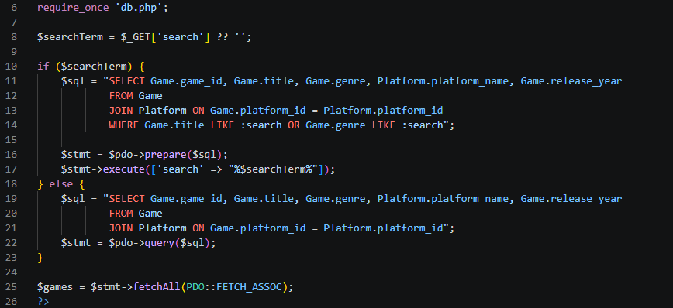
Because the SQL structure is compiled and locked by the database before the user's input is ever inserted, any malicious SQL commands entered the search bar are treated strictly as harmless literal text strings, not as executable code.
“Figure 1, Part B, Implementation of PDO Prepared Statements in index.php"

Testing and Security Verification
To demonstrate the effectiveness of this security architecture, a deliberate SQL injection payload was tested in the application's search facility. The standard injection string ' OR '1'='1 was submitted into the search input.
In an insecure database system, this payload would evaluate to a tautology (always true), bypassing filters and returning the entire database. In the GameTracker application, because the input is strictly bound as a literal string through PDO parameterization, the query treats the entire payload as the game's name. As a result, no unauthorized data was exposed, and the system safely returned a "No games found matching your search" message.
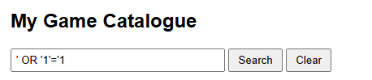

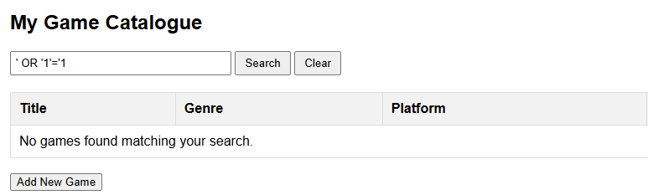

“Figure 2: Deliberate SQL Injection test resulting in 0 matches and zero data breach”

Conclusion
Developing the GameTracker application has shown me how critical it is to secure database connections. Before learning about these vulnerabilities, I might have just concatenated user inputs directly into my SQL strings. However, by taking the time to implement PDO and Prepared Statements, I now understand how to force the database to treat user input strictly as plain data, not as executable code. Alongside using htmlspecialchars() to prevent basic XSS attacks, these practical security measures ensure the website functions safely and meets the module's requirements for data protection.

