
Assignment Title: Recommendation of a Machine Learning Model
Programme: MSc Data and Artificial Intelligence
Module: L7 – Application of Machine Learning
Module code: ACCA7025
Student name: Sravanthi Sangam
Student ID number: 2536458
Lecturer: Dr Aliyu Sambo
Date of Submission: 25th June 2026

Abstract
Predictive maintenance is very important in the industrial sectors because it makes it possible for early detection of equipment failures using machine learning. Systems that are used in the sector usually generate large volumes of sensor data related to temperature, vibration or pressure. A challenge however occurs in manufacturing environments in balancing prediction accuracy with limited computational resources. Thus there is need for interpretable and efficient traditional machine learning models.
Approach that was adopted in this paper was first conducting an extensive literature review of traditional machine learning methods that can be integrated with industrial systems to assist with predictive maintenance. A methodology was then proposed for a machine learning workflow including data preprocessing, feature engineering, model training and evaluation. Evaluation of the prosed models was done on multiple evaluation metrics including precision and recall. Findings from the evaluation highlighted that ensemble methods have superior predictive performance compared to simpler methods. Random Forest is recommended as the optimal balance between performance and efficiency.

Contents
Abstract 2
1. Introduction 5
1.1 Background and Industrial Context 5
1.2 Problem Statement 5
1.3 Aim and Objectives 5
Aim 5
Objectives 6
2. Literature Review 6
2.1 Predictive Maintenance and Equipment Failure Prediction 6
2.2 Traditional Machine Learning Approaches 8
2.2.1 Decision Trees 8
2.2.2 Random Forest 9
2.2.3 Support Vector Machine (SVM) 9
2.2.4 Logistic Regression 10
2.2.5 k-Nearest Neighbour 10
2.2.6 Gradient Boosting / XGBoost 11
2.3 Comparison of Existing Studies 11
3. Proposed Workflow Methodology 13
3.1 Proposed Machine Learning Pipeline 13
3.2 Data Collection and Feature Selection 14
3.3 Data Preparation 15
3.4 Model Selection Strategy 15
3.5 Training and Hyperparameter Optimisation 16
3.6 Model Evaluation Metrics 17
4. Discussion and Recommendation 18
4.1 Comparative Analysis of Candidate Models 18
4.2 Recommended Algorithm 18
4.3 Recommended Industrial Workflow 19
5. Conclusion 21
References 22

List of Figures
Figure 1: General predictive maintenance workflow showing sensor data acquisition, data processing, machine learning analysis, failure prediction and maintenance decision-making 7
Figure 2: Decision Tree structure for equipment failure classification 8
Figure 3: Random Forest ensemble structure (multiple trees voting system) 9
Figure 4: SVM hyperplane separation with margin boundaries 10
Figure 5: Proposed machine learning workflow for predictive maintenance and equipment failure prediction. 13
Figure 6: Model Selection Criteria for Predictive Maintenance 15
Figure 7: Cross-Validation and Grid Search Hyperparameter Optimisation Process 16
Figure 8:Industrial Deployment and Feedback Loop for Predictive Maintenance System 20

List of Tables
Table 1: Comparison of Existing Studies 11
Table 2: Comparative Analysis of Candidate Models 18

1. Introduction

1.1 Background and Industrial Context
Predictive maintenance or PdM is a proactive maintenance strategy that makes use of historical and real-time equipment data to predict failures before they occur and therefore help in reducing unexpected downtime and maintenance costs [1]. Equipment failure in the manufacturing industry is likely to result in production delays, reduced productivity, increased repair expenses and potential safety risks. Methods that have been used traditionally for reactive maintenance in most cases lead to unnecessary interruptions and inefficient resource usage. Manufacturing systems that are used in the modern era generate large volumes of industrial sensor data for monitoring machine health and operating conditions [2]. Some of the key sensor measurements include temperature, pressure and vibration. In some cases manufacturing environments operate under limited computational resources and therefore predictive models that minimise processing power and memory consumption as well as deployment cost are required.

1.2 Problem Statement
Organisations in the manufacturing sector need to have reliable methods for effectively predicting equipment failures in order to minimise downtime and reduce maintenance costs which is very essential for maintaining continuous production operations. Accurately predicting failures is however challenging because industrial machinery generates large volumes of sensor data with varying patterns and operational conditions. Most of the manufacturing environments also operate with limited computational resources and this restricts the use of highly complex models. Therefore there is a need for interpretable and computationally efficient traditional machine learning models that are capable of delivering accurate predictions while remaining practical for industrial deployment.

1.3 Aim and Objectives

Aim
Main aim for the report presented in this paper is to perform a critical evaluation of traditional machine learning techniques and recommend an effective predictive maintenance approach which is well-suited for forecasting equipment failure in manufacturing environments that operate under limited computational resources.

Objectives
1. To review existing literature and industrial applications of traditional machine learning methods that are used in predictive maintenance.
2. To compare suitable machine learning algorithms based on prediction performance and interpretability and also computational efficiency.
3. To develop an efficient predictive maintenance workflow that includes critical steps of data preparation, model training and evaluation stages.
4. To recommend appropriate model evaluation metrics for assessing reliability and practical deployment suitability.

2. Literature Review

2.1 Predictive Maintenance and Equipment Failure Prediction
PdM approach is data driven and is mainly reliant on historical and real-time operational data to make predictions on potential equipment failures before breakdowns occur. It's different from reactive mainainance and preventive maintenance in that it enables interventions based on certain set conditions [3]. Primary objective of predictive maintenance is to reduce unplanned downtime and lower maintenance costs which leads to improved asset utilisation and extension of equipment lifespan through early fault detection and timely maintenance actions. Prediction of equipment failure is made by analysing patterms from machine operating data and from this signs of degradation are identified and the likelihood of future malfunction is estimated [4]. Process of making the estimation is supported by machine learning through the learning of relationships between sensor inputs and failure events. Summary of the prediction process using machine learning is represented in figure 1.

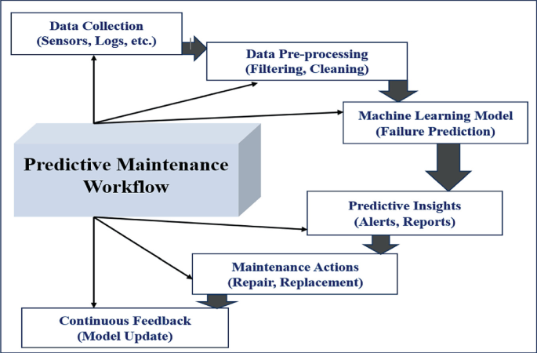
Figure 1: General predictive maintenance workflow showing sensor data acquisition, data processing, machine learning analysis, failure prediction and maintenance decision-making
Source: Gahane et al., 2025 [5]
There is now a wide adoption of predictive maintenance across different industries. For instance in the manufacturing industry it is used for monitoring production equipment and reducing downtime [6]. In the automative industry it is to predict wearing of different components and also estimating of maintenance schedules. And in the energy and utilities industry it is used to monitor components like turbines and pipelines.

2.2 Traditional Machine Learning Approaches

2.2.1 Decision Trees
Decision Trees operate on the working principle of a tree-based hierarchical model which uses recursive binary splits. Splits that are made are usually based on impurities of features such as Gini index and entropy [7]. In predictive maintenance decision trees are used for classifying faults by the use of sensor thresholds including temperature and vibration [8]. Faults are then identified by the application of the already preset rules if the specified thresholds are deemed not to have been met. Main advantage of decision trees is that they are highly interpretable because they are based on visualizable rules. They also require minimal preprocessing and are capable of handling nonlinear relationships effectively. However they are limited in that they are prone to overfitting and are very sensitive to small data changes.
Evaluation of decision tree models across different studies has shown that they mostly achieve moderate accuracy results in predictive maintenance. Their interpretability is very high and this makes them suitable for application across different industries because results they produce can be easily interpreted. Figure 2 shows the process undertaken to predict equipment failure when using the decision tree method.
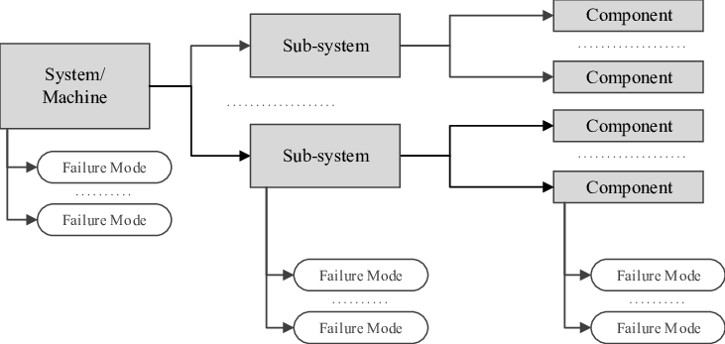
Figure 2: Decision Tree structure for equipment failure classification
Source: Vilarinho et al., 2017 [9]

2.2.2 Random Forest
Random forest model is simply a combination of multiple decision tree whereby the final prediction is usually determined by majority voting [10]. The model has been widely used in industrial anomaly detection and it is able to achieve high accurate results where less noisy sensor datasets are used. In comparison to single decision trees, random forest significantly reduces overfitting. Missing data and feature importance ranking is also effectively handled by the model. However it is less interpretable than decision trees and has higher computational cost. Structure of the model is represented in figure 3.
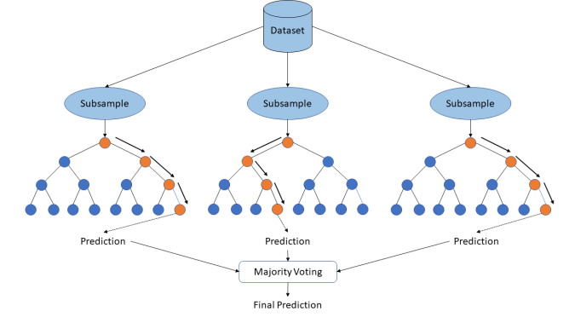
Figure 3: Random Forest ensemble structure (multiple trees voting system)
Source: Padovese, Bruno and Padovese, 2019 [11].

2.2.3 Support Vector Machine (SVM)
Operation of the SVM model is by finding the optimal hyperplane that separates classes. It is able to maximise margin between failure and non-failure states [12]. For non-linear separation it uses the kernel trick. In predictive maintenance the model is particularly effective for binary failure classification and works very well with high-dimensional sensor data. For small and medium datasets it is capable of achieving very strong performance. However its performance in large datasets is computationally expensive [12]. Tuning the kernel parameters of the models is also difficult and it has been determined to have low interpretability. Hyperplane separation for the model is demonstrated by figure 4.
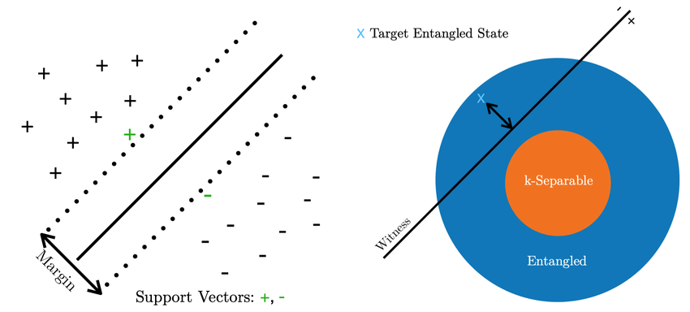
Figure 4: SVM hyperplane separation with margin boundaries
Source: Rosebush et al., 2023 [13].

2.2.4 Logistic Regression
Logistic regression model is based on the working principle of linear probabilistic classifier using sigmoid function [14]. Output produced by the model is the probability of equipment failure. In predictive performance the models us mainly used as a baseline model for binary failure prediction and is quite useful for early-stage diagnostics systems. From different research conducted the model has been determined to produce highly interpretable coefficients and has fast training and inference time. Its limitation has been shown by the poor performance on complex sensor interactions.

2.2.5 k-Nearest Neighbour
K-NN operates on instance-based learning principle using distance metrics e.g., Euclidean distance [15]. Classification by the model is usually based on majority class of nearest neighbours. In predictive maintenance the model is able to identify equipment failure patterns by using similarlity based detection. Mainly it is useful when applied for small-scale anomaly detection tasks. Among its major advantages is the fact that it is very simple and intuitive and requires no training phase. During prediction it is however computationally expensive and it is very sensitive to irrelevant features and scaling.

2.2.6 Gradient Boosting / XGBoost
Working of XGBoost model is based on sequential ensemble learning while correcting previous errors that are identified [16]. It is able to build additional decision trees that are normally optimised using gradient descent. When used on industrial datasets the model has been determined to demonstrate high performance for equipment failure prediction. High adoption of the models across different industries has been majorly influenced by its high predictive accuracy. Additionally it has built-in feature importance ranking which plays a key role of determining which factors mainly contribute to the equipment failure. The model however comes with the risk of overfitting if it is not tuned properly and has higher computational cost compared to basic models.

2.3 Comparison of Existing Studies
Table 1: Comparison of Existing Studies
Model / Study Focus | Datasets Used | Feature Engineering Approaches | Performance Metrics Used | Computational Trade-offs
Decision Trees [7][8][9] | Industrial sensor datasets (temperature, vibration, RTUs, case study manufacturing systems) | Manual threshold-based feature selection; rule-based discretisation of sensor signals | Accuracy, precision, recall, F1-score | Low computational cost; fast training and inference but prone to overfitting on noisy industrial data
Random Forest [10][11] | Multi-sensor industrial datasets and classification benchmarks | Feature importance ranking; implicit feature selection through bagging | Accuracy, ROC-AUC, confusion matrix | Moderate-to-high computation due to multiple trees; highly parallelisable and robust to noise
SVM [12][13] | Medium-scale high-dimensional datasets | Feature scaling, kernel transformation | Accuracy, precision, recall | High training complexity for large datasets; memory-intensive but effective in high-dimensional spaces
Logistic Regression [14] | Binary classification datasets | Minimal preprocessing; linear feature weighting | Accuracy, log-loss, confusion matrix | Very low computational cost; unsuitable for complex nonlinear patterns
k-NN [15] | Small-scale experimental datasets and anomaly detection datasets | Requires normalisation; distance-based feature scaling critical | Accuracy, F1-score | No training cost but very high inference cost; inefficient for large datasets
XGBoost [16] | Industrial predictive maintenance datasets with residual life prediction data | Advanced feature engineering with gradient-based feature selection | Accuracy, RMSE, AUC | High computational cost; risk of overfitting but highly accurate and scalable

3. Proposed Workflow Methodology

3.1 Proposed Machine Learning Pipeline
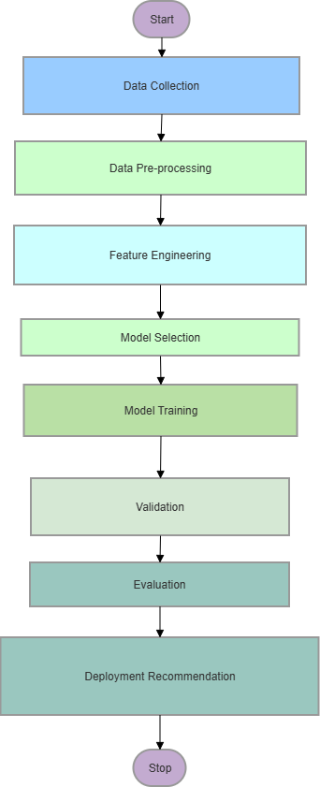
Figure 5: Proposed machine learning workflow for predictive maintenance and equipment failure prediction.

As shown in Figure 5, the proposed methodology will begin with data collection whereby historical and real-time sensor readings will be gathered from industrial equipment. Data that will be collected should contain both normal and failure conditions. Pre-processing of the data will then be done to remove duplicate records and handle missing values. Any inconsistencies will be corrected at this stage and noise in sensor measurements removed. During feature engineering stage the most relevant sensor variables will be selected and derived features like moving averages and trends will be generated. Comparison will then be made for different traditional machine learning algorithms including Decision Trees, Random Forest, SVM, Logistic Regression and k-NN. Selection of the best model will be based on accuracy and interpretability and also computational efficiency. Selected models will then be trained using historical labelled data and model parameters will be optimised so that their predictive performance is improved. Cross-validation techniques will be applied to assess model robustness and reduce the risk of overfitting. Developed models will then be evaluated across different metrics with consideration made on computational cost and inference time. Model that will be deemed to offer the best balance between prediction performance and resource requirements will be selected and recommended for deployment.

3.2 Data Collection and Feature Selection
Historical and real-time data will be collected from sensors that are installed on manufacturing equipment. Data collected from these sensors are typically time-series in nature and continuously generated during machine operation. Sensor data that will be collected is likely contain noise and missing values and even outliers and hence appropriate preprocessing will be necessary. Data collected should include both normal operating conditions and recorded failure events in order to support supervised learning. Some of the relevant features that will be the most important from the collected data will be selected for model training:
- Temperature - will help in identifying overheating and abnormal thermal behaviour.
- Vibration - will facilitate detection of mechanical wear and imbalance or component degradation.
- Pressure – important for pin pointing blockages or operational instability.
- Operating hours - Equipment usage and wear accumulation may be determined by the hours they have been operating.
- Machine status indicators - Contextual information for failure prediction can be provided by the machine status indicators.

3.3 Data Preparation
Before the actual modeling of the machine learning modes the dataset has to be prepared well if accurate results are to be obtained. Initially data cleaning will be done whereby duplicate records will be removed and inconsistencies in sensor measurements corrected. Any missing values in the dataset also have to be correctly handled at this stage by replacing them using techniques such as mean or median. Scaling of numerical features to a common range will be very important to improving model performance especially for distance-based models such as k-NN and margin-based models such as SVM. Once the data has been prepared correctly it will then be divided into training and testing subsets in a 80:20 ratio. Training set will be used for model development and the testing set for unbiased performance evaluation.

3.4 Model Selection Strategy
In predictive maintenance interpretability is an important requirement because maintenance engineers should be able to understand the factors that contribute to equipment failure predictions [17]. Decision Trees and Logistic Regression models provide outputs that are highly interpretable through decision rules and feature coefficients and this makes them suitable for explaining maintenance decisions. Interpretability for the random forest is moderate and is offered through feature importance rankings but individual predictions are more difficult to explain here.
Selecting of the machine learning models will also be highly influenced by speed because manufacturing environments often require timely predictions to support proactive maintenance actions. Logistic Regression and Decision Trees have been determined to provide fast training and inference times and therefore they are capable of enabling rapid deployment and real-time decision-making. Random forest model’s prediction speed is acceptable generally and the model is able to achieve higher predictive accuracy than simpler models.
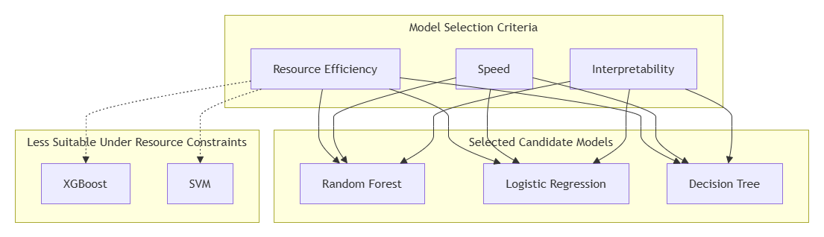
Figure 6: Model Selection Criteria for Predictive Maintenance

3.5 Training and Hyperparameter Optimisation
After selecting the preferred models they have to be trained using historical equipment monitoring data. Objective of training the algorithms is to enable the model to learn relationships between sensor measurements and equipment failure events and at the same time minimise prediction errors. Cross-validation should also be applied during the training process so that model reliability and generalisation is improved [18]. An approach that can be undertaken here is k-fold cross-validation where the dataset can be divided into multiple subsets to allow the model to be trained and validated on different portions of the data. Risk of overfitting will be reduced in this way and a more robust estimate of model performance will be provided.
Predictive accuracy can further be improved by using grid search for hyperparameter optimisation. Using grid search there is a systematic evaluation of different combinations of model parameters. Parameter combination that produces the best validation performance is then selected for the final model. With this process there is an optimal balance between prediction accuracy and model complexity. Training and Hyperparameter Optimisation can be done as shown in figure 6.
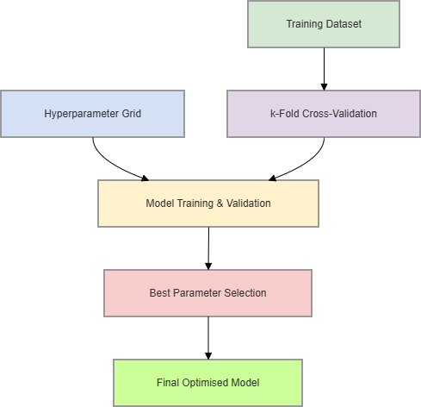
Figure 7: Cross-Validation and Grid Search Hyperparameter Optimisation Process

3.6 Model Evaluation Metrics
Accuracy is one of the most important metrics that can be used for evaluating the developed models as it is able to measure the proportion of correctly classified instances out of total predictions. Basically it provides a general performance indicator but can be misleading in imbalanced datasets. Precision is used for measuring the proportion of correctly predicted failures out of all predicted failures and this is important in predictive maintenance to reduce false alarms and unnecessary maintenance actions [19]. Proportion of actual failures that are correctly identified by the model will be measured using recall and this is very critical in industrial settings for minimising missed failures that may lead to costly downtime.
Confusion matrix will be used for presenting True Positives, True Negatives, False Positives, and False Negatives in a tabular format and this will help with the evaluation of classification errors and model performance. Ability of the developed models to distinguish between failure and non-failure classes across thresholds will be determined by ROC–AUC. Models that have higher AUC will be said to have better separability and robustness.

4. Discussion and Recommendation

4.1 Comparative Analysis of Candidate Models
Candidate models for the manufacturing company are compared based on different evaluation metrics and their suitability for deployment in resource-constrained industrial environments. Evaluating of all the suggested models showed that there are trade-offs between model complexity and operational practicality in predictive maintenance systems (Table 2).
Table 2: Comparative Analysis of Candidate Models
Algorithm | Accuracy | Interpretability | Training Cost | Deployment Suitability
Decision Trees | Moderate | Very High | Low | High (simple industrial deployment)
Random Forest | High | Medium | Moderate | High (robust and scalable)
SVM | High | Low | High | Moderate (resource-dependent)
Logistic Regression | Moderate–Low | Very High | Very Low | High (baseline/edge systems)
k-NN | Moderate | Medium | Low training, High inference | Low–Moderate (poor scalability)
XGBoost | Very High | Medium–Low | High | Moderate (performance-focused systems)

4.2 Recommended Algorithm
Algorithm which was recommended for the manufacturing company is Random Forest because it is able to provide a consistently high accuracy across industrial predictive maintenance datasets [10]. Nonlinear relationships which exist between sensor variables will be effectively handled by the algorithm. Random Forest model is also effective in reducing overfitting since it performs ensemble averaging of multiple decision trees which makes the algorithm to perform robustly on noisy and incomplete sensor data.
Random Forest model is more computationally efficient than gradient boosting methods like XGBoost. Training of the model can be parallelised to improve scalability in practical environments and it is able to offer a strong balance between performance and computational demand [10]. Implementation process of the model is also simple because it simply relies on standard machine learning libraries. In industrial settings the model works well without extensive parameter tuning and it is well-suitable for integration into real-time monitoring systems for equipment failure prediction.

4.3 Recommended Industrial Workflow
Recommendation is made for the predictive maintenance system adopted by the manufacturing company to be integrated with existing industrial sensor networks so that there will be continuous acquisition of data. For this to be possible a centralised data pipeline is required to support ingestion and secure storage of sensor streams. Random Forest model should be deployed as an edge or on-premise inference service to suit limited computational resources. Review of feature selection has to be done from time to time to maintain relevance when operational conditions change.
Continuous monitoring during the operation of the systems will help in detecting model drift and its performance degradation over time. There can be periodic retraining of the model using newly collected sensor and failure data. Important metrics such as recall and false negative rate should be prioritised for missed failures to be reduced. Furthermore maintenance engineer feedback should be incorporated into the system to validate alerts and improve decision quality. Operational workflow of the predictive maintenance system is presented in figure 8 with a highlight on continuous monitoring and decision feedback. Model retraining is also captured to ensure that there is long-term reliability.
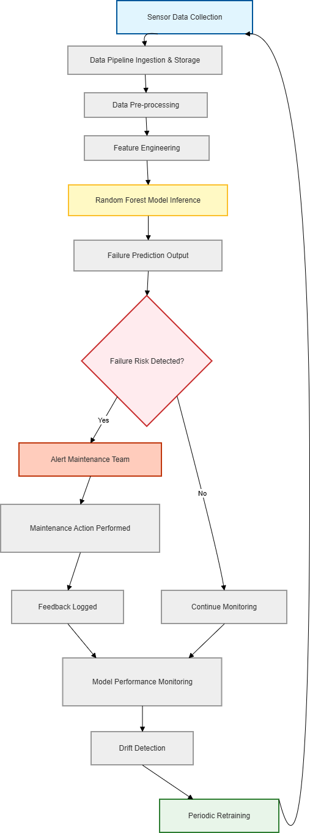
Figure 8:Industrial Deployment and Feedback Loop for Predictive Maintenance System

5. Conclusion
Application of traditional machine learning techniques for predictive maintenance in manufacturing environments operating under limited computational resources were examined in detail in this report. Literature review that was done pointed out that ensemble-based methods generally achieve higher predictive performance compared to simpler models. Workflow methodology that was proposed for the manufacturing company demonstrated how sensor data from industrial equipment can be processed, engineered and used to train and evaluate predictive models using appropriate performance metrics.
Random Forest algorithm was the recommended algorithm for integration into the system used by the company mainly because of its strong balance between accuracy and robustness to noisy sensor data and also the fact that it has moderate computational requirements. Ability of the algorithm to provide feature importance also enhances interpretability for industrial stakeholders. Workflow approach that was proposed in the report will help in reducing downtime and improving maintenance scheduling in manufacturing contexts. However there are potential improvements in the future such as integrating real-time streaming analytics and integration with edge computing systems which can further enhance scalability and responsiveness in industrial environments.

References
[1] Molęda, M., Małysiak-Mrozek, B., Ding, W., Sunderam, V. and Mrozek, D., 2023. From corrective to predictive maintenance—A review of maintenance approaches for the power industry. Sensors, 23(13), p.5970.
[2] Pech, M., Vrchota, J. and Bednář, J., 2021. Predictive maintenance and intelligent sensors in smart factory. Sensors, 21(4), p.1470.
[3] Shamim, M.M.R. and Ruddro, R.A., 2025. Smart diagnostics in industrial maintenance: a systematic review of AI-enabled predictive maintenance tools and condition monitoring techniques.
[4] Molęda, M., Małysiak-Mrozek, B., Ding, W., Sunderam, V. and Mrozek, D., 2023. From corrective to predictive maintenance—A review of maintenance approaches for the power industry. Sensors, 23(13), p.5970.
[5] Gahane, S., Sharma, D., Khode, P., Verma, P. and Anawade, P., 2024, December. Predictive Maintenance Using Machine Learning and Data Analytics for Performance Optimization at Koradi Thermal Power Station, Nagpur. In International Conference on Information and Communication Technology for Competitive Strategies (pp. 119-132). Singapore: Springer Nature Singapore.
[6] Achouch, M., Dimitrova, M., Ziane, K., Sattarpanah Karganroudi, S., Dhouib, R., Ibrahim, H. and Adda, M., 2022. On predictive maintenance in industry 4.0: Overview, models, and challenges. Applied sciences, 12(16), p.8081.
[7] Costa, V.G. and Pedreira, C.E., 2023. Recent advances in decision trees: An updated survey. Artificial Intelligence Review, 56(5), pp.4765-4800.
[8] Lekidis, A., Georgakis, A., Dalamagkas, C. and Papageorgiou, E.I., 2024. Predictive maintenance framework for fault detection in remote terminal units. Forecasting, 6(2), pp.239-265.
[9] Vilarinho, Sandrina L., Isabel O., José. (2017). Preventive Maintenance Decisions through Maintenance Optimization Models: A Case Study. Procedia Manufacturing. 11. 1170-1177. 10.1016/j.promfg.2017.07.241.
[10] Salman, H.A., Kalakech, A. and Steiti, A., 2024. Random forest algorithm overview. Babylonian Journal of Machine Learning, 2024, pp.69-79.
[11] Padovese, Bruno and Padovese, L.R., 2019. A Machine Learning Approach to the Recognition of Brazilian Atlantic Forest Parrot Species. 10.1101/2019.12.24.888180.
[12] Rzayeva, L., Myrzatay, A., Abitova, G., Sarinova, A., Kulniyazova, K., Saoud, B. and Shayea, I., 2023. Enhancing LAN failure predictions with decision trees and SVMs: Methodology and implementation. Electronics, 12(18), p.3950.
[13] Rosebush, Aiden G., Alexander K., Brian and Qian, L., 2023. An Exponential Reduction in Training Data Sizes for Machine Learning Derived Entanglement Witnesses.
[14] Zaidi, A. and Al Luhayb, A.S.M., 2023. Two statistical approaches to justify the use of the logistic function in binary logistic regression. Mathematical Problems in Engineering, 2023(1), p.5525675.
[15] Ortiz-Villaseñor, D., Trujillo-Hernández, G., Real-Moreno, O., Castro-Toscano, M.J., Medina-Madrazo, L.D. and Barrera-Román, D., 2025. K-nearest neighbors regression and applications. In Exploring Psychology, Social Innovation and Advanced Applications of Machine Learning (pp. 295-316). IGI Global Scientific Publishing.
[16] Mohril, R.S., Solanki, B.S., Kulkarni, M.S. and Lad, B.K., 2023. XGBoost based residual life prediction in the presence of human error in maintenance. Neural Computing and Applications, 35(4), pp.3025-3039.
[17] Gawde, S., Patil, S., Kumar, S., Kamat, P., Kotecha, K. and Alfarhood, S., 2024. Explainable predictive maintenance of rotating machines using LIME, SHAP, PDP, ICE. IEEE Access, 12, pp.29345-29361.
[18] Kernbach, J.M. and Staartjes, V.E., 2021. Foundations of machine learning-based clinical prediction modeling: Part II—Generalization and overfitting. Machine Learning in Clinical Neuroscience: Foundations and Applications, pp.15-21.
[19] Hermansa, M., Kozielski, M., Michalak, M., Szczyrba, K., Wróbel, Ł. and Sikora, M., 2021. Sensor-based predictive maintenance with reduction of false alarms—A case study in heavy industry. Sensors, 22(1), p.226.

