HPHI 5023 6023 - (Level 5 and 6 - 20 credits)
‘War made the State and the State made War’: Politics and Warfare in the Modern Age
2021-2022 Block 7 (Lampeter)
May 9th - June 1st 2022
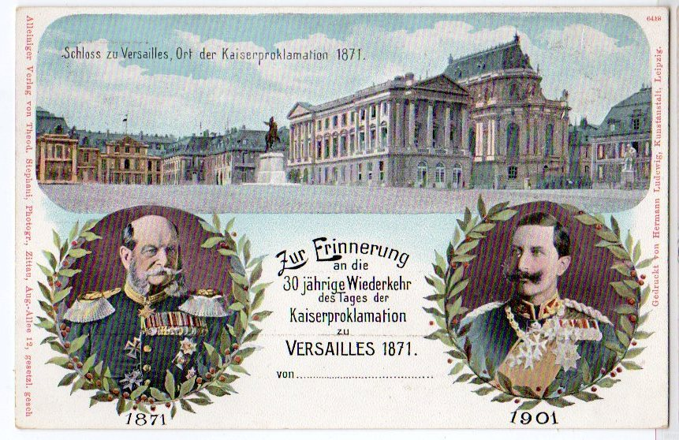

Tutor: Doctor Lester Mason
l.mason@uwtsd.ac.uk

AIMS:
To encourage students to acquire a broad knowledge of how war and conflict helped create the modern state, and why nation-states decide to go to war; a sophisticated understanding of the political decisions behind state declarations of war; a close and critical familiarity with a variety of primary source material relating to the politics that dictate decisions to go to war and how policies during conflicts are devised; and a detailed appreciation of the historiographical debates and issues surrounding the subject matter of warfare and state decision making.
LEARNING OUTCOMES:
Upon the successful completion of this module, the student should be able to:
• Demonstrate a critical understanding of the political, strategical, and military contingencies behind the decision-making process that leads to a nation-state going to war, and to allow a thorough assessment of the wider significance of this process.
• Demonstrate a sophisticated understanding of the political decisions that lead nations to choose war over peace, through the analysis of a series of case studies from the Modern Age, while developing a sophisticated understanding of the extent and significance of these decisions.
• Demonstrate advanced skills in the handling and evaluation of primary source material relating to the subject matter at hand, while developing a sophisticated understanding of the contextual significance of such material.
• Critically evaluate various historiographical debates and interpretations surrounding aspects of politics and warfare while identifying and assessing contrasting and contesting approaches relating to politics and warfare.

INDICATIVE CONTENT:

• Why do nations decide to go to war, and what are the political, strategic, and military contingencies that dictate the decision-making process during conflicts? These questions will be analysed and answered through a series of case studies covering the 18th Century right up to the Cold War. Indicative case studies include:

o The 18th Century Wars of Succession and the rise of the Prussian State.

o The threat from Revolutionary France and challenging Napoleonic power in Europe.

o War and Empire: Conflict and the expansion of the British Empire in the 19th Century.

o War by Timetable or a ‘Train Crash’?: The Origins of World War One.

o Appeasement and the quest for peace during the Age of Extremes: Europe 1918-1939.

o ‘Fateful choices: Ten choices that changed the World1 – a survey of decisions made in London, Berlin, Tokyo, Rome, Washington, Moscow, during 1940-41.

o The Politics of Insecurity: Post-1945 and the Origins of the Cold War.

- Title taken from: Ian Kershaw’s seminal publication: Fateful choices: Ten choices that changed the World 1940-41 (London: Penguin, 2007).

• These events will be examined in detail, while also assessing a range of primary and secondary material; including, letters and diaries, memoirs, autobiographies, speeches, film and documentaries sources

Activity type Hours Percentage

Scheduled learning 48 24

Independent learning 152 76

Placement learning

TOTAL 200 100%

ASSESSMENT: PORTFOLIO, 5000 WORDS

Due by 23.59 hrs, Sunday 5th June 2022
Portfolio Part 1 (worth 50%) - 2500 words 3 x Gobbets (Primary Source Analyses) : 800-850 words each from a multi-choice list.

This involves the assessment of primary source documents relating to Politics and Warfare in Modern Age, (e.g article or letter in a newspaper; Government paper; private papers or letters; propaganda poster etc, pictorial source), so the following points must be discussed:

- Who is it by? Discuss the author, and the motives behind the document.

- Where did it appear – e.g. which newspaper; who were the
intended audience?

- When was it written? For example, a letter written before the declaration of war in August 1914 will need a different approach than one written after.

- If possible, compare the document against others, e.g. other letters that appear in the newspaper, or elsewhere, at the time.

- What is being said – fully analyse the content; this again, could include a compare and contrast element.

Indicative examples: (these are not the full extracts to be offered to students). Others will be presented to students over the course of the module. If you decide to choose alternative primary sources to analyse 9which is encouraged) please pass them by the module lead, to ensure they are appropriate.

- Frederick II (the Great), King of Prussia (1740-86), The First Servant of the State, intended as a blueprint for his heir on how best to rule the Prussian kingdom.

‘In a State like this, the ruler must necessarily take charge of things personally, because if he is wise, he will pursue only the public interest, which is his own; whereas a minister always has his mind on things which further his own interests; and instead of promoting deserving candidates, appoints his own creatures and strives to consolidate his own position through the number of people whom he makes dependent on him. The monarch on the other hand, will support the nobility, keep the clergy within its proper bounds, will not allow the princes of the blood to intrigue or plot, and will reward merit without those partisan views which ministers secretly entertain in everything they do.

- EXTRACT FROM VON CLAUSWITZ ‘WHAT IS WAR’ From : Chapter 1 ‘On War’

War is a mere continuation of policy by other means.
We see, therefore, that war is not merely a political act, but also a real political instrument, a continuation of political commerce, a carrying out of the same by other means. All beyond this which is strictly peculiar to war relates merely to the peculiar nature of the means which it uses. That the tendencies and views of policy shall not be incompatible with these means, the art of war in general and the commander in each particular case may demand, and this claim is truly not a trifling one. But however powerfully this may react on political views in particular cases, still it must always be regarded as only a modification of them; for the political view is the object, war is the means, and the means must always include the object in our conception…

- Memorandum by Prince Karl Max Lichnowsky, January 1915 (German Ambassador to London 1912-14)

When I arrived in London in November 1912 the First Balkan War had really already ended with the Allies’ victory over Turkey, and the disposal of the Turkish heritage raised the spectre of a European war. A few days after my arrival, Lord Haldane, a close friend of Sir E. Grey’s, visited me to tell me roughly the following: England desired peace and friendship with us, and hoped with my help to strengthen our relations and to remove all misunderstandings. But he drew my attention to one important point from the first: England could never permit the destruction or weakening of France. This was a vital question for Great Britain. She had to support France, as we had to support Austria. The basis of any understanding with us must therefore be an unquestionable policy of peace, since England would be drawn through France into a European war. But England no more wished to attack us than to foster the French idea of revanche.

Portfolio Part 2 (worth 50%) - 2500 words Written assignment Essay taken from the multiple titles:

LEVEL 5 - HPHI 5020: CHOOSE A TITLE FROM THE ESSAY QUESTIONS BELOW

- Can the incessant ‘Dynastic Wars’ that characterised 18th Century Europe be truly reconciled with the so-called ‘Age of Enlightenment’?

- Discuss the impact of the French Revolution and the campaigns of Napoleon on constitutional reforms in both Europe and the wider world.

- Why is the so-called ‘long 1860s’ such a significant period when assessing the impact of warfare upon the development of nation-states?

- Considering the impact of so-called ‘Hybrid Wars’ on constitutional developments, it was inevitable that ‘Total War’ between 1914-18 would lead to major political change in Europe. Discuss.

- With at least three countries in mind, compare and contrast the decision-making process in 1939-1941 that chose conflict over peace.

LEVEL 6 - HPHI 6020: CHOOSE A TITLE FROM THE ESSAY QUESTIONS BELOW
- Can the incessant ‘Dynastic Wars’ that characterised 18th Century Europe be truly reconciled with the so-called ‘Age of Enlightenment’. Your answer should address the war policies of both Catherine the Great and Frederick the Great.

- Discuss the impact of the French Revolution, and the campaigns of Napoleon, on constitutional reforms in both Europe and the wider world. Your answer should address the impact on existing monarchic systems.

- Why is the so-called ‘long 1860s’ such a significant period when assessing the impact of warfare upon the development of nation-states? As part of your answer, discuss the importance of technological changes at the time.

- Considering the impact of so-called ‘Hybrid Wars’ on constitutional developments, it was inevitable that ‘Total War’ between 1914-18 would lead to major political change in Europe. Discuss, with specific reference to events in both Germany and Russia.

- With at least three countries in mind, compare and contrast the decision-making process in 1939-1941 that chose conflict over peace. Your choice of countries should include examples from the liberal-democracies and the dictatorships.

SELECT BIBLIOGRAPHY (A more comprehensive bibliography is available on the HPHI 5020 6020 Moodle site)

Armstrong Starkey, War in the Age of Enlightenment (London: Praeger, 2003)

Brian Orend, War and Political Theory (Cambridge: Polity Press, 2019 )

J.Stone, Military Strategy: the Politics and Techniques of War (London: Continum, 2011).

M.Howard, War in European History (Oxford: OUP, 2009)

R.Paret et al, Makers of Modern Strategy: from Machiavelli to the Nuclear Age (OUP, 1986)

Christopher Clarke, The Sleepwalkers: How Europe Went to War in 1914 (London: Penguin, 2013)

Tim Bouverie, Appeasement: Chamberlain, Hitler, Churchill, and the Road to War (Bodley Head, 2019).

Ian Kershaw, Fateful choices: Ten choices that changed the World 1940-41 (London: Penguin, 2007)

- J. Schofield, A Fearsome Heritage: Diverse Legacies of the Cold War (Left
Coast Press, 2007)

Linda Colley, The Gun, The Ship, and the Pen: Warfare, Constitutions and the Making of the Modern World (London: Profile Books, 2021)

MARKING CRITERIA FOR THE ASSESSMENT OF WRITTEN WORK

With all assessment, judgments will include an element of subjectivity. However, the School is able to offer you the following indicators, which will help you to assess your performance and progress.

HIGH FIRST CLASS (marks of 80 and above)

High First class work is of an outstanding standard. It will display all, of the following attributes:
• a clear and sharp focus upon the question of arguably publishable quality
• a sophisticated awareness of the historiographical dimensions of historical debate
• a broad, sophisticated and deep knowledge of the relevant topic
• a highly cogent and structured argument, with traces of originality
• a subtle and highly perceptive analysis, perhaps with glimpses of originality
• based upon a wide and thorough reading of secondary source materials
• written with exceptional fluency, clarity and accuracy
• presentation to an outstanding scholarly standard, including a full bibliography and clear referencing

FIRST CLASS (marks of between 70 and 80 and above)
First class work is of an excellent standard. It will display some, but not necessarily all, of the following attributes:
• a clear and sharp focus upon the question
• a sophisticated awareness of the historiographical dimensions of historical debate
• a broad and deep knowledge of the relevant topic
• a highly cogent and structured argument
• a subtle and highly perceptive analysis, perhaps with glimpses of originality
• based upon a wide and thorough reading of secondary source materials
• written with fluency, clarity and accuracy
• presentation to a high scholarly standard, including a full bibliography and clear referencing

UPPER SECOND CLASS (marks between 60 and 69)
Upper Second Class work is of a very good standard. It may show some of the qualities of First Class work, but not in a sustained way. Work of the Upper Second Class is characterised by some, but not necessarily all, of the following attributes:

• a clear focus upon the question
• an awareness of the historiographical dimensions of historical debate
• a broad knowledge of the relevant topic, though with some gaps
• a well developed and solidly structured argument
• a good and thoughtful analysis
• based upon a wide reading of secondary source materials
• written with clarity and accuracy.
• presented to a scholarly standard, with bibliography and referencing.

LOWER SECOND CLASS (marks of between 50 and 59)
Lower Second Class work is of a good standard. It is work that may show some of the qualities of work in a higher class, but not in a sustained way. Lower Second Class work displays some, but not necessarily all, of the following features:

• some focus on the question, though not sustained or always clearly focused
• some grasp of the historiographical dimensions of historical debate
• a sound knowledge of the relevant topic, with some limitations
• a reasonable level of argument
• some analysis but not sustained and mixed with description/ narrative
• some reading of the secondary source materials but significant gaps in the bibliography
• written in a satisfactory style, with some accuracy.
• presented to a reasonable scholarly standard, but with problems in the bibliography and/ or referencing.
THIRD CLASS (marks of between 40 and 49)
Third Class work is of an adequate/fair standard for an honours degree. It may show some of the qualities of work in a higher class, but not in a sustained way. Work in this class is marked by some, but not necessarily all, of the following qualities:

• limited understanding of and focus upon the question
• lacks structure and a sustained argument
• some knowledge of the relevant topic but with significant limitations
• tends towards description, with glimpses perhaps of analysis
• limited range of reading or familiarity with the secondary literature
• some attempt at following scholarly standards of presentation, though problems with referencing and/or bibliography
• limited attention to writing style, clarity or accuracy

FAIL CLASS (marks of 39 and below)
Fail class work is unsatisfactory. It is work that may display some of the characteristics of the Third Class standard but not in a sustained or significant amount.

- Very limited understanding of the question or focus upon it
- Lacks structure and argument
- Limited knowledge of the relevant topic
- Descriptive and narrative in structure
- Little evidence of sustained reading or familiarity with the secondary literature
- Fails to meet accepted norms of scholarly standards of presentation, including both referencing and bibliography.
- Weak writing style.

