MARKETING PLAN
<HILTON HOTEL>

MIHAELA TEODORESCU
ID NUMBER: 2233479
MODULE TITLE: MARKETING ESSENTIALS BMIH4005
LECTURER: LUCIANA SUARDI
WORD COUNT : 1163

Hilton Hotels is a global brand that offers luxury accommodation and amenities to its guests. The Hilton Hotel brand is known for its excellent customer service, stylish rooms and great locations. This marketing plan will outline the hotel's strategies to maintain and grow the Hilton Hotel's market share and customer base in the highly competitive hospitality industry.
For Hilton hotels, key domains and frameworks used to frame the marketing plan include SOSTAC, 4'Ps and Bowmans. Its purpose is to analyze the micro environment and the macro environment to provide new directions for the business. It includes situation analysis, Objectives, Strategy, Tactics, Action and Control.
The 5Cs include Company, Customers, Competitors, Collaborators and Climate. The SWOT analysis of Hilton Hotels (Company) shows that the brand's advantages include reputation, brand recognition and diversified product portfolio, however, its disadvantages include high prices and a rather limited target audience. The hotel's opportunities include increasing the number of locations and expanding into new markets, while its threats include the global economic slowdown and the rise of alternative accommodation services.
Hilton's target market is a diverse group of people, including leisure and business travelers, families and luxury travelers. The company segments its market based on demographic, psychographic and geographic data. Hilton has a global presence and operates in several segments, including luxury, full-service and select-service hotels.
Competitors in the hotel industry include Marriott International, Hyatt Hotels Corporation, InterContinental Hotels Group and Accor. Hilton's perceptual positioning map shows that it is positioned as a luxury hotel brand. To maintain this position, Hilton must continue to differentiate itself from its competitors by offering unique and memorable experiences.
Hilton Hotel's target market consists of both business and leisure travelers. Business travelers are typically corporate executives, salespeople, and other professionals who travel for work. Leisure travelers, on the other hand, are individuals or families who travel for pleasure or vacation. Hilton Hotels should continue to cater to both markets by offering services and amenities tailored to their specific needs and preferences.
PESTLE analysis (climate) shows that the hotel industry is affected by political, economic, social, technological, legal and environmental factors.
In this marketing plan, you can try to increase the degree of awareness of the Hilton brand and attract new customers, offering unique and memorable experiences.
Hilton Hotel's marketing goals are to increase occupancy by 10% by the end of the year through aggressive marketing and promotional efforts, increase customer loyalty and retention by 15% by improving guest satisfaction and offering loyalty programs, increase revenue per room available (RevPAR) by 5% through pricing and upselling strategies.
The marketing mix includes product, price, place and promotion. Hilton products include its hotel rooms, amenities and services. Hilton will differentiate its products by offering unique and memorable experiences such as personalized tours and activities.
Hilton hotels should continue to provide its guests with high quality accommodation, facilities and services. The hotel should focus on maintaining its reputation for providing excellent customer service and luxury accommodation. To differentiate itself from other hotels, Hilton should invest in technology and innovations to enhance the guest experience, such as offering virtual check-in and check-out, smart room technology and personalized experiences.
Hilton hotels should implement a pricing strategy that takes into account season, location and customer demand. During the peak season, the hotel should charge higher rates, while in the off-peak season, the hotel should offer discounts and promotions to attract guests. The hotel should also offer loyalty packages and discounts to encourage customers to book directly through Hilton's website.
Hilton hotels should maintain their prime locations in key cities and tourist destinations. The hotel should also focus on expanding its presence in emerging markets and developing countries. Hilton should also focus on improving its online presence through its website and social media channels to reach a wider audience.
Promotion Hilton Hotels should focus on aggressive marketing and promotion efforts to attract new customers and retain existing ones. The hotel should invest in digital marketing campaigns such as pay-per-click advertising and social media advertising to target specific demographics and interests. Hilton should also offer loyalty programs and incentives to its guests, such as discounts on future stays, free room upgrades, and exclusive access to events.
The promotion strategy will include various tactics including advertising, public relations and sales promotion. Hilton will use the RACE (Reach, Act, Convert, Engage) model to implement its promotional tactics. The Reach stage involves identifying your target audience and raising brand awareness. For Hilton, this could involve using social media platforms such as Instagram and Twitter to showcase the hotel's luxury amenities and services, as well as creating engaging content such as videos and blog posts that highlight the unique experiences available at their properties.
The Act stage involves encouraging potential customers to take action, such as making a reservation or signing up for the Hilton Honors loyalty program. To achieve this, Hilton may use tactics such as targeted email campaigns, personalized offers and retargeting ads to reach customers who have previously interacted with the brand online.
Implementation plan for the Hilton Hotel should by conducting a market analysis to identify new growth opportunities and potential threats, Developing customer satisfaction surveys to identify areas of improvement and opportunities to improve guest experience, implementing strategy pricing that takes into account customer demand and seasonality, investing in technology and innovations to improve the guest experience, such as virtual check-in and check-out and smart room technology, developing a loyalty program and incentivizing guests to book directly through the Hilton website, the development and implementation of digital marketing campaigns to attract new customers and keep existing ones, but also to expand Hilton's presence in emerging markets and developing countries.
To measure the success of Hilton's marketing plan, they will track several key performance indicators (KPIs), such as the number of new customers, customer engagement, positive reviews, and revenue growth. Hilton will also conduct periodic customer surveys to collect feedback on their experiences and identify areas for improvement. These metrics will be used to evaluate the effectiveness of the marketing plan and make adjustments as needed to ensure its continued success.
These things can be seen in Appendix 1, the Gantt chart of marketing activities and the schedule of marketing channels.
Through advanced technologies, global scale and key partnerships, Hilton is able to drive demand, maximize revenue and build strong customer relationships.
Hilton Hotels should measure the success of its marketing plan by monitoring occupancy rates, customer loyalty and retention, and revenue per available room (RevPAR). Hilton should also track its online presence and engagement through website traffic and social media analytics. By regularly evaluating the success of its marketing efforts, Hilton can make the necessary adjustments to its strategies and continue to maintain its position as a global leader in hospitality.
Hilton Hotels should continue to focus on providing high quality accommodation, amenities and services to its guests. The hotel should invest in technology and innovation to improve the guest experience and develop a loyalty program to retain and incentivize customers.

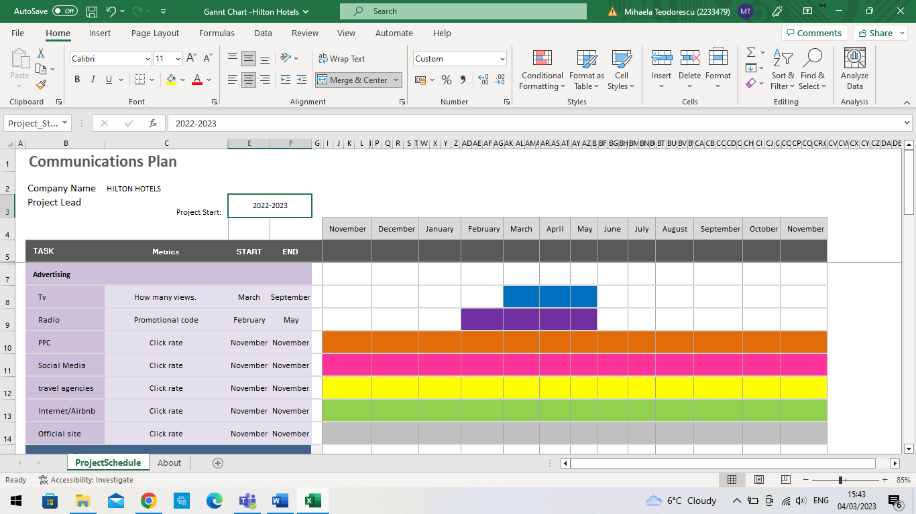
Appendix 1

- https://awario.com/blog/hilton-social-media-case-study/
- Baloglu, S., & McCleary, K. W. (1999). A model of destination image formation. Annals of Tourism Research, 26(4), 868-897. https://doi.org/10.1016/S0160-7383(99)00030-4
- Bonn, M. A. (2001). Strategy and tactics: how to match them to fit your business. Management Decision, 39(2), 91-96. https://doi.org/10.1108/00251740110382286
- https://digitalmarketinglesroches.wordpress.com/2019/06/24/digital-marketing-strategies-from-hilton-hotels/
- Hilton. (n.d.). About Hilton. Retrieved from https://www.hilton.com/en/corporate/about/
- https://www.hilton.com/en/hilton-honors/
- Jusoh, J., & Ling, N. G. (2015). The impact of promotional tools on customer buying behaviour: A study from Malaysia perspective. Journal of Applied Economics and Business Research, 5(3), 57-70. Retrieved from https://www.aebjournal.org/articles/0503/0503.pdf
- Kotler, P., Bowen, J. T., Makens, J. C. (2014). Marketing for Hospitality and Tourism. Pearson Education Limited.
- Mintel. (2021). Hotel chains in the UK. Retrieved from https://reports.mintel.com/display/1068088/
- https://www.nerdwallet.com/article/travel/hilton-honors-complete-guide
- Peelen, E., & Beltman, R. (2013). Customer Relationship Management (2nd ed.). Pearson Education Limited.
- Porter, M. E. (1980). Competitive strategy: Techniques for analyzing industries and competitors. Free Press.
- Visit Britain. (2020). Global Britain: post-Brexit tourism. Retrieved from https://www.visitbritain.org/global-britain-post-brexit-tourism
- Visit Britain. (2021). Key tourism facts for the UK. Retrieved from https://www.visitbritain.org/key-tourism-facts-uk
- https://www.nerdwallet.com/article/travel/hilton-honors-complete-guide



