NAME: Livia Sas
ID: 2126832
TITLE OF DISSERTATION: Optimising Logistics and Fleet Management for Small-Scale Trucking Companies in the UK: Challenges and Strategies for Success

Declaration
This work has not previously been accepted in substance for any degree and is not being concurrently submitted in candidature for any degree
Signed: Livia Sas
Date: 10/07/25
STATEMENT 1
This dissertation is being submitted in partial fulfilment of the requirements for the degree of BA.
Signed: Livia Sas
Date: 10/07/25
STATEMENT 2
This dissertation is the result of my own independent work/investigation, except where otherwise stated. Other sources are acknowledged by footnotes giving explicit references. A bibliography is appended.
Signed: Livia Sas
Date: 10/07/25
STATEMENT 3
I hereby give consent for my dissertation, if accepted, to be available for photocopying and for interlibrary loan, and for the title and summary to be made available to outside organisations.
Signed: Livia Sas
Date: 10/07/25
STATEMENT 4
I hereby give consent for my dissertation, if accepted, to be available on the university’s IT system to those who have consent to use the system.
Signed: Livia Sas
Date: 10/07/25
Abstract
This research primarily investigates how small UK trucking firms manage maintenance, compliance, routing, and digital tools to improve efficiency. A literature review identified cost control, vehicle upkeep, regulatory demands, and technology adoption as key challenges. Primary data from an employee survey revealed irregular preventive maintenance, uneven telematics use, limited AI-driven routing, and inconsistent data sharing. Communication gaps and weak spare-parts, and fuel-price strategies further hinder performance. Discussion linked these findings to theories on resources, transaction costs, technology acceptance, and contingency planning. Practical recommendations include regular maintenance schedules, standardised compliance training, phased telematics and AI adoption, digital checklists, routine KPI sharing, and stronger dispatcher-driver communication. Strategic partnerships, clear fuel-management policies, and basic automation for administrative tasks were also proposed. Future research should track implementation effects, explore behavioural barriers, and employ mixed-method case studies to refine guidance. By combining people-centred and process-driven measures, small fleets can overcome operational constraints and achieve sustainable growth.

Acknowledgement
I would like to sincerely thank my supervisor for their continuous support and guidance throughout this research. Their feedback was very helpful at every stage. I also thank all the respondents who took part in the survey, as their input was vital for completing the study. I am grateful to my friends and family for their constant encouragement, which kept me motivated. Lastly, I appreciate everyone who helped me in any way during this research journey.
With thanks,
Livia Sas
Table of Contents
Chapter 1: Introduction 5
1.1 Research Background 5
1.2 Outline of the issue/problem or challenge being researched 5
1.3 Research aim 6
1.4 Research objectives 6
1.5 Research Significance 7
Chapter 2: Literature Review 8
2.1 Chapter Introduction 8
2.2 Different challenges faced by the small-scale trucking businesses 8
2.3 Fleet Management and Route Optimisation 9
2.4 The role and other important aspects of Digital Transformation 9
2.5 Strategic approaches towards overcoming the challenges 10
2.6 Theoretical Underpinnings of different Logistics Decisions 11
2.7 Literature Gap 12
2.8 Summary 12
Chapter 3: Research Methodology 14
3.1 Aims and Objectives 14
3.2 Research Rationale 14
3.3 Research Design 14
3.4 Research Paradigm 15
3.5 Data Collection 15
3.6 Population and Sample 16
3.7 Data analysis 16
3.8 Reliability and Viability 17
3.9 Limitations of the research 17
3.10 Research Ethics 18
Chapter 4: Analysis and Discussion 19
4.1 Introduction 19
4.2 Survey questions and responses 19
4.3 Discussion 28
Chapter 5: Conclusion and Recommendations 30
5.1 Conclusion 30
5.2 Recommendations 31
5.3 Future Scope 31
References 32
Appendix 38

List of Figures
Figure 1: Scheduled preventive maintenance on vehicles 20
Figure 2: Access to real time GPS tracking on every vehicle 21
Figure 3: Primary software or system for route planning 22
Figure 4: Fuel consumption data is accurate and timely for decision making 22
Figure 5: Company’s process for handling unexpected vehicle breakdowns 23
Figure 6: Experience with regulatory compliance training 24
Figure 7: Review and adjust routes based on live traffic or weather data 25
Figure 8: Digital checklists or mobile apps used by drivers 26
Figure 9: Clarity of communication between dispatchers and drivers regarding schedule changes 27
Figure 10: Performance metrics shared 28
Figure 11: Adequacy of spare parts inventory for routine repairs 28
Figure 12: Fuel price volatility is effectively managed 29
Figure 13: Use of AI‑driven or automated route-optimisation tools 30
Figure 14: The company’s ability to minimise logistics costs through digital solutions 31

Chapter 1: Introduction

1.1 Research Background
Over the recent years, the logistics and transportation sphere has been mutating quite intensively following the development of digital tools and new fleet management systems (Ibrahim and Dharmawan, 2022). Such changes are not confined to big companies but may also be observed in small and medium-sized companies, particularly those involved in the trucking business. Small trucking companies in the United Kingdom are significant elements of the supply chain (Diao et al., 2021). They assist in the transportation of goods among cities, warehouses and the final customers. But most of these small companies are faced with day-to-day challenges in maintaining their fleet and in the area of cutting down the costs of operations.
Fleet management is associated with numerous activities, including designing routes, vehicle maintenance, driver performance and tracking the government regulations. Most of these activities were traditionally undertaken manually or using the bare minimum tools. But nowadays, there are more recent modern solutions such as GPS tracking, route optimisation software and fuel monitoring solutions that are being utilised (Surya et al., 2024). Such technologies will enable companies to be more cost-effective as well as efficient. However, such systems cannot be used by every small company. This brings serious concerns about how these companies control their business and what they require to enhance.
The application of digital tools in logistics is also promoted by several governmental as well as private organisations in the UK. More awareness programs and software programs that are specific to small businesses are also available. However, even with such measures, a great number of small trucking companies continue to fail to manage their fleets accordingly. Past literature tends to study bigger logistics companies or cross-national supply chains and overlook smaller regional companies. Thus, a high necessity is emerging to discuss how these minor market players are managing in this new environment.

1.2 Outline of the issue/problem or challenge being researched
In the UK, small trucking firms experience numerous challenges which have a direct impact on their performance and expansion. The inability to switch to modern digital solutions for controlling their logistics and fleet operations is one of their major issues (Katsela et al., 2022). These applications are aimed at guiding businesses to plan their delivery methods more efficiently, manage fuel consumption, prevent vehicle breakdowns and adhere to the law. Nevertheless, a good number of small businesses continue to rely on manual planning or simple systems, either because of the absence of funds, training or even awareness. This causes inefficiencies and escalates their operational costs of operations. Poor access to real-time data is another major problem. As an example, it is difficult to predict traffic or weather with the lack of live GPS and route updates. Moreover, when the maintenance of vehicles is not performed in time, because there was no planning, this may lead to delays in deliveries and in loss of business because of sudden breakdowns (Redreev et al., 2021). Additionally, in most instances, the drivers and dispatchers lack the appropriate communication equipment, causing confusion and errors in delivery.
There is also an increased concern about regulatory compliance. Small trucking companies should adhere to a number of regulations that concern driver hours, emissions, and the safety of vehicles. Nonetheless, not every company trains its employees on these regulations. In certain companies, the drivers are unaware of the fundamental rules that they have to adhere to. This may lead to penalties or court actions, something that creates additional financial burdens to budgets that are already insignificant. On the route-planning level, some companies operate with very basic GPS hardware or even with paper. Since they lack access to automated or AI-assisted route optimisation, fuel is heavily consumed, delivery time becomes longer, and customer satisfaction goes down. Moreover, small companies lack appropriate mechanisms to monitor vehicle efficiency or even compile and analyse this information in order to facilitate future planning (Hazra et al., 2023).

1.3 Research aim
The main objective of this dissertation is to study the problems of small trucking companies in the UK and to find out the techniques which can help minimise logistics and fleet management issues. The research objectives are as follows.

1.4 Research objectives
- To conduct a detailed literature review regarding the challenges faced by the logistics and fleet management companies in the United Kingdom
- To explore the strategies that can be effective for the fleet management and logistics companies to overcome their issues and challenges using primary data collection
- To explore the methodological tools and data collection techniques for gathering appropriate and relevant data using secondary sources

1.5 Research Significance
The study is relevant due to the significant role of small trucking firms in the supply chain of the UK, which is overlooked in the context of large-scale logistics studies. This study can help the policy makers, industry experts and software developers, since it is based on putting the needs and problems of small-scale trucking companies first.

Chapter 2: Literature Review

2.1 Chapter Introduction
This chapter summarises the available literature on issues and approaches of logistics and fleet in small-scale UK trucking firms. Small trucking companies are an important part of the UK supply chain, but they have been affected by the increase in fuel costs, coupled with intricate regulations and the pressure to utilise new technologies. First of all, the cost control, fuel efficiency and maintenance problems will be considered. Next, there is route optimisation and telematics. After that, data and information have been gathered about greater digital change (including fleet management software and the AI-powered planning tools) and the effectiveness that it can bring to efficiency and minimise risk. Subsequently, the literature review discusses the strategic measures that firms can adopt in order to succeed in overcoming the operational restrictions and become more competitive. Lastly, theoretical constructs have been used to support the logistics decision and address the literature gaps.

2.2 Different challenges faced by the small-scale trucking businesses
It has been noted from the research of Rozhko et al. (2022) that management of costs is one of the main concerns of small trucking companies. There is a high degree of uncertainty regarding the budget due to the fluctuations in fuel billing costs. According to Romero et al. (2024), ineffective driving habits and unreasonable routes may increase the cost of fuel consumption. There may be no formal methods of monitoring the fuels used, consequently resulting in increased costs and lowered profits. Another significant challenge is vehicle maintenance. As described del Castillo and Parlikad (2024), numerous small fleets are based on reactive maintenance, with the concept correlated with addressing breakdowns instead of preventing them. According to Eswararaj et al. (2025), this strategy usually results in increased repairs and unscheduled downtimes. Older cars are more demanding in terms of repairs and maintenance, and a delay in repairs can disrupt schedules. Small operators are burdened by regulatory compliance as well. As defined in Poo and Yang (2021), the transport laws of the UK have limitations on the time a driver can spend on (driving) road, emission, and safety measures. According to the EU Fourth Directive, businesses need to store the activities of drivers by using a tachograph, as well as deal with targets on emissions. Small businesses usually cannot afford to hire personnel to administer these demands, and it becomes difficult to keep track of new regulations. There are also operational constraints. As described by Farahpoor et al. (2023), most businesses lack centralised dispatch software or real-time access to their fleets. This information deficiency may lead to empty backhauls, wasteful allocation of resources, and inefficiency. There is also limited access to capital by small operators, and therefore, there is difficulty in investing in new equipment or technology. These issues demonstrate the necessity of effective plans that accommodate cost, maintenance, compliance, and data inadequacies.

2.3 Fleet Management and Route Optimisation
It is stated that preventive maintenance planning is the key to reducing the downtime of the vehicles. According to Ramere and Laseinde (2021), periodic inspection and maintenance will prolong the life of a vehicle and prevent its expensive repairs. Monitoring mileage and engine hours enables firms to schedule maintenance prior to the development of failure. This strategy minimises the unforeseen breakdowns and maintenance costs. The other important practice is route optimisation. Telematics systems, which incorporate both GPS tracking and engine data, can be used to advise on superior routing choices as described by Ghaffarpasand et al. (2022). According to Omran et al. (2024), inefficiencies are detected through these systems because they monitor the following factors: speed, engine load, and idling. In the absence of telematics, planners are forced to do things manually and make guesses, which may result in suboptimal routes and fuel wastage. Further improvements have been made by AI-driven planning tools. As per Verbytskyi (2023), machine learning algorithms are able to review the old delivery data, traffic, and weather conditions and recommend the most efficient routes. Such devices have the capability of altering plans in real-time, so as to prevent the delays of accidents or congestion. Even though AI-powered optimisers have potential, small firms can be reluctant to use them because of budget issues or because of technical expertise and knowledge. The efficiency is also achieved through load matching and backhauling. Digital load exchange platforms have been able to help carriers access backhaul loads, which allow them to utilise dead miles. This habit promotes vehicle utilisation, and fixed expenses become divided among additional trips. Prices and subscriptions to these platforms may, however, decrease participation of small operators. The effective introduction of fleet management best practices is associated with proper planning and data flows. As noted by Farahpoor et al. (2023), companies will have better operations that reduce unit costs when they incorporate scheduling maintenance, telematics, and digital load matching of the company into a single system.

2.4 The role and other important aspects of Digital Transformation
As per Harris (2024), fleet management software combines all the maintenance, compliance, and telematics information in a single dashboard. According to George et al. (2023), a cloud-based platform also minimises the requirement of in-house IT infrastructure, and it also grows as the business grows. The ability to have maintenance reminders, driver hours tracking, and compliance alerts is readily available to small firms without having to make significant investments up front. Data collection through mobile is another way to achieve transparency. As described by Gavrilă et al. (2024), driver apps reduce data inaccuracy as they digitise the pre-trip inspection, the logs of the clinometer and delivery confirmation. According to Kelly (2021), geotagged photographs of vehicles in the damaged condition guarantee that various maintenance problems are being documented in time and fixed prior to their further deterioration. Another advantage of digital systems is the automated compliance monitoring. As per Widen and Koopman (2022), software may warn of imminent breach of driving hours, renewal of the licence or non-compliance with emissions. This allows taking on the initiative instead of the reactive aspect of managing penalties. Raw data is converted into data analytics and performance dashboards. Managers are able to visualise trends of fuel utilisation, on-time performance and costs of maintenance over time. According to Wolniak and Grebski (2023), predictive analytics determine whether or not maintenance will be required in the future or whether the demand will escalate; this enables improved budgeting and resource allocation. Even though the benefits exist, adoption is still uneven. According to Al‐Swidi et al. (2023), small companies tend to test new devices on a limited number of cars before their general implementation. This long-term plan assists in cost control and progressive employee training. It is important to comprehend the human aspect in the acceptance of technology. Perceived ease of use and perceived usefulness of new tools are the factors that determine the adoption of new tools by drivers and planners. As per Trenerry et al. (2021), effective communication to employees about the benefits of the digital transformation, coupled with training, may raise uptake and guarantee that all the potential of the digital transformation is achieved.

2.5 Strategic approaches towards overcoming the challenges
As per the description of Busch and Barkema (2021), the resource constraints in small tracking companies can apparently be mitigated by collaborative partnerships. According to Eckert (2024), membership in transport cooperatives or regionals enables firms to combine volumes to make fuel buys, share telematics platforms or co-finance training programmes. The collaborative networks provide available expertise and economies of scale which the individual operators cannot acquire on their own. Another strategy is flexible contracting models. Historically, small carriers can have a blend of long-term commitments with fixed revenue and spot market labour at increased margins when peak demand arises (Dimitriou, 2021). This balance is used to regulate the underutilisation of capacity during low traffic periods and capture high rates during usual traffic. Nevertheless, reliance on spot markets may result in fluctuations, and therefore, companies have to watch market trends thoroughly. Updating the drivers through training and interaction is also critical. Eco-driving programmes could educate drivers to reduce idling, drive slowly and change gears at optimal levels. According to Tay et al. (2021), drivers who are trained/informed about the fuel-efficiency objectives stand a better chance of engaging in best practices. Positive behaviours can be strengthened through incentive schemes, for example, recognition or bonuses when targets for efficiency are met. Risk can be managed through the early adoption of technology. As per Herterich et al. (2023), piloting telematics in a small sample of vehicles can enable the firms to realise the software abilities, staff training, and to quantify gains and scale up. It is a phased system that limits the risk of financial outlay and develops trust in the users. Announcing small victories will promote more acceptance and an easier start to the process.

2.6 Theoretical Underpinnings of different Logistics Decisions
The resource-based view, as per Khanra et al. (2022), indicates that the development of competitive advantage is based on distinctive resources and capabilities. Some examples of these in small-scale trucking may be experienced drivers, good customer contacts, and specialised equipment. Companies which invest in such resources are able to distinguish their services and charge higher prices. According to Marjosola (2021), transaction cost economics points out that transactions are structured to reduce the costs of market exchanges by firms. Transaction costs and coordination costs are compared when deciding whether to own vehicles or lease, or whether to do in-house maintenance or outsource. The expenses can be reduced with the help of digital platforms that simplify the management of the contract and data flows. The technology acceptance model, formulated by Alsharida et al. (2021) clarifies the adoption of new technologies by their users. Adoption decisions are motivated by a systematic belief about ease and usefulness. Telematics or planning apps will only be adopted by truckers and dispatchers when they understand how it can help them immediately, and when the interface is simple to use. The contingency theory, based on the research of Abedin (2022) claims that it is not the best way to organise. Rather, the best structures and practices are contingent upon contexts. Simple manual planning might be enough in the case of a small local haulier with fixed routes. In comparison, a cross-border carrier that operates in more than one country would need state-of-the-art digital systems and specialised compliance personnel. These theories are able to tell why some firms perform well in certain ways and others fail. They emphasise that resources, technology and organisational design should be matched to operational requirements.

2.7 Literature Gap
Although the literature is extensive on most aspects of fleet management and logistics optimisation, there is still a gap towards covering small trucking businesses operating in the UK. The majority of research is concentrated on large fleets or foreign airlines, where little has been done in terms of garnering micro-level information on how small operators make regular decisions. The regional context is poorly represented; data and experiences of North America or continental Europe may not be generalisable to the UK regulatory and market environment. There is also insufficient longitudinal research. Not many studies follow the impact of the implementation of technology on small carriers over a period of years to study long-term sustainability. More attention should be given to behavioural factors. Knowledge of the perceptions expressed by drivers and planners towards the use of new tools can help establish training and even change management. Still, user attitudes and cultural barriers are poorly studied in qualitative research. Mixed methods must be used to integrate quantitative performance measures with qualitative interviews and case studies. This sort of study would offer greater understanding of the manner in which small businesses alter their strategies, allocate resources, and change on a real-time basis. Filling these gaps will help create custom recommendations that will be applicable to the practicalities of small trucking companies in the UK.

2.8 Summary
In this literature study, it has been discussed how small trucking firms in the UK deal with the prevailing challenges as well as their methods to enhance logistics and fleet management. The immediate issues include cost management, vehicle maintenance and compliance with regulations. Preventive maintenance, telematics, AI-based route planning and load matching are among the best practices used in fleet management that could boost efficiency when judiciously implemented. The implementation of digital change in fleet management software, mobile data gathering and automated compliance tracking is highly beneficial, yet the process needs a well-designed plan for technology acceptance. Some of the strategic strategies that small firms can use to overcome their resource deficiency and stay safe amidst risk are partnerships, flexible contracts, driver training, and incremental adoption. Resource-based view, transaction cost economics, technology acceptance model and contingency theory are some theoretical perspectives that offer an insight into decision making and organisational design. Nevertheless, the micro level UK focused research, long term adoption studies, behavioural insights and mixed methods have some gaps still. The operationalization of these areas should be addressed in the research conducted in the future to develop practical guidance depending on the context. A mixed-method approach can allow scholars to gain a stronger insight into how small companies in the UK trucking market can succeed in evolving logistics market principles. The work builds on this review and provides a guide to practitioners who wish to optimise their operations without needing large-scale resources.

Chapter 3: Research Methodology

3.1 Aims and Objectives
The main objective of this dissertation is to study the problems of small trucking companies in the UK and to find out the techniques which can help minimise logistics and fleet management issues. The research objectives are as follows:
- To conduct a detailed literature review regarding the challenges faced by the logistics and fleet management companies in the United Kingdom
- To explore the strategies that can be effective for the fleet management and logistics companies to overcome their issues and challenges using primary data collection
- To explore the methodological tools and data collection techniques for gathering appropriate and relevant data using secondary sources

3.2 Research Rationale
This research’s rationale is based on the need to support the particular issues of small-scale UK trucking companies, a context that has not been thoroughly explored by existing studies. Although Oteri et al. (2023) and Sarvaiya et al. (2021) focus on controlling costs, fuel usage, and maintenance, and Ujlacka et al. (2024) show the efficiency improvement of telematics, the majority of the literature considers wider international contexts. A mixed-methods approach has been utilised here, which is a survey of 100 employees to gather real-time operations information and an analysis of secondary qualitative information contained in academic journals and industry reports. Focusing on regulatory compliance on a regional level, fuel volatility, and digital adoption, the proposed study will generate resolvable, practical strategies specific to the small trucking industry in the UK.

3.3 Research Design
Research Design refers to a systematic scheme that facilitates every procedure of data collection and analysis (Muzari et al., 2022). To collect both the trends and the pre-existing knowledge, this study employs a mixed methods design (Dawadi et al., 2021). The sources of the primary data are a structured online survey of employees of small UK trucking companies. The survey is conducted over two months in the middle of 2025, and it includes questions about the fuel consumption, the maintenance procedures, route planning instrumentation, access to telematics, and adherence to the statutes.
Secondary sources comprise the white papers from the industry association, and fleet efficiency-related academic articles. These secondary sources assist in validating survey results and providing context for them. The results of the quantitative survey will be summarised using a basic statistical approach to indicate patterns in fuel costs and tool use, and maintenance frequency. Second-hand literature will be revised to determine important topics and excellent examples.
This cross-sectional snapshot is underpinned by historical information from 2021 to 2024. That aspect aids in reasoning the existing patterns without additional fieldwork. The study maintains reliability and repeatability of the obtained results by implementing clear procedures and standardised measurement scales in the context of a positivist approach (Maksimovic and Evtimov, 2023).

3.4 Research Paradigm
A research paradigm refers to a group of assumptions and beliefs which dictate the research planning and execution (Kumatongo and Muzata, 2021). According to positivism, social phenomena are observable and measurable objectively through standardised tools and through empirical data (Ali, 2024). It presumes the existence of an external reality that is not dependent on the researcher and attaches significance to the statistical evidence to define the reality. Interpretivism, also known as anti-positivism, refutes this by claiming that social life is too complicated to appraise solely in objective terms and must be comprehended in the subjective experiences of participants (English and Nielsen, 2023). It focuses on context, meaning and the role of the researcher in the interpretation of data.
Pragmatism is concerned with that which works practically, and therefore prizes methods in terms of whether they effectively address real-world problems (Allemang et al., 2022). It also opposes rigid work with only quantitative or only qualitative methodology and helps select the methods which can best answer the research question. Pragmatism regards knowledge as tentative and subject to revision in light of new information. It gives preference to pragmatic results and adaptability, where researchers are able to change approaches as new revelations become available (Hampson and McKinley, 2023). The mixed methods position of the study is supported by this paradigm, as it confirms the numerical patterns and the contextualization simultaneously, which makes the research dynamic and practical.

3.5 Data Collection
The primary data has been collected through an elaborate questionnaire in the form of a survey that was distributed among employees of small UK trucking companies using Google Forms. Industry associations (for example, the Freight Transport Association) and professional LinkedIn groups centred on logistics are used as sources of contacts with the respondents. An information sheet containing details about the purpose of the study, promising the person anonymity, and a consent form is attached to an invitation email, which is required to be signed off prior to gaining admission into the survey. The survey is conducted within eight weeks in the middle of 2025. There are two reminder emails sent out every two weeks in order to receive the highest responses. All answers are kept safely, and only the aggregate data is analysed.
The survey contains only closed-ended questions regarding how they would monitor their fuel use, manage scheduled maintenance, access route-planning tools, telematics, and regulatory compliance processes. The duration is about 10 minutes. The consent is reiterated at the end of the survey, and the participants are free to withdraw without any penalty.
Secondary sources of data are white papers of logistics associations and recent academic papers on optimising fleets and digital technologies. These published authoritative sources assist in vindicating self-reported survey findings and serve as contextual points of reference. The combined strategy of data gathering (mixed data collection method) guarantees that the major insights gathered at a grassroots level among the workforce are complemented and supplemented by shared industry expertise.

3.6 Population and Sample
The population will entail all the workers within small-scale trucking companies in the United Kingdom. 100 respondents are selected through a simple random sample of the lists of members in industry organisations like the Freight Transport Association and Logistics UK, which provide wide coverage to guarantee external validity. Equality is ensured since invitations are sent by email and each employee has the same amount of opportunity to act on them, with clear instructions and consent information. This method of sampling would provide wide coverage of positions, including drivers, dispatchers, and fleet coordinators, in order that the recommendations can be based on considering the entire continuum of experiences in the target population.

3.7 Data analysis
The process of data analysis occurs in two stages. The basic descriptive statistics are used to summarise the responses of the survey. This includes the number of participants and frequency of fuel few-monitoring process, maintenance checks, route-planning tools, and the proportion of vehicles with telematics. Findings are displayed in straightforward percentages and numbers to demonstrate the practices and improvement areas of concern.
During the second step, these survey results are compared to secondary information on industry white papers, and academic articles. This comparison reveals areas where small trucking companies are in line with general trends and areas where there are gaps. All significant differences, including reduced digital tool usage or less maintenance, are highlighted as areas of action. The convergence of both simple summaries of the survey responses and industry standards provides practical, direct information in the analysis. On the basis of these insights, specific recommendations can be provided to enhance fleet efficiency and compliance within the small trucking sector of the UK.

3.8 Reliability and Viability
Reliability is the stability of the measurement, which states that any time the survey is reproduced under identical circumstances, the results should be similarly (Kennedy, 2022). To guarantee consistency and ensure stability, the questionnaire contains standardised and closed-ended items, which are based on peer-reviewed studies on fleet management. Internal consistency is tested through the conduct of a pilot survey of ten industry professionals prior to complete administration. Ambiguous items are clarified. Inter-rater reliability (similarity among observers) does not apply directly because the participants respond to self-report questions, although clear instructions and standard wording of questions contribute to a reduction of interpretation differences.
Validity looks into whether the instrument measures what it (purports to) measure. Construct validity is satisfied by developing an adaptation of measurement scales to concepts such as the effectiveness of route planning and compliance with maintenance practices based on well-established logistics studies (Markus and Borsboom, 2024). Expert opinion by two academics in the field of transportation allows content validity, since they review questions and make sure every construct is properly covered. Comparison with secondary data (such as confirming the identified patterns of reported telematics use against published UK adoption rates) helps strengthen internal validity. Externality or generalisability is enhanced by basing the random sample on wide industry directories, including drivers, dispatchers, and fleet coordinators in various geographical locations.

3.9 Limitations of the research
Although these safeguards exist, there are a number of limitations. To begin with, the cross-sectional survey only takes a short view of the data; it is unable to demonstrate any development in practices or opinions. The historical industry information will provide a context, but not prove causation or clear directions. Second, the responses consist of self-report, which can cause recall failures or social-desirability bias. This risk will be minimised by verifying important figures with those in the industry reports, but not completely removed. Third, the method might introduce non-response bias since people who refuse are not necessarily like those who participate; reminder emails mitigate this, but it is not eliminated. Lastly, using closed-ended questions can only offer a limited understanding of the underlying causes. In a future study, one should add open-ended questions or interviews to get into these deeper concerns.

3.10 Research Ethics
Ethical standards safeguard the rights of the involved participants and guarantee the quality of the research (Nguyen et al., 2023). The ethics board of the university provides its approval. Online informed consent is obtained and includes well-informed information sheets detailing the study purpose, data handling, and the possibility of withdrawal (Burkhardt et al., 2023). A distinct code is assigned to each respondent, and the names or identifiers are eliminated to maintain the anonymity of the answers. All digital files are stored on password-protected, encrypted drives, and any hard-copy records are locked up. The research adheres to the rules of GDPR and the British Educational Research Association. The participants can withdraw anytime without receiving any penalty, and the data can be accessed only by the research team.

Chapter 4: Analysis and Discussion

4.1 Introduction
Chapter 4 includes and analyses the primary results of the employee survey about the fleet management practices of small UK trucking companies. Questions on the survey were designed regarding maintenance periods, real-time access to the GPS system, route planning systems, accuracy of fuel data, management of breakdowns and training on compliance. It included frequency of route publication, utilisation of digital checklists, clarity of communications, performance reporting, spare parts availability, fuel price policies, artificial intelligence-based route tools, as well as cost savings achieved by digital. Here, the responses will be interpreted together with the pertinent literature to understand current practices and challenges. The primary research has been correlated with secondary research to identify the core tendencies and the points of improvement concerning the sphere of preventive maintenance, technological use, and operational efficiency.

4.2 Survey questions and responses
4.2.1 How frequently does your organisation conduct scheduled preventive maintenance on vehicles?
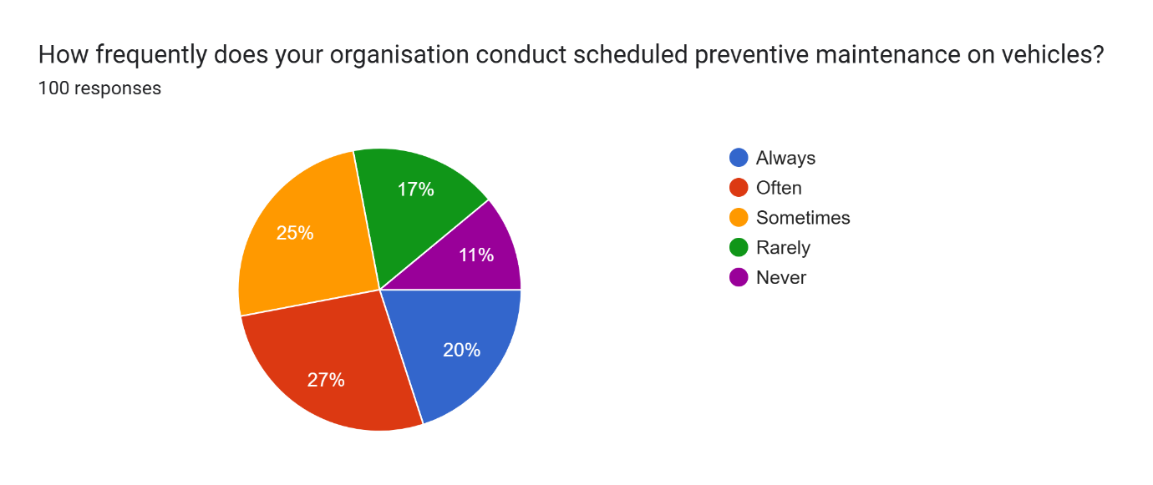
Figure 1: Scheduled preventive maintenance on vehicles
When it comes to scheduled preventive maintenance, only 20% of respondents noted that the organisation follows the practice always, whereas 27% of them said their organisation does the above practice frequently. Another 25% also stated that it is carried out occasionally, and this indicates that more than half of the organisations are not regular in their maintenance programmes. Also, 17% of them stated that their organisation is doing maintenance seldom, whereas 11% revealed that their organisation never does it. Such results indicate poor consistency in the preventive maintenance of vehicles, which in turn, potentially poses an operational risk and a long-term expense to small trucking companies with informalized maintenance programs, which is in line with the overall findings by (Markudova et al., 2021).
4.2.2 Do you have access to real-time GPS tracking on every vehicle in your fleet?
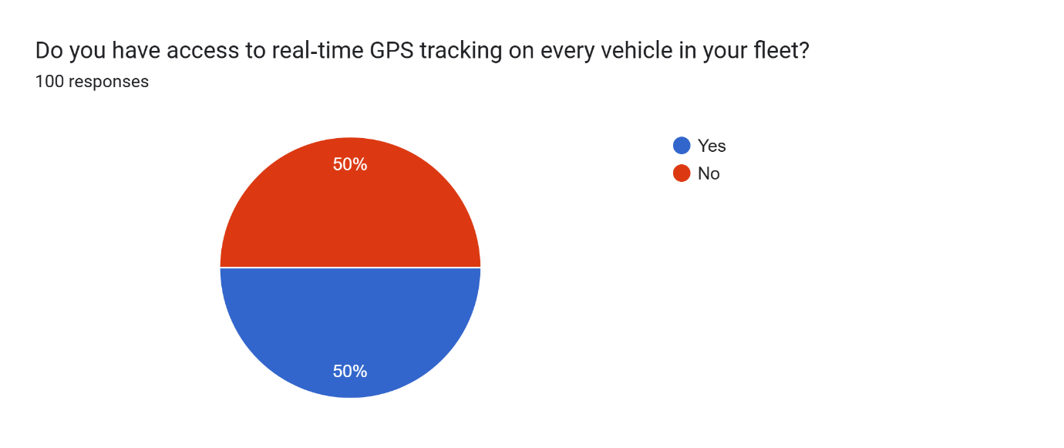
Figure 2: Access to real time GPS tracking on every vehicle
When the question regarding access to real-time GPS tracking on all vehicles in their fleet was presented, half of the respondents responded by saying yes, and a similar number responded by saying no. This indicates that the GPS tracking system in small trucking firms has been embraced by just 50% of the firms. This is because of the absence of full GPS coverage, which can minimise the capabilities of monitoring routes, delivery tracking and rapid response in cases of concern. Aliaj (2023) emphasised that GPS tracking and telematics ensure better route planning and minimise fuel expenses, which implies that the companies that lack this equipment can miss the essential features of fleet efficiency and management.
4.2.3 Please select the primary software or system your team uses for route planning
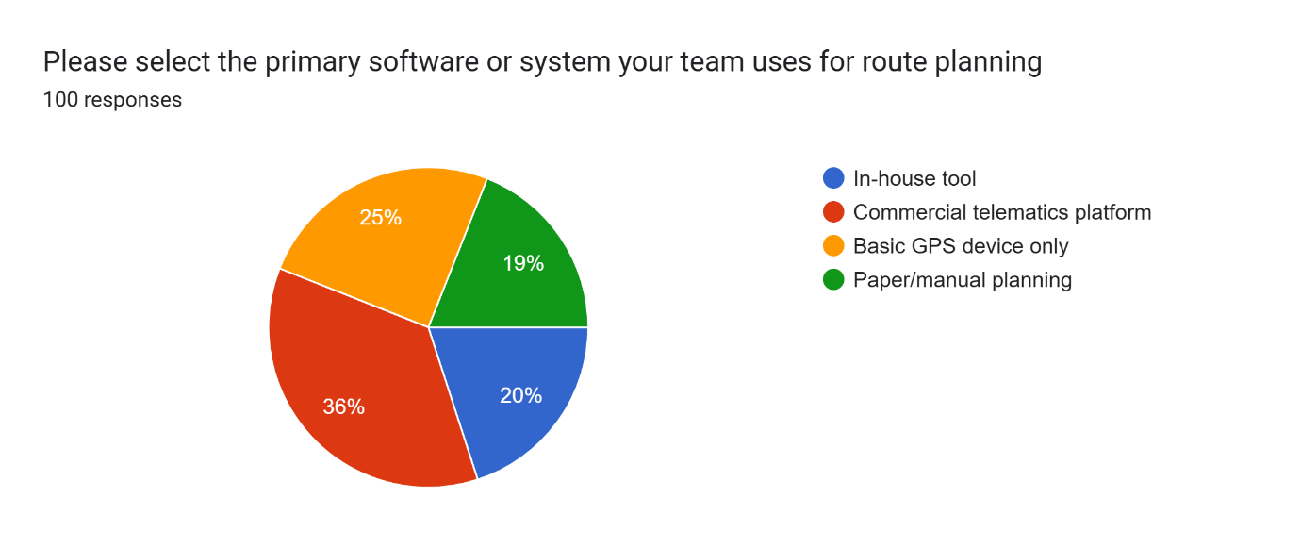
Figure 3: Primary software or system for route planning
In terms of the software or system employed in route planning, 36% of our respondents indicated that they utilise the commercial telematics platform, which is an indication of a decent penetration of modern technology. Nonetheless, 25% use the most basic GPS systems and 19% use paper or manual planning, which could cause errors or inefficiencies. Only 20% stated that they used an in-house tool to plan the route. This implies that there are small trucking companies that are employing highly advanced tools, and there are many that rely on simple or primitive tools. In accordance with Ghaffarpasand et al. (2022), telematics and smart tool usage will also allow enhancing the fuel consumption and efficiency of routes.
4.2.4 To what extent do you agree that fuel-consumption data is accurate and timely for decision-making?
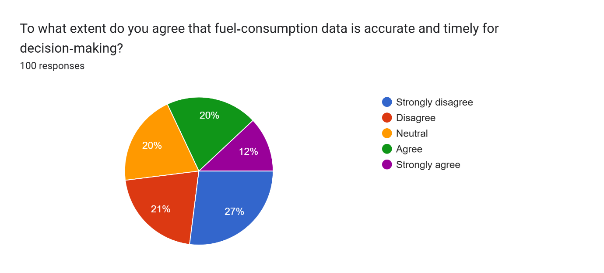
Figure 4: Fuel consumption data is accurate and timely for decision making
On whether information on fuel consumption is accurate and timely to make a decision, 27% strongly disagreed and 21% disagreed. This implies that about 50% of the respondents cannot use their fuel data to make competent decisions. A further 20% were not sure and were fixated. Only 20% of them and 12% strongly agreed that the fuel information is correct and current. Such findings indicate that most small trucking enterprises have ineffective fuel monitoring systems. According to Reddy and Bhuvan (2024), fuel data plays a crucial role in monitoring the performance and lowering the expenses in a fleet.
4.2.5 Overall, how satisfied are you with the company’s process for handling unexpected vehicle breakdowns?
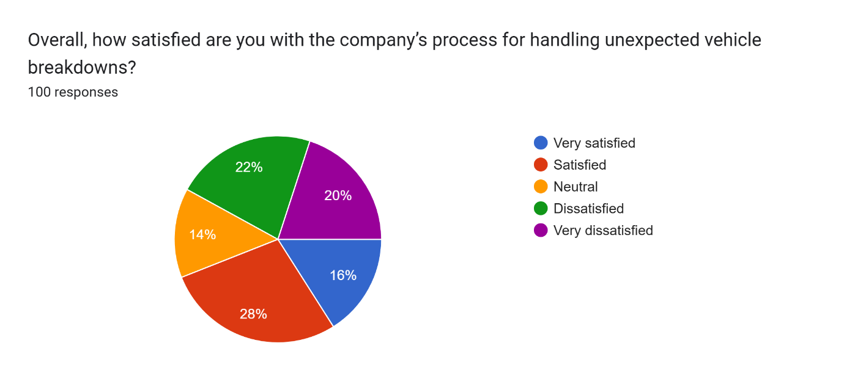
Figure 5: Company’s process for handling unexpected vehicle breakdowns
Regarding their satisfaction with the outcome when experiencing unexpected car breakdowns, there were 16 and 28% of the respondents answered very satisfied and satisfied, respectively. This indicates that only a few of the employees are satisfied with the process. In contrast, 22% said they were dissatisfied, and 20% said they were very dissatisfied, so there are significant issues in the manner in which breakdowns are handled. 14% of the respondents selected a neutral option. This indicates that most small trucking firms might lack proper mechanisms for handling breakdowns within a short time. This may cause delays and increased costs of repair.
4.2.6 Which best describes your experience with regulatory-compliance training (e.g., driver hours, emissions standards)?
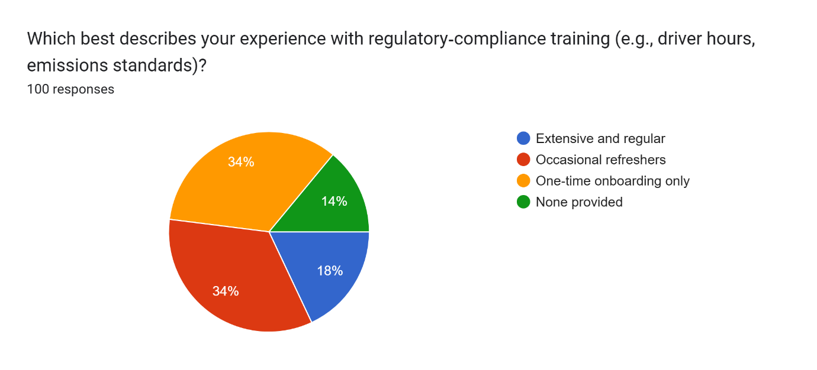
Figure 6: Experience with regulatory compliance training
In terms of the experience in regulatory compliance training, 18% of the respondents said that they had not received any extensive and regular training. The biggest percentage, 34%, responded that they are refreshed occasionally, and 34% simply stated that training was provided once during the onboarding process. Scarily, 14% said that they were given no training at all. These findings indicate that frequent compliance education might not be a major priority for most of the small firms in the trucking industry. This may result in ignorance concerning significant rules like driver working hours or requirements set out on emissions. According to Woods (2024), effective regulatory awareness is crucial when preventing fines and having safe and productive fleets.
4.2.7 How often does your team review and adjust routes based on live traffic or weather data?
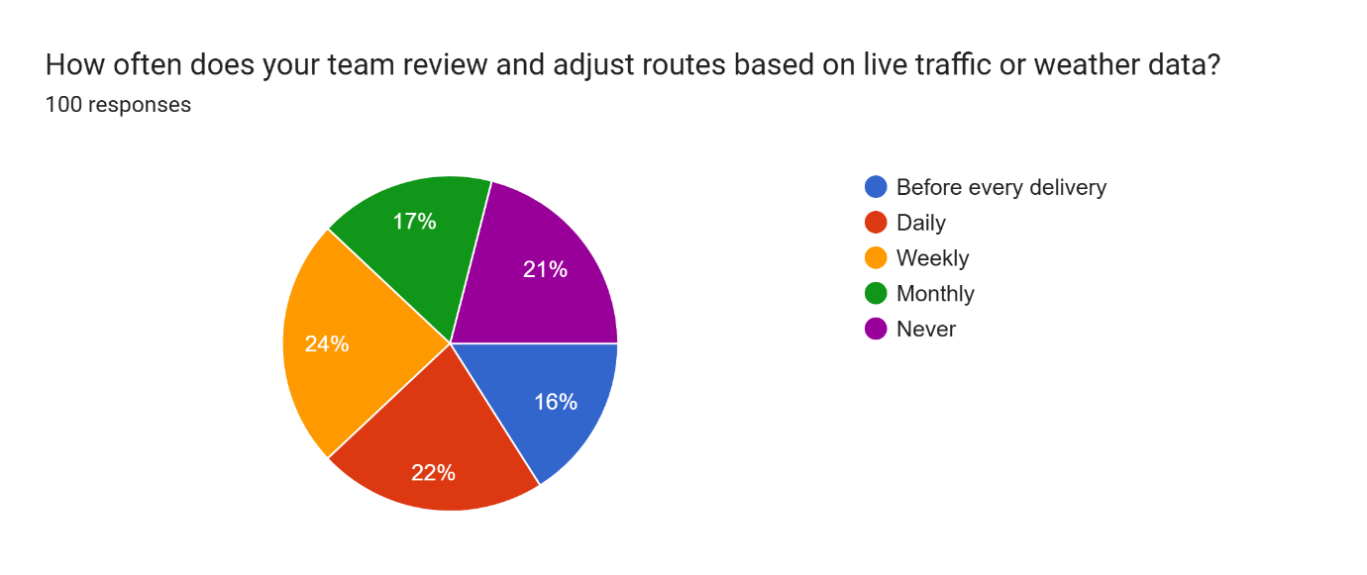
Figure 7: Review and adjust routes based on live traffic or weather data
When respondents were questioned on how they tend to revise and re-route the routes as frequently as they can based on live traffic info or weather data, only 16% of them stated that they do that before each delivery, with 22% stating that they do the same on a daily basis. A little bit more, 24%, said that route reviews are made weekly, and 17% of them said they do it monthly. It is also important to note that 21% of respondents never change their routes using live information. This means that a large part of the small-scale trucking companies is not doing enough to enhance efficiency and prevent delays. In-transit route optimisation has the potential to minimise fuel consumption and delivery, which is consistent with the findings by Golinska-Dawson and Sethanan (2023) on the prospects of GPS and telematics.
4.2.8 Are digital checklists or mobile apps used by drivers to report vehicle condition at the start/end of shifts?
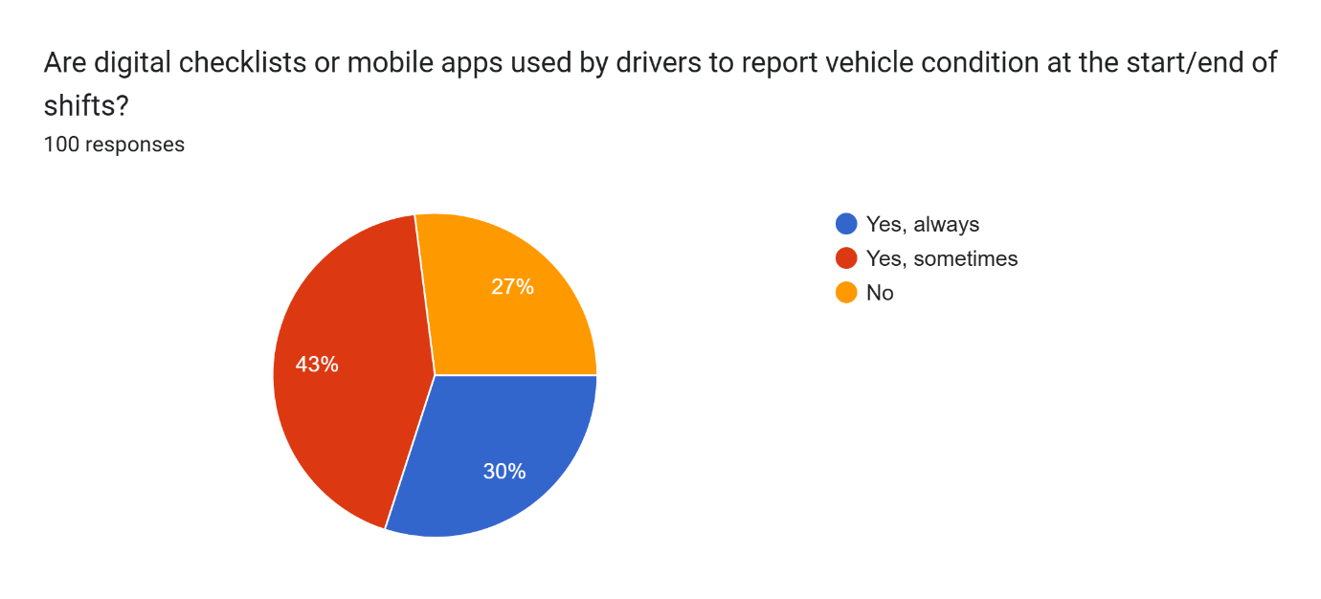
Figure 8: Digital checklists or mobile apps used by drivers
When respondents were asked questions about whether drivers use digital checklists or mobile apps during their shifts to communicate the condition of vehicles at the beginning or the end of the shifts, 30% of them replied that tools are actively utilised. In the meantime, 43% responded that such tools are applied rather occasionally, which shows a less consistent method. Nevertheless, 27% said that there are no digital tools used at all in this regard. This indicates that, as some companies are employing modern procedures in carrying out daily check-ups of the vehicle, a lot of them are still depending on irregular or manual techniques. Dedefo et al. (2025) stated that digital reporting tools assist in increasing the efficiency of the operations and eliminating maintenance delays.
4.2.9 Rate the clarity of communication between dispatchers and drivers regarding schedule changes
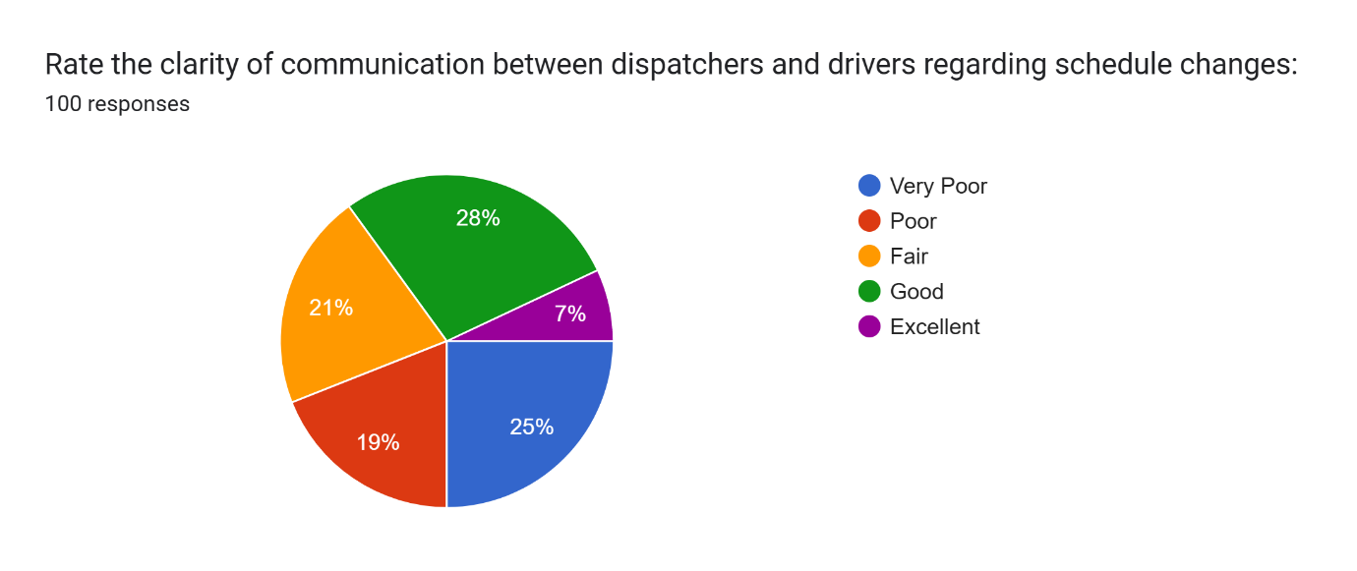
Figure 9: Clarity of communication between dispatchers and drivers regarding schedule changes
When the respondents were requested to give the clarity of communication between dispatchers and drivers about schedule changes, it was revealed that 25% respondents stated that it was very poor and 19% said that it was poor, which means a considerable number of respondents are having communication issues. In the meantime, 21% chose fair, which demonstrates a balanced or unbiased experience. Only 28% indicated good communication, and 7% indicated that it was excellent. This implies that some of the organisations have established effective communication, but most of them still have loopholes that may affect route effectiveness and responsiveness. As Hänninen (2021) argues, effective internal communication is a crucial element of eliminating delays and maintaining an efficient flow of processes within fleet management.
4.2.10 Which statement best reflects how performance metrics (e.g., miles per gallon, delivery times) are shared with you?
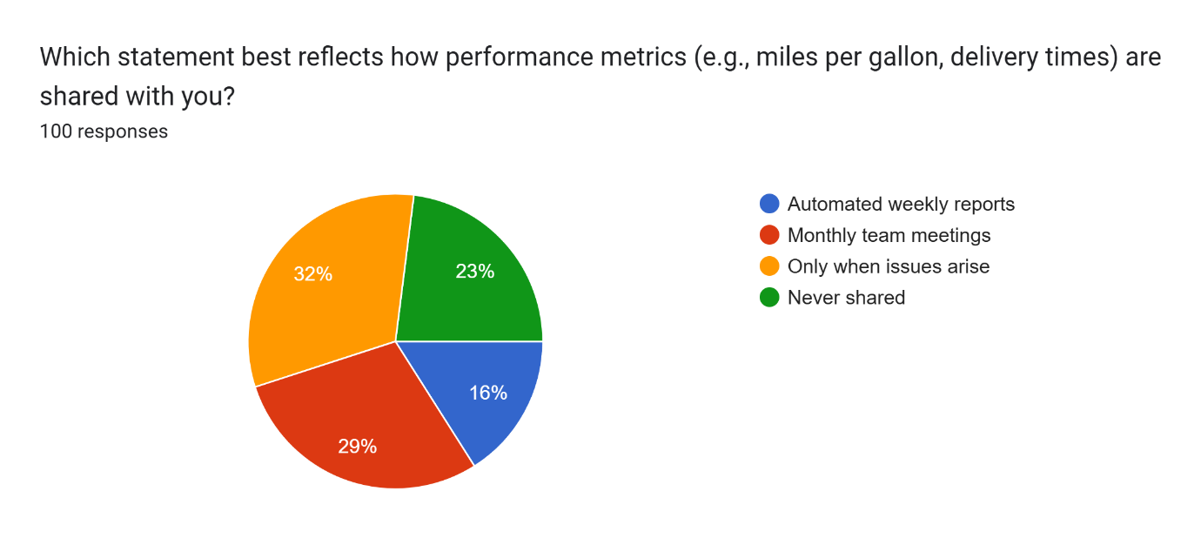
Figure 10: Performance metrics shared
In response to the question on how metrics like miles per gallon or delivery times are conveyed, 32% of the respondents claimed that they only get to hear such information when problems happen. The other 29% indicated that they discuss metrics at monthly team meetings, and 16% said they receive automatic weekly reports. Noteworthy, 23% responded that such measures are never disseminated to them. This shows that not all organisations follow a pattern of regular reports or formal meetings, but a big percentage either get feedback in a reactive manner or not at all. Kanuku and Ng’eno (2023) also, explain that regular data exchanges enable teams to implement improvements in time and foster the effectiveness of the fleet.
4.2.11 How satisfied are you with the adequacy of spare-parts inventory for routine repairs?
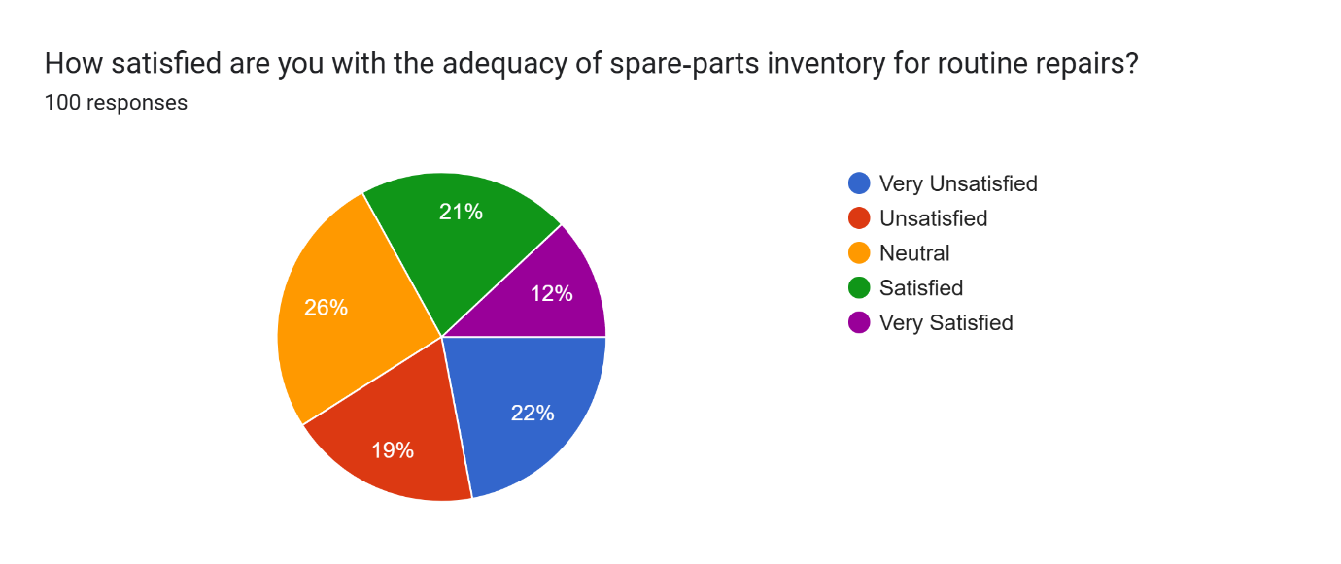
Figure 11: Adequacy of spare parts inventory for routine repairs
When it comes to satisfaction with the availability of vehicle spare parts to perform routine repair on the vehicles, 22% of the respondents were very unsatisfied, and 19% were unsatisfied. It implies that more than 40% of respondents believe that the inventory is not satisfactory most of the time. In the meantime, 26% gave no opinion, which could be a sign of inconsistent supply. On the positive side, 21% indicated that they were satisfied, and only 12% indicated that they were very satisfied. The results indicate that improvement in the management of the spare parts is indeed necessary as a way of preventing delays during regular maintenance. This is according to a fact by Sebata (2024) that adequate inventory management in logistics is vital in ensuring the maintenance of fleets goes smoothly in the industry and minimises downtime.
4.2.12 Do you feel that fuel-price volatility is effectively managed through hedging or budgeting strategies?
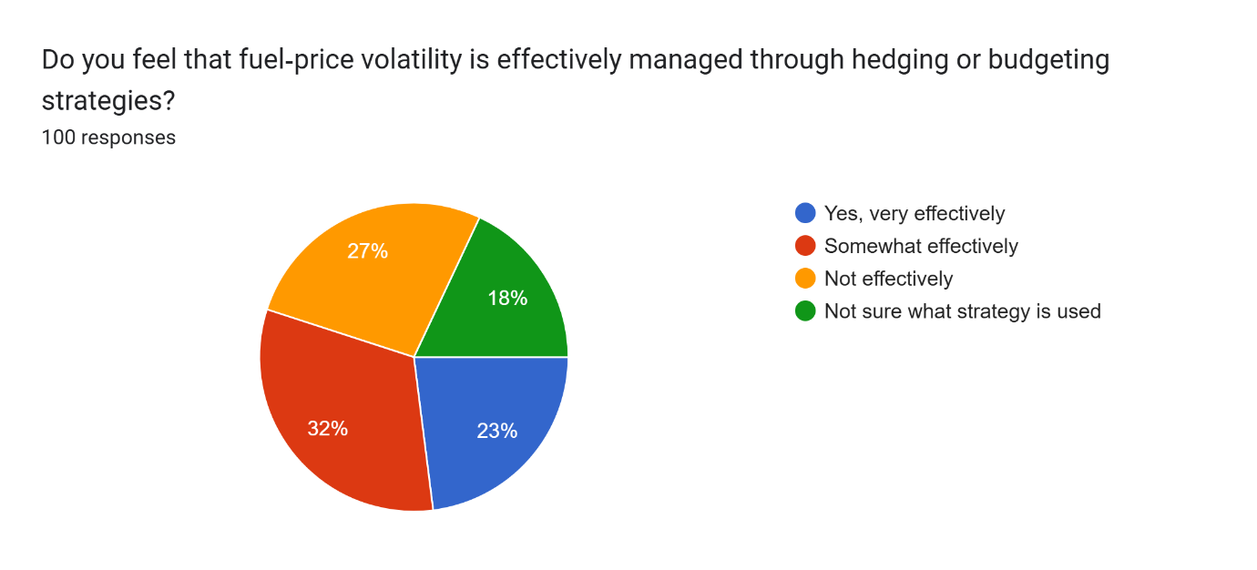
Figure 12: Fuel price volatility is effectively managed
On a question of how fuel volatility is being effectively dealt with, either by hedging or budgeting, 23% of the respondents responded that it is being dealt with very competently, and 32% responded that it is dealt with somewhat competently. Nonetheless, 27% of them answered that it is not managed effectively, and 18% of them were uncertain what approach is being applied. This mixed response indicates that there is no consistency and clarity in the fuel management practices of the small fleet companies. According to Parry et al. (2023), the uncertainty surrounding fuel prices can have serious consequences as far as logistics costs are concerned, and companies should embrace transparent and clear policies to curb the effects of fuel price changes.
4.2.13 Which describes your use of AI‑driven or automated route-optimisation tools?
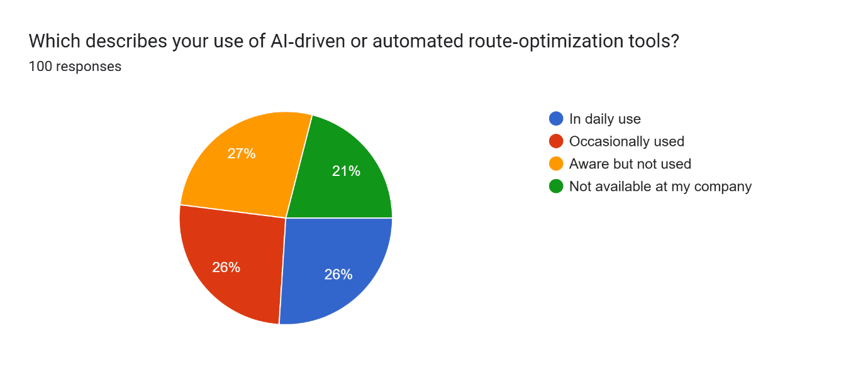
Figure 13: Use of AI‑driven or automated route-optimisation tools
Answering a question on the usage of AI-driven or automated route-optimisation tools, 26% of respondents claim that those tools are used every day, whereas 26% of respondents answer that they are used periodically. Intriguingly, 27% said that they know of these tools but do not utilise them, and that could point to the absence of training and integration. Moreover, 21% have reported that they do not have such tools in their company at all. This demonstrates that the level of awareness about AI route tools is relatively broad, but an uneven distribution of their application is observed. According to Chen et al. (2024), the implementation of AI technologies in the field of logistics has the potential to enhance the speed of delivery and route optimisation to a highly impressive extent.
4.2.14 Overall, how would you rate the company’s ability to minimise logistics costs through digital solutions?
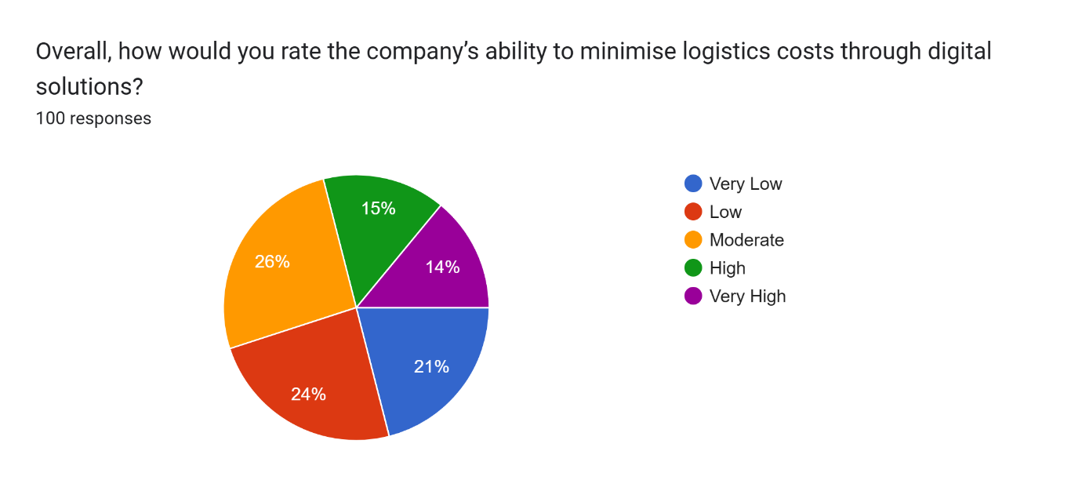
Figure 14: The company’s ability to minimise logistics costs through digital solutions
In response to the question regarding the capacity of the respondent’s company in reducing the cost of logistics through digital solutions, 26% of the respondents rated it as moderate. Nevertheless, a large percentage of them were concerned, with 24% assessing it as low and 21% deemed it very low. Just 14% chose very high, and only 15% believed that the ability is high among their companies. This means that even though some companies are already experiencing the positive effects of digital tools, many are still not exploiting their potential in terms of cost savings. King and Navarra (2024) postulate that the operating costs of business can be significantly reduced through the proper utilisation of digital logistics platforms, and in most instances, integration and employee education are needed to succeed in this process.

4.3 Discussion
4.3.1 Maintenance and Compliance Challenges
The survey showed that scheduled preventive maintenance is irregular in most firms, with only 20% reporting “always” and 27% “often.” These findings mirror the concerns raised by del Castillo and Parlikad (2024), who noted that reactive maintenance leads to higher repair costs and unplanned downtime. As per Eswararaj et al. (2025), unplanned breakdowns disrupt schedules and erode customer trust. Likewise, only half of the respondents have full GPS tracking, echoing Aliaj’s (2023) warning that a lack of telematics limits route visibility and response capabilities. Compliance training was also inconsistent: 34% receive only occasional refreshers, and 14% none at all. Woods (2024) emphasises that gaps in driver-hours and emissions training heighten legal risks. Together, these results confirm that small UK trucking firms face persistent maintenance and regulatory challenges described in the literature.
4.3.2 Technology Adoption and Operational Strategies
Responses on route-planning tools showed mixed adoption: 36% use commercial telematics, 25% basic GPS, and 19% manual planning. Bathla et al. (2022) argued that telematics and AI-driven routing can reduce fuel use and improve efficiency. However, our data reveal that budget and expertise barriers still slow uptake. Only 26% use AI tools daily, and 21% lack access entirely, supporting Verbytskyi’s (2023) point that small firms often pilot new systems before wider rollout. In-transit route reviews are also infrequent: just 38% adjust daily or per delivery. This underuse contrasts with Golinska-Dawson and Sethanan (2023), who showed live-data rerouting minimises delays. Regarding breakdown handling, only 44% are satisfied, aligning with Markudova et al. (2021) finding that informal maintenance programmes heighten operational risk. These patterns suggest that while strategic approaches, like phased technology adoption recommended by Herterich et al. (2023), are known, they remain unevenly implemented.
4.3.2 Data Tools and Future Resource Planning
The survey underlines uneven use of data-collection tools. Only 30% always use digital checklists, while 27% rely solely on manual reports. Gavrilă et al. (2024) highlighted that mobile apps improve data accuracy and speed up maintenance decisions. Our findings also show that performance metrics are often shared reactively: 32% only receive data when problems arise, and 23% never. Kanuku and Ng’eno (2023) stressed that regular KPI sharing fosters continuous improvement. Fuel-data reliability is low, with nearly half of the respondents unable to trust their reports for decision-making. Reddy and Bhuvan (2024) argued that accurate fuel data is crucial for cost control, yet our data suggest many firms lack effective monitoring systems. Satisfaction with spare-parts availability is also weak, supporting Sebata’s (2024) emphasis on the need for robust inventory management. Finally, only 55% of firms manage fuel-price volatility effectively, despite Parry et al. (2023) calling for clear hedging or budgeting policies. These gaps point to the need for tailored, mixed-method research, combining quantitative performance analysis with qualitative insights, to develop practical data-tool recommendations for small UK trucking businesses.

Chapter 5: Conclusion and Recommendations

5.1 Conclusion
This paper discussed the way small companies in the UK trucking business handle the maintenance of their trucks, regulatory requirements, route designing, and computerised aids. It was discovered that numerous organisations depend on reactive maintenance compared to a preventive schedule. This practice results in a breakdown of vehicles and increased repair expenses. Training on regulations is irregular, which keeps many drivers unaware of crucial regulations concerning working hours and emissions. The methods of route planning are diverse, ranging from highly sophisticated telematics to manual paper-based maps. Use of AI-powered tools is still underutilised due to affordability and employee skill level. There is inconsistency in data-collection practices: few companies employ digital checklists on a regular basis, and the measurement of performance is frequently reserved only in response to problems. The communication between drivers and the dispatcher is not very clear, and this may slow down their response to changes in the schedule. Lastly, the spare-parts management and the fuel-price approach tend to be inadequate, lowering the general efficiency of the fleet. Combinedly, these results indicate that small operators are challenged by interdependent issues pertaining to the maintenance, technology adoption, and information flow, which limit their competitiveness.
Additionally, most companies face uncertainties in the market demand and shortage of drivers. The service levels can be sustained by enhancing the working conditions and career building of the drivers. Focusing on constant feedback between the drivers and the managers will create a trustful relationship and unveil ground-based problems in time. Simple data‑sharing investments can create a culture of transparency and allow employees to propose efficiency ideas. Smaller companies can even look at low cost automination of non valuable administration duties like, digital invoice and schedule automation exchange of just a portion of the workforce to add-value gain. Setting performance standards which measure against strategic objectives enable returns to be quantified in terms of technology investments. Lastly, a culture of continuous learning should be encouraged by providing teams with short workshops, peer mentors, and online resources to become ready to use the new tools and address the changing standards in the industry. Small UK trucking companies have a chance of turning operational challenges into competitive strengths, and sustaining the growth in the long term by incorporating these people‑centricity measures and process measures.

5.2 Recommendations
- Establish regular preventive maintenance schedules: Use simple checklists and reminders to ensure vehicles are serviced before problems occur.
- Standardise compliance training: Provide brief, regular refresher sessions on driver-hours rules, emission standards, and safety protocols.
- Adopt basic telematics widely: Begin with low-cost GPS tracking on all vehicles to improve route visibility and monitoring.
- Pilot AI-route optimisation tools: Try these tools on a few vehicles to evaluate benefits before wider rollout.
- Implement digital checklists: Supply drivers with mobile apps for pre-trip and post-trip inspections to record vehicle condition quickly.
- Share performance metrics regularly: Schedule weekly or monthly updates on fuel use, delivery times, and maintenance status to all staff.
- Improve dispatcher-driver communication: Use group messaging or dedicated communication apps to notify drivers of schedule changes in real time.
- Maintain a basic spare-parts inventory: Identify high-use parts and keep a small stock to reduce downtime during routine repairs.
- Develop clear fuel-price policies: Establish simple budgeting or hedging guidelines so drivers and managers understand cost controls.
- Form strategic partnerships: Join local transport cooperatives or industry groups to share resources, training, and technology access.

5.3 Future Scope
In future studies, it should be interesting to understand how these recommendations are put into practice by small fleets and their effects in the medium term. In-depth information would be given by case studies of successful companies that embrace preventive maintenance and the use of digital tools. Cultural or behavioural barriers to the use of technologies may be identified in qualitative interviews of the drivers and dispatchers. Interregional or fleets of the same magnitude comparative research can determine situational variables that influence adoption. More longitudinal study following costs savings, downtime, and customer satisfaction of the pre- and post-intervention perspective would assist in the quantification of benefits. Lastly, as integrative strategies that entail performance and staff responses, mixed-method designs would inform custom support programmes and policy suggestions to small trucking businesses in the UK.

References
Abedin, B., (2022). Managing the tension between opposing effects of explainability of artificial intelligence: a contingency theory perspective. Internet Research, 32(2), pp.425-453.
Ali, I.M., (2024). A guide for positivist research paradigm: From philosophy to methodology. Idealogy Journal, 9(2).
Aliaj, A., (2023). Fleet management solutions: a census of market offerings and business expectations.
Allemang, B., Sitter, K. and Dimitropoulos, G., (2022). Pragmatism as a paradigm for patient‐oriented research. Health Expectations, 25(1), pp.38-47.
Alsharida, R., Hammood, M. and Al-Emran, M., (2021). Mobile learning adoption: A systematic review of the technology acceptance model from 2017 to 2020. International Journal of Emerging Technologies in Learning (IJET), 16(5), pp.147-162.
Al‐Swidi, A.K., Hair, J.F. and Al‐Hakimi, M.A., (2023). Sustainable development‐oriented regulatory and competitive pressures to shift toward a circular economy: The role of environmental orientation and Industry 4.0 technologies. Business Strategy and the Environment, 32(7), pp.4782-4797.
Burkhardt, G., Boy, F., Doneddu, D. and Hajli, N., (2023). Privacy behaviour: A model for online informed consent. Journal of business ethics, 186(1), pp.237-255.
Busch, C. and Barkema, H., (2021). From necessity to opportunity: Scaling bricolage across resource‐constrained environments. Strategic Management Journal, 42(4), pp.741-773.
Chen, W., Men, Y., Fuster, N., Osorio, C. and Juan, A.A., (2024). Artificial intelligence in logistics optimization with sustainable criteria: A review. Sustainability, 16(21), p.9145.
Dawadi, S., Shrestha, S. and Giri, R.A., (2021). Mixed-methods research: A discussion on its types, challenges, and criticisms. Journal of Practical Studies in Education, 2(2), pp.25-36.
Dedefo, M.G., Lim, R., Kassie, G.M., Gebreyohannes, E.A., Salekdeh, N.N., Roughead, E. and Kalisch Ellett, L., (2025). Consumer views on the use of digital tools for reporting adverse drug reactions: a cross-sectional study. International Journal of Clinical Pharmacy, 47(2), pp.423-434.
del Castillo, A.C. and Parlikad, A.K., (2024). Dynamic fleet management: Integrating predictive and preventive maintenance with operation workload balance to minimise cost. Reliability Engineering & System Safety, 249, p.110243.
Diao, M., Kong, H. and Zhao, J., (2021). Impacts of transportation network companies on urban mobility. Nature Sustainability, 4(6), pp.494-500.
Dimitriou, D.J., (2021). The evolution in transport operator’s corporate structure: Ownership and governance. In Outsourcing and Offshoring. IntechOpen.
Eckert, D., (2024). A Digital Agenda. In 40 Years of European Digital Policies: Forgotten Lessons (pp. 97-114). Cham: Springer Nature Switzerland.
English, J. and Nielsen, R.A., (2023). Combining interpretivist and positivist approaches in social science research [online]
Eswararaj, D., Koppada, L.R. and Bodala, R.S., (2025). Quantifying the Influence of Artificial Intelligence and Machine Learning in Predictive Maintenance for Vehicle Fleets and Its Impact on Reliability and Cost Savings.
Farahpoor, M., Esparza, O. and Soriano, M., (2023). Comprehensive IoT-driven fleet management system for industrial vehicles. IEEE access.
Gavrilă, M., Murariu, M.G., Bărbuță, D.E., Mihăilescu, E. and Tărniceriu, D., (2024, June). Enhancing driver safety through a data collection platform. In 2024 16th International Conference on Electronics, Computers and Artificial Intelligence (ECAI) (pp. 1-8). IEEE.
George, A.S., Sagayarajan, S., AlMatroudi, Y. and George, A.H., (2023). The Impact of Cloud Hosting Solutions on IT Jobs: Winners and Losers in the Cloud Era. Partners Universal International Research Journal, 2(3), pp.1-19.
Ghaffarpasand, O., Burke, M., Osei, L.K., Ursell, H., Chapman, S. and Pope, F.D., (2022). Vehicle telematics for safer, cleaner and more sustainable urban transport: A review. Sustainability, 14(24), p.16386.
Golinska-Dawson, P. and Sethanan, K., (2023). Sustainable urban freight for energy-efficient smart cities—systematic literature review. Energies, 16(6), p.2617.
Hampson, T. and McKinley, J., (2023). Problems posing as solutions: Criticising pragmatism as a paradigm for mixed research. Research in Education, 116(1), pp.124-138.
Hänninen, S., (2021). The strategic value of efficient and effective communication in the order-fulfilment process.
Harris, L., (2024). Telematics and Big Data: Revolutionizing Fleet Management in the Automotive Industry.
Hazra, A., Rana, P., Adhikari, M. and Amgoth, T., (2023). Fog computing for next-generation internet of things: fundamental, state-of-the-art and research challenges. Computer Science Review, 48, p.100549.
Herterich, M.M., Dremel, C., Wulf, J. and vom Brocke, J., (2023). The emergence of smart service ecosystems—The role of socio‐technical antecedents and affordances. Information systems journal, 33(3), pp.524-566.
Ibrahim, M.F. and Dharmawan, Y.S., (2022). Implementation of Open-Source ERP-Based Fleet Management System on SMEs Transportation Service Provider. Jurnal RESTI (Rekayasa Sistem dan Teknologi Informasi), 6(5), pp.883-890.
Kanuku, S. and Ng’eno, W.K., (2023). Technology application effects on maintenance efficiency of the fleet at the Parliamentary Service Commission, Kenya. International Academic Journal of Arts and Humanities, 1(3), pp.422-438.
Katsela, K., Güneş, Ş., Fried, T., Goodchild, A. and Browne, M., (2022). Defining urban freight microhubs: A case study analysis. Sustainability, 14(1), p.532.
Kelly, S., (2021). Internet Searching, Geo-Tagging, Geo-Fencing and Open Source Investigations: A Plaintiff’s Perspective. Trial Journal, 23(1).
Kennedy, I., (2022). Sample size determination in test-retest and Cronbach alpha reliability estimates. British Journal of Contemporary Education, 2(1), pp.17-29.
Khanra, S., Kaur, P., Joseph, R.P., Malik, A. and Dhir, A., (2022). A resource‐based view of green innovation as a strategic firm resource: Present status and future directions. Business Strategy and the Environment, 31(4), pp.1395-1413.
King, G. and Navarra, D., (2024). Transaction cost theory, organisational ambidexterity, and digital platforms: an interpretative case study exploring the implementation of a business-to-business logistics digital platform in a South African organisation. The Business & Management Review, 15(3), pp.36-44.
Kumatongo, B. and Muzata, K.K., (2021). Research paradigms and designs with their application in education. Journal of Lexicography and Terminology (Online ISSN 2664-0899. Print ISSN 2517-9306)., 5(1), pp.16-32.
Maksimovic, J. and Evtimov, J., (2023). Positivism and post-positivism as the basis of quantitative research in pedagogy. Research in Pedagogy, 13(1), pp.208-218.
Marjosola, H., (2021). The problem of regulatory arbitrage: A transaction cost economics perspective. Regulation & Governance, 15(2), pp.388-407.
Markudova, D., Mishra, S., Cagliero, L., Vassio, L., Mellia, M., Baralis, E., Salvatori, L. and Loti, R., (2021). Preventive maintenance for heterogeneous industrial vehicles with incomplete usage data. Computers in Industry, 130, p.103468.
Markus, K.A. and Borsboom, D., (2024). Frontiers of test validity theory: Measurement, causation, and meaning. Routledge.
Muzari, T., Shava, G.N. and Shonhiwa, S., (2022). Qualitative research paradigm, a key research design for educational researchers, processes and procedures: A theoretical overview. Indiana Journal of Humanities and Social Sciences, 3(1), pp.14-20.
Nguyen, A., Ngo, H.N., Hong, Y., Dang, B. and Nguyen, B.P.T., (2023). Ethical principles for artificial intelligence in education. Education and information technologies, 28(4), pp.4221-4241.
Omran, I., Mostafa, A., Seddik, A., Ali, M., Hussein, M., Ahmed, Y., Aly, Y. and Abdelwahab, M., (2024). Deep reinforcement learning implementation on IC engine idle speed control. Ain Shams Engineering Journal, 15(5), p.102670.
Oteri, O.J., Onukwulu, E.C., Igwe, A.N., Ewim, C.P.M., Ibeh, A.I. and Sobowale, A., (2023). Cost optimization in logistics product management: strategies for operational efficiency and profitability. International Journal of Business and Management. Forthcoming.
Parry, I., Black, M.S. and Vernon, N., (2021). Still not getting energy prices right: A global and country update of fossil fuel subsidies. International Monetary Fund.
Poo, M.C.P. and Yang, Z., (2021, October). Global food supply chain resilience assessment: A case in the United Kingdom. In 2021 6th International Conference on Transportation Information and Safety (ICTIS) (pp. 5-9). IEEE.
Ramere, M.D. and Laseinde, O.T., (2021). Optimization of condition-based maintenance strategy prediction for aging automotive industrial equipment using FMEA. Procedia Computer Science, 180, pp.229-238.
Reddy, M.H. and Bhuvan, M.B., (2024). Real-Time vehicle tracking and fleet monitoring. International Journal of Information Technology and Computer Engineering, 12(4), pp.94-101.
Redreev, G.V., Luchinovich, A.A. and Boltovsky, S.N., (2021, April). Transport vehicle maintenance optimization. In IOP Conference Series: Earth and Environmental Science (Vol. 720, No. 1, p. 012043). IOP Publishing.
Romero, C.A., Correa, P., Ariza Echeverri, E.A. and Vergara, D., (2024). Strategies for reducing automobile fuel consumption. Applied Sciences, 14(2), p.910.
Rozhko, N., Plekan, U., Tson, O. and Matviishyn, A., (2022). Digitalization of truck companies: current challenges and development prospects.
Sarvaiya, S., Ganesh, S. and Xu, B., (2021). Comparative analysis of hybrid vehicle energy management strategies with optimization of fuel economy and battery life. Energy, 228, p.120604.
Sebata, D., (2024). Investigating How Logistics Operations Affect an Organization’s Financial Performance.
Surya, S., Keerthiga, A. and Shalini, S., (2024). FUEL PULSE: Digital Fuel Logistics Revolutionizing Delivery Management. Available at SSRN 4776337.
Tay, Z.Y., Hadi, J., Chow, F., Loh, D.J. and Konovessis, D., (2021). Big data analytics and machine learning of harbour craft vessels to achieve fuel efficiency: A review. Journal of Marine Science and Engineering, 9(12), p.1351.
Trenerry, B., Chng, S., Wang, Y., Suhaila, Z.S., Lim, S.S., Lu, H.Y. and Oh, P.H., (2021). Preparing workplaces for digital transformation: An integrative review and framework of multi-level factors. Frontiers in psychology, 12, p.620766.
Ujlacka, K., Konecny, V. and Valaskova, K., (2024). INCREASING THE ECONOMIC EFFICIENCY OF TRANSPORT ENTERPRISES THROUGH TELEMATICS SYSTEMS. Economic & Managerial Spectrum/Ekonomicko-manažérske Spektrum, 18(2).
Verbytskyi, Y., (2023). Delivery routes optimization using machine learning algorithms.
Widen, W.H. and Koopman, P., (2022). Autonomous vehicle regulation & trust: The impact of failures to comply with standards. UCLA JL & Tech., 27, p.169.
Wolniak, R. and Grebski, W., (2023). Predictive maintenance–the business analytics usage in Industry 4.0 conditions. Zeszyty Naukowe Politechniki Śląskiej. Organizacja i Zarządzanie, 187, pp.709-726.
Woods, J.B., (2024). Reimagining Traffic Fines and Fees. UC Irvine Law Review, 14(3).

Appendix
1. How frequently does your organisation conduct scheduled preventive maintenance on vehicles?
2. Do you have access to real-time GPS tracking on every vehicle in your fleet?
3. Please select the primary software or system your team uses for route planning
4. To what extent do you agree that fuel-consumption data is accurate and timely for decision-making?
5. Overall, how satisfied are you with the company’s process for handling unexpected vehicle breakdowns?
6. Which best describes your experience with regulatory-compliance training (e.g., driver hours, emissions standards)?
7. How often does your team review and adjust routes based on live traffic or weather data?
8. Are digital checklists or mobile apps used by drivers to report vehicle condition at the start/end of shifts?
9. Rate the clarity of communication between dispatchers and drivers regarding schedule changes
10. Which statement best reflects how performance metrics (e.g., miles per gallon, delivery times) are shared with you?
11. How satisfied are you with the adequacy of spare-parts inventory for routine repairs?
12. Do you feel that fuel-price volatility is effectively managed through hedging or budgeting strategies?
13. Which describes your use of AI‑driven or automated route‑optimization tools?
14. Overall, how would you rate the company’s ability to minimise logistics costs through digital solutions?

