Trinity Saint David University of Wales
Statistical Programming (ACCB5021)

Author: | Tutor:
Chris Hampton | Dr. Nik Whitehead
2116517@student.uwstd.ac.uk | nicola.whitehead@uwtsd.ac.uk

18/03/2024

Contents
Table of Figures 2
1. Introduction 4
1.1 Abstract 4
2. Pell and Fibonacci Sequencing 4
2.1 Pell Numbers 4
2.2 Fibonacci Numbers 4
3. Data Flows 4
Task 1 6
Task 2 8
Task 3 9
Task 4 9
4. Conclusion 11
4.1 Further Steps 12
References 12

Table of Figures
Figure 1 - Pell Number Equation 3
Figure 2 - Fibonacci Sequence 3
Figure 3 - Data Flow 1 4
Figure 4 - Data Flow 2 4
Figure 5 - R - Generate a loop. 5
Figure 6 - R - IF/Else Statement 5
Figure 7 - R - Pell Calculation 5
Figure 8 - Co-Pilot R script 5
Figure 9 - Co-Pilot - Pell Number output 6
Figure 10 - R - Pell Number Output 6
Figure 11 - R - Fibonacci Calculation 6
Figure 12 - Co-Pilot - Fibonacci Sequence 7
Figure 13 - Co-Pilot Fibonacci Output 7
Figure 14 - Data Flow 3 8
Figure 15 - Approximate Square Root Calculation 8
Figure 16 - R- Approximate Square Root 8
Figure 17 - R Square Root Difference 8
Figure 18 - R - Square Root Correct to Decimal Place 9
Figure 19 - R - Square Root Accuracy 9
Figure 20 - Co-Pilot – Regex 9
Figure 21 - R - Data correction. 10
Figure 22 - R – Options 10

Introduction

1.1 Abstract
Create a data-frame using R and R Studio to show the Pell number and Fibonacci number sequences to the 200th number. Within the data-frame should show the approximation to the square root of 2 and how correct each Pell number is to 5 decimal places.

Pell and Fibonacci Sequencing

2.1 Pell Numbers
Pell numbers are an infinite sequence of numbers that closely related to the approximation of the square root of 2 [1]. The way in which Pell Numbers are calculated is the sum of the previous Pell Number multiplied by 2 added to the previous Pell number before that.
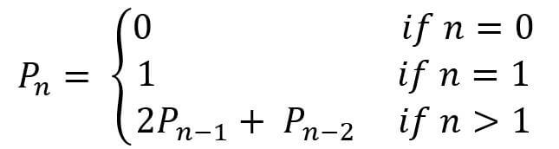
Figure 1 - Pell Number Equation
Source: https://allmathsymbols.com/pell-number-checker/
Taking the equation above the fifth Pell Number would be 5*2+2. With 5 being the previous number and 2 being the previous number before 5.

2.2 Fibonacci Numbers
Fibonacci Number sequencing is like the Pell Number sequence, but it is a simple addition of the two previous Fibonacci numbers [2]. So, using the same example above to get the fifth number in the sequence it would be 2+1 equalling 3.
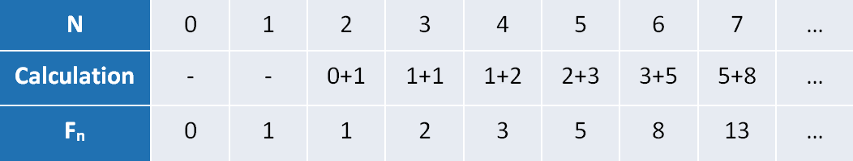
Figure 2 - Fibonacci Sequence
Source: https://semiengineering.com/the-fibonacci-calculator/
Each of these sequences start with 0,1.

Data Flows
To create a sequence of Pell and Fibonacci numbers the statistical programming language of R can be used.
The figure below shows the high-level flow of the functionality of the R script.
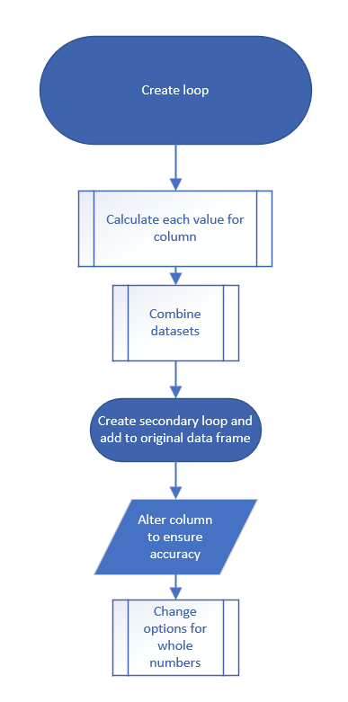
Figure 3 - Data Flow 1
To generate the Pell and Fibonacci sequences the following steps within the R script will be taken: -
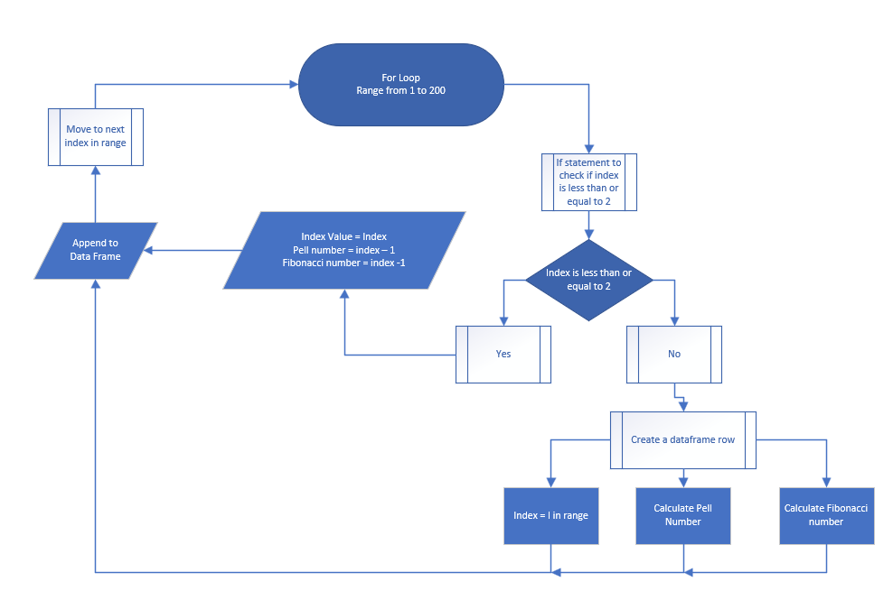
Figure 4 - Data Flow 2
The first step is to generate a loop that will loop through 200 times. This is written, as below, using a ‘for’ command within R. R will execute the script between the curly braces 200 times.
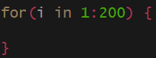
Figure 5 - R - Generate a loop.
To ensure that the data is correct and IF statement is used to calculate the first Pell and Fibonacci numbers manually, as both sequences start with a 0 and 1.
Figure 6 - R - IF/Else Statement

Task 1
To calculate the Pell number, within the loop, the following snippet of code is used.
Figure 7 - R - Pell Calculation
This code will take the previous Pell Number, denoted by the [i-1], multiply it by 2 and add the second previous Pell number. As R uses an index notation, using the square brackets, the previous value can be obtained.
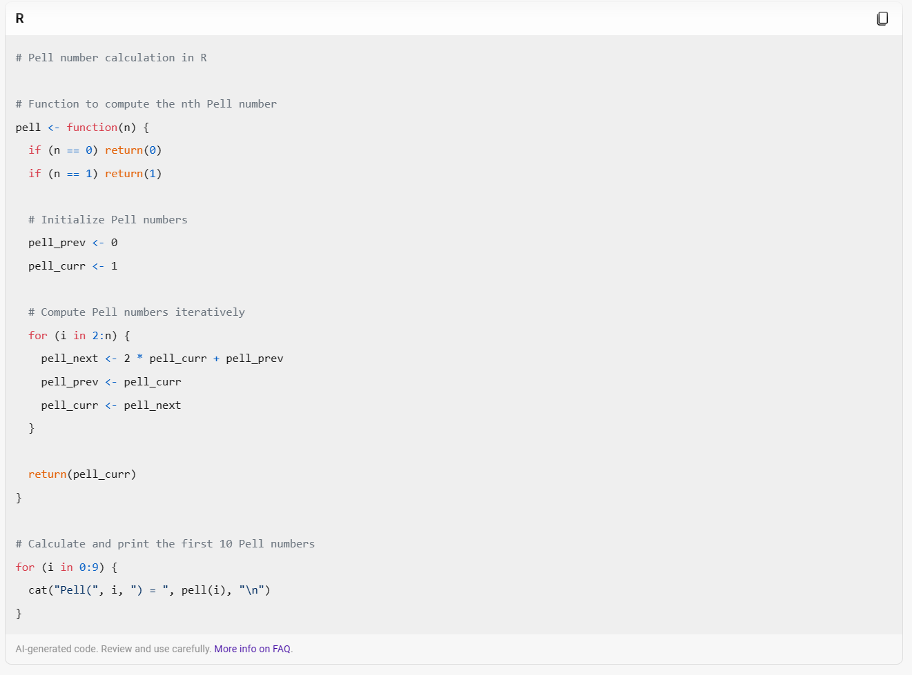
Figure 8 - Co-Pilot R script
By using generative AI, specifically Bing’s Co-Pilot, a script can be generated to formulate the Pell Number. Analysing the script above, a function is created that can pass in any integer value and output the corresponding Pell Number.
Although, this script has been tested there does seem to be some ambiguity around the indexing with the function.
For example, by asking Co-Pilot for the seventh Pell Number the output is 29.

Figure 9 - Co-Pilot - Pell Number output
By looking at the results from the R script, below, the seventh Pell Number is represented as 70.

Figure 10 - R - Pell Number Output
This could be down to many factors in the way in how the starting point of the sequence is determined. Whether the sequence starts at an index of 1 or 0.
As with the Pell number code snippet, the Fibonacci calculation is made in the same way, however the previous number isn’t only multiplied by 1. Realistically, this can be omitted from the code and the output would be the same.
Figure 11 - R - Fibonacci Calculation
As with the Pell Number, Co-Pilot was asked to generate an R script to calculate the Fibonacci number.
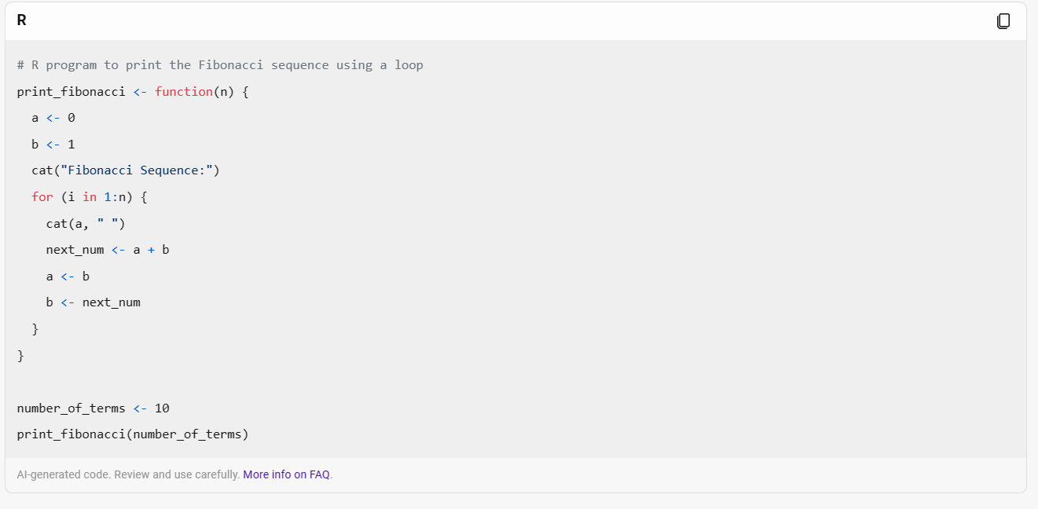
Figure 12 - Co-Pilot - Fibonacci Sequence
When asking Co-Pilot the seventh number in the sequence it generated the correct reposonse.

Figure 13 - Co-Pilot Fibonacci Output

Task 2
To calculate the approximate value to the square root of 2 and additional data frame is used to hold these values. By following the data flow diagram below two values for each index was generated. The approximate square root and the difference between that and the square root of 2.

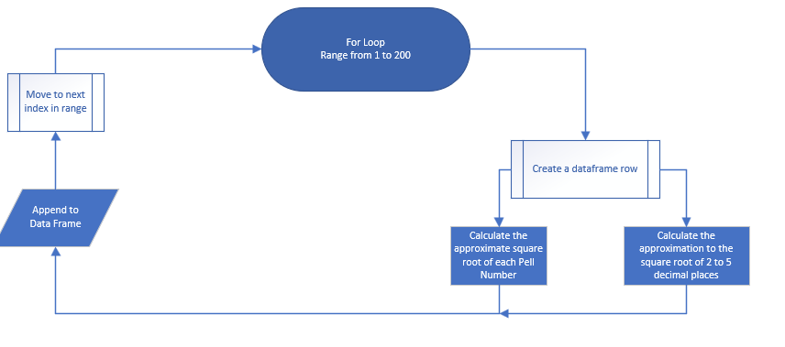
Figure 14 - Data Flow 3
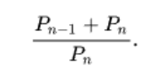
Figure 15 - Approximate Square Root Calculation
With the calculation above, the following R script takes the previous Pell Number adds it the current Pell number and divides by the same number. This will give the approximate square root of the Pell Number.
Figure 16 - R- Approximate Square Root

Task 3
To find how close the value generated above is to the square root of 2 a subtracted of these figures will take place. The snippet below uses the R function “sqrt()” to generate the square root of 2, this is then subtracted from the calculation that was made previously. By using the “Round()” function within R we can then round the value to 5 decimal places.
Figure 17 - R Square Root Difference

Task 4
To find out how accurate the Pell Number is to the square root of 2, to five decimal places, as demonstrated in the data diagram below, we can simply use a regex to count the number of zeros that appear after the decimal point.
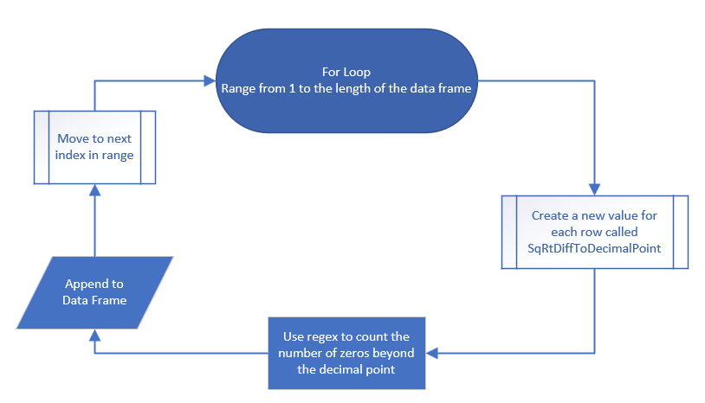
Figure 18 - R - Square Root Correct to Decimal Place
For this, a separate loop is created to loop through the data frame. Each value of ‘SqRtDiff’ is formulated against the regex.
Figure 19 - R - Square Root Accuracy
By asking Co-pilot to explain the regex, it gives a full explanation of how regular expressions uses pattern matching to determine output the user is asking.
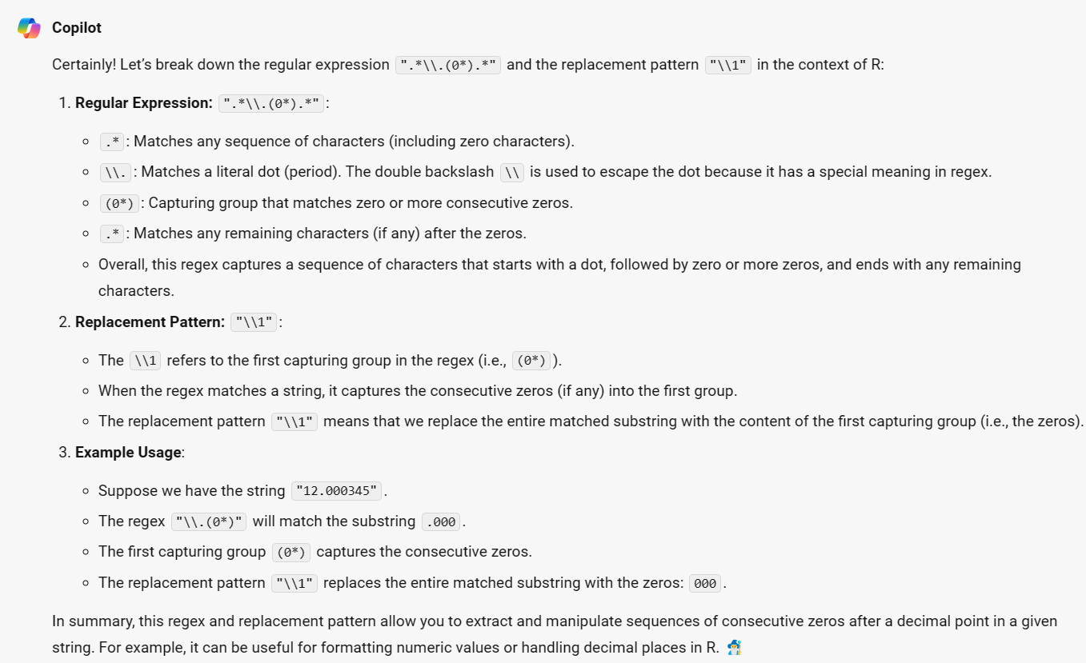
Figure 20 - Co-Pilot – Regex
After testing the script there appeared to be some discrepancies with the out. Once of these discrepancies seemed to be the way in how R was handling the ‘correct to decimal point’ value. When the value was correct to 5 decimal places the output was presenting as zero. To correct this the following code was implemented.
Figure 21 - R - Data correction.
By using the snippet above, each value is found using the “which()” function and replaced with a five.
Finaly, to ensure that the output is human readable the options can be changed for R to ensure that the integers shown are not their scientific values.
Figure 22 - R – Options

4. Conclusion
To conclude, by leveraging the functions of R along with R Studio many mathematical and statistical queries can be made. Reflecting on the scenario above, there are many ways to calculate sequences such as Pell and Fibonacci. By analysing the results, it became apparent that from the 9th Pell number onwards is correct to five decimal places. However, by only restricting the results to five decimal places the accuracy can only be measured up until this point.
As technology advances, technology such as AI can be used alongside research to facilitate a better understanding of the subject.
By asking Co-Pilot to explain the script there was a surprising accuracy in how the script is explained. The results from this are:
- Creating an Empty Data Frame pelldata:
  - The line pelldata <- data.frame() initializes an empty data frame called pelldata.
- Creating an Additional Data Frame Additional:
  - The next section creates another data frame called Additional.
  - It initializes the ApproxSqR and SqRtDiff columns with a single value of 0.
- Loop to Populate pelldata:
  - The loop runs from i = 1 to i = 200.
  - Inside the loop:
    - For the first two iterations (i <= 2), it adds rows to pelldata with the index, Pell number, and Fibonacci number.
    - For subsequent iterations, it calculates the Pell number and Fibonacci number based on the previous values in the data frame.
    - The Pell number is calculated as 2 * pelldata$Pell[i-1] + pelldata$Pell[i-2].
    - The Fibonacci number is calculated as pelldata$Fibonacci[i-1] + pelldata$Fibonacci[i-2].
- Adding to Additional Data Frame:
  - Inside the loop, it also calculates the approximate square root (ApproxSqR) and the difference between the square root and the square root of 2 (SqRtDiff).
  - The ApproxSqR is computed as (pelldata$Pell[i-1] + pelldata$Pell[i]) / pelldata$Pell[i].
  - The SqRtDiff is calculated as round(sqrt(2) - (pelldata$Pell[i-1] + pelldata$Pell[i]) / pelldata$Pell[i], digits = 5).
- Combining Data Frames:
  - Finally, the script combines the two data frames (pelldata and Additional) using the cbind function.
In summary, this script generates a data frame pelldata containing Pell numbers, Fibonacci numbers, approximate square roots, and square root differences. The loop iterates through indices from 1 to 200, calculating values based on previous entries. The Additional data frame stores additional information related to square roots and differences.

4.1 Further Steps
To improve the script functions can be used along with the “apply()” functions within R. This will make the script more efficient and eloquent.
To improve the script all elements can be developed to reside within a single loop. This will reduce the amount of computation needed to run the script. Also, by researching and implementing a more sufficient script to calculate the correct decimal places will reduce the need to retrospectively correcting the data.

References

[1] | W. contributors, “Pell number,” 2024. [Online]. Available: https://en.wikipedia.org/w/index.php?title=Pell_number&oldid=1193940048. [Accessed 03 2024].
[2] | W. contributors, “Fibonacci sequence,” 2024. [Online]. Available: https://en.wikipedia.org/w/index.php?title=Fibonacci_sequence&oldid=1214297477. [Accessed 03 2024].

