
Skills for the Workplace
Module Assignment Submission
Student Name: | Lianne Davies
Student Number: | 1917783
Module No: | BMSK6001
Module Title: | Emergent Leadership skills in the workplace

Statement of Confirmation of Authenticity
By the act of making this submission, the student declares that this is the work of the student named above. The work has not, in whole or in part, been knowingly presented elsewhere for assessment, or where assessment has been built on a previous assessment, this has been identified. Where materials have been used from other sources it has been properly acknowledged. If this statement is untrue, the student acknowledges that an assessment offence has been committed.
Attention is drawn to the plagiarism and unfair practice policies of both the University and of ILM.
Permission for ILM to use this script
ILM uses learners’ submissions – on an anonymous basis – for assessment standardisation. By submitting, both the centre and the learner agree that ILM may use this script on condition that identifying information is removed. However, if you are unwilling to allow ILM to use this script, please refuse by ticking the box: □

Table of Contents
1.0 Introduction 3
2.0 Critically assess a recognised leadership model or theory in relation to its ability to impact on individual’s workplace performance 3
2.1 What is a Manager and Leader? 3
2.2 What are Leadership Theories? 5
2.3 What are leadership models 6
2.3a Adair’s Action Centred Leadership 7
2.3b Hersey- Blanchard Situational Leadership Theory 8
3.0 Evaluate own ability to use a range of leadership styles, in different situations and with different types of people, to fulfil the leadership role 10
3.1 What are leadership styles 10
3.2 Identifying leadership styles 11
4.0 Assess your own ability to set direction, motivate, delegate, and empower others to bring about a workplace change 13
4.1 Leaders setting direction 13
4.2 Culture of Change 13
4.3 Motivation 16
4.4 Delegation 18
4.5 Empowerment 19
Conclusion 20
References 21
Appendix A 22
Appendix B 26
Appendix C 29
Appendix E 32

Introduction

The first part of this report will critically assess leadership and management, it will look at the differences and similarities and how organisations see them, are they 2 different positions or are they one of the same? The report will explain what Leadership theories are, explaining Adair’s Action- centred Leadership model and Hersey- Blanchard Situational Leadership model and how they work and why. The second part of this report will evaluate Leadership styles and the ability to use them in different circumstances. Starting with what leadership styles are, According to Kippenberger, (2002) leadership styles are mirrored in a leader’s attitude and behaviour. And how to identify personal leadership styles using questionnaires such as (Mind Tools, 2021) and Hersey- Blanchard Situational Leadership self-assessment. Student A completed both questionnaire and results can be found in Appendix A and Appendix B. The final part of the report will assess Student A’s ability to set direction, motivate, delegate, and empower others to bring about a workplace change.

2.0 Critically assess a recognised leadership model or theory in relation to its ability to impact on individual’s workplace performance
To understand Leadership theories and models, one must start with defining what a leader and a manger is, and what their roles are. Many mistake them for being 2 distinct roles instead of being one of the same. Leadership theories are important to most organizations, understanding what they are and how to use them can be beneficial to both the leader and organization. Adair’s Action-Centred Leadership and Hersey- Blanchard Situational Leadership are two popular leadership models that can have a successful impact on an organization.

What is a Manager and Leader?

“Leadership is the quality that sets great managers apart from good ones,”
(Azad et al., 2017)
Managers and leaders within an organisation have a very important role to play, a manager can be described as a decision maker, problem solver and someone who steers the team towards the organisation’s goals. A leader can be described as someone who motivates and inspires others and coaches’ others to work towards achieving the organisational goals. There’s still an ongoing debate among academics and researchers regarding managers and leaders, some believe they are separate roles, while some believe they are synonymous. Azad et al., (2017) said that in both the academic world and organisations that are high performing, managing and leading are the same. They concluded that an organisation can’t have effective leadership without the blend of both a leader and manger, as each possess the same abilities as the other. Meaning a manager and leader are synonymous, and that organisations recognises that both a manager and a leader as the same role. Postuła & Majczyk (2018) paper concluded that differences were found between managers and leaders, managers apply and enforce organisational goals, while leaders were free to create new ideas for organisational development. They found that Leaders dealt with the issues that arose during implementation of goals which can be seen as more important than a manager’s job of solving everyday problems. This view sees a Manager and Leader as two separate roles, managers are seen to be ridged in keeping to the organisational goals and problem-solving everyday issues, where as a Leader is seen as someone who can be free with creative ideas to push the organisation forward. Prevodnik & Biloslavo, (2009) said that managers and leaders in an organisation are different, but also alike. They wrote that during an organisation’s life cycle the need for either a manager or leader change to match the needs of the time, but to keep stability within an organisation both a manager and leader are needed. Again, this views managers and leaders as separate roles, but they also recognise the skillset of each and how useful they can be to an organisation, to help keep balance and keep moving forward the use for both a leader and a manager is essential. Toor & Ofori, (2008) concluded that organisations need managers with leadership skills and leaders with managerial skills. They said it’s important for organisations to have plans in place to develop their managers into successful leaders, enabling these managers to be able to execute a leadership role. And because of this leadership development should be part of an organisation’s goals, as a way of getting ahead of the competition. This suggests that organisations should be proactive in developing their managers and potential managers in leadership, an organisation can benefit from this in many ways, for example leadership can affect the bottom line, having a strong leadership culture can create a well-run organisation, where morale is high which will in turn increase productivity.

Leaders Vs Managers
- Leaders create a vision - Leaders inspire and engage the team, turning the vision into reality
- Managers create goals -Managers focus on setting goals, measuring, and achieving said goals.
- Leaders are change agents - Leaders accept change, and even when things are working, they are looking for the best way forward.
- Managers maintain the status quo - Managers know what works and will use them, refining these systems, structures, and processes to improve them.
- Leaders are unique - Leaders are self-aware and are willing to be themselves.
- Managers copy – Managers imitate the capabilities and behaviours they learn from their peers and mimic their leadership styles instead of creating their own.
- Leaders take risks - Leaders are willing and able to try new things. Even if they fail, they learn from that failure to get back on track.
- Managers control risk - Managers work to minimize risk. They try to avoid problems or control issues rather than accepting them.
Sourced from (Arruda, 2016)

What are Leadership Theories?
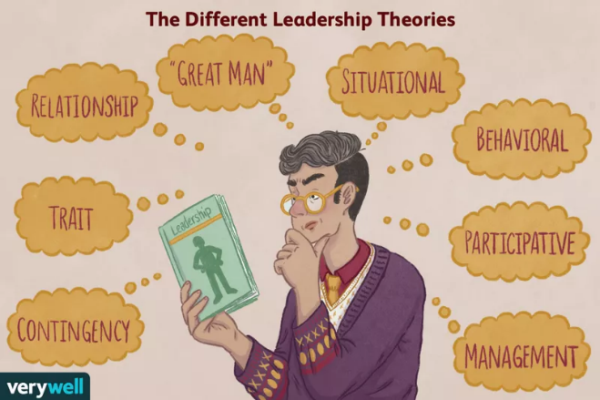
Sourced form (Cherry, 2019)

Leadership theories are descriptions of how and why individuals become leaders. The theories explain the characteristics and the behaviours that individuals can endorse to improve their own leadership skills.
- Management Theories – Focus on role of supervision, organization, and uses rewards and punishments. ​
- Relationship Theories – Also called “transformational leadership;” Focus on motivating and inspiring followers.​
- Great Man Theories – Leaders are born, not made.​
- Trait Theories – Certain traits make people better leaders, e.g., assertiveness, intelligence.
Reference ABOVE slides

Horner, (1997) said that Leadership is commonly defined by the traits, qualities, and behaviours of a leader. Implying that certain characteristics and qualities define what a good leader should have. (Antonakis & House, 2014) said that leadership is important for motivating employees and assembling resources towards the achievement of the organization's goals, they said it is also necessary for organizational change and performance. They found that Studies show leadership is important to countries, organizations, and teams. This shows how the leadership role is important to the world in general, having strong leaders who understand their role and their team can enable them to get the results required while improving everyone’s development.

What are leadership models
Leadership models are theories and ideas on how to become an effective leader or a better leader. (Trastek et al., 2014) wrote a study about leadership within the health care sector, they concluded that models of leadership will change depending on the circumstances at the time, and in real time leaders will use a mix of leadership models to suit the situation. This study shows that leaders are willing to adapt and change their leadership style to meet the needs of their team and organization. (Avery & Ryan, 2002) study on how managers use situational Leadership within Australian workplace culture. They found that managers liked to use this model because it provides structure for managing employees, such as relevance, instinct, and judgement. They concluded that managers like the model because of how easy it is to understand and follow and because of its relevance to their role. This study shows that an organization can work with using just one leadership style. Situational leadership was used because of the simplicity and adaptability. These studies show that there is no right or wrong way to use leadership models, each leader has their own style of leading just as team members have their own way of learning.

2.3a Adair’s Action Centred Leadership
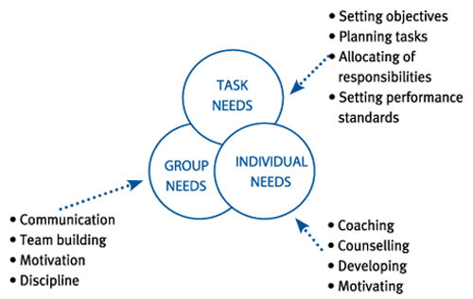
Sourced From (Kaplan Financial Limited, 2012)
Action Centred Leadership Model was designed and published by John Adair in 1973. The model spotlights the fundamental actions that you must take to effectively lead your team. The model is easy to use, can be used at any level and in any industry, it involves, taking action and leading by example. Adair claims that leaders are responsible for three functions that are represented by the three circles that overlap.
- Achieve the task
- Build and maintain the team
- Develop the individual
The reason the three circles overlap is because they are dependent on one another. An individual requires a task, a task requires a team, and the team will only achieve the task if the individuals are at full capacity personally and professionally.
Sourced from (Northamptonshire Chamber, 2022)
(Braun et al., 2012) concluded that Adair’s Action-Centred Leadership can have an effective impact on team members and a project team environment. The environment the team works in encourages the team to talk to each other, which provides a platform for collaboration and self-learning. Meaning that Adair’s model has a positive influence on the individual team members and the team. Ensuring the environment is a happy, healthy, and functional, gives the individuals and team confidence to communicate more effectively, which can be a beneficial to both organisation and individual. (Odhiambo, 2014) said that the Adair model can be a helpful tool when thinking about effective leadership and what it means in connection to being a leader. The leader executes the functions and shows the behaviours portrayed by the three circles. This shows the model can be used as a development tool for leaders to improve on their own skills and knowledge. They believe an effective leader will be able to follow the model in order; Task, Team and individual and be able to adapt at each section.

2.3b Hersey- Blanchard Situational Leadership Theory
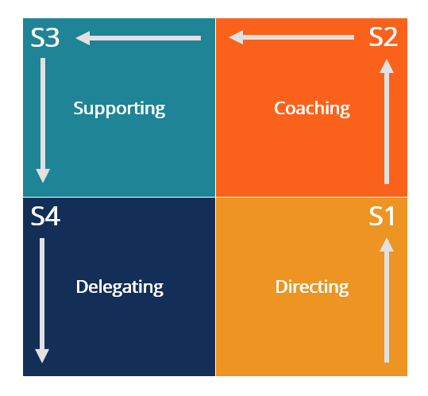
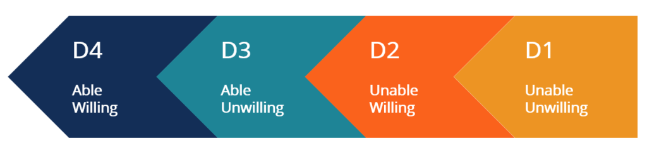
Sourced from (Corporate Finance Institute, 2015)
The Hersey-Blanchard Model was designed by Paul Hersey and Ken Blanchard in the late 1960’s, the model proposes that no sole leadership style is better than any other, and leaders adapt their styles to fit the individual team members ability and willingness to work. The model's leadership styles are directly related to the different maturity levels of followers or employees
The model uses a diagram to categorize employees (also known as ‘Followers’) based on their knowledge and experience.
- Unable and Unwilling (D1) – Employees are unable to finish their work because they don’t have the necessary skills, they lack motivation and confidence in themselves.
- Unable and unwilling (D2) – Employees are unable to finish their work, typically due to limited skills and lack of experience. Yet they are willing to give it a try. It shows employees are willing but don’t have the correct knowledge and experience.
- Able and Unwilling (D3) – Employees have the knowledge and experience to complete their task but are unwilling to. It can be chalked up to no confidence in their own skills or no motivation to follow their leader.
- Able and Willing (D4) – Employees have the skills, knowledge, experience, and confidence to complete their work successfully, and take responsibility for the work they competed.
Sourced from (Corporate Finance Institute, 2015)
Hersey and Blanchard’s model has four types of leadership styles. The styles are based on tasks and relationships that leaders participate in, in the workplace. The following are styles of leadership managers can use.
- Delegating style: Is a low-task, low-relationship style. The leader will allow the team to take responsibility for task decisions. This style is best used with high maturity employee/followers.
- Participating style: Is a low-task, high-relationship style that highlights the sharing of ideas and decisions. Leaders can use this style with moderate followers who are knowledgeable and experienced but doesn’t have the confidence to complete the tasks assigned.
- Selling style: Is a high-task, high-relationship style in which the leader attempts to sell their ideas to the team. Explaining task directions in an effective way. Leaders use this style with moderate followers. Different from the previous style, these employees have the ability and confidence, they but are unwilling to do the job.
- Telling style: Is a high-task, low-relationship style. The leader gives direct and clear directions and oversees the work closely. This style is for low maturity followers.
Hersey and Blanchard’s model suggests no single leadership style is better than another. Leader’s must adjust and adapt their style to fit those the lead. The model proposes successful Leadership is both task-relevant and relationship-relevant. (Tortorella & Fogliatto, 2017) said that situational leadership gives means to effectively change a leader’s working style, through strong communication and cooperation to increase productivity. This implies that having strong relationships with your team enables them to feel confident which opens a line of communication and support. However (Thompson & Vecchio, 2009) study found several criticisms with the situational leadership theory, one criticism is the uncertainty around the speculative definition of employee development level, another is its lack of clear empirical support. (Thompson & Glasø, 2015) Study on ambiguity surrounding "follower competence and commitment" found that individual relationships may happen quickly, with employee’s gaining confidence and knowledge in completing tasks within a few short months. Leaders should be mindful of this and be careful to changes in their employees and adapt accordingly by developing their efforts to choose the best and most effective leadership style. This shows that leaders following the situational leadership style create good relationships with their employees, however if this is not monitored issues can arise. A leader must be aware of their employee’s development and always stay on top, if an employee surpasses all expectations and its not noticed by the leader, the organization may lose a potential future leader.
The next part of this report will look at leadership styles and how to identify them.

3.0 Evaluate own ability to use a range of leadership styles, in different situations and with different types of people, to fulfil the leadership role
There are many leadership styles available that leaders may identify with, being able to identify an individual’s own leadership style can help them in their professional development. Student A and student B completed two Leadership style questionnaires found on the internet, neither knew what type of style they had, and both found completing them beneficial to their roles.

3.1 What are leadership styles
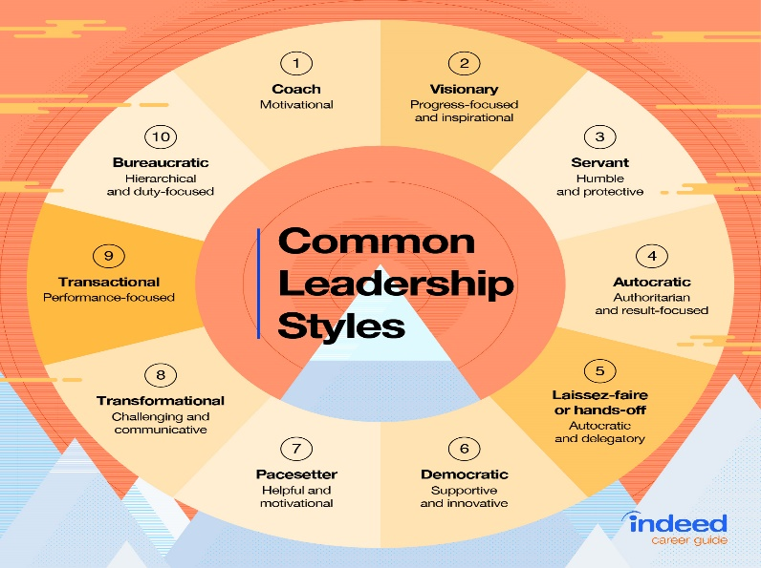
Sourced from (Indeed Editorial Team, 2021)
Leadership styles are a leaders’ approach of putting plans in action, helping with direction and motivating team members towards the organisational goals. Yahaya & Ebrahim, (2016) said that leaderships styles have been an important subject in the development of management, with leadership style being a influence on team members within an organisation. Some examples of Leaderships styles are below.
- Coach – Can recognise the strengths and weaknesses of their team and help them set goals while giving them constant feedback.
- Visionary – will lead by inspiring and giving confidence to their team.
- Servant – will help their team feel fulfilled
- Autocratic or Authoritarian – will focus on results, with little or no input from their team.
- Laissez- faire or hands off – will delegate all tasks to their team with giving support.
- Democratic – will take their teams input before making decisions
- Pacesetter – will focus on performance while setting high standards for their team.
- Transformational – is like the coaching style, gives clear information, sets goals, and motivates their team.
- Transactional – will have focus on performance like the pacesetter style, using incentives to help achieve their goals.
Sourced from (Indeed Editorial Team, 2021b) and (Indeed Editorial Team, 2021)
(Kanika et al., 2018) said that leadership is a social effect where a leader gains the trust and engagement of their team to enable them to reach organisational goals, meaning the actions of leaders within an organisation can make an impact on relationships with their employees which can improve morale, productivity, and revenue. (Hassi, 2018) study found that employee job satisfaction, commitment, and organisational citizenship behaviour was only influenced by the transformational leadership style. The study also indicates that personality and intellectual stimulation (transformational Leadership) and contingent reward and only involving managers on specific issues (transactional Leadership) did not submit notable results. Meaning that employees were influenced by leaders who guided and motivated them towards set goals. The study also indicated that they didn’t have any memorable results from leaders who had likeable personalities or a leader who encourages transformation and imagination, as well as critical thinking and problem-solving and incentivising. Which could look like there isn’t strong leadership in the organisation.

How does one identify their own leadership style, there are many ways to do that?
- Identify Personality Traits.
- Identify any Weaknesses.
- Ask For Feedback from your line manager.
- Complete Situational questionnaires.
The next section will use situational questionnaires to help identify leadership style, using student A and B as an example.

3.2 Identifying leadership styles
Having a basic understanding of leadership styles can help a leader identify their own and give feedback to team members that are potential leaders within an organisation to see what qualities they may possess. Many questionnaires are available to help identify leadership styles (Mind Tools, 2021), (Murphy, 2017) and Hersey- Blanchard Situational Leadership Style self-assessment.
Student A is a Team Leader in the hospitality industry and oversees approximately 25 team members, when asked what leadership style they have the student didn’t know. Student A was asked to complete two different leadership style questionnaires. The first questionnaire completed was Hersey- Blanchard Situational Leadership self-assessment see Appendix A, the results revealed that student A scored high in coaching, meaning High task focus and high relationship focus and facilitating, meaning Low task focus and high relationship focus, this shows that student A is very team orientated and believes maintaining relationships with them is a high priority, completing tasks is still a priority but not before the team. The second questionnaire was (Mind Tools, 2021) see Appendix B, the results revealed that student A had a ‘Democratic, participative Leadership’ style meaning this style of leader sets the desired goals, involves the team in discussions, but the overall decision is with the leader. This type of leader acknowledges the team for their input and includes them when suitable. Meaning that student A sets goals and makes all the decisions but includes and appreciates the team’s participation.
Student A agreed with the first questionnaire, they said that their relationship with the team is of high importance, they believe that a happy team helps create good results. Student A also agreed that tasks come second to the team. For example, if the housekeeping team were short staffed, student A would leave the tasks and go help the team by either entering rooms and stripping them down, enabling the team to take on extra work, or even cleaning rooms themselves. The student would then work overtime to finish tasks. This shows that student A does not have a good work life balance and would benefit with further researching other leadership styles to further their own development.
Student B is a business owner with their own café, and is responsible for 12 members of staff, most of them part time students. Student B has no idea what leadership style they had and felt like the were a mix. Student B completed the same questionnaires as Student A. Hersey- Blanchard Situational Leadership self-assessment see Appendix C. The results show that Student B is Telling (directing) had a high task focus, low relationship focus. Meaning that the tasks are more important to complete than maintaining relationships with their employees. The second questionnaire completed was (Mind Tools, 2021) see Appendix D. The results for Student B was ‘Authoritarian, autocratic Leadership’ style meaning their style of leading can be helpful when the team need to follow a set of processes exactly to meet the required goals. Meaning Student B is in charge, and every decision and plan will be theirs, some can see this style as a strict way of leading. This way can lead to poor relationships, which can affect commitment, productivity, and loyalty. Student B admits that they do tend to micromanage their employees and feel they need to be in complete control. For example, Student B will not let any staff member use the till and cash up and close the tills after every shift, which means that student B must work till finish every evening, and they don’t allow any decisions to be made by staff members everything has to be run by them. This can insinuate that student B has no trust in their staff members, this can cause huge issues for student B, for example staff turnover can be affected, productivity will be low, and costs will be high which could lead to a failure of the business.

4.0 Assess your own ability to set direction, motivate, delegate, and empower others to bring about a workplace change
Organizational leadership is responsible for setting direction for their team, creating a culture that everyone follows is essential for consistency, however with the times rapidly changing, it’s important for organizations to keep up, and this may include a complete change in processes. Understanding what can change in an organization will enable a leader to introduce changes successfully and effectively without any major problems, ensuring communication, motivation and empowerment is key factor.

4.1 Leaders setting direction

A leader must be able to set direction for their team, creating an environment that share purpose and behaviours. This means a leader must develop a vision of where the organization needs to go. (Quinn & Dalton, 2009) defined setting direction as the behaviours and actions leaders use to communicate the vision, goals and objectives connected with the introduction of sustainability in the workplace. By setting direction rather than giving direction, leaders can create more roads for creativity, diverse thinking, and commitment. (Solow & Szmerekovsky, 2013) said a leader that lacks the buy-in skills may not be able to convince their team to attain the decided goals, and leaders with strong Buy-in skills may lose the trust of their employees if goals are being regularly changed. This implies that leaders with poor skills of persuasion may not get the team motivated to complete the goals set, and even if they have strong persuasive skills they may overload their team with change after change, which can create conflict with the team that can lead to loss of trust from the team. So how does a leader motivate their team?

4.2 Culture of Change
The business world is ever changing and evolving, organizations need to adapt to new norms and business models on a regular basis to stay competitive, introducing new approaches that are needed to aid these changes effectively. Culture change acknowledges that values are still in place and looks to bring them in on the new vision. Helping to create a sense of belonging within the organisation by empowering employees to have input into the changing process. (Al-Ali et al., 2017) said that change is unavoidable, and that in modern times the rate of change is greater than ever. They said change management can be seen as a permanent feature of organizations, and a chance for organizations to improve their competitive edge, productivity, and profits. This can be seen as organizations inciting the changes or being made to accept the changes. This shows that change management is seen as a normal process within organizations, helping the leaders to continually keep up with the changes that happen in the world, and implying that the workforce are being forced to keep up with these changes, which may seem extreme however if the industry is fast paced constant changes are expected. (Farrell, 2018) said that organizational culture is an evasive notion and hard to understand, this is because each individual employee has their own strengths, weaknesses, perceptions, and characteristics that they bring to the workplace, all this can create an undetermined environment. They said that failure to understand and value culture within an organization will obstruct a leader’s capacity to lead effectively, and transformational change will be hard to implement. Meaning that culture within organizations is complex, different personalities, development needs and beliefs can be challenging for a leader to monitor and failure to do so can result in problems when change is implemented to reshape an organization. To help an organization transition change management more effectively Kurt Lewin’s theory of change would be a great tool.
Lewin’s Field Theory
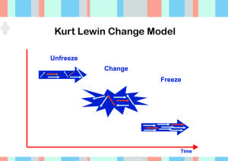
Sourced from (Morrison, 2014)
Kurt Lewin was a German professor and in the 1940s put forward his model of ‘Change Management’ that showed how organizations can adapt and deal with change. The Theory has 3 steps.
- Unfreeze – Before implementing any change within an organization it must start with Unfreezing. Employees will naturally resist change, so the unfreezing stage creates awareness that current processes are not working and to maintain advantage within the market, change is needed. Communication is important at this stage, ensuring the team is informed at every change will ensure motivation and cooperation.
- Change – The changing stage is also known as the ‘Transitioning Phase’ is when the change is implemented, during the changing stage people begin to learn, new behaviour’s, processes, and ways of thinking. Being prepared for this stage will make it easier to follow and complete. All through the process of change, employees should be regularly reminded of the reasons change was being implemented in the first place and how it will benefit them going forward.
- Freeze – The finial stage of the stage Freeze is when the changes have been fully implemented and accepted, so it’s refrozen as the new normal. This is important to prevent the team from reverting back to the ‘old’ ways of thinking or behaving. Organizations must ensure the change are not lost and is part of the daily culture of the organization. Reward and recognition can help reinforce the behaviours of the change.
(Burnes & Cooke, 2013) wrote that ‘Field Theory’ allows employees and teams to understand, and learn about themselves, and explore the world and those around it. Meaning the model is a successful tool for personal and professional development. The model can also be used by organizations to initiate a large-scale change. A case Study completed by Medley & Akan, (2008) examined the activities undertaken by a community-based organization to tackle the decline in client losses and funding. The study surveys an application of Kurt Lewin’s model to an assessment and the rewriting of processes used by the organization. The study concluded that non-profit organizations looking to reinforce their organizations or acknowledging the need for change can give advantage by integrating the Lewin model in the preplanning stage. This study shows that the model was successful in helping the organization undo the decline in clients and funding, whilst helping to fix other issues making the community-based organization more successful and long lasting.

4.3 Motivation
Motivational leaders make decisions, set goals, and ensure their team has the tools to empower them to achieve success towards organisational goals. Leaders need to know what their team needs, from supporting to guiding. For example, using ‘Maslow’s Hierarchy of Needs’ is a great tool to assess the team and see what they need.
Maslow Hierarchy of Needs
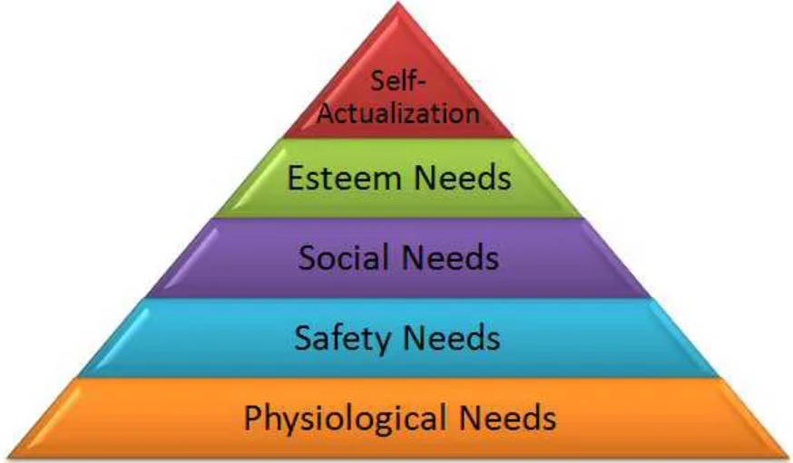
Sourced from (Does evidence support Maslow's Hierarchy of Needs, 2012)
Maslow’s Hierarchy of Needs was introduced to the world by Abraham Maslow in his 1943 paper, he described 5 factors of human needs as.
- Physiological Needs - the physiological needs relate to the preservation and survival of human life. These needs include food, clothing, air, water and other necessaries for life, these needs are primary needs.
- Safety Needs – After a team member has satisfied the physiological needs, they will need assurance of maintaining a given economic level. They want job security, personal security, financial security, insurance against risks or injury.
- Social Needs – Humans are generally interested in conversation, sociability, exchange of feelings and grievances, companionship, recognition, and belongingness.
- Esteem Needs - These needs welcomes such things as self-confidence, achievement, knowledge, and success, these boost the ego of a team member. They also feel the need to gain respect and appreciation from others.
- Self-actualization Needs - the final step is the need for self-fulfilment. It involves realizing team members potentials for continued self-development and for being creative. Once all needs have been met the next step would be personal achievement, doing something that challenges and exciting. The sense of achievement can give psychological satisfaction.
Sourced from (Cherry, 2022)
A study completed using ‘Maslow’s Hierarchy of Needs’ by Ștefan et al., (2020) aimed to analyse the motivation levels of employees in the Romanian healthcare system and attempt to assess the impact of gratifying the needs on performance and job satisfaction. The research results showed that Romanian health system employees are primarily motivated by meeting the needs of the higher level of the pyramid, particularly the need of self-actualization, and to a lesser measure by meeting the lower levels of the pyramid. This study shows that ‘Maslow’s Hierarchy of Needs’ can be used within an organization, the results of the study are positive toward to the model showing where employees see themselves on the pyramid will aid the organization in supporting and developing them, which will help increase job satisfaction, decrease staff turnover, and improve productivity. (Udechukwu, 2009) found Maslow’s theory was lacking in explaining the type of satisfaction which consider the types of needs, which push an individual’s type of behaviour, which conceives attitude. Maslow’s theory focuses on only the levels of need for an individual, and not the type of need the individual has. This implies the model doesn’t have the capacity to assess the types of needs people may have, which could cause problems when trying to take the steps required to reach self-actualization.

4.4 Delegation
Delegation refers to the transferring of responsibility for specific tasks from one person to person. From a management viewpoint, delegation occurs when a manager allocates specific tasks to their employees, which can help in their professional development.
Laissez- faire Leadership Style
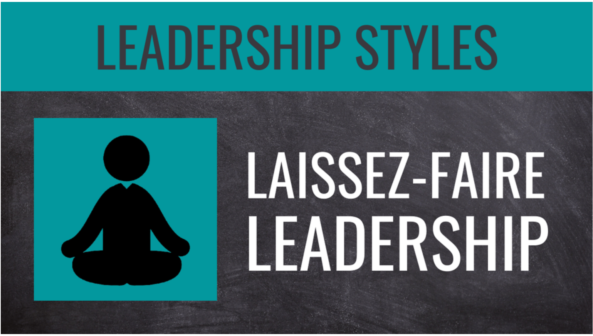
Sourced from (Sandling, 2014)
Laissez-faire leaders have a point of view of trust and reliance with their employees. They don't like to micromanage or get overly involved, they try not to give too much instruction or guidance. Rather, laissez-faire leaders give their employees time and space to use their creativity, methods, and experience to help them meet their set goals. Or can be seen as lazy on the leader’s behalf. (Wong & Giessner, 2016) said that in opposite to empowering leadership, leaders who follow laissez-faire leadership are broadly seen as unsuccessful and even damaging to employee performance. This implies that this style of leadership is not the best as employees don’t get to develop themselves, this can affect employee behaviours and create conflict amongst the team. (Yang, 2015) said that there are times that employees appreciate being left alone to manage their own workload. Leaders who lead with a hands-off approach can help their employees feel valued and autonomous, this is suggesting that leaders with limited involvement can be rewarded with high productivity and job satisfaction. This implies that allowing employees freedom to complete their tasks creates a trusting environment where employees can work without anyone over their shoulder checking their every move.

4.5 Empowerment
Empowerment can be considered a new management style for organizations to help promote new goals for personal development. It will help structure an employee's expectations and set achievable goals to attain their main intentions of their work. It will help an employee to take control of their job and use skills they have gained that they never knew they could use.
Servant Leadership
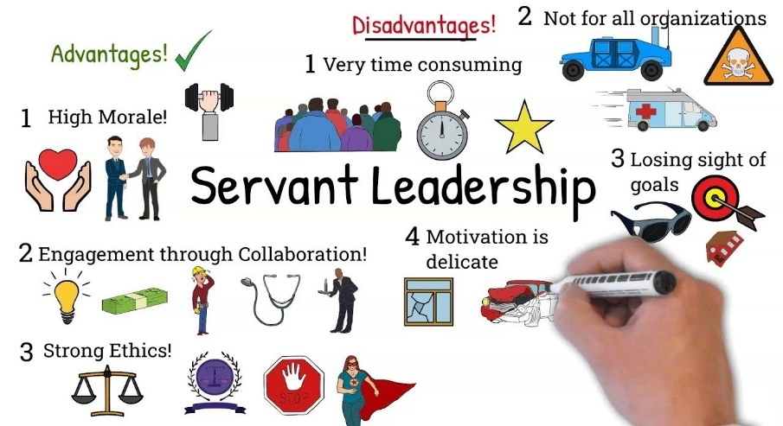
Sourced from (Leadershipahoy, 2020)

The servant leadership style is proposed on the idea that leaders prioritize serving the greater good. Leaders who use this style always serve their team and organization primarily. These types of leaders don't prioritize their own development needs or goals. Servant leadership looks to achieve a vision by strongly supporting their employees. (Van Dierendonck, 2011) said that a Servant leader is honestly concerned with serving their team members, while other leadership styles aim for the well-being of the organization. Showing that relationships are important in this style of leading, showing employees genuine interest can boost confidence and empower them in making decisions. (Gui et al., 2020) found that a lot of research in hospitality businesses has been conducted regarding the positive impact of servant leadership on employees, such as psychological capital, organizational commitment, job satisfaction work engagement service quality, and creativity. Again, showing that this style of leading can have a widespread positive impact on employees.

Conclusion
The research in this report found that no leadership style, theory, or model is the same, and with different organizations that have different values and beliefs, not all will agree on the same or due to different processes one maybe be better than the other. Understanding leadership styles and theories can help develop a leader’s professional career, and the professional careers of their employees. The second part of this report is identifying leadership styles Student A was all about their relationship with their employees, maybe they should try the Laissez- faire leadership style and let the team take charge. Student B had issues with trust, maybe they should research transformational leadership and take steps to show the team they are trusted. The final part of the report is about the role of a leader, setting direction, culture of change, motivation, delegation, and empowerment. The leader’s job is to ensure their team are up to date on all things work related, communication, encouragement, responsibility, and trust will ensure that an organization is successful.

References

Al-Ali, A. A., Singh, S. K., Al-Nahyan, M., & Sohal, A. S. (2017). Change management through leadership: the mediating role of organizational culture. International Journal of Organizational Analysis, 25(4), 723–739. https://doi.org/10.1108/ijoa-01-2017-1117
Antonakis, J., & House, R. J. (2014). Instrumental leadership: Measurement and extension of transformational–transactional leadership theory. The Leadership Quarterly, 25(4), 746–771. https://doi.org/10.1016/j.leaqua.2014.04.005
Arruda, W. (2016). 9 Differences Between Being A Leader And A Manager. Forbes. https://www.forbes.com/sites/williamarruda/2016/11/15/9-differences-between-being-a-leader-and-a-manager/?sh=61d7a8d84609
Avery, G. C., & Ryan, J. (2002). Applying situational leadership in Australia. Journal of Management Development, 21(4), 242–262. https://doi.org/10.1108/02621710210423784
Azad, N., Anderson, H. G., Brooks, A., Garza, O., O’Neil, C., Stutz, M. M., & Sobotka, J. L. (2017). Leadership and Management Are One and the Same. American Journal of Pharmaceutical Education, 81(6), 102. Ncbi. https://doi.org/10.5688/ajpe816102
Braun, F. C., Avital, M., & Martz, B. (2012). Action‐centered team leadership influences more than performance. Team Performance Management: An International Journal, 18(3/4), 176–195. https://doi.org/10.1108/13527591211241015
Burnes, B., & Cooke, B. (2013). Kurt Lewin’s Field Theory: A Review and Re-evaluation. International Journal of Management Reviews, 15(4), 408–425. https://doi.org/10.1111/j.1468-2370.2012.00348.x
Cherry, K. (2019, November 7). The Major Leadership Theories. Verywell Mind; Verywellmind. https://www.verywellmind.com/leadership-theories-2795323
Corporate Finance Institute. (2015). Hersey-Blanchard Model - Overview, Leadership Style, and Downsides. Corporate Finance Institute. https://corporatefinanceinstitute.com/resources/careers/soft-skills/hersey-blanchard-model/
Does evidence support Maslow's Hierarchy of Needs. (2012, January 25). Does evidence support Maslow’s Hierarchy of Needs? Psychology & Neuroscience Stack Exchange. https://psychology.stackexchange.com/questions/169/does-evidence-support-maslows-hierarchy-of-needs
Farrell, M. (2018). Leadership Reflections: Organizational Culture. Journal of Library Administration, 58(8), 861–872. https://doi.org/10.1080/01930826.2018.1516949
Gui, C., Zhang, P., Zou, R., & Ouyang, X. (2020). Servant leadership in hospitality: a meta-analytic review. Journal of Hospitality Marketing & Management, 30(4), 438–458. https://doi.org/10.1080/19368623.2021.1852641
Hassi, A. (2018). “You get what you appreciate.” International Journal of Organizational Analysis, 27(3). https://doi.org/10.1108/ijoa-08-2018-1506
Horner, M. (1997). Leadership theory: past, present and future. Team Performance Management: An International Journal, 3(4), 270–287. https://doi.org/10.1108/13527599710195402
Indeed Editorial Team. (2021, March 8). 10 Common Leadership Styles | Indeed.com. Indeed. https://www.indeed.com/career-advice/career-development/10-common-leadership-styles
Indeed Editorial Team. (2021b, June 9). Leadership Styles and Theories | Indeed.com. Indeed.com. https://www.indeed.com/career-advice/career-development/leadership-styles-and-theories
Kanika, G., Karan, R., Shubham, J., & Tushar, J. (2018). To identify the leadership orientation styles among management and engineering students. International Journal of Education and Management Studies, 9(2), 306–308.
Kaplan Financial Limited. (2012). Adair - Action-centred leadership. Default. https://kfknowledgebank.kaplan.co.uk/adair---action-centred-leadership-
Kippenberger, T. (2002). Leadership Styles. Capstone Pub. https://r1.vlereader.com/Reader?ean=9781841123585
Leadershipahoy. (2020). Servant Leadership! How to become a good servant leader? Is Servant Leadership the right choice? Www.youtube.com. https://www.youtube.com/watch?v=f1WWXyXFOkU
Medley, B. C., & Akan, O. H. (2008). Creating positive change in community organizations: A case for rediscovering Lewin. Nonprofit Management and Leadership, 18(4), 485–496. https://doi.org/10.1002/nml.199
Mind Tools. (2021). What’s Your Leadership Style? – Learn About the Strengths and Weaknesses of the Way You Like to Lead. Mindtools.com. https://www.mindtools.com/pages/article/leadership-style-quiz.htm
Morrison, M. (2014, July 7). Kurt Lewin change theory three step model – unfreeze, change, freeze. RapidBI; RapidBi. https://rapidbi.com/kurt-lewin-three-step-change-theory/
Murphy, M. (2017, March 30). Quiz: What’s Your Leadership Style? Leadership IQ. https://www.leadershipiq.com/blogs/leadershipiq/36533569-quiz-whats-your-leadership-style
Northamptonshire Chamber. (2022). John Adair’s Action-Centred Leadership Model | Northamptonshire Chamber. Www.northants-Chamber.co.uk. https://www.northants-chamber.co.uk/blog/john-adairs-action-centred-leadership-model
Odhiambo, G. (2014). The challenges and future of public higher education leadership in Kenya. Journal of Higher Education Policy and Management, 36(2), 183–195. https://doi.org/10.1080/1360080x.2014.884676
Postuła, A., & Majczyk, J. (2018). Managers and Leaders in Need of Entrepreneurial Competences. Entrepreneurial Business and Economics Review, 6(1), 91–103. https://doi.org/10.15678/eber.2018.060105
Prevodnik, M., & Biloslavo, R. (2009). Managers and Leaders in Organizations of a Post-transition Economy. Organizacija, 42(3). https://doi.org/10.2478/v10051-009-0006-1
Quinn, L., & Dalton, M. (2009). Leading for sustainability: implementing the tasks of leadership. Corporate Governance: The International Journal of Business in Society, 9(1), 21–38. https://doi.org/10.1108/14720700910936038
Solow, D., & Szmerekovsky, J. G. (2013). Setting leadership goals and getting those goals accomplished: insights from a mathematical model. Computational and Mathematical Organization Theory, 20(1), 36–51. https://doi.org/10.1007/s10588-013-9155-0
Ștefan, S. C., Popa, Ș. C., & Albu, C. F. (2020). Implications of Maslow’s Hierarchy of Needs Theory on Healthcare Employees’ Performance. Transylvanian Review of Administrative Sciences, 59 E, 124–143. https://doi.org/10.24193/tras.59e.7
Thompson, G., & Glasø, L. (2015). Situational leadership theory: a test from three perspectives. Leadership & Organization Development Journal, 36(5), 527–544. https://doi.org/10.1108/lodj-10-2013-0130
Toor, S.-R., & Ofori, G. (2008). Leadership versus Management: How They Are Different, and Why. Leadership and Management in Engineering, 8(2), 61–71. https://doi.org/10.1061/(asce)1532-6748(2008)8:2(61)
Tortorella, G., & Fogliatto, F. (2017). Implementation of lean manufacturing and situational leadership styles. Leadership & Organization Development Journal, 38(7), 946–968. https://doi.org/10.1108/lodj-07-2016-0165
Trastek, V. F., Hamilton, N. W., & Niles, E. E. (2014). Leadership Models in Health Care—A Case for Servant Leadership. Mayo Clinic Proceedings, 89(3), 374–381. https://doi.org/10.1016/j.mayocp.2013.10.012
Udechukwu, I. I. (2009). Correctional Officer Turnover: Of Maslow’s Needs Hierarchy and Herzberg’s Motivation Theory. Public Personnel Management, 38(2), 69–82. https://doi.org/10.1177/009102600903800205
Van Dierendonck, D. (2011). Servant Leadership: A Review and Synthesis. Journal of Management, 37(4), 1228–1261. https://doi.org/10.1177/0149206310380462
Wong, S. I., & Giessner, S. R. (2016). The Thin Line Between Empowering and Laissez-Faire Leadership: An Expectancy-Match Perspective. Journal of Management, 44(2), 757–783. https://doi.org/10.1177/0149206315574597
Yahaya, R., & Ebrahim, F. (2016). Leadership styles and organizational commitment: literature review. Journal of Management Development, 35(2), 190–216. https://doi.org/10.1108/jmd-01-2015-0004
Yang, I. (2015). Positive effects of laissez-faire leadership: - ProQuest. Www.proquest.com. https://www.proquest.com/docview/1724864650?accountid=130472

Appendix A

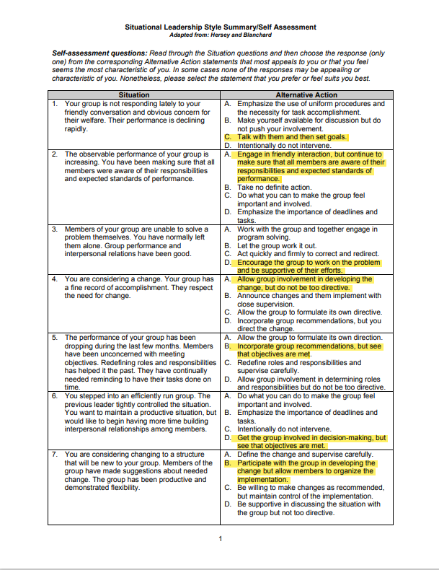

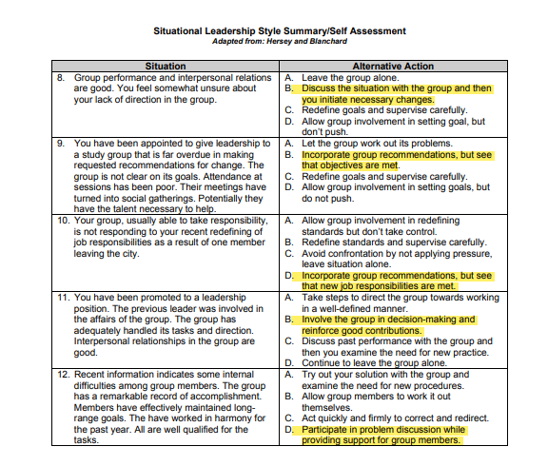

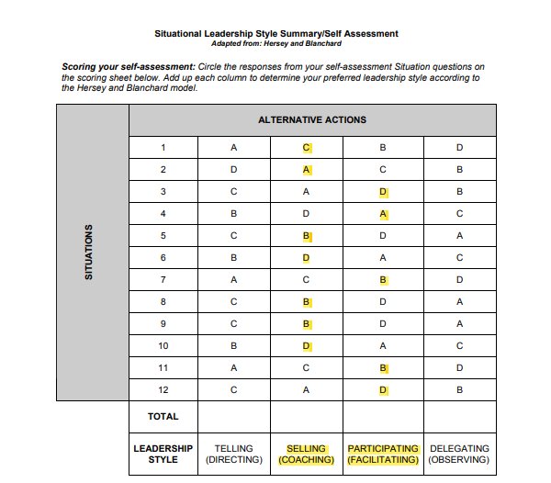
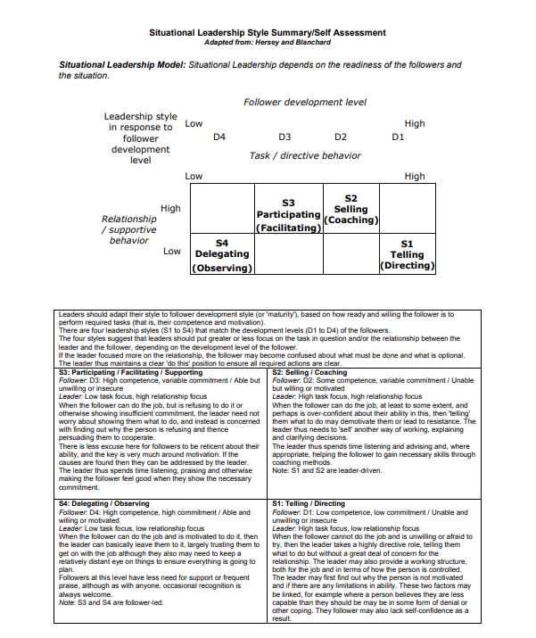

Appendix B
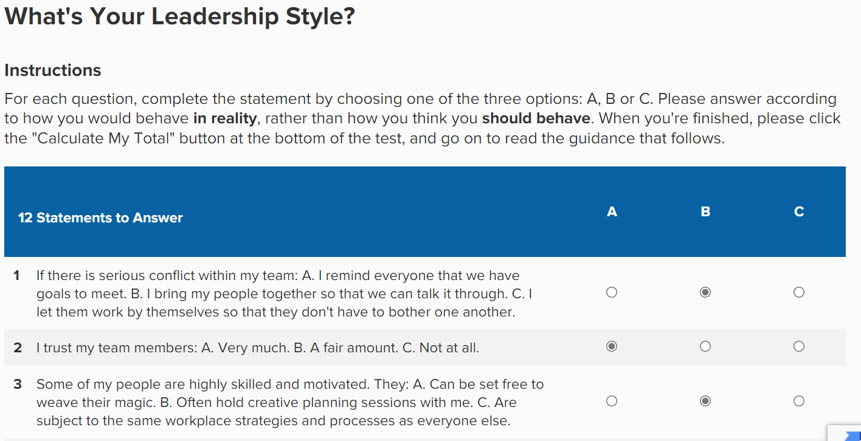
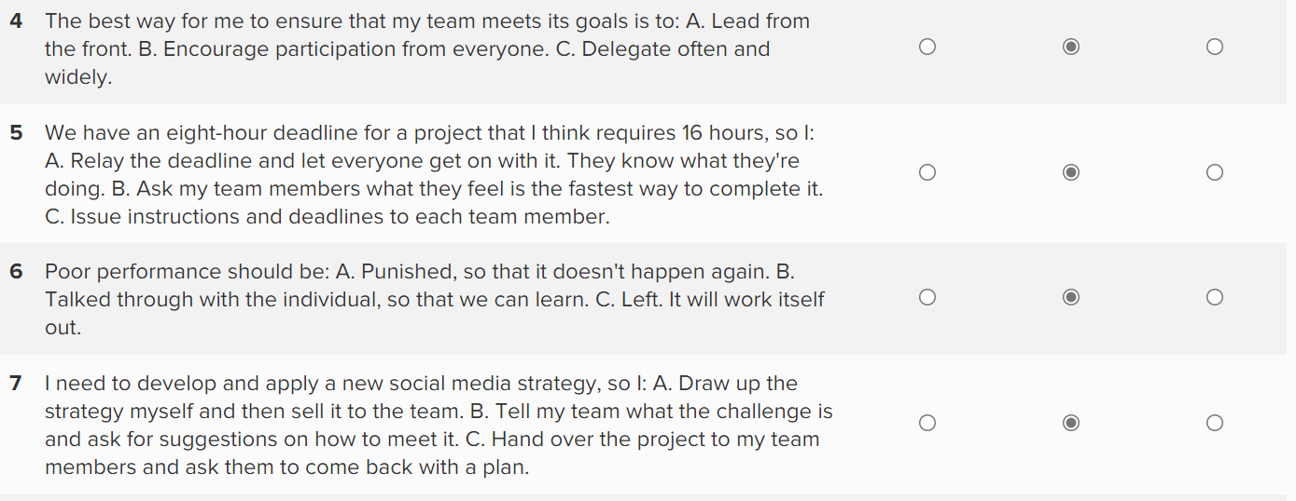
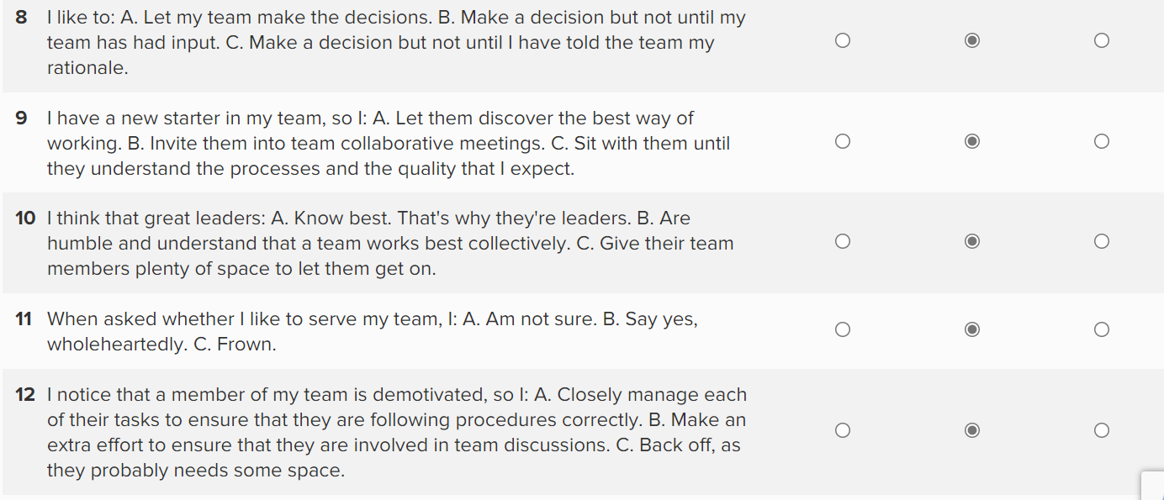

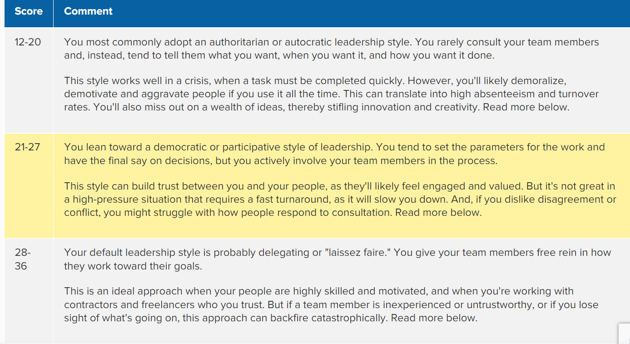
RESULTS –
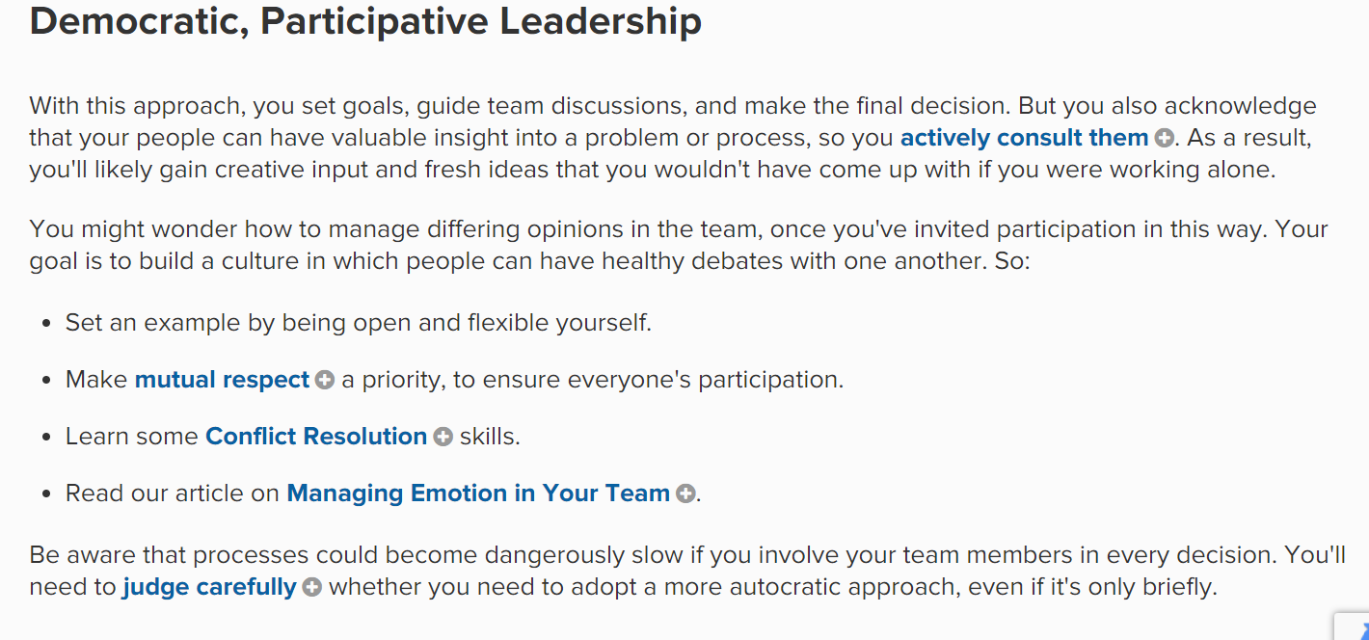
Sourced from (Mind Tools, 2021)

Appendix C
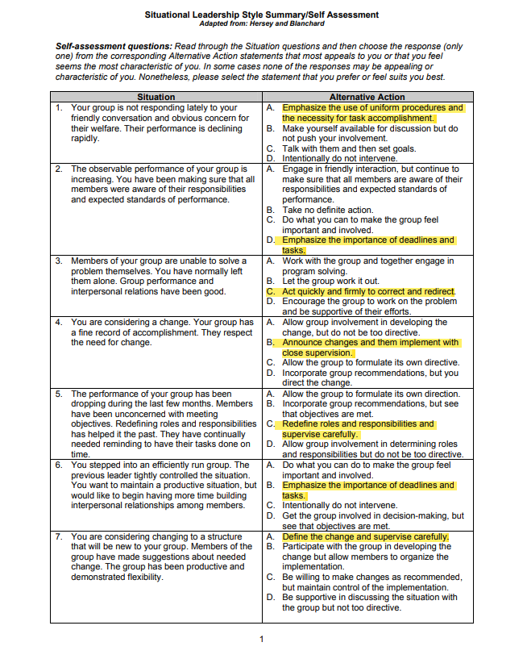
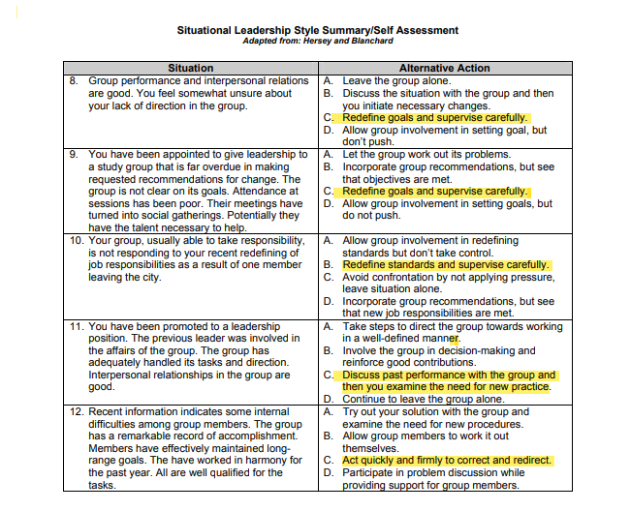
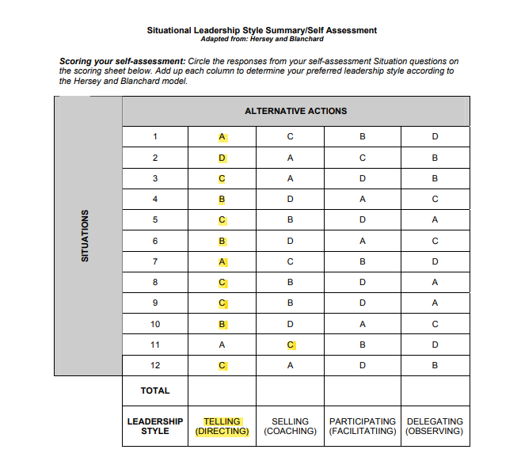
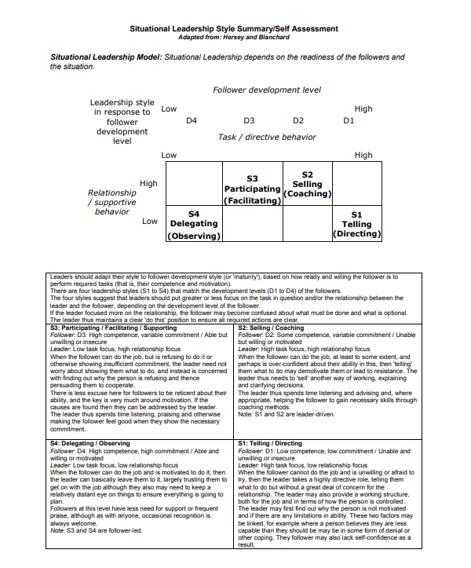

Appendix E


