

Student name: Flor de Maria Killick
Student ID: 2124309

Module name: Introduction to Physiology
Module code: BMHP5003
Lecturer name: Olusegun Awolaran

Assessment: Component 2

Topic: Cirrhosis of the Liver
Table of Content
Introduction……………………………….... Page 3
Anatomy and Physiology………………… Page 4
Health and Lifestyle routine measures…. Page 7
Health and Social Care practice…………. Page 9
Recommendations………………………… Page 12
Conclusion…………………………………. Page 14
References…………………………………. Page 15

- Introduction
Cirrhosis is a liver disease that develops over time, usually due to chronic liver injury, which causes the appearance of liver fibrosis. Fibrosis disrupts all liver functions and results in structural changes that lead to portal hypertension. This disease is initially asymptomatic until cirrhosis develops, and the more common complications of this disease are portal hypertension and intestinal microbial translocation in cirrhotic patients, which can lead to spontaneous bacterial peritonitis and hepatic encephalopathy. (Poordad, 2015). Cirrhosis is an advanced stage of liver disease caused by years of alcohol consumption. It is also caused by hepatitis B and C, non-alcoholic fatty liver disease, autoimmune hepatitis, inflammation of the gallbladder, some hereditary conditions, and the long-term use of certain medications. (NHS, 2020). In the United Kingdom, liver cirrhosis is still common; in 2019, 18,047 men and 11,596 women per 100,000 UK population had liver cirrhosis or another chronic liver disease, but men have a much higher rate of this disease. (Stewart, 2021).

Normal liver
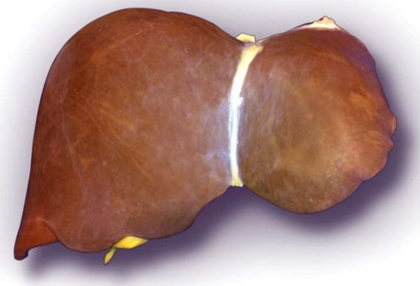

(AASLD, 2013)

Liver cirrhosis
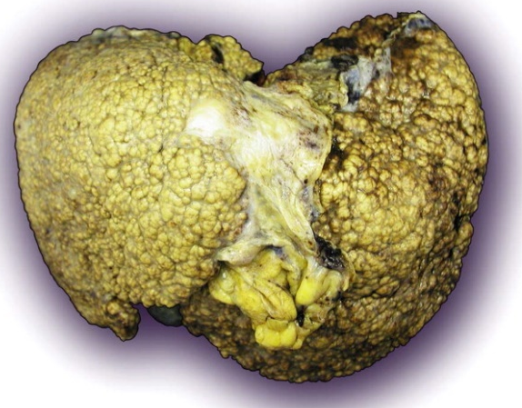

(AASLD, 2013)

- Liver Anatomy
The liver is a dark reddish-brown organ weighing 1.36 kilograms and conical in shape. It is in the upper right part of the abdomen, above the stomach and below the diaphragm, near the intestines, and the tip of the cone runs down to the right kidney. The liver is one of the largest organs in the body, occupying most of the abdominal cavity. Furthermore, the liver is divided into two large lobes, each of which has eight segments, and these have 1,000 smaller lobes. (Johns Hopkins Medicine, 2023). The liver is made of soft epithelial tissue and is surrounded by a connective tissue capsule. The peritoneum of the abdominal cavity lines and reinforces this capsule, which helps protect and retain the liver in the abdomen. (Innerbody, 2019). Hepatocytes are the most abundant liver cells, accounting for 90% of all liver cells; all these cells are similar and are organised into groups called lobules. Those cells have various functions, but each of them performs different jobs in the liver. Each lobe revolves around a central vein, and strips of hepatocytes extend from this central vein like the spokes of a wheel. On the outside of each lobe, both the portal vein and the hepatic artery have branches. (The Hepatitis C Trust, 2023).
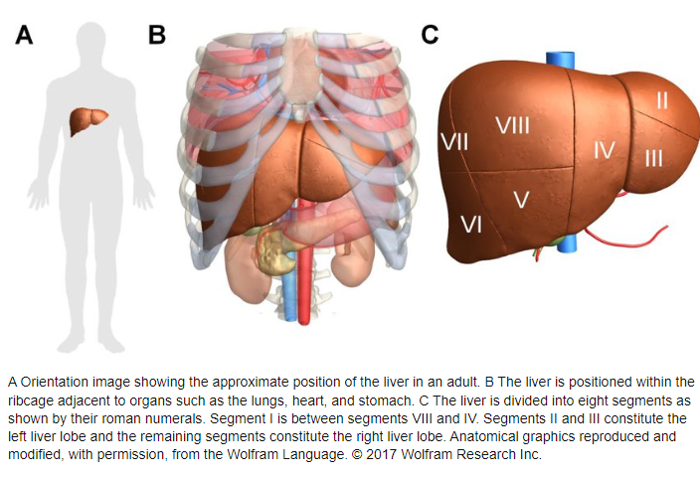

(ResearchGate, 2023)

Anterior and posterior of the Liver
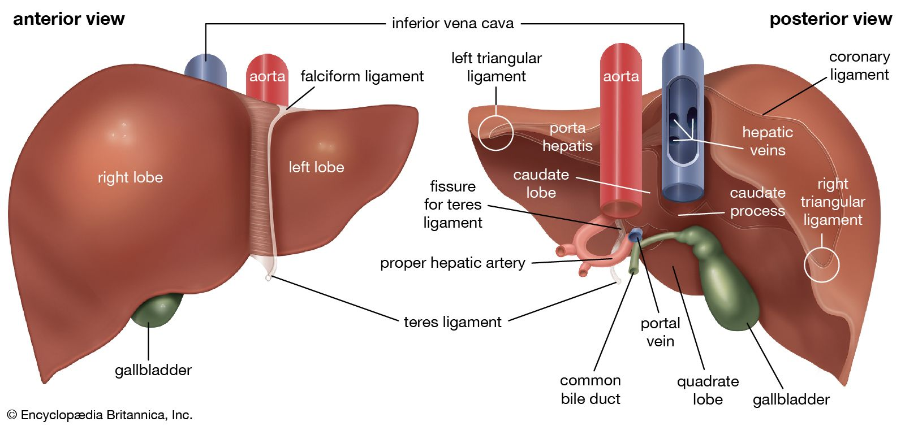

(Britannica, 2023)

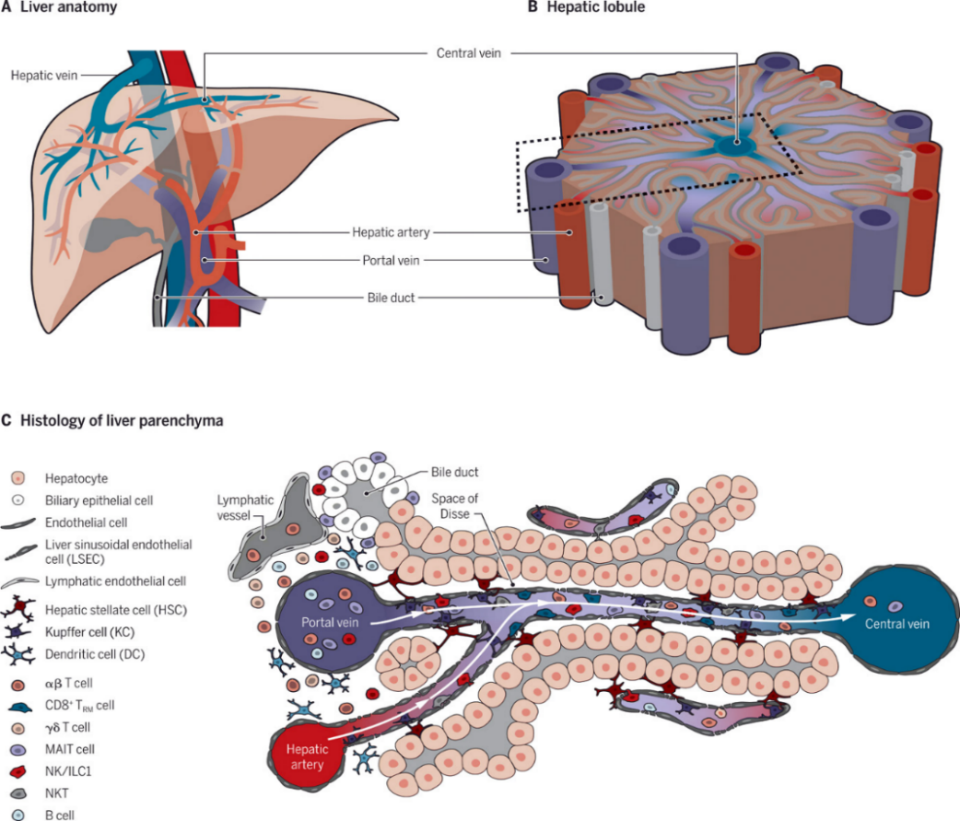
Inside the liver

(Science Immunology, 2020)

  - Physiology of the Liver
The liver has more than 500 vital functions to keep the body healthy, including the production of albumin proteins, which ensure that fluids from the bloodstream do not leak into surrounding tissue, and the transport of hormones, vitamins, and enzymes throughout the body. In addition, the liver produces bile fluid, which is used in the small intestine for fat digestion and absorption. It also filters blood as it travels from the stomach and intestines to the liver, removing toxins and other potentially harmful substances. It regulates amino acid levels in the bloodstream, as well as blood clotting and infection resistance, by removing bacteria from the bloodstream during filtration. (Columbia Surgery, 2023). The liver is supplied by the portal vein and the hepatic artery. As a result, significant amounts of nutrients reach the liver, providing the materials and energy necessary for the synthesis and processing of glucose, protein, and fat. It is also a vital location for the destruction and removal of exogenous drugs. The liver also serves as a storage organ for the hematologic and endocrine systems. (Yang, 2020).

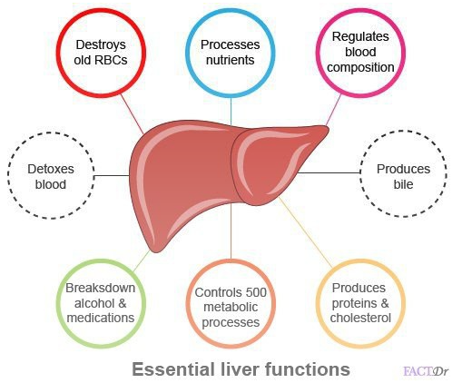

(Schilling, 2023)

- Health and Lifestyle routine measures
  - NHS Health lifestyle
The patient is a 40-year-old self-employed British man who does not participate in sports and has smoked 10 cigarettes per day for the past 20 years. He consumes at least 15 cans of beer per week, but neither of his parents suffers from cirrhosis. The patient is concerned because he is experiencing pain on the right side of his abdomen, but he continues to spend most of his time drunk. His friends have advised him to stop drinking on numerous occasions, but he refuses. (NHS Health Check, 2023).
Statistics
Liver disease in the UK is the leading cause of death among people aged 35–49. Deaths from liver disease have increased by 400% since 1970. This disease is the third-leading cause of premature death in the UK. (British Liver Trust, 2023).
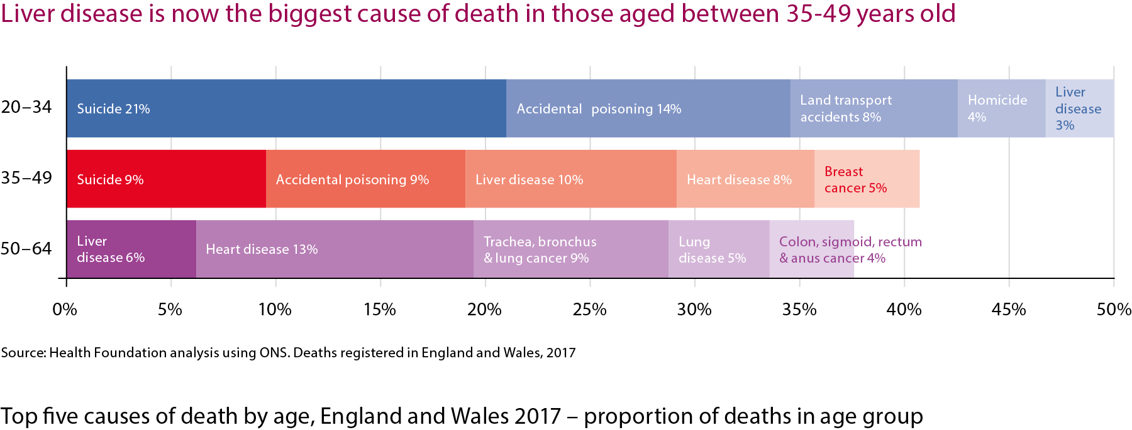

(BritishLiver Trust, 2023)

3.2. Healthy lifestyle diet
The patient also has a poor lifestyle; for example, he does not eat breakfast and does not eat five fruits or vegetables per day. He only eats saturated fats, consumes far too many starchy foods, consumes far too much sugar, and salts his meals. Furthermore, he consumes a lot of alcohol and does not drink two litres of water per day. (UWTSD, 2023).
3.3. Health Risks
Unhealthy habits and lifestyles, such as alcohol consumption, contribute to the prevalence of liver cirrhosis in the population. As a result, alcohol is the main cause of this disease, and fatty liver disease causes liver cirrhosis; 63% of UK adults are classified as overweight or obese. In addition, liver cancer is another disease of the liver. (British Liver Trust, 2023). Cirrhosis is also caused by viral hepatitis, of which there are three types: acute hepatitis A, which does not cause cirrhosis, and hepatitis B and C, which are chronic and cause liver infection. There is a vaccine available for hepatitis A and B, but not for hepatitis C. (New York State, 2023). Medications such as anabolic steroids taken by athletes and the dependent use of acetaminophen can cause liver damage. Also, excess cholesterol in the body can lead to non-alcoholic fatty liver disease. Diabetes type 2, according to the Mayo Clinic, increases the risk of developing non-alcoholic liver problems. A family history of liver problems increases the chance of some family members developing this disease. (Frank, 2020).

- Health and Social Care practice
The British Liver Trust has launched a national campaign called "Love your liver!" to raise awareness about liver health and provide people with the tools they need to keep their livers healthy. The organisation provides information, support, and a free online evaluation to anyone suffering from or seeking advice on prevention. So, the objective of this campaign will be to educate people on how to prevent the disease; for example, 9 out of 10 cases could be avoided. In addition, they will allow people to have the opportunity to participate in the campaign so they can advise other people on how to take care of their liver. Throughout the campaign, educational materials on how to start taking care of the liver will be distributed. For starters, alcohol should be avoided or consumed in moderation, as excessive consumption causes liver damage. As a result, men and women must limit their weekly alcohol intake to 14 units. Give your liver regular rest by abstaining from alcohol two to three days a week. The graph below contains information on how to start reducing your alcohol intake. We must consume a balanced diet and engage in sports or other activities to avoid getting a fatty liver. To lower the chance of having this condition, we must maintain a healthy weight. Below, you can some graphics detailing how to lower risk by eating a healthy, balanced diet. (British Liver Trust, 2018).
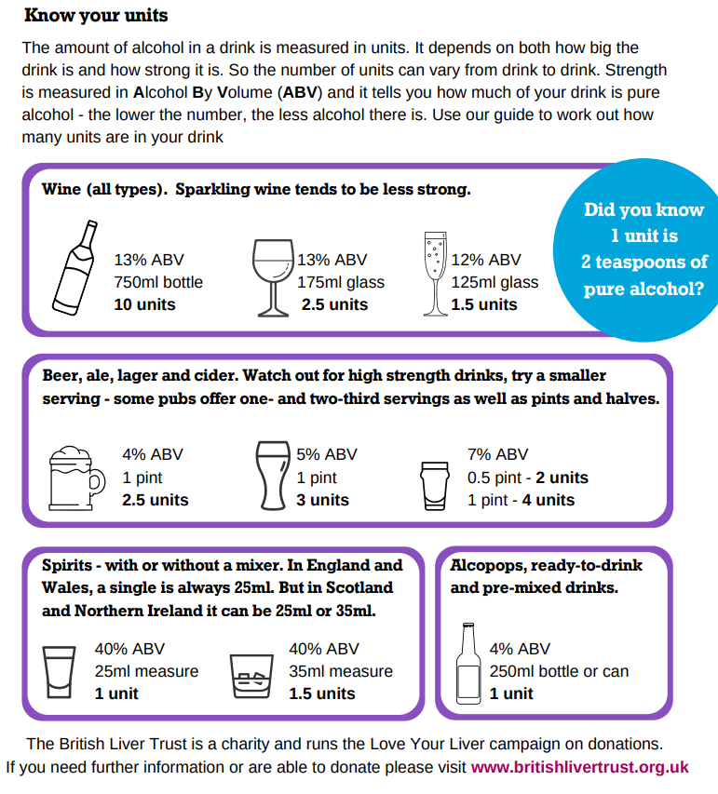

(British Liver Trust, 2018)
Eating well for a healthy liver
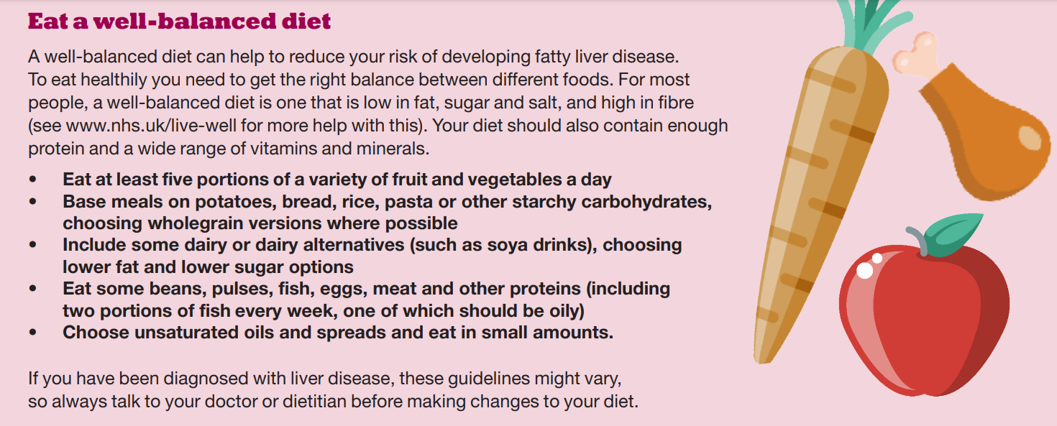

(British Liver Trust, 2018)
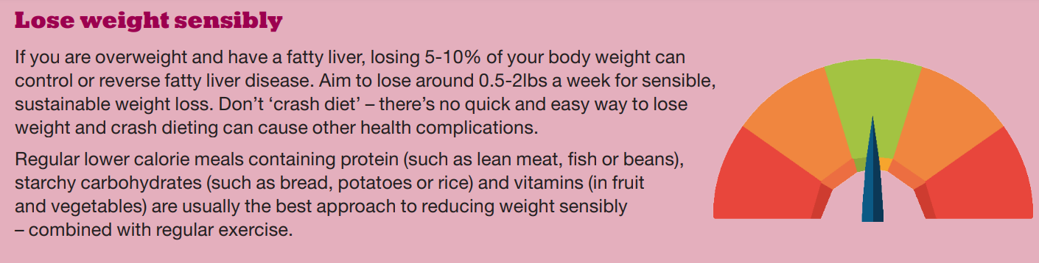

(British Liver Trust, 2018)
The campaign is for the public, but especially for people who want more information about the health of their liver or who are concerned about the risk of developing liver disease. The British Liver Trust also organises the "Love Your Liver Roadshow,", which tours England, Northern Ireland, Scotland, and Wales to help people learn about the health of their livers. They perform free liver scans with a non-invasive Fibro Scan device, performed by liver specialist nurses. They also have the advice of expert health professionals. (British Liver Trust, 2023).
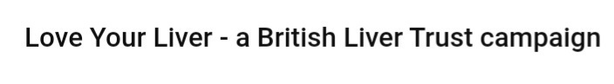

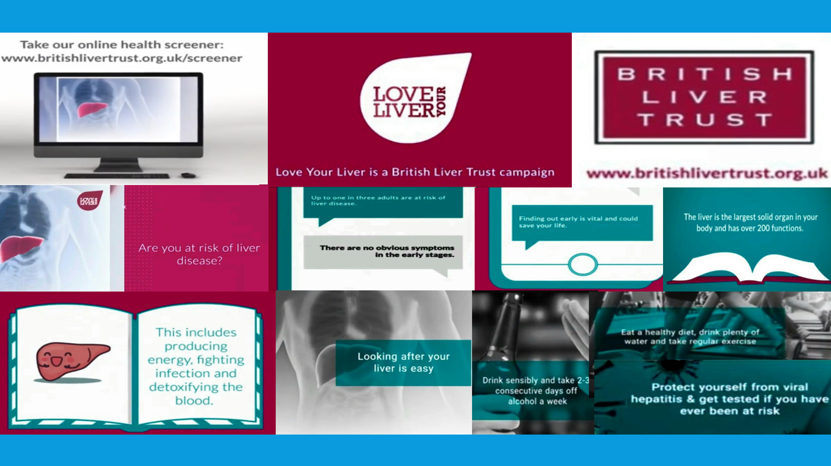

(British Liver Trust, 2018)

- Recommendations
To eat healthily, it is necessary to achieve the right balance between different foods. The Eatwell Guide, developed by Public Health England, is below. It will give you an idea of how much you should eat from each food group to maintain a good balance. For example, starchy foods should make up about a third of the meal we eat, as should fruits and vegetables. (British Liver Trust 2017)
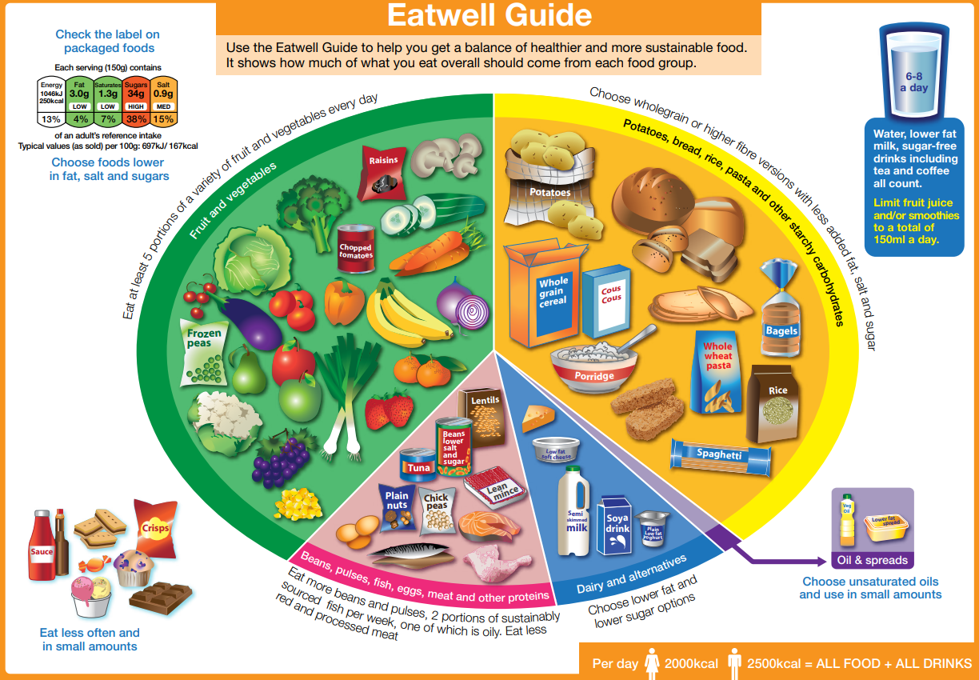

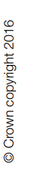

(British Liver Trust 2017)

Cirrhosis patients must modify their lifestyle to maintain their health and reduce the risk of developing new diseases. These are some examples:
- Quit smoking.
- Avoid drinking alcohol completely, as it hastens the progression of the condition.
- Exercises will help you recover from muscle loss and will also help you lose weight.
- To reduce your chances of contracting an infection, practise good hygiene.
- Consult your doctor about annual flu shots or travel vaccinations.
- If you are taking prescription or over-the-counter medications, you should consult your doctor or pharmacist because liver disease can affect how your body processes some medications.
Dietary modifications
- Eat a healthy balanced diet rich in fruits and vegetables to get all the nutrients.
- Eating a little salt in your diet will help reduce fluid buildup in your legs, feet, and abdomen.
- Increase the consumption of calories and protein.
- Eating small, nutritious snacks between meals (3–4 servings per day instead of 1-2 large meals) may be beneficial. (NHS, 2020).
Other recommendations
- People should never share razors, nail clippers, or toothbrushes.
- Cover wounds when playing sports.
- Use only licensed tattoo and piercing studios.
- Use condoms during sex. (British Liver Trust, 2018).

- Conclusion
This report has greatly improved my understanding of the liver disease. Now I know where the liver is and what its functions are. People who lead an unhealthy lifestyle can develop life-threatening cirrhosis of the liver. However, thanks to the non-profit British Liver Trust, which campaigns to prevent and diagnose liver disease, the rate of the disease is falling. Also, if people follow the recommendations, they can live a higher-quality life.

- References

- National Health Service (2020) Cirrhosis. Available at: https://www.nhs.uk/conditions/cirrhosis/ (Accessed: 15 April 2023).
- Johns Hopkins Medicine (n.d) Liver: Anatomy and Functions. Available at: https://www.hopkinsmedicine.org/health/conditions-and-diseases/liver-anatomy-and-functions (Accessed: 14 April 2023).
- Innerbody (2019) Liver. Available at: https://www.innerbody.com/image_digeov/card10-new2.html (Accessed: 01 April 2023).
- Fred, P. (2015) “Presentation and complications associated with cirrhosis of the liver”, Current Medical Research and Opinion, 31(5), pp.925–937. Available at: https://www.tandfonline.com/doi/abs/10.1185/03007995.2015.1021905
- Lucy, Yang. (2020) "Anatomy and Physiology of the Liver", Anesthesia for Hepatico-Pancreatic-Biliary Surgery and Transplantation, pp.15–40. Available at: https://link.springer.com/chapter/10.1007/978-3-030-51331-3_2#citeas
- British Liver Trust (n.d.) Statistics. Available at:https://britishlivertrust.org.uk/about-us/media-centre/statistics/ (Accessed: 02 April 2023).
- Damon, F. (2020) "Lifestyle Choices That Might Put You at Risk for Liver Disease", Walk-in-Lab blog, 9 November. Available at: https://www.walkinlab.com/blog/lifestyle-choices-might-put-risk-liver-disease/ (Accessed: 3 April 2023).
- British Liver Trust (n.d.) Love Your Liver. Available at: https://britishlivertrust.org.uk/information-and-support/love-your-liver/ (Accessed 5 Apr. 2023).
- British Liver Trust (n.d.) Love Your Liver roadshow. Available at: https://britishlivertrust.org.uk/information-and-support/love-your-liver/roadshow/ (Accessed 5 April 2023).
- National health service (2020) Treatment-Cirrhosis. Available at: https://www.nhs.uk/conditions/cirrhosis/treatment/ (Accessed 6 Apr. 2023).
- Columbia Surgery (n.d.) Center for Liver Disease and Transplantation. Available at: https://columbiasurgery.org/liver/liver-and-its-functions (Accessed 16 April 2023).
- The Hepatitis C Trust (n.d.) Inside the liver, Hepatocytes. Available at: http://hepctrust.org.uk/information/liver/inside-liver (Accessed 16 April 2023).
- Conor, S. (2021) Prevalence of cirrhosis and other chronic liver diseases in the United Kingdom from 2000 to 2019, by gender. Available at: https://www.statista.com/statistics/1036415/prevalence-of-cirrhosis-in-the-uk-by-gender/#:~:text=In%202019%2C%20approximately%2018%2C047%20men,a%20lot%20higher%20in%20males (Accessed: 16 April 2023).
- New York State (2023) Viral Hepatitis. Available at: https://www.health.ny.gov/diseases/communicable/hepatitis/#:~:text=Hepatitis%20A%20is%20an%20acute,not%20one%20for%20hepatitis%20C (Accessed: 19 April 2023).
- British Liver Trust (2018). Love Your Liver - a British Liver Trust campaign. Available at: https://www.youtube.com/watch?v=Evm-3BPRobA&t=3s (Accessed 6 April 2023).

