George Welham
Student number: 2140225

Workshop Skills for electronics- assessment logbook
ACDA4022

Contents
Figures 2
Tables 2
Introduction 3
Schematic of Amplifier drawing in Proteus 3
Simulation of the amplifier circuit in Proteus 4
Simulated Bandwidth 5
PCB Design 6
Breadboard Prototype 7
Nodal Analysis 7
Breadboard Plan 7
Breadboard 9
Breadboard Measurements 10
Breadboard Test configuration 10
Breadboard Results 11
Breadboard Bandwidth 13
PCB Component Population and Soldering 14
PCB Measurements 15
PCB Bandwidth 16
Simulated, Breadboard and PCB Gain Compared 17
References 18

Figures
Figure 1 non-inverting amplifier in Proteus schematic capture window. The circuit design is specified in the assessment instructions. Simulation virtual instruments have been added, such as a signal generator (seen left) and an oscilloscope (seen right). 3
Figure 2 Graph of Simulated Gain of Non-inverting Amplifier Circuit with varying Input Signal Frequency 5
Figure 3 Cropped Screenshot of Schematic of Non-inverting Amplifier within Easy-PC 6
Figure 4 Images of the PCB created in Easy-PC. Left is the top copper and top silk. Right is the Bottom copper. 7
Figure 5 Breadboard planned layout of the amplifier circuit 8
Figure 6 Picture of Breadboard amplifier circuit 9
Figure 7 Breadboard Gain of Non-inverting Amplifier Circuit 12
Figure 8 Photo of Oscilloscope measuring input signal (CH1 - Red) and output signal (CH2 - Yellow) of amplifier circuit with input frequency of 100000 Hz 12
Figure 9 PCB Gain of Non-inverting Amplifier Circuit 15
Figure 10 Graph of Compared Simulated and Measured gain of the amplifier circuit, overlayed 17

Tables
Table 1 Simulated gain results for non-inverting amplifier circuit 4
Table 2 Simulated Low-Frequency measurement at the point voltage gain is 3dB Less than the Maximum Gain 5
Table 3 Simulated High-Frequency measurement at the point voltage gain is 3dB Less than the Maximum Gain 6
Table 4 Node Analysis of Amplifier Circuit 7
Table 5 Settings of test instrument during breadboard measurement 10
Table 6 Breadboard Operational Amplifier circuit. Voltage Input, output and calculated gain 11
Table 7 Breadboard Low-Frequency measurement at the point voltage gain is 3dB Less than the Maximum Gain 13
Table 8 Breadboard High-Frequency measurement at the point voltage gain is 3dB Less than the Maximum Gain 13
Table 9 PCB Amplifier circuit. Voltage Input, output and calculated gain 15
Table 10 PCB Low-Frequency measurement at the point voltage gain is 3dB Less than the Maximum Gain 16
Table 11 PCB High-Frequency measurement at the point voltage gain is 3dB Less than the Maximum Gain 16
Table 12 Simulated, Breadboard and PCB gain at a range of frequencies 17

Introduction
The following lab report records a practical electronics example of building a non-inverting amplifier circuit PCB. It contains the schematic used, simulation, breadboarding, breadboard testing, PCB schematic, and PCB testing.

Schematic of Amplifier drawing in Proteus
The following is the schematic drawn in Proteus. Once the circuit is laid out in Proteus, it can be simulated to test its functionality and measure its performance.
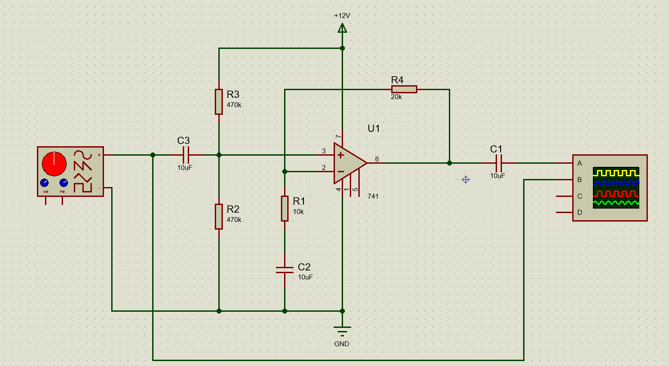
Figure 1 non-inverting amplifier in Proteus schematic capture window. The circuit design is specified in the assessment instructions. Simulation virtual instruments have been added, such as a signal generator (seen left) and an oscilloscope (seen right).
The calculated gain for this schematic is 3. This is calculated using an LM741 datasheet [1] which includes the following equation.
“Gain = 1 + (R2/R1)” [1]
Where R2 is a feedback resistor, and R1 is connected to pin 2 of the LM741.
Due to the numbering scheme in my schematic, R4 is the feedback resistor, and R1 is connected to the inverted input.
In this circuit, C3 filters any DC current from the input AC signal. The capacitor allows for AC current to charge and discharge the capacitor, passing the AC signal through the component. R3 and R2 create a potential divider so that a +6V DC bias is applied to the input signal.
The input is then connected to pin 3 of the LM741.
Like C3, C1 removes any DC component of the output signal.

Simulation of the amplifier circuit in Proteus
The following shows the output voltage results and calculated gain from the schematic. The input signal voltage for this simulation was 1.00V and a continuous sine wave. The frequency varied during the test. Measurements are taken from the peaks of each of the waveform traces using the vertical marker.
The voltage gain in the table is calculated using the following formula:
Gain = 20Log₁₀ (Vin/Vout)
The following in Table 1 is the result of the simulation and is plotted against frequency in Figure 2.
Input |  | Output Voltage (Peak) (mV) | Voltage Gain (dB)
Frequency (Hz) | Voltage (Peak) (mV) | Output Voltage (Peak) (mV) | Voltage Gain (dB)
1 | 495 | 888 | 5.08
2 | 500 | 1210 | 7.68
5 | 500 | 1440 | 9.19
10 | 500 | 1480 | 9.43
20 | 500 | 1490 | 9.48
50 | 500 | 1500 | 9.54
100 | 500 | 1500 | 9.54
200 | 500 | 1500 | 9.54
500 | 500 | 1500 | 9.54
1000 | 500 | 1500 | 9.54
2000 | 500 | 1500 | 9.54
5000 | 500 | 1500 | 9.54
10000 | 500 | 1500 | 9.54
20000 | 500 | 1500 | 9.54
50000 | 500 | 1490 | 9.48
100000 | 500 | 1350 | 8.63
200000 | 500 | 750 | 3.52
300000 | 500 | 512 | 0.21
500000 | 500 | 262 | -5.61
Table 1 Simulated gain results for non-inverting amplifier circuit

Figure 2 Graph of Simulated Gain of Non-inverting Amplifier Circuit with varying Input Signal Frequency

Simulated Bandwidth
To Calculate and measure the bandwidth of the non-inverting operational amplifier, the point at which the amplifiers drop 3dB or to 0.707 of the amplifier maximum gain.
From the results in Table 1 and Figure 2, the Bandwidth product of the non-inverting amplifier circuit can be estimated to be between 5Hz and 150KHz.
Additional measurements were taken to accurately find the low and high frequency at which the voltage gain is -3dB of maximum voltage gain.
The maximum voltage gain when simulated was 9.54 dB.
Low-Frequency Intersection (-3dB of Max Gain)
Input |  | Output Voltage (Peak) (mV) | Voltage Gain (dB)
Frequency (Hz) | Voltage (Peak) (mV) | Output Voltage (Peak) (mV) | Voltage Gain (dB)
1 | 495 | 888 | 5.08
1.2 | 495 | 975 | 5.89
1.3 | 495 | 1010 | 6.19
1.4 | 495 | 1050 | 6.53
1.5 | 495 | 1090 | 6.86
Table 2 Simulated Low-Frequency measurement at the point voltage gain is 3dB Less than the Maximum Gain
High Frequency Intersection (-3dB of Max Gain)
Input |  | Output Voltage (Peak) (mV) | Voltage Gain (dB)
Frequency (Hz) | Voltage (Peak) (mV) | Output Voltage (Peak) (mV) | Voltage Gain (dB)
90000 | 500 | 1410 | 9.00
100000 | 500 | 1350 | 8.63
110000 | 500 | 1270 | 8.10
120000 | 500 | 1210 | 7.68
130000 | 495 | 1090 | 6.86
140000 | 495 | 1050 | 6.53
150000 | 500 | 1020 | 6.19
Table 3 Simulated High-Frequency measurement at the point voltage gain is 3dB Less than the Maximum Gain
Using the following equation, the bandwidth product can be calculated as follows.
“Bandwidth Product = Bandwidth x Gain”
From the values highlighted in green in Table 2 and Table 3 and using 3 as the value of Gain.
The simulated bandwidth product for this circuit is 420KHz.

PCB Design
I created a schematic and PCB design in Easy-PC. This involved translating the schematic from Proteus into Easy-PC. I was then able to use the PCB editor to create a PCB that meets the manufacturer's design rules.
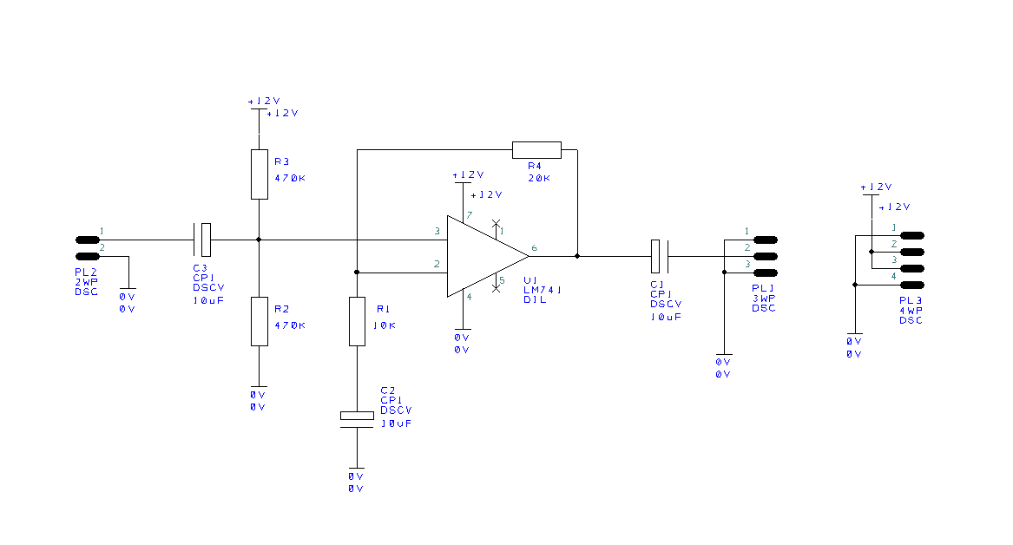
Figure 3 Cropped Screenshot of Schematic of Non-inverting Amplifier within Easy-PC
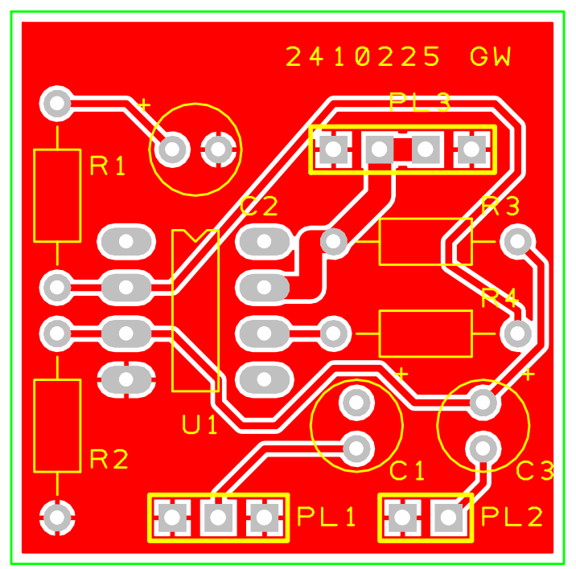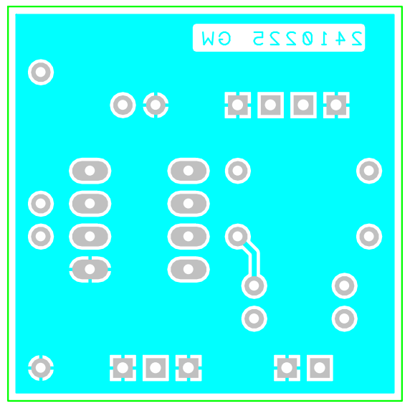
Figure 4 Images of the PCB created in Easy-PC. Left is the top copper and top silk. Right is the Bottom copper.
The board dimensions of this PCB are 1200 thou x 1200 thou. Both the top and bottom copper have a GND copper fill. My student number and initials are also placed on the top silkscreen and bottom copper.
The design was exported to a Gerber file for printing.

Breadboard Prototype

Nodal Analysis
Table 4 Node Analysis of Amplifier Circuit
To aid in my understanding the connections of the circuit, I made this table with the expected values at each junction/node.

Breadboard Plan
The following figure 5 is the plan for the Breadboard layout. I started by placing the most complex component in the centre, in this case, the 741 integrated circuit. I then worked outward from the middle with the other components. Ground and 12V power rails were used on the left and right of the plan.
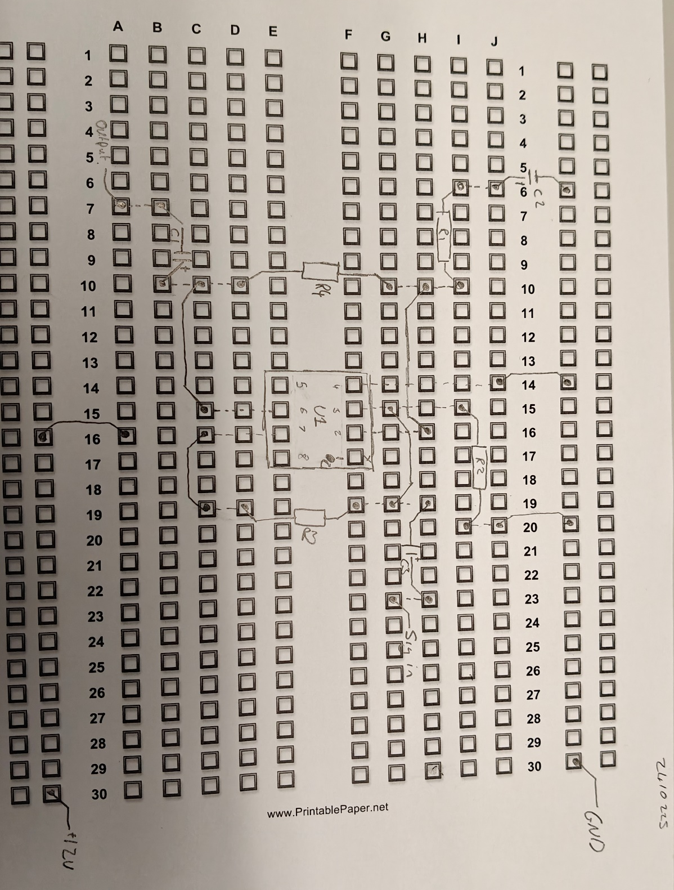
Figure 5 Breadboard planned layout of the amplifier circuit

Breadboard
Figure 6 shows my breadboard layout. The plan and the breadboard differ slightly. Where possible, wires were cut short on the board to make it easy to understand and troubleshoot.
When initially testing I discovered I had placed the input signal capacitor (C3) the wrong way round. After changing the polarity, the circuit worked.
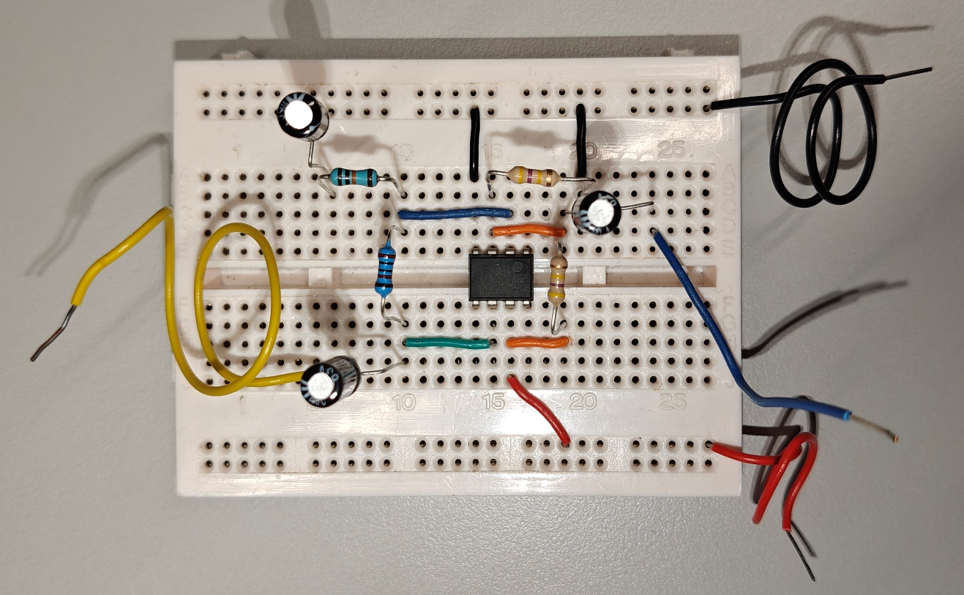
Figure 6 Picture of Breadboard amplifier circuit

Breadboard Measurements

Breadboard Test configuration
Oscilloscope connections
The oscilloscope's channel 1 lead was connected to the input signal generated by the signal generator. Channel 2 was connected to a wire from the breadboard, which was connected to the negative side of capacitor C1. Both probes' ground was connected to the ground wire.
Signal Generator connections
The output signal from the signal generator was split using a BNC T-Bar. This allowed two crocodile connectors to be used. The signal was connected to the input wire, and the signal ground was connected to the circuit ground.
Power Supply connection
A crocodile connector was used to connect input power, a second crocodile connector was used to connect the power supply to the ground of the circuit under test.
Name | Value
Power supply input voltage | 12.00V
Frequency Generator input voltage | 1.000Vpp
Oscilloscope | Multicomp MP720012
Time | 200.0ms – 5.0us
Channel 1 (input) | 200mV /div
Channel 2 (Output) | 500mV /div
During the test, the instruments were set to the following settings, and the frequency of the frequency generator was changed.

Table 5 Settings of test instrument during breadboard measurement

Breadboard Results
Table 6 and Figure 7 show the results from the breadboard testing. The input signal's voltage was set to 1.00V. During testing, the input voltage often fluctuated. The Voltage Gain in the right column was last calculated from the measured input voltage, not the displayed voltage on the signal generator.
Input |  | Output Voltage (Peak) (mV) | Voltage Gain (dB)
Frequency (Hz) | Voltage (Peak) (mV) | Output Voltage (Peak) (mV) | Voltage Gain (dB)
1 | 400 | 640 | 4.08
2 | 520 | 1080 | 6.35
5 | 520 | 1440 | 8.85
10 | 520 | 1520 | 9.32
20 | 520 | 1520 | 9.32
50 | 520 | 1520 | 9.32
100 | 520 | 1520 | 9.32
200 | 520 | 1520 | 9.32
500 | 520 | 1520 | 9.32
1000 | 520 | 1520 | 9.32
2000 | 520 | 1520 | 9.32
5000 | 520 | 1520 | 9.32
10000 | 520 | 1520 | 9.32
20000 | 520 | 1520 | 9.32
50000 | 520 | 1480 | 9.09
100000 | 600 | 1000 | 4.44
200000 | 600 | 520 | -1.24
300000 | 560 | 360 | -3.84
500000 | 560 | 200 | -8.94
Table 6 Breadboard Operational Amplifier circuit. Voltage Input, output and calculated gain

Figure 7 Breadboard Gain of Non-inverting Amplifier Circuit
Once at a high frequency (>100kHz) the signal starts to distort to closer resemble a sawtooth waveform instead of an amplified continuous sine wave. As seen below in figure 8.
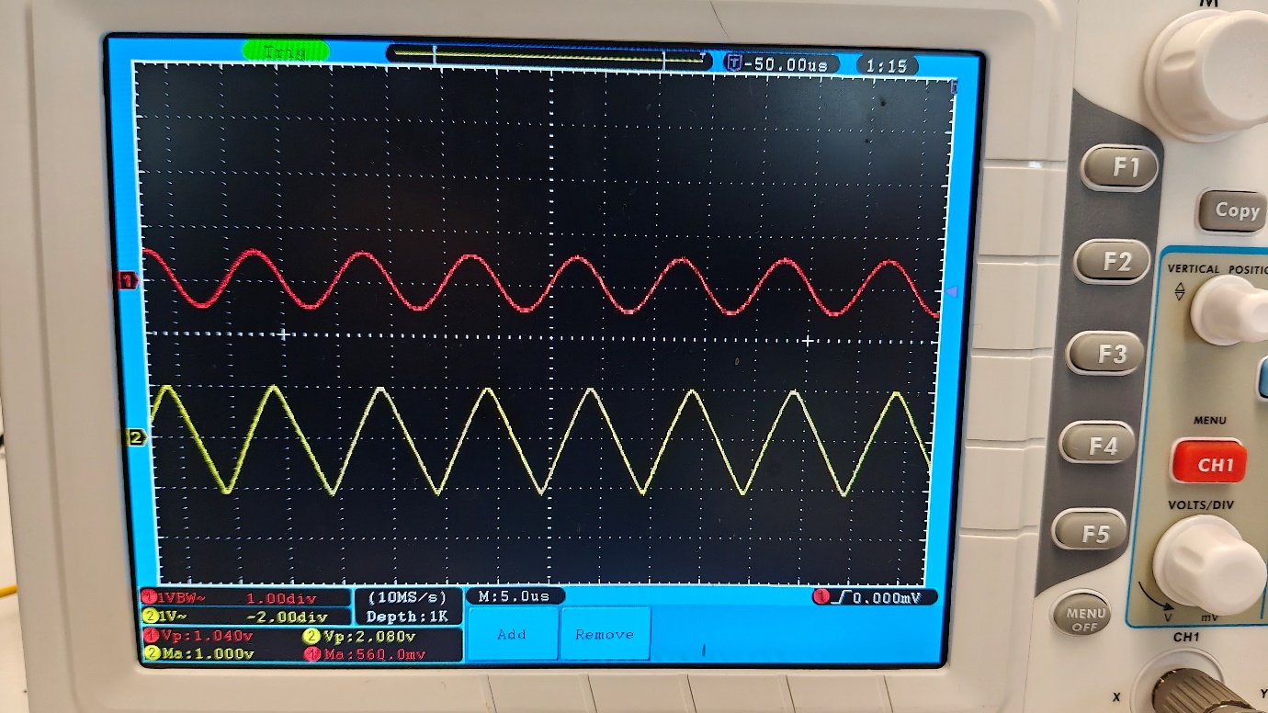
Figure 8 Photo of Oscilloscope measuring input signal (CH1 - Red) and output signal (CH2 - Yellow) of amplifier circuit with input frequency of 100000 Hz

Breadboard Bandwidth
The following tables show additional measurements of the breadboard to find the low and high frequencies where the voltage gain is 3dB lower than the maximum gain.
Low-Frequency Intersection (-3dB of Max Gain)
Input |  | Output Voltage (Peak) (mV) | Voltage Gain (dB)
Frequency (Hz) | Voltage (Peak) (mV) | Output Voltage (Peak) (mV) | Voltage Gain (dB)
1 | 344 | 620 | 5.12
1.2 | 376 | 760 | 6.11
1.3 | 392 | 800 | 6.20
1.325 | 392 | 820 | 6.41
1.35 | 392 | 820 | 6.41
1.4 | 400 | 860 | 6.65
1.5 | 416 | 920 | 6.89
1.8 | 424 | 1020 | 7.62
2 | 448 | 1080 | 7.64
2.2 | 464 | 1140 | 7.81
2.5 | 472 | 1200 | 8.10
3 | 480 | 1268 | 8.44
Table 7 Breadboard Low-Frequency measurement at the point voltage gain is 3dB Less than the Maximum Gain
High-Frequency Intersection (-3dB of Max Gain)
Input |  | Output Voltage (Peak) (mV) | Voltage Gain (dB)
Frequency (Hz) | Voltage (Peak) (mV) | Output Voltage (Peak) (mV) | Voltage Gain (dB)
90000 | 504 | 1060 | 6.46
91000 | 504 | 1060 | 6.46
91500 | 504 | 1040 | 6.29
93000 | 504 | 1040 | 6.29
95000 | 504 | 1020 | 6.12
Table 8 Breadboard High-Frequency measurement at the point voltage gain is 3dB Less than the Maximum Gain
From the values highlighted in green in Table 7 and Table 8 and using 3 as the value of Gain.
The bandwidth product for the circuit, when measured on the breadboard, is 273KHz

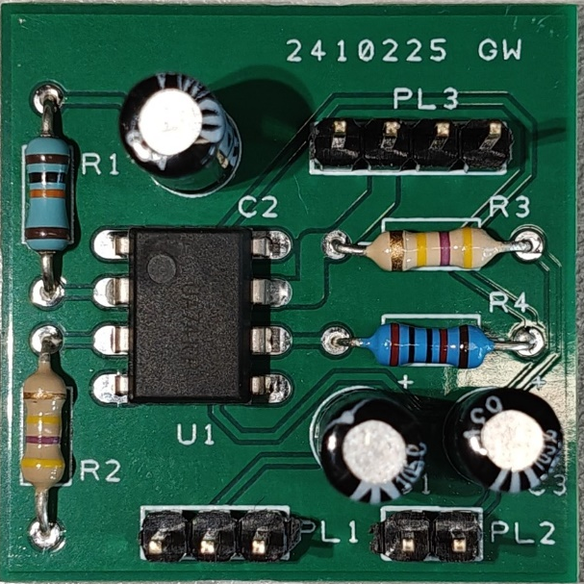
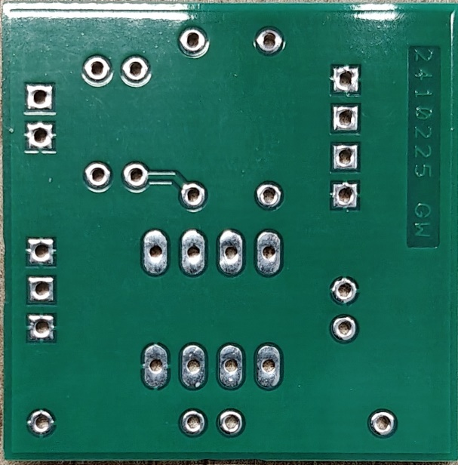
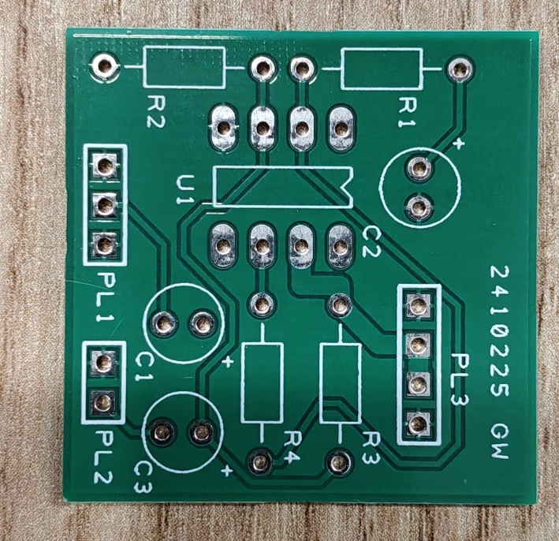
PCB Component Population and Soldering
Figure 10 PCB With components soldered in place
Figure 9 PCB without components
When soldering the components in place, all components were flat to the PCB. The shortest components were populated first, so the order of soldering was resistors, 741 IC, Pin headers, and capacitors.
When soldering the pin headers, to keep the pin header straight, I placed the pins in a spare breadboard to give support whilst soldering.
When soldering the 741 IC, I was mindful not to unnecessarily heat the component. As the absolute maximum rating soldering of 300 °C for 10 seconds [1]. Beyond this limit, could cause permanent damage to the amplifier.

PCB Measurements
Table 9 and Figure 11 show the results from the PCB testing.
Input |  | Output Voltage (Peak) (mV) | Voltage Gain (dB)
Frequency (Hz) | Voltage (Peak) (mV) | Output Voltage (Peak) (mV) | Voltage Gain (dB)
1 | 360 | 620 | 4.72
2 | 460 | 1080 | 7.41
5 | 520 | 1420 | 8.73
10 | 520 | 1500 | 9.20
20 | 520 | 1520 | 9.32
50 | 520 | 1520 | 9.32
100 | 520 | 1520 | 9.32
200 | 520 | 1520 | 9.32
500 | 520 | 1520 | 9.32
1000 | 520 | 1520 | 9.32
2000 | 520 | 1520 | 9.32
5000 | 520 | 1520 | 9.32
10000 | 520 | 1500 | 9.20
20000 | 520 | 1500 | 9.20
50000 | 520 | 1440 | 8.85
100000 | 500 | 1000 | 6.02
200000 | 520 | 500 | -0.34
300000 | 500 | 320 | -3.88
500000 | 500 | 180 | -8.87
Table 9 PCB Amplifier circuit. Voltage Input, output and calculated gain

Figure 9 PCB Gain of Non-inverting Amplifier Circuit

PCB Bandwidth
The following tables show the frequency of -3dB of Max Gain.
Low-Frequency Intersection (-3dB of Max Gain)
Input |  | Output Voltage (Peak) (mV) | Voltage Gain (dB)
Frequency (Hz) | Voltage (Peak) (mV) | Output Voltage (Peak) (mV) | Voltage Gain (dB)
1 | 344 | 620 | 5.12
1.2 | 376 | 760 | 6.11
1.3 | 392 | 800 | 6.20
1.325 | 400 | 820 | 6.24
1.35 | 400 | 820 | 6.24
1.4 | 400 | 860 | 6.65
1.5 | 416 | 920 | 6.89
1.8 | 424 | 1020 | 7.62
2 | 448 | 1080 | 7.64
2.2 | 464 | 1140 | 7.81
2.5 | 472 | 1200 | 8.10
3 | 480 | 1268 | 8.44
Table 10 PCB Low-Frequency measurement at the point voltage gain is 3dB Less than the Maximum Gain
High-Frequency Intersection (-3dB of Max Gain)
Input |  | Output Voltage (Peak) (mV) | Voltage Gain (dB)
Frequency (Hz) | Voltage (Peak) (mV) | Output Voltage (Peak) (mV) | Voltage Gain (dB)
90000 | 504 | 1060 | 6.46
91000 | 504 | 1060 | 6.46
91500 | 512 | 1060 | 6.32
93000 | 504 | 1040 | 6.29
95000 | 504 | 1020 | 6.12
Table 11 PCB High-Frequency measurement at the point voltage gain is 3dB Less than the Maximum Gain
From the values highlighted in green in Table 10 and Table 11 and using 3 as the value of Gain.
The simulated bandwidth product for this circuit is 274KHz.

Simulated, Breadboard and PCB Gain Compared
Table 12 and figure 14 show the Simulated breadboard and PCB circuits compared on one table and graph.
Input Frequency (Hz) | Simulated  Voltage Gain (dB) | Breadboard Voltage Gain (dB) | PCB Voltage Gain (dB)
1 | 5.08 | 4.08 | 4.72
2 | 7.68 | 6.35 | 7.41
5 | 9.19 | 8.85 | 8.73
10 | 9.43 | 9.32 | 9.20
20 | 9.48 | 9.32 | 9.32
50 | 9.54 | 9.32 | 9.32
100 | 9.54 | 9.32 | 9.32
200 | 9.54 | 9.32 | 9.32
500 | 9.54 | 9.32 | 9.32
1000 | 9.54 | 9.32 | 9.32
2000 | 9.54 | 9.32 | 9.32
5000 | 9.54 | 9.32 | 9.32
10000 | 9.54 | 9.32 | 9.20
20000 | 9.54 | 9.32 | 9.20
50000 | 9.48 | 9.09 | 8.85
100000 | 8.63 | 4.44 | 6.02
200000 | 3.52 | -1.24 | -0.34
300000 | 0.21 | -3.84 | -3.88
500000 | -5.61 | -8.94 | -8.87
Table 12 Simulated, Breadboard and PCB gain at a range of frequencies
Figure 10 Graph of Compared Simulated and Measured gain of the amplifier circuit, overlayed

References

[1] | Texas Instruments, “LM741 Operational Amplifier Datasheet,” October 2015. [Online]. Available: https://www.ti.com/lit/ds/symlink/lm741.pdf. [Accessed 13 October 2024].

