Problem
Analysis and Solution
Development

Module Name: Analysing and Solving Problems
Module Code: ACCA 4019
Student Name: Guido Llanos
Student ID: 2438787
Group: 3
Lecturer’s Name: Dr Redhwan Al-amri

Table of Contents
Table of Contents 1
1. Introduction 2
2. Deconstruct the Problem 2
2.1 MoSCoW Technique Requirement 2
Must haves 2
Should haves 2
Could haves 2
Won’t haves 2
2.2 Identification of key variables 3
3. Proposed Solution 4
3.1 Flowchart 4
3.2 Flowchart Explanation 4
4. Reflection and Justification 4
4.1 Abstract thinking 4
4.2 Sub-dividing 4
4.3 Justification of solution 4
4.4 Limitation 4
4.5 Assumption 4
5. Conclusion 4
References 5

Introduction
In most universities, classrooms are still assigned manually, without any clear criteria. This often results in some rooms being half-empty while others become overcrowded, causing timetable clashes and wasted time as students and staff have to walk back and forth between classes. This report examines this issue as it occurs in the college where I study. The aim is to understand the problem properly before proposing a more efficient solution. Using the MoSCoW method and identifying key variables, the problem is broken down into smaller parts to make it easier to analyse [1].

Deconstruct the Problem
The classroom allocation problem faced by the college can be broken down into three interconnected components (Wing, 2006) [2]. The first is a mismatch between class sizes and room capacities, which results in some rooms being overcrowded while others remain underused. The second is the occurrence of scheduling conflicts, where two or more classes are accidentally assigned to the same room at the same time. The third is the inefficient spatial distribution of classes across the building, which forces students and staff to travel unnecessarily long distances between lessons. Each of these components is addressed through the requirements and variables identified below.

MoSCoW Technique Requirement

Must haves
- Each classroom must have sufficient capacity for the exact number of students in the class.
- Two different classes can not be scheduled in the same room at the same time.
- The system must generate the complete classroom allocation before the academic period begins.
- Every class must be processed by the system and either assigned a room or logged for manual review.

Should haves
- Classes should be assigned to rooms that are close to each other to reduce walking time.
- Large rooms should be prioritised for bigger groups.
- The system should avoid students constantly changing floors between classes.

Could haves
- The system could suggest alternative rooms when the first option is not available.
- It could consider the type of class (theory or practical) when assigning rooms.

Won’t haves
- It will not be integrated with the college’s current management systems.
- Students will not be able to choose their preferred rooms.

Identification of key variables

Six Key variables were identified (Dym, Agogino, Eris, Frey, & Leifer, 2005) [4] as relevant to the classroom allocation problem in the college.
Class size refers to the number of students in each group. This variable is critical because rooms must be assigned according to the actual size of each class to avoid overcrowding.
Room capacity represents the maximum number of students that each classroom can physically hold. It must be matched correctly with class size to ensure efficient space utilisation.
Room location indicates the position of each classroom within the college building. Since the building has a specific layout, the location directly affects the distance students need to travel.
Travel time between rooms measures the time required to move from one classroom to another. Minimising this time is important to reduce delays between lessons.
Timetable constraints include the scheduled times and duration of classes. These must be respected to prevent any scheduling clashes between different groups.
Number of available rooms refers to the total number of classroom accessible in the college. This limits the options available when creating the allocation schedule.

Proposed Solution

Flowchart
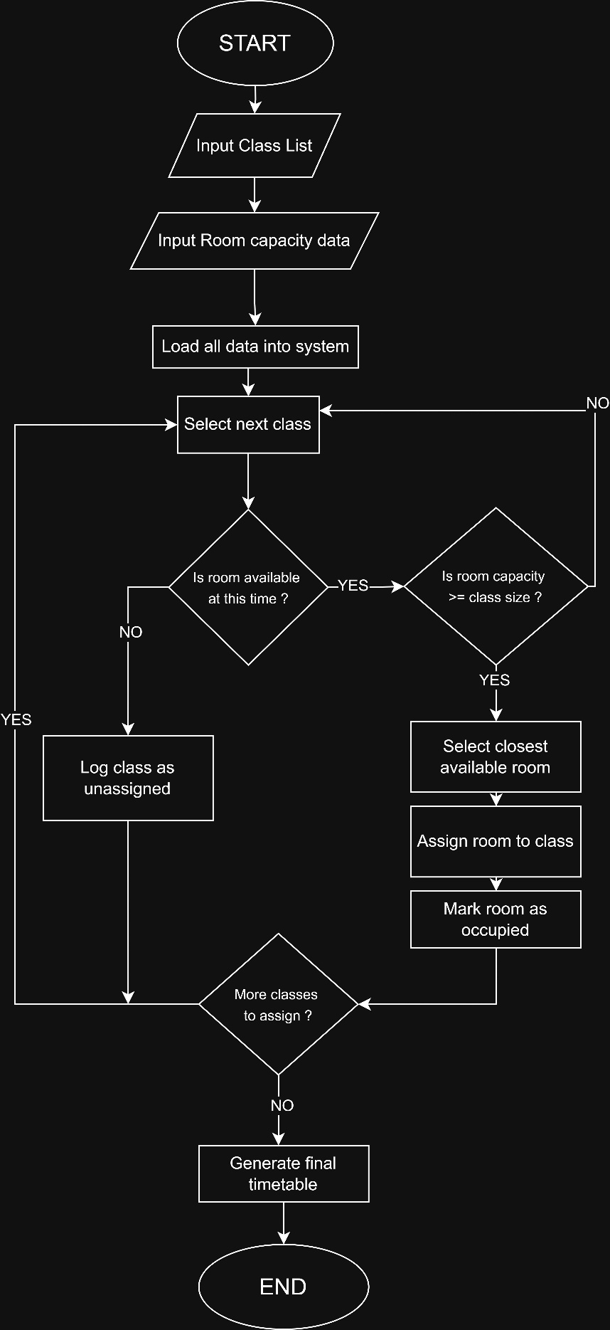

Flowchart Explanation
The flowchart that was designed for this solution follows a logical and organised process to assign classroom in an efficient way. The main goal is to make sure that each class gets a suitable room, avoiding timetable clashes and the waste of space that currently affects the college.
The process begins when two lists are entered into the system. The first one is the list of the classes, which contains information about each group, including how many students are in each one and what time their class takes place. The second one is the list of rooms, which includes all the available spaces in the building, their maximum capacity and their location inside the college. Without these two sets of data, the system cannot work properly, because the whole allocation logic depends on comparing this information.
Once the data has been entered, the system selects the next class from the list and starts the allocation process. The first thing that is checked is whether there is any room available at the time required for that class. This check is necessary because it could happen that there are rooms in the building but all of them are already occupied by other classes at the same moment. If none are available, the class is automatically recorded as unassigned. This means that the system recognises that it could not find a room for it and leaves it marked so that it can be reviewed manually later.
If there is at least one room available at that time, the system moves to the second decision point, which checks whether the room capacity is equal to or greater than the number of students in the class. This step is especially important because one of the main problems the college has it is that some rooms get too crowded while others remain almost empty. Assigning a class to a room that does not have enough space, does not solve the problem; it actually makes it worse. That is why, if the available room is too small, the class is also recorded as unassigned, just like in the previous case.
When both conditions are met meaning there is a room available and it also has enough capacity for the group, the system selects the closest room that meets those requirements. This decision is directly related to one of the main objectives of the project: reducing the time that students and staff lose when moving between classes. If there are several available rooms with enough capacity, the closest one is chosen, which minimises the travel distance. Once selected, the room is formally assigned to that class and marked as occupied at that time, so that no other class can be assigned to the same space at the same time. This is what avoids timetable clashes.
After each class is processed, the system checks whether there are still more classes left to assign in the list. If there are, the process goes back to the beginning and repeats exactly the same for the next class. This loop continues until all the classes have gone through the allocation process, whether they received a room or were logged as unassigned. When there are no more classes left to process, the system generates the final timetable which includes all the successful allocations and also the list of classes that could not be assigned automatically.
It is important to mention that unassigned classes are not a system failure, but a necessary part of the process. In situations where the demand for rooms exceeds availability, it is better to clearly record those cases than to try to force an incorrect allocation. This allows college staff to intervene only where it is really needed, saving time and effort compared to doing the whole process manually from scratch.
- Reflection and Justification

Abstract Thinking
Abstract thinking was applied by identifying only the information strictly necessary for the allocation process. Details such as lecturer preferences, room furniture, or floor numbers were ignored. The flowchart was built around three essential elements: class size, room capacity, and time slot availability. These three elements are sufficient to drive both decision points in the flowchart and produce a valid room assignment [2].

Sub-dividing
The allocation problem was divided into three separate components, each solved by a specific step in the flowchart. The availability check addresses scheduling conflicts. The capacity check prevents overcrowding by ensuring the room is large enough for the class. The selection of the closest available room reduces unnecessary travel time. Dividing the problem in this way allowed each flowchart step to have a clear and focused purpose [2].

Justification of solution
A rule-based approach was selected because the allocation process depends on two fixed and measurable conditions, which are represented by the two decision diamonds in the flowchart. When a room passes both the availability check and the capacity check, the assignment is made automatically. This guarantees that the Must Have requirements defined in the MoSCoW analysis are always met, making the solution transparent, consistent, and easy to review each academic term (Russell & Norvig, 2020) [3].

Limitation
The solution has three limitations directly linked to the flowchart design. First, the algorithm runs once and can not adjust if a room becomes unavailable after allocation. Second, room type is not considered as a variable, so the system could assign a practical session to a standard classroom. Third, the process depends entirely on the accuracy of the two-input list entered at the start (Daskalaki, Birbas, & Housos, 2004) [5].

Assumption
The flowchart assumes that both input lists, the class list and the room capacity data, are complete and accurate before the process begins. It is also assumed that time slots are fixed and will not change. Every room loaded into the system is assumed to be fully accessible and operational throughout the academic term.

Conclusion
This report has analysed the classroom allocation problem faced by a local college and proposed a structured solution based on a rule-based algorithm. The problem was broken down into three main components-capacity mismatch, scheduling conflicts, and spatial inefficiency- and the MoSCoW technique was used to prioritise the system requirements. The flowchart outlines a clear and logical process for assigning rooms efficiently, minimising travel time between classes, and avoiding timetable clashes. Abstract thinking and sub-dividing were the two main problem-solving techniques applied throughout the design process. Although the current solution is static, it provides a solid foundation that could be extended in future versions to handle dynamic changes during the academic term.

References
[1] Fadlallah, K. I., Sharif, M. M., & Eldow, M. E. (2024). Developing parallel requirements prioritization machine learning model integrating with MoSCoW method.
[2] Wing, J. M. (2006). Computational thinking.
[3] Russell, S., & Norvig, P. (2020). Artificial Intelligence: A Modern Approach. Hoboken, NJ.
[4] Dym, C., Agogino, A., Eris, O., Frey, D., & Leifer, L. (2005). Engineering design thinking, teaching, and learning.
[5] Daskalaki, S., Birbas, T., & Housos, E. (2004). An integer programming formulation for a case study in university timetabling.

