Current trends of Business Intelligence

Name of student: Vasile Ciprian Alin Diaconu

Student ID: 2030168

Table of Contents
Introduction 3
Business Intelligence Trends 3
Data Governance 3
Data Security 4
Data discovery/Visualization 5
Real-Time Data Analytics 6
Collaborative BI 7
Conclusion 7
References 8

Introduction
Business Intelligence (BI) has revolutionized, data became prominent, and all businesses now have access to the cloud. 2021 was a massive year of the BI industry, where the BI landscape is evolving rapidly. BI trends shows that the future starts now. BI is the process driven by technology for analysing the data and delivering actionable information that helps managers make decisions based on data-driven. Adair (2019) argues that strategies and tools of BI are becoming increasingly popular and customized in 2022. Companies are considering a substantial investment in business intelligence technologies to maintain competitive advantage. Thus, the report will explore and discuss five latest and current Business Intelligence trends with the help of five authentic academic resources. All the trends will be explained thoroughly and will be critically evaluated.

Business Intelligence Trends
The trends of business intelligence shows that companies are working in establishing themselves for long-term regarding the basis of their data usage. Previously, the firms were no longer concerned whether data visualization improves analyses. However, rising awareness about importance of data, and its usages for the business intelligence has made it an interesting topic. Hence, 2022 is the year where firms collaborate business intelligence and artificial intelligence initiatives to generate insightful information based on which decision could be made. Thus, following are latest trends of business intelligence.

Data Governance
Data governance is one of the biggest business intelligence trends at the moment. Authentication protocols and role-based access are used to guarantee the quality of a firm’s assets (Quintela, Carneiro, and Ferreira, 2019). The strategy of data governance provides a framework for managing corporate data. In addition, data governance trends enable firms to take advantage of technologies related to data management. Moreover, it helps businesses provide personnel with accurate, complete, and secure information. According to ReportLinker (2022), the worldwide data governance market had a value of $1.2 billion in 2016 and is expected to reach $4.9 billion in 2026. Below, the table predicts that the demand for data governance will grow to $11.68 in 2030. The study by Stedman (2022) found that around 64% of the firms have included programs related to data governance. Data governance in 2022 represents a massive shift in the data management environment with a focus on centralization, increased data security, and easy remote access. The trend of data governance currently dictates how a firm manages its data throughout the data’s life cycle, from acquisition to disposal. Moreover, it involves tools and processes that individuals follow to ensure data integrity, availability, and security.
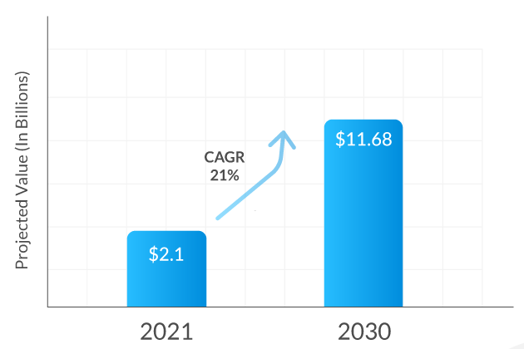
Figure 1: Growth rate of Data governance

Data Security
Businesses are not concerned if data visualizations improve analyses, but firms are looking for the best approach for data narrative, precisely cutting-edge business intelligence technology. 2022 is the year of data discovery and data security. Data security trends picked up pace in 2019, and it is predicted that businesses will continue to find more secure solutions for securing data. Firms investing in data security with the help of business intelligence tools benefit from answers to ensure that data is secured from leakage and other vulnerabilities (O’Connor, 2021). With data governance, data security is one of the critical BI trends in sectors like financial services and health care.

Data discovery/Visualization
Since, 2017 data discovery has been one of the important trends.. It refers to a user-centric process of data collection from different kinds of databases and manufacturing them into a unfied source to simplify data analysis (Broscorp, 2022). The impact of data security increased last year. The business application research center conducted a survey that showed the importance of data discovery as it was listed in the top four trends of BI.
BI practioners shows that empowerment of business users is consistent and solid. Data discovery has is known to be the primary trends in BI as it leverages the overall value of information and improves decision making. In addition, it also impacts the process of business optimization and supports business modes directly. It has evolved into a stat of the art solutions in presenting and interacting with different kinds of graphics on one screen. Data discovery procedure ensures that decision makers reveals insights by using visualization and teams finds out trend with significant outliers within no time.
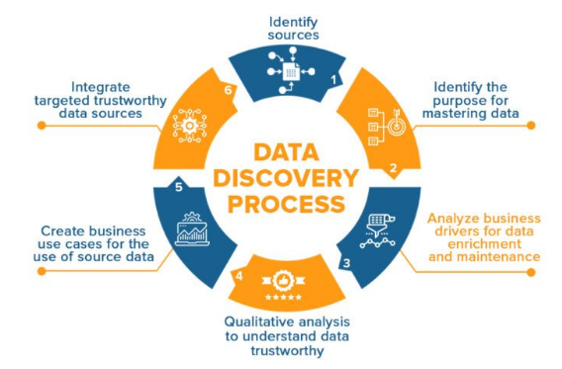
Figure 2: Data Discovery Process

Real-Time Data Analytics
In recent times, firms started to see the need for real-time data, and the trend will continue in the coming years. Up-to-date information is becoming increasingly crucial for companies. COVID-19 showed the significance of real-time data for obtaining accurate results and updates. Accessing real-time data has become a standard in businesses and daily life. The trend of real-time analysis has allowed firms to stay at the top of every possible change and to adopt any challenge that the previous or current year has bought (Rolustech, 2022). In addition, a live dashboard enables businesses to stay up to date in case any concern arises. The tools of BI have changed and put business data where users can take action. Various platforms are emerging with critical business processes and workflow through features like dashboard extension and embedded analytics. Furthermore, the creation of ad hoc analysis has permitted firms to be at the top and adapt to any challenge and issue.

Collaborative BI
Nowadays, workers and managers are interacting differently as they are facing competitive environment. Collaborative BI is a new trend emerging in business intelligence as it combines tools that include 2.0 technologies and social media. The movement has emerged with enhanced technologies and collaboration addressing new challenges that businesses provide and where advanced analyses are performed and reported. Collaborative BI has gained a significant amount of importance for better utilization of data. The reason lies as it combines traditional BI tools and collaboration BI tools. It enables individuals to analyze and understand data in an advanced formatted and easier way.
Collaborative BI helps people engage in the decision-making process, and there is no need to reach a conclusion at an individual level. Meanwhile, it emphasizes a problem-solving approach (Tseng, 2021). Thus, collaborative BI enables users to analyze information and share ideas through web 2.0 tools. In early 2020, experts predicted that the onset of the semantic web and 3.0 web was upon us. In the coming years, it will allow businesses to use data from sensors and the Internet of Things (IoT) to tap into their operational data.

Conclusion
It can be concluded that the world is emerging towards the latest business intelligence technologies in the coming years. The report discussed key business intelligence trends and provided a few statistical analyses regarding their growth in previous and future years. Data governance, security, discovery, real-time data analytics, and collaborative business intelligence are the main trends discussed in the report. It was found that data governance in 2022 represents a massive shift in the data management environment with a focus on centralization, increased data security, and easy remote access. AI and BI analytics are the future and will evolve even further in the coming years. On the other hand, experts predict extravagant changes in business intelligence, but it will be interesting to see what excitement these trends bring in the coming years. In addition, watching which direction has the most significant impact on industries will be fun.

References
Quintela, H., Carneiro, D. and Ferreira, L., 2019. Business Intelligence, Big Data and Data Governance. In Business Intelligence and Analytics in Small and Medium Enterprises (pp. 123-150). CRC Press.
O’Connor, E. (2021). Microsoft BI Approach for Business Intelligence Security. [online] EPC Group. Available at: https://www.epcgroup.net/business-intelligence-security/.

‌ Broscorp. (2022). Business Intelligence Trends for 2022/2023: Current and Future of BI. [online] Available at: https://broscorp.net/business-intelligence-trends/.

Adair, B. (2019). Types of Business Intelligence Tools & Systems In 2020. [online] SelectHub. Available at: https://www.selecthub.com/business-intelligence/key-types-business-intelligence-tools/.
ReportLinker (2022). Global Data Governance Market to Reach US$6 Billion by the Year 2026. [online] GlobeNewswire News Room. Available at: https://www.globenewswire.com/news-release/2022/06/29/2471455/0/en/Global-Data-Governance-Market-to-Reach-US-6-Billion-by-the-Year-2026.html [Accessed 18 Nov. 2022].

Tseng, H. (2021). Business Intelligence Trends in 2021 | Latest Trends In BI. [online] SelectHub. Available at: https://www.selecthub.com/business-intelligence/business-intelligence-trends/.

‌ Rolustech. (2022). Top 8 Business Intelligence and Analytics Trends for 2022. [online] Available at: https://www.rolustech.com/blog/top-8-business-intelligence-and-analytics-trends-for-2022 [Accessed 19 Nov. 2022].
‌ Stedman, C. 2022. What Is Data Governance and Why Does It Matter? [online] SearchDataManagement. Available at: https://www.techtarget.com/searchdatamanagement/definition/data-governance.
‌

‌

‌

