Amina Meah
University of Wales Trinity Saint David [Company address]

Operating Systems
Contents
Table of figures 2
Introduction 4
Key functions of general Operating Systems 5
Use of Windows OS CLI commands 11
Batch Commands 11
Echo 11
Dir 11
Mkdir 12
Whoami 12
Tasklist 13
Powershell 14
Get-process 14
Get-service 15
Get-help (get-process) 15
Get-child item 16
Move-item 16
Use of Linux OS CLI commands 17
Bash Commands 17
pwd 17
Ls 17
Cd home 18
Mkdir 18
Touch 18
Echo 18
Df 19
History 19
Ifconfig 20
Clear 20
Use of Windows OS scripts 21
Variables 21
Goto command 21
User input /p switch and if else 22
For loop 22
array 23
Function 24
Use of Linux OS scripts 26
Variables 26
Conclusion 32
Reference list 33

Table of figures
Figure 1 – Image showing functions of operating system [6] 5
Figure 2- Resource Monitor showing the memory management function. 6
Figure 3 – Task Manager showing processor management functions. 6
Figure 4- Command prompt showing file system management using dir command. 7
Figure 5- Start menu showing warm boot function. 7
Figure 6- Control panel showing Networking capabilities by showing network connections, network status, and network adapter properties. This can represent various functions such as User Interface, Security, and Networking capabilities. 8
Figure 7 – Event Viewer showing Error detection by displaying system logs and event information. 9
Figure 8- Device manager showing Device Management by displaying the list of hardware devices installed on the system and their status. 10
Figure 9-Screenshot 11
Figure 10 11
Figure 11 12
Figure 12 12
Figure 13 13
Figure 14 14
Figure 15 15
Figure 16 15
Figure 17 16
Figure 18 16
Figure 19 17
Figure 20 17
Figure 21 18
Figure 22 18
Figure 23 18
Figure 24 18
Figure 25 19
Figure 26 19
Figure 27 20
Figure 28 20
Figure 29 21
Figure 30 21
Figure 31 21
Figure 32 21
Figure 33 22
Figure 34 22
Figure 35 22
Figure 36 23
Figure 37 23
Figure 38 24
Figure 39 24
Figure 40 25
Figure 41 26
Figure 42 26
Figure 43 26
Figure 44 27
Figure 45 27
Figure 46 27
Figure 47 28
Figure 48 28
Figure 49 28
Figure 50 29
Figure 51 29
Figure 52 30
Figure 53 30
Figure 54 30
Figure 55 31
Figure 56 31
Figure 57 31

Introduction
Operating systems are the pillar of modern computing, providing the essential framework for managing hardware resources and enabling software applications to run efficiently. In this comprehensive report, I explore into the key functions of popular general-purpose operating systems, namely Windows and Linux. I will also explore how these OS platforms handle critical tasks such as memory management, processor allocation, file system organization, device management, and security. Through detailed descriptions and accompanying screenshots, I will illustrate how these functions can be monitored and managed within the operating system environment. Additionally, I will examine the use of command-line interfaces in both Windows and Linux systems, showcasing the versatility and power of scripting languages such as Batch, PowerShell, and Bash. This report aims to deepen understanding of operating system functionality and empower users to leverage CLI commands and scripting for efficient system administration and automation tasks.

Key functions of general Operating Systems
The operating system performs several critical functions to ensure the efficient and secure operation of a computer system[1]. Figure 1 below shows some examples of the functions of an operating system.
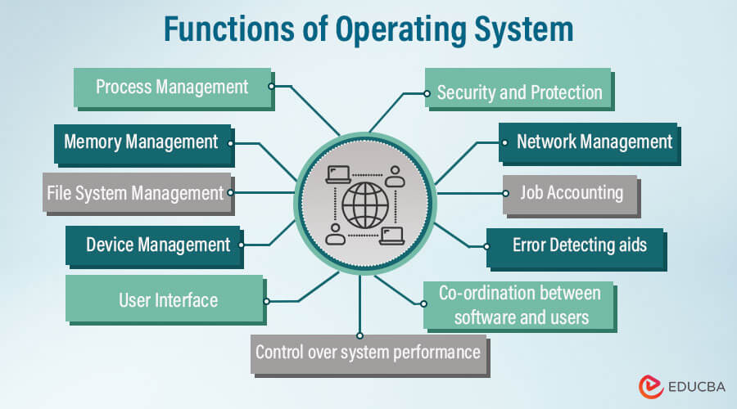
Figure 1 – Image showing functions of operating system [6]

One function is Memory Management this tracks and manages primary memory usage, allocating and deallocating memory to processes. It also decides the order and duration of memory access in multiprogramming[1]. Figure 1 below shows an example of this from my windows OS.
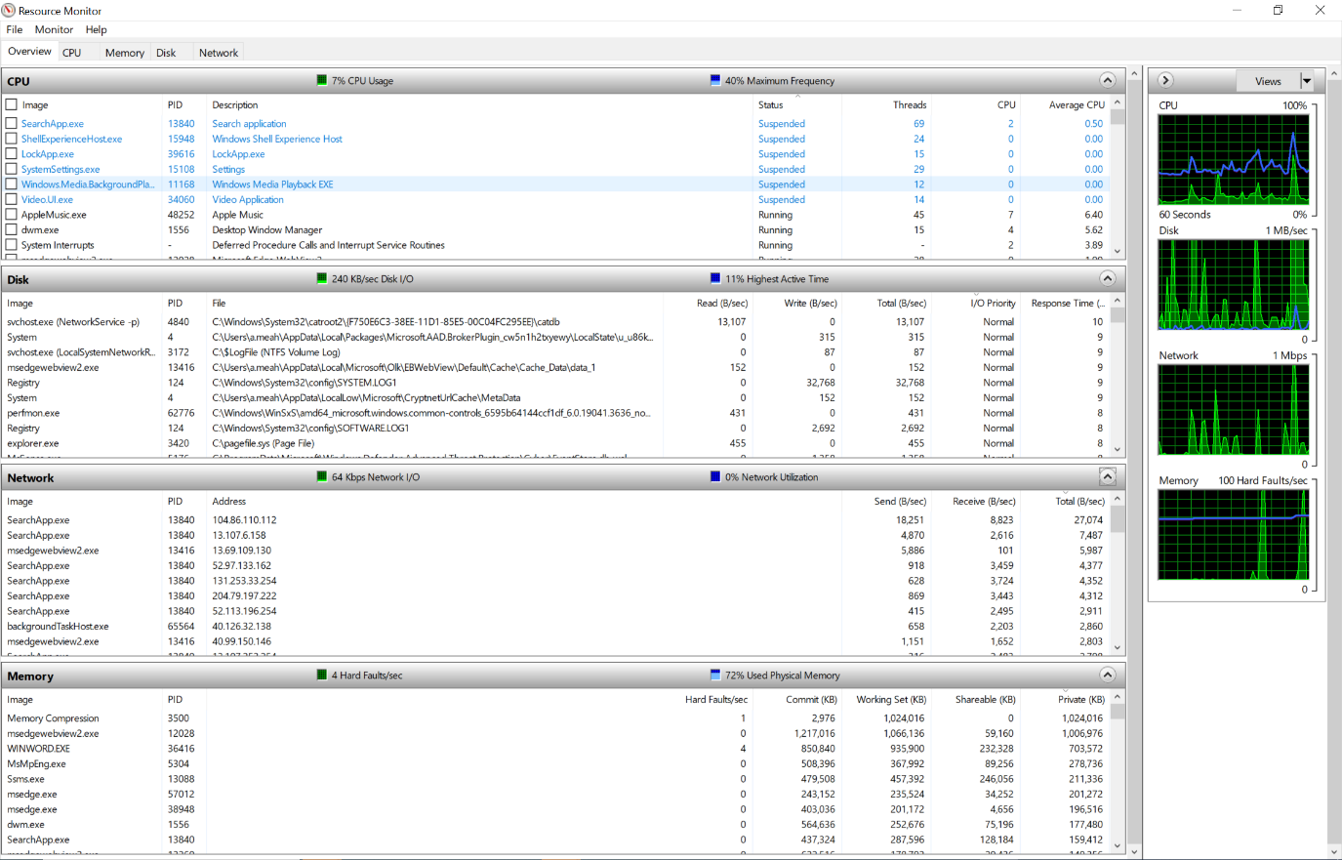
Figure 2- Resource Monitor showing the memory management function.
Another function is Processor Management this allocates processor time to processes through process scheduling. It also keeps track of process status, allocating and deallocating the CPU as needed [1]. Device Management controls input and output devices, facilitating communication with software applications [2]. Figure 3 below shows an example of this from my windows OS.
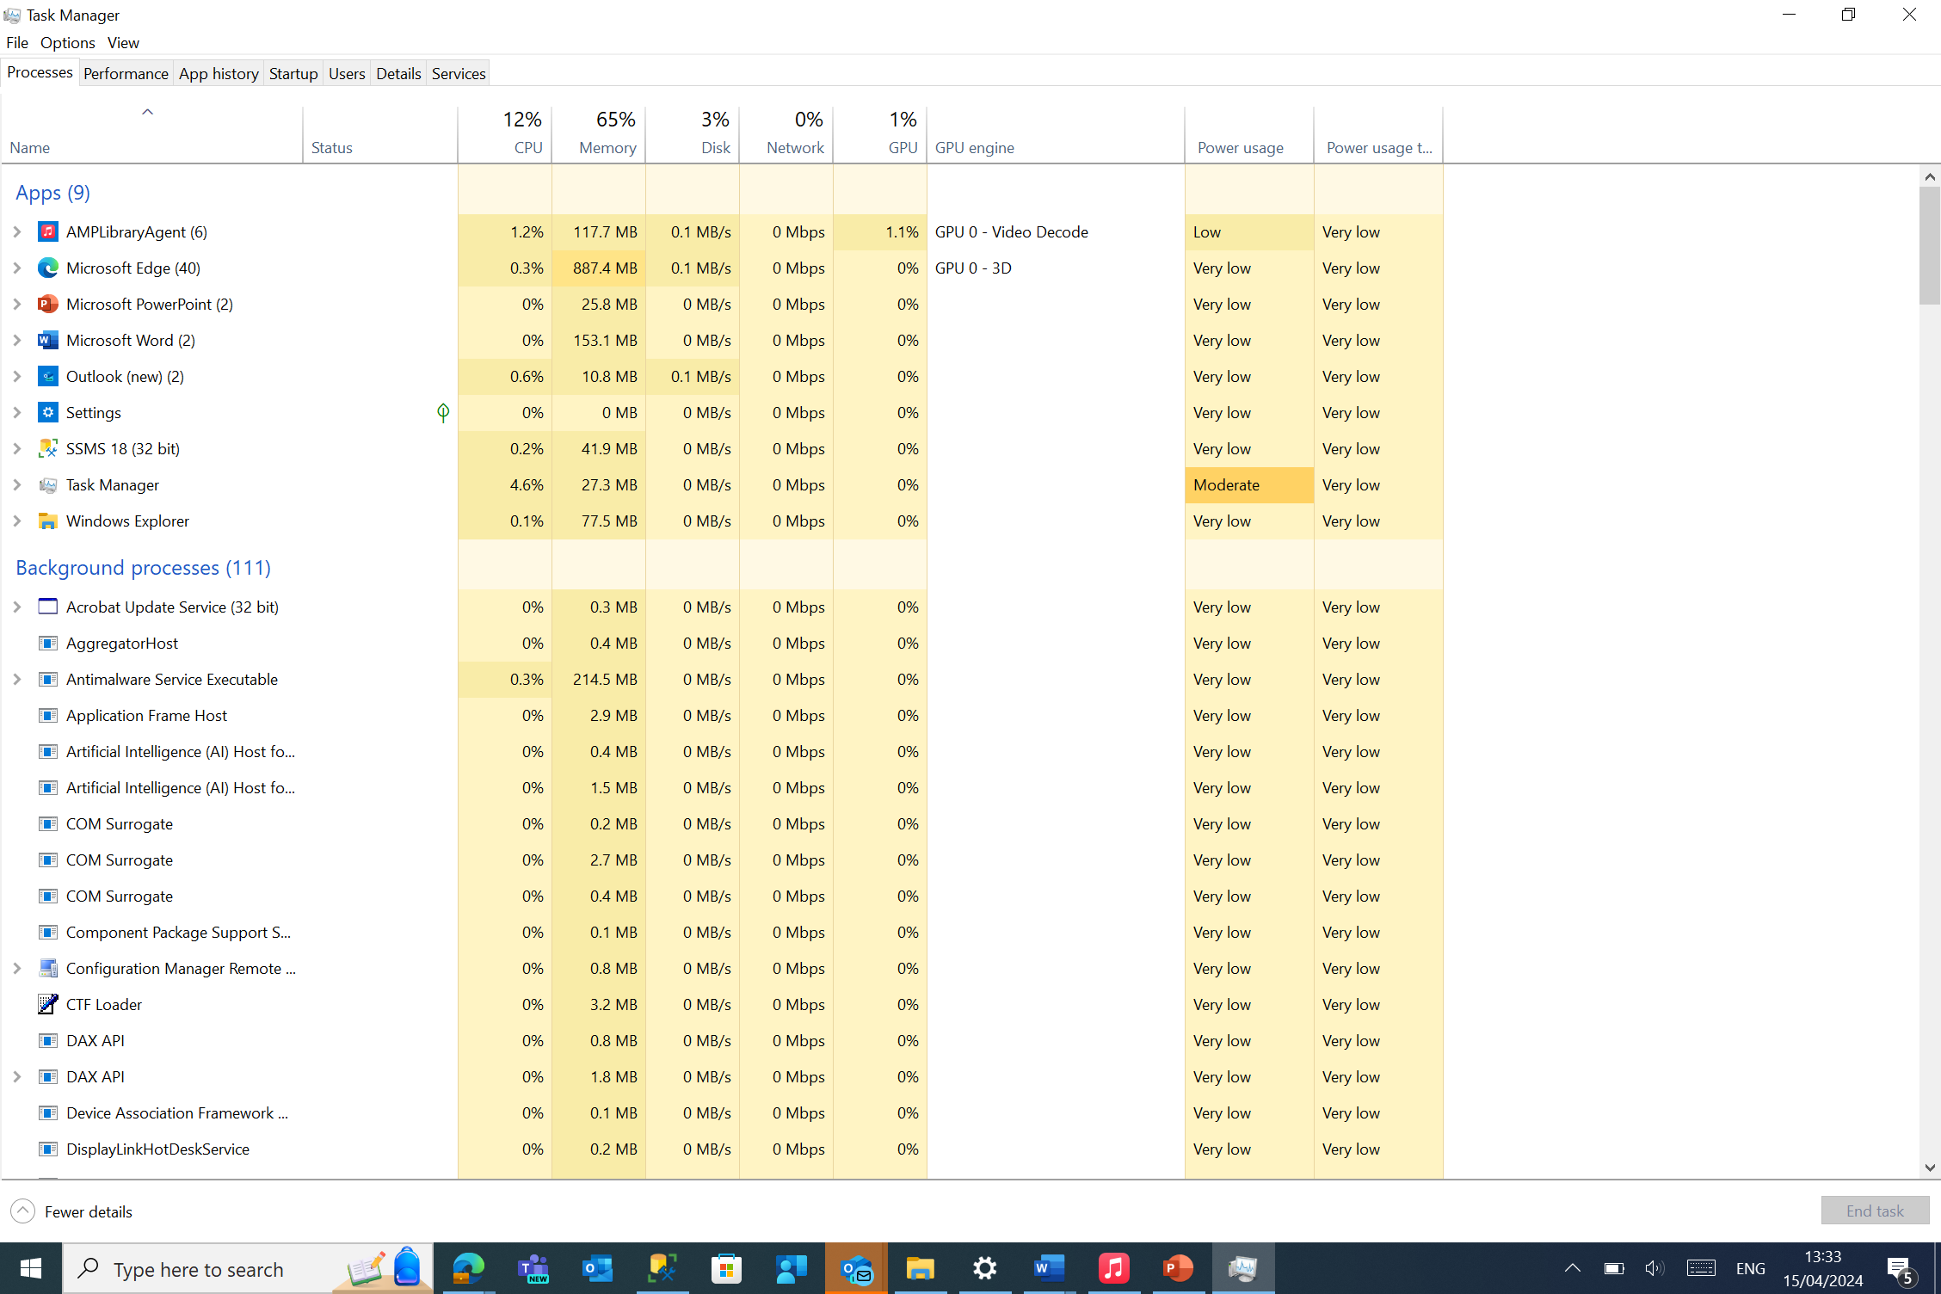
Figure 3 – Task Manager showing processor management functions.
File System Management provides a hierarchical structure for file organisation and access [2]. It organises the file system into directories for navigation and keeps track of file information, access settings and status. Lastly it ensures data integrity and protects against unauthorised access [1]. Figure 4 below shows an example of this from my windows OS.
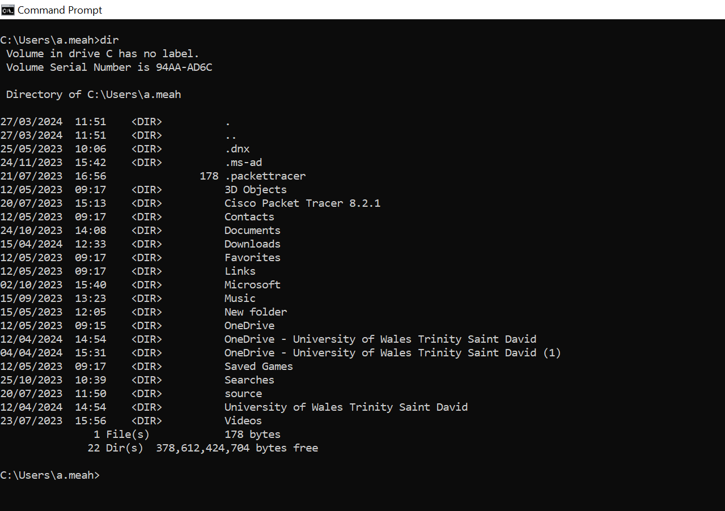
Figure 4- Command prompt showing file system management using dir command.
Booting the Computer is another function this involves starting or restarting the computer. There are 2 types the first is a Cold boot this involves Turning on a computer that has been completely turned off the second is Warm boot which is using the operating system to restart the computer [3]. Figure 5 below shows an example of this from my windows OS.
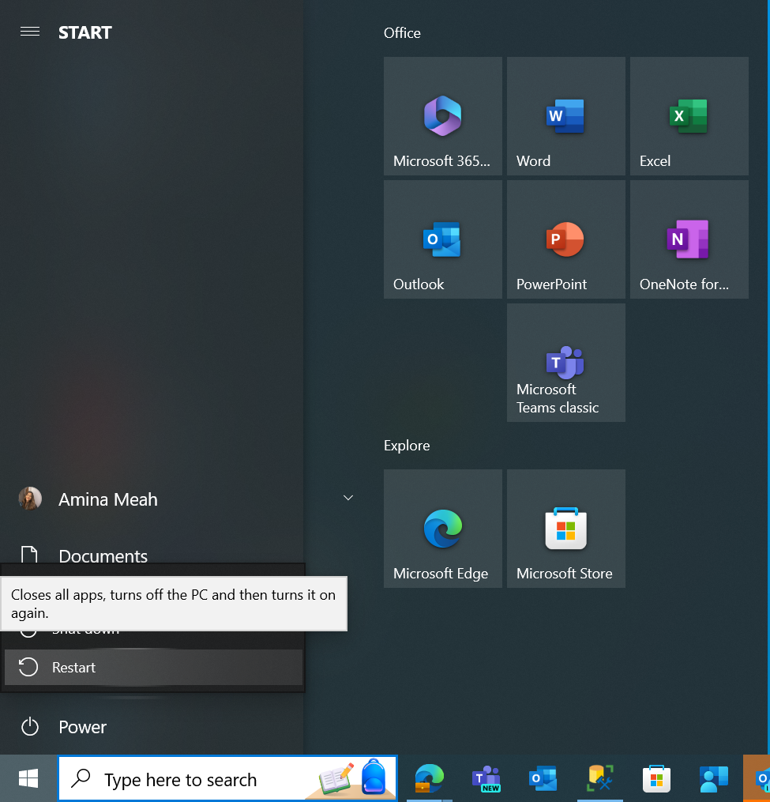
Figure 5- Start menu showing warm boot function.
Another function is Security this implements password protection and other techniques to safeguard user data. It also Prevents unauthorised access to programs and data. Lastly it Monitors system vulnerabilities and displays relevant messages[1]. User Interface allows user-system interaction through interfaces like CLI or GUI[2]. Networking capabilities enable communication with other devices over networks[2]. It also Manages data packaging and transmission over the network. Also sets up and monitors network connections, adjusting speed and ensuring security [1]. Figure 6 below shows examples of this from my windows OS.
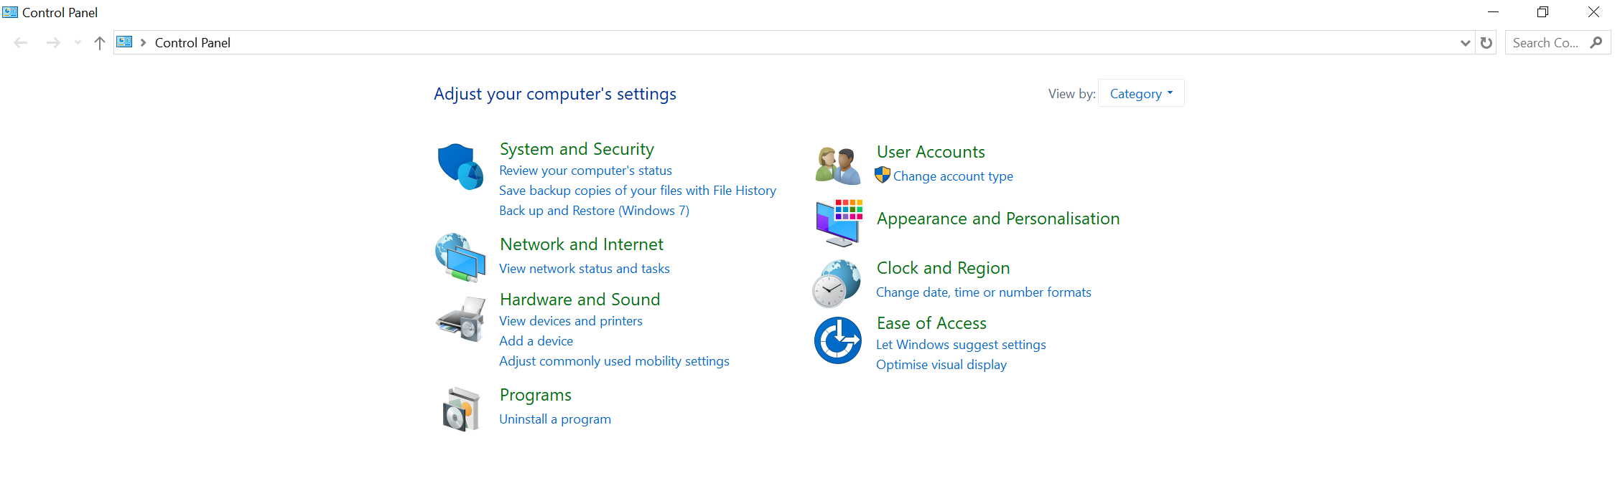
Figure 6- Control panel showing Networking capabilities by showing network connections, network status, and network adapter properties. This can represent various functions such as User Interface, Security, and Networking capabilities.

The os provides a function of Control Over System Performances by Allocating CPU time, memory, and I/O devices to processes for optimal resource utilisation. It also Performs process scheduling to enable effective multitasking [1].
The job accounting function of an operating system serves as a vital tool for monitoring and managing the utilisation of computer resources. By documenting system activities, resource usage, memory allocation, and errors, the OS enables administrators to track and analyse system performance effectively [4]. This information facilitates troubleshooting of performance issues, identification of unauthorized software installations, and billing users for resource consumption [4].
The Error detection function is an essential component of a computer system, tasked with identifying and addressing potential issues that may arise during operation [1]. These mechanisms play a crucial role in ensuring the reliable transmission of data over vulnerable networks. Continuously vigilant, the operating system actively monitors the system environment, swiftly identifying and acknowledging errors to safeguard the system from potential harm [5]. Figure 7 below shows an example of this from my windows OS.
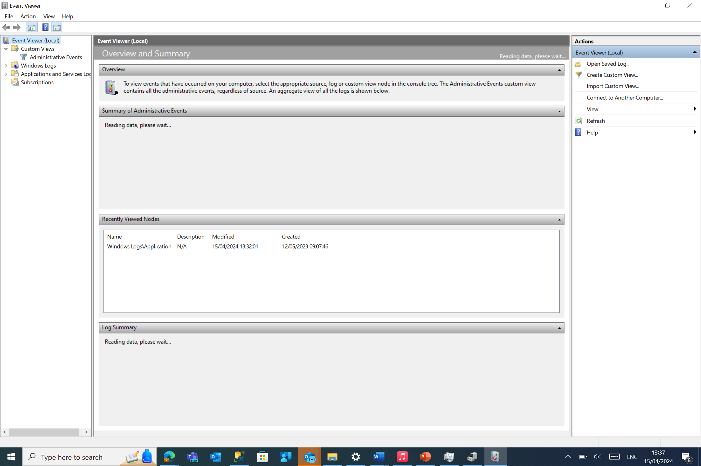
Figure 7 – Event Viewer showing Error detection by displaying system logs and event information.
Another key function is the Coordination Between Other Software and Users. This Coordinates and assigns interpreters, compilers, and other software to users. It also manages the sharing of computer resources among different software programs[1].
The operating system also Performs Basic Computer Tasks, including device management such as mice, keyboards, and printers[1]. It ensures seamless functionality by supporting plug-and-play features, enabling automatic recognition and configuration of devices as they are connected to the system[3]. Figure 8 below shows an example of this from my windows OS.
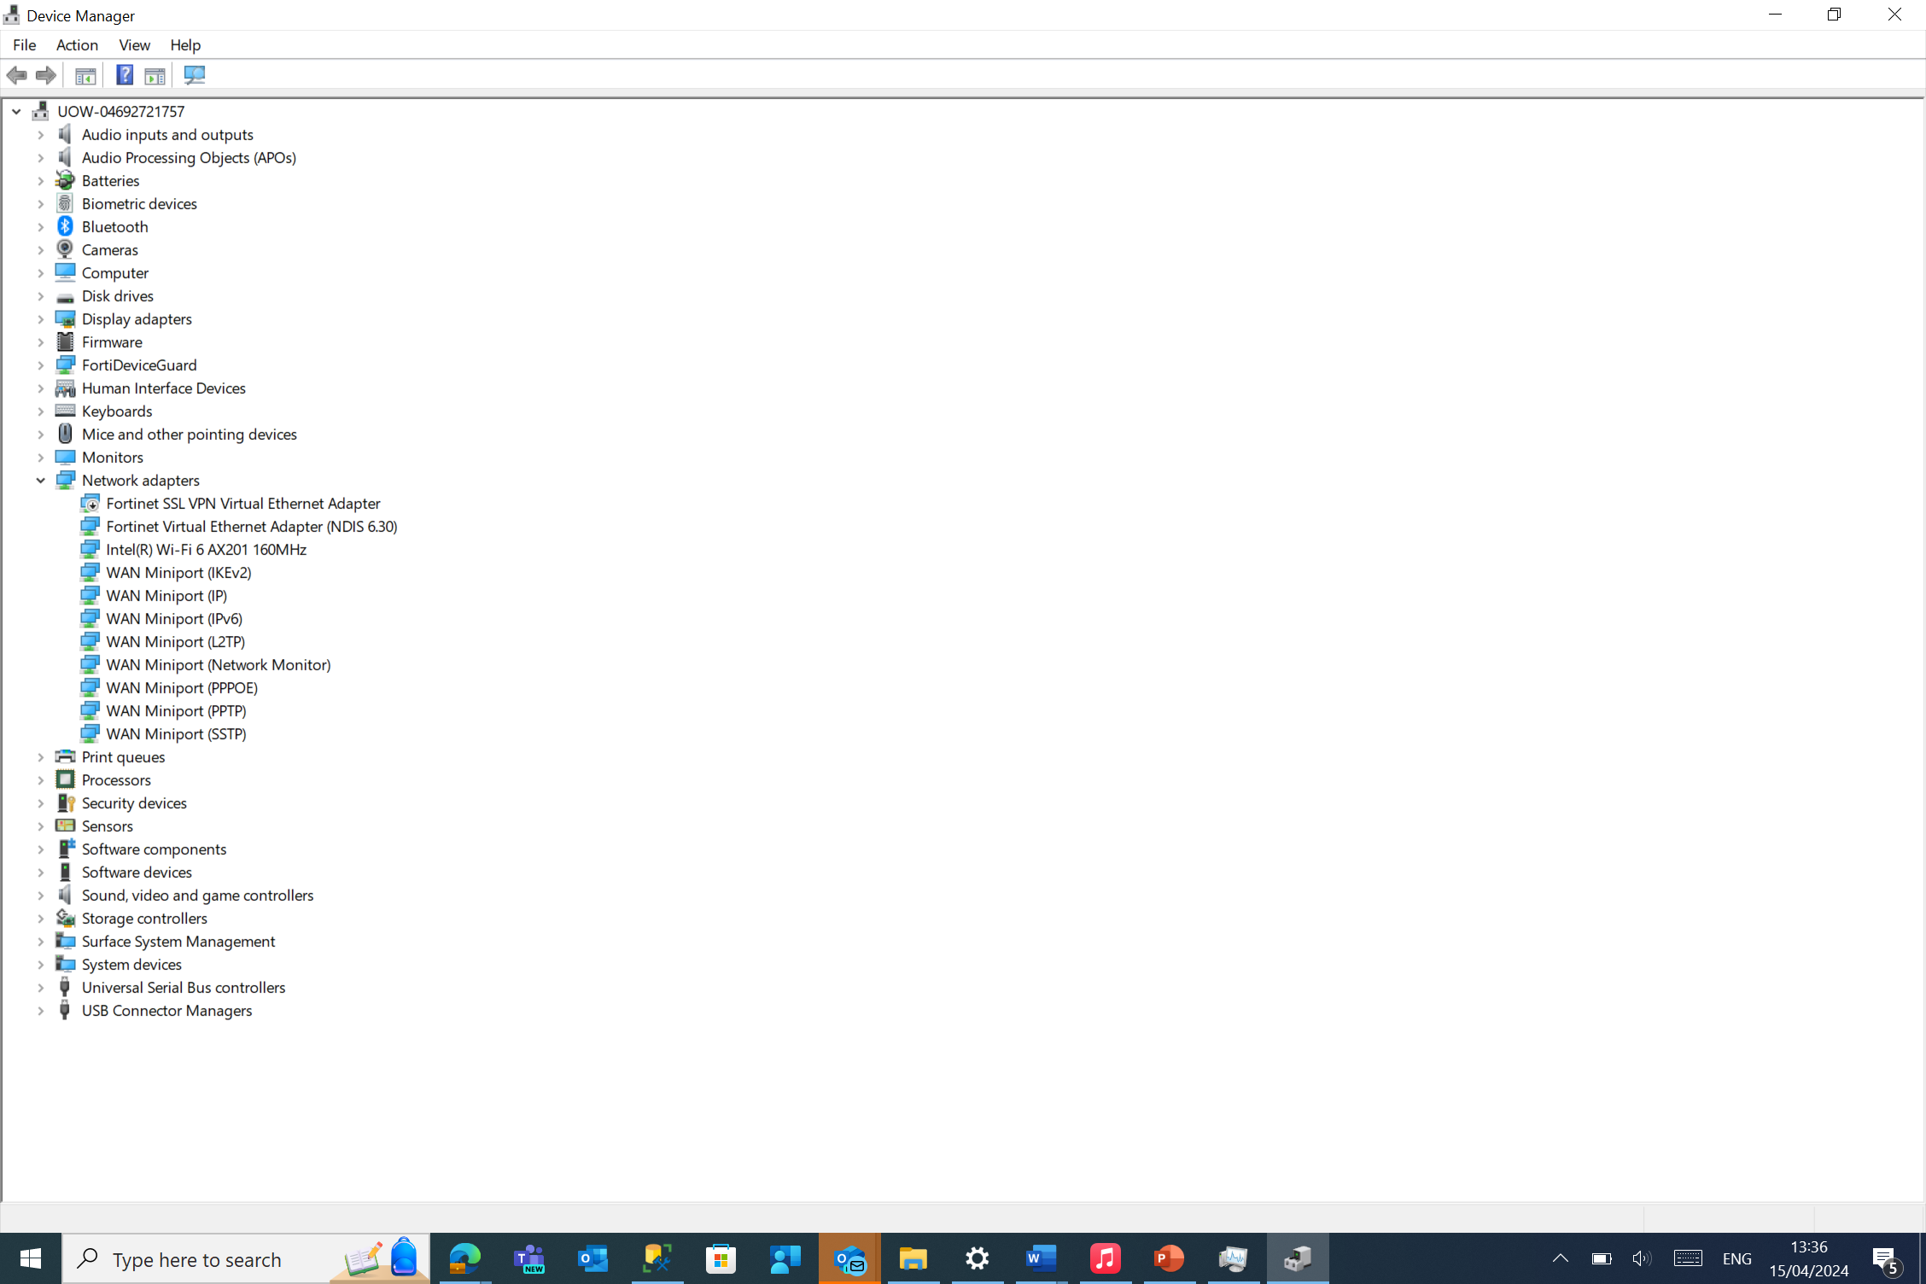
Figure 8- Device manager showing Device Management by displaying the list of hardware devices installed on the system and their status.

Use of Windows OS CLI commands

Batch Commands

Echo
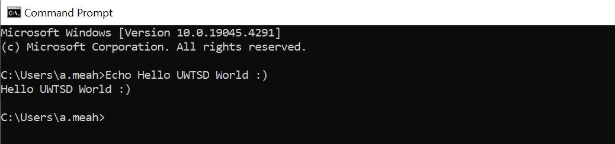
Figure 9-Screenshot.
In figure 9 I have used the echo command. The echo command prints messages to the console [7]. My message ‘Hello UWTSD World’ has been printed using this command.

Dir
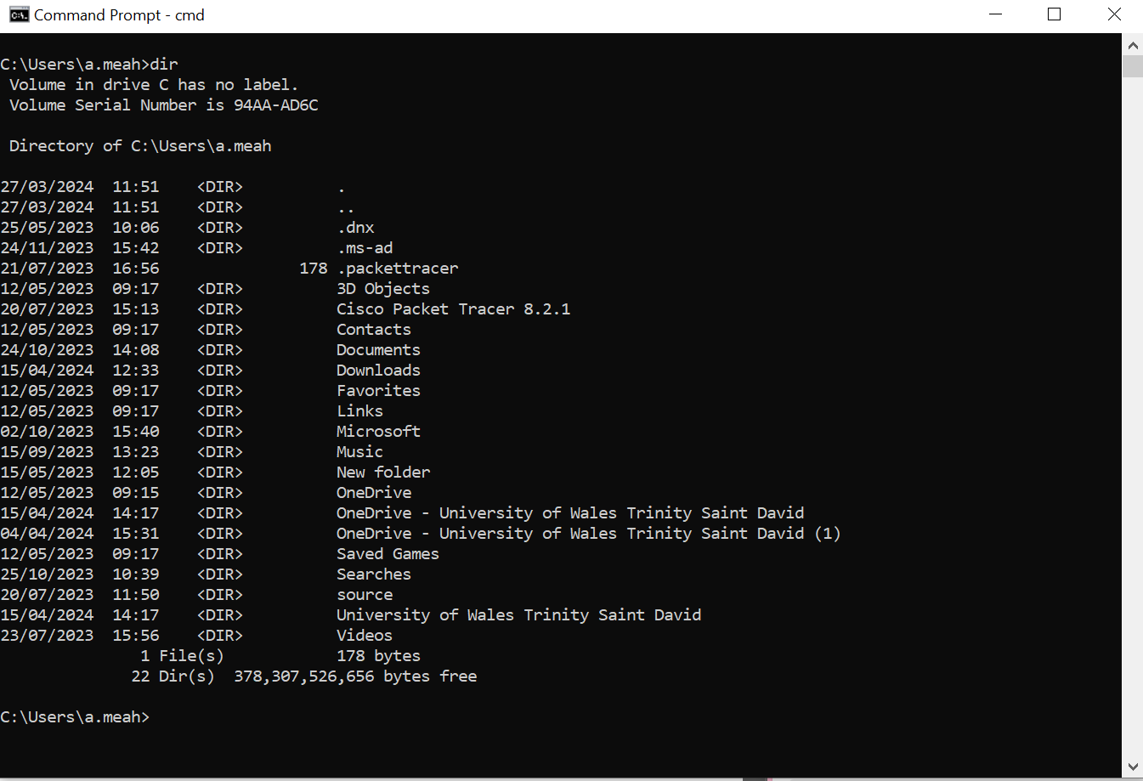
Figure 10
In figure 10 I have used the ‘dir’ command. This command when used without options will display information about the current directory [7].

Mkdir
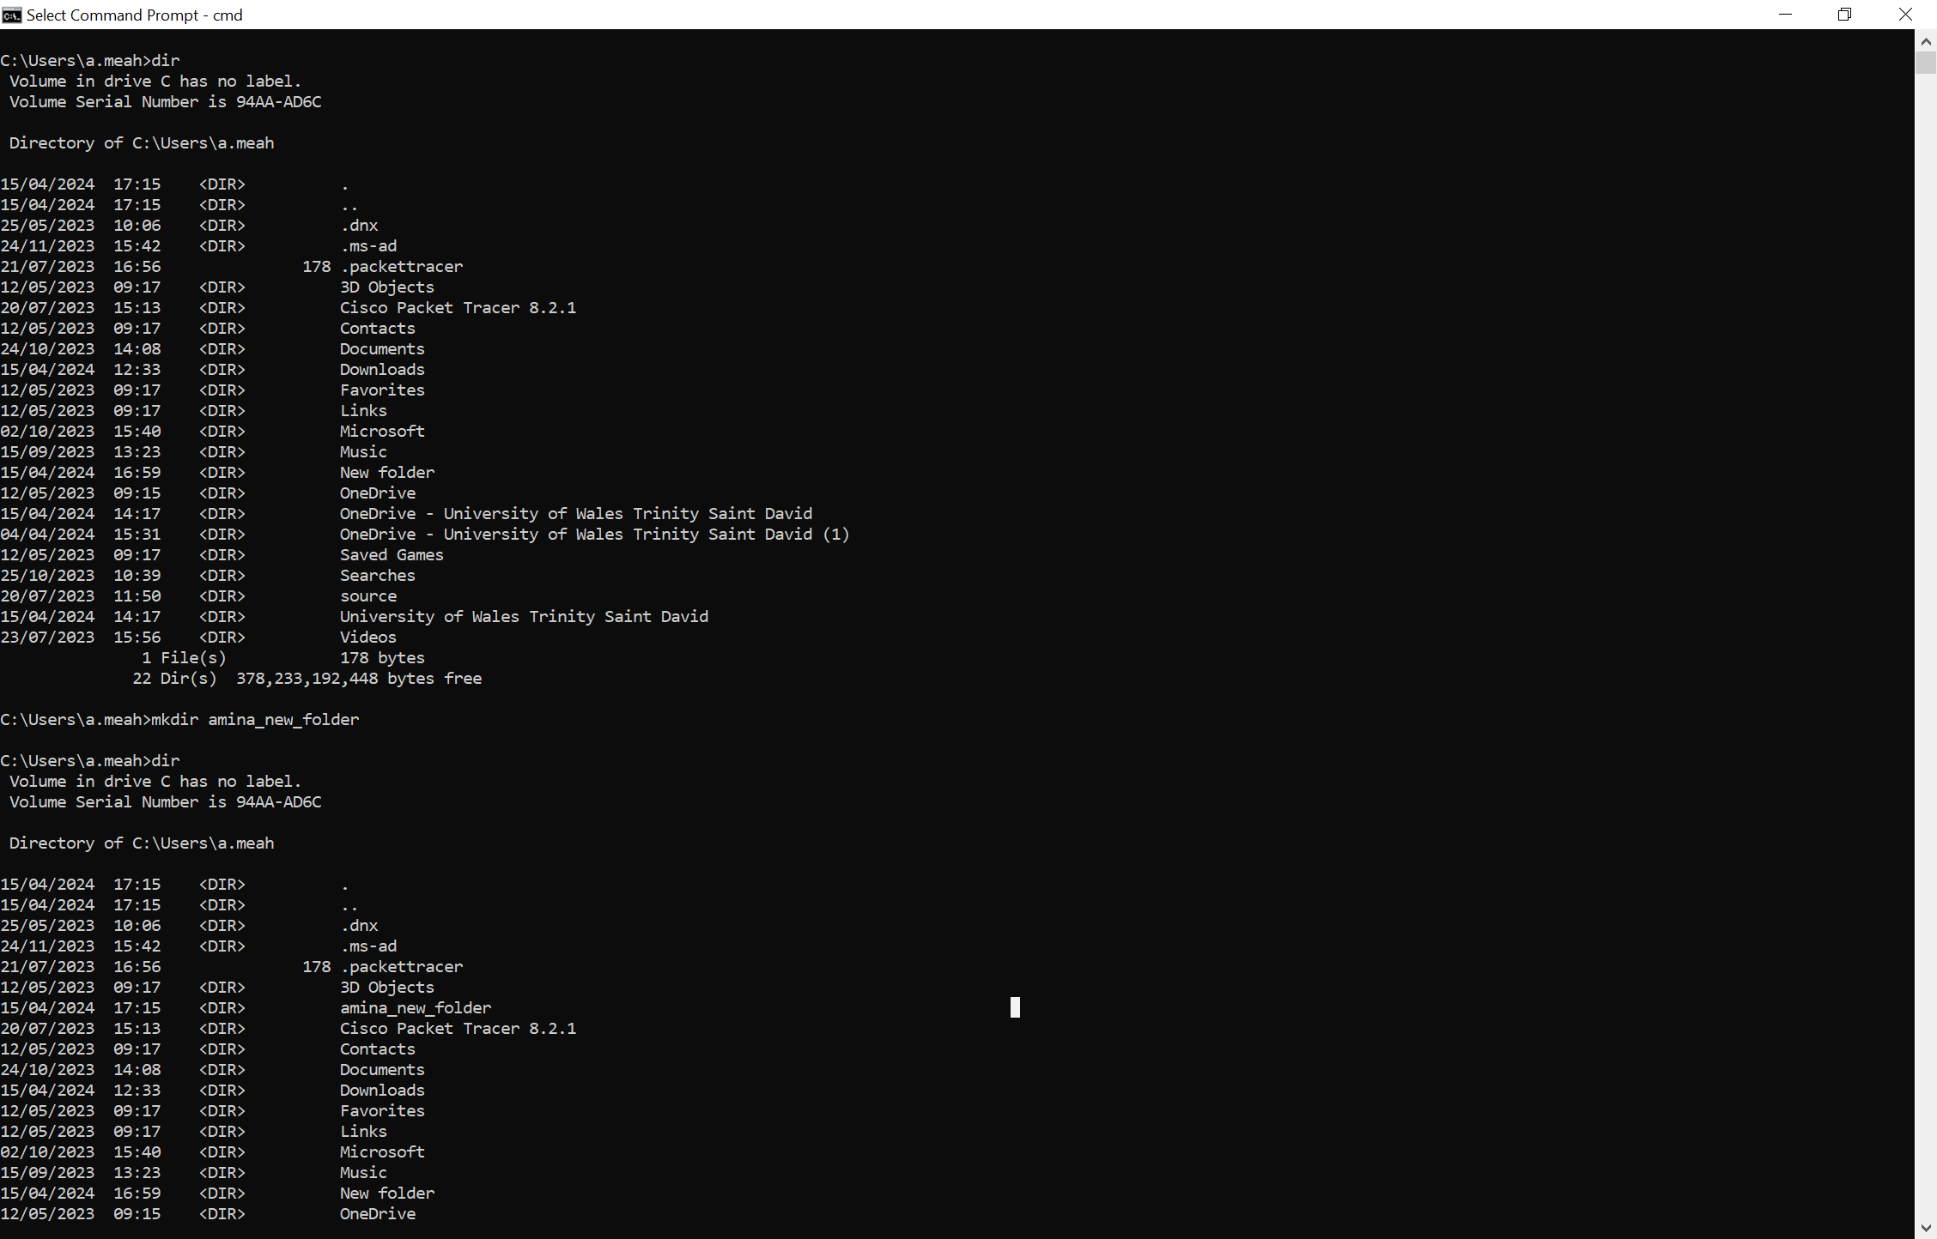
Figure 11
In figure 11 I have used the ‘Mkdir’ command. This command creates a folder with the name you specify [8]. Figure 11 shows my directories before I used the command and after to show the new folder in my C drive.

Whoami
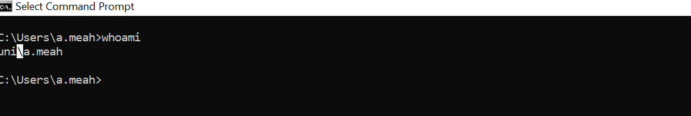
Figure 12
In figure 12 I have used the ‘whoami’ command this shows which user is currently logged into the system [9]. After running this command, it showed ‘uni\a.meah’ as the user logged in.

Tasklist
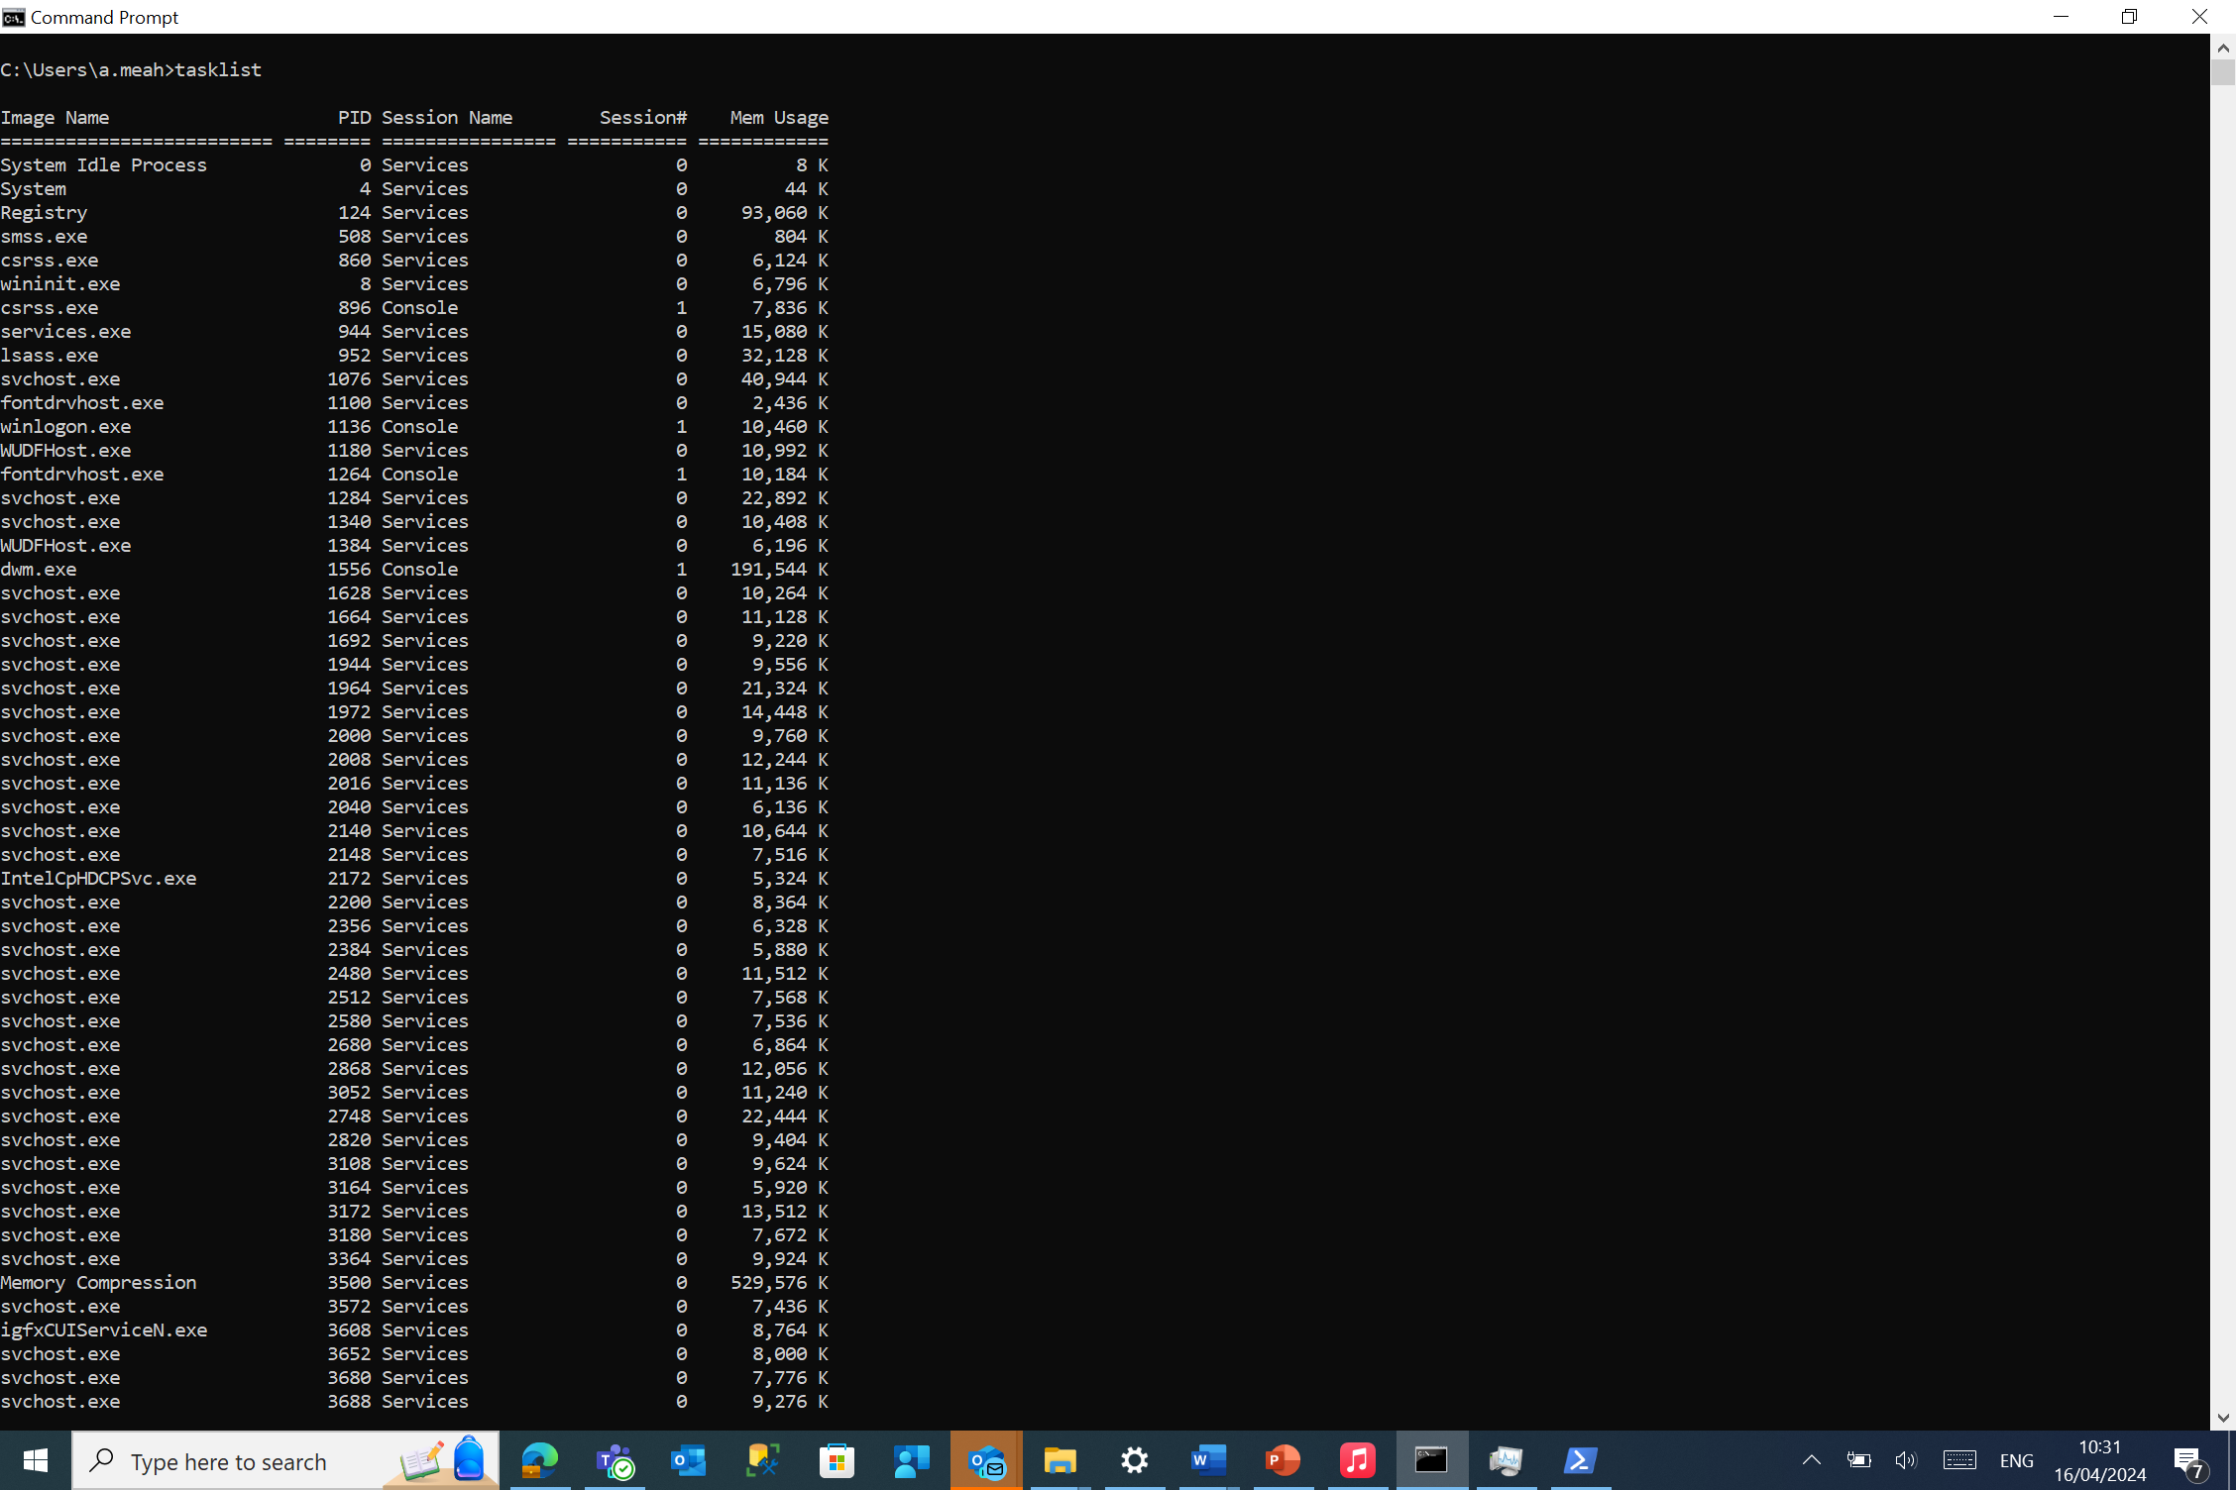
Figure 13
In figure 13 I have used the command ‘Tasklist’ this command shows information about running task [9].

Powershell

Get-process
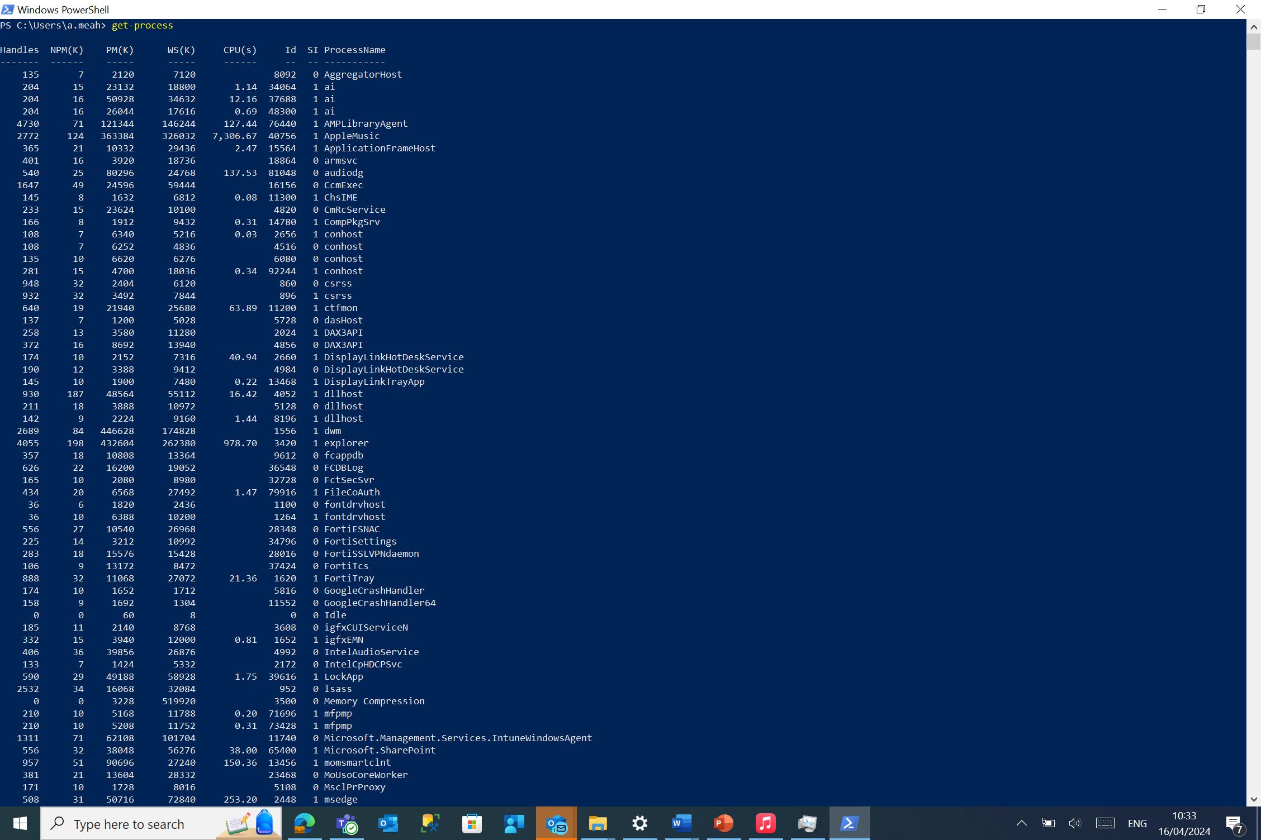
Figure 14
In figure 14 I have used the ‘Get-process’ command on windows PowerShell. This command allows me to see what processes are running on my local machine [10].

Get-service
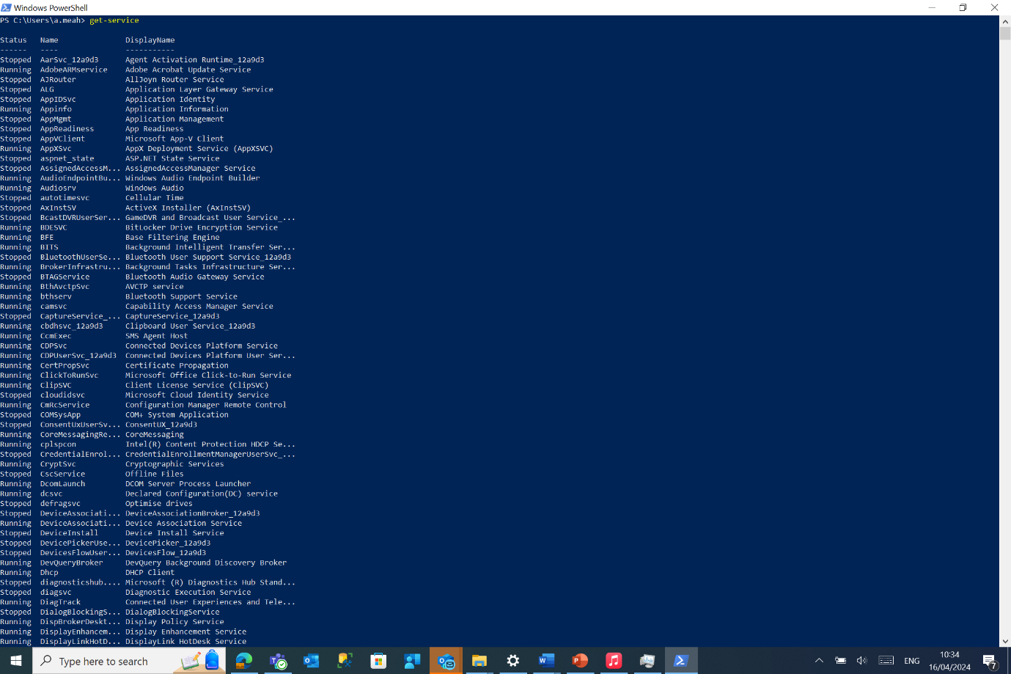
Figure 15
In figure 15 I have used the Get-service command. This command is used by the user to query services [9].

Get-help (get-process)
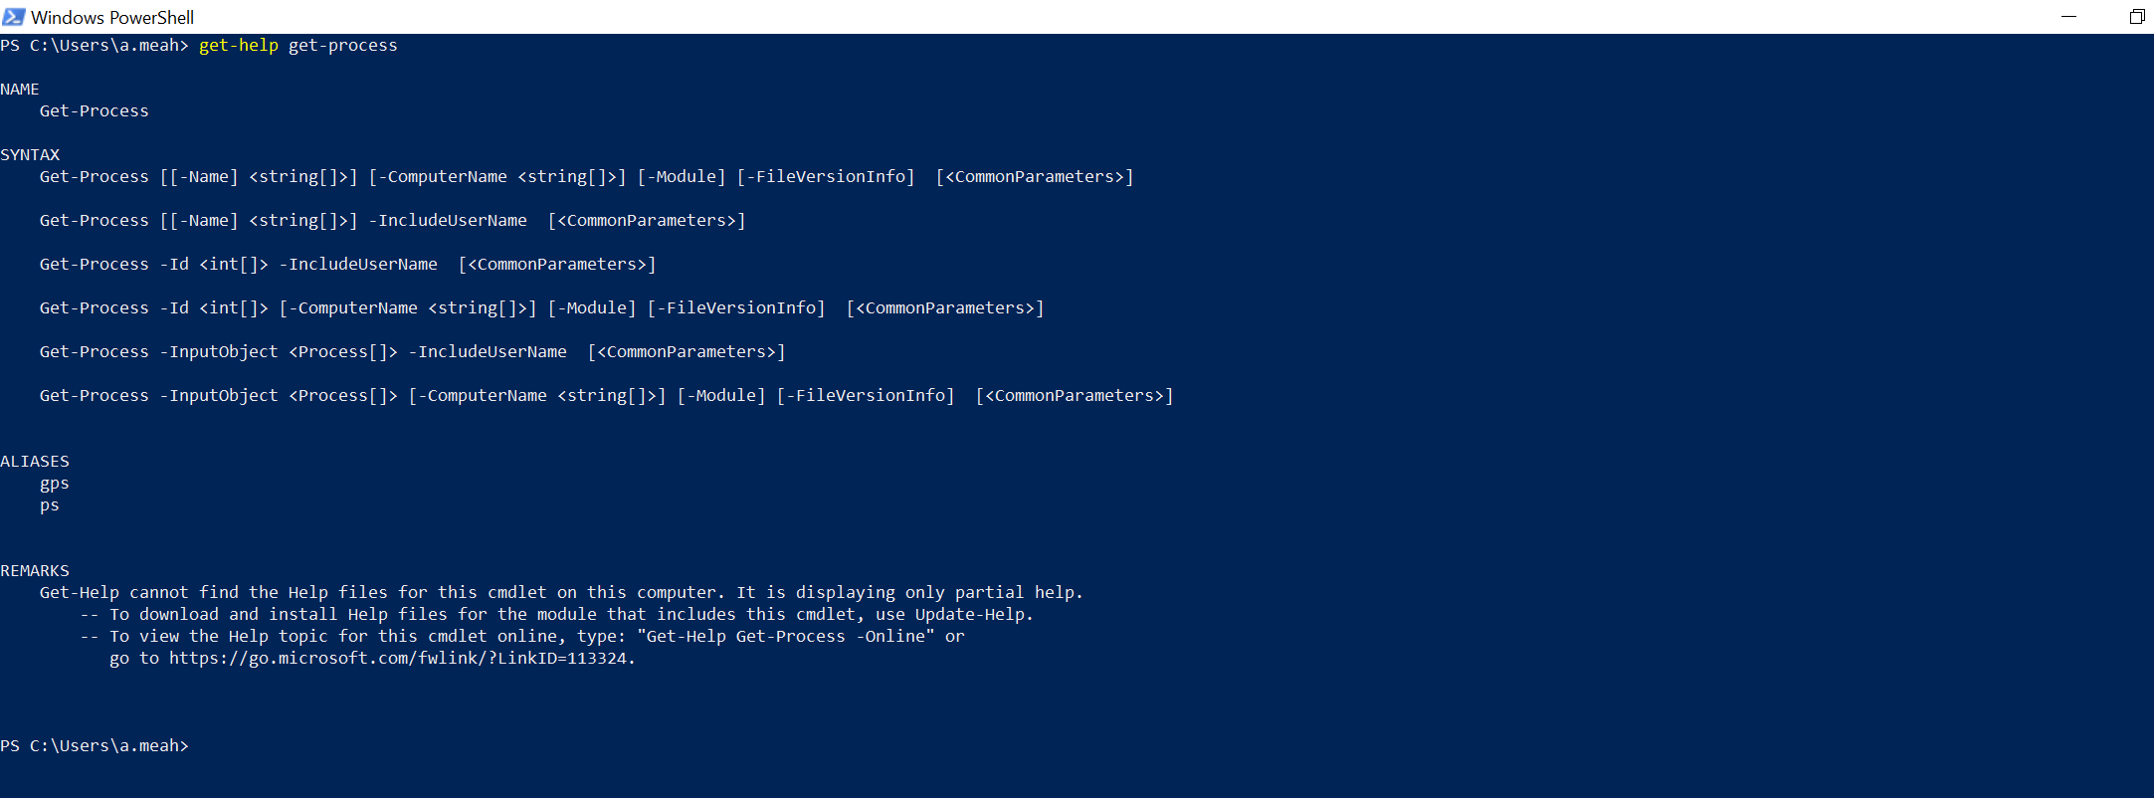
Figure 16
Figure 16 shows the ‘get-help’ command. I used this command with the parameter of finding help about the get-process command. The get-help command is used to get information about individual commands [10].

Get-child item
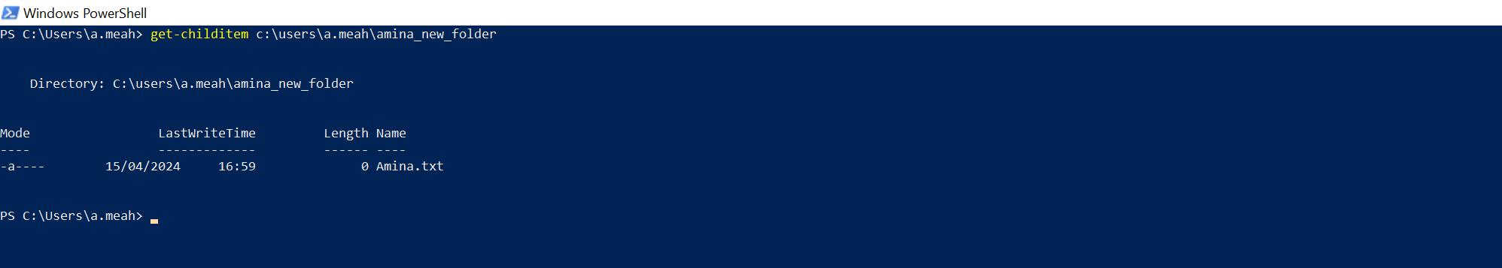
Figure 17
In figure 17 I have used the get-childitem command. This command allows the user to find information about the items in a specific folder [10]. I used it to find out what was in my folder named ‘amina_new_folder’.

Move-item
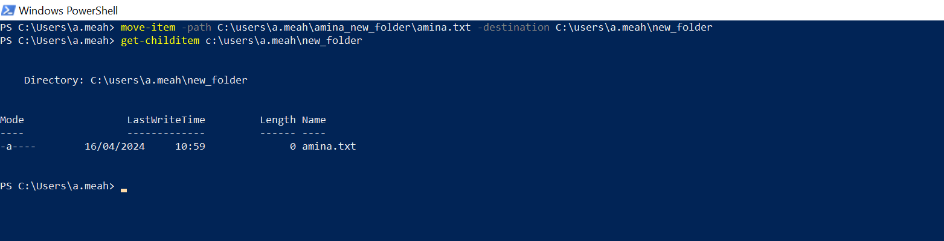
Figure 18
In figure 18 I have used the ‘move-item’ command to move my text file to a different folder. The move-item command moves an item from one location in the system to another location [11].

Use of Linux OS CLI commands

Bash Commands

pwd
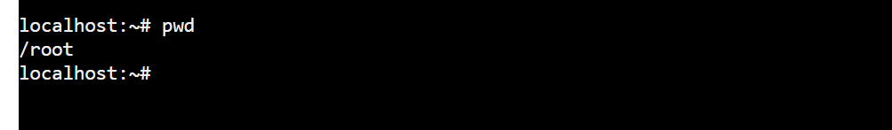
Figure 19
In figure 19 I have used the ‘pwd’ bash command. This command prints the current directory that I am in [12].

Ls
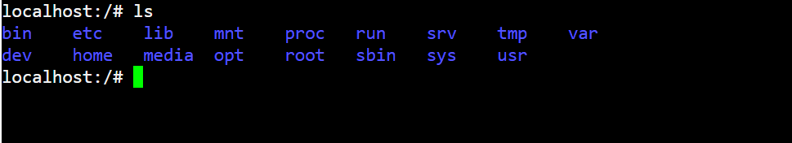
Figure 20
In figure 20 I have used the ‘Ls’ command. This command lists all the file and directories that are available in the directory I am in [13].

Cd home
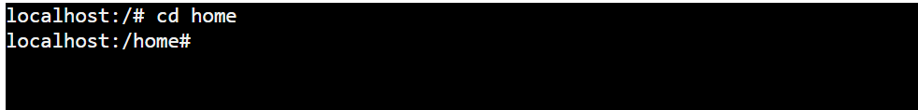
Figure 21
In figure 21 I have used the cd bash command. This command changes the current directory to the directory that the user asks for which in my case is the ‘home’ directory [13].

Mkdir
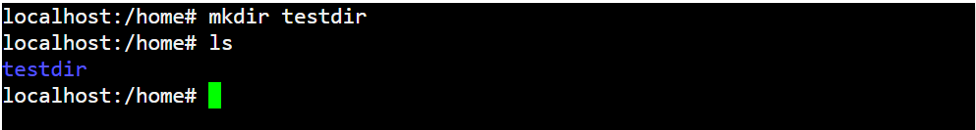
Figure 22
Figure 22 shows the ‘mkdir’ bash command. This command allows me to create a new directory with the name ‘testdir’ [13].

Touch
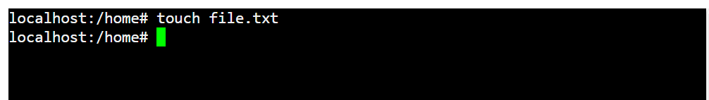
Figure 23
Figure 23 shows the touch bash command. Using this command you can create a blank file [14]. I used this command to create a blank text file named ‘file.txt’.

Echo
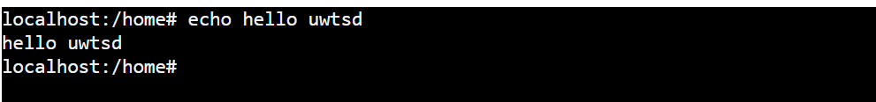
Figure 24
In figure 24 I have used the echo bash command. This command allows me to print text to the terminal window [12]. I used this command to print ‘hello uwtsd’.

Df
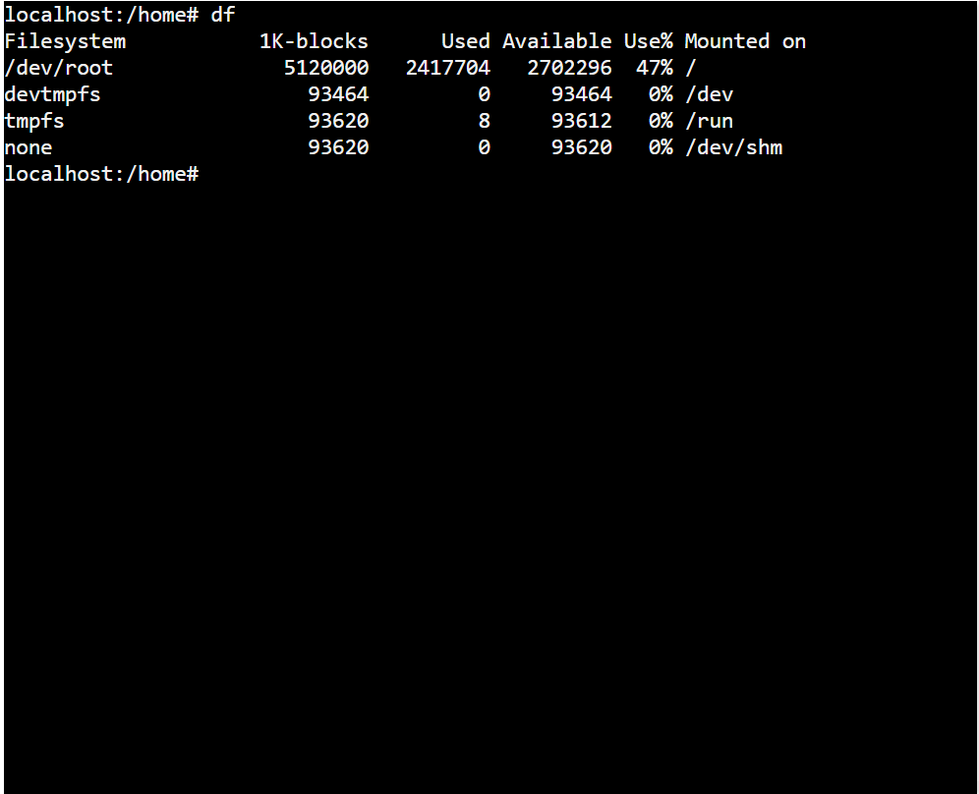
Figure 25
In figure 25 I have used the ‘df’ bash command. This command shows me the systems complete disk space usage [14].

History
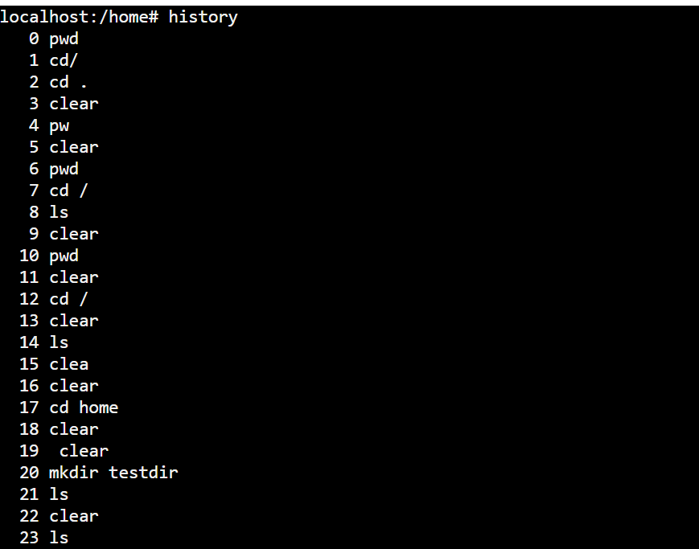
Figure 26
Figure 26 shows the ‘history’ command being used. This command allows me to view the previous commands that I have run [14].

Ifconfig
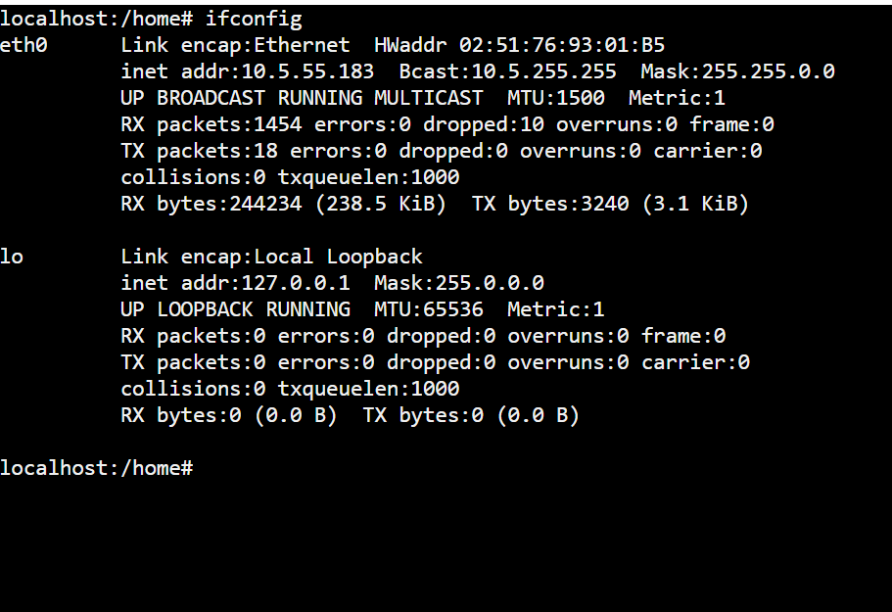
Figure 27
Figure 27 shows the ‘ifconfig’ being run without any parameters. This command shows me information about all the network interfaces that are currently being used in my system [15].

Clear
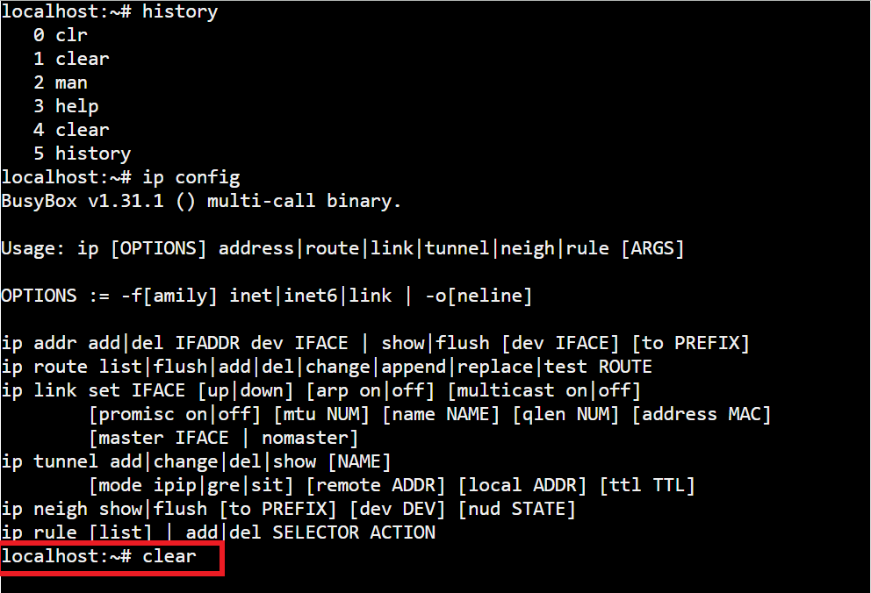
Figure 28
Figure 28 shows the clear command being used. This command will clear the command prompt screen once entered [14].

Use of Windows OS scripts

Variables
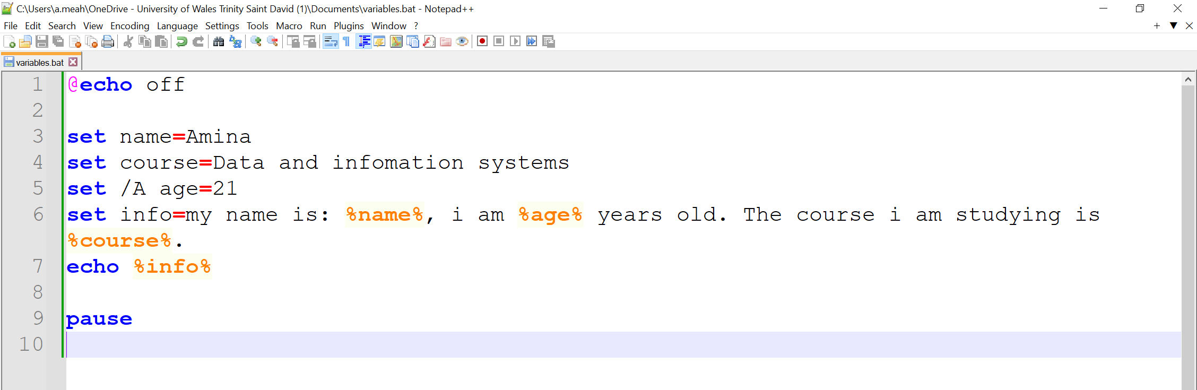
Figure 29
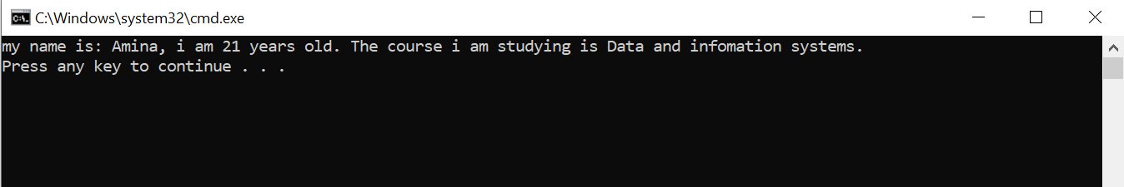
Figure 30
Figure 29 shows the batch script I created. It begins by setting up variables: "name" is assigned the value "Amina," "course" is assigned "Data and Information Systems," and "age" is assigned the numeric value 21. Variables store numbers and non-numeric values [16]. All these variables construct a string called "info". It then echoes the "info" string to the console. Figure 30 shows the execution.

Goto command
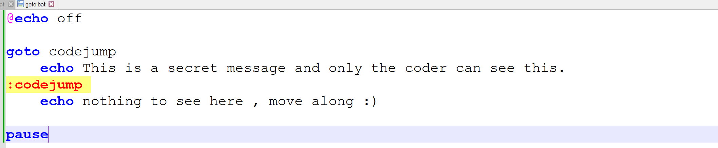
Figure 31
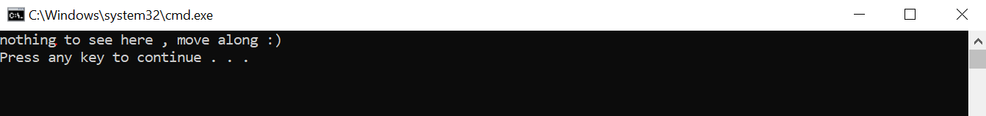
Figure 32
Figure 31 shows the script I created, the "goto" command directs the program's flow to a designated label named "codejump." However, before reaching that label, there's a line attempting to display a secret message, but it doesn't execute because it's not associated with any label. Once at the "codejump" label, the script prints "nothing to see here, move along :)" to the console before pausing. The "goto" guides the program's path to specific points based on predefined conditions or instructions [17].

User input /p switch and if else
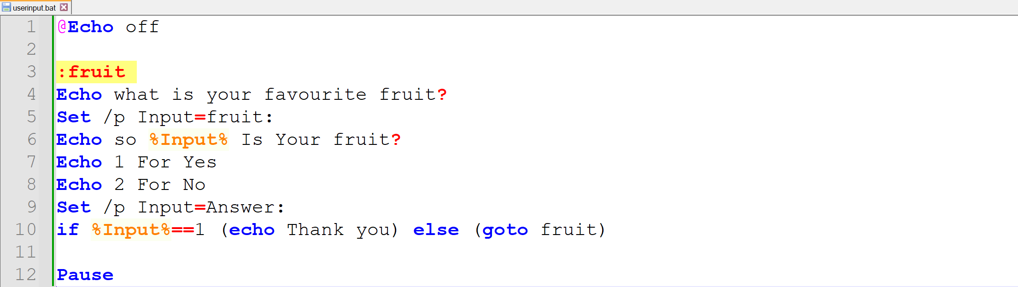
Figure 33
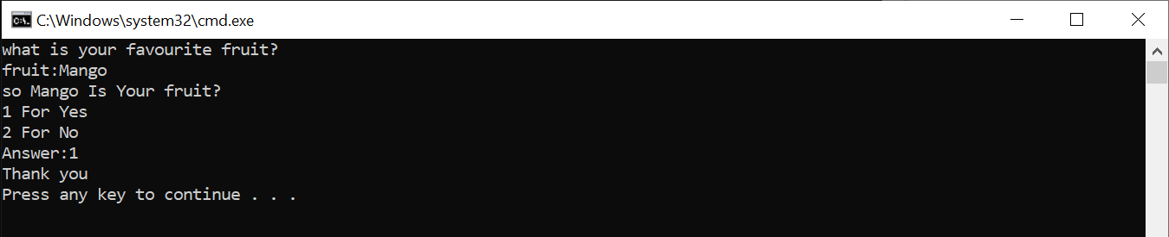
Figure 34
In this script shown in figure 33, the `Set /p` command with the `/p` switch is used to prompt the user for input. It allows the user to enter their favourite fruit, and the input is stored in the `%Input%` variable [18].
The `if` statement is then used to check the value of the `%Input%` variable [19]. If the value is "1", indicating that the user answered yes, the script echoes "Thank you". If the value is not "1", the script uses the `else` clause to return to the `:fruit` label, restarting the process of asking for the user's favourite fruit [19].

For loop
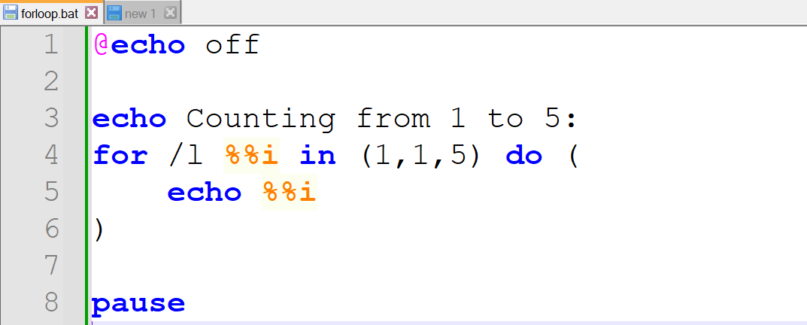
Figure 35
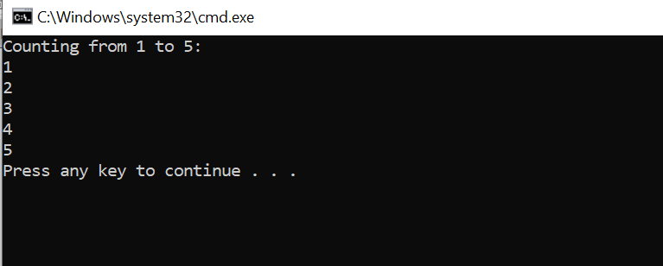
Figure 36
This batch script shown in figure 35 demonstrates a simple `for` loop in Windows Command Prompt. The loop iterates over a range of numbers from 1 to 5 and prints each number to the console. The loop iterates from 1 to 5 with a step size of 1. This script showcases the basic functionality of a `for` loop in batch scripting, providing a way to perform repetitive tasks efficiently [20].

array
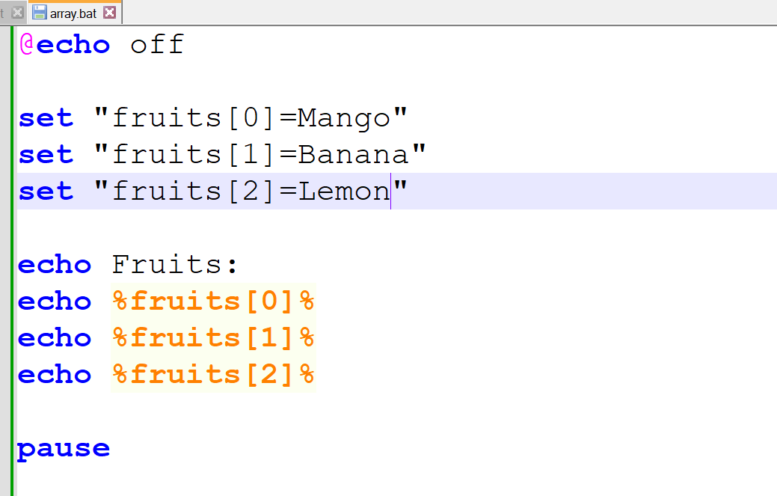
Figure 37
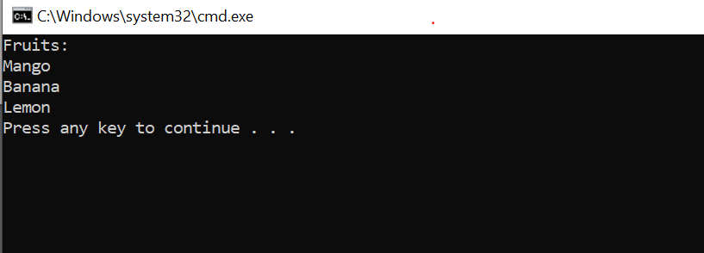
Figure 38
This batch script in figure 37 shows the use of arrays in Windows Command Prompt. Arrays provide a convenient way to store and access multiple values under a single variable name [21]. This script showcases how arrays can be used to organize and manage data efficiently in batch scripting, providing a structured approach to working with multiple values [21].

Function
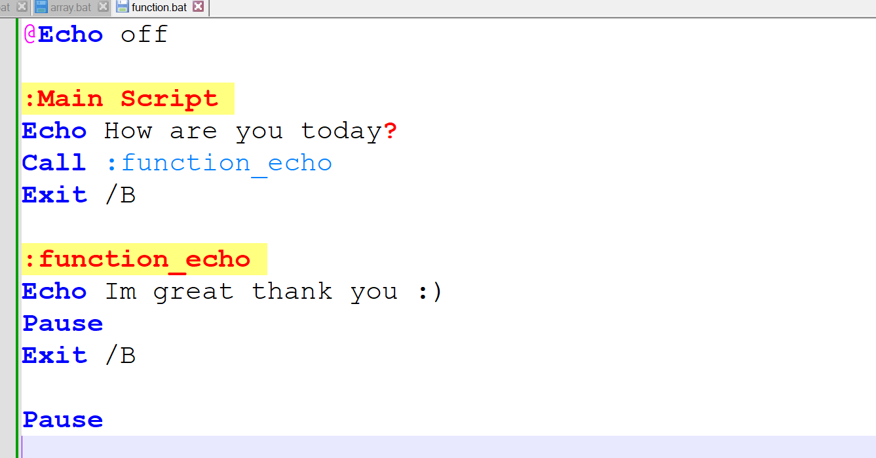
Figure 39
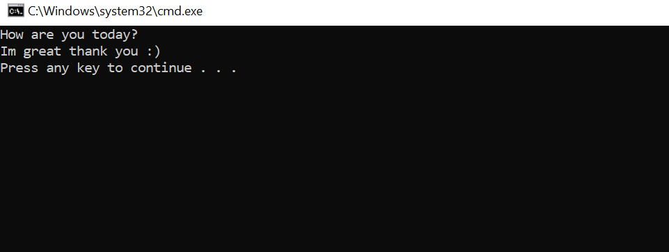
Figure 40
In this batch script shown in figure 39 , the `:function_echo` label defines a function called `function_echo`. This function prints "Im great thank you :)" when called. The `:Main Script` section invokes this function using the `Call` command, executing the echoed message. Functions in batch scripts enable code reuse and organisation, improving script readability and maintenance [22].

Use of Linux OS scripts

Variables
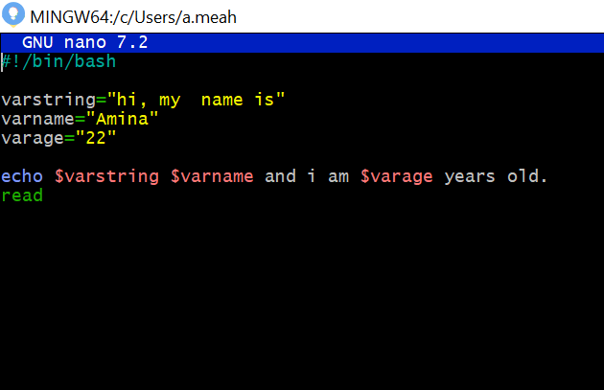
Figure 41
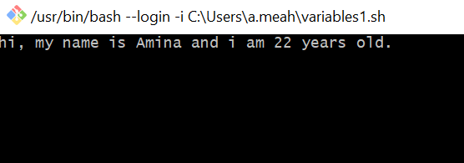
Figure 42
This Bash script In figure 41 introduces the variables `varstring`, `varname`, and `varage` to store a greeting phrase, a name, and an age, respectively. It then echoes these variables to form a complete sentence, introducing the name and age. Variables store information until they are needed [23].

User input
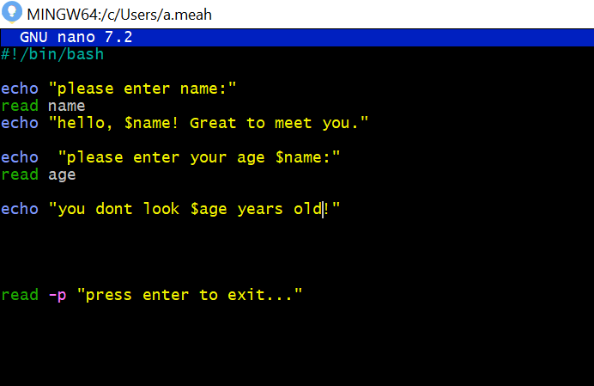
Figure 43
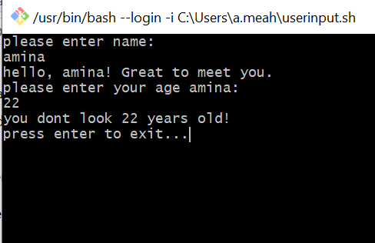
Figure 44
This Bash script shown in figure 43 prompts the user to enter their name using the `read` command, storing the input in the variable `name`. It then echoes a greeting message including the entered name. Next, it asks the user to input their age using `read` again, storing it in the variable `age`. The read command allows us to get user input [24].
If statement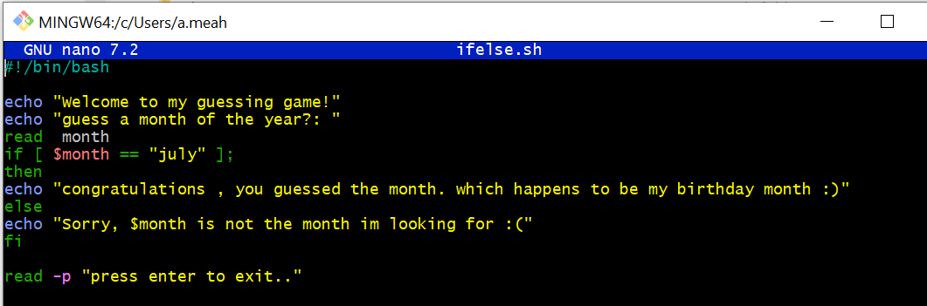
Figure 45
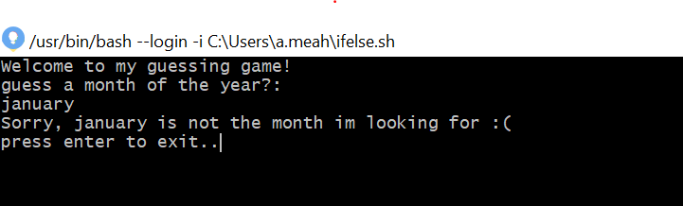
Figure 46

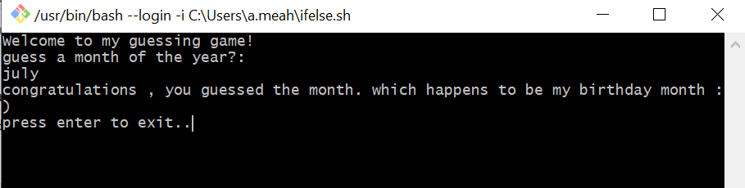
Figure 47
This Bash script shown in figure 45 is a simple guessing game where the user is prompted to guess a month of the year. After inputting their guess, the script checks if the input matches "july" using an `if` statement. If the input is "july", it congratulates the user. Otherwise, it informs the user that their guess was incorrect.

Until loop
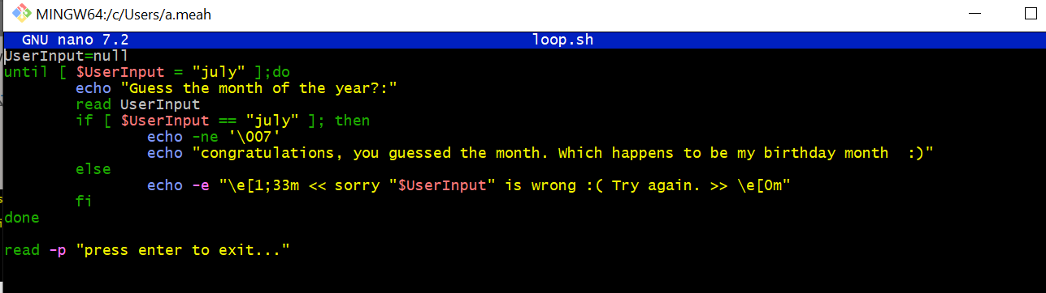
Figure 48
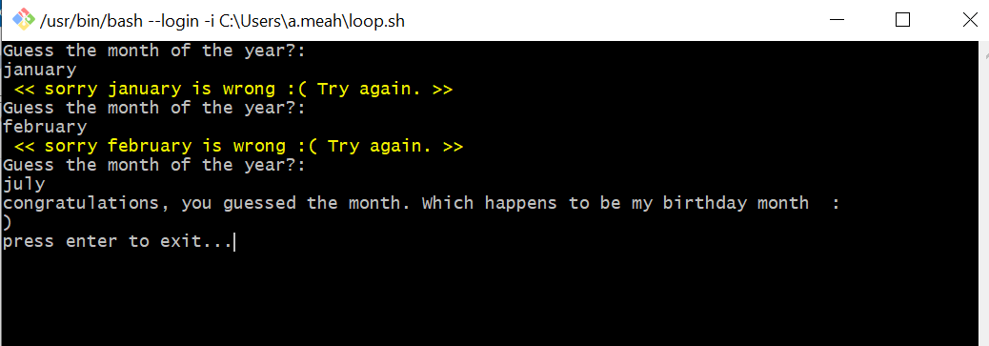
Figure 49
This Bash script implements a guessing game using a `until` loop. The loop continues until the user correctly guesses the month "july". The Until loop is used to repeat a block of commands until the required condition is met [25].

Array
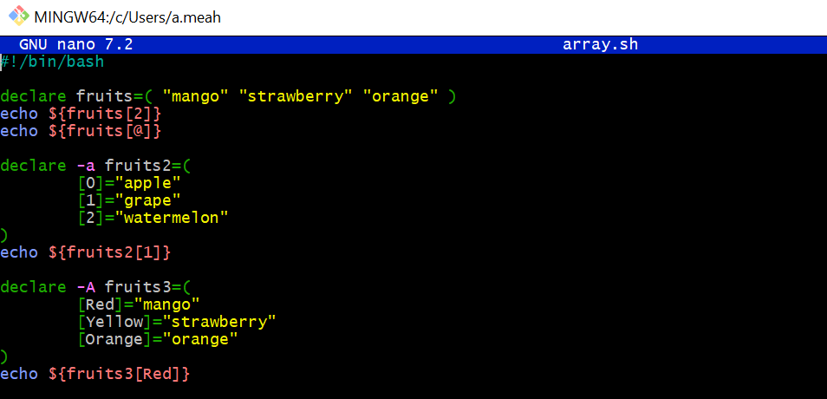
Figure 50
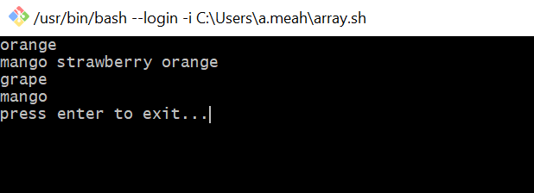
Figure 51
This Bash script shown in figure 50 shows the use of arrays. It starts by defining an indexed array, accessing, and printing its elements. Next, it demonstrates the creation of an indexed array with specific indices and retrieves and prints an element.

Case statement
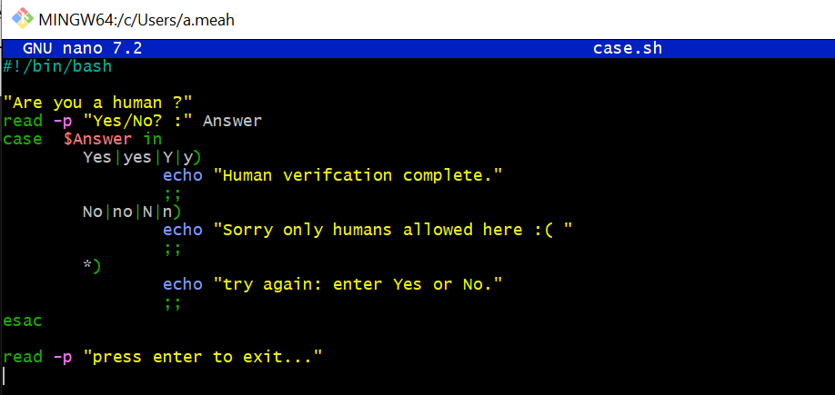
Figure 52
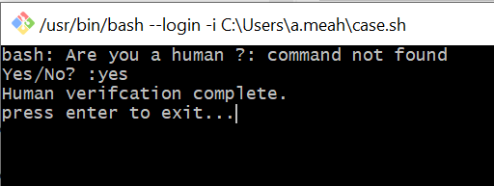
Figure 53
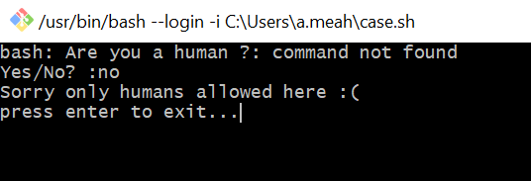
Figure 54
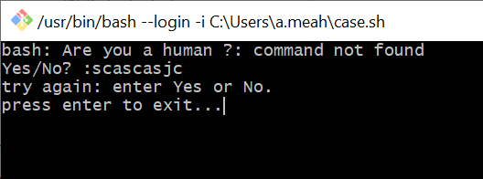
Figure 55
The script shown in figure 52 applies a case statement to handle user input for human verification. After the user responds with "Yes" or "No," the script checks the input using the case statement. In Bash scripts, a case statement is applied to make decisions based on multiple possible choices [26].
Function
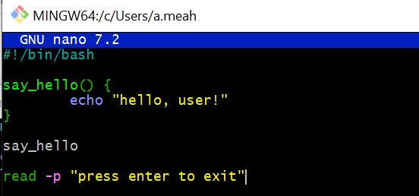
Figure 56
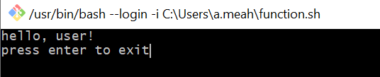
Figure 57
This script shown in figure 56 demonstrates the use of a function in Bash. The `say_hello` function is defined to echo the message "hello, user!" When the function is called with `say_hello`, it outputs the greeting. Finally, the script waits for the user to press enter to exit. A bash function is a way to bundle and name a set of commands so they can be easily reused later in a script [27].

Conclusion
In conclusion, the operating system acts as the central hub for computer functionality, orchestrating various critical tasks to ensure seamless operation. From managing memory allocation and processor scheduling to controlling input/output devices and maintaining file systems, it handles diverse responsibilities efficiently. Moreover, through functions like job accounting and error detection, it empowers administrators to monitor system performance effectively and address any issues promptly.
The use of CLI commands and scripting languages like Batch, PowerShell, and Bash provides users with powerful tools for system management and automation, enhancing productivity and facilitating streamlined workflows. Overall, the operating system is indispensable in modern computing, serving as the backbone that supports a multitude of applications and services while empowering users to accomplish tasks with ease and efficiency.

Reference list
[1] GfG, “Functions of operating system,” GeeksforGeeks, https://www.geeksforgeeks.org/functions-of-operating-system/ (accessed Mar. 15, 2024).
[2] M. Preston, "Operating System," July 05, 2023 (accessed Mar. 15, 2024).
[3] A. Sahu, S. Singh, and R. Chawda, "Research Paper on Operating System,", vol. 9, no. 6, Jun. 2021 (accessed Mar. 15, 2024).
[4] A. Singh, “Functions of operating system - shiksha online,” shiksha, January 23,2024 https://www.shiksha.com/online-courses/articles/functions-of-operating-system/ (accessed Mar. 15, 2024).
[5] “Functions of operating system: Definition, types of OS and examples,” Toppr, https://www.toppr.com/guides/computer-science/computer-fundamentals/operating-system/functions-of-operating-system/ (accessed Mar. 15, 2024).
[6] “Functions of operating system: Comprehensive guide,” EDUCBA, https://www.educba.com/functions-of-operating-system/ (accessed Mar. 15, 2024).
[7] M. Dancuk, “Windows CMD commands: Mastering the command prompt,” Knowledge Base by phoenixNAP, https://phoenixnap.com/kb/cmd-commands#ftoc-heading-23 (accessed Apr. 10, 2024).
[8] K. Chris, “Command line commands – cli tutorial,” freeCodeCamp.org, https://www.freecodecamp.org/news/command-line-commands-cli-tutorial/ (accessed Apr. 10, 2024).
[9] T. Carpenter, Microsoft Windows Operating System: Essentials. Indianapolis, IN: Wiley, 2012.
[10] A. Watt, Professional Windows Powershell. Indianapolis, IN: Wiley/Wrox, 2007.
[11]“Move-item - powershell command,” PDQ, https://www.pdq.com/powershell/move-item/ (accessed Apr. 10, 2024).
[12] “Bash cheat sheet: Top 25 commands and creating custom commands,” Educative, https://www.educative.io/blog/bash-shell-command-cheat-sheet (accessed Apr. 12, 2024).
[13] B. Marijan, “Bash commands: The ultimate cheat sheet + downloadable pdf,” Knowledge Base by phoenixNAP, https://phoenixnap.com/kb/bash-commands#ftoc-heading-3 (accessed Apr. 12, 2024).
[14] V. C., “60 essential linux commands + free cheat sheet,” Hostinger Tutorials, https://www.hostinger.co.uk/tutorials/linux-commands (accessed Apr. 12, 2024).
[15] “Linux ifconfig command help and examples,” Computer Hope, https://www.computerhope.com/unix/uifconfi.htm (accessed Apr. 13, 2024).
[16] T. Hill, “Chapter 2: VBScript Language Essential,” in Windows Script Host, 1999, pp. 31–33
[17] JasonGerend, “Goto,” Microsoft Learn, https://learn.microsoft.com/en-us/windows-server/administration/windows-commands/goto (accessed Apr. 14, 2024).
[18] GfG, “Batch script - input / output,” GeeksforGeeks, https://www.geeksforgeeks.org/batch-script-input-output/ (accessed Apr. 15, 2024).
[19] “Batch script - if/else statement,” Tutorialspoint, https://www.tutorialspoint.com/batch_script/batch_script_if_else_statement.htm (accessed Apr. 15, 2024).
[20] “Batch script - looping through ranges,” Tutorialspoint, https://www.tutorialspoint.com/batch_script/batch_script_looping_through_ranges.htm (accessed Apr. 15, 2024).
[21] “Batch script - arrays,” Tutorialspoint, https://www.tutorialspoint.com/batch_script/batch_script_arrays.htm (accessed Apr. 15, 2024).
[22] “Batch script - functions with parameters,” Tutorialspoint, https://www.tutorialspoint.com/batch_script/batch_script_functions_with_parameters.htm (accessed Apr. 15, 2024).
[23] R. Chadwick, “Bash scripting tutorial - 2. variables,” A collection of Technology Tutorials, https://ryanstutorials.net/bash-scripting-tutorial/bash-variables.php (accessed Apr. 15, 2024).
[24] GeeksforGeeks, “Bash script - read user input,” GeeksforGeeks, https://www.geeksforgeeks.org/bash-script-read-user-input/ (accessed Apr. 15, 2024).
[25] GeeksforGeeks, “Bash scripting - until loop,” GeeksforGeeks, https://www.geeksforgeeks.org/bash-scripting-until-loop/ (accessed Apr. 15, 2024).
[26] GfG, “Bash scripting - case statement,” GeeksforGeeks, https://www.geeksforgeeks.org/bash-scripting-case-statement/ (accessed Apr. 15, 2024).
[27] M. Dancuk, “Bash function & how to use it {variables, arguments, return},” Knowledge Base by phoenixNAP, https://phoenixnap.com/kb/bash-function (accessed Apr. 15, 2024).
[28] “5 most popular operating systems,” Western Governors University, https://www.wgu.edu/blog/5-most-popular-operating-systems1910.html (accessed Apr. 15, 2024).
[29] “Intro to real-time operating systems (RTOS),” Wind River, https://www.windriver.com/solutions/learning/rtos (accessed Apr. 15, 2024).
[30] GfG, “Types of operating systems,” GeeksforGeeks, https://www.geeksforgeeks.org/types-of-operating-systems/ (accessed Apr. 15, 2024).

Appendices
- Tutorial Activity on OS Types from OS Tutorial 1
There are many types of operating systems, catering to different preferences and needs of users. Microsoft Windows, with its long history and regular updates, remains a popular choice due to its compatibility with various software and continuous improvements in user experience [28]. Mobile operating systems such as Apple macOS, known for its sleek interface and seamless integration with Apple products, provides a user-friendly experience appreciated by many [28]. Google's Android OS leads the mobile market, offering a customizable and feature-rich platform for smartphones and tablets. Apple iOS, exclusive to iPhones, stands out for its intuitive touch gestures and seamless device connectivity [28]. Linux, being open-source and highly customizable, appeals to tech enthusiasts and professionals seeking flexibility and control over their operating system. A real-time operating system (RTOS) is recognized by its emphasis on predictability and determinism [29]. Unlike general-purpose operating systems, where task execution times can vary widely, an RTOS ensures that tasks are performed within precise time constraints, leading to consistent and predictable outcomes [29]. Another type of operating system is the Network Operating System which runs on servers and facilitates centralised management of data, users, and networking functions, allowing shared access to resources over a network[30]. Distributed Operating System are another type of operating system which coordinates communication and resource sharing among interconnected computers over a network, enhancing scalability, fault tolerance, and resource utilization[30]. Batch Operating Systems operate without direct user interaction, grouping similar tasks into batches for efficient processing. Examples include payroll systems and bank statements [30]. Each OS has its strengths and caters to different user preferences, ensuring a diverse ecosystem of options for consumers.

- Evidence of engagement with 1 online certified course

I have been learning powershell using the LinkedIn learning course that is available. Below are screenshots of some engagement I have had with this course. I am enjoying learning more about powershell and I am hoping to complete this course during the summer.



