BMIH5003: Foreign Languages and Cultural Awareness

Student Name: Shamima Begum
Student ID: 2130973
Module Code: BMIH5003
Lecturers Name: Rodrigo Fernandes Aguilera

Executive Summary
The hotel personnel can increase their sensitivity and cultural knowledge when interacting with guests from different nations, notably those from Finland, with the use of this handbook. Understanding and adapting to the cultural differences, customs, and behaviours of Finnish visitors can help hotel workers create a more welcoming and inclusive atmosphere. The implications for culture and suggested tourist services for Finnish guests are the main subjects of this study. To ensure positive customer experiences and promote constructive relationships, a list of "Do's and Don'ts" is provided.

Table of Contents
Introduction 4
Understanding Cultural Intelligence and Sensitivity 5
Cultural Implication 5
Key Cultural Differences, Customs, and Behaviour of Finland 6
Dos and Don’ts 8
Conclusion 10
Recommendation 11
References 12

Introduction
In today's globalized world, the hotel industry is essential for welcoming and hosting foreign visitors. If hotel employees want to provide exceptional customer experiences, they must have the ability to comprehend and be sensitive to cultural differences. The ability to understand and accept the cultural differences, traditions, and behaviour of international tourists is essential for a successful and pleasurable stay. This hotel handbook's objective is to arm hotel staff with the knowledge and insight necessary to effectively plan for and oversee the guest experience for visitors from abroad. By critically evaluating applicable cross-cultural ideas and models, we may better understand why cultural sensitivity and intelligence are essential qualities for hotel employees. The purpose of this study is to assist hotel staff in planning for and overseeing the experience of foreign visitors.

Understanding Cultural Intelligence and Sensitivity
The ability to interact with, comprehend, and adapt to persons from different cultural backgrounds is referred to as "cultural intelligence". It contains all of the knowledge, skills, and attitudes necessary to overcome cultural barriers and forge close relationships (Trang, 2019). Cultural intelligence is crucial in the hospitality industry if hotel staff members are to provide wonderful guest experiences to travellers from all over the world.
Cultural intelligence and sensitivity go hand in hand. It requires being considerate of and mindful of the cultural norms, traditions, and values of guests from different cultures (Aren, 2016). By adopting cultural sensitivity, hotel workers may create a welcoming, inclusive environment where guests feel appreciated and understood.

Cultural Implication
When servicing Finnish visitors, hotel personnel should take into account certain consequences because Finland is a nation renowned for its distinctive cultural history. Hotel staff can personalize their services and provide Finnish visitors a special experience by being aware of these cultural quirks.
1. Communication Styles and Etiquette: Communication in Finland is typically straightforward, brief, and basic (Zin, 2020). Honesty is prized, and Finns place a premium on accurate, truthful information. The aim of hotel staff should be to reply to inquiries accurately and concisely without making unneeded small talk. Furthermore, when conversing in Finland, it is important to respect others' personal space and avoid excessive physical touch.
2. Social Customs and Norms: In Finnish social customs, equality and modesty are highly regarded. When dealing with people, Finns may maintain a greater physical distance since they frequently value their personal space. Maintaining eye contact is regarded as a sign of respect and sincerity in addition to the traditional handshake (Awan, 2021). To make guests feel welcomed and valued, hotel staff employees should be aware of these customs and adapt their behaviour as needed.
3. Business Etiquette and Practices: Finland places a great value on efficiency, professionalism, and punctuality. Meetings are typically well-run affairs, and decision-making is frequently done by consensus. Hotel staff members should appear on time for any scheduled meetings or appointments with Finnish visitors (Baniya, 2017). When conducting business, it is important to respect people's privacy and avoid making intrusive queries.
The comparison of cultural dimensions between Chinese and Finnish hotel guests:
Cultural Dimensions | Chinese Hotel Guests | Finnish Hotel Guests
Power Distance | High | Low
Individualism | Collectivist | Individualist
Masculinity | Emphasized | Balanced
Uncertainty Avoidance | High | Low
Long-Term Orientation | Present | Short-term
Indulgence | Restraint | Restraint

Table 1: Comparison of cultural dimensions
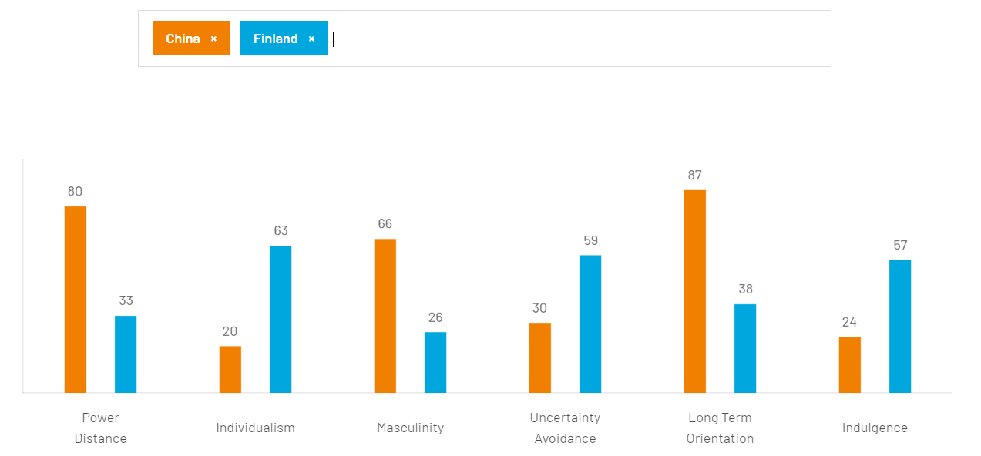
Figure 1: Comparison between China and Finland
Source: (Insights, 2023)

Key Cultural Differences, Customs, and Behaviour of Finland
1. Personal Space and Privacy: Personal space and privacy are important to Finns. When interacting with Finnish visitors, hotel staff must show respect and keep a suitable distance. When visitors are in their rooms or public areas, refrain from unnecessary physical contact and respect their right to privacy.
2. Direct Communication Style: Communication in Finland is frequently plain and direct (Jeaheng, 2019). The communication style of hotel workers should be simple, direct, with correct information, and little to no small talk. Be ready to answer questions directly and do it in an open and sincere manner.
3. Punctuality and Efficiency: In both personal and professional dealings, Finns place a high priority on timeliness and effectiveness (Zin, 2020). Hotel staff should handle check-in procedures, room service, and other guest services quickly and effectively. Respect visitors' time and make an effort to respond to their requirements quickly.
4. Equality and Modesty: In Finnish society, equality is highly regarded. Hotel staff, who should also refrain from giving any guests special attention, should treat all guests equally. Avoid giving the hotel undue praise or making inflated claims about its amenities because modesty is also valued.
5. Personal Boundaries and Silence: Finns typically value privacy and silence. To maintain a calm and tranquil atmosphere, hotel employees should pay attention to noise levels in common areas and guest rooms. Respect people's privacy and refrain from prying or becoming overly familiar.
6. Saunas are an essential component of Finnish culture. In Finland, there are several hotels with guest saunas. Hotel employees should become knowledgeable about sauna etiquette and instruct visitors on how to use it properly. Observe the privacy and sauna preferences of visitors.
7. Finland places a lot of focus on environmental sustainability. The use of sustainable resources, trash management, and energy conservation should all be encouraged by hotel workers. Inform visitors about the hotel's environmental initiatives and invite their participation.
8. Nature and Outdoor Activities: Finland is known for its outdoor activities and natural beauty. To help customers arrange their activities, hotel employees should be educated about nearby tourist destinations, hiking trails, and outdoor activities (Aren, 2016). Inform visitors about local nature preserves, wildlife watching opportunities, and seasonal activities.
9. Respect for Cultural Holidays and Traditions: Cultural holidays and traditions are significant to Finns (Wu, 2017). The personnel at the hotel should be aware of the important Finnish holidays, festivals, and events and, when suitable, think about incorporating aspects of Finnish culture into the hotel's products or festivities.
10. Appreciating Silence and Privacy: Finns respect their personal space and alone time. Hotel workers should recognise the requirement for privacy and stillness (Yilmaz, 2018). Reduce noise, uphold calm, and make sure that guest rooms have sufficient soundproofing and privacy measures.

Dos and Don’ts
"Do's and Don'ts" for hotel staff when interacting with Finnish guests
Do's | Don'ts
Greet with a firm handshake and maintain eye contact | Invade personal space without consent
Respect personal space and avoid excessive contact | Engage in excessive small talk
Provide accurate and concise information | Make assumptions or stereotypes based on nationality
Prioritize punctuality for meetings and appointments | Be late for meetings or appointments
Appreciate Finnish cultural values | Disregard Finnish cultural norms and customs
Respect customs, like removing shoes if requested | Overdo personal compliments or exaggerate claims
Offer fresh and locally sourced food options | Serve food that lacks freshness or authenticity
Engage in professional and structured interactions | Rush or pressure during decision-making
Listen actively and attentively | Interrupt or speak over during conversations
Express gratitude and appreciation | Forget to bid farewell and express gratitude upon departure
Table 2: "Do's and Don'ts" for hotel staff

Conclusion
Hotel staff can successfully manage the guest experience for international tourists, particularly those from Finland, by adopting cultural intelligence, sensitivity, and practical application abilities. Hotels may create an atmosphere that respects and celebrates Finnish culture while offering excellent service by knowing the fundamental cultural distinctions, norms, and behaviours and putting them into practise. Finally, by building trusting relationships with Finnish visitors and ensuring their happiness throughout their stay, these efforts help to create a good and memorable guest experience.

Recommendation
1. Cultural Training and Education: Offer thorough cultural training and education programmes for hotel workers, concentrating on Finnish culture. Communication methods, social norms, business procedures, and cultural quirks unique to Finnish visitors should all be included in this course. By arming personnel with this information, they will be more equipped to comprehend and cater to Finnish visitors' demands, producing more individualised and excellent service.
2. Encourage staff members to actively interact with people from different cultures and advance their cross-cultural competency. This can be accomplished by encouraging staff interaction with visitors from different cultural backgrounds, planning hotel-wide multicultural events, and supporting exchange programmes. Staff members will become more skilled in navigating cultural differences, adjusting to guest preferences, and creating an inclusive and welcome environment for Finnish visitors by encouraging cross-cultural competency.

References
Aren, W., 2016. Understanding the customer experiences from the perspective of guests and hotel managers: Empirical findings from luxury hotels in Istanbul, Turkey.. Journal of Hospitality Marketing & Management, 25(4), pp. 395-424.
Awan, M. S. A. a. A. J., 2021. Implementing ‘cleanliness is half of faith’in re-designing tourists, experiences and salvaging the hotel industry in Malaysia during COVID-19 pandemic.. Journal of Islamic Marketing, 12(3), pp. 543-557.
Baniya, R. a. T. P., 2017. Hotel Attributes Influencing International Tourists’ Satisfaction and Loyalty. Journal of Tourism and Hospitality Education, 7(2), pp. 44-61.
Insights, H., 2023. https://www.hofstede-insights.com/country-comparison-tool?countries=china%2Cfinland, s.l.: s.n.
Jeaheng, Y. A.-A. A. a. H. H., 2019. Halal-friendly hotels: Impact of halal-friendly attributes on guest purchase behaviors in the Thailand hotel industry. Journal of Travel & Tourism Marketing, 36(6), pp. 729-746.
Jiang, Y. and Wen, J., 2020. Effects of COVID-19 on hotel marketing and management: a perspective article. International journal of contemporary hospitality management, 32(8), pp.2563-2573.
Lu, V.N., Capezio, A., Restubog, S.L.D., Garcia, P.R. and Wang, L., 2016. In pursuit of service excellence: Investigating the role of psychological contracts and organizational identification of frontline hotel employees. Tourism Management, 56, pp.8-19.
Mohamed, L.M., 2016. Assessing the effects of transformational leadership: A study on Egyptian hotel employees. Journal of Hospitality and Tourism Management, 27, pp.49-59.
Okumus, B., Taheri, B., Giritlioglu, I. and Gannon, M.J., 2020. Tackling food waste in all-inclusive resort hotels. International Journal of Hospitality Management, 88, p.102543.
Shin, H.H. and Jeong, M., 2020. Guests’ perceptions of robot concierge and their adoption intentions. International Journal of Contemporary Hospitality Management, 32(8), pp.2613-2633.
Xiang, K., Huang, W.J., Gao, F. and Lai, Q., 2022. COVID-19 prevention in hotels: Ritualized host-guest interactions. Annals of Tourism Research, 93, p.103376.
Trang, H. L. J. a. H. H., 2019. How do green attributes elicit pro-environmental behaviors in guests? The case of green hotels in Vietnam.. Journal of Travel & Tourism Marketing, 36(1), pp. 14-28.
Wu, M. P. P. a. D. W., 2017. How satisfying are Shanghai’s superior hotels? The views of international tourists. International Journal of Contemporary Hospitality Management, 29(4), pp. 1096-1115.
Yilmaz, Ö., 2018. Revisiting employee-guest interactions in hotels: An analysis of critical incidents.. Journal of Tourism, Heritage & Services Marketing, 4(2), pp. 17-23.
Zin, X., 2020. Guest satisfaction & dissatisfaction in luxury hotels: An application of big data. International Journal of Hospitality Management, 8(4), pp. 1023-1065.

