

Independent Project
Student NAME: Emriona Bushaj
Student ID: 2313944
Supervisor: Fahad Ahmed
Trinity saint david University of Wales (London Campus)

ABSTRACT
The digital transformation of cultural heritage has become increasingly significant in preserving, managing, and promoting historical assets in the modern era. This project presents the development of AlbaHeritage, a changemaker digital platform designed to transform how Albanian cultural heritage is managed and experienced.
Despite Albania's rich cultural heritage and increasing tourism potential, the current digital representation and management of heritage assets remain fragmented, underdeveloped, and largely static. Information is scattered across multiple websites, social media pages, and informal sources, resulting in inconsistent content, limited accessibility, and poor visibility for lesser-known heritage locations.
AlbaHeritage introduces a dual-layer structure consisting of a public user platform and an administrative dashboard. The public platform allows tourists, students, and researchers to browse and search heritage sites by name or location, view detailed information and image galleries, view the transport options available for each site, browse a directory of hotels, and submit reviews once registered. The administrative dashboard allows an authenticated administrator to securely manage heritage sites, images, hotels, and transport services through Create, Read, Update, and Delete (CRUD) operations, and to view and moderate the reviews submitted by tourists.
The platform is built using HTML, CSS, Bootstrap, and JavaScript for the presentation layer, PHP for the application layer, and MySQL for the data layer, and it runs within a local WAMP/XAMPP development environment. It aims to centralise heritage information, improve accessibility, support cultural preservation, and provide a scalable foundation on which further features, such as bilingual content and connected cultural routes, could later be built.

ACKNOWLEDGEMENT
I am very glad to take this opportunity to acknowledge all those who helped me in designing, developing, and successfully executing my project on “AlbaHeritage”.
I would like to extend my sincere thanks and gratitude to my Project Supervisor, Fahad Ahmed, for his valuable guidance, encouragement, and timely assistance throughout the development of this project.
I would also like to extend my thanks and gratitude to my Course In-charge, Renuga Jayakumar, without whose help and support this project would not have been possible.
I am thankful to the Head of the Department and the entire faculty of the University of Wales, Trinity Saint David (London Campus), for providing the necessary facilities and a supportive learning environment.
Finally, I would like to thank each and everyone who was directly or indirectly involved with this project report.
Thank You
Emriona Bushaj

INDEX
STUDENT DETAILS 2
ABSTRACT 3
ACKNOWLEDGEMENT 4
INDEX 5
1. INTRODUCTION 9
1.1 Aims 9
1.2 Objectives 10
1.3 Motivation 10
2. BACKGROUND READING / LITERATURE REVIEW 12
2.1 Research on the Problem Domain 12
2.2 Evaluating Existing Examples 12
2.3 Analysis on Tools Required 12
3. SOFTWARE DEVELOPMENT LIFE CYCLE 14
Phase 1 – Planning and Requirement Analysis 14
Phase 2 – System and Database Design 14
Phase 3 – Iterative Development 14
Phase 4 – Testing and Quality Assurance 15
Phase 5 – Deployment and Evaluation 15
4. ANALYSIS 16
4.1 Requirement Analysis 16
4.1.1 Functional Requirements 16
4.1.2 Non-Functional Requirements 16
4.2 Scope and Feasibility 17
4.3 UML Diagrams 17
Entity Relationship Diagram (ERD) 17
Context Level Diagram 18
Class Diagram 19
Use Case Diagram 20
Activity Diagram – Admin 21
Activity Diagram – User 22
4.4 System Requirements 23
Software Requirements 23
Hardware Requirements 23
4.5 Risk Analysis 24
Detailed Risk Mitigation 24
5. DESIGN 26
5.1 Website Design and Interface 26
5.2 Database Design 26
Admin Table 26
Heritage Site Table 27
Site Image Table 28
Hotels Table 29
Transport Services Table 29
Tourist Table 30
Review Table 31
5.3 Data Dictionary 32
6. IMPLEMENTATION 34
6.1 System Architecture 34
6.2 Project Structure 34
6.3 Main Modules 35
Database Connection Module (MySQLi) 35
Admin Authentication Module 35
Heritage Site Management Module (CRUD) 36
Search Module 36
Hotels Directory Module 36
Transport Module 37
Review Module 37
Input Handling and Security 37
6.4 Data Flow 37
6.5 Implementation of the Dual-Layer System 38
6.6 Selected Code Snippets 38
index.php – Home Page 38
dashboard.php – Admin Dashboard 38
edit_transport.php – Editing a Transport Service 38
tourist_register.php – Tourist Registration 39
tourist_login.php – Tourist Login 39
tourist_logout.php – Tourist Logout 39
7. TESTING 40
7.1 Types of Testing Performed 40
7.2 Test Cases 41
8. EVALUATION 43
8.1 Personal Evaluation 43
8.2 System Evaluation 43
Advantages 44
Limitations 44
9. FURTHER ENHANCEMENT 45
10. CONCLUSION 46
11. REFERENCES 47
12. APPENDICES – SCREENSHOTS 48
Home Screen 48
Admin Login Form 48
Add Heritage Site Form 48
Add Hotel Form 49
Explore Heritage Sites 49
Heritage Site Details 50
Tourist Registration Form 50
Tourist Login Form 51
Review Moderation (Admin) 51

1. INTRODUCTION
Travelling has become an important part of modern life, allowing people to explore new places, experience different cultures, and learn about the history and traditions of other countries. Whether travelling locally or internationally, most visitors rely on clear, reliable, and easily accessible information to help them plan their journeys and make informed decisions about which places to visit. In today's digital world, travellers expect to find this information quickly through online platforms that are simple to navigate, visually engaging, and regularly updated. When information is scattered across multiple websites or is incomplete, planning a trip can become confusing, time-consuming, and frustrating.
Albania is a country with a remarkable cultural and historical heritage that spans thousands of years. It is home to a wide variety of attractions, including medieval castles, archaeological parks, museums, ancient cities, traditional villages, religious monuments, and several UNESCO World Heritage Sites. These landmarks represent the country's rich history and cultural identity, attracting both domestic and international visitors each year. Despite the importance of these heritage sites, information about them is often spread across numerous independent websites, government pages, travel blogs, and social media platforms. As a result, users frequently struggle to locate consistent, accurate, and up-to-date information when planning their visits.
AlbaHeritage has been developed to address this problem by providing a single, web-based platform that brings together information about Albania's cultural heritage in one organised and user-friendly location. Instead of requiring visitors to search through multiple sources, the platform enables them to explore historical sites, discover cultural attractions, and access essential travel information through one structured digital system. The website is designed to provide an intuitive browsing experience, making it easier for users to search for destinations, view detailed information, and plan their journeys more efficiently.
In addition to supporting visitors, AlbaHeritage also includes a secure administrative dashboard that allows an authorised administrator to manage the website's content. This enables heritage information to be updated efficiently, ensuring that the platform remains accurate, relevant, and reliable over time. By combining an engaging public interface with an administrative management system, AlbaHeritage not only improves access to Albania's cultural heritage but also contributes to the preservation and promotion of these important historical assets in the digital age. The project aims to encourage greater awareness of Albania's rich heritage while providing both tourists and local communities with a modern, centralised platform that makes discovering and appreciating the country's cultural landmarks easier than ever before.

1.1 Aims
To design and develop an innovative web-based platform that transforms the accessibility, management, and user experience of Albanian cultural heritage through an interactive, dynamic, and scalable digital system. The platform is intended to serve two distinct groups at once: members of the public who wish to discover and explore heritage sites, and an administrator responsible for keeping the underlying information accurate and current.

1.2 Objectives
- Analyse existing digital heritage platforms and identify their limitations.
- Design a user-friendly and responsive interface using modern web technologies.
- Develop a functional, dynamic, web-based cultural heritage platform.
- Design and implement a relational database system using MySQL.
- Develop a secure administrative dashboard for dynamic content management.
- Implement interactive user features such as search, image galleries, and reviews.
- Provide a directory of hotels and transport options associated with heritage sites.
- Implement user registration and authentication for tourists to submit reviews.
- Conduct functional, usability, and database testing of the system.
- Evaluate the effectiveness of the system in addressing current digital heritage challenges in Albania.

1.3 Motivation
Although Albania is recognised for its rich history, diverse traditions, and significant cultural heritage, there is currently no single digital platform that brings together this information in a structured, organised, and user-friendly way. Information about historical landmarks, museums, archaeological sites, castles, religious monuments, and UNESCO World Heritage Sites is scattered across a variety of government websites, tourism pages, travel blogs, local organisations, and social media platforms. Because these sources operate independently, users often need to search through multiple websites to gather the information they need, making the process time-consuming and often confusing.
This lack of a centralised system creates several challenges for both visitors and the organisations responsible for promoting and preserving Albania's cultural heritage. Information can vary between sources, resulting in inconsistencies, missing details, or outdated content. Some heritage sites receive significant online attention, while many smaller or less well-known locations remain difficult to discover despite their historical and cultural importance. In addition, many existing platforms focus only on presenting basic information and provide limited opportunities for interactive exploration, efficient content management, or long-term digital development. The absence of a unified management system also makes it more difficult to maintain accurate records, update information regularly, and support future expansion as new heritage sites or tourism services become available.
The motivation behind the AlbaHeritage project is to overcome these limitations by developing a modern, scalable, and interactive web-based platform that makes Albania's cultural heritage more accessible to a wider audience. The platform has been designed not only to improve the experience of tourists, students, researchers, and local communities, but also to provide the administrator with a secure dashboard for managing and updating heritage information efficiently. By combining an engaging public website with an administrative management system, AlbaHeritage offers a practical solution that supports both cultural promotion and digital heritage management. This project also demonstrates how modern web technologies can be applied to solve real-world problems by improving the accessibility, organisation, and presentation of cultural information. Rather than existing solely as an academic prototype, AlbaHeritage has been designed with future development in mind, making it a realistic solution that could be expanded and adopted by tourism organisations, cultural institutions, or government authorities.

2. BACKGROUND READING / LITERATURE REVIEW

2.1 Research on the Problem Domain
The digitalisation of cultural heritage has become a significant area of research, particularly regarding accessibility, preservation, and public engagement. According to UNESCO, digital technologies provide opportunities for cultural institutions to preserve and share heritage resources more effectively while ensuring wider accessibility. [1]
Research by the OECD highlights that digital platforms play a key role in transforming how users interact with cultural content, moving from passive information consumption to interactive and user-centred experiences. This confirms the need for a system that is dynamic rather than static. [2]
These findings shaped the direction of AlbaHeritage. Rather than presenting cultural information as fixed pages that rarely change, the platform was designed so that content can be created and updated through a database-driven administrative dashboard, and so that visitors can actively search, browse, and contribute reviews. This reflects the shift from static publishing towards interactive, maintainable digital heritage systems described in the literature.

2.2 Evaluating Existing Examples
Existing systems such as English Heritage demonstrate effective approaches to digital heritage presentation through categorisation, multimedia integration, and structured navigation. However, these systems are often designed within highly resourced infrastructures and may not address the unique challenges faced by developing digital ecosystems such as Albania's. [1]
Existing digital heritage approaches within Albania are largely static and non-interactive. Most platforms focus primarily on displaying information rather than creating engaging and accessible digital experiences. Another major issue is the lack of administrative tools for efficient digital heritage management, as institutions often lack integrated systems that allow real-time updates, content organisation, structured management, and data consistency. To overcome these limitations and improve accuracy, the system needs to be computerised, with a single database acting as the authoritative source of information and a controlled interface through which that information is maintained.

2.3 Analysis on Tools Required
The literature and the review of existing systems indicate the necessity for several specific features and tools:
Responsive Interface: A responsive, interactive interface is required, because studies show that well-structured and accessible systems significantly improve usability for international and local audiences. [3]
- Administrative Dashboard: Effective backend management tools improve content organisation, data consistency, and long-term maintainability, which justifies building a dedicated administrative dashboard rather than editing static files.
Web Technologies: Modern web technologies such as HTML, CSS, Bootstrap, JavaScript, PHP, and MySQL are required to build the presentation, application, and data layers respectively. [4][5][6][7]
Based on this analysis, AlbaHeritage was implemented with HTML, CSS, Bootstrap, and JavaScript on the client side, PHP on the server side, and MySQL for persistent storage. Bootstrap was chosen specifically to deliver responsive layouts across desktops, tablets, and mobile devices with minimal custom styling, while PHP and MySQL provide a well-documented and widely supported combination for dynamic, database-driven web applications.
Taken together, the research and the review of comparable systems justify the central design decision behind AlbaHeritage: to build a database-driven platform with a clear separation between public browsing and administrative management. The literature points to interactivity, accessibility, and maintainability as the qualities that distinguish effective digital heritage systems from static websites, and comparable platforms show that categorisation, multimedia, and structured navigation improve the user experience. At the same time, the gap in the Albanian context, the absence of a single, well-maintained system, defines the specific opportunity this project addresses. These conclusions shaped both the functional requirements and the architecture described in the following chapters, ensuring that the design responds directly to documented needs rather than to assumptions.

3. SOFTWARE DEVELOPMENT LIFE CYCLE
For the development of the AlbaHeritage platform, an Iterative Agile Software Development Life Cycle (SDLC) was selected. Unlike traditional sequential models, such as the Waterfall model where testing only occurs at the very end, the Agile methodology supports the continuous iteration of development and testing throughout the entire project lifecycle.
This approach was well suited to the project because of its dual-layer architecture, which requires balancing the needs of a visually engaging, public-facing user interface with a secure, data-driven administrative dashboard. The Agile approach allowed the project to be broken down into manageable cycles, or sprints, ensuring that each independent module was systematically designed, developed, tested, and refined before moving on to the next. The main phases of the SDLC are described below.

Phase 1 – Planning and Requirement Analysis
The scope, feasibility, and core requirements of the platform were defined during this phase. Existing digital heritage platforms within Albania and internationally were analysed to identify their primary limitations, specifically noting that current local systems are highly fragmented, static, and lack administrative control. Comprehensive functional and non-functional requirements were then documented for both primary user groups: the public users, comprising tourists, researchers, and students, and the administrator responsible for maintaining content. Key requirements at this stage included dynamic search, interactive navigation, image management, and real-time content updates through a protected dashboard.

Phase 2 – System and Database Design
The architectural blueprint and visual layout of the platform were created in this phase. The relational database structure was mapped out as an Entity Relationship Diagram for MySQL and organised to reduce redundancy and handle the relationships between the main entities: Admin, Heritage Sites, Site Images, Hotels, Transport Services, Tourists, and Reviews. The project's three-tier logical architecture was finalised during this stage, explicitly separating the Presentation Layer, the Application Layer, and the Data Layer. The visual identity, using a heritage-themed colour palette and the Playfair Display and Poppins typefaces, was also defined here.

Phase 3 – Iterative Development
The design was transformed into a functional platform using HTML, CSS, Bootstrap, JavaScript, and PHP. Development progressed in sprints. The first sprint set up the basic web structure, routing, and the reusable MySQLi database connection module. The second sprint delivered the secure administrative dashboard, including full Create, Read, Update, and Delete operations for heritage sites and the logic for handling cover-image and multiple gallery-image uploads. The final sprint delivered the public-facing features: dynamic search by name or location, the hotels directory, the display of transport options on each site's detail page, tourist registration and login, and the review system.

Phase 4 – Testing and Quality Assurance
Basic testing occurred concurrently with development, and a dedicated testing phase was then carried out. Functional testing verified that core mechanisms, such as administrator authentication, CRUD operations, review submission, and dynamic search, worked correctly. Usability testing confirmed that the Bootstrap framework rendered responsive layouts across mobile, tablet, and desktop viewports and that navigation was intuitive. Database testing checked that records were stored and retrieved correctly and that foreign-key relationships, such as transport services linked to a heritage site, behaved as expected. Basic input-based security checks were also carried out on user input fields.

Phase 5 – Deployment and Evaluation
The completed prototype was deployed within the local development environment using a WAMP/XAMPP server for final integration testing and evaluation. A comprehensive evaluation confirmed that the dual-layer structure successfully centralised Albanian cultural heritage data and provided the required administrative controls, solving the problems identified in the initial problem statement and transitioning cultural heritage information from static presentation towards a dynamic and maintainable digital system.

4. ANALYSIS

4.1 Requirement Analysis
Requirement analysis defines precisely what the system must do and the qualities it must exhibit. The requirements below reflect the features that are actually implemented in the AlbaHeritage prototype, separated into functional requirements, which describe specific behaviours, and non-functional requirements, which describe overall qualities of the system.

4.1.1 Functional Requirements
User Features:
- Browse heritage sites and view their associated category and location.
- Search for heritage sites dynamically by name or location.
- View detailed heritage information and image galleries for each site.
- View the transport options available for a heritage site on its detail page.
- Browse and search a directory of hotels by name or location.
- Register for a tourist account and log in and out securely.
- Submit ratings and reviews for heritage sites once logged in.
- Explore featured heritage sites presented on the home page.
Admin Dashboard Features:
- Log into the administrative dashboard securely using session-based authentication.
- Add, edit, and delete heritage site information.
- Upload and manage a cover image and multiple gallery images per heritage site.
- Add, edit, and delete hotels in the hotel directory.
- Add, edit, and delete transport services linked to specific heritage sites.
- View and moderate reviews submitted by tourists by removing unwanted entries.

4.1.2 Non-Functional Requirements
- Responsive Design: The system must function effectively across desktops, tablets, and mobile devices, using the Bootstrap responsive grid.
- Usability: The platform must provide intuitive navigation, a consistent layout, and an accessible content structure.
- Performance: The platform requires reasonably fast page loading, efficient search results, and stable performance.
- Security: Passwords must be hashed, user input handled before use in queries, and the administrative dashboard protected so that unauthenticated users cannot reach it directly.
- Scalability: The architecture should support future expansion and additional digital services without a fundamental redesign.

4.2 Scope and Feasibility
The scope of the AlbaHeritage prototype was defined carefully so that it could be delivered to a working, testable standard within the available time. In scope are the public platform, the administrative dashboard, and the seven database tables, together with the features listed in the functional requirements: heritage-site management with images, a hotels directory, transport services tied to sites, tourist accounts, dynamic search by name or location, and reviews with moderation. Explicitly out of scope for this prototype, and therefore treated as future enhancements, are online booking and payment, live map integration, bilingual content, connected cultural routes, and category or region filtering.
The project was assessed as feasible on three grounds. Technically, the chosen stack of HTML, CSS, Bootstrap, JavaScript, PHP, and MySQL is mature, well documented, and runs on a standard local WAMP or XAMPP server, so no specialised infrastructure was required. Operationally, the dual-layer design mirrors how a real cultural institution would separate public browsing from staff content management, making the system realistic to operate. Economically, all the tools used are free and open, and the platform runs on ordinary hardware, which keeps the cost of development and future adoption low.

4.3 UML Diagrams
The Unified Modelling Language (UML) is a standardised visual modelling language used in software engineering to specify, visualise, construct, and document the artefacts of a software system. For the AlbaHeritage project, UML and data-modelling diagrams were used during the analysis and design phases to translate the functional requirements into clear, visual blueprints before coding commenced.

Entity Relationship Diagram (ERD)
The Entity Relationship Diagram is a structural representation of the AlbaHeritage platform's underlying MySQL database. It illustrates the logical structure of the database by mapping out the core entities and defining how they relate to one another: an administrator adds heritage sites and hotels; each heritage site has many images, requires transport services, and has many reviews; and each review is written by a tourist.
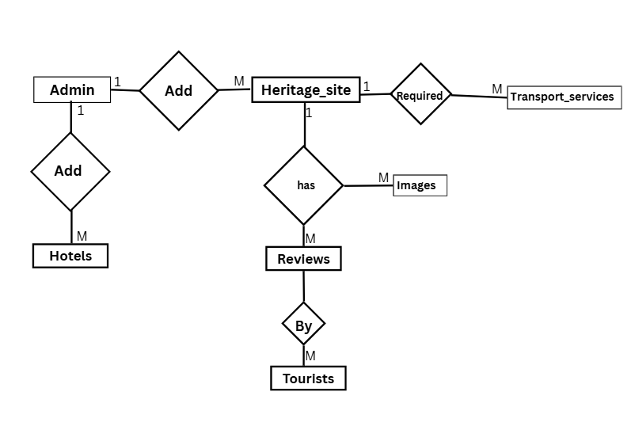
Figure 4.1 – Entity Relationship Diagram

Context Level Diagram
The Context Level Diagram, also known as a Level 0 Data Flow Diagram, provides the highest-level view of the AlbaHeritage system. It abstracts the entire platform into a single core process and maps out the external entities, or actors, that interact with it, along with the primary data flowing between them, such as the administrator adding heritage sites and hotels and tourists searching and giving reviews.
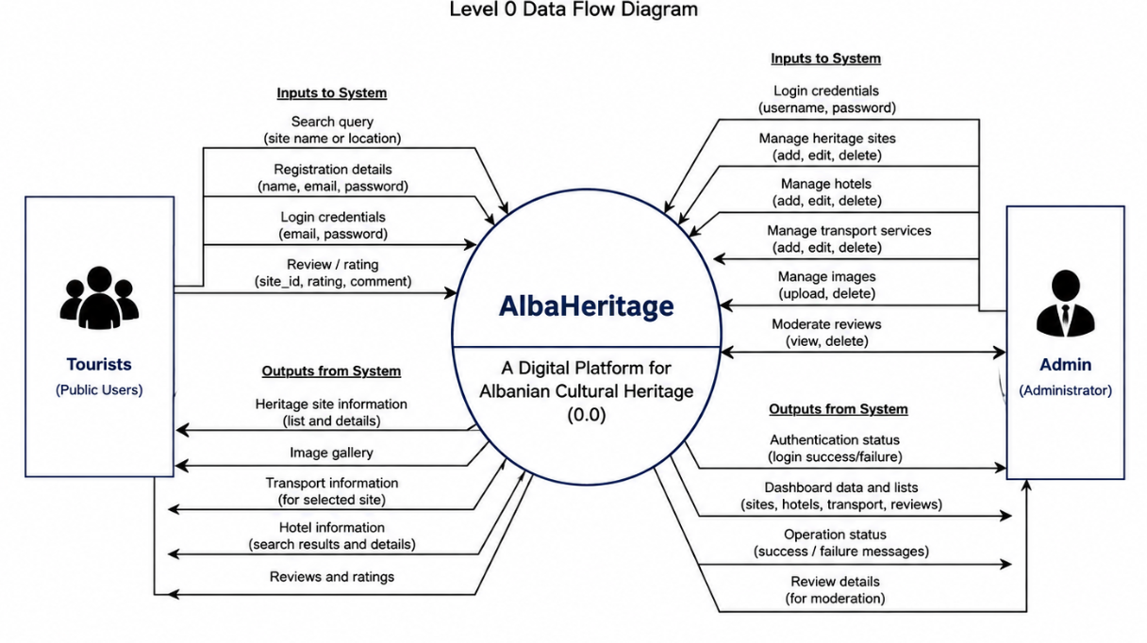
Figure 4.2 – Context Level Diagram

Class Diagram
While the Entity Relationship Diagram maps out the static database tables, the Class Diagram models the conceptual object-oriented structure of the application. It defines the system's core classes, their attributes, their operations, and the relationships between them, providing a bridge between the data model and the PHP logic that operates on it.
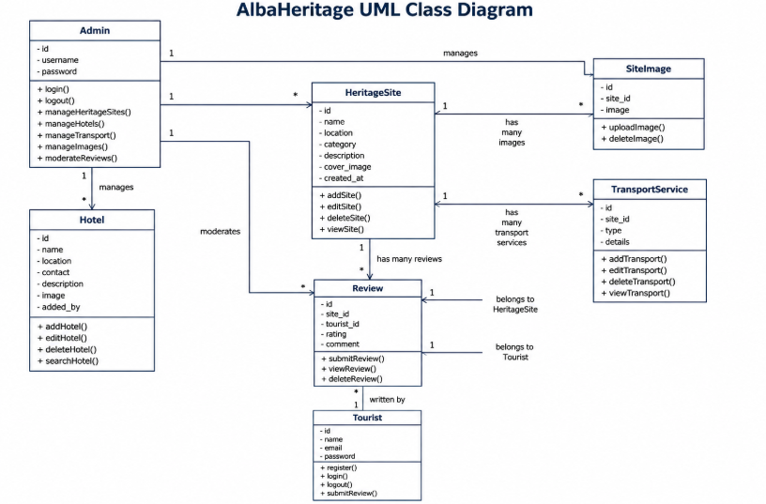
Figure 4.3 – Class Diagram

Use Case Diagram
The Use Case Diagram is a behavioural diagram used to describe the functional requirements of the platform from the users' perspective. It defines the system boundary and illustrates who interacts with the system and what operations they can perform. The two primary actors are the Tourist, who can search heritage sites, check transport, upload reviews, and search hotels, and the Administrator, who can log in and add heritage sites, hotels, images, and transport services and check reviews.
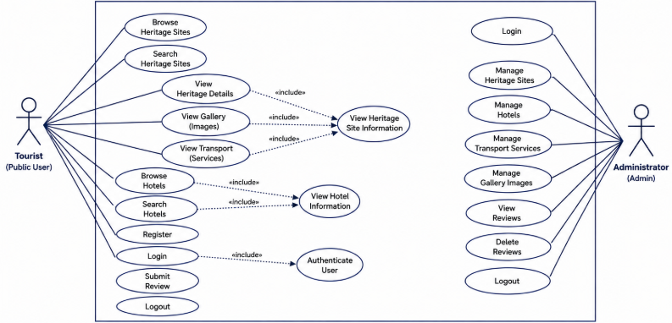
Figure 4.4 – Use Case Diagram

Activity Diagram – Admin
This activity diagram models the workflow of the administrator. After logging in, an invalid attempt returns to the login screen, while a valid attempt displays the admin home page, from which the administrator can add hotels, add heritage sites, add images and transport services, and check reviews.
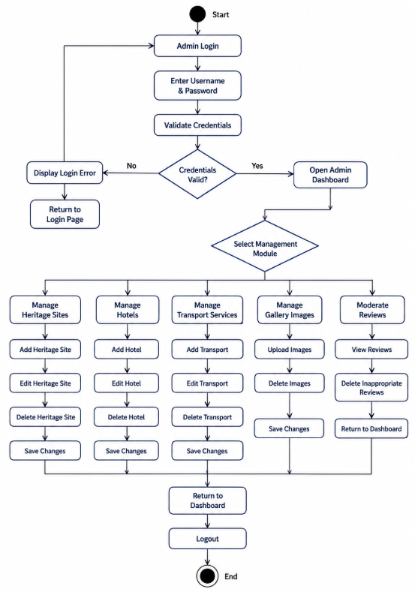
Figure 4.5 – Activity Diagram (Admin)

Activity Diagram – User
This activity diagram models the workflow of a public user. The tourist registers and logs in; an invalid attempt returns to the login step, while a valid attempt displays the tourist home page, from which the user can search heritage sites, search transport services, search hotels, and, after selecting a valid site, upload a review.
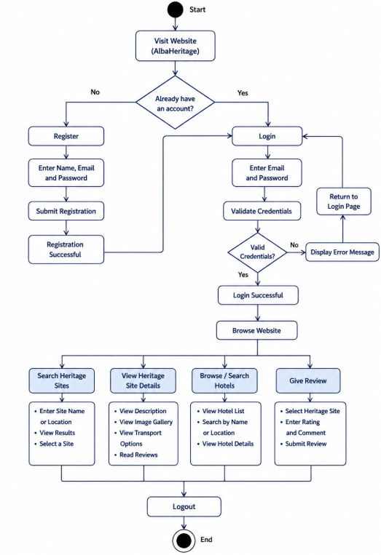
Figure 4.6 – Activity Diagram (User)

4.4 System Requirements

Software Requirements
- Presentation Layer: HTML, CSS, Bootstrap, JavaScript
- Application Layer: PHP
- Data Layer: MySQL
- Server Environment: WAMP / XAMPP Server (Apache)
- Browser: Google Chrome, Mozilla Firefox, or Microsoft Edge

Hardware Requirements
- Processor: Intel Pentium IV 2.4 GHz or above
- RAM: 256 MB or higher (2 GB recommended)
- Hard Disk: 40 GB or higher
- Monitor: SVGA Colour Monitor
- Keyboard: 108 Keys
- Mouse: 2-Button Mouse

4.5 Risk Analysis
Risk management is a continuous process throughout the Software Development Life Cycle. Given the dual-layer architecture of the AlbaHeritage platform, which balances public accessibility with secure administrative management, identifying and mitigating risks early was important to the project's success. The following table summarises the key risks, their probability and impact, and the strategies used to mitigate them.
Risk | Probability | Impact | Mitigation
System / hardware failure | Rarely | High – work and data may be lost | Take regular backups and store the code and database exports online, for example using version control.
Data loss or corruption | Occasionally | High – loss of heritage records | Maintain periodic SQL exports and validate input before saving; delete related image, transport, and review rows when a site is removed.
Time / schedule overrun | Occasionally | Medium – delays in delivery | Follow the Agile sprint plan and prioritise the core CRUD modules before secondary features.
Security weaknesses in input handling | Occasionally | Medium – invalid or malicious input | Escape text input and cast numeric identifiers; adopt prepared statements and output escaping before production.
Scope creep | Occasionally | Medium – increased workload | Freeze the core requirements early and record additional ideas in the Further Enhancement section.

Detailed Risk Mitigation
For system or hardware failure, the codebase and database exports are backed up to remote storage at the end of each sprint, so a local machine failure does not result in the loss of the project. For data loss or corruption, the deletion logic in the administrative dashboard removes related site images, transport services, and reviews when a heritage site is deleted, keeping the database consistent, and a full SQL export is taken before any major structural change. For schedule risk, the public home page and the core CRUD operations were prioritised over secondary features so that a working core prototype would always be available. For security, passwords are hashed and never stored in plain text, text input is escaped before being used in queries, and numeric identifiers are converted with intval(); stronger measures such as prepared statements are documented as a future improvement. For scope creep, the project scope was frozen during requirement analysis, and additional ideas such as online booking, mapping, and bilingual content were deliberately deferred to the Further Enhancement section rather than being added mid-development.

5. DESIGN

5.1 Website Design and Interface
The platform introduces a dual-layer structure consisting of a public user platform and an administrative dashboard.
- Public User Platform: Designed for tourists, students, researchers, and local users. The home page features heritage sites and a dynamic search by name or location. The design is responsive, featuring image galleries and cultural information. Registered users can view sites, browse hotels and transport options, and submit reviews.
- Admin Dashboard: Provides a secure login for an authenticated administrator to manage heritage information. The administrator can add, edit, and delete heritage sites, manage images, manage the hotels directory and transport services, and moderate reviews submitted by users.
The interface uses a heritage-themed colour palette of deep red, gold, cream, and charcoal, with the Playfair Display and Poppins fonts, to create a professional and culturally appropriate visual identity. Responsiveness is implemented using the Bootstrap framework. Bootstrap's JavaScript bundle supports interactive components such as the collapsible responsive navigation menu, while form validation in the current prototype relies on standard HTML form attributes, such as the required attribute, together with server-side PHP processing.

5.2 Database Design
The AlbaHeritage system uses a structured relational database, built in MySQL, to manage the flow of data between the public platform and the administrative dashboard. The data layer is organised to reduce redundancy and to keep related information together. It consists of seven main tables: Admin, Heritage Sites, Site Images, Hotels, Transport Services, Tourists, and Reviews. The descriptions below reflect the fields actually used by the application. The accompanying figures show the conceptual table designs prepared during the design phase; where a figure lists additional descriptive attributes, these represent the fuller design intent, while the implemented prototype uses the core fields described in the text.

Admin Table
The Admin table is the security foundation for the administrative dashboard. It stores the credentials of the administrator who manages the platform's content. In the implemented prototype it holds an auto-increment id, a unique username, and a securely hashed password; the administrator account is created once through a setup script.
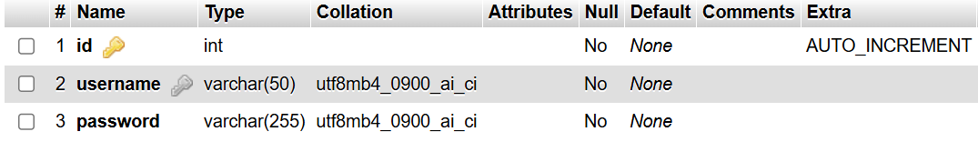
Table 5.1 – Admin Table

Heritage Site Table
The Heritage Site table is the core entity of the database. It stores the primary information about each cultural location: an auto-increment id, the name, the location, the category (such as Castle, Museum, or Beach), a text description, and the file name of the cover image. A created-at timestamp records when the record was added. This table is written to and updated by the administrator and read by the public platform.
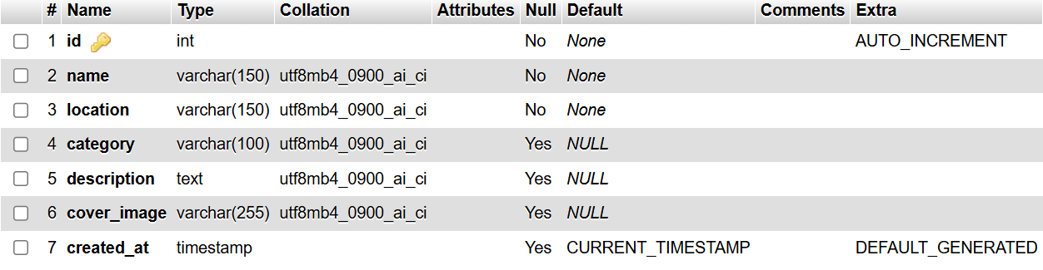

Table 5.2 – Heritage Site Table

Site Image Table
To keep the design clean, gallery images are stored separately from the main site record. The Site Image table holds an auto-increment id, a site_id foreign key linking each image to its heritage site, and the image file name. This one-to-many relationship allows each heritage site to have multiple gallery images, which are displayed together on the site's detail page.
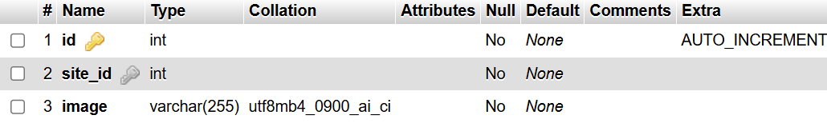
Table 5.3 – Site Image Table

Hotels Table
The Hotels table stores accommodation records that form a standalone hotels directory. In the implemented prototype each hotel record contains an id, a name, a location, a contact field, a description, an image file name, and an added_by field recording the administrator who created it. Unlike transport services, hotels are not linked to an individual heritage site through a site_id; they are browsed and searched independently by name or location. Linking hotels directly to specific heritage sites is noted as a future enhancement.
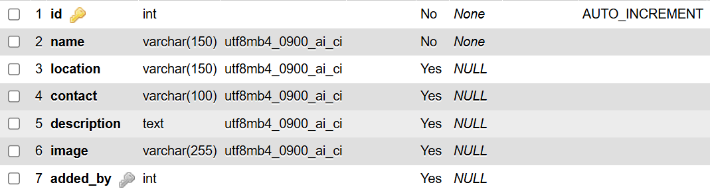
Table 5.4 – Hotels Table

Transport Services Table
The Transport Services table stores the transport options for reaching a heritage site. Each record contains an id, a site_id foreign key linking it to a specific heritage site, a type such as Bus, Taxi, or Car Rental, and a details field describing the route, frequency, or other information. Because each transport record is tied to a site, the relevant options can be displayed directly on that site's detail page.
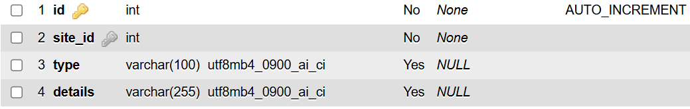
Table 5.5 – Transport Services Table

Tourist Table
The Tourist table stores registered public-user accounts. In the implemented prototype each record contains an id, the tourist's name, a unique email address, and a securely hashed password. Tourist accounts allow visitors to authenticate with the platform and submit reviews; features such as saving favourite sites or building personalised journeys are not part of the current prototype and are listed as future enhancements.
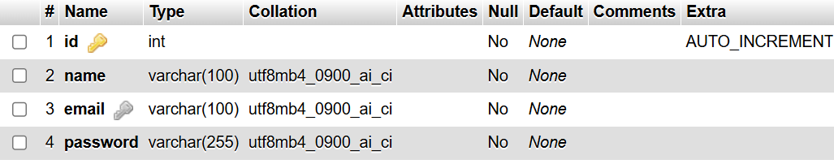
Table 5.6 – Tourist Table

Review Table
The Review table stores the feedback submitted by tourists. Each record contains an id, a site_id foreign key linking the review to a heritage site, a tourist_id foreign key linking it to the author, a numeric rating, a comment, and a created-at timestamp. Reviews are created by logged-in tourists and displayed on the site's detail page; the administrator can view all reviews and delete unwanted entries.
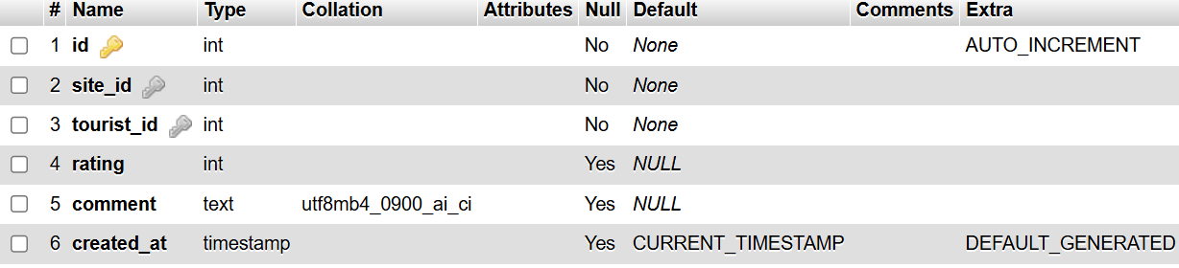
Table 5.7 – Review Table

5.3 Data Dictionary
The data dictionary below summarises the fields used by the application in the implemented prototype. It lists the key columns of each table together with a representative data type and a short description, providing a concise reference to the structure that the PHP code reads from and writes to.
Table | Field | Type | Description
admin | id | INT (PK) | Unique identifier for the administrator.
admin | username | VARCHAR | Administrator login name.
admin | password | VARCHAR | Securely hashed password.
heritage_sites | id | INT (PK) | Unique identifier for the heritage site.
heritage_sites | name | VARCHAR | Name of the heritage site.
heritage_sites | location | VARCHAR | Location of the site.
heritage_sites | category | VARCHAR | Category, e.g. Castle, Museum, Beach.
heritage_sites | description | TEXT | Descriptive information about the site.
heritage_sites | cover_image | VARCHAR | File name of the cover image.
site_images | id | INT (PK) | Unique identifier for the gallery image.
site_images | site_id | INT (FK) | Links the image to a heritage site.
site_images | image | VARCHAR | File name of the gallery image.
hotels | id | INT (PK) | Unique identifier for the hotel.
hotels | name | VARCHAR | Name of the hotel.
hotels | location | VARCHAR | Location of the hotel.
hotels | contact | VARCHAR | Contact phone or email.
hotels | image | VARCHAR | File name of the hotel image.
transport_services | id | INT (PK) | Unique identifier for the transport option.
transport_services | site_id | INT (FK) | Links the transport option to a heritage site.
transport_services | type | VARCHAR | Type of transport, e.g. Bus, Taxi.
transport_services | details | VARCHAR | Route, frequency, or other details.
tourists | id | INT (PK) | Unique identifier for the tourist.
tourists | name | VARCHAR | Tourist's name.
tourists | email | VARCHAR | Unique email used to log in.
tourists | password | VARCHAR | Securely hashed password.
reviews | id | INT (PK) | Unique identifier for the review.
reviews | site_id | INT (FK) | Links the review to a heritage site.
reviews | tourist_id | INT (FK) | Links the review to its author.
reviews | rating | INT | Numeric rating given by the tourist.
reviews | comment | TEXT | Written feedback from the tourist.

6. IMPLEMENTATION
The implementation phase translated the conceptual design and database model into a fully functional, interactive platform. The system was developed using a three-tier logical architecture that separates the presentation, logic, and data layers to support clarity, maintainability, and future scalability. In this prototype the three tiers are logical rather than being hosted on physically separate servers, and the whole application runs within a local WAMP/XAMPP environment.
The implementation directly delivers the objectives set out at the start of the project. The relational database was designed and built in MySQL; a secure administrative dashboard was created for dynamic content management; interactive user features such as search, image galleries, and reviews were implemented; a directory of hotels and transport options associated with heritage sites was provided; and tourist registration and authentication were added so that reviews could be submitted. The sections below describe the architecture, the project structure, and each of the main modules, and then present selected code from the actual project files to show how these features were realised in practice.

6.1 System Architecture
Presentation Layer (Client-Side)
This layer is responsible for user interaction, responsive interface display, and capturing user input. It is built with HTML5, CSS3, Bootstrap, and standard JavaScript. Bootstrap provides a mobile-first, responsive grid so that the platform scales across desktops, tablets, and smartphones, and Bootstrap's JavaScript bundle powers interactive components such as the collapsible navigation menu.
Application Layer (Server-Side Logic)
This layer acts as the middleware that processes system logic, handles authentication, and routes requests between the user and the database. It is built with PHP. PHP manages session state for tourist and administrator logins, processes form submissions such as adding heritage sites or uploading images, handles user input before it is used in queries, and communicates with the database.
Data Layer (Database Management)
This layer is responsible for the persistent storage, retrieval, and integrity of all heritage and user data, and is implemented in MySQL. The application communicates with MySQL through the MySQLi extension.

6.2 Project Structure
The application is organised into a clear folder structure that separates configuration, shared includes, public pages, administrative pages, and uploaded media. This separation keeps the codebase maintainable and makes the flow of the application easy to follow.
- config/ holds the reusable database connection file (db.php) used by every page that needs data access.
- includes/ contains the shared header (with the public navigation) and footer, which are included on the public pages so the layout stays consistent.
- root pages: holds the public-facing pages: index.php (home), places.php (site listing and search), place.php (site detail with gallery, transport, and reviews), hotels.php (hotels directory), and the tourist registration, login, and logout scripts.
- admin/ contains the protected dashboard and its modules: login and logout, the auth guard, the dashboard, and the add, edit, and delete scripts for heritage sites, hotels, transport, and reviews, plus the shared admin header and footer.
- uploads/ and assets/ stores the uploaded cover and gallery images; the assets/css folder holds the site's stylesheet.
This structure reflects the three-tier separation in practice: the includes and public pages form the presentation layer, the PHP scripts in the root and admin folders form the application layer, and the config connection plus MySQL form the data layer. Because the database connection and the header and footer are centralised, a change made in one place is reflected across the whole site, which supports maintainability and reduces duplication.

6.3 Main Modules

Database Connection Module (MySQLi)
The database connection module is the bridge between the application layer and the data layer. A single reusable connection file establishes the link between PHP and MySQL using the MySQLi function mysqli_connect(), and it is included on every page that requires data access. In this project the MySQL service runs on a non-default port, which is supplied as the final argument to the connection call.
<?php
$conn = mysqli_connect("localhost", "root", "", "albaheritage", 3308);
if (!$conn) {
die("Connection failed: " . mysqli_connect_error());
}
?>

Admin Authentication Module
The admin authentication module is the secure gatekeeper for the dashboard. When the administrator submits the login form, the entered username is looked up in the admin table and the entered password is checked against the stored hash using password_verify(). On success, a session variable is created to keep the administrator logged in, and a guard file included at the top of every admin page redirects unauthenticated visitors back to the login screen. The prototype has a single administrator permission level rather than multiple roles.
$result = mysqli_query($conn, "SELECT * FROM admin WHERE username='$username'");
if (mysqli_num_rows($result) == 1) {
$admin = mysqli_fetch_assoc($result);
if (password_verify($password, $admin['password'])) {
$_SESSION['admin_id'] = $admin['id'];
header("Location: dashboard.php");
}
}

Heritage Site Management Module (CRUD)
This module is the core of the administrative dashboard and provides the full Create, Read, Update, and Delete operations for heritage sites. When the administrator adds a site, the text fields are captured, the cover image and any gallery images are uploaded and moved into the uploads folder, and their file names are stored in the database. The site record is written with an INSERT statement, and each gallery image is stored in the site_images table against the new site's id, keeping the system fully dynamic.
$sql = "INSERT INTO heritage_sites (name, location, category,
description, cover_image) VALUES ('$name', '$location',
'$category', '$description', '$cover')";
if (mysqli_query($conn, $sql)) {
$site_id = mysqli_insert_id($conn);
foreach ($_FILES['gallery']['name'] as $key => $val) {
move_uploaded_file($_FILES['gallery']['tmp_name'][$key],
'../uploads/'.$gimg);
mysqli_query($conn, "INSERT INTO site_images (site_id, image)
VALUES ($site_id, '$gimg')");
}
}

Search Module
The search module makes the public sites page interactive. It allows users to search heritage sites dynamically by entering a site name or location. PHP receives the keyword, escapes it, and queries the heritage_sites table using the SQL LIKE operator against the name and location columns. Filtering by category, region, or historical period is not implemented in the current prototype and is listed as a future enhancement.
$query = "SELECT * FROM heritage_sites";
if ($search != '') {
$query .= " WHERE name LIKE '%$search%'
OR location LIKE '%$search%'";
}
$result = mysqli_query($conn, $query);

Hotels Directory Module
The hotels module provides a separate Hotels and Stays directory. The administrator adds hotels through the dashboard, and the public hotels page lets users browse and search accommodation by hotel name or location. Unlike transport services, hotel records are not linked to a specific heritage site, so the directory operates independently of the heritage-site pages.

Transport Module
The transport module links transport options to individual heritage sites. When adding a transport service, the administrator selects the heritage site it belongs to, and the record is stored with that site's id as a foreign key. On the public site, the transport options for a site are displayed on its detail page under a “Getting There” heading.

Review Module
The review module allows logged-in tourists to submit a rating and comment for a heritage site. Each review is stored against both the site and the tourist, and the reviews for a site are displayed on its detail page. Visitors who are not logged in are prompted to log in or register before reviewing. The administrator can view all reviews and remove unwanted entries, providing moderation without editing users' content.
if ($_SERVER['REQUEST_METHOD'] == 'POST' && isset($_SESSION['tourist_id'])) {
$rating = intval($_POST['rating']);
$comment = mysqli_real_escape_string($conn, $_POST['comment']);
$tid = intval($_SESSION['tourist_id']);
mysqli_query($conn, "INSERT INTO reviews (site_id, tourist_id,
rating, comment) VALUES ($id, $tid, $rating, '$comment')");
}

Input Handling and Security
User-supplied text is processed using mysqli_real_escape_string() before being incorporated into database queries, while numeric record identifiers are converted using intval(). Passwords for both the administrator and registered tourists are securely hashed using PHP's password_hash() function and verified with password_verify(). For a production version, prepared statements and consistent output escaping would be introduced throughout the system to provide stronger protection against SQL injection and cross-site scripting.

6.4 Data Flow
Public User Data Flow:
A user enters a search query into the front-end interface. The browser sends an HTTP request to the PHP back-end, which escapes the query and executes a SELECT statement on the MySQL database. The database returns the matching records, and the back-end renders them as responsive cards that are sent back to the user's screen. In summary: User → Frontend → Backend → Database → Response.
Admin Data Flow:
The administrator submits an updated site description through the dashboard form. The browser sends an HTTP POST request to the back-end, which validates the administrator's session, executes an UPDATE query on the database, and, once the database confirms the change, returns a response so that the updated content is reflected on the public platform. In summary: Admin → Dashboard → Backend → Database → Updated Content.

6.5 Implementation of the Dual-Layer System
- Public User Platform: The front-end delivers an engaging experience for tourists, students, and researchers. Implemented features include dynamic search by name or location, responsive image galleries, the display of transport options per site, a hotels directory, and tourist registration and reviews.
- Administrative Dashboard: The back-end is engineered for secure content management by the administrator. It implements a session-protected login and provides tools to perform CRUD operations on heritage sites, hotels, and transport services, to upload and remove images, and to moderate reviews.

6.6 Selected Code Snippets

index.php – Home Page
The home page assembles the shared header and footer, presents the hero section and category tiles, and dynamically loads the most recent heritage sites from the database into a responsive Bootstrap grid.
<?php include 'config/db.php'; include 'includes/header.php'; ?>
...
$result = mysqli_query($conn, "SELECT * FROM heritage_sites
ORDER BY id DESC LIMIT 6");
while ($row = mysqli_fetch_assoc($result)) {
// render each site as a Bootstrap card with cover image,
// category badge, name, location and a 'View Details' link
}

dashboard.php – Admin Dashboard
The dashboard is the administrator's control panel. After the guard confirms an authenticated session, it lists all heritage sites in a table with edit and delete actions and a link to add a new site.
<?php include '../config/db.php'; include 'admin_header.php'; ?>
$result = mysqli_query($conn, "SELECT * FROM heritage_sites ORDER BY id DESC");
while ($row = mysqli_fetch_assoc($result)) {
// output a table row with the site image, name, location,
// category and Edit / Delete action buttons
}

edit_transport.php – Editing a Transport Service
This admin page updates a transport service. It reads the record by id, and on submission it updates the site_id, type, and details, escaping text values and casting identifiers before use.
$id = intval($_GET['id']);
if ($_SERVER['REQUEST_METHOD'] == 'POST') {
$site_id = intval($_POST['site_id']);
$type = mysqli_real_escape_string($conn, $_POST['type']);
$details = mysqli_real_escape_string($conn, $_POST['details']);
mysqli_query($conn, "UPDATE transport_services SET site_id=$site_id,
type='$type', details='$details' WHERE id=$id");
}

tourist_register.php – Tourist Registration
Registration captures the tourist's name, email, and password. The email is checked for uniqueness, the password is hashed with password_hash(), and the new account is inserted into the tourists table.
$check = mysqli_query($conn, "SELECT id FROM tourists WHERE email='$email'");
if (mysqli_num_rows($check) > 0) {
$error = "This email is already registered.";
} else {
$hash = password_hash($password, PASSWORD_DEFAULT);
mysqli_query($conn, "INSERT INTO tourists (name, email, password)
VALUES ('$name', '$email', '$hash')");
}

tourist_login.php – Tourist Login
Login looks up the tourist by email and verifies the entered password against the stored hash. On success, session variables are set and the user is redirected to the sites page.
$result = mysqli_query($conn, "SELECT * FROM tourists WHERE email='$email'");
if (mysqli_num_rows($result) == 1) {
$t = mysqli_fetch_assoc($result);
if (password_verify($password, $t['password'])) {
$_SESSION['tourist_id'] = $t['id'];
$_SESSION['tourist_name'] = $t['name'];
header("Location: places.php");
}
}

tourist_logout.php – Tourist Logout
Logout securely ends the tourist's session by unsetting the session variables and redirecting to the home page, which is particularly important on shared or public devices.
<?php
session_start();
unset($_SESSION['tourist_id']);
unset($_SESSION['tourist_name']);
header("Location: index.php");
exit;
?>

7. TESTING
Testing is a critical phase in the Software Development Life Cycle that ensures the platform operates reliably and effectively. Given the dual-layer architecture of AlbaHeritage, a structured, multi-stage testing strategy was used, progressing from individual components towards complete user workflows and basic security checks. The goal of testing was not only to confirm that features worked, but also to verify that the two layers interacted correctly, that data written by the administrator appeared accurately on the public platform, and that the protections around the dashboard and user input behaved as intended within the scope of a prototype.
Because the project followed an iterative Agile process, informal testing happened continuously during development, with each feature checked as soon as it was built. The structured testing described below was then carried out as a dedicated pass over the finished prototype, so that every major module was exercised against clearly defined inputs and expected outputs. The results were recorded as pass or fail, and any issues found were fixed and re-tested before the phase was considered complete.

7.1 Types of Testing Performed
Unit Testing
Unit testing was performed during active development, checking individual pieces of functionality in isolation. This included confirming that the database connection module established a connection to MySQL and that the password-hashing logic produced hashed values rather than plain text before insertion.
Functional Testing
Functional testing verified that each feature worked according to its requirement: administrator login and the session guard, the Create, Read, Update, and Delete operations for heritage sites, hotels, and transport, cover-image and gallery-image uploads, dynamic search by name or location, and tourist registration, login, and review submission.
Database Testing
Database testing confirmed that records were stored and retrieved correctly, that content created in the dashboard appeared immediately on the public platform, and that relationships behaved as expected, for example that transport services were correctly associated with their heritage site and that deleting a site also removed its related images, transport, and reviews.
Usability and Responsiveness Testing
Usability testing evaluated the clarity of navigation and the layout across devices, confirming that the Bootstrap layout rendered correctly on desktop, tablet, and mobile viewports and that the navigation collapsed into a responsive menu on small screens.
Security Testing
Basic security testing checked that unauthenticated users were redirected away from admin pages, that passwords were stored as hashes rather than plain text, and that special characters entered into the search field were escaped so that they did not break the query. Comprehensive protection using prepared statements and output escaping is identified as a future improvement.

7.2 Test Cases
The following test cases demonstrate the verification process across the major modules of the platform.
Purpose of Test Case | Input | Expected Output | Result
Login with incorrect data | Wrong username / password | Error message shown, access denied | Pass
Login with correct data | Valid admin credentials | Redirected to dashboard | Pass
Direct URL access protection | Open an admin URL while logged out | Redirected to the admin login page | Pass
Add heritage site | Valid site details + image | Site saved and shown on public page | Pass
Upload gallery images | Select image files | Images stored and shown in gallery | Pass
Search heritage site | Keyword (name / location) | Matching sites displayed | Pass
Add hotel | Valid hotel details | Hotel saved and listed on hotels page | Pass
Add transport for a site | Select site + transport details | Transport shown on the site detail page | Pass
Submit review (logged in) | Rating and comment | Review saved and displayed | Pass
Submit review (not logged in) | Attempt to review | Prompted to log in first | Pass
Delete heritage site | Click delete | Site and related records removed | Pass
Special characters in search | ' OR '1'='1 | Input escaped; no database error | Pass (prototype scope)
Password storage | Inspect admin / tourists tables | Passwords stored as hashes, not plain text | Pass
Mobile rendering | View on ~375 px width | Navigation collapses; layout re-aligns | Pass
Note: in the special-character search test, the input is escaped before it is placed into the query, so it does not break execution. As a future improvement, dynamic SQL would be replaced with prepared statements to provide stronger, structural protection against SQL injection.

8. EVALUATION

8.1 Personal Evaluation
The project has been a comprehensive experience that demonstrates the practical application of web development, database design, system analysis, and user interface design. The development process moved from analysing existing limitations in Albanian cultural tourism, to designing a user-friendly interface, and finally to building a functional, dynamic, web-based platform. Working on this project strengthened my understanding of back-end development with PHP and MySQL, including how to design a relational database that balances public data with secure administrative control while keeping data consistent and queries efficient.
I also gained hands-on experience with secure session handling and authentication, which were essential for protecting the dashboard, and with handling dynamic content such as file uploads for image galleries. Bridging the gap between the front-end interface built with HTML, CSS, and Bootstrap and the back-end logic written in PHP was one of the most challenging but rewarding aspects of the project. Overall, taking the system from an initial problem statement through to a working, testable prototype gave me a realistic view of the full software development life cycle.
A particularly valuable lesson was the importance of keeping the documentation aligned with what the code actually does. Early on it was tempting to describe an ambitious system, but reviewing the report against the implemented files highlighted the difference between features that were planned and features that were genuinely built. Correcting this taught me to be precise about scope and to present unimplemented ideas honestly as future work rather than as completed functionality. This discipline is directly relevant to professional practice, where accurate technical documentation is as important as the code itself, and it made the final report easier to defend because every claim can be traced to a specific file or database table.
If I were to repeat the project, I would introduce prepared statements and output escaping from the very first sprint, plan the search and filtering features around a richer set of site attributes, and design the hotels table with a site relationship from the outset. These reflections have given me a clearer sense of how early design decisions shape what is realistic to deliver later, and how a modular structure makes those later improvements far easier to add.

8.2 System Evaluation
The platform effectively moves beyond traditional static heritage websites by introducing a more interactive, scalable, and maintainable digital environment. By addressing the fragmentation of cultural information across Albania, the system centralises heritage data, improves accessibility, and provides a foundation tailored to the country's cultural needs.
A key measure of success is the working dual-layer architecture. The administrative dashboard provides a secure, centralised hub where the administrator can add, edit, and remove heritage sites, hotels, and transport services, upload and manage images, and moderate reviews, all without direct database intervention. The public platform delivers an engaging experience through dynamic search, rich image galleries, transport information on each site, a hotels directory, and user reviews, transforming the system from a simple information directory into a more practical cultural companion. The underlying architecture was deliberately kept modular so that it can accommodate future enhancements, such as bilingual content, connected cultural routes, mapping, and recommendations, which are described in the next section.

Advantages
The system is simple in design and straightforward to deploy, requiring only a standard local server and modest hardware, and it therefore runs on almost any common configuration. It centralises heritage information in one place, reduces the manual effort of maintaining separate pages, and updates the public site instantly whenever the administrator changes content. The clear separation into presentation, application, and data layers makes the code easier to maintain, and the modular structure means new features can be added without redesigning the whole system. Passwords are hashed, the administrative area is protected by a session guard, and the responsive Bootstrap interface works across desktops, tablets, and phones.

Limitations
As a prototype, the system also has clear limitations that define its honest scope. Search is limited to matching a site's name or location and does not yet filter by category, region, or historical period. Hotels form a standalone directory and are not linked to individual heritage sites. There is a single administrator permission level rather than multiple roles. Input is escaped and identifiers are cast, but the system does not yet use prepared statements or consistent output escaping, so it is intended for local, controlled use rather than production deployment. Bilingual content, connected cultural routes, saved favourites, mapping, and online booking are not implemented. Each of these limitations is addressed as a specific item in the Further Enhancement section, which turns them into a clear roadmap for future work.

9. FURTHER ENHANCEMENT
The system architecture supports the future integration of additional technologies and features. Because the current prototype focuses on a solid, accurate core, there is clear scope for extension. Planned improvements include:
- Bilingual support (English and Albanian), storing paired text so the platform can serve local and international audiences.
- Cultural route planning that links related heritage sites into connected journeys using a route table and join queries.
- Filtering and browsing of heritage sites by category, region, and historical period, extending the current name and location search.
- Linking hotels directly to specific heritage sites so that accommodation can be shown by proximity on a site's detail page.
- Allowing registered tourists to save favourite sites and build personalised itineraries.
- Introducing prepared statements and consistent output escaping throughout the system for stronger security.
- Interactive maps and 360-degree virtual tours to locate and preview heritage sites.
- Analytics to understand user engagement, AI-based recommendations for related sites, and a dedicated mobile application.

10. CONCLUSION
In conclusion, the AlbaHeritage project presents an innovative solution to the current limitations in the digital management and presentation of Albanian cultural heritage. By integrating a user-friendly public platform with a dedicated administrative dashboard, the system provides a structured and efficient approach to accessibility, organisation, and content management.
The platform supports both major and lesser-known heritage locations while improving engagement for local and international users. The inclusion of a hotels directory, transport services linked to heritage sites, and user reviews creates a more connected and practical tourism experience. Overall, AlbaHeritage demonstrates strong technical, analytical, and design capabilities while addressing a real-world cultural challenge, and it provides a solid, honest foundation on which the further enhancements described above can be built.
Beyond its technical outcomes, the project shows how a well-scoped web application can make a genuine difference to how cultural information is organised and shared. By replacing scattered, inconsistent sources with a single, database-driven system, AlbaHeritage makes heritage information easier to find, easier to keep up to date, and easier to extend. The administrative dashboard means that non-technical staff could maintain the content, while the public interface gives visitors a clear and engaging way to discover Albania's cultural landmarks. In this sense the project achieves its aim of transforming static heritage presentation into a dynamic and maintainable digital experience.
The clear boundary between what has been implemented and what is planned is one of the project's strengths. Rather than overstating its capabilities, the report presents an accurate account of a working core and a well-defined roadmap of enhancements. This honest framing makes the system credible, keeps it defensible under close inspection, and positions it as a realistic starting point that a tourism organisation or cultural institution could adopt and grow over time.

11. REFERENCES
[1] UNESCO, "Cultural Heritage and Digitalisation," United Nations Educational, Scientific and Cultural Organization, 2022.
[2] OECD, "Digital Platforms in Cultural Heritage," Organisation for Economic Co-operation and Development, 2021.
[3] Google, "Multilingual Accessibility and User Experience Report," 2022.
[4] Bootstrap, "Bootstrap Documentation." [Online]. Available: https://getbootstrap.com/docs/
[5] The PHP Group, "PHP Manual." [Online]. Available: https://www.php.net/manual/
[6] Oracle, "MySQL Documentation." [Online]. Available: https://dev.mysql.com/doc/
[7] W3Schools, "Online Web Tutorials." [Online]. Available: https://www.w3schools.com/

12. APPENDICES – SCREENSHOTS
The following screenshots demonstrate the working functionality of the AlbaHeritage platform.

Home Screen
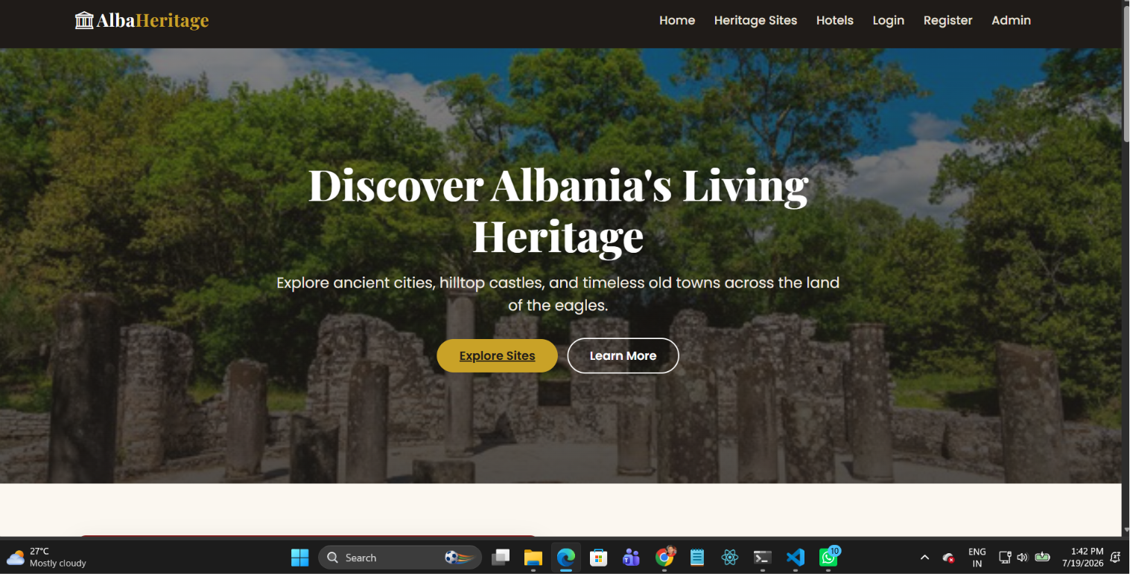
Screenshot 1 – Home Screen

Admin Login Form
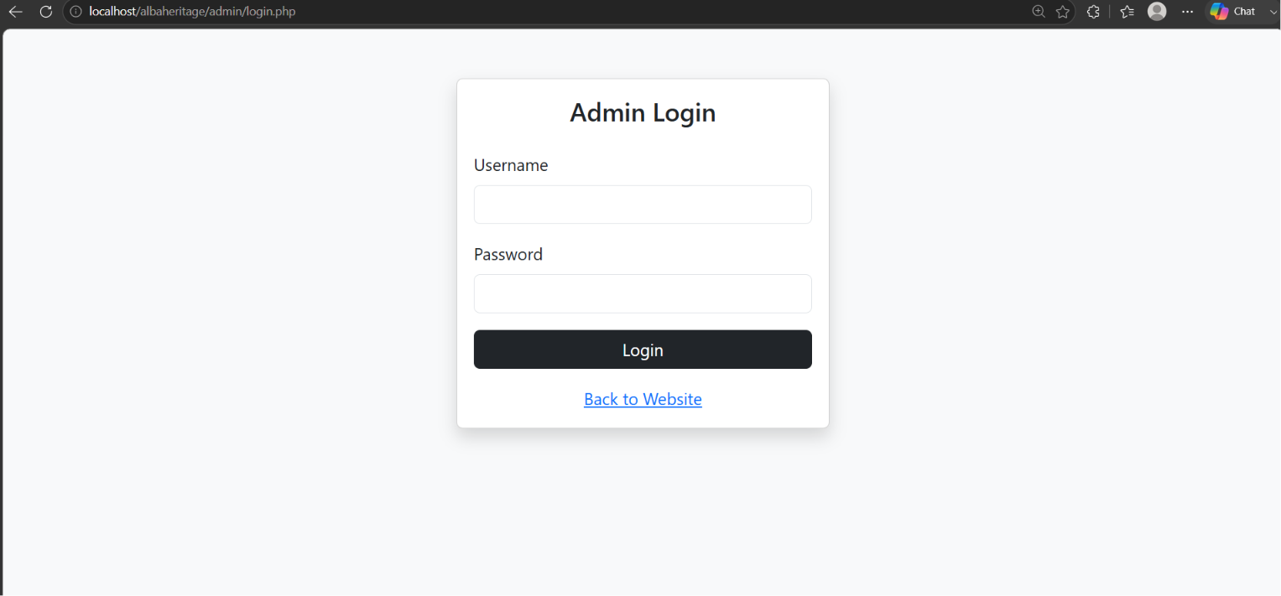
Screenshot 2 – Admin Login Form

Add Heritage Site Form
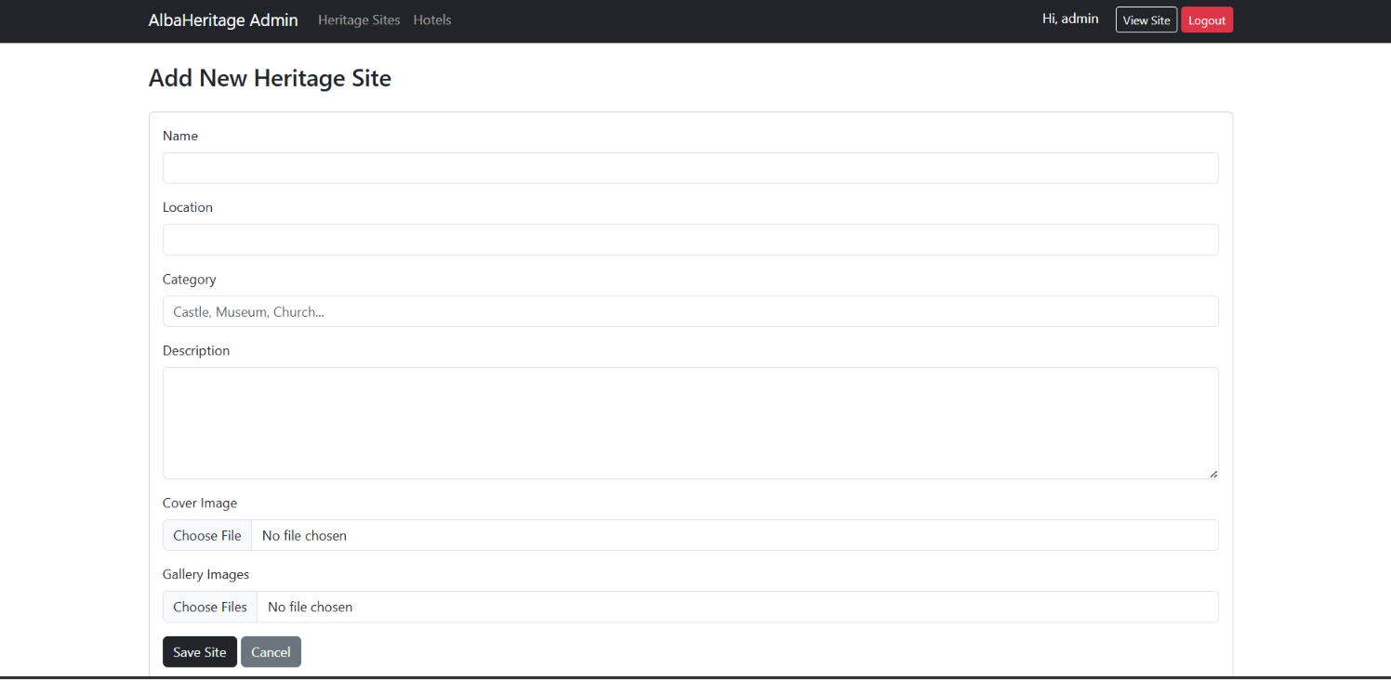
Screenshot 3 – Add Heritage Site Form

Add Hotel Form
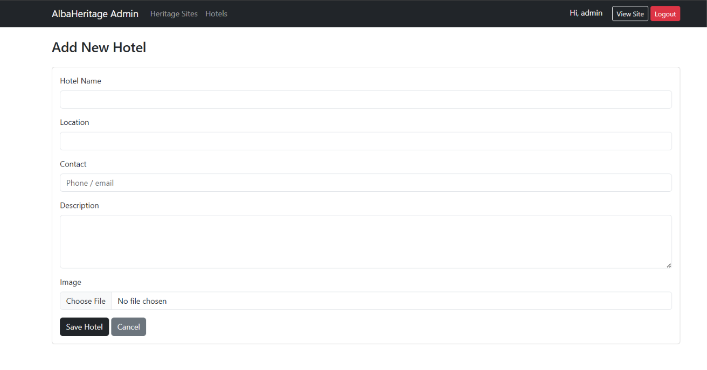
Screenshot 4 – Add Hotel Form

Explore Heritage Sites
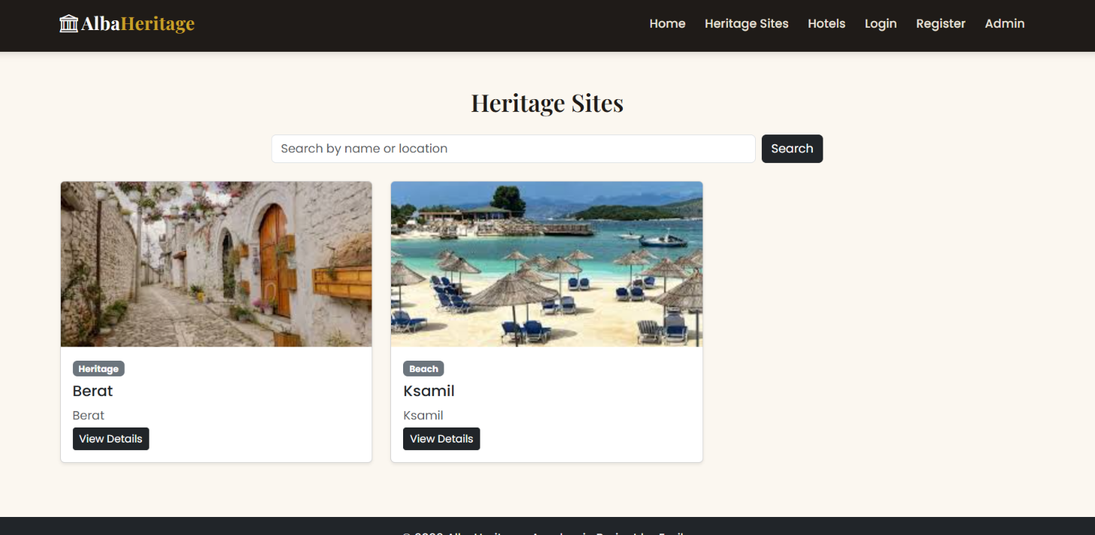
Screenshot 5 – Explore Heritage Sites

Heritage Site Details
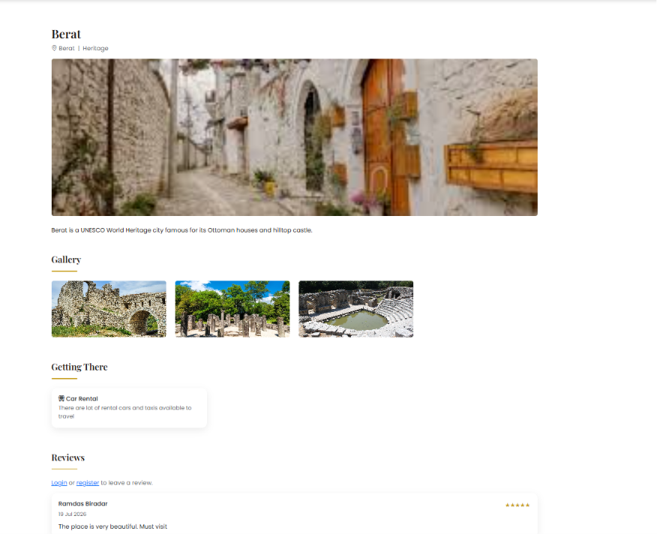
Screenshot 6 – Heritage Site Details

Tourist Registration Form
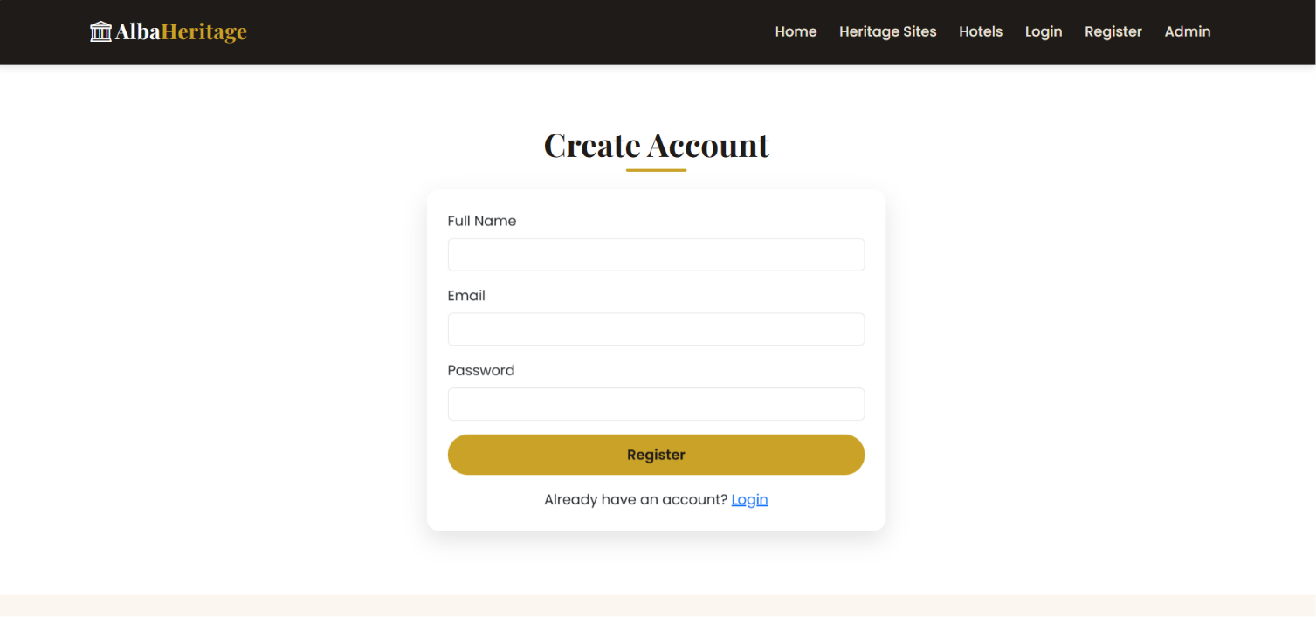
Screenshot 7 – Tourist Registration Form

Tourist Login Form
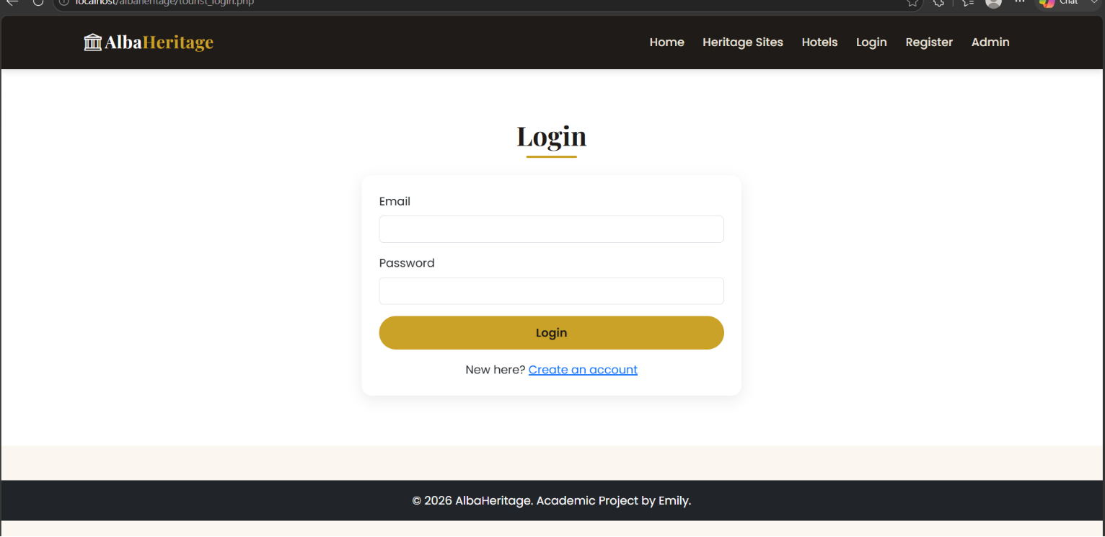
Screenshot 8 – Tourist Login Form

Review Moderation (Admin)
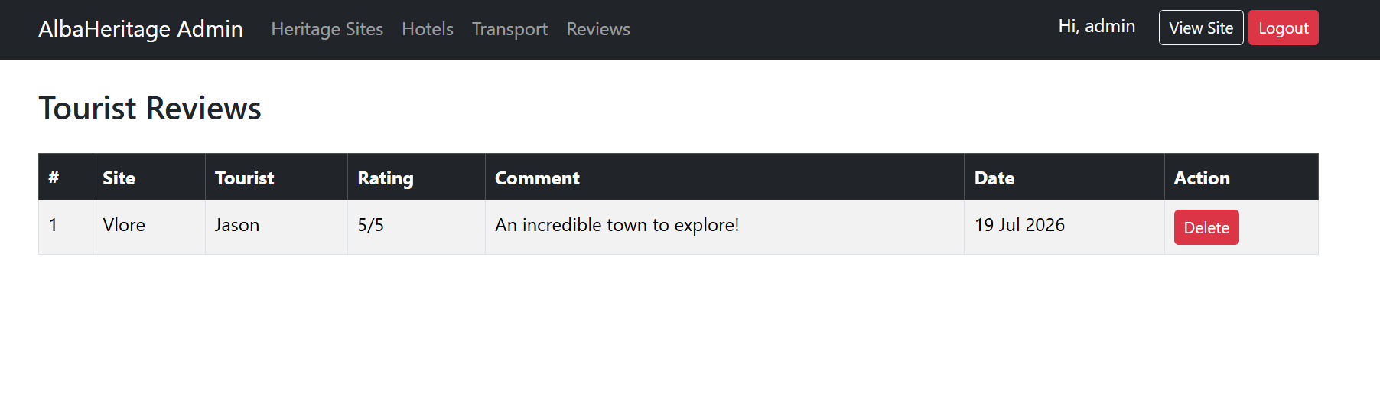Screenshot 9 – Review Moderation (Admin)

Declaration of Originality

I, Emriona Bushaj declare that I am the sole author of this Project; that all references cited have been consulted; that I have conducted all work of which this is a record, and that the finished work lies within the prescribed word limits.

This work has not previously been accepted as part of any other degree submission.

Signed : EB

Date : 09/08/2026

FORM OF CONSENT

I Emriona Bushaj hereby consent that my Project, submitted in candidature for the B.Sc.(Hons) Computer Networks degree, if successful, may be made available for inter-library loan or photocopying (subject to the law of copyright), and that the title and abstract may be made available to outside organisations.

Signed : EB

Date : 09/08/2026

Copyright Acknowledgement

I acknowledge that the copyright of this project report, and any product developed as part of the project, belong to University of Wales Trinity Saint David, Swansea.

