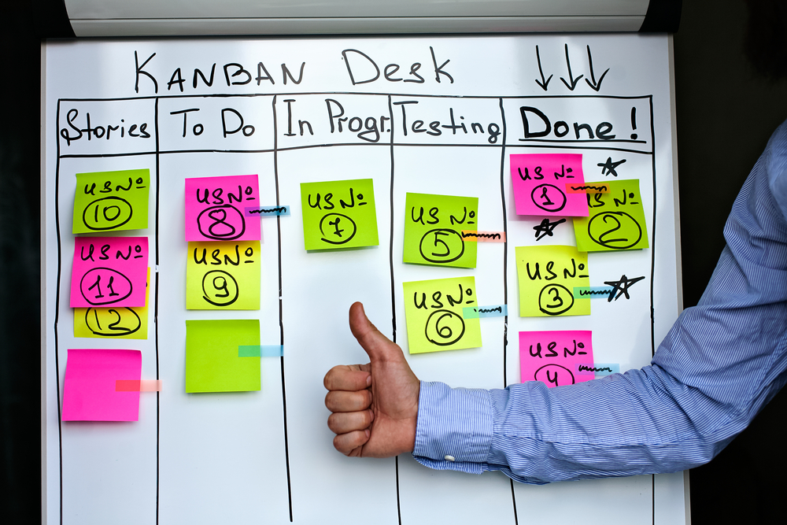
  - An analysis of modelling logistics operations solutions to support lean management.

  - Modelling Logistics operations
  - M5X01280
Kamila Andrzejewska P125093 | Logistics and supply Chain Management | 23/04/2018

Table of contents.

- Introduction ………………………………………………………………………………….….2-3
  - Introduction and background of Kanban System.……………….2-3
  - Lean production…………………………………………………………………………3
- Main Body ………………………………………………………………………………………….3-7
  - Kanban in the Supermarket ……………………………………………………..3
  - Pull System………………………………………………………………………………3-4
  - Kanban in Tesco Stores…………………………………………………………. 4-5
  - Vending machine as an example of a Kanban System …………….5
  - Kanban Board …………………………………………………………………………….5
  - Simulation ………………………………………………………………………………….5
    - First Simulation Example ………………………………………………….5-6
    - Second Simulation Example …………………………………………………6
- Conclusion……………………………………………………………………………………………..7
- References ……………………………………………………………………………………………..8

- Introduction.

  - Definition and background of Kanban System.

The word Kanban originates from Japanese language and it means ‘card, ticket, sign, or signboard’ (Cimorelli, 2013).
The Toyota Production System (Toyota’s Lean enterprise system) has developed Kanban and used it as a tool in order to manage ‘the flow of production and materials in a JIT “pull” production process’ (Cimorelli, 2013). Just-in-Time (JIT) and Jidoka are the two pillars of Lean. JIT ‘aims to meet demand instantaneously, with perfect quality and no waste’ (Bicheno, 1991). The term Jidoka can be described as ‘automation with a human touch’ (Toyota-global.com, 2018). The term Jidoka means “building in quality and designing operations and equipment so that people are not tied up to machines and are free to perform value-added, multitask work that is appropriate for humans” (Cimorelli, 2013). Pull system is a system which allows more parts to be released into the process only when the other parts have been “pulled” by other process. Jidoka helps the pull system by selecting only quality parts. Those parts are than passed on to the next operation and stopping production or if that’s not the scenario, it makes fast action to correct the error.
The word Jidoka originates from the time when the first self- powered loom was invented in 1986 by Sakichi Toyoda who was the founder of the Toyota Group. The invented machine was called “Toyota Power Loom”. The term ‘jido’ in the Toyota vocabulary, was applied to describe the device with the capability to make judgments which was built in the machine. Whereas for the usual Japanese “Jido” term the meaning of it is an automation, and was used to describe a machine that moves by itself. The 1896 was the year when Sakichi Toyoda invented the first ever self-powered loom which was given name of “Toyoda Power Loom”. This machine contained numerous inventions such as,” the weft-breakage automatic stopping device” (toyota-global.com, 2018). That machine had the ability to stop automatically in case of detection of broken thread. Then, in 1924, Sakichi Toyoda invented the “Type-G Toyoda Automatic Loom” that was upgraded with the feature of shuttle changing without having to stop the operation (toyota-global.com, 2018).

  - Lean Production.
Lean can be described as to” generate the maximum added value at lowest cost as fast as possible” (Chohmann.free.fr, 2018).

- Main body.

  - Kanban in the Supermarket.
It all started when Taiichi Ochno was impressed after seeing how Americans supermarket had ability to keep the stock on the shelfs without having to hold big amounts of inventories. This was done because of the implementation of the simple Kanban system. Simply, the shop replenishes the item when the customer pulls the item of the shelf.

The Kanban implementation can be adopted in order to better their replenishment systems and achieve improved material flow. This is because a Kanban system works ideally in controlling the whole value chain which begins from the supplier and it ends with the customer. To use a Kanban system one must remember that Kanban needs to be always monitored in the process. Special attention needs to be paid to prevent bottlenecks which when overlooked could cause delay in the production process. The main objectives of Kanban are
- to achieve higher material flow with a minimum delivery lead times (digite.com, 2018).
- To eliminate possible bottlenecks

  - Pull-System.
One can differentiate the pull from the push for the fact that a pull system always limits the amount of inventory that is in the system. The completed parts also count as a part of the inventory limits. So it doesn’t matter how the inventory is being stored the fact is that there cannot be more parts produced than what limit on work in progress agrees. The signal is sent as a permission for more parts to produced only when the parts that have been already made leave the system. In case of a Kanban System this signal is the Kanban. The Kanban is sent as a signal to the beginning of the process to re-produce more parts. The parts must be precisely same, with the same quantity and the same quality (allaboutlean.com, 2018).
  - Kanban in Tesco Stores.
The report will use an example where the Kanban information is directly associated with the product. The system of Kanban works best when the future demand for a specific material is predictable and stable. Although this information could be much useful, nevertheless Kanban is not entirely depending or limited to these conditions. However, other factors may play important role when deciding if Kanban is the correct tool that is used for specific product. The factors may include “cost, annual quantity, lead times, and lot sizes” (Cimorelli, 2013).

The use of Kanban system in the Supermarket can be illustrated by an example of Tesco store in the UK. As the study shows, Tesco has followed the footsteps of the Kanban predecessors and also adopted the Kanban technique in the stores. In Tesco the upstream process is within sight. The parts or products are being replaced when they are bought by the customers or disappear. The signal to produce more parts is the empty space.

Walking down the aisle in the Tesco stores one can notice, that usually the shelfs are replenished and most of the products are always in stock. The material replenishment and production are main aspects of Kanban. There are different Kanban’s. One of the Kanban in Tesco can be the customer who just walked towards the till and has put the items on the conveyer belt. The Kanban therefore is the product that is on the conveyer belt which sends the signal to the cashier to put the foot down on the break to stop the conveyer belt from moving. A product works as a Kanban because the package of the item always has an attached card with the information for the product. When the items card is scanned the sound of “beep” is activated as a signal that the item has been purchased. Therefore, this signal is sent further to the data base of the store letting it know that this purchased item is now out of stock and a new product needs to be ordered to replace the one that has been just bought. A Kanban in the supermarket is essentially an order point system. The customer when buying a product sends signal to the supplier that more products are needed (Cimorelli,2013).
In supermarkets like Tesco, product is always replenished but this is depending on the customer consumption of the product.
The products are stored in specified area. But when the product is pulled from its place the empty space is an indicator to fill it up for all those who are involved in the operations. In other words, the customer leaves Kanban by picking a product. So in this visual observation the empty space is a Kanban. This is a system of visual communication. The Kanban is on the product and it is in a form of a card. The card is associated with the product from the time of its production. The destiny of the manufactured product is to be associated to the Kanban card. In other words, if there aren’t any Kanban cards waiting for produce than there is no further manufacturing. Customer leaves a Kanban by picking up the product. This Kanban which was isolated from its shelf location becomes an order for a new replenishing product. This product is going to replenish the one that was just picked up by the customer.
  - Vending machine as an example of a Kanban System.
The example of a vending machine will be used to further understand the principle of Kanban system used in the supermarket. Furthermore, in the vending machine the slots are the number of spaces in the depth and rows at the front. The slots are organized according to the number of sales of each specified product. The products of a higher demand will get more slots than the products of a less demand. This is done in order to avoid lost sales for shortages between the time of two replenishments. In the real world supermarkets, the spaces on the shelves are limited.

The suppliers are required to deliver the products in the right quantity and expected lead time.

  - Kanban Boards.
There is no doubt that Kanban Boards is a tool that works great for improving workflow and boosting efficiency. Often the problem of different project teams is the lack of efficiency. The problem exists because the teams don’t have the clear insight into the progress which they are making. Teams who use this tool are able to visualize all the work in progress and are able to see all their work items. In essence, a Kanban Board is a great tool because it tells the team how much work they still have to do, how many work items is currently in progress and how much work has been done. Likewise, it allows the team to have complete control over those items while they go through various stages in the workflow. Therefore, the board need to be always supervised and accustomed depending on the needs of the team.

  - Simulation.

A simulation can be a software package but it can also be a very simple physical simulation.

    - First Simulation example.

One of the workers of the warehouse at the back of the supermarket is required to work out the correct time which takes to put the tins of beans on the shelf. This needs to be done without disturbing the shop, because there is a lot of customers out there. The worker needs to simulate the time of putting ten tins of beans on the shelf from a trolley. The whole picture needs to be calculated from the time when the worker pics the ten tins from the shelf in the warehouse, he puts the ten tins of beans onto the trolley, he then pushes the trolley X numbers of meters to get to the shelf and puts the tins on the shelf. The worker then goes back to the warehouse. The person is required to do that without going into the shop. So first of all, the manager of the shop will need to simulate herself the worker going into the shelf from the supermarket. The manager will only need to do the timing not the entire simulation itself. The worker can start the simulation once the timing of going from the warehouse to the shelf is calculated. Knowing the distance from the warehouse to the shelf is 50 meters the simulation will take place at the warehouse. The worker will now push the trolley filled with 10 cans of bins to the shelfs allocated 50 meters away from his position. The worker will simulate putting the tins on the shelfs inside the supermarket while he is at the warehouse. The worker simulates the shops environment. He then times himself doing the whole entire simulation. With the simulation being done the manager will be informed of the calculated time of the simulation. This will allow him/her to know how long it takes to put ten tins of beans on the shelf in the supermarket.

    - Second Simulation example.

The worker was given a task to simulate the times that takes a customer to pick up bananas, milk and bread from the supermarket. His task includes the measurements of:
- The distance from “A” to “B”,
- The time of walking from “A” to “B”,
The time simulation starts from the time when a person gets out the car in front of the supermarket and walks into the shop. The second element of the task is to time walking into the shop and to pick up the basket. The worker walks into the shop and inspects the location of the basket then picks it up. The worker then looks for the isles where his listed items are located. Each time simulation of picking up an item is measured separately. The first item on the list is the bananas. The worker measures the distance from the basket location up to the banana location. He also times the process of walking from the basket collection point until picking up the right bananas that he is looking for. The next measurement starts from the location of the bananas to the location of milk with the same procedure of timing and distance measure. The followed measurement starts from the milk location to the location of the bread with the same principle of measurement of time and distance.

- Conclusion.

The use of Kanban Inventory System is great way of saving money and improving efficiency and effectiveness of a company. The main focus of Kanban is to replenish the stock one needs and it needs to be done at time of its need. This method is used in managing work by the industry teams. The Kanban is designed in a way that allows the products to flow through all the manufacturing processes and still achieves the limitation of labor and unnecessary waste. The Lean production is forever associated with the Kanban Inventory System as it minimises or even eliminates waste. The companies that use Kanban Inventory System take advantage of its many benefits, especially from reduced inventory levels and its costs. This spears the company from unwanted inventory from sitting at the warehouses for long periods of time. The Kanban Inventory System because it prevents overproduction. In essence, the items are pulled only based on the customer demand.

References

- Bicheno, J. (1991). Implementing Just-In-Time. Bedford: IFS.

- CORPORATION., T. (2018). Toyota Global Site | Jidoka. [online] Toyota Motor Corporation Global Website. Available at: http://www.toyota-global.com/company/vision_philosophy/toyota_production_system/jidoka.html [Accessed 10 Apr. 2018].

- Chris, H. (2018). HC online Lean Enterprise Portal. [online] Chohmann.free.fr. Available at: http://chohmann.free.fr/lean/index_us.html [Accessed 28 Apr. 2018].

- Cimorelli, S. (2013) Kanban for the Supply Chain. 2nd ed. CRC Press, pp. 1,3.

- Rushton, A., Croucher, P. and Baker, P. (2017). The Handbook of Logistics and distribution management. 6th ed. London: Kogan Page, pp.78, 207.

- Digité. (2018). What is Kanban? 📚 Comprehensive Overview of the Kanban Method for Knowledge Teams. [online] Available at: https://www.digite.com/kanban/what-is-kanban/ [Accessed 29 Apr. 2018].

- Roser, C. (2018). Theory and Practice of Supermarkets – Part 1 | AllAboutLean.com. [online] AllAboutLean.com. Available at: https://www.allaboutlean.com/supermarket-basic/ [Accessed 10 May 2018].

