Advanced character animation
Animation title: Didn’t see it coming
Harry Hixson 2005116 Ba Computer Games Design Level 6
Intro
For this assignment my goal was to make a 20 to 30 seconds in one smooth sequence, but as with most assignments like this there where ups and downs going through it, I will use this document to explain what went right for me and what went wrong.
Initial idea
First of all, when I began this project my initial idea was to create a horror themed animation were a creature was slowly staking and hunting either a person or pray of some kind so I began to create my model of the creature which I decided to base on the art style of H R Giger who was a Swiss sic-fi artist that help to create the xenomorphs in the Alien movies and had quite a similar style to the art you see in Warhammer 40k, so with this in mind I decided to use a program called Zbrush which is perfect to make any sort of organic based model such as the creature I was planning on making.
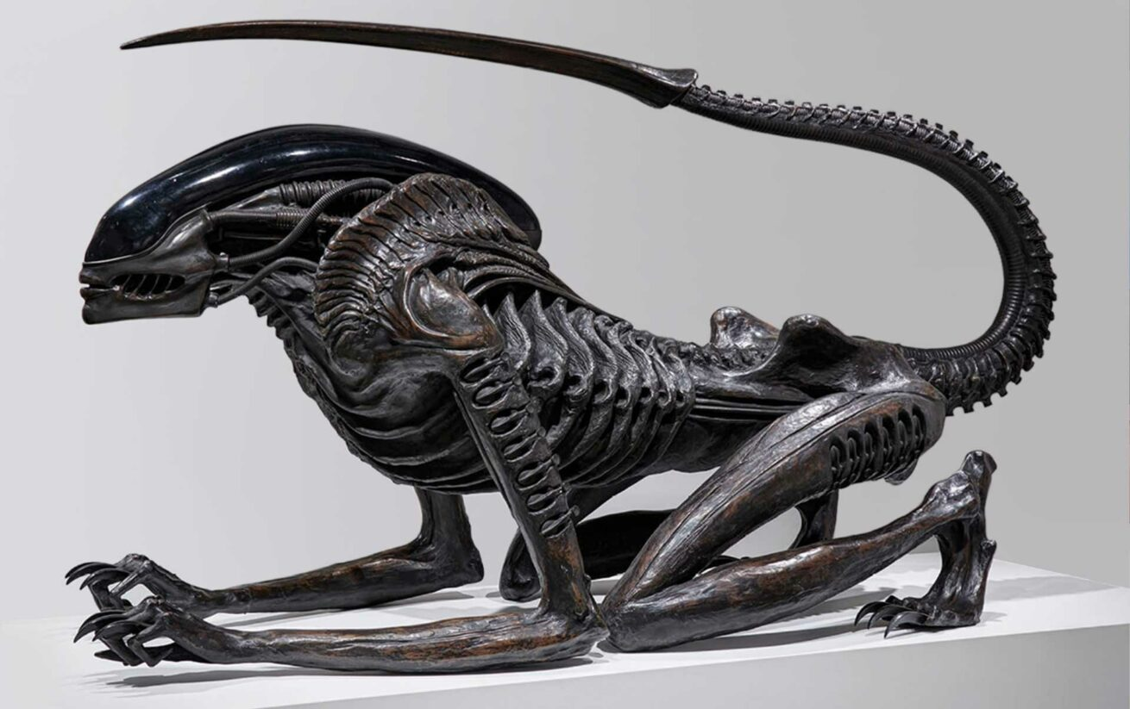

Modelling
So with that in mind I decided to the male human pressets as a base that I could model and hard bake over the top of giving me more time to work on the animation its self, with that in mind I also decided instead of spending too much time on making a second model which the creature would be staking and hunting I decided to instead use a place holder either a ball or cube so I didn’t spend even more time away from the animation.

Problems that accrued
After I had finished making my creature I imported it into a program called Maya 3D which is primarily a 3d modelling software but it also has a wide rand of animation tools as well making it perfect to use for this assignment, one said tool is the ability to create a skeleton wire rig for my creature model so I could move its different limbs and also a way to get the model into poses I needed to make my animation truly work, but sadly a major problem accrued while using one of the features within Maya the auto rigging feature which creates a skeleton wire rig for the selected model within the scene, unfortunately because I had used a pressets from Zbrush that had its anatomy slightly altered by the hard baking of textures present on the model maya could not determine where the joints of within the body should go and through multiple of attempts to try to fix a seemingly simple issue became more difficult.
Solution
In that moment I decided the easiest option to me at the time was to find a premade free rig online that could fit within my initial idea however the rigs I kept on finding were not compatible with the version of Maya 3d located on the uni system so I had to completely scrap my initial idea, luckily for me there were a few rigs given to us that we could use for our animation so while looking through them I began to come up with a new idea on what I could do my animation.

Second idea
So then after choosing my new rig that had been given all the control points needed to make it a seamless 20 second animation, with this new rig I came up with a new idea of what I could for this new animation I decided to go on the same lines as loony toons wile e coyote and road runner in a way where the main character would be simply minding their own business just casually walking down a street where out of seemingly nowhere a string of misfortunate events befouled on the character, very similar to how in the loony toons wile e coyotes own traps seem to always fail and hurt him instead of getting his target the road runner, I’m using the same type of physical gag in my new animation but with my own twist because my character as no idea why these events are happening to him.
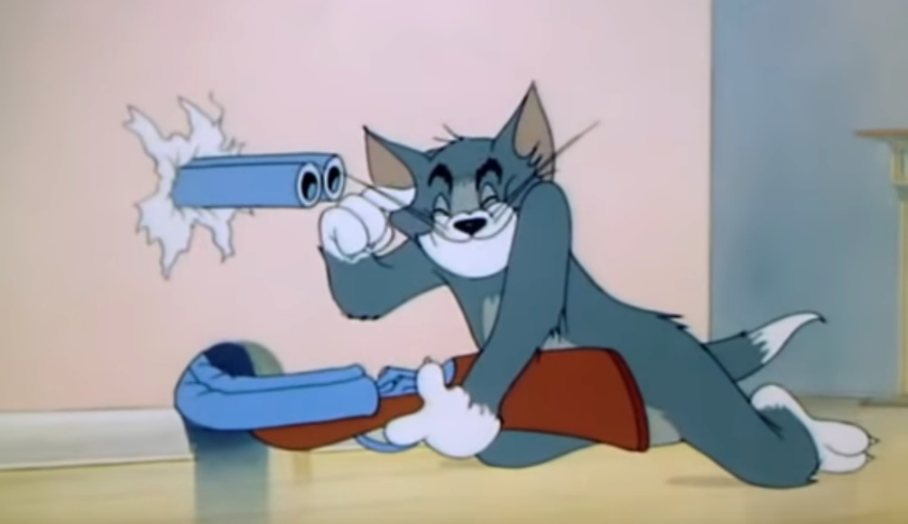
Now for me to understand this type of slap hit comedy I looked at two different cartoons that feature them both as their main focus Wile e coyote and the Road runner as I've already stated I was also looking at Tom and Jerry and from what I could see while watching there clips it all came down to the over confidence of the protagonists with this meaning Wile w coyote and Tom but also the timing in between them thinking they have succeeded to them failing, so with my animation I wanted to try to replicate that same feeling of the character thinking he’s succeeded but ultimately failing in a spectacular way.

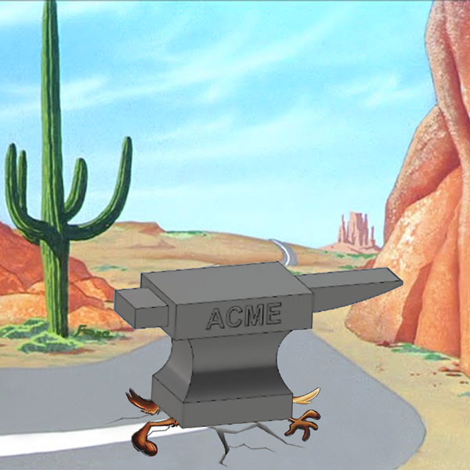

Research
Now for my research for this animation project as I have already stated I have looked into Wile e coyote and the Road Runner and Tom and Jerry because they are the perfect example of slap hit humour, so while looking at them both I began to watch a lot of clips from each show to get an even more in-depth look at what makes them both work so well.
Wile e coyote and the Road Runner
Looney Tuesdays | Iconic Duo: Wile E. Coyote & Road Runner | Looney Tunes | WB Kids
After looking at clips of Wile e coyote and the road runner it is clear that Wile e coyote is always the butt of the joke with every scheme and a labret contraption he comes up with to catch the road runner seem to always fail and backfire on him with the road runner just missing the traps, even though is seems to be quite repetitive it still works all because of the animators use of timing so you almost think that Wile e coyote will finally get the road runner even though you know that he will always fail.
Tom and Jerry
Tom & Jerry | Tom & Jerry in Full Screen | Classic Cartoon Compilation | WB Kids
Now then after looking at Wile e coyote I needed something else to look at, so I had another source to gain even more inspiration and the first thing that came to mind that had quite the similar type of humour and animation sense was Tom and Jerry with the wacky ways both Tom and Jerry try to get each other from cutting out holes under them so they fall into a dark hole or putting a double barrel shot gun into a mouse hole for it to then be turn back on the user, however the differences between Tom and Jerry and Wile e coyote is that in Wile e coyote and the Road Runner only Wile is affected by the traps that he makes but in Tom and Jerry both of them get an equal amount of punishment dolled out apon them even if at times it seems that Tom gets the most punishment mainly from his own schemes with Jerry getting away.
With all the information I have obtained from both of these similar and different animations I will hopefully try to incorporate some of the humour technics they has used in both within my own animation to create something funny to watch.

Animation prosses
For the animation itself I used one of the rigs provided so I didn’t have to worry about the problems I encountered with my original idea and suffer no setbacks right at the beginning of this animation.
So after loading the rig into Maya and playing around with it to get a feel of how the joints moved on the model itself, I sat down and began to plan what I was going to animate, after a while I realised that the legs on the model weren't connected to the feet physically so by just moving the body I could make it seem like he flew out of his shoes.
Now then with that as my main concept I just needed an object to use that could be seen as hitting the character so I used an extended pole that would fly directly at the character after he made it to the middle of the platform, he would initially duck under the pole just missing him but as the character starts to stand up thinking he is in the clear the pole then flips in mid-air after missing him to then come back to try to hit him again, as the pole is coming back towards the character he turns back and quickly realises that he needs to jump backwards so he can dodge it in time.
Finally, after jumping over the pole and falling down the character begins to stand back up in a sigh of relief but then out of nowhere the pole comes back and hits the character square in his chest lifting him into the air backwards but leaving his feet in place which gives it a more comedic feel to the overall animation.
Conclusion
With this assignment I had a clear goal from the start, to create a 20 second long animation which was easy to follow with the premiss and was enjoyable to watch, however in the beginning I came across difficult obstacles with my original model not being able to rig and animate while in Maya which coast me a considerable amount of time to create a completely new animation with the miniscule amount of time I actually had, looking back at it I could of tried to use a different program like blender to see if I could of still used my initial idea but I also honestly do not regret having to restart my entire animation because I have really enjoyed making the comedy style sketch with my animation.

Having said that there are one or two things I would change if I were to ever revisit a project like this, I would create a second idea ahead of time while coming up with my first idea, I would try to make the animation run a little more soother, but this was more down to a time constate than a lack of ability and finally if I had enough time I would of liked to add sound to my animation in a similar way to the two animations I was using as inspiration Wile e coyote and the Road Runner & Tom and Jerry. Hopefully in the future I will be able to use what I have learnt from my mistakes within this assignment to propel any assignments that may be similar to this to a higher level of work.

https://youtu.be/VVTEM3HuVgU
This is a link to my YouTube video of my final animation

