Name – Luke Hart
Module name – Construction Management
Module code – ACBA6000
Course – BSC Quantity Surveying
Date of submission – 07/12/2020

Contents page.

Page 3 – Introduction & Question 3
Page 4 – Question 3 Cont.
Page 5 - Cost Overview & Cash Flow Report
Page 6 – Question 4
Page 7 – Question 4 Cont.
Page 8 – Site Setup Sketch
Page 8 – Question 1 Part A (Scenario)
Page 9 – Part A Cont.
Page 10 – Part A Cont.
Page 1 – Part A Cont.
Page 12 – Question 1 Part B (Scenario)
Page 12 – Part B Cont.
Page 13 – Part B Cont.
Page 14 - References & Bibliography

Introduction –
The aim of this assignment was for me to be able to complete the tasks given to the best of my ability whilst advising and allowing the client to clearly understand the reasoning and workings out behind the decisions I made. Having conducted in depth research into the required topics I believe that I have made the correct decisions based on my knowledge and research and that they would be adequately suited for the client to follow and understand throughout the project.
Q3.
Definition -
Incentivisation in construction is where something is used to motivate the contractor to increase their performance on the job in question. For example, a client may need the job done by a certain date, but may reward the contractor for every day before the original end date the job is completed ahead of schedule (Corr, 2013) or it may be agreed that for every day over the deadline date the project is completed the contractor will receive an extra charge.
Incentives are used to achieve set targets or influence the personnel in question to behave in a set manner, these can be financial or non-financial (CIRIA, 2001).
The incentive has to be achievable and must be beneficial to the contractor otherwise there is no inspiration to hit the objectives. You can have positive and negative incentives, although positive ones are regarded as working better.
Addressing performance issues in terms of productivity and incentivisation.
There are many ways of using incentives to motivate and influence the contractor regarding the construction stage of a project, some which may work better for some rather than others, but everyone may have different preferences/experiences for what they think.
Negative incentive - negative incentives can be used to improve productivity by having an outcome that is not wanted. For example, promising bonuses – if the targets are not hit then the bonuses are taken away. The last thing the contractor will want is to get penalised for not doing what was agreed (Jeffries, 2018).
Positive incentive – positive incentives look to reward when certain targets are hit, like bonuses for completing x amount in the desired time frame.
Incentives can be agreed between the client and the contractor or even the contractor and the contractors’ staff. Financial incentives are probably the most common type of incentive used throughout the construction industry and are usually based around situations where the client will benefit financially because of the enhanced performance provided by the contractor – reducing costs / delivering project early (Constructing Excellence, 2015)

Type of Incentive | Motivator Used | Findings
Direct Negative | Penalties and liquidated damages. | They do not improve performance.
Direct Positive | Immediate financial rewards for achieving specific performance targets in terms of cost, quality and schedule. Usually used in conjunction with direct negative. | They improve performance but foster adversarial relations (disputes, risk taking).
Indirect Positive | Vary in relations to the mutual goals of those involved. | They are especially effective when used to foster the achievement of medium-term goals within a collaborative framework.
(Source CII, 1986 and CIRIA, 1996)
Financial incentives – construction clients frequently use this method of incentivisation to inspire the contractors to deliver tasks at an earlier date rather than the contractual date but to the same quality or even better.
An example of this would be, the contractor has agreed to do a project for a client and have agreed a finish date. The client now needs the finish date brought forward 3 weeks. You may agree to put the working hours in to manage this but at the expense of the client.
Financial incentives are not always between the client and the contractor but can also be between the contractor and the workforce, this could be incentives e.g., money paid in return for hitting certain targets e.g. bonuses, wage increases.
Another type of incentive would be shared risk incentives. Shared risk incentives are where the risk is shared between both the client and the contractor in order to influence the contractor to keep the costs of the project to a minimum. This will all be agreed in the contract of the project.
The best way of addressing potential performance issues throughout the construction stages of the new library for the ‘University of Wales Trinity Saint David’ would be to use financial incentives. There could be incentive payments made to the contractor at the end of each stage that has been hit on or before the date that was originally agreed e.g., Substructure – payment, Superstructure – payment etc (all providing agreed standards of work have been met).
Now, the problem with the concrete company going on strike could also be addressed using incentives. This could be positive and negative in my opinion. As the two-week strike is on a stage of the construction which would change the overall finish date and hold up other stages this could be a real issue. The client could say that for every day that you are behind and go over the dates that have been agreed then they will penalise you and deduct money from your overall payments – this would be a negative incentive and the contractor would try and find ways of getting over the strike, such as getting concrete elsewhere – this may be more expensive but will be cheaper than the client deducting money.
Then the positive incentive for this scenario could be;
Between the client and the contractor, it could be agreed that every stage that is completed on or before the agreed date will warrant a reward. Again, this would motivate the contractor to overcome the issue of the strike and look at various ways to try and overcome the problem. There could also be a promise of future work together if the targets are hit for this project, this could then put immense pressure on the contractor if they are in dire need of work. Then between the contractor and the work force this could be used to influence the workforce to increase productivity, working more days and longer hours for example to get the concrete in on time with promises of a reward if this is achieved - pay rise, bonus, time off.
Conclusion.
Although in my opinion positive incentives would work far better in the construction industry, I also feel that sometimes it may be necessary to include negative incentives too. If you feel that you have very little chance of the contractor achieving what you are asking then I think including a negative incentive, such as penalising them for each day they haven’t achieved what was asked of them would push them on a bit. There can be an issue with pushing the contractor to hit deadlines and this can be – people start to cut corners, quality declines to improve speed. But overall, I’d be inclined to use positive incentives unless you deem it necessary to include negative.
Cost Overview
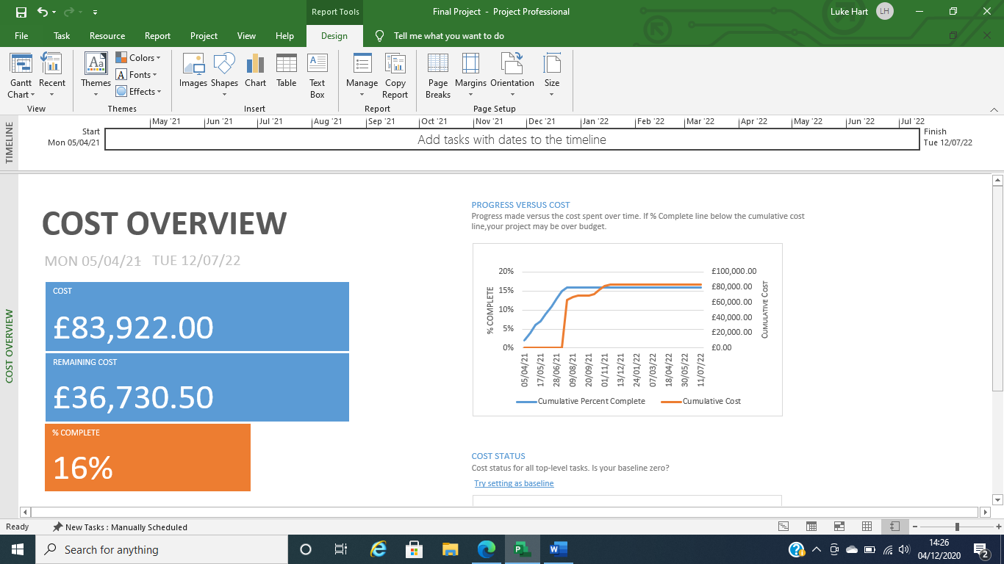
The above cost overview shows that the total cost of the project is £83,922.00 but because the project is currently 13% completed then the remaining cost of the project is £36,730.50.
Cash Flow Report
Below, I have presented a cash flow report for the costs that I have added into the Gantt chart that I have produced for this project. I understand that I have not included all the prices neither have I added all the prices to my Gannt chart but the above report will show you the quarterly costs for the duration of the project – only going off the information which I have inserted in the chart.

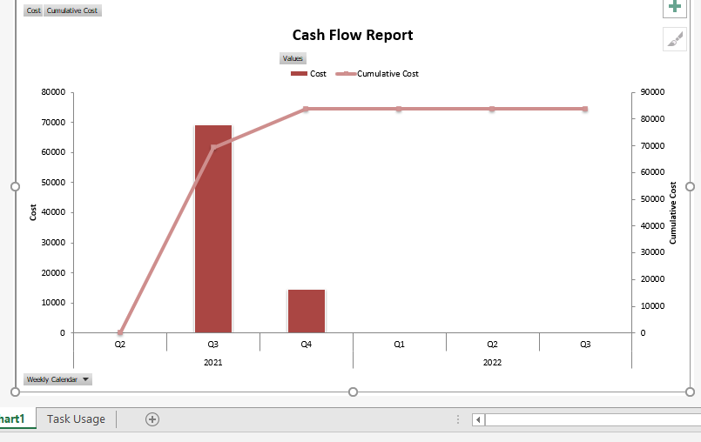
Q4.
For question 4 of the assignment, I have designed a site setup layout for the project of constructing the new library for the UWTSD. This is shown below. I will also aim to give a brief explanation of the reasoning of what I have put on this site setup and why I have put it where it is.
Around the perimeter of the site, I have decided to put up solid hoarding which across the top will have a layer of anti-climbing paint, I have chosen this for a few reasons. One of the reasons is it stops people looking in and seeing what plant, materials we have on show, and the second reason is to stop people who do decide that they want to access the site from climbing over the hoarding from doing so.
The traffic management system that I have chosen to put in place is a one-way system (with gates) with easy access along the way to the designated delivery drop off point to ensure that deliveries can flow smoothly with no disruptions. I have also got access for vehicles to the waste management storage at the top of the site so waste can be stored correctly and taken away easily, also at the top of the site the traffic system runs besides the pile of top soil which I have done so that again it is easily accessed by heavy machinery when it needs to be manoeuvred. On the way out of the site on the right-hand side I have got a wheel washing area with appropriate drainage, allowing us to ensure that the dirt picked up whilst traveling through the site is then not brough outside the site gates and distributed elsewhere (I have located this not far from the services to ensure the access of clean water).
To the right of the delivery drop off point I have the material storage area with extra security fencing around just to be safe, allowing deliveries to be placed directly into storage without having to double handle them.
Towards the front of the site then I have included the first aider station, I have tried to keep this reasonably close to the working area so if something does go wrong then the journey is a short one to reach the station so you can get treated ASAP. To the right of the first aid, I have located the workers toilets and canteen, which will include the correct facilities needed such as – clean water, hot water, wash stations etc – again located near to the services to get the correct things needed. Alongside this to the left I have located the main site office; I have situated this at the very front of the site to make sure it is easily accessed by everyone who needs to and I think that it helps with security too – in front of the site office I have put the ‘fire muster point’ this would be adequately sign posted and I believe it is the best place to situate this. You would also be taught this including all the other site rules and what is expected of you when you attend the induction building, this is located just behind the site offices and next to the first aid station – everyone who is to come on the site will have to do an induction, whether you’re a visitor, a delivery driver or part of the workforce. This is to ensure that everything and everyone is kept safe.
I have included a sign in office which is located right by the main gates and everyone who enters and exits the site will have to complete this, this again is to ensure safety and for if something goes wrong then we don’t spend valuable time looking for someone who isn’t actually still on site because they haven’t followed the rules and signed out.
The last thing I have included on my site setup plan is over on the far right I have included another gate which will lead you to very limited car parking, this could be for office staff and visitors. Although the parking is over on the right-hand side you will still have to immediately head over to the sign in office and fill in your details, which is why I have erected a fence between the toilets and the outer hoarding to prevent people from avoiding the sign in area.
Overall, I feel that I have selected and designed the most appropriate and efficient site setup plan for this project taking into account that the students and staff are already in the IQ building to the left of the site – I have given them temporary access to the side of the IQ building which enables us to maintain safety measures whilst continuing on this project.

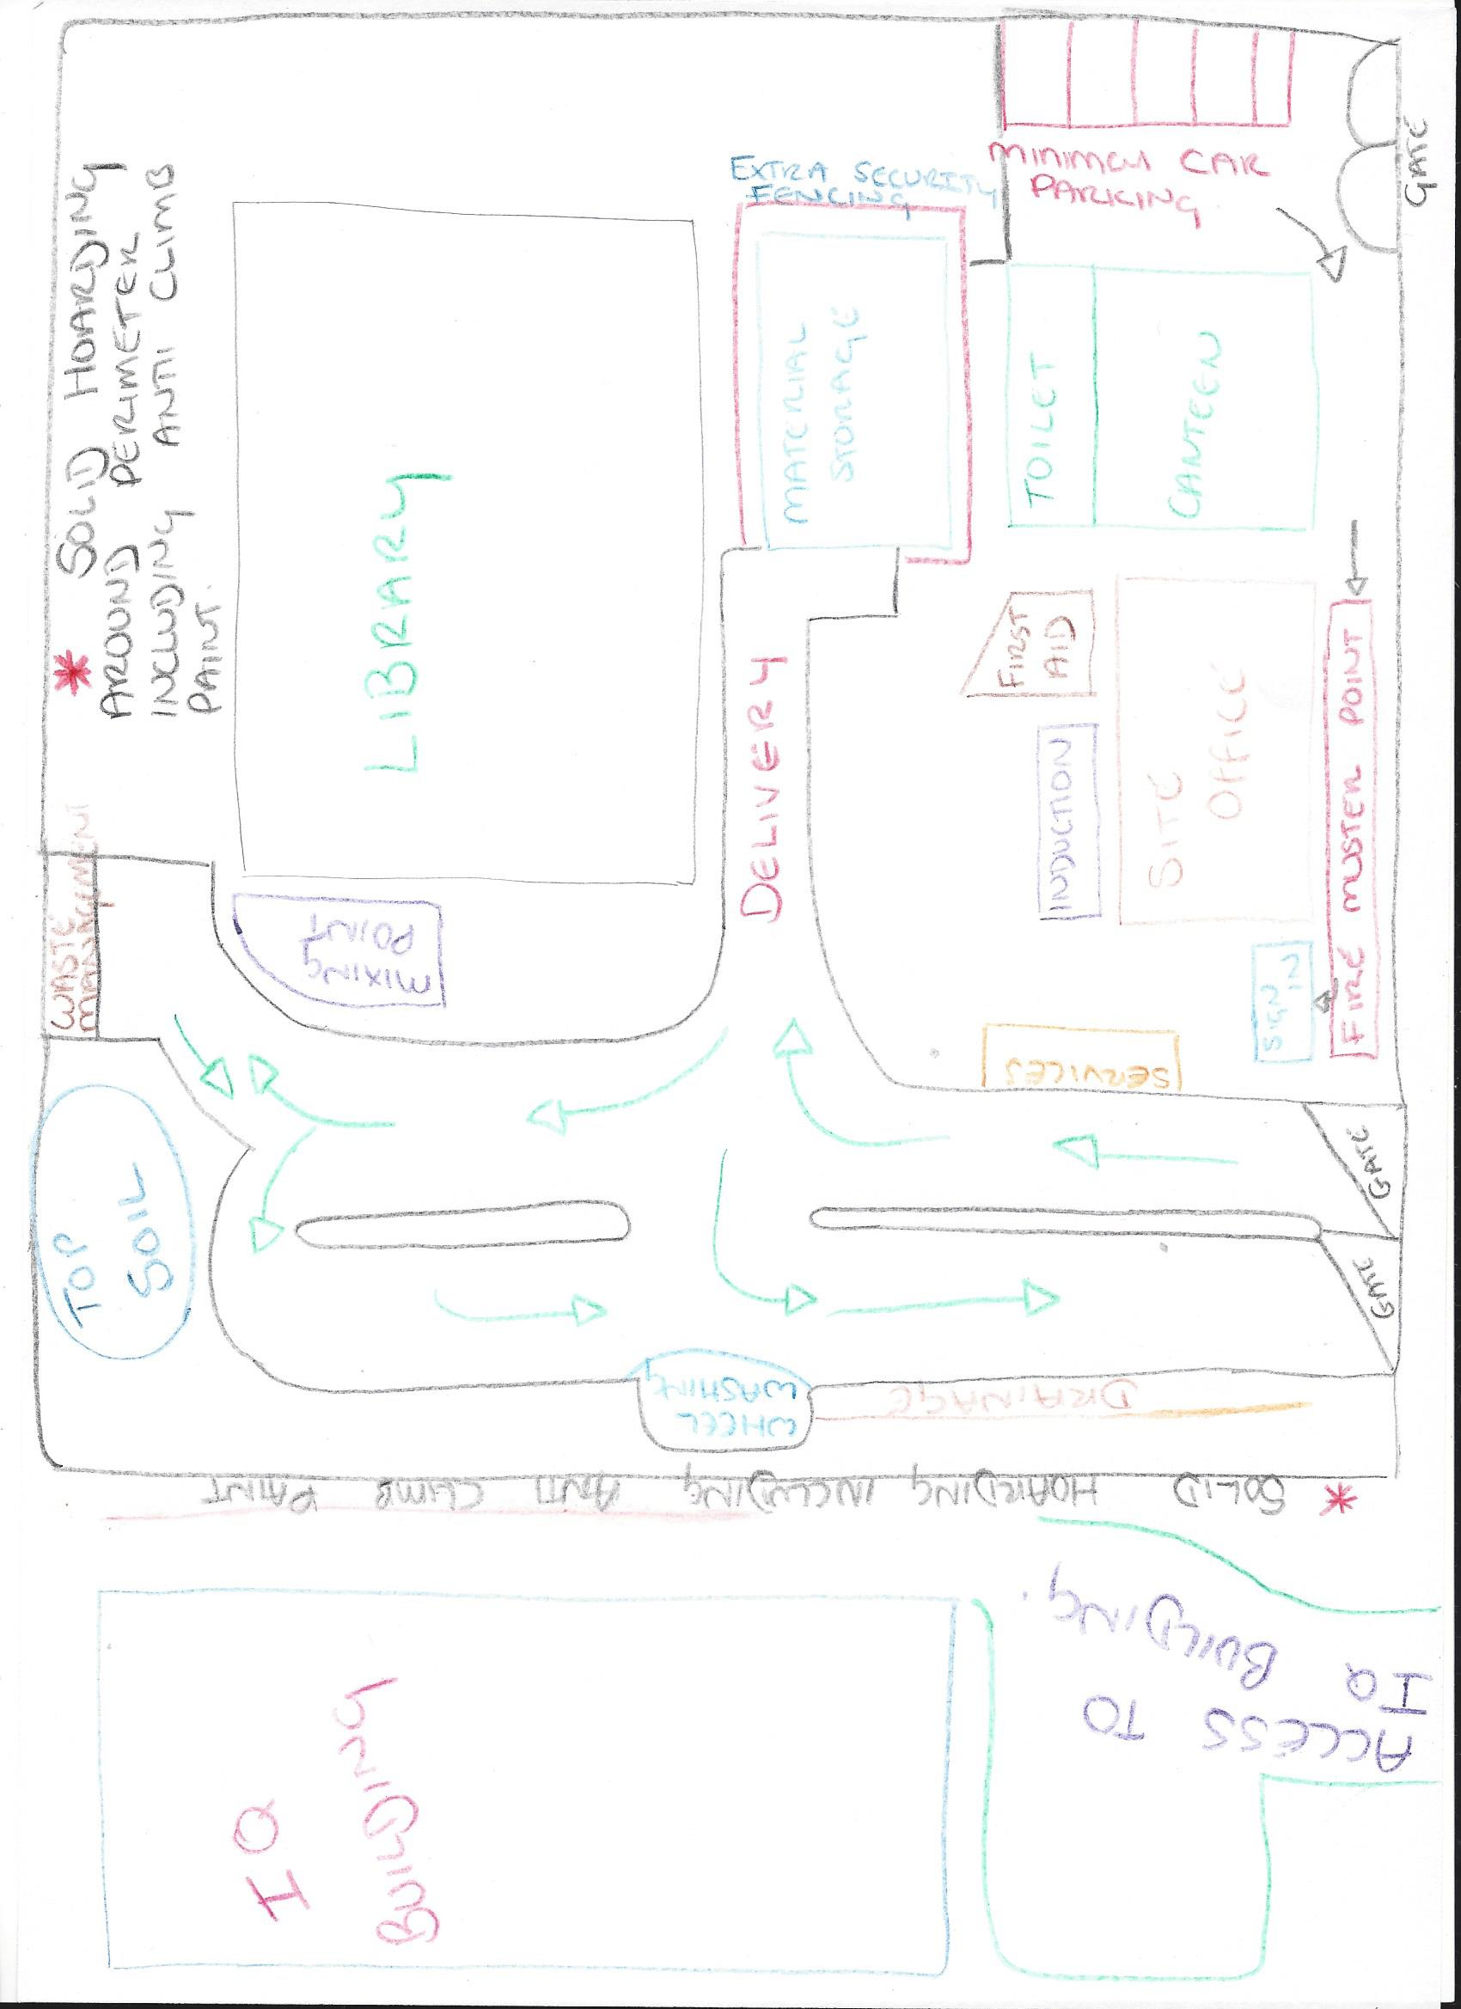

Question 1 Part A - Scenario
This is what the Gantt chart looks like before I have addressed the complications that the 2-week strike is going to have on it.
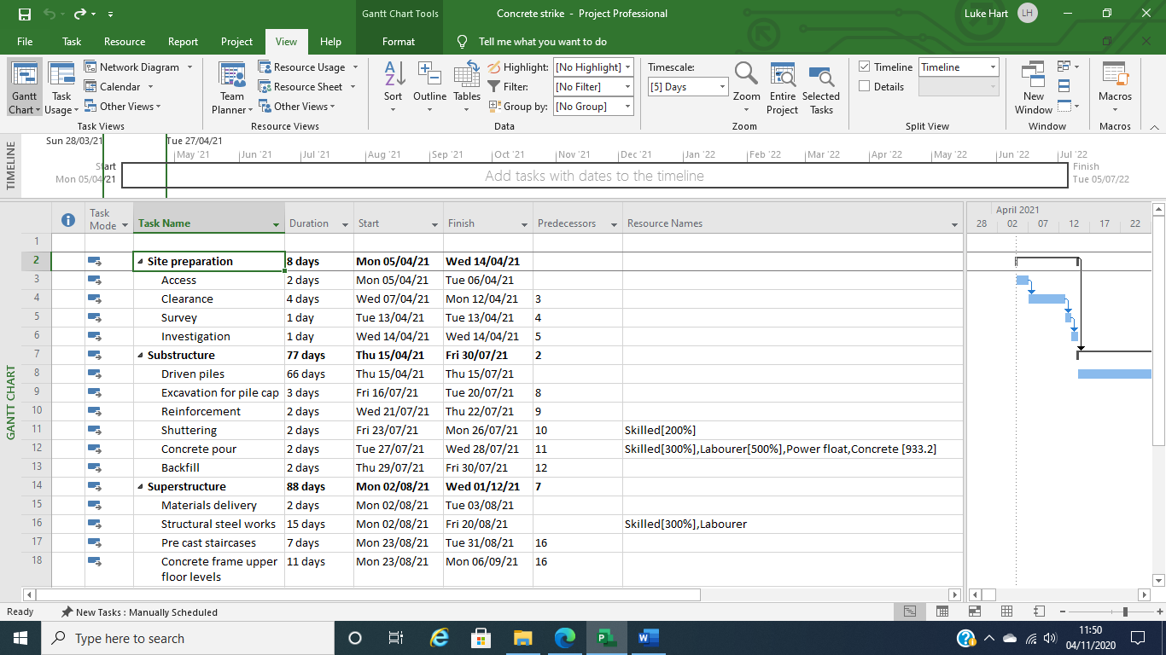
Below you can see that straight after the shuttering has been completed then the concrete pouring is able to run sequentially.
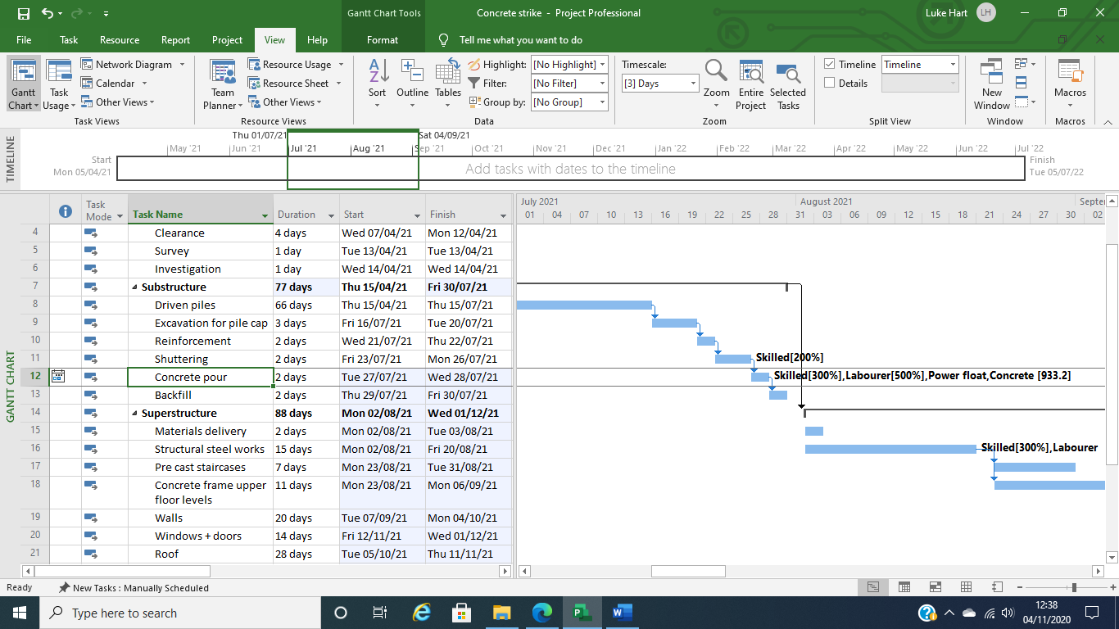
Below is how the Gannt chart now looks after adding in the 2-week delay on the concrete pour caused by the strike at the local concrete company.
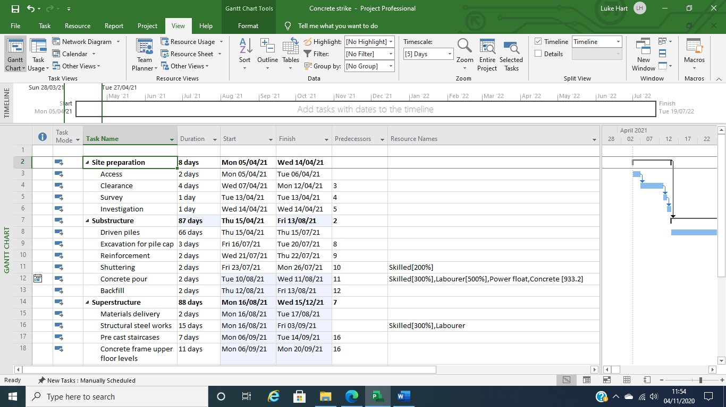
You can clearly see below the 2-week gap which you now have between doing the shuttering and being able to pour the concrete.
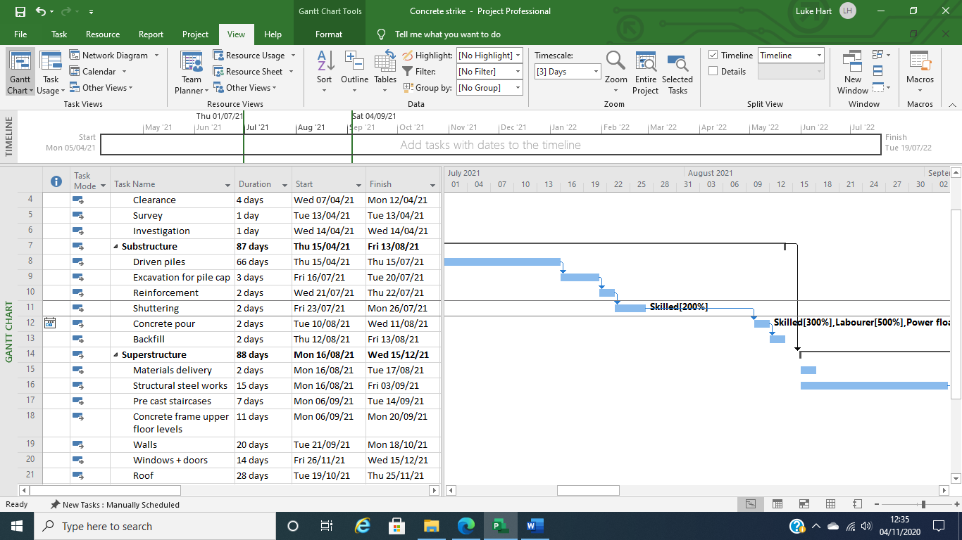

Also, by having a two- week delay in the middle of this project will obviously have an effect on the finish date that was projected.
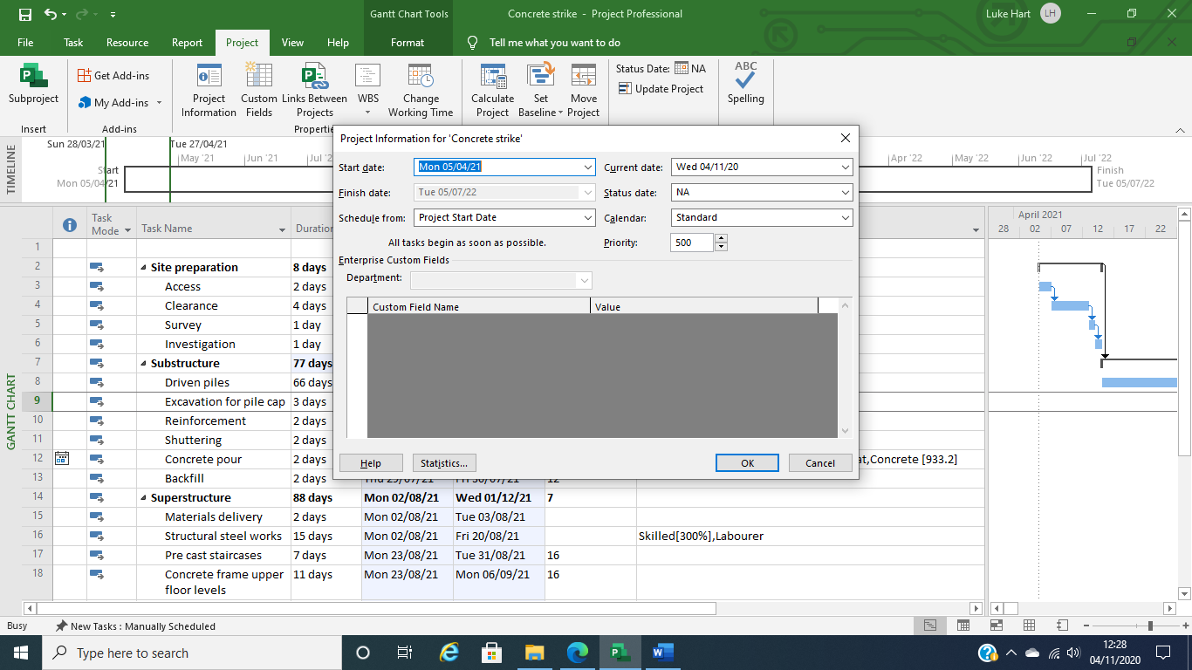
Above you can see that the end date is projected as being on the 05/07/22.
Below is the projected finish date after adding the 2-week strike into the Gannt chart.
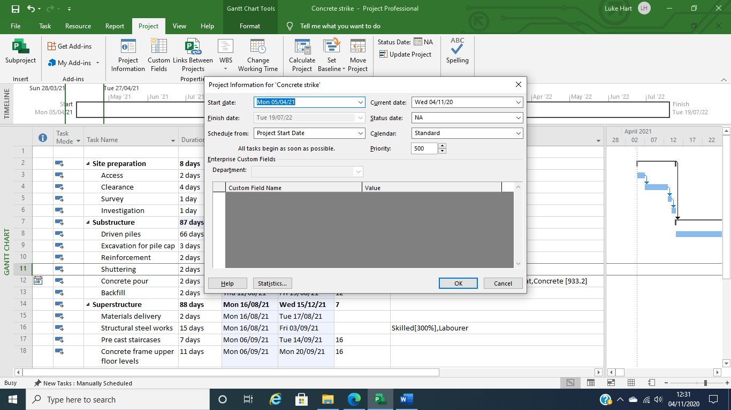
The projected finish date is now the 19/07/22.

Below, I have also included my Gannt chart with a baseline set.
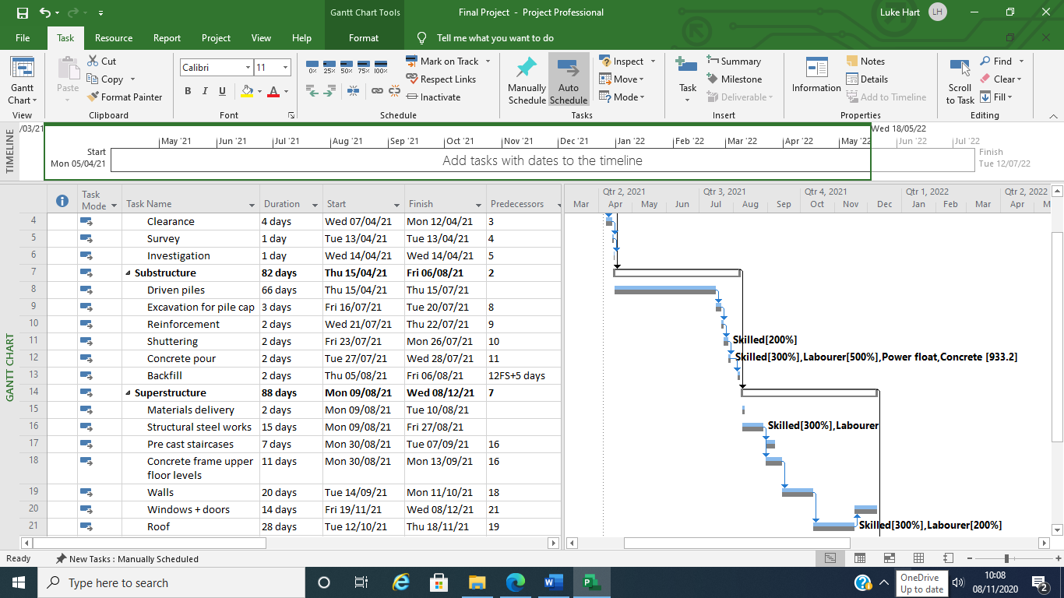
Having this in place you will be able to see the original dates set for each task and then the actual dates it took place on and the actual length it took to complete.

Question 1 Part B)
After looking at the plans provided, I was able to work out roughly how much concrete would have been needed to produce the pile cap on top of the driven piles –
21.650m x 47.892m this is the length and the width of the building, I then assumed that the pile cap would be a depth of 900mm, so –
21.650m x 47.892m x 0.9m = 933.17m21.650m x 47.892m x 0.9m = 933.17m³
So, to pour the pile cap you would need to order 933.2m³ of concrete.
To work out the price of the concrete I got a price of £65 per m³.
(2017, A Guide to Ready Mix Concrete Prices)
933.2m³ x £65 = £60,658.00.
This can be seen below.
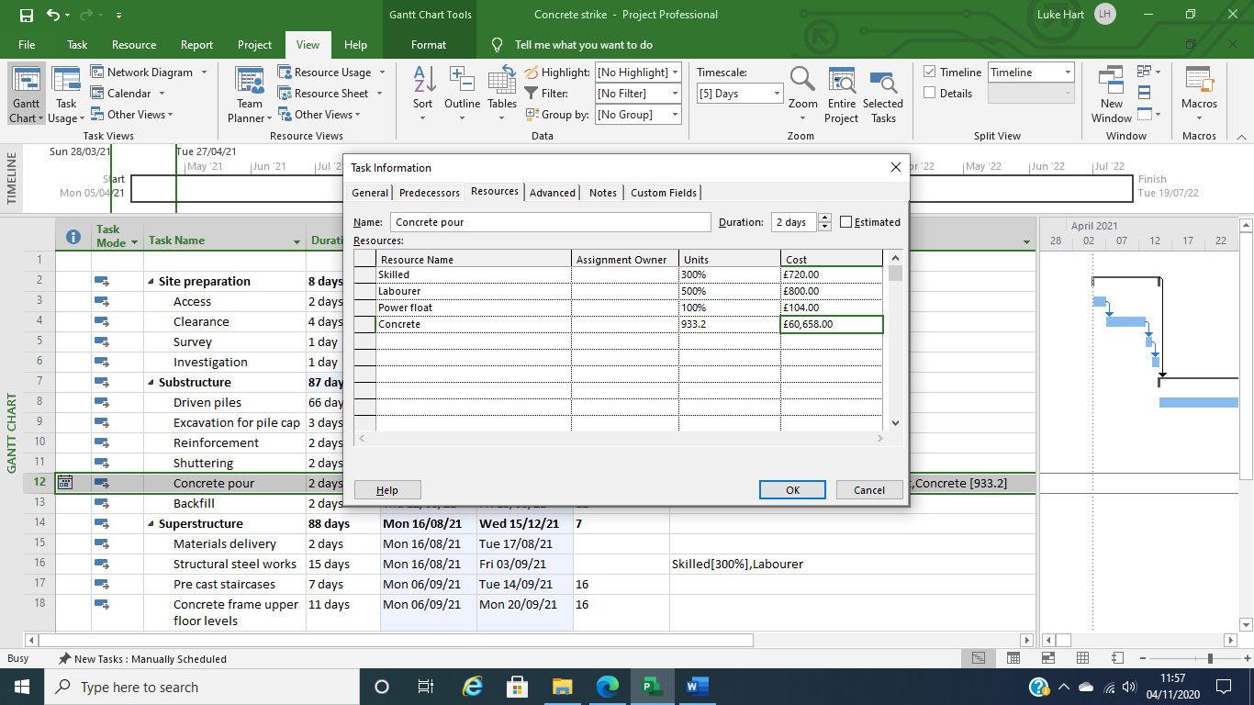
To bring in concrete from further away whilst the strike is going on would cost an extra £1 per m³.
933.2m³ = £933.20
£60,658.00 + £933.20 = £61,591.20.
The new price of the concrete would be £61,591.20.
As I have shown below.
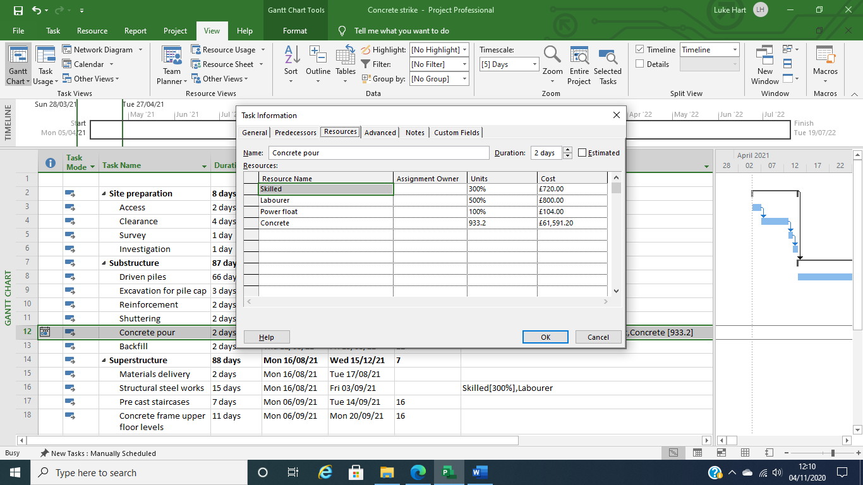

References.
Ashley, D. B. and Workman, BW. (1986) “Incentives in Construction Contracts”. Austin (TX): CII, SD 8 [Accessed 29 Nov. 2020]
CIRIA (1996) Construction Productivity Network (1996) ‘Incentive Based Contracts for win-win Solutions’ [Accessed 29 Nov. 2020]
CIRIA (2001), Construction Contract Incentivisation Schemes: Lessons from Experience, CIRIA, London. [Accessed 28 Nov. 2020]
Corr, C. (2013). How to Incentivise Under NEC3. [online] Built Intelligence. Available at: https://www.builtintelligence.com/blogs/home/9101375-how-to-incentivise-under-nec3 [Accessed 5 Nov. 2020].
Designingbuildings.co.uk. (2016). Construction site facilities. [online] Available at: https://www.designingbuildings.co.uk/wiki/Construction_site_facilities. [Accessed 16 Nov. 2020]
Guide, U. and Quotes, G., 2020. A Guide to Ready Mix Concrete Prices. [online] Householdquotes.co.uk. Available at: <https://householdquotes.co.uk/a-guide-to-concrete-prices/> [Accessed 8 November 2020].
Jeffries, J. (2018). Why Negative Incentives Work. [online] Spinify. Available at: https://spinify.com/blog/why-negative-incentives-work/ [Accessed 8 Nov. 2020].
SECTION II.6 SETTING INCENTIVES AND SHARED SAVING SCHEMES. (n.d.). [online] Available at: https://constructingexcellence.org.uk/wp-content/uploads/2015/03/D6Disc-inc.pdf. [Accessed 29 Nov. 2020]
Bibliography
Appelbaum, S.H. and Kamal, R. (2000). An analysis of the utilization and effectiveness of non‐financial incentives in small business. Journal of Management Development, 19(9), pp.733–763. [Accessed 16. Nov. 2020]
Braimah, N. (2013). Construction Delay Analysis Techniques—A Review of Application Issues and Improvement Needs. Buildings, 3(3), pp.506–531. [Accessed 16 Nov. 2020]
Bryde, D.J. and Joby, R. (2007). Incentivising project performance in the construction of new facilities. Journal of Facilities Management, 5(2), pp.143–149. [Accessed 16. Nov. 2020]
Hughes, D., Williams, T. and Ren, Z. (2012). Is incentivisation significant in ensuring successful partnered projects? Engineering, Construction and Architectural Management, 19(3), pp.306–319. [Accessed 16 Nov. 2020]
Olsen, Trond E. and Osmundsen, Petter (2000). Sharing of endogenous risk in construction. [online] Available at: https://core.ac.uk/display/154614903 [Accessed 8 Nov. 2020].
SECTION II.6 SETTING INCENTIVES AND SHARED SAVING SCHEMES. (n.d.). [online] Available at: https://constructingexcellence.org.uk/wp-content/uploads/2015/03/D6Disc-inc.pdf [Accessed 8 Nov. 2020].
Trentcotney.com. (2017). Using Incentive Programs to Motivate Construction Workers. [online] Available at: https://trentcotney.com/construction/using-incentive-programs-to-motivate-construction-workers/ [Accessed 8 Nov. 2020].

