10.12.2019

Digital Skills and Research Methods

Student Name: Andrei Strechie
Student Number: 1811974
Module cod: BMSK4003
Lecturer: Balendran Kandasamy
Table of content
0
Introduction 2
Background 2
Aims and objectives 4
Method 5
Results 6
Discussion 7
Conclusion 13
References 13

Digital Skills in Employee Training

Introduction
The research is based on the application of digitals skills in employee training and the impact of the same on employee skills development. The report will be based on the understanding of the meaning and practical application of digital skills and making changes in the workplace and develop associated values with the same. The report will be helpful in studying the application of various resources in the growth and development of various features associated with digital skills and understands its applicability in real life and better development of resources. The report will establish a basic idea about the skills and identify the gaps in the current workplace and how the same can be changed. The research is based on a quantitative research method and analysis.

Background
As per the study of Correa (2016), there are 68% of the employee that says that training is an essential part of working in an organization thus helping in better resource generation and effective application of knowledge.
As per Scheerder (2016), the need to have digital training in the workplace is necessary because of three major reasons: employee requests for digital training, the digital world is surrounding us, many digital skills are needed in day to day life but they are not taught explicitly in schools. Among various employees that have been asked the need for digital training many of them said that the current industry needs digitally experienced individuals and if the company is not able to deliver effective training and skills to the employees, they are ready to leave the organization for something else and better. Many said they can gain digital knowledge outside the organization for better development of their potential.
As per the study of Van Laar (2017) lack of digital skills and knowledge has been costing organizations with the large potential risk of lacking in society. These digital skills have become the backbone of the organizations which were previously just secondary resource for organizations. An application like Dropbox, Twitter and Skype are very pervasively being used by the employees to increase the quality and productivity of their work and help in driving better work in the organization. When organizations put effort into training employees this puts a frantic pace on the digital transformation in the organization. The training process can be done by first looking into the business size and capability and determining special training objectives that are needed to be boosted. Developing short term and long tern training programs in the process. in a smaller business, there can be small in a house in house training that can support workforce while for larger companies external training partners can be used in the process. The inclusion of the holistic learning process is used in organizations to express immerse training programs that can express the features of microlearning and focussing small digital lessons. Inclusion of carefully designed digital videos is needed to build self-directed learning tracks that are needed to layer one lesson at a time.
As per Pagani (2016), the growth of social media and digital platforms around an individual makes them more inclined towards the use of digital skills; in that case, if the company does not support such case they might need to develop a strategy to be digitally sound and well-aligned. A well informed and trained employee will have better competent skills in a workplace and the same will be developing the position and brand of the organization as per industry needs and standards associated with them. The learning programs can be developed in five ways:

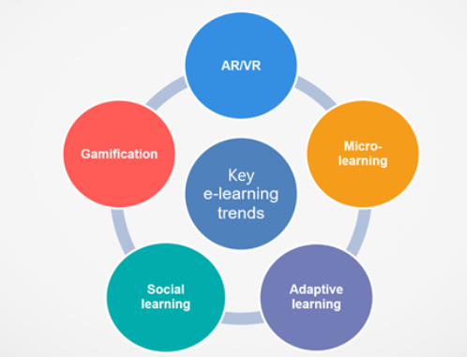
In the augmented reality and virtual reality platform, there is a need to develop effective virtual roles and needs to effectively demonstrate employees the need for training and the expected outcomes. This can be elaborated using role plays and deep learning. In microlearning, the process is very short and to the point, this was majorly done in order to train those employees who are extremely busy and do not have effective time for training. In adaptive learning, there is a customized development of learning processes and efforts to cater to different employees with different needs. In social learning, the major aim is to develop social groups so that employees can learn from each other. This is necessary to develop effective communication and understanding through blogs, live chats, videos, podcasts, discussion forum, etc. the last process is gamification process in which the company uses games to develop e-learning fun, by engaging employees and developing an interactive session for all the people in an organization. This develops competitive skills and helps the employees to perform better.

Aims and objectives
Aim: To identify the impact of digital technology in the development of skills in employees.
Objectives: Major objectives are:
- To study the difference in technical knowledge before and after digital training.
- To apply different technology to train employees.
- To study the response of employees regarding digital training methods adapted by the organizations.

Method
The research was based on the application of a quantitative research method that includes the collection of primary data from prime resources and making changes as per them. The first step to applying this method includes an understanding of the geographical area on which the research was supposed to be conducted. In this research, the participants were taken from some well-known IT companies located at the domestic and global levels to understand the idea of digital training in various companies. As per age, experience, association with training module there was a collection of 50 people from which only 20 people were selected for the survey (Flick, 2015). The survey was conducted face to face with participants on a domestic level while those who were beyond reach were contacted through the internet.
This research methodology was based on the ethical process thus the participants were well briefed about the context of the research and making an effective understanding of the desired results from the market survey. This was also seen in the process that with the gradual understanding there can be an effective collection of data supporting a course of action. The research was analysed by applying statistical tools and techniques that support the collection and evolution of the implication of digital skills into making the various process that is useful in making substantial growth in the overall process. The nature of questions was simple and directly associated with digital training methods and adaption of skills in the various process thus taking advantage of various methods that are needed to develop an effective understanding of the cost and knowledge advantage that has been seen in both the sections (Quinlan, 2019).

Results
Based on the selected sample population and the application of research methodology following questions have been made to collect views of participants.
Questions | Option 1 | Option 2 | Option 3 | Option 4
How long have you been associated with the organization? | >2 years | 2-5 years | More than 10 years | More than 15 years
Does your organization use digital technology to train employees? | Definitely | Sometimes | Rarely | Never
Have you been actively participating in all digital training courses? | Always | Sometimes | Rarely | Never
Has these training modules improved your skills and knowledge base? | Definitely | Some changes are seen | No changes are seen | -
Have you notice any competitive advantage of digital skills on organizational development? | Definitely | Some changes are seen | No changes are seen | -
Are you looking forward for further digital training modules in your work tenure? | Definitely | Occasionally | Only in groups | Never

Discussion
As per the collected responses following arguments were derived from the survey:
Question 1: How long have you been associated with the organization?
Options | Response
>2 years | 4
2-5 years | 5
More than 10 years | 5
More than 15 years | 6

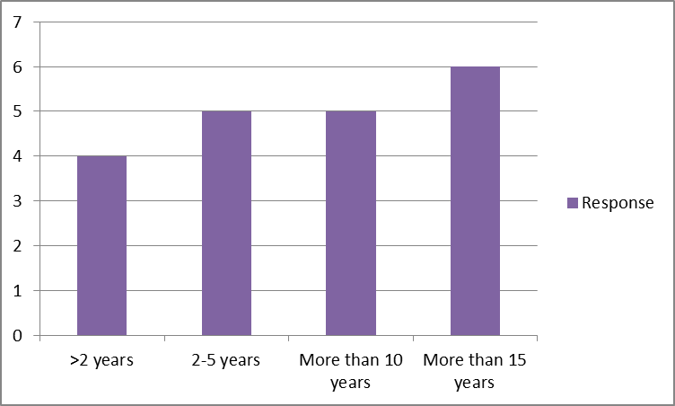
Data interpretation: This has been observed that most of the participants have been associated with the organization for a very long time thus their experience with multiple technology and training processes is varied. The learning taken from various digital sources was very useful for them and this has been one of the reasons for long term association with the organization. This shows there is a positive impact on employee skills development and evaluation purpose.

Question 2: Does your organization use digital technology to train employees?
Options | Response
Definitely | 10
Sometimes | 5
Rarely | 2
Never | 3

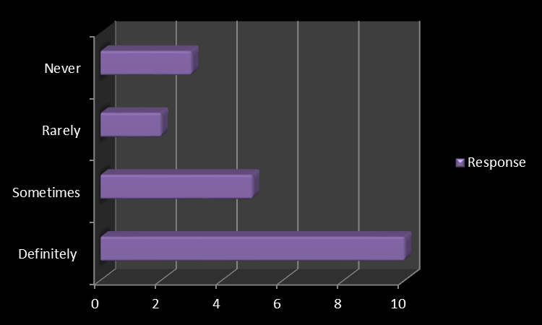
Data interpretation: As per discussion with domestic and international employees this was seen that the overall process was well analysed and associated with employee learning. Most of the organization has been very deeply interested in using digital technology as a part of their learning process and supports needs that follow. This was seen in research that there still some organizations that are not fully acquainted with digital technology thus the same has been affecting their performance somehow.

Question 3: Have you been actively participating in all digital training courses?
Options | Response
Always | 8
Sometimes | 7
Rarely | 4
Never | 1

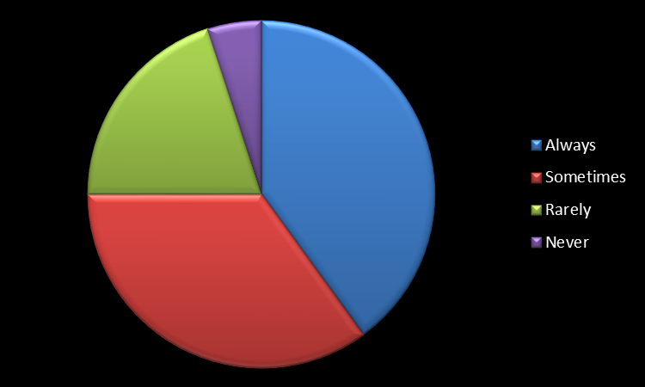
Data interpretation: Apart from a few participants all of them are either actively participating or randomly participating in the digital training features. They believe the decision depends upon the curriculum of the course and the amount of successful implication this training can put on the growth of the organization. Taking self-growth in priority the same was designed to see a reflective response in the process.

Question 4: Has these training modules improved your skills and knowledge base?
Options | Response
Definitely | 12
Some changes are seen | 5
No changes are seen | 3

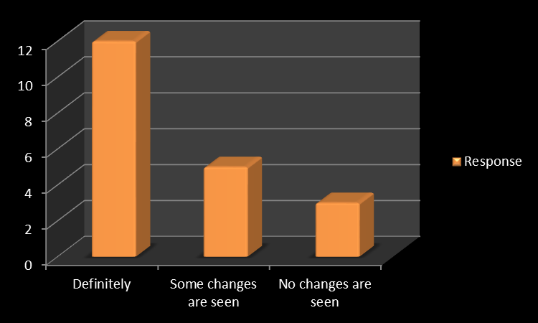
Data interpretation: All the participants were quite clear about the knowledge implications of these digital training modules. Most of them have seen a positive impact on their performance. Some of the participants were still hesitant to adopt the new digital technology in their working process thus affecting consecutive demands that come.

Question 5: Have you notices any competitive advantage of digital skills on organizational development?
Options | Response
Definitely | 12
Some changes are seen | 6
No changes are seen | 2

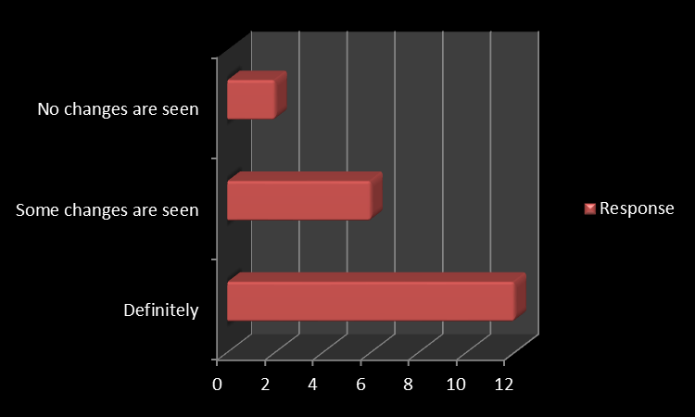
Data interpretation: Most of the impact of digital technology was seen on the competitive development of the participants and making effective changes in the working and interaction pattern of the employees. This has shown leadership over other global and domestic needs that supports consecutive demands in the same.

Question 6: Are you looking forward for further digital training modules in your work tenure?
Options | Response
Definitely | 12
Occasionally | 4
Only in groups | 3
Never | 1

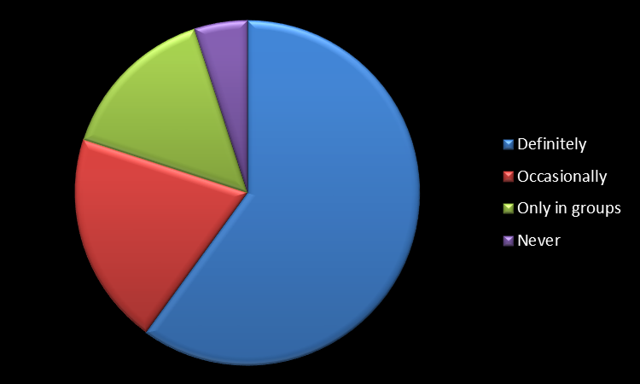
Data interpretation: As per the survey on a both domestic and international level this was seen that in both cases the participants were very much interested in having more digital training and development classes. They are more inclined towards an effective process that supports all these things.

Conclusion
The research has helped in understanding the need for digital skills and the application of the same in developing workplace. The research helped in the application of a quantitative research method using the survey to understand the impact of various digital skills and their need in the development of an employee skillset. The analysis of knowledge depicts the development of personal and professional skill development that can be useful in developing organization culture and workplace.

References
- Pagani, L., Argentin, G., Gui, M. and Stanca, L., 2016. The impact of digital skills on educational outcomes: evidence from performance tests. Educational studies, 42(2), pp.137-162.
- Velmurugan, T.A. and Sankar, J.G., 2017. A Comparative Study on Motivation Theory with Maslow’s Hierarchy theory and Two-factor theory in Organization. Indo-Iranian J Sci Res, 1(1), pp.204-8.
- Scheerder, A., van Deursen, A. and van Dijk, J., 2017. A systematic review of the second-and third-level digital divide. Telematics and Informatics, 34(8), pp.1607-1624.
- Correa, T., 2016. Digital skills and social media use: how Internet skills are related to different types of Facebook use among ‘digital native’. Information, Communication & Society, 19(8), pp.1095-1107
- Van Laar, E., Van Deursen, A.J., Van Dijk, J.A. and De Haan, J., 2017. The relation between 21st-century skills and digital skills: A systematic literature review. Computers in human behaviour, 72, pp.577-588.
- Flick, U., 2015. Introducing research methodology: A beginner's guide to doing a research project. Sage.
- Quinlan, C., Babin, B., Carr, J. and Griffin, M., 2019. Business research methods. South Western Cengage.
- Rybnicek, R., Bergner, S. and Gutschelhofer, A., 2019. How individual needs influence motivation effects: a neuroscientific study on McClelland’s need theory. Review of Managerial Science, 13(2), pp.443-482.
- Shih, C.Y., Huang, C.Y., Huang, M.L., Chen, C.M., Lin, C.C. and Tang, F.I., 2019. The association of sociodemographic factors and needs of haemodialysis patients according to Maslow's hierarchy of needs. Journal of clinical nursing, 28(1-2), pp.270-278.
- Velmurugan, T.A. and Sankar, J.G., 2017. A Comparative Study on Motivation Theory with Maslow’s Hierarchy theory and Two-factor theory in Organization. Indo-Iranian J Sci Res, 1(1), pp.204-8.

