
Skills for the Workplace
Module Assignment Submission
Student Name: | Samantha Griffiths
Student Number: | 2014899
Module No: | BMSK4006
Module Title: | Managing Enterprise in the 21st Century

Statement of Confirmation of Authenticity
By the act of making this submission, the student declares that this is the work of the student named above. The work has not, in whole or in part, been knowingly presented elsewhere for assessment, or where assessment has been built on a previous assessment, this has been identified. Where materials have been used from other sources it has been properly acknowledged. If this statement is untrue, the student acknowledges that an assessment offence has been committed.
Attention is drawn to the plagiarism and unfair practice policies of both the University and of ILM.



Welsh Vape
Est. 2021
Manager/Owner Samantha Griffiths

Table of Contents
Executive Summary 4
Business Overview 5
Markets and Competition 6
Target Markets 6
Competition 6
Sales and Marketing 7
Product Positioning 7
Marketing 7
Sales 11
Management 12
Key Personnel 12
Advisors and support services 12
Operations 14
Premises and Equipment 14
Employees 14
Suppliers 14
Financial Forecast 16
Sales. 16
Cashflow 16
Profitability 17
Financing 18
References………………………………………………………………………………………………………………………………..….19

Executive Summary
My Name is Samantha Griffiths, and I have worked in the retail sector for the last 18 years and have a vast experience in selling. In a business where customer service is paramount, I have the required skills to satisfy customer needs and knowing what is expected. I have been in retail management for 5 years and have successfully led my teams in also exceeding customer expectations in service. I have been developing the idea of supplying Vape batteries by mail order. The business will be set up as a Limited Company by guarantee. The reason by selecting this type of business because its legally separate from the owner/manager. The market has been ever expanding in recent years, and there appears to be an opening for providing specific batteries to vape users. Health-conscious individuals and those looking for a new smoking experience have altered the smoking market and people are looking for quicker methods of supply, and improved reliability. There are many types of battery available for these users, but my business focuses on one specific type. This is the most widely used of the vape batteries in the United Kingdom, and it is with this type that I propose to develop the idea. The ever-increasing awareness of recycling and the impact on the environment with new manufacturing methods has also prompted the concept of recycling used vape batteries and offering a discount on the purchase price to those returning their expired batteries.
The business operates from home, and on a part time basis with a view to expanding based on sales and demand. It will be a web-based service for people to order with a link to social media sites.

Customers will place an order for their batteries online, where there will be a price to supply a new battery, and an option for those returning expired batteries for recycling. The customer will have been provided with a postage paid envelope to return the expired battery, which we at Welsh Vape we collect and return to the local recycling depot.

It is my intention to grow the business and expand the range of batteries available based on the ever-changing market and new products coming on to the market.

Battery type (Ref 5)

Business Overview

Welsh Vape will provide a fast delivery of the most popular type of battery for the Vape community. Deals will be sought at Wholesale price and sold online using our dedicated website and through social media.
The operation runs out of my home, thus keeping overheads to an absolute minimum. Due to the size of the operation, extraordinarily little impact will be felt within the household and due to its infrastructure, there will be minimal intrusion within the home. This will take the form of stock deliveries.
Deliveries of stock will arrive weekly based on turnover on Wednesday each week, as this is the day that I will be home all day with no restrictions, and delivery costs are cheaper on a Wednesday.
Orders will be taken online and processed between 14.00 each day. This will enable the items purchased by our customers to be packed, labelled, and transported to the Post Office for next day delivery. Pre-packed bundles of various quantities will be ready depending on the customer requirements – therefore the application of an address label is the only required activity. Postage cost will already be known for each consignment, as the weight will only vary with the quantity ordered, thus reducing processing time at the Post Office.
Receipt of used batteries to be recycled will be processed as and when they are returned to the business, where they will be unpacked and stored appropriately until the specified volume is reached for recycling, then transported to the recycling facility.
Government legislation states that all business premises that sell batteries must provide a facility to recycle batteries for customers who purchase from them. What we at Welsh Vape offer is a method to encourage customers to do the right eco-friendly thing and pass their expired batteries to us to be recycled.

Markets and Competition

Target Markets
Our target market are those vapers wishing to take advantage of the eco friendly option of having their batteries recycled and new batteries despatched using the fastest methods possible. By focusing on one type of battery, we can almost guarantee being able to supply our customers the moment they place their order. Whilst these batteries are re-chargeable, they do have an expiry life and it is essential that these lithium-ion batteries are readily available.

Competition
The key competitors are often supplying a whole range of vape products, carrying smaller amounts of stock of individual lines to keep their cost of stock holding down – thus running the risk of not being able to supply the instant demand required for the most popular type of battery. Most operate via Amazon and Ebay and their range is often difficult to navigate.
They offer a full range of products but cannot guarantee a swift despatch dur to demand and small stock holding, neither do most of them offer a recycling service.
See Reference 1

Sales and Marketing

Product Positioning
Our unique offer takes the form of supplying the most popular battery type for Vaping, and the facility to recycle cleanly expired batteries. We will be able to our sell our battery at an extremely competitive price due to the volume we will be procuring to satisfy the projected orders. The service will be simple, the website and ordering platform simple. Remember, Welsh Vape sell just one item – with such a simple offer Welsh Vape will advertise this is a fact – thus grabbing our potential customers attention knowing that we are a position to supply direct next day.
Welsh Vapes battery will be neutrally priced whilst still generating a profit. If the product is too expensive it will not sell. If the product is priced too cheaply, people will have no confidence in its quality, and again, it will not sell. Extensive market research has taken place studying the selling prices of this type of Vape Battery, and we at Welsh Vape have settled in a mid-price. Do not forget, our selling strength will be “always in stock, always available, and always next day delivery” – not necessarily the lowest price – thus ensuring profit.

Marketing
The principal method of marketing will be to promote Welsh Vapes website through social media using platforms such as Facebook and Instagram. The dedicated website created for orders will be advertised on these platforms.
Flyers and business cards will be passed to all local businesses in the area for display and spreading the word. Merchandise such as Pens with our logo on have also been discussed as market research shows that this is quite a popular method of brand highlighting.
(Reference 7)
A swot on current suppliers’ websites has been carried out (See Reference 1) and what has been apparent is that they appear cluttered and far too complex. It is understood that these sites have a multiple offer, however, they still appear off putting whilst navigating. I researched the top 5 sites on a google search and analysed these.
Strengths – Great presence on Google search – Offers a great range
Weaknesses – All of the websites look the same – websites appear overly complicated to navigate – logos are not very eye catching, they made me want to scroll past. There are no unique selling points to any of the companies
Opportunities – Develop eye catching websites and create a unique offer
Threats – Established businesses may act fast and hard if they think we are trying to undercut or steal market share
Here are some ideas for Marketing using the “7 Ps” of marketing tailored to Welsh Vape and it’s marketing:
Product | What do Welsh Vape sell – Highlight and Showcase the product and service
Price | Reviewing Pricing strategies – Market penetration, Market Sharing and neutral pricing
Promotion | Mix of techniques, digital promotion, advertising, direct marketing – getting into the community and talking product
Place | Ensure the online market is navigable for your targeted audience and customers
People | Excellent customer service is critical to build faith and trust – creating a great reputation is by far one of the best advocates for any business
Process | An efficient and quick process that satisfies your customers and does not prove to be stressful or awkward to work with
Physical Evidence | This is the study of what our customers sees, hears and sometimes smells. Taking these into consideration when marketing is critical, as people purchase based on different elements.

It is imperative that all elements are considered when beginning a market campaign, Political, Economic, Social, Technological, legal, and Environmental considerations must made to be able to create a relevant and impactful marketing campaign, to ensure that the “Brand” is respected and noticed and is capable of adapting.
Political Analysis | Potential Impact on Welsh Vape | Relevant to Welsh Vape
Political stability | Government changes, so does policy – may impact rules on smoking | Y
Corruption | GDPR Awareness and following guidance | Y
Foreign Trade Policy | Adhering to local and international rules | Y
Tax Policy | Be aware, as potential to defraud the government | Y
Funding Grants | Does the locally run government offer granting | Y
Economic | Potential Impact on Welsh Vape | Relevant to Welsh Vape
Economic Growth | Being able to grow alongside economy | Y
Interest Rates | Being aware that this changes frequently, if I borrowed it could cost | Y
Inflation | Cost of goods and raw materials increase affecting the bottom line | Y
Disposable income of consumers | Welsh vape sell a luxury item, will consumers be squeezed through inflation and or lower wages | Y
Labour costs | Pay rises in line with inflation – employees will need to be paid more | N
Social | Potential Impact on Welsh Vape | Relevant to Welsh Vape
Population growth | Population is growing as well as living longer – can Welsh Vape increase demand in the future | Y
Age Distribution | Ensure we are targeting the correct age group as out product is a restricted product | Y
Cultural Barriers | Be careful where and how we advertise as we may offend some cultures with the type of product | Y
Consumer Views | Are we encouraging a dangerous habit | Y
Workforce trends | How is the workforce retained, what inventive | N
Technological | Potential Impact on Welsh Vape | Relevant to Welsh Vape
Emerging Technologies | Newer Batteries/improved charge time – be aware | Y
Maturing Technologies | Is the market dying, is the market being saturated | Y
Copyright and patents | Ensure Welsh Vape has not and will not infringe others, and ensure others do not infringe on our concepts and ideas | Y
Production and Distribution | Review quality of product we offer, review methods of transport for delivery and recycling | Y
Research and Investment | Ensure cash is kept back to invest in purchasing newer emerging ranges | Y
Legal | Potential Impact on Welsh Vape | Relevant to Welsh Vape
Regulation | Recycling regulation updates / Smoking restrictions altering | Y
Employment laws | Ensure we are adhering to all employment laws, even if it is a small one-person operation | Y
Consumer protection | Welsh Vape need to ensure that we deliver exactly what we promise | Y
Tax Policies | Be aware of changes in policies to ensure no unintentional defrauding takes place | Y
Anti-trust laws
Environmental | Potential Impact on Welsh Vape | Relevant to Welsh Vape
Climate | Is our product damaging the environment | Y
Environmental policies | Recycling g is our first factor, noise to our neighbours from deliveries | Y
Availability of inputs | Ensure alternative suppliers for materials and stock are sought and are on standby | Y
Corporate social responsibility | How are we impacting our neighbourhood – can we give back to our community | Y

To place Welsh Vape into the market, there are several objectives that will be set and aimed for:
Create a meaningful Brand based on all elements of the PESTLE analysis
Create Brand identifying Logo as a priority through research and opinion poll
Construct Simple eye-catching website / Social media presence
Close observation of the reaction from our competitors
Rapid response to competition and using “war chest” in reserve to counteract deals
Apply to and join the UK Vaping Industry Association (See reference 4)

Sales
Selling will take place using the dedicated website online and through social media exposure. Blanketing of the local area will take place with leaflets and business cards, and discussions have already taken place with local shops (Who do not stock this type of item) to help promote our business, all of which have agreed to place adverts within their premises free of charge for the first two months of our operation, and should the business take off as anticipated, we will then pay these business to further advertise in their premises.
Local Pubs and restaurants have all been spoken to with the same request, as Vaping and or smoking traditionally go hand in hand with these types of establishments. An agreement has also been reached, should the business take off as anticipated we will pay for advertising space.
Local doctors’ surgeries have all been approached via email stating the benefits of vaping over smoking with a view to advertising our product within their premises. To date, no response has been received from any surgery, which, is understandable due to the research into the effects of vaping not being fully known at present.
Vaping is still an age restricted activity, and we at Welsh Vape will take utmost caution in ensuring we only expose our product to those people of the appropriate age. We shall follow all government guidelines and advice and ensure that the website is only accessible by those over the age of twenty-one.

Management

Key Personnel
The operation will be owned, run, and managed by Samantha Griffiths, with 18 years retail experience 5 of which is retail management. My experience within retail includes presentation of product, the need for knowing who my customers are and want they need. I have Developed excellent IT skills over my years on retail, all relating to cashflow, performance and delivering profit. I have used many software systems to track sales and turnover and I will bring this to my business.
I am committed to making the business as profitable as possible and to enable it to provide me with financial independence. It is a great opportunity to work from home and to spend time with my family. I have invested a lot of time into this project to ensure it is viable, and with the support of my family we will be successful. Time will be split evenly between my current job and this venture.
(See Reference 6)

Advisors and support services
Advice from environmental agencies is essential due to the collection, storage, and disposal of used batteries. Within the references, there is a link to the relevant government legislation regarding the correct methods for recycling batteries.
I have been in discussions with NatWest bank to open a business account, as they are able to offer free advice, and free accounting software to enable me to track my finances.
As will be explained later, discussions have taken place with suppliers of the merchandise and stationery – such topics discussed have been availability, price, reliability and talking to their customers and reviewing their feedback to ensure that the right suppliers have been selected.
The Post office has been consulted to ensure that the most cost-effective methods of postage are offered, and discussions including the potential leasing of franking equipment has taken place should the need arise as the business grows.
I now have a list of contacts from each element of the business which have all been contacted and advice sought. No outsourcing will take place, as the entire process will take place “in house”
The only area where more expertise is required will be in bookkeeping. Initial advice has been forthcoming from NatWest bank. Further reading of HMRC website regarding bookkeeping is needed, and further advice from other small business owners will take place.
Gaining advice from both official bodies and small business owners has strengthened my knowledge and has galvanised my resolve into making this business work.

Operations

Premises and Equipment
The main business will be operated from my home. The spare room will be for packaging and distribution, and the secure garage for storage. There is off road parking in front of the garage to ease unloading from suppliers. My insurance company has been contacted for a revised quote to ensure the premises are highlighted as having a business operating within it.
Initial start – up purchases will take the form of an office set up. A laptop or PC , Accounting and Office software, A Printer, ink cartridges, paper, stationary, Internet upgrade, telephone (Dedicated Land line and dedicated Mobile phone) Email account. Website, Desk, chair, Files for records
Converting the garage into a warehouse will involve purchasing warehouse type racking, ensuring security is reviewed and upgraded if required, further insulation and additional protection against damp and fire extinguishers.
Cost of the equipment will be met by savings put aside for the venture
(See Reference 3)

Employees
I will be the sole employee of the business, as owner, manager, distributor, bookkeeper. The primary business will be handled online therefore there will not be the necessity of a dedicated employee available twenty-four hours a day.
See Reference for CV of employee

Suppliers
My key suppliers after research will be for the stock, Supreme Importers – an established company with a positive track record of reliable supply and offering good discounts for increasing purchases. Due to them being a wholesaler, they often encourage multiple purchase to keep cost down.
Vistaprint for business headers and merchandise. Business cards will be produced, and the local area will be blanketed with these cheap simple cards. Vistaprint will also supply letter heads for invoices. Additional promotional merchandise has been looked at such as pens and keyrings which we could offer as an incentive as our share of the market grows. Designs are currently sitting with them with Welsh Vape logo, so we can be ready to go if we find it necessary.

Financial Forecast

Sales.
Welsh Vape will focus solely on the supply of one battery type, therefore sales and turnover forecast can be quite accurate based on assumptions and studying market trends. With an initial cash injection of £2150.00 after the purchase of equipment and set up fees, projected sales are within the first month of operation 60 units – this is in 2 units per day – a low figure, however, as we establish our presence and position within the vape battery market, this will increase during the first year to month 12 where we anticipate 3000 units per month, which is a manageable 100 units per day for the size of operation.
On terms of cash, this is in an initial sales turnover of £417.00 per month rising to £20,850.00 per month by the end of the financial year. (See Reference 3 for full breakdown) this is anticipated sales figure in the first year of £71,000.00

Cashflow
What is your cashflow forecast over coming months and years? Make sure you are realistic about how quickly you expect customer to pay you. Will your business have enough cash to survive?
Cashflow within the first year looks promising, with enough money flowing into the business from anticipated sales to be able to purchase more stock to satisfy increasing demand. This is essential as the business grows. As the cash flow forecast shows (See Reference 3c) the cost for the stock is well covered to sustain. As the projections show, Cash inro the business within year one totals £88,907.00 – this includes all start up costs, my existing salary, and cash from sales.
Cash out totals £53,777.00. This leaves Welsh Vape / Samantha Griffiths a net cash flow for the financial year of £35,130.00
There is no risk of not being paid by our customers, as the product will not be despatched until immediate payment is made using one of the payment methods, such as via PayPal/ Visa etc. Cash will always flow in whilst we are trading/selling.

Profitability
The forecast looks very promising. With a unit cost price of £4.95 per unit guaranteed for a year from our supplier, and reviewing the average market selling price to consumers, we can safely see a %40 return on each item sold, less operating expenses. Having used the forecasting tool, after the initial set up costs have been included, a profit in month one is forecast. Overheads of this operation are incredibly low and the monthly outgoings to sustain the business are negligible at present. It is anticipated that consumable expenses will increase with volume, thus eating into the profit, but this will be re-forecast every month.
In conclusion, and according to the forecast, Welsh Vape will steadily increase profit during the first year of trading.

Financing
As it is a small operation, I will be setting up the business using savings, as the initial set up costs have been calculated as £2000 – keeping some aside as a contingency against supplier failure or replacement of equipment, or to cover short falls in achieving sales.
The majority of the £2000 start up will be to purchase office and storage equipment as detailed previously in the plan, along with relevant waste carrying and storage licenses as determined by the local authorities.
After discussions with the bank, and on opening the business account, they have also given an agreed overdraft limit of £1000.00 per month based on projected sales to help cover any unexpected cost interruption within the first six months of operating.
Here is a breakdown of the expected costs:
Item | Cost | Running total
Laptop | £800.00 | £800.00
Software package | £50.00 | £850
Desk | £45.00 | £895
Chair | £80.00 | £975
Filing equipment | £30.00 | £1005
Printer | £40.00 | £1045
Paper | £10.00 | £1055
Printer ink | £25.00 | £1080
Telephone | £30.00 | £1110
Mobile Phone | £100.00 | £1210
Warehouse racking | £300.00 | £1510
Garage conversion and protection | £400.00 | £1910

References
(Ref 1) Competitor SWOT

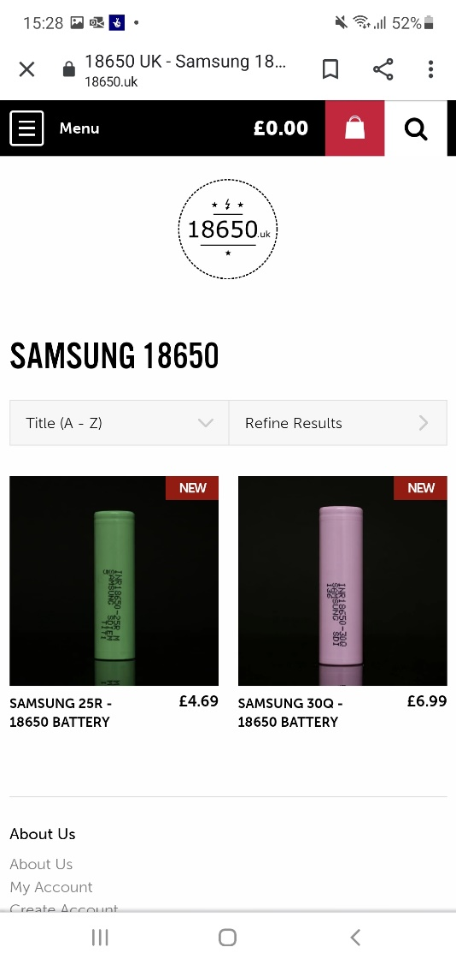
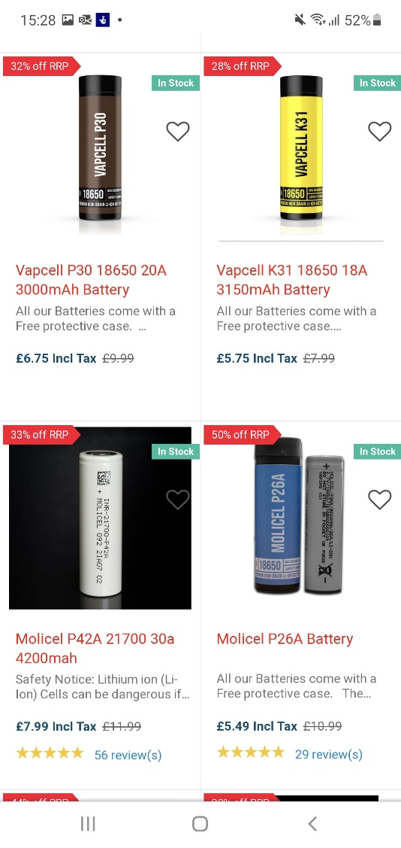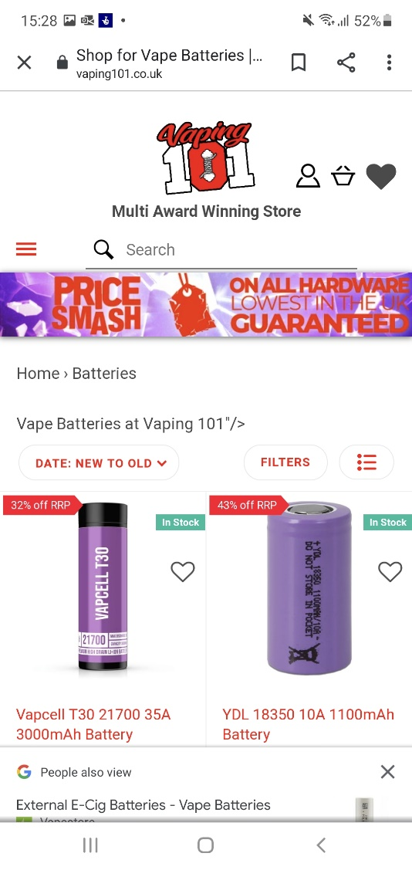
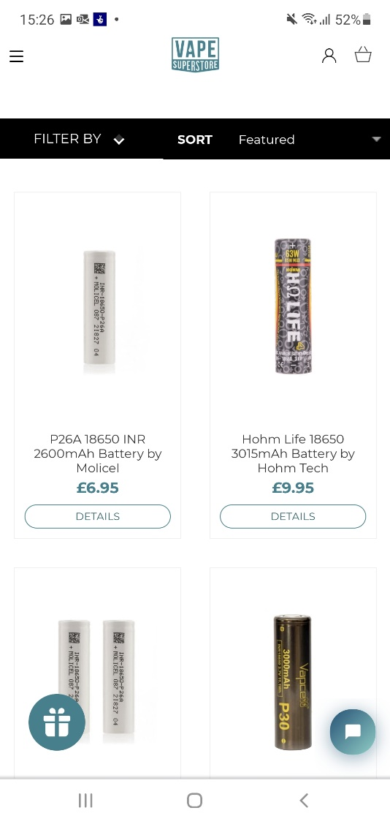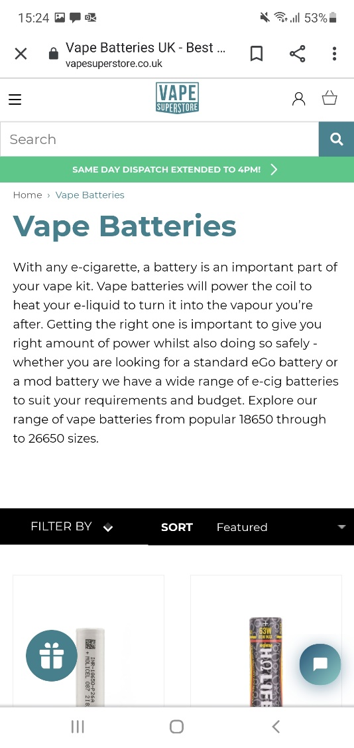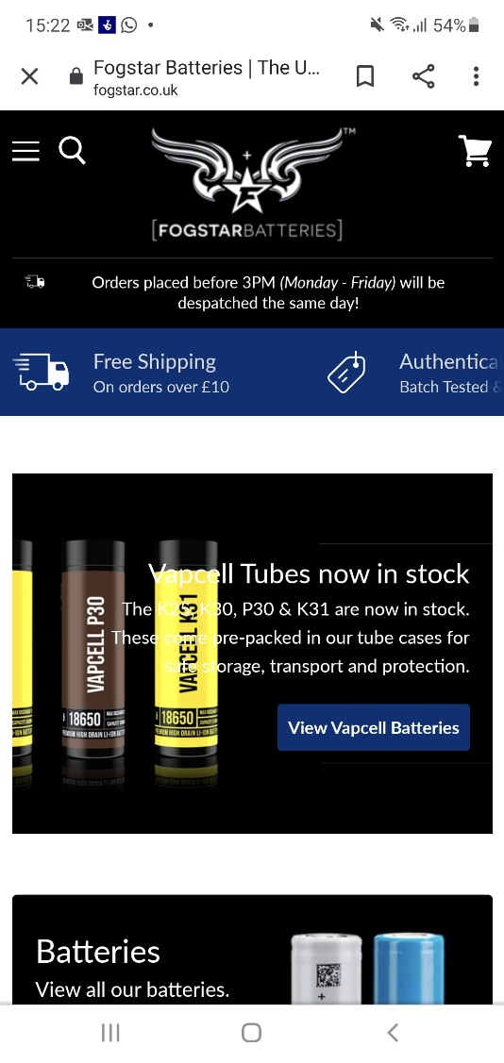

(Ref 2) Battery Recycling
https://www.gov.uk/battery-waste-supplier-reponsibilities

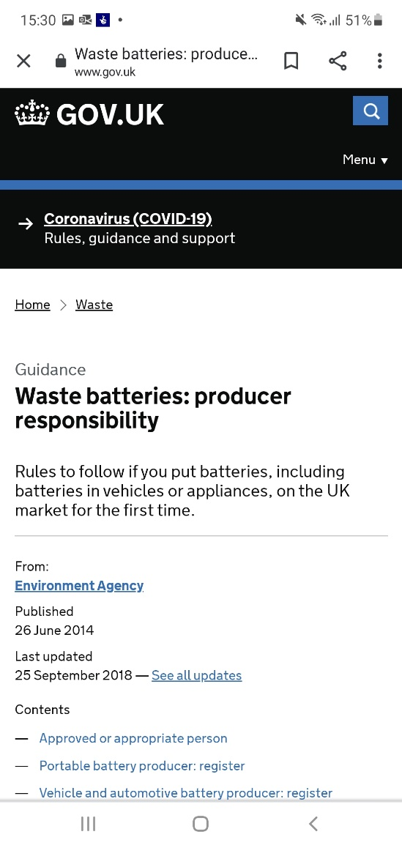

(Ref 3 a) Financial

Financial
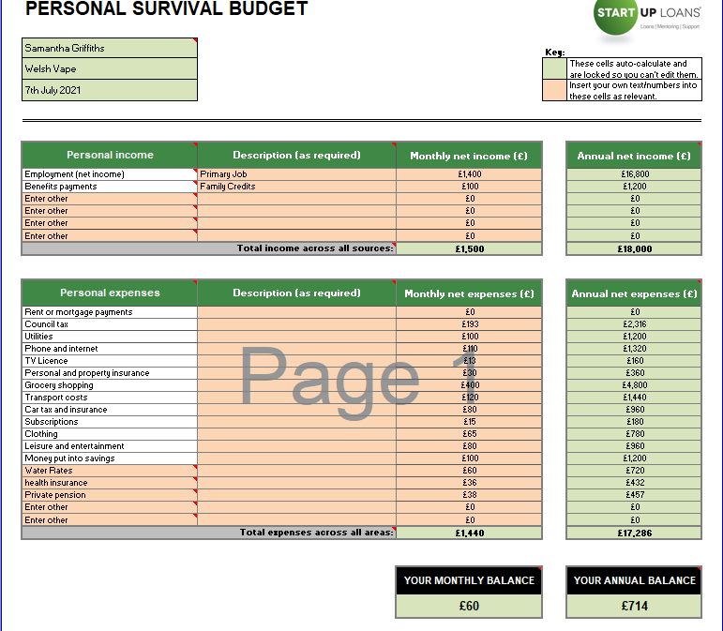

(Ref 3b)
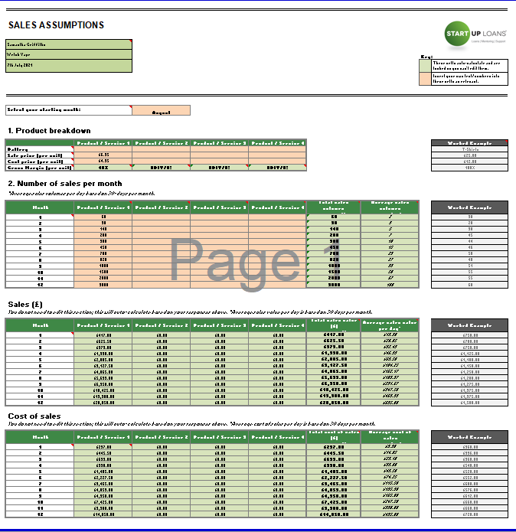

(Ref 3c)

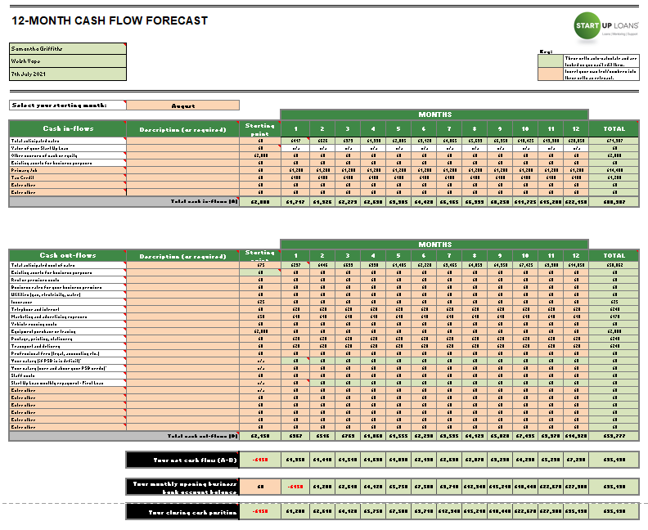

(Ref 4)
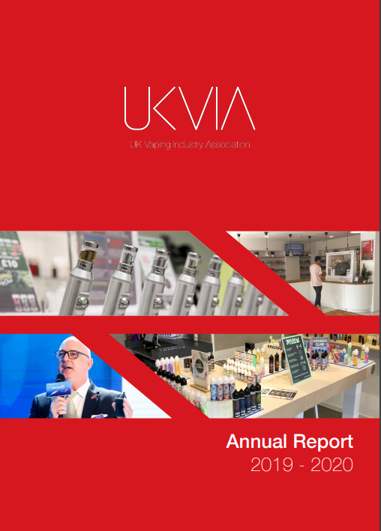
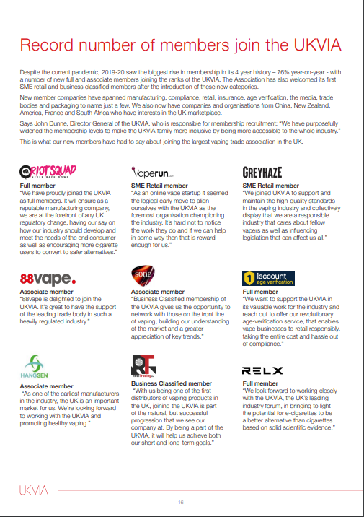

(Ref 5) Battery type
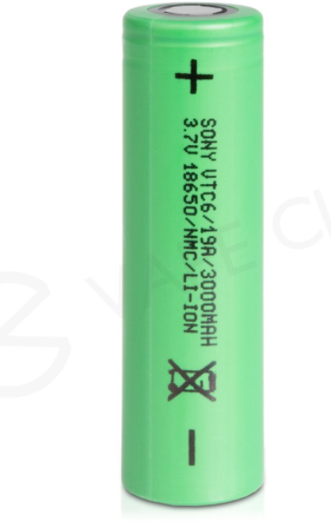

(Ref 6)
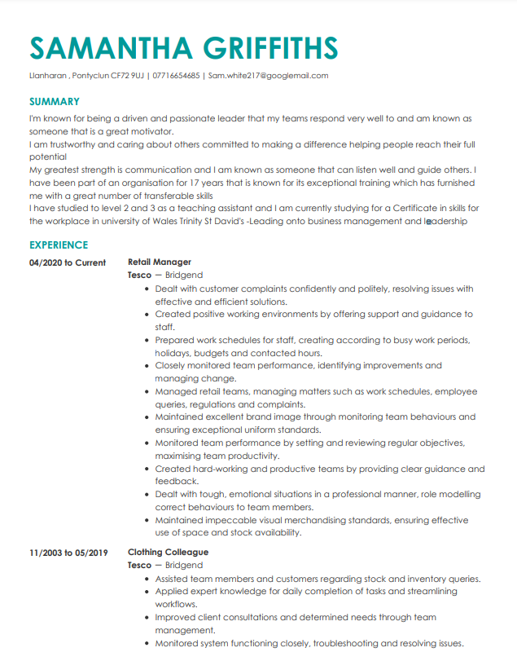
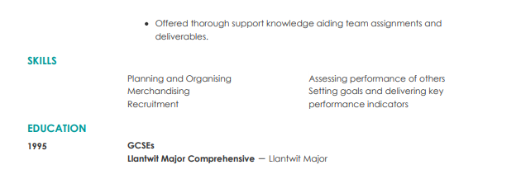

(Ref 7)


