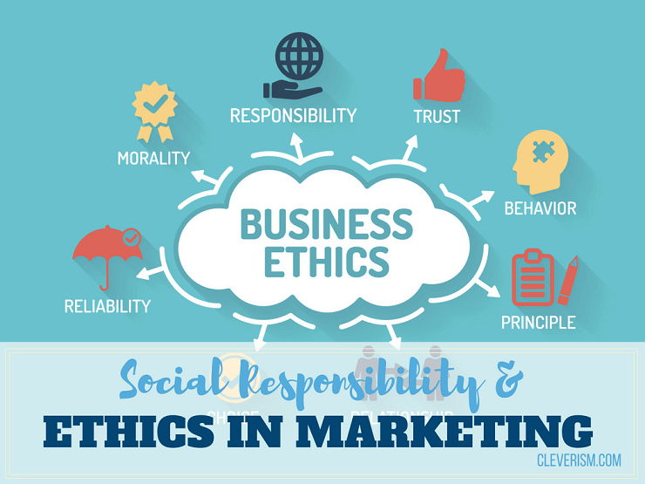
Social and Ethical Marketing BMSP5003
Ethics
Natalie Male (1702161) | 1702161 | Jessica Shore

Introduction
Marketing has grown to be one of the most important tools in product placement and promotion. Social responsibility and ethics are an ever-changing concern for businesses. With developments in technology, practises are more exposed than ever before, and consumers are using this platform to their advantage. With the rise of sustainability, individuals are increasingly concerned with all aspects of the product chain. (Caroll, 2015) proposes that “Today, ethics and philanthropy help to round out the socially responsible expectations placed on modern organizations striving to be sustainable in a competitive, dynamic, global marketplace”.

History of Marketing
Marketing has experienced a progressive change in over a century. Shaped by the developments in technology and the shift to consumer preferences. (Grayson & Hodges, 2004) attain that “ Business opportunities have always been the result of a complex interaction of advances in technology and science, of political economic and social developments and of innovation, inspiration and risk-taking”. The simple trade era is experiencing somewhat of a revival, with the increase of hand made goods.
We are currently in the Social/ mobile marketing era and this has brought both advantages and disadvantages for retailers. Web 1.0 allowed organisations to be able to state their practises unchallenged. Web 2.0 has given consumers the resources to challenge these claims. Though, greenwashing was once commonplace, it is now easier to detect. Consumers will call organisations out on this practise, through social media platforms. (Dahl, 2018) states that “By engaging and getting involved on social media, you can ask questions, make companies accountable, and spread information through online word of mouth “
From the industrial revolution to present day, an example of the eras of marketing, displayed in image 1

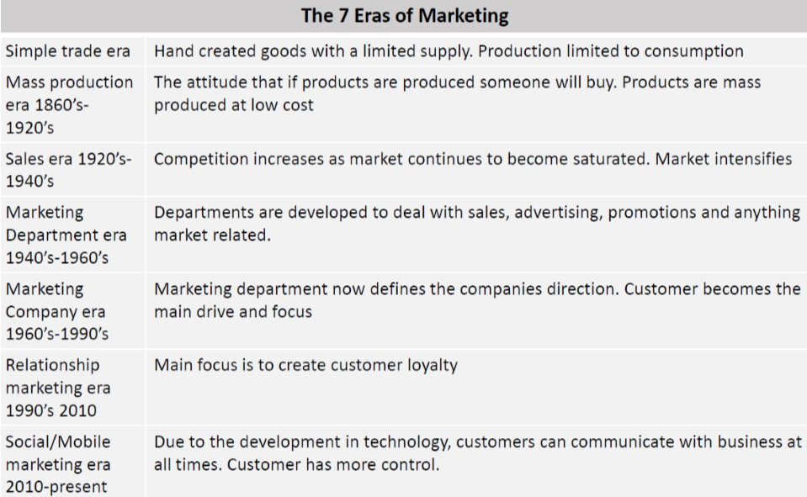
Image 1

Progressive change in marketing
Marketing is facing many new challenges. Gender Fluid or non-binary is a lifestyle for individuals, that choose not to be defined by gender. This can be a complex consideration for companies, as historically there has been only some work in breaking down gender stereotypes. (Robertson & Davidson, 2013) suggest that “The influence of gender-role stereotypes on the effectiveness of advertising has been of considerable interest for the past 30 years. However, the focus of research has been limited to commercial advertising, female stereotypes, and traditional roles”. How can existing companies’ approach this very delicate and complex situation. It is important to remember that as the community is becoming less defined and more diverse, this will only become increasingly difficult.
Proctor and Gamble has faced this dilemma recently. Members of the transgender and non-binary community took to twitter to express their feelings, with posts directly at the Always brand. In response to the feminine Venus logo displayed on the packaging. (Whitehead, 2019) states that “Could someone from Always tell me why it is imperative to have the female symbol on their sanitary products? There are non-binary and trans folks who still need to use your products too you know!” Always have responded by committing to changing the packaging to promote inclusivity. This is an example of how evangelism, is a powerful tool for the consumer. (Singh, 2015) comments that “Customer Evangelists work independently of, and are unpaid by, any central source or corporate body while attempting to influence other’s consumption behaviour”.
On the other hand, women have taken to express how they feel and are threatening to boycott the brand. With the feeling that they are not taken as seriously, and the move is just political correctness. (Bindel, 2019) argues that “I wish it only took a tweet or two to pressurise advertisers into ditching sexist and demeaning images of women, for example. But, usually, we are simply ignored”. However, it is the nature of humanity that some people will be offended by our actions and it is impossible to satisfy everybody. (Gimesy, 2020) explains that” In a pluralistic world, where conflicts of interest will always arise and trade-offs need to be made, there is no simple or single way to always determine what the ‘right thing to do is”.

Corporate social responsibility & ethics
Companies have a social and ethical responsibility by law, although they have a duty to be fair, honest and forthright in their practises. This applies to all aspects of the company’s operations. (Wicks, Werhane, Thompson, & Bowie, 2019) propose that “Business ethics is a hybrid discipline built on the conceptual resources of several fields, including moral and political philosophy, economics, sociology, and social psychology”.
Developments in technology and social media mean that companies can be held to account, by reviews, personal vlogs and blogs. (Tadajewski & Jones, 2014) suggest that “Marketing management is not undertaken in a vacuum, affecting only those within the organisation and its customers. It shapes the society in which it is practiced, performed and controlled at the macro and micro level”. An example of CSR considerations is shown in image 2

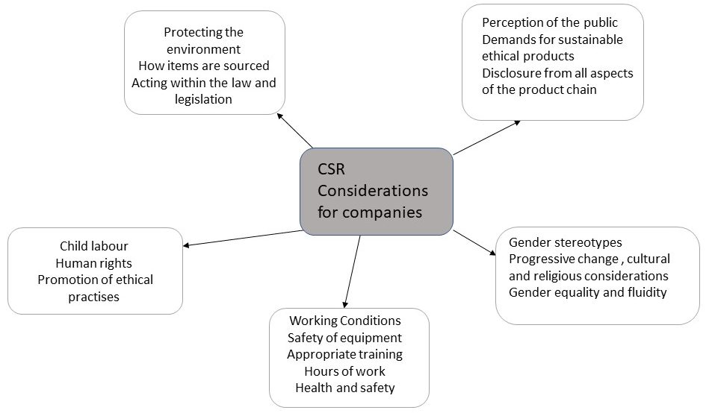

Image 2

Primark has faced much criticism for its ethical practises since it opened. The company received negative press on more than one occasion. (Fast fashion: 'How do you justify selling a £2 T-shirt?', 2018) remarks that "How can you justify selling T-shirts in your stores for as little as £2 or £3, and how can you be making a profit on those?" Primark insists that they keep prices low as they do not advertise. The fast fashion brand has been criticised for its throw away clothes. Though the company is planning a take back programme to forward clothing to third world countries.
When clothes are disposed of in an unsustainable manner, it is possible that the consumer is equally as responsible. If clothes are sent to landfill is this necessarily the sole fault of the retailer.? There are now clothing banks outside most schools, items can be donated to charity shops or passed to friend or family. Material, even if past its best can be weighed in by charities. There really is no justification to take clothes to landfill. An example of the ramifications of fast fashion is displayed in image 3

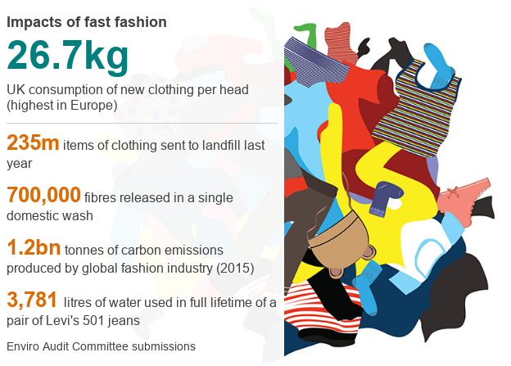
Image 3 (Fast fashion: 'How do you justify selling a £2 T-shirt?', 2018)

Yet, these important issues do not seem to deter shoppers, is it possible that to be ethical you need to be financially able? In Primark if a child’s t-shirt is £1.80 you are more likely to question how this product is made ethically for this price. Marks and Spencer’s prices are considerably more so you would assume they have more ethical practises, however, is this the case? It is interesting to note that Marks and Spencer’s have had its share of negative press, However, the company has worked hard to establish its sustainability plan. (Sustainabillity, 2020) suggests that “Plan A is our way to help build a sustainable future by being a business that enables our customers to have a positive impact on wellbeing, communities and the planet through all that we do”
Unfortunately, both companies are not in the minority for previous unethical conduct. Although, it is important to note that most issues appear to stem from subcontracted work outside of the EU. A consideration for fashion retailers is that most do not own their own factories. (Primark, 2020) attain that “In fact, 98% of the factories making products for Primark also manufacture for other brands. We require every supplier and factory to commit to meet internationally recognised standards”. This is in response to the 2013 Rana Plaza factory disaster, which killed 1,129 workers in Bangladesh. Poor building and safety conditions contributed to the accident. Many UK retailers were having goods produced at the factory. (Butler, 2013) explains that “Under the terms of the deal, brands including H&M and Marks & Spencer, as well as Primark, have each agreed to contribute up to $500,000 (£325,000) a year towards rigorous independent factory inspections and the installation of fire safety measures”. This is a large-scale tragedy which displayed the true cost of cheap production, above welfare standards.
Corporate social responsibility can increase trust and confidence in a brand. Customers can display brand loyalty and reassurance that their purchases are ethical. This can change in the event of exposed unethical practises. (Siham, 2013) states that “Marketers have been among the fastest to perceive the market's preference for ethical companies, often moving faster to take advantage of this shift in consumer taste. This results in the expropriation of ethics itself as a selling point or a component of a corporate image”.
Equally through evangelism customers can display unethical behaviour. Writing unfair reviews or trying to obtain a fraudulent refund, even though the product is fine. Small businesses may feel the need to comply to avoid negative feedback, despite the fact it is unjust. Companies are taking action and there are consequences for some customers (Frichou, 2018) explains that “One woman in New York found herself being sued by her doctor for roughly $1 million after leaving a review that called the business “very poor and crooked.” This is not the only case of companies firing back at negative criticism online”.
Some consumers are becoming increasingly concerned with the products they purchase, the way they are produced and conditions they are made in. For some there is a desire to be ethical, but finances are limited. Ethically produced products at one point were very expensive, with increasing demand this is changing. (Schuler, Rasche, Dror, & Newton, 2017) state that “Today’s practices of corporate sustainability management are infused with ethical questions and dilemmas. For instance, the basic question “What does it mean to be sustainable?” asks us to reflect on the end goal of sustainability and raises normative questions”. In the future companies will be expected to be increasingly transparent, regarding its sustainable practises.

Marketing mix
The marketing mix refers to the methods companies employ to market their product or service. The four P’s for example, each element has ethical considerations.
Product: Packaging is a consideration, including misleading labels and sustainable materials. How and where the product is developed. If the product could be harmful or faulty
Price: Realistic prices with no price discrimination. High prices that do not reflex the cost of production
Promotion: Deception through misleading adverts, false promotions.
Place: Supermarkets manipulating stock, items on low shelves for children. Subliminally manipulating shoppers to pick up more goods, by product placement
The segmentation, targeting and positioning process links to ethical considerations. For example, targeting a vulnerable group such as children, elderly or poor minorities. Charging higher insurance premiums to individuals with poor credit score. (Davies, Finney, & Hartfree , 2016) observes that “In the UK the poverty premium has been highlighted as an important social policy concern by charities and organisations working with low-income families”.

Gender Stereotyping and specific toys
Toy manufacturers have gender specified most of their toys for decades. Playing is a form of escapism and essential part of a child's development. Created in 1959 Barbie has evolved through some of the marketing eras and possibly different marketing tools. She has been attacked for her slim frame and sexualised features. ( Yager, 2014) argues that “Research with 3-5 year olds indicates that they already clearly associate larger figure sizes with more negative characteristics, such as being naughty and mean. This also has the effect of reinforcing the societal “thin-ideal” for women. There is also the nature nurture element to consider, outside factors could have caused these negative stereotypes, such as upbringing, environment and media.
The company launched their dream gap project in 2018. Claiming research shows that from the age of five, girls begin to think they are not as capable as boys, developing doubt in the ability of their gender. The global initiative provides resources and support. (Mattel, 2020)
However, barbie does send a positive message that you can be whatever you want to be. She has had many roles over the years including doctor, vet and a teacher, though there are many more. It is therefore possible that parents are not offended by her ethos, it is her appearance. Mattel tackled this issue promoting inclusion, manufacturing barbie in many different shapes and skin tones. (Sherman, 2019) states that "Barbie's always been at her best when she is a reflection of culture and when she's connecting to culture. We've made a real concerted effort over the past few years to ensure that Barbie is keeping pace”. In 2017 Mattel released a new doll wearing a hijab, in honour of American fencer, Ibtihaj Muhammad. Image 4
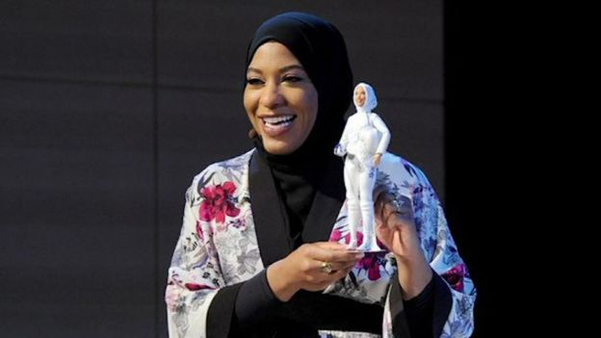
Image 4 (Sherman, 2019) Ibtihaj Muhammad

As parents, we are potentially looking too closely at the impact toys have on our children. It is possible that children just enjoy the dolls and accessories, our nephew certainly did. He was not concerned that it was classed as a girl's toy, as we did not make an issue and he enjoyed the role play. Equally our daughters enjoyed Scalextric and Lego. Many men are stay at home parents looking after children and keeping the home. Therefor is it ethical to target this type of role play solely at girls? The Mattel Barbie website specifically uses the term girl or girls on its website.
It is entirely possible that this is an issue parents have, becoming so critical and over analysing children's toys. Ultimately, parents have some control over the toys their children play with. In this case how are toys still gender orientated? (Freeman, 2007) argues that “Could it be that in spite of parents’ intentions to free their children from the constraints created by narrow gender stereotypes that the schema they developed in their own childhoods have proven difficult to replace”?
There is also the issue of advertising to children, they are a captive audience, often viewing perpetual stereotypes, reinforcing their gender choice of toys. This could be considered unethical practise, especially the volume of adverts in children's programmes. This will no doubt create a conflict with parents as children's requests for toys intensifies. Just as with the case of Always, will gender specificity become an issue for the parents of gender fluid children. This could be an issue moving forwards or companies could likely capitalise on producing gender neutral toys.

Conclusion

Firstly, though companies have legal and moral obligations, the consumer also shares responsibility in every aspect of their consumerism. It is no longer justifiable to simply blame the producer of goods. When members of the public are choosing to buy and dispose of items, there should be some accountability. In contrast it is not always possible for the consumer to be ethical, due to financial constraints. However, the welfare of workers should not come at an adverse cost. Secondly the market is facing some difficult challenges with a growing diverse customer base. Through developments in technology, customers are gaining more control, on how businesses market their products. With so many considerations it is highly likely that mistakes will be made, and products will be challenged by the public. In conclusion, when satisfying the needs of one customer it is likely another will be offended. This is human nature and unlikely to change moving forwards.

References

Yager, Z. (2014, December 22nd). Is Barbie bad for body image? Retrieved January 13th, 2019, from The conversation.com: http://theconversation.com/is-barbie-bad-for-body-image-33725
Bindel, J. (2019, 21St October). The Guardian. Retrieved January 12th, 2020, from By caving in to trans activists, Always have eliminated women: https://www.telegraph.co.uk/women/life/caving-trans-activists-always-have-eliminated-women/
Butler, S. (2013, June 23rd). Bangladeshi factory deaths spark action among high-street clothing chains. Retrieved January 13th, 2019, from The Guardian: https://www.theguardian.com/world/2013/jun/23/rana-plaza-factory-disaster-bangladesh-primark
Caroll, A. B. (2015). Corporate social responsibility: The centerpiece of competing and complementary frameworks. Organizational Dynamics, 44(2), 87-96.
Dahl, F. (2018, August 1st). End Greenwashing with your social media power. Retrieved January 14th, 2020, from Duffy Agency: http://duffy.agency/brandbase/greenwashing-social-media/
Davies, S., Finney, A., & Hartfree , Y. (2016). Paying to be poor: Uncovering the scale and nature of the poverty premium. Bristol: University of Bristol. Retrieved January 14th, 2020
Fast fashion: 'How do you justify selling a £2 T-shirt?'. (2018, November 27th). Retrieved January 13th, 2020, from BBC News: https://www.bbc.co.uk/news/business-46358969
Freeman, N. K. (2007). Preschoolers’ Perceptions of Gender Appropriate Toys and their Parents’ Beliefs About Genderized Behaviors: Miscommunication, Mixed Messages, or Hidden Truths? Early childhood education journal, 34(5), 357--366.
Frichou, F. (2018, September 6th). Bad reviews: why people write them, and what they expect. Retrieved January 14th, 2020, from Trust Pilot: https://uk.business.trustpilot.com/reviews/bad-reviews-why-people-write-them-and-what-they-expect
Gimesy, D. (2020, January 13th). Every breath you take:adding ethics to the marketing mix. Retrieved from The Marketing Society: https://www.marketingsociety.com/the-library/every-breath-you-take-adding-ethics-marketing-mix
Grayson, D., & Hodges, A. (2004). Corporate social opportunity 7 stepts to make corporate social responsibility work for your business. Sheffield: Greenleaf Publishing.
Marks and Spencers. (2020, January 13th). Sustainabillity. Retrieved from Marks and Spencers.com: https://corporate.marksandspencer.com/sustainability
Mattel. (2020, January 13). What is the dream gap. Retrieved from Barbie Mattel: https://barbie.mattel.com/en-us/about/dream-gap.html
Primark. (2020, January 13th). Our ethics, how we do it. Retrieved from Primark: https://www.primark.com/en/our-ethics/how-primark-keeps-prices-low
Robertson, K., & Davidson, J. (2013). Gender-role stereotypes in integrated social marketing communication: Influence on attitudes towards the ad. Australasian Marketing Journal, 21(3), 168-175.
Schuler, D., Rasche, A., Dror, E., & Newton, L. (2017). Corporate Sustainability Management and Environmental Ethics. Business Ethics Quarterly, 27, 213-238.
Sherman, N. (2019, December 21st). Is Barbie's makeover working? Retrieved January 11th, 2020, from BBC News: https://www.bbc.co.uk/news/business-50829046
Siham, D. (2013). Marketing mix an area of unethical practises? British Journal of Marketing Studies, 1, 20-28.
Singh, N. (2015). Evangelism Marketing: The Evolution of Consumer Fidelity. Journal of Marketing & Communication, 11, 5-17.
Tadajewski, M., & Jones, B. (2014). Historical research in marketing theory and practice: a review essay. Journal of Marketing Management, 30, 1239-1291.
Whitehead, J. (2019, October 21st). Always sanitary products remove feminine symbol in move towards inclusivity. Retrieved January 12th, 2020, from The Independant: https://www.independent.co.uk/life-style/women/always-sanitary-products-female-symbol-inclusive-transgender-female-erasure-a9164671.html
Wicks, A. C., Werhane, P. H., Thompson, L., & Bowie, N. (2019). Business Ethics Quarterly . Exploring Important Thinkers to Generate New Theory in Business Ethics, 155-157.

