Name: Nurjahan Begum
Student number: 1912210
Assignment title: Marketing management
Essay one
Module code: LCMB 7001
Lecturer: Efua Adams

Fig: 1 Source: National Federation of Cypriots in the UK, (2022).

Content
Introduction.............................................................................................................................4
Part 1:
1.0 The concept and marketing resources authorised by Midlands Greek and Cypriot Assocation ...............................................................................................................4-5
1.1 Midlands Greek and Cypriot Association target market.................................................6-7
1.2 The Internal micro and macro factors environment influence on the Organisation...........7
1:3 Marketing mix 7p’s of The Greek Cypriot Association................................................7-8-9
1.4 SWOT Analysis for the organisation..........................................................................10-11
1.5 Midlands Greek and Cpriot Assocation Measurment of success....................................12
Part: 2
2.0 Managerial implications on the organisations marketing strategies ...............................12
Part: 3
3.0 Recommendations and how the organisation marketing strategies can be improved...........................................................................................................................1213
4.0 Conclusion......................................................................................................................13
5.0 References...........................................................................................................13-14-15
6.0 Appendices
Fig: 2 Banqueting Hall.........................................................................................................15
Fig: 3 Gents toilet and outdoor shelter.................................................................................15
Fig: 4 Monday and Wednesdays menu................................................................................16
Fig: 5 Sundays menu............................................................................................................17
Fig: 6 Google reviews for The Mdlands Greek Cypriot Association......................................17

.

Introduction
Kotler & Keller (2006) suggest that creating, conveying, and delivering value to customers as well as maintaining customer relationships, to the advantage of the firm and its stakeholders, are all part of the organisational function known as marketing.
According to Kotler & Keller, (2006) to fully comprehend market concepts, it is crucial to understand key marketing terms. Some of these terms include needs, which refer to fundamental human needs, wants, which are directed at particular objects that may satisfy needs and demands, and wants for particular products supported by financial means.
This is a study on The Midlands Greek Cypriot Associations marketing strategy and its effect and overall outcome. My engagement in this study will be to perform my duties as a consultant so that I can assess the gaps for further potential improvements to the current marketing functions of Midlands Greek and Cypriot Association. The organisation was established in 1974 and relocated to the Erdington Community Centre in 1983. Within the organisation services held are the Banqueting Suite for hire, Greek School named Ayia Triada Greek School, Orthodox Church, and traditional Greek restaurant and café for the community in Erdington, Birmingham. Within my report the key elements of discussion will be staged in three parts. Part one's discussion will be based around a critical evaluation on the organisations marketing activities and the resources which have been used as a marketing strategy to operate their business. The second part will be an evaluation on the managerial implication on the organisations marketing strategy and the effectiveness of it and the overall performance measures of the organisation. Furthermore, my final end report on part three of this study will include recommendations for the organisation on how to improve its marketing strategies within the business by using applicable marketing techniques and marketing models with examples of organisations who have found success from the marketing techniques and marketing models.
Part 1:
1.0 The concept and marketing resources authorised by Midlands Greek and Cypriot Assocation
The Midlands Greek Cypriot Association has been serving its community since 1974, its mission is to be the best Greek restaurant for the neighbourhood and serve the best Greek food. They organisation is an industrial and provident society registered in England and Wales with ownership of the building. Since they are a non-profit, they rely on donations and the labour of volunteers to operate the centre. In addition to asking for advertising and conducting surveys, they provide a donation channel of communication for anyone interested in contributing to and supporting the organisation. Christos and his family manage a few of the establishments such as the banqueting suite, which is housed on the top level of the main building and has space from fifty, and two hundred and seventy people, Christos has his own website for the restaurant that he runs at the organisation giving access for bookings information and updates, (Midlands Greek Cypriot Association, 2013) offering services at affordable rates for catered and self-catered events, including full access to the kitchen, licence for alcohol, music, and dancing, plenty of parking, and facilities for guests with disabilities. These services include parties, meetings, social functions, receptions, christenings, Greek weddings and entertainment. Images of the association is placed in the appendices; The banqueting hall can be found in the appendix as fig:2 Banqueting gallery and Fig:3 Gents toilet and outdoor shelter.
The organisation has a café which offers freshly produced Greek coffee, Koupes, Tahinopita, Baklava, and Cypriot sandwiches, among other things. Furthermore, they market imported goods from Cyprus and Greece and run a Greek shop. (Midlands Greek Cypriot Association, 2013). Their café opening times are Monday and Wednesday ten till late, Tuesdays, Thursdays and Fridays they open from ten till five yet Saturdays one of the busiest days of the week they are only open from three till six and Sundays they are open ten till five. The organisations restaurant is run by Christos and his family who has spent all his working life in catering & Music and most of it in Restaurants he managed The Greek Restaurant, in Tamworth for about 15 years, as the main chef, manager and musician, (Christos Greek Cypriot Restaurant). The restaurant opening times and takeaway collection times are as follows:
Restaurant opening times
- Monday & Wednesday from 6pm.Serving mainly its community members and their guests but they state that everyone is welcome, yet they only serve Greek food, their mission does not align with what they are doing.
- Saturdays: By prior bookings, Deposits are required on most booking Once a month on a Saturday live Greek night are hosted with Live Greek music and entertainment on the following dates, 25th February and 25th March.
- Sundays: Lunch dining from 1pm. There is last minute availability on most occasions, but they do advise to call first to be assured of any availabilities, (Christos Greek Cypriot Restaurant).
They state that it serves mainly community members and guests but say that everyone is welcome this message is unclear and needs revising if they want to everyone from different ethnicities and backgrounds to come to their Restaurant. The restaurant's menu can be found in appendices as fig: 4, Monday and Wednesday menu and fig: 5, Sunday's menu.
Take away collection times
Monday and Wednesday collection service is from 6pm but for large orders and party orders 72 hours' notice is required.
Nights Live Greek
Once a month they hold Live Greek Party nights with Live Greek music and entertainment available on the 25th of February for £28 per person and 25th March, dedicated for mother's week prices held at 28 pound per person on these nights' doors open at 7.30p, last meal bookings are at 9.30pm
Private Parties /functions
They cater for all private parties, functions & corporate dining on Fridays Saturdays and Sundays. A deposit of £10 per person is required and full balance payment to be advised at time of booking. Once a month, the organisation offers live bouzoukia with meze. They also offer entertainment and games,,cards and tavli/backgammon, a 300-inch projector showing Greek and Cypriot TV, a sport, leisure, and kickboxing club, football, rugby, and a golf society, as well as access to a library and free wi-fi.
1.1 The Midlands Greek Cypriot Associations target market
A target market is a group of potential customers that you identify to sell products or services to. Each group can be divided into smaller segments. Segments are typically grouped by age, location, income and lifestyle, (Business, 2021).
The organisation captures their target market by communicating through different platforms such as Facebook, Twitter, Instagram, website, leaflets, email, events, telephone, mobile. And the overall target marketing has been successful to a certain point. It has been effective because their location is in a dominant Greek community Their target market is the Greek community, children, families, businesspeople. They attract new customers and retain existing customers through their events, fundraising and activities that are held at the organisation's restaurant, café, schools and churches which is open to all . But there is room for improvement on their target marketing they need to expand. It is evident on their social media pages such as Instagram which has a following of 834 and Facebook with 3k followers and 2.8k likes which shows they have room to expand as social media platforms are the quickest and cheapest way to promote and engage consumers to their business, people share like review and spread information through word of mouth, as I have found through research, as of January 2023, it was found that men between the ages of 25 and 34 years made up Facebook largest audience, accounting for 17.6 percent of global users (Dixon, 2023), Additionally, Facebook's second largest audience base could be found with men aged 18 to 24 years. And almost 31 percent of global Instagram audiences were aged between 18 and 24 years, and 30.3 percent of users were aged between 25 and 34 years (Dixon, 2023), Overall, 15.7 percent of users belonged to the 35-to-44-year age group which implies that The Greek Cypriot Associations understands who their target audience is and knows how to promote their business but they need to review constantly to keep customers engaged, attract a wider audience and be able to build their brand.
1.2 The Internal micro and macro factors environment influence on the Oganisation
The internal micro and macro factors environment inside the organisation have a few influences on the organisations marketing strategy. The macro factors are customers, supplier, competitors, media and shareholders. The organisations macro internal factors such as customers and media are explained below.
customers
The customers contribute to generating revenue by attracting more customers. So the organization focuses on its existing customer retention and attracting potential customers by satisfying their needs and preferences and this is done by the organisation listening to the community and their needs which was refurbish the interior design such as the men's toilet, the restaurant and added a outside shelter for smokers was done through fundings raised by the organisation and its stakeholders it used its marketing strategy to advertise to the local community about their brand , their activities their charity work, functions, live events etc. The community and the organisation, the church, the Greek school is used to work closely together to complete the objectives and goals of the organisation. Media:
The organisation uses media channels to market themselves for its business promotional activities, products and services to reach their audience and to create a positive brand image among them. Different media channels are being used for this such as advertisements, leaflets, posters which can be found around the organisations Greek school and church, social media platforms like Facebook, Twitter, Instagram, website and word of mouth spread from customers social media platforms etc
1.3 Marketing Mix 7p’s of The Greek Cypriot Association
The marketing mix is the most essential marketing concept, according to Khan (2014). According to Kotler, Armstrong, Wong, and Saunders (2008) and Riaz and Tanveer (n.d.), the marketing mix is "a set of regulated marketing instruments used by a firm to elicit a desired response in the targeted market. These components or instruments of the marketing mix make up the core, tactical elements of a marketing plan. The "Marketing Mix" is a term that refers to the Four Ps of product, pricing, place of distribution, and promotion. They make up the primary parts of a marketing strategy and are used to carry out marketing planning. McCarthy first proposed the four Ps in 1960. Researchers later added three more elements, producing the 7Ps marketing mix, which includes product, price, place, promotion, people, and process and physical evidence, ( Muala & Qurneh 2012).
Below a model of the 7p’s marketing mix has been added with a brief explanation on how to convert any marketing strategies into a successful one.

Source: EZY BUSINESS
Below I have conducted my own analysis of the organisations marketing mix 7p’s strategy and findings are stated as following.
.
Marketing Mix 7p’s of The Greek Cypriot Association
MARKETING MIX 7p’s ANALYSIS OF THE GREEK CYPRIOT ASSOCIATION
PRODUCT | Their mission is to be the best Greek restaurant and serve quality food. This mission statement is limited to only Greek people, but they should change the mission and expand to other cultures and ethnicities.
PRICE | Prices are too high; it is not affordable due to recession. People are trying to save money with the soaring electric gas bills rise in rent, mortgages, and food etc. Their prices should be aimed at middle class and lower-class people, pensioners people on benefits. The price being high will only target one segment of consumers who have a higher pay and can afford to pay.
PLACE | It is located in a Greek community it has A Greek supermarket a deli, a café, a Greek school at the weekend a church. There is a function room upstairs which is rented out for private venues other parts of the building are used by other Greek charities that support the vulnerable. The Banquet Hall and kitchen should be open to other cultures who want to prepare their own food and use the space for their own events, this will broaden their target market.
PROMOTON | Their promotional activities are done through Facebook, Instagram. Twitter, events, fundraising, and their own website and word of mouth. Their target audience is the Greek people, families, children, businesses.
PEOPLE | They have stakeholders who are the community, employees, volunteers and sponsors such as kebab, Love Joes, First class food service ,AKP, The Greek outdoors, Middleton cash & carry, Theos creative with food,TCR food service, They do not receive funding from government to so they rely on all the donations from their stakeholders to run the organisation most of the staff are volunteers any paid staff are paid from funds.
PROCESS | The staff are trained but there is room for more training. Their website states that reservations must be made in advance to book a table or for small families or big 72 hours' notice is recommended.
PHYSICAL EVIDENCE | They have ample space for parking, but the car park looks dull and old it needs grass, flowers to attract more and new customers. The building itself is not pleasing to the eye and the interior needs modernising and the fresh look needs to look like it’s a Greek place with Greek colours. They have modernised the men's toilet, the restaurant, and a smoking shelter outdoors all through funding. and intend to do further renovation throughout the building through funds.

I did a little research on reviews on the organisation and the results for The Midlands Greek & Cypriot Association which showed that they had a very favourable rating from Google users, receiving 4.7 stars, (Restaurant guru, 2023). Reviews offer consumers a public outlet to voice their opinion. Reviews provide consumers a chance to tell their side of the story and have it heard by their peers and the businesses being reviewed and understanding the consumers needs and wants. Here is what three of the customers said, Chris reviewed the restaurant and said the food was nice but was too expensive, Rebecca said the outside was not appealing and looked old, but was surprised with the inside, which was nicely decorated, Jaqueline stated it was nice for functions great parking. The full google review and ratings from the customers can be found in appendices under Fig: 6, Google review on The Midlands Greek Cypriot Association.
1.4 SWOT Analysis for the organisation
Also, I have conducted a SWOT Analysis for the organisations (strengths, weaknesses, opportunities, threats) a business strategy tool to assess how an organization compares to its competition, (Teoli et al, 2019) the strategy is historically credited to Albert Humphrey in the 1960s and staying ahead of market trends. Below is a description identifying each part of the SWOT framework. Along with a SWOT analysis conducted by me to analyse and evaluate the organisations competitive opportunities for improvement.
Fig: 3
Source: WordStream

SWOT ANALYSIS FOR THE GREEK AND CYPRIOT ASSOCIATION
S  STRENGTHS | W  WEAKNESSES | O  OPPORTUNITIES | T  THREATS
Their chef Christos has fifteen years experience and skills and knowledge which they are wasting instead of using that as a strength, he needs to explore his skills and knowledge at a broader target audience.  They serve Good quality Greek food  Loyal and retained customers  Ownership of the building  Part of the community  Loyal volunteers strong relationship and teamwork involved to keep the business running.  Big building with outdoor space opportunities to do more events, more fundraising, renting space out and attracting more customers for its growth and brand recognition. | Their mission and vision state they serve food for Greek people, but they should offer diverse types of food from diverse backgrounds and change their mission statement to not only Greek food but a variety of food for different ethnicities and backgrounds which will draw in more customers.  Unattractive, not nice to look at uninviting not very appealing to new customers, the building looks like a warehouse. The building inside or out does not look like a Greek restaurant.  Unclear selling points.  Lack of finances  Lack of staff  Not enough opening times and not clear  Dependant on funding. | The building itself has so much potential they should offer their space to all ethnicities and background; this opportunity will give them the chance to raise more money more quickly as it depends on donations to run the organisation.  They can Broaden their product range to target new segments  They can offer halal and vegan food.  Birmingham has around 341,000 Muslims in Birmingham, which is 29.9 per cent of the city's population  according to (Birminghamlive, 2023).  Use a social media influencer to attract consumers  Sign up with online ordering and delivery apps such as Uber eats, Deliveroo and Just Eat.  Provide more and longer opening times.  Build online engagement with organisation | Threat of competitors they could lose out on potential customers as there are many more Greek restaurants that attract customers because of the way they market and promote their business. They look like Greek restaurants and are more appealing and engaging.  competitors  1.Santorini Greek restaurant was voted as the number one best Greek restaurant in the midlands. (Santorini Greek Restaurant Birmingham, 2023).  2. Mythos Greek Taverna  3. The Athens Greek Restaurant  Slower growth due to inability to raise funds  Losing key valuable customers  Home delivery competitors  Competitors introducing better food  Poor ratings on review sites.

The Cypriot association definitely has competition as there are many Greek restaurants in Birmingham that are their competition and serve similar Greek food stated below.
1: Santorini Greek restaurant was voted as the number one best Greek restaurant in the midlands. (Santorini Greek Restaurant Birmingham, 2023). Santorini Greek Restaurant is a family-run business that has been providing the community with authentic Greek dishes for more than 40 years! Open 7 days a week. Their mission statement is to make sure their customers get to enjoy their favourite meals or eat out with their friends. No matter the occasion, Santorini cannot wait to welcome customers into their restaurant at any time, (Santorini Greek Restaurant Birmingham, 2023). The Greek Cypriot should follow the marketing strategies of Santorini they were voted number one.
2: Mythos Greek Taverna are proud to say that all of their dishes are made in house from scratch, from the dips and mezze to the marinated meats. Their menu is authentically Greek, and they state that their customers will experience all the classic dishes from across the country with some dishes that they may not have seen before. Mythos Taverna has been designed to transport all their customers to Greece with Authentic brick walls and their famous overgrown Bougainvillea trees that will give customers the holiday experience and a great photo opportunity too. (Mythos, 2022).
3: The Athens Greek Restaurant Recommended in both the local and the national press, Athens is an international restaurant offering both typically Greek food and a cosmopolitan menu. Athens is a licensed restaurant with a full entertainment licence, and entertainment is the name of the game. The excellent food is only part of the story. The live music starts with Greek table music followed on by belly dancers who take the floor and encouraging lots of audience participation. After the meal guests are take outside to participate in their Greek tradition of plate smashing, around 11.20pm the disc night starts with their top DJ who comes on with hits from the 60s, 70s and 80s etc, something for all tastes (Athens Greek Restaurant,2023).
Cypriot & Greek Society (@cypriotgreeknotts) • Instagram photos and videos
The Midlands Greek & Cypriot Association | Facebook
1:5 Midlands Greek and Cypriot Assocation Measurment of success
The Midlands Greek Cypriot association uses social media platforms such as Instagram, Facebook to publicly advertise the organisations activities. They collect customer data from Facebook and Instagram, then use this information to make product offers tailored to customers' needs and wants by listening to the customer, resultings in higher customer satisfaction and increased sales for the organisation. The Midlands Greek Cypriot Association also uses its Greek school and church to place leaflets and posters to advertise their business activities and promote their products in order to attract and engage new and old customers to come back repeatedly.
Part: 2
2.0 Managerial implications on the organisations marketing strategy.
Marketing mangers’ commitment towards strategy implementation has a significant positive impact on the Midlands Greek Cypriot Associations organizational performance. Innovative culture, top management support and job autonomy should be considered to be the key antecedents of managers’ commitment in the organisation. All three antecedents have significant positive impact on commitment. In addition, commitment is partially mediate the links of top management support and autonomy with the organizationasl performance. Marketing managers’ involvement moderates the relationship between job autonomy and managers’ commitment, (Ramaseshan et al).
Part: 3
3.0 Reccomendations on how the organisation marketing strategies can be improved.
In my end report I can conclude that after a full research and analysis on the marketing strategies of the Greek Cypriot Associations and my own findings for better improvement of the organisations overall success and increase in sales, I found that it is important for the association to understand the gaps in their marketing activities. It is recommend that they should implement the 7p’s of marketing mix to review competitive strategies across its product and customer service and define the key issues that affect the marketing of its products and services it will help improve their marketing activities and will be beneficial to them as it will attract and engage new customers, retain existing customers and through all the offers and promotions set by the organisation will be a strategy to tempt consumers to come back for another visit. Further to my investigation I would also recommend that they should conduct a swot analysis for the industry environment of The Midlands Greek Cypriot Association which involves diverse challenges. The organisations business faces issues such as competition, imitation, and social trends that oppose players in local market. Based on the current condition of the business, some of the most notable strategic management concerns enumerated in this SWOT analysis of The Greek Cypriot Association are the threat of competition involving low-cost sellers.A recommendation to protect The Midlands Greek Cypriot Associations business against imitation is to aggressively innovate, especially in product development. Innovation can make the company’s products more difficult to imitate. It is also recommended that the organisation consider pricing strategies that attract more customers. For instance, bundle pricing can help address the threat of competition involving low-cost sellers. Furthermore, a suitable recommendation in this case is to implement creative marketing and branding strategies that build the organisations image.
4.0 Conclusion
Taking into consideration all the research and analysis I have acquired from The Midlands Greek Cypriot Associations Market strategies; I can conclude that the organisation has been somewhat successful through its marketing strategies but has many gaps and room to expand. The Midlands Greek Cypriot Association has maintained its product quality and brand image efficiently over many years. It opens its organisation facilities to engage and attract its target audience. The organisation maintains its public presence via public relations through social media platforms such as Facebook, Instagram. Twitter, where they actively engage with their target audiences that are the best promoters of their brand. Overall marketing is important for the organisation's business and growth and success in increased revenue. Without marketing the business will not thrive.
References
Athens Greek Restaurant, (2023) Available at:Athens Greek Restaurant - Greek Restaurant Birmingham (Accessed: 25th February 2023).
Baycheva-Merger, T. and WolfsLehner, B., (2016). Evaluating the implementation of the Pan-European Criteria and indicators for sustainable forest management–A SWOT analysis. Ecological indicators, 60, pp.1192-1199. [Google scholar] Available at: https://www.sciencedirect.com/science/article/pii/S1470160X15004938?casa_token=pRNqcC3aYAAAAA:2Qu71UNme9g4pT8fwX89zNZ1eVytnTe3ObJagHRvddfMim8QqWq4BDi2_Q-HpOwYy5GHtaUSKQrf (Accessed: 20th February 2023.)
Birminghamlive, (2023) Muslim communities in Birmingham and the midlands [internet] Available at: Muslim Communities in Birmingham and the Midlands - Latest news updates, pictures, video, reaction - Birmingham Live (birminghammail.co.uk) (Accessed: 20^{t} February 2023).
Business, (2021) Identify your target market [internet] Available at:Identify your target market | business.gov.au (Accessed: 12th February 2023).
Christos Greek Cypriot Restaurant, Available at: https://www.letsgochristos.co.uk/opening-hours (Accessed 10th February 2023).
Christos Greek Cypriot Restaurant,[ Internet] Available at:Home Page (letsgochristos.co.uk) (Accessed: 10th February 2023).
David Ardley, (2018)EzyEducation, The marketing mix [internet image Available at:]Education resources for teachers, schools & students | EzyEducation (Accessed 5th February 2023).
Dixon,S (2023) Distribution of Facebook users worldwide as of January 2023, by age and gender [Internet]. Available at:Global Facebook user age & gender distribution 2023 | Statista (Accessed: 23rd February 2023).
Dixon,S (2023) Distribution of Instagram users worldwide as of January 2023, by age group [Internet] Instagram: age distribution of global audiences 2023 | Statista
Khan, M.T., (2014). The concept of ‘marketing mix’and its elements. International journal of information, business and management, 6(2), pp.95-107. [Google scholar] Available at:.28-libre.PDF (d1wqtxts1xzle7.cloudfront.net) (Accessed: 12th February 2023).
Kotler, P. and Keller, K.L. (2006). Marketing management 12e. Upper Saddle River, NJ: Pears Education. [Google scholar] Available at:Marketing_Management.pdf (Accessed: 10th^{th} February 2023).
Midlands Greek Cypriot Association, (2022) National federation of Cypriots [Internet] Available at:MIDLANDS GREEK CYPRIOT ASSOCIATION - National Federation of Cypriots (cypriotfederation.org.uk) (Accessed: February 10th, 2023).
Midlands Greek.org, Monday and Wednesdays menu [Internet] Available at: Menu-1.jpg (720×1040) (midlandsgreek.org) (Accessed: 16th February 2023).
Midlands Greek Cypriot Association, (2022) National federation of Cypriots [Internet] Available at:MIDLANDS GREEK CYPRIOT ASSOCIATION - National Federation of Cypriots (cypriotfederation.org.uk) (Accessed: February 10th, 2023).
Midlands Greek.org. Sundays menu [Internet] Available at:Sundays-Menu.jpg (720×1040) (midlandsgreek.org) (Accessed:16th February 2023).
Mythos, (2022) Available at: Mythos Greek Taverna Home - Mythos - Mythos Greek Restaurant (mythostaverna.co.uk) (Accessed 25th February 2023).
Rahman (2022) Howandwhat, Marketing mix of Starbucks – Starbucks Marketing mix [Internet] Available at: Marketing mix of KFC (7Ps of KFC) - www.howandwhat.net (Accessed: 22nd February 2023).
Ramaseshan, B., Ishak, A. and Rabbanee, F.K., 2013. The role of marketing managers' commitment and involvement in marketing strategy implementation. Journal of Strategic Marketing, 21(6), pp.465-483.The role of marketing managers' commitment and involvement in marketing strategy implementation (tandfonline.com) (Accessed: 1st March 2023)
Restaurant Guru, (2023) The Midlands Greek Cypriot Association [Internet] Available at:The Midlands Greek & Cypriot Association in Birmingham - Restaurant reviews (restaurantguru.com) (Accessed: 17th February 2023).
Santorini Greek Restaurant, (2023) About Santorini Greek Restaurant [Internet image] Available at: About Santorini Greek Restaurant (Accessed: 22nd February 2023).
Santorini Greek Restaurant, (2023) About Santorini Greek Restaurant [Internet] Available at: About Santorini Greek Restaurant (Accessed: 22nd February 2023).
Shewan D, (2022) WordStream, how to do a swot analysis [Internet] Available at: https://www.wordstream.com/blog/ws/2017/12/20/swot-analysis (Accessed: 20th February 2023).
Teoli, D., Sanvictores, T. and An, J., (2019). SWOT analysis. [Google scholar] Available at: SWOT Analysis - Abstract - Europe PMC ( Accessed: 20th February 2023).
The Midlands Greek Cypriot Association (2013) Advertise with us [Internet] Available at:Advertise With Us ΕΛΛΗΝΙΚΗ ΚΥΠΡΙΑΚΗ ΕΣΤΙΑ (The Midlands Greek and Cypriot Association)(Accessed:14th February 2023).
The Midlands Greek Cypriot Association (2013) Banqueting [Internet] Available at: Banqueting ΕΛΛΗΝΙΚΗ ΚΥΠΡΙΑΚΗ ΕΣΤΙΑ (The Midlands Greek and Cypriot Association) (Accessed: 17th February 2023).
The midlands Greek Cypriot Association, (2013) Facilities [Internet] Facilities ΕΛΛΗΝΙΚΗ ΚΥΠΡΙΑΚΗ ΕΣΤΙΑ (The Midlands Greek and Cypriot Association) (Accessed: 14th February 2023).
Appendix
Fig: 2 Banqueting Hall
Source: The Midlands Greek Cypriot Association

Fig: 3 Gents toilet and outdoor shelter
Source: The Midlands Greek Cypriot Association

Fig: 4 Monday and Wednesdays menu
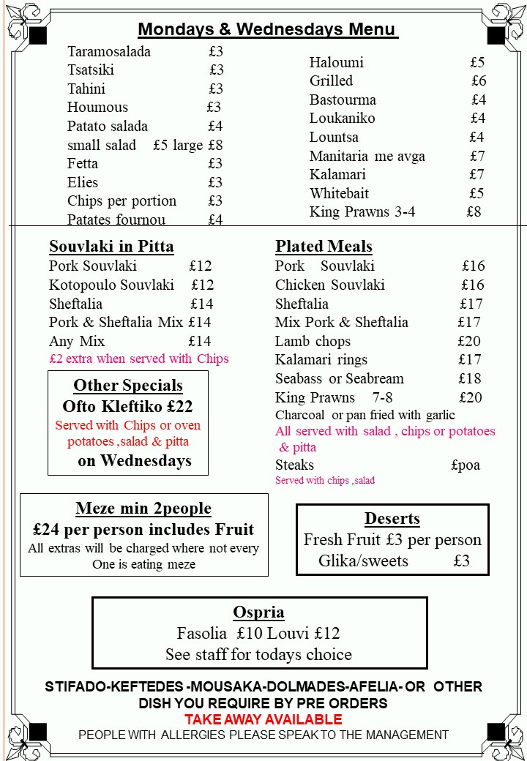
Source: Midlands Greek.org

Fig: 5 Sundays menu
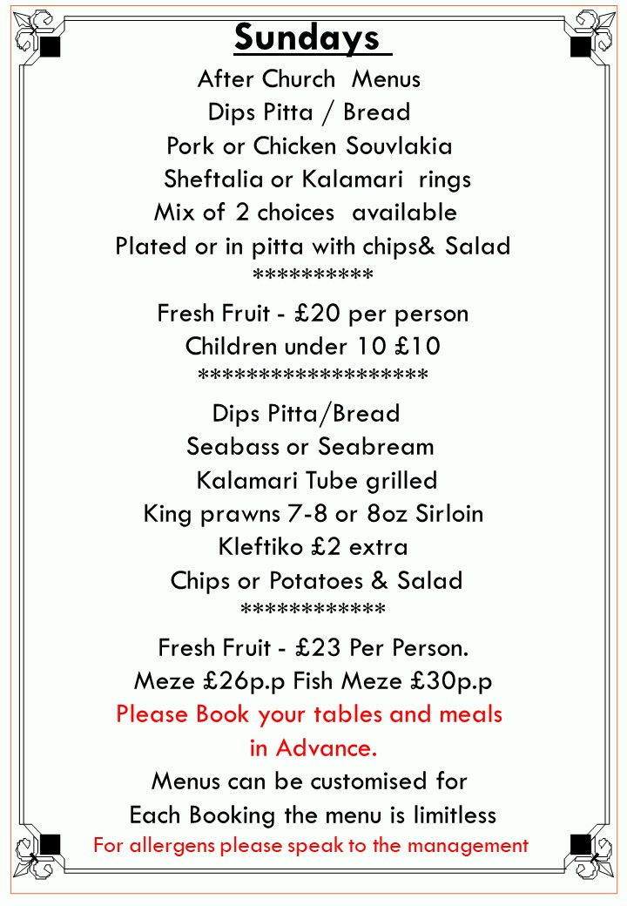
Source: Midlands Greek .org

Fig: 6 Google reviews for The Midlands Greek Cypriot Association
Source: Restaurant Guru, (2023)

