

Programme: Master of Business Administration
Module: Marketing Management
Module code: LCMB7024
Title : Marketing Environment Analysis
Word count: 2711
Lecturer : Dian Mayasari (Birmingham)
Student Name : Sifat Al Galib
Student ID: 2438313
Submission Date- 24th October 2025

Table of Contents
1.0 Introduction and Strategic Context………………………………. 3
2.0 Industry Context and Company Profiles…………………………. 4-5
3.0 Macro-Environmental Forces Analysis…………………………… 6-10
4.0 Strategic Marketing Responses: Comparative Evaluation……. 11-13
5.0 Competitive Synthesis and Strategic Assessment……………… 13-14
6.0 Conclusions and Future Implications…………………………….. 14-15
References………………………………………………………………….. 15-17

1.0 Introduction

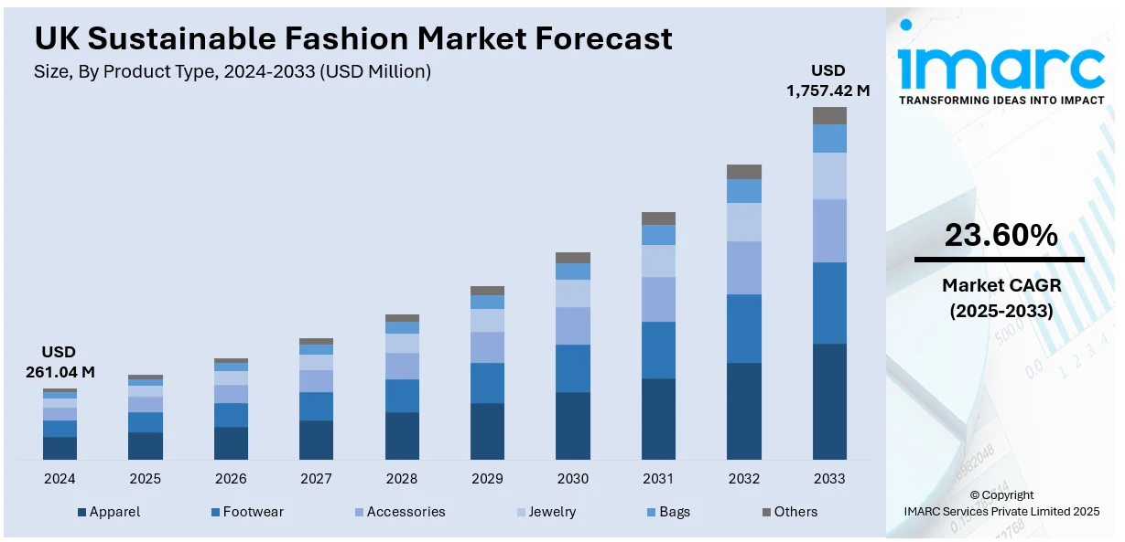
The UK fashion retail industry is a PS62bn industry that is experiencing disruption due to the technological, social cultural and regulatory factors (Mintel, 2023). The digital-native pace, data-controlled inventory and acquisition through social media is challenging high-street, seasonal, heritage models, whereas the growing attention to the environmental impact of high street fashion (e.g. sustainability; labour issues; supply chain) has cast the viability of the fast fashion models in a new light and demanded reconfiguration capabilities (Environmental Audit Committee, 2019). We compare Boohoo (ultra-fast fashion online with algorithms/influencers) and M&S (140-year incumbent) that can spend PS600m to transform digitally and have over 1000 multi-channel stores to operate ( Marks and Spencer, 2023a). RQs: pioneer and follower constraints on sustainability and technology imperatives; differentiation in marketing in the presence of asymmetric capabilities and heritage; dynamic capabilities and effectiveness in transforming. Agility and velocity of reconfiguration form the basis of advantage in the institutional, disruptive innovation, RBV and dynamic capabilities perspective (Christensen, 1997 Teece, 2009, Barney, 2014).

Source : UK Sustainable Fashion Market Size … 2024-2033

2.0 Industry Context and Company Profiles
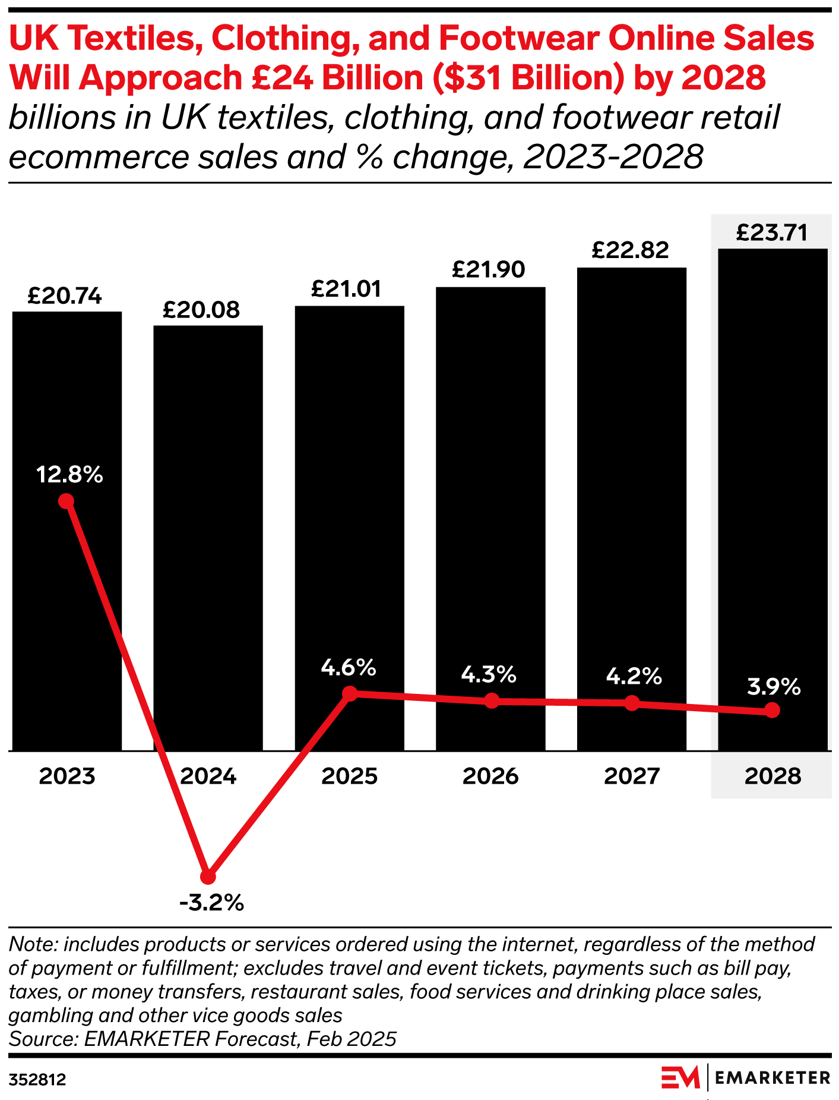
The structural change of the UK clothing retail industry can also be observed after 2008: the footfall to the high street dropped by 25% (2010-2020), and the percentage of clothing sales made online ranged between 8 and 33 (British Retail Consortium, 2023). Meanwhile, ultra fast fashion was changing: Boohoo, Missguided and PrettyLittleThing compressed design-to-retail timescale (months to weeks), reacted in real-time to social media trends (Bhardwaj and Fairhurst, 2010) and maintained PS5-PS20 prices through lean offshore manufacturing and fast-responsive logistics.
Source : Online vs. high-street sales in UK clothing retail

The physical stores were experiencing their margins squeezed because the online price transparency increased competition; business rates on physical stores were on top of PS700m annually when digital exclusive competitors paid no more than a nominal tax rate on property space and under 35s value trend, speed, and value over quality or longevity (Mintel, 2023). The high street household names such as Debenhams, Arcadia and HoF had gone into administration.
Boohoo Group (early adopter): Founded in 2006, Boohoo developed an online only ultra-fast fashion offer to the 16-30s targeting group; she has built trend responsive product development, influencer marketing, and competitive pricing strategies into its brand. The model is supported by test and repeat production (small scale ups in no time), near shore production (40+ UK 5-6 week turnaround), social media native advertising and data-driven inventory (Bhardwaj and Fairhurst, 2010). One of the ways revenue grew was by growth and acquisition PS45m (2014) to PS1.98bn (2022) (Boohoo Group, 2023a). The challenges intensified: the 2020 Leicester labour exploitation scandal, and sustainability criticism associated with its own added 700+ new weekly items; although acquisition costs have continued to rise due to growing competition.
Marks & Spencer (follower): M&S is a clothing powerhouse based in the UK (boasting a 33% market share in the 1990s) that began as way back as 1884 and has operated since then, selling quality own label brand and ubiquitous high street and out of town stores the nearly century long (Marks and Spencer, 2023a). The formula seasonal purchasing 12+ months in advance, vertical integration, 1,000 plus stores, high-end pricing failed with a market share dropping to 8 percent by 2023 (Mintel, 2023). The redesign also includes a PS600m investment versus a reduction in lead times of 30-35% and more than 300 store closures and sustainability repositioning (Marks and Spencer, 2023b). Obstacles still exist: legacy IT (40 or more platforms), culture change, and frumpy brand associations with younger consumers.

3.0 Macro-Environmental Forces Analysis
3.1 Sustainability and Socio-Cultural Imperatives.
Value changes and sustainability awareness are transforming the competitive standards in the society (Henninger et al., 2016). There is a sharp generation dichotomy between Gen Z whose fashion is up to date, social first, affordable and ethically responsible, and the older generation (45+) who are more focused on quality, durability and familiar brands (Francis and Hoefel, 2018; Mintel, 2023). The immediate nature and cost sensitivity of the Gen Z generation is matched to Boohoo ultra-fast fashion model (700+ new items in a week at PS5-PS20) but poses a cognitive dissonance on sustainability (Fletcher, 2010). The quality/sustainability positioning of M&S shares values-led consumption, although it is perceived as an old-fashioned brand that does not allow young consumers to engage (Marks and Spencer, 2023a).
The externalities of sustainability are tangible and accumulated: fashion generates a carbon footprint of approximately 10 percent, an industrial water footprint of approximately 20 percent, and a volume of annual textile waste of approximately 92m tonnes (Ellen MacArthur Foundation, 2017). The pressure on the UK policy is growing through the Modern Slavery Act (2015), suggested Extended Producer Responsibility (EPR) on textiles, and potential microfibre regulation (Environmental Audit Committee, 2019).
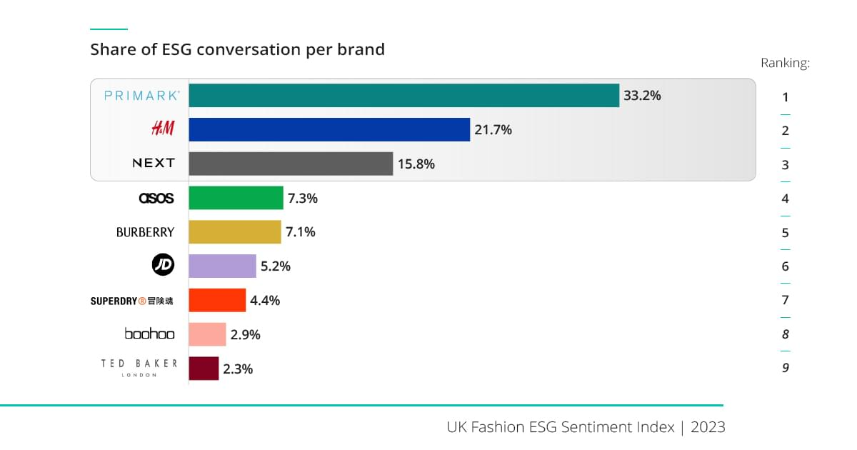

Pioneer (M&S) opportunities and threats:
Opportunities: The reputation of quality and trust that M&S has had over many years gives it a plausible platform to dominate in sustainable practice. The objectives of Plan A, net zero by 2040 and 100% sustainable/recycled materials, allow the early-mover advantage. There is a shift in consumer preference towards a brand that exhibits true sustainability and this is particularly among the value-oriented segments. New sources of revenue such as garment repair, recycling, and take-back programs are in line with the premium and long-lasting product of M&S.
Threats: Initial expenses of supply chain transparency, material traceability and sustainable sourcing can be a burden on margins. First-mover analysis can lead to the accusations of greenwashing against M&S when the implementation is not in line with the communications. The need to design in terms of durability can lead to low purchase rates, which is opposed to revenue expectations. The existence of complex legacy systems and supply chains increases the rate of transformation and consumption of resources.
Follower (Boohoo) has opportunities and threats.
Opportunities: Boohoo can study the problems faced by pioneers and take a selective approach to sustainability as industry standards level off. The trial mechanisms that can be used in the future change can be introduction of green capsules and improvements in recycling content through incremental means. Its existing model remains commercially viable due to the continued need of novelty and trends among the main Gen Z consumers.
Threats: Current high-churn, high-volume model is directly contradictory to the principle of the circular economy and future regulation. Past ethical failures (e.g. Leicester scandal) cost them more because they boost regulatory and media scrutiny by exposing them to reputational damage (Boohoo Group, 2023a). With the consumer values in constant change, low-cost, high-speed fast fashion might be rejected by the ethical shoppers more and more. The model is not ready to absorb compliance costs due to sudden policy changes (e.g. EPR implementation or tougher labour audits).
The weakness of Boohoo is structural. The model, founded on the principle of disposability and novelty, is high-volume, low-price and high-velocity and is incompatible with the concept of circularity (Fletcher, 2010). The reputational and regulatory risk was increased by the Leicester labour scandal of 2020 (workers reportedly paid a bit more than PS3.50/hour) (Boohoo Group, 2023a). Responses Supplier audits, Agenda for Change (including science-based targets), and increased share of recycled content are all improvements but fail to balance growth-by-consumption and the demands of sustainability (Henninger et al., 2016). With the change in regulation and values, the gain in speed/price may turn into a drawback.
In the case of M&S, sustainability is one of the credible differentiators when it is implemented on a deeper level. Plan A aims at reaching net zero by the year 2040, 100 percent sustainable/ recycled materials by 2025 and escalation of take-back and repair (Marks and Spencer, 2023b). Quality/repairability/long-wear proposal is in line with the new values. Nevertheless, the middle-range pricing (PS25-PS100) limits its accessibility to the value stretched customers, and the old world global supply chains makes it more complicated, and forward movement demands more than messaging.
3.2 Transition of Technological and Digital Commerce.
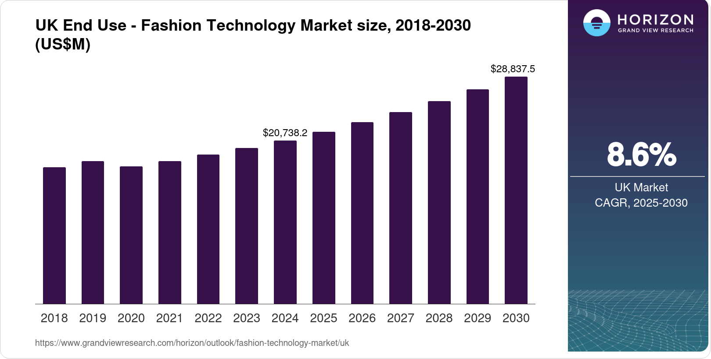
Retail is being digitised on an end-to-end basis, including discovery, and checkout, fulfilment and returns, that is rewiring the value chains and customer relationships (Grewal et al., 2017). Consumers desire mobile-first experience, quick delivery, convenient returns and customisation.

Opportunities and threats of Pioneer (Boohoo):
Opportunities: Inventory systems based on algorithms and real-time data permit incredibly short design-to-shelf-cycles (2-3 weeks). High levels of digital presence, mobile-first UX, social marketing, micro-influencer networks lower the price of acquiring customers and allows expanding to a global level. Asset-light international model broadens the market within a short time through digital platforms. Quick testing and learning on live trend data eliminates trend risk and allows responsiveness.
Threats: The reliance on paid digital advertisements and social media platforms puts Boohoo at risk of changes in algorithms and the increase in advertising prices. The fact that the rate of returns and the cost of logistics are high, is still shrinking the margins of operation. The legacy players bridge the technology gap and advantages in speed and engagement can become imitable. It involves urgent reinvestment of capital and quick innovation to sustain an advantage- not sustainable.
Follower (M&S) Opportunities and Threats:
Opportunities: M&S enjoys the advantages of hindsight, as embracing established platforms and evading the business traps of legacy technology. Omnichannel convenience through stores (click and collect, in-person return) is made possible by multi-channel capability. First-party customer data of high value are created by loyalty programmes and in-store contacts. Back-end (cloud, unified data) investment enables M&S to monolithically innovate and massively scale digital operations.
Threats: Digital innovation can be slowed down even by the investment in legacy IT systems and operational culture. The complexity of the omnichannel can lead to lack of consistency in user experiences compared to digital-native rivals. There is friction in digital profitability in store-related cost structure (rents, operations). Still exposed to the threat of disintermediation by third-party solutions (e.g., Amazon, Zalando).
An automated inventory, mobile-first UX (75%+ smartphone transactions), cloud infrastructure, and digital-native stack (test-and-repeat merchandising) are all aligned with real-time signals which are transformed into production at scale by Boohoo (Boohoo Group, 2023a). The cost of customer acquisition is relatively low (PS8-PS12 vs PS25+ in case of many traditional retailers), which is made possible through the performance marketing, micro-influencer networks and social virality.
The rejuvenation of M&S was facing the problem of decency-old complexity (~40+ legacy systems), which used to provide clumsy UX and minimal personalisation historically. On a c.PS600m transformation, consolidated platforms, redesigned applications, moved to cloud and increased analytics. Results: online clothing sales increased by -PS1bn (2018-23) to -PS1.8bn (35% of clothing sales) but the economics are under strain due to fulfilment and returns; here capabilities are on a par with the industry and no longer headline (Marks and Spencer, 2023a).
4.0 Competitive Strategy Implications

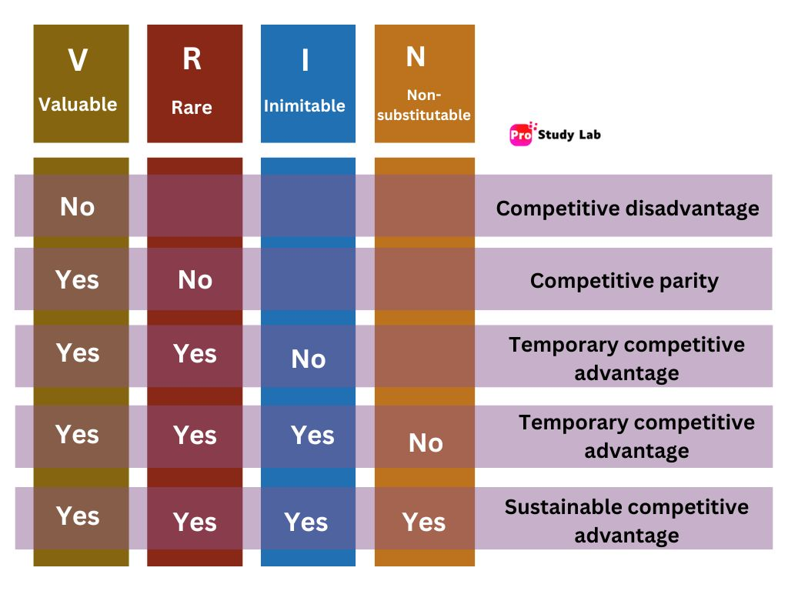
Source : VRIN Framework

4.1 The digital-native disruption at Boohoo.
Strategic thrust: on price-sensitive, trend-sensitive 16-30s through ultra-fast cycles, low prices and social-native marketing (Porter, 1980). Main macro factors responded: Technology and socio-cultural. Secondary: Economic. Risks of misalignment Sustainability/regulatory.
STP
Segmentation [Socio-cultural]: Demographic/psychographic-trend-followers, social active, value conscious, frequent buyers. Market focus: [Socio-cultural/Tech]: Gen Z/young Millennials; international mix US = -25, EU = -20, RoW = -15 (Boohoo Group, 2023a). Positioning [Socio-cultural/Price]: "Latest trends at unbeatable prices.
7Ps (with factor linkage)
Product (Socio-cultural/Tech): 50k+ SKUs; 700+ new weekly products, portfolio includes PLT, Nasty Gal (Boohoo Group, 2023b). Price [Economic/Operations]: Average PS5-PS20 facilitated by volume Boohoo direct-to-consumer (D2C) online sales, i.e. without wholesalers and third-party retailers (through own websites/apps) and lean operations, off/nearshore sourcing and data-driven inventory (Bhardwaj & Fairhurst, 2010). Location [Technology] : Online only (sites/apps) 75%+ in mobile (Boohoo Group, 2023a). Promotion [Technology/Socio-cultural]: 5k+ micro-influencers, UGC (#boohoo, #ootd), Tik Tok/IG formats; regular promo; marketing 8% revenue high ROI (Boohoo Group, 2023b).
Individuals [Ability]: Digital-native youthful teams (mean age of about 28). Process [Technology/Operations]: One- click checkout, algorithmic recommendation, automated fulfilment, self-service returns (Kotler and Keller, 2016). Physical evidence [Technology/Social proof]: UI design, influencer imagery, packaging, ratings/review (Parasuraman et al., 1985).

Critical vulnerabilities
Sustainability/regulatory: Exposure to EPR fees/labor due-diligence/ post-leicester reputational risk (Financial Times, 2020).
Economics/technology: Margins are squeezed due to increasing CAC, high returns and logistics expenses (10%-~4%, 2020-2023) (Boohoo Group, 2023b).
Platform risk: Reliance on social algorithms, fee-based promotion media.
4.2 The legacy transformation in Marks and Spencer.
Strategic thrust: price vigilance, differentiation on quality, trust and sustainability (Porter, 2008). Key macro-factors considered: Sustainability and socio-cultural. Secondary: Technology (catch-up/enablement).
STP
Segmentation [Socio-cultural]: Selective youth outreach; 30-45 aspirational; core 45-70 females. Focusing [Socio-cultural]: Maintaining base and appealing to younger shoppers. Positioning [Socio-cultural/ Sustainability]: Quality worth paying for, modernised heritage and sustainability (Marks and Spencer, 2023a; 2023b).
7Ps (with factor linkage)
Product [Socio-cultural/Sustainability]: investment pieces and own-brand staples; sizes 6–24; over 70% recycled or sustainable content (2023); collaborations (e.g., Nobody's Child) (Marks and Spencer, 2023a).
Price [Economic/Value]: Mid-market ( PS25-PS100), and focusing on the total cost of ownership/longevity compared to fast fashion ( Marks and Spencer, 2023b). Location [Technology/Omnichannel]: 1,000 or more stores; e-commerce, approximately 35 per cent of clothing; click-and-collect; stores estate, over PS400m of property values (Marks and Spencer, 2023a).
Advertisement [Socio-cultural/Brand]: TV/digital/social; Must-Haves; sustainability narration; youth perception is a drag (Drapers, 2023). Human resources [Capability/Culture]: The number of employees is 65 000; digital reskilling; cultural transformation is not a light matter (Tripsas and Gavetti, 2000).
Process [Technology/Operations]: Integrated data, enhanced application, in-store consultants, mobile checkout; complexity of omnichannel (Verhoef et al., 2015).
Physical experience [Brand/Experience]: Intense flagships; conditioning small formats differentially (Parasuraman et al., 1985).
Critical assessment (factor linkage)
Technology: Online has been improved to about PS1.8bn and CX, although mosttly to parity, not to category leadership (Marks and Spencer, 2023a). Socio-cultural: Older parts of the heritage and quality, youth-resonance change gradually.
Sustainability: Plan A is a plausible platform; it requires rewiring of supply-chain to be completely differentiated.
5.0 Competitive Synthesis and Strategic Assessment
Competitive rivalry: Strong fragmentation in high-street chains (Next, H&M), online pureplays (ASOS, Boohoo), supermarkets (Tesco, Sainsbury clothing) and ultra-budget (Primark). Price competition and compression of margins are brought about by low switching costs and style commoditisation.
Buyer power: Strong because there are plenty of substitutes, ease of price comparison, transparency in social media, and the absence of switching costs: moderate in some markets (e.g., the historical customers of M&S).
Supplier power: Moderate; the concentration in manufacturing in Bangladesh/China leads to dependency, but competitors vie on volume. The production in the UK by Boohoo is diversified and lowers the supplier power; the M&S scale enhances bargaining (Boohoo Group, 2023a). Threat of new entrants: Digital barriers to entry (Shopify, dropshipping, social marketing) are too easy, yet profitable scale demands advanced capabilities and logistics, which prevents really disruptive entrants (Christensen et al., 2015).
The threat of substitutes: Clothing rental, resale (Vinted, Depop), and wardrobe sharing, in particular among sustainability-minded consumers (Ellen MacArthur Foundation, 2017). Resource-Based Comparative Assessment (Barney, 2014) Boohoo VRIN: Algorithmic merchandising (valuable; increasingly commoditised; moderately imitable); agile supply chain (valuable; rare; hard to imitate); social media marketing expertise (valuable; moderately rare; imitable); acquisition fire power (valuable; substitutable).
M&S VRIN: Brand equity/trust (valuable; rare; very hard to replicate); owned property portfolio (valuable; increasingly doubted; and can be substituted by leasing); supplier relationships (valuable; common); sustainability leadership potential (valuable unless fake; rare; hard to imitate; moderate substitutability).
At the end: Both have no indestructible resources in terms of VRIN; success will depend on how well it is coordinated, how fast it learns and how it adapts continuously and not how it is endowed with resources beforehand (Eisenhardt and Martin, 2000).
6.0 Conclusions
Within the context of disrupted markets, ongoing advantage is a function of the interaction between macro conditions, organisational capabilities and resource endowment—rather than leader or heritage position (Teece, 2009; Porter, 1996). Monzo had the perks of permissive regulation and technology, but scale reveals classic banking challenges: broaden demographics, find durable sources of revenue and earn trust. Lloyds’ investment of resources and dynamic capabilities outweigh determinist disruption narratives digital showing omnichannel resilience to Schumpeterian shocks (Barney, 2014). Both of these positions are contestable: Monzo is under profitability pressure, demographic constraint and competitive response; Lloyds has cultural momentum, legacy systems and cost–service trade‑offs. Future consequences depend less on pioneer–follower designations or any legacy decisions than the quality of execution, crystallization of strategy, and capacity for adaptation; advantage is always superyielding (not fixed) (Teece 2007; Porter 2008). Successful efforts require quicker coordination and a coordinated strategy.
References
Barney, J.B. (2014) Gaining and Sustaining Competitive Advantage. 4th edn. Harlow: Pearson.
Bhardwaj, V. and Fairhurst, A. (2010) 'Fast fashion: response to changes in the fashion industry', The International Review of Retail, Distribution and Consumer Research, 20(1), pp. 165–173.
Boohoo Group (2023a) Annual Report and Accounts 2023. Available at: https://www.boohooplc.com (Accessed: 20 October 2025).
British Retail Consortium (2023) Retail Statistics 2023. Available at: https://brc.org.uk (Accessed: 20 October 2025).
Christensen, C.M. (1997) The Innovator's Dilemma: When New Technologies Cause Great Firms to Fail. Boston, MA: Harvard Business School Press.
DataEQ (n.d.) Is the fashion industry sustainable? Available at: https://dataeq.com/resources/news/is-the-fashion-industry-sustainable?hs_amp=true (Accessed: 19 October 2025).
Ellen MacArthur Foundation (2017) A New Textiles Economy: Redesigning Fashion's Future. Available at: https://www.ellenmacarthurfoundation.org (Accessed: 20 October 2025).
eMarketer (2025) State of UK Fashion Ecommerce 2025. Available at: https://www.emarketer.com/content/state-of-uk-fashion-ecommerce-2025 (Accessed: 19 October 2025).
Environmental Audit Committee (2019) Fixing Fashion: Clothing Consumption and Sustainability. London: House of Commons.
Fletcher, K. (2010) 'Slow fashion: An invitation for systems change', Fashion Practice, 2(2), pp. 259–266.
Francis, T. and Hoefel, F. (2018) 'True Gen: Generation Z and its implications for companies', McKinsey & Company. Available at: https://www.mckinsey.com (Accessed: 20 October 2025).
Grewal, D., Roggeveen, A.L. and Nordfält, J. (2017) 'The future of retailing', Journal of Retailing, 93(1), pp. 1–6.
Henninger, C.E., Alevizou, P.J. and Oates, C.J. (2016) 'What is sustainable fashion?', Journal of Fashion Marketing and Management, 20(4), pp. 400–416.
IMARC Group – UK Sustainable Fashion Market Size, Share, Trends and Forecast by Product Type… (2024-2033)
Marks & Spencer (2023a) Annual Report and Financial Statements 2023. Available at: https://corporate.marksandspencer.com (Accessed: 20 October 2025).
Marks & Spencer (2023b) Reshaping M&S for Growth. Available at: https://corporate.marksandspencer.com/our-strategy (Accessed: 20 October 2025).
Mintel (2023) Clothing Retailing UK 2023. Available at: https://www.mintel.com/reports (Accessed: 20 October 2025).
Porter, M.E. (2008) On Competition. Updated edn. Boston, MA: Harvard Business Press.
ProStudyLab (n.d.) Resource-based view and VRIO framework (VRIN framework). Available at: https://prostudylab.com/resource-based-view-and-vrio-framework-vrin-framework/ (Accessed: 19 October 2025).
Teece, D.J. (2009) Dynamic Capabilities and Strategic Management: Organising for Innovation and Growth. Oxford: Oxford University Press.

