

Assessment 1 – Reading Task Template
Upload your photo of your A3 in-class notes here:
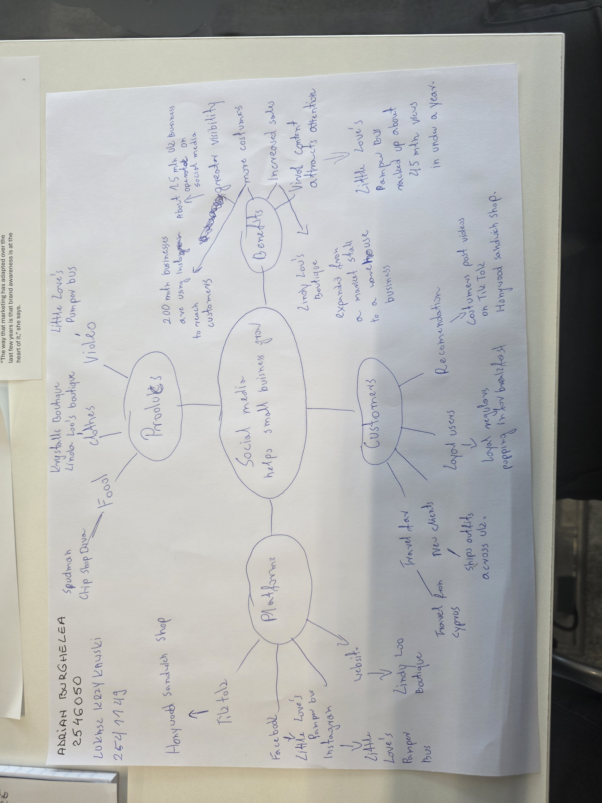

1. Answer these questions using the sentence starters below
a. What is the main idea of the text?
Social media like TICK TOC,INSTAGRAM,FACEBOOK can help small business become successful by attracting new customers increasing sales when their posts is going viral
b. What are two key points?
One key point is
Social media is transforming small business, often touring quiet local shops into viral destinations with national or even international reach
Another key point is
Often its not business own posts but customers video that go viral
c. What part of the text did you find most important? Why?
The most important part is
The strongest evidence comes from examples of business that became popular after going viral
d. Was anything unclear or difficult to understand
The article includes different examples of business which can be confusing
e. How did your group help you understand the text better?
My group helped me understand the text better by discussing it and share different ideas
2. One sentence reflection
Question: What did you find challenging about this task?
I found it challenging to identify the most important information because the text included many different examples
The hardest part was deciding which details where more important

