Programme: MBA- Masters of Business Administration
Module: Marketing Management – Assessment 2
Module code: LCMB7001
Selected company: Primark

Student Id:
Table of Contents
Question A 2
Introduction 2
Background information on Primark 2
Macro environment analysis of the company 2
Relating Five Force Model to Primark 4
SWOT analysis of the company 5
Segmentation, targeting and positioning of Primark 6
Dissecting the marketing mix strategy of the company 7
Conclusion 8
Question B 8
Suggestions for future marketing strategies for Primark 8
Application of Ansoff matrix 8
Application of product lifecycle model 9
Competitive strategy 10
Reference List 11

Question A

Introduction
The marketing environment of a company comprises various forces and factors that impose a significant impact on the ability of management terms of evolving and maintaining flourishing transactions with the targeted consumers (Kotler et al., 2018). The purpose of the first section of the report is to perform an environmental marketing analysis of Primark taking salient drivers associated with the internal and external environment under consideration and the role of marketing in the clothing company.

Background information on Primark
Primark is a leading clothing retailer that started its journey in the year 1969. At present, the company has effective international footprint covering 15 countries (Corporate.primark, 2023). The company’s range of product includes accessories, clothing and homeware under different segments, including women, kind and men. Arthur Ryan was the founder of the company. The mission statement of the company is to present consumers with superior quality fashion at affordable price tags (Corporate.primark, 2023).

Macro environment analysis of the company
PESTEL analysis
Political factors:
Some of the major political elements affecting the growth of the fast fashion industry are Brexit, and government regulation on fast fashion (Pfoser et al., 2022). Further, in the context of the UK and EU region, Brexit has resulted in several bottlenecks in the fast fashion supply chain (Loscialpo, 2019). Therefore, the threat is evident in the political domain.
Economic factors:
The recurrent hikes in energy prices as an aftermath of the Russia-Ukraine war have affected the fashion sector to a considerable extent. As stated by Veit (2023), the skyrocketing increase in oil prices has negatively impacted the production of man-made fibres. As reported by Statista (2023), as of February 2023, the average annualised price of Brent crude oil reached 82.55 USD due to the ongoing war between Russia and Ukraine. Therefore, the threat is evident in the fast fashion sector where Primark operates.
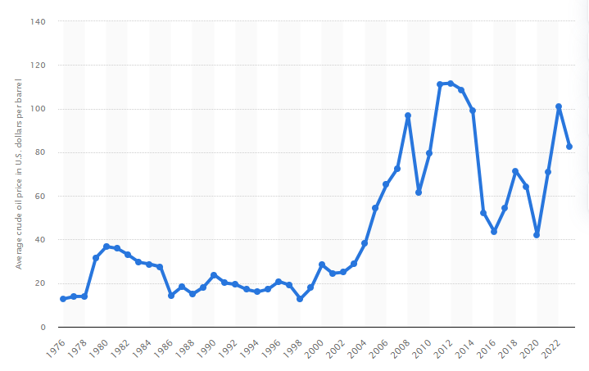
Figure 1: Crude oil price hike (1976 to 2023)
(Source Statista, 2023)
Social Factors:
In recent times, sports apparel and athleisure become exponentially popular among millennials (Yip and Lando, 2020). Further, consumers are demonstrating more interest in purchasing sustainable fashion products made of organic materials. Frequent swing in customer preference has emerged as a threat to the fast fashion sector.
Technological factors:
In the year 2021, fashion businesses have made an investment of 1.7% of their revenue in procuring technology (3DLOOK, 2023). The figure is expected to get doubled in 2030. Besides, rapid e-commerce growth has also become apparent in recent years. As reported by Statista (2023), global e-commerce revenue is supported to touch a growth rate of 11.5%. Therefore, in the technological sphere, umpteen numbers of opportunities exist for fast fashion companies.
Environmental factors:
Statistics brought out by the United Nations reveal that the fashion industry is a prime contributor to greenhouse gas discharge which is around 10% (Unfccc.int, 2023). Moreover, the consumers of the UK tend to buy more clothes compared to any other nations in the globe and it has been resulting in landfills. The possibility of an updated regulation is likely around the globe and it can impose threat.
Legal factors:
Misleading claims by fashion brands have become common in the realm of the fashion industry (Pfoser et al., 2022). Further, incidents of breaching consumer protection laws have also been amplified. Therefore, a lack of legal compliance can create a number of hurdles for fashion companies.

Relating the Five Force Model to Primark
Suppliers’ power:
Suppliers' power is insignificant in the fashion sector because companies can easily change their preferred suppliers. Further, large fashion brands usually opt for long-term contracts with suppliers across the world (Duoyan, 2021). Thus, the possibility of bargaining is low.
Buyers’ power:
In the fast fashion industry, consumers enjoy plenty of bargaining power due to intense completion among existing companies (Long and Nasiry, 2022). Moreover, since products offered by a company are replicable by others, switching cost is low. As a result, the fast fashion sector is witnessing high bargaining power.
New entry threat:
In recent times, the skyrocketing growth of e-commerce has inspired new players to offer low-cost apparel via e-commerce sites. Moreover, the tactical use of social media is also evident among newcomers (Duoyan, 2021). However, high investment necessity has kept the number of new players considerably low.
Substitution threat:
At present, there is no viable product that can replace fashion. Although companies are working on bio-fabric, it can be seen as an alternative to the traditional fabric rather than a substitution (Long and Nasiry, 2022). Thus, the threat is insignificant in this quadrant.
Competitive rivalry:
As reported by Modern Retail (2022), in recent years, first fashion brands come under tremendous pressure from competition due to the rapid growth of e-commerce. By offering low-cost and trendy garments, fast fashion brands have been attempting to allure consumers. Leading fast fashion brands include Zara, UNIQLO, Gap and Fashion Nova and H&M and so on. Therefore, Primark has been noticing rising rivalry in the UK and abroad.

SWOT analysis of the company
Strengths (S) | Weaknesses (W)
- Primark has ensured quick international expansion and currently operates in 15 nations (Corporate.primark, 2023)  - The company offers a myriad of products in men, kids, beauty and home segment  - Primark has developed a brand image in different parts of the globe for affordability (Ibid, 2023) | - The greatest concern for Primark is that the company has kept itself aloof from e-commerce (Fabri and Valverde Márquez, 2020)  - As reported by the Guardian (2021), the company is accused of underpaying the workers  - The company has failed to improve its products as the changing customer requirements  - The company is lagging behind the competitors for lacking online strategy and poor marketing
Opportunity (O) | Threats (T)
- Primark has the opportunity to develop an online selling strategy  - The company has the opportunity to grow in Asian countries since the demand of clothing is exponentially high in the region | - Intense rivalry with Next, Zara, JD Sports, Uniqlo and H&M can upset the market share of Primark  - The absence in e-commerce can also lead the company towards extinction in the coming years

Segmentation, targeting and positioning of Primark
Segmentation:
The key divisions pertaining to market segmentation encompass demographic, behavioural, psychographic and geographic (Fahy and Jobber, 2019). The chief focus of Primark remains on the demographic segment since the company seeks to cater to the wants and needs of price-sensitive consumers. Apart from this, the company's focus also rests on the psychographic and behavioural segment.
Targeting:
Targeting strategy involves examining the attractiveness and potentiality of each segment. Key targeting strategies are distinguished as mass marketing, niche marketing differentiated marketing and micro marketing (Hollebeek et al., 2019). Primark has opted for niche marketing for targeting a few consumer groups. For instance, the demographic segment is comprised of low to mid-income consumers. The behavioural segments comprised those buyers who enjoy in-store shopping. The psychographic segment targets those customers who value sustainable lifestyles.
Positioning:
Primark has positioned itself in the fashion segment as a brand that offers trendy fashion products with affordable pricing (Quijada et al., 2021). It has assisted the company to win the confidence of the budget segment consumers, especially those whose ages from 16 to 30 years. Primark’s positioning map has been mentioned below.
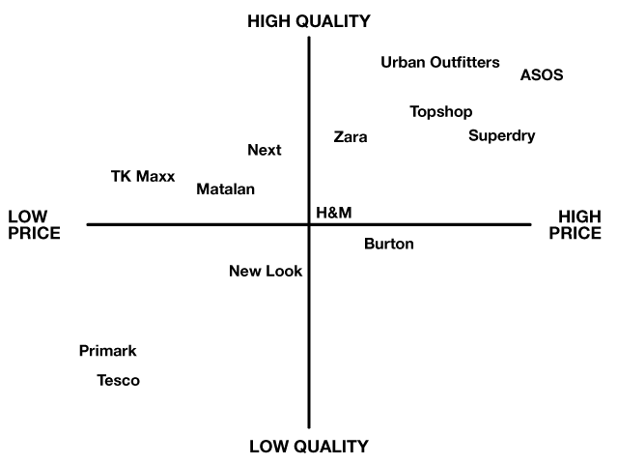
Figure 2: Positioning map of Primark
(Source: Quijada et al., 2021)

Dissecting the marketing mix strategy of the company
Product:
Primark offers a myriad of products, including clothing, footwear, skincare and homeware for kids, women and men. Primark has incorporated a brand extension strategy to attract consumers in numbers (Quijada, 2021). For instance, Primark fulfils its remaining product range with trendy products frequently. In the year 2020, the company launched a wellness collection comprising an array of eco-friendly products.
Price:
Primark's vision is to make trendy products available at a cheaper price. For a long time, Primark has been dependent on penetration pricing. As stated by Ikechi, Chinenye and Chiyem (2017), penetration pricing is a pricing method where a company set lower pricing to attract a large number of potential customers. As a result of this strategy, Primark has managed to increase its customer base while maintaining a low profit margin.
Place:
Primark offers its products to a large number of consumers across Europe and the US through its 415 retail outlets. In most of the countries, Primark has opted for a selective distribution strategy (Quijada et al., 2021). As a part of this strategy, Primark offers its products mainly from stores located in highly accessible areas.
Promotion:
Primark has extensively utilised word-of-mouth for a prolonged time (Arriaga et al., 2017). The company has always encouraged brand advocators to spread its name so that it can allure more consumers. Primark comes among the list of exceptional brands that do not depend heavily on traditional marketing efforts, like advertising, PR campaigns and celebrity endorsements. However, nowadays, the company has increased its presence on social media to some extent.

Conclusion
In conclusion, it can be averred that Primark has been observing a range of challenges emerging from the external and internal business environment. Challenges coming from the external environment include high energy prices, Brexit, changing consumer behaviour and sustainability issues. Issues emerging from the internal environment include extreme competition, lack of online presence and controversies. Based on the analysis of Primark's marketing mix, it is evident that the company has not incorporated a well-developed marketing strategy like integrated marketing which is the need of the hour based on the threats it is encountering.

Question B

Suggestions for future marketing strategies for Primark

Application of Ansoff matrix
Based on the SWOT analysis, it has been observed that Primark needs to expand rapidly in the Asia Pacific region to reduce competitive pressure. In order to identify opportunities for Primark, Ansoff Matrix can be resorted. Ansoff Matrix has enlisted four strategies to ensure the growth of a company. They are as follows:
- Market penetration (i.e. selling existing offerings to available consumers)
- Market development (i.e. offering available products to new region or country)
- Product development (i.e. Penetrating new markets with brand new products)
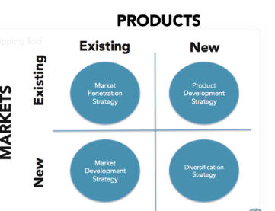
Figure 3: Ansoff Matrix
(Source: Khajezadeh et al., 2017)
It is recommended that Primark needs to opt for a market development strategy in order to enter the Asia Pacific region. As a low-risk strategy, it can assist the fast fashion retailer to capture a new market in a cost-saving way. Implementation of the strategy does not necessitate the utilisation of R&D as the company can offer its existing portfolio in new region.

Application of product lifecycle model
The product lifecycle model is formed of four phases (Stark, 2022). The first stage namely introduction talks about the development of a marketing strategy. Since Primark lacks a well-structured marketing strategy, it is suggested that the company needs to invest in online advertising and content marketing in order to increase product and brand awareness. While expanding in Asia Pacific, at the second stage of the product lifecycle, the company needs to ramp up production. The company can continue its low-cost pricing in the Asia Pacific market, when a product will enter into maturity stage, the company can opt for research to look for new opportunities. Finally, when a product offered by Primark enters the decline phase, the company can apply a brand extension strategy in order to launch new ones.
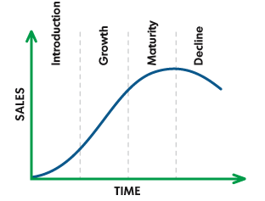
Figure 4: Product Life Cycle Model
(Source: Stark, 2022)

Competitive strategy
Based on the SWOT and Five Force analysis, it has become apparent that Primark lacks an effective strategy to stand apart from market rivalry. Competitive strategies can be assorted as defensive and offensive strategies (Palmatier and Martin, 2019). An offensive strategy necessitates huge investment and therefore not suitable for Primark since the company maintains a low-profit margin. Therefore, as a part of the defensive strategy, the company needs to put much emphasis on managing its reputation, reducing the risk of loss and secure brand. It is recommended that Primark needs to divest strategy to accomplish certain objectives by selling unprofitable assets.

Reference List
Arriaga, J.L.D.O., Andreu Domingo, D. and Berlanga Silvente, V., (2017). Facebook in the low-cost fashion sector: the case of Primark. Journal of Fashion Marketing and Management: An International Journal, 21(4), pp.512-522.
Corporate.primark (2023). About Us. Primark Corporate. Available at: https://corporate.primark.com/en-gb/a/about-us/who-we-are (Accessed: May 6, 2023).
del Rocío Bonilla Quijada, M., Arriaga, J.L.D.O. and Domingo, D.A., (2021). Insights into user engagement on social media. Findings from two fashion retailers. Electronic Markets, 31(1), pp.125-137.
Duoyan, H., (2021), April. Research on ZARA strategy from the perspective of SWOT analysis method. In 2021 6th international conference on social sciences and economic development (ICSSED 2021) (pp. 201-205). Atlantis Press.
Fabri, L. and Valverde Márquez, I., (2020). Will e-commerce dominate physical store?. International Journal of Technology for Business (IJTB), 2(1), pp.23-29.
Fahy, J. and Jobber, D., (2019). EBOOK: Foundations of Marketing, 6e. McGraw Hill.
Hollebeek, L.D., Sprott, D.E., Andreassen, T.W., Costley, C., Klaus, P., Kuppelwieser, V., Karahasanovic, A., Taguchi, T., Islam, J.U. and Rather, R.A., (2019). Customer engagement in evolving technological environments: synopsis and guiding propositions. European Journal of Marketing, 53(9), pp.2018-2023.
Ikechi, A., Chinenye, E.P. and Chiyem, O., (2017). Marketing Mix Concept: Blending the Variables to Suit the Contemporary Marketers. International Academic Journal of Management and Marketing, 9(1), pp.55-65.
Khajezadeh, M., Niasar, M.S.F., Asli, S.A., Davari, D.D., Godarzi, M. and Asgari, Y., (2019). Application of neural network in portfolio product companies: integration of Boston consulting group matrix and Ansoff matrix. International Journal of Economics and Management Engineering, 13(6), pp.821-825.
Kotler, P., Keller, K.L., Ang, S.H., Tan, C.T. and Leong, S.M., (2018). Marketing management: an Asian perspective. London: Pearson.
Lokanan, M.E., (2021). Analyzing Primark’s Financial Performance Using Financial Ratios and Models. In SAGE Business Cases. SAGE Publications: SAGE Business Cases Originals.
Long, X. and Nasiry, J., (2022). Sustainability in the fast fashion industry. Manufacturing & Service Operations Management, 24(3), pp.1276-1293.
Loscialpo, F., (2019). “I am an immigrant”: Fashion, immigration and borders in the contemporary trans-global landscape. Fashion Theory, 23(6), pp.619-653.
Modernretail (2022) Fast-fashion leaders like H&M and Zara Face increased competition, Modern Retail. Available at: https://www.modernretail.co/operations/fast-fashion-leaders-like-hm-and-zara-face-increased-competition/ (Accessed: May 6, 2023).
Palmatier, R.W. and Martin, K.D., (2019). The intelligent marketer's guide to data privacy: The impact of big data on customer trust. Cham, Switzerland: Springer International Publishing.
Pfoser, S., Herman, K., Massimiani, A., Brandtner, P. and Schauer, O., (2022), May. From Linear to Circular Packaging: Enablers and Challenges in the Fashion Industry. In Dynamics in Logistics: Proceedings of the 8th International Conference LDIC 2022, Bremen, Germany (pp. 435-445). Cham: Springer International Publishing.
Stark, J., (2022). Product lifecycle management (PLM). In Product Lifecycle Management (Volume 1) 21st Century Paradigm for Product Realisation (pp. 1-32). Cham: Springer International Publishing.
Statista. (2023) Brent Crude Oil Price annually 1976-2023, Statista. Available at: https://www.statista.com/statistics/262860/uk-brent-crude-oil-price-changes-since-1976/ (Accessed: May 6, 2023).
Statista.com (2023). ECommerce - worldwide: Statista market forecast (no date) Statista. Available at: https://www.statista.com/outlook/dmo/ecommerce/worldwide#:~:text=Revenue%20in%20the%20eCommerce%20market,US%246.35tn%20by%202027. (Accessed: May 6, 2023).
The Guardian. (2021) 'wage theft' in Primark, Nike and H&M Supply Chain. Guardian News and Media. Available at: https://www.theguardian.com/global-development/2021/jul/02/wage-theft-in-primark-nike-and-hm-supply-chain-report (Accessed: May 6, 2023).
Unfccc.int. (2023) Unfccc.int. Available at: https://unfccc.int/news/un-helps-fashion-industry-shift-to-low-carbon#:~:text=The%20fashion%20industry%2C%20including%20the,aviation%20and%20shipping%20industry%20combined. (Accessed: May 6, 2023).
Veit, D., (2023). Processes for the Production of Man-Made Fibers. In Fibers: History, Production, Properties, Market (pp. 453-475). Cham: Springer International Publishing.
Yip, J. and Lando, A.F., (2020). Introduction to activewear. In Latest Material and Technological Developments for Activewear (pp. 1-23). Woodhead Publishing.

