

Programme: Master of Business Administration
Module Name: International Marketing – Principles and Practices
Module Code: LCMB7026

Submission deadline: 13th August 2026

Lecturer’s Name: Tushara Balendran Dian Mayasari

Student Name: Hira Akter
Student ID: 2530059

Word Count: 5,000 words (±10%)

Individual Report

Acknowledgement of AI Tool Use
I certify that generative artificial intelligence has been used in preparing this report in accordance with the university's academic integrity guidelines.

I acknowledge the use of Perplexity AI (https://www.perplexity.ai/) on 30 July 2026 to support my research using the prompt(s):

What are Pizza Hut’s US same-store sales trends, market share versus Domino’s from 2015–2025, and recent ownership changes under Yum! Brands?

Summarise India’s food-service market size, growth to 2028, and Tier-2/3 spending increases.

I confirm that I have not presented any AI-generated text as my own work. I confirm I have copies of my drafts, notes, and other resources I used before and after the use of AI tools, which I may be asked to provide as evidence.

I acknowledge the use of Google Gemini (https://gemini.google.com/) on 1 August 2026 to support my research using the prompt(s):

Provide a comparative PESTEL overview of the United States versus India focused on economic, social and legal factors relevant to QSR brands.

Explain Hofstede’s cultural dimensions with specific scores and implications for food marketing between the US and India.

Summarise Devyani International and Sapphire Foods’ roles as Pizza Hut franchise operators in India.

I confirm that I have not presented any AI-generated text as my own work. I confirm I have copies of my drafts, notes, and other resources I used before and after the use of AI tools, which I may be asked to provide as evidence.

I acknowledge the use of Microsoft Copilot (https://copilot.microsoft.com/) on 3 August 2026 to support my research using the prompt(s):

Outline STP strategies for Pizza Hut in mature versus emerging markets, including targeting differences.

Compare the 7Ps marketing mix adaptation requirements for a Western pizza brand entering India versus operating in the US.

I confirm that I have not presented any AI-generated text as my own work. I confirm I have copies of my drafts, notes, and other resources I used before and after the use of AI tools, which I may be asked to provide as evidence.

I acknowledge the use of ChatGPT (https://chatgpt.com/) on 4 August 2026 to support my research using the prompt(s):

Apply the standardisation-versus-adaptation debate to Pizza Hut’s product and promotion decisions in the US and India.

Summarise key ethical considerations around HFSS food marketing and value-bundle promotions in the United States.

I confirm that I have not presented any AI-generated text as my own work. I confirm I have copies of my drafts, notes, and other resources I used before and after the use of AI tools, which I may be asked to provide as evidence.

I acknowledge the use of Claude AI (https://claude.ai/) on 5 August 2026 to support my research using the prompt(s):

Find and summarise recent data on Domino’s versus Pizza Hut revenue and average daily sales per store in India for FY25.

Explain franchising as an entry mode for culturally distant markets using Dunning’s internalisation logic.

I confirm that I have not presented any AI-generated text as my own work. I confirm I have copies of my drafts, notes, and other resources I used before and after the use of AI tools, which I may be asked to provide as evidence.

I acknowledge the use of SciSpace (https://typeset.io/) on 6 August 2026 to support my research using the prompt(s):

Locate academic sources on services marketing mix (7Ps) and integrated marketing communications applied to global QSR brands.

I confirm that I have not presented any AI-generated text as my own work. I confirm I have copies of my drafts, notes, and other resources I used before and after the use of AI tools, which I may be asked to provide as evidence.

I acknowledge the use of Grammarly (https://www.grammarly.com/) on 7 August 2026 to check my work using the prompt(s):

Review the full draft for grammar, spelling, academic tone, clarity and flow, with particular attention to the PESTEL, Hofstede, STP and 7Ps sections.

Improve readability of the reflective account while maintaining first-person voice.

I confirm that I have not presented any AI-generated text as my own work. I confirm I have copies of my drafts, notes, and other resources I used before and after the use of AI tools, which I may be asked to provide as evidence.

I acknowledge the use of Quillbot (https://quillbot.com/) on 8 August 2026 to check my work using the prompt(s):

Paraphrase the academic tone in the recommendations and ethical evaluation sections without changing core arguments or data.

I confirm that I have not presented any AI-generated text as my own work. I confirm I have copies of my drafts, notes, and other resources I used before and after the use of AI tools, which I may be asked to provide as evidence.

Table of Contents
Table of Contents 5
List of Figures 6
List of Tables 6
Section 1: Comparative Marketing Analysis 7
1.1 Introduction 7
1.2 Comparative Macro-Environment: PESTEL 7
1.3 Comparative Culture: Hofstede's Dimensions 12
1.4 Comparative STP: Segmentation, Targeting and Positioning 15
1.5 Comparative Marketing Mix: The 7Ps 17
1.6 Market Entry Strategy: India 23
1.7 Ethical Evaluation: HFSS Marketing in the United States 25
1.8 Recommendations 28
Section 2: Reflective Account 30
Description 30
Feelings 30
Evaluation 30
Analysis 31
Conclusion 31
Action Plan 32
References 33

List of Figures
Figure | Title | Page
1 | Macro-environment contrast between the two markets | 10
2 | US pizza market share, Pizza Hut versus Domino's, 2015–2025 | 11
3 | Pizza Hut US same-store sales growth, 2022–2025 | 11
4a | PESTEL favourability by factor and country | 12
4b | PESTEL favourability grid, US versus India | 13
4 | Cultural distance between the US and India (Hofstede) | 14
5 | Targeting emphasis by market | 16
5a | Perceptual map of the US pizza market (Pizza Hut vs Domino's) | 18
6 | Degree of marketing-mix adaptation by market | 19
6a | Pizza Hut's direct and indirect distribution channels | 21
6b | Comparative physical evidence, US and India | 23
7 | India pizza revenue, Domino's versus Pizza Hut | 25
7a | Advantages and disadvantages of franchising | 25
8 | India average daily sales per store | 26
9 | Calorie density and the HFSS ethics question | 27
10 | Recommendation priority matrix | 29

List of Tables
Table 1: Comparative PESTEL analysis, US versus India (Section 1.2)
Table 2: Comparative 7Ps marketing mix, US versus India (Section 1.4)

Section 1: Comparative Marketing Analysis

1.1 Introduction
Pizza Hut represents a useful case study for a single clear reason: the brand is underperforming in two markets that differ in almost every respect. In the United States, same-store sales fell 5% in 2025, and category share declined from 16.9% in 2015 to 12.1% by late 2025, with Domino's having overtaken it in 2017 and retained the lead thereafter (Restaurant Dive, 2026). Its parent company, Yum! Brands, agreed in June 2026 to sell the brand for US$2.7bn (Restaurant Business, 2026). That a company should struggle simultaneously in a mature home market and a fast-growing host market suggests that the difficulty lies in execution rather than environment.
The two countries were selected for maximum contrast. The United States is a mature, individualist and saturated market in which pizza functions as ordinary convenience food. India presents the reverse conditions: it is fast-growing, collectivist and price-sensitive, with a large vegetarian population, and Western chains continue to carry genuine aspirational weight. The report begins by comparing the two macro-environments through PESTEL, then examines culture through Hofstede, before addressing segmentation, targeting, positioning and the seven-element marketing mix.

1.2 Comparative Macro-Environment: PESTEL
This analysis prioritises the PESTEL factors most material to the marketing decision rather than treating all six equally. Three factors are most significant in this comparison: the economic environment (saturated versus growing), the socio-cultural context (meat-heavy individual meals versus family-oriented vegetarian consumption), and the legal framework (tightening regulation of unhealthy-food marketing from differing baselines). The remaining factors, though relevant, exert less influence on the strategic choices examined here.
Factor | United States | India
Political | Stable, business-friendly; franchising well established. Low materiality to the comparison. | Stable democracy, pro-FDI reforms; foreign QSR encouraged. Low materiality.
Economic | Mature, ~2.8% GDP growth; saturated pizza category in decline; high labour costs. High materiality. | ~6.5% GDP growth; food-service market heading towards US$79bn by 2028; Tier 2/3 spending up 108% in two years. High materiality.
Social | Individualist, convenience-led; delivery and single-serve dominate; median age ~39. High materiality. | Collectivist, family dining; ~39% vegetarian, no beef/pork for most; median age ~28. Very high materiality.
Technological | Advanced app/delivery ecosystem; Domino's set the digital pace. Medium. | Rapid smartphone and delivery-aggregator growth (Zomato, Swiggy). Medium-high.
Environmental | Packaging and sustainability pressure rising. Low materiality. | Similar pressure, lower enforcement. Low materiality.
Legal | Growing scrutiny of HFSS food marketing and calorie disclosure. Medium-high. | FSSAI labelling rules tightening; vegetarian/non-veg marking mandatory. Medium-high.

Economic factors
Economic direction is the sharpest single contrast. For the United States, the economic factor is unfavourable: Pizza Hut operates roughly 6,300 domestic outlets in a saturated category in structural decline, with around 1,500 net closures over the decade to 2026 (Restaurant Dive, 2026). For India it is highly favourable: a food-service market projected to reach approximately US$79bn by 2028, with middle-class fast-food spending up 108% in two years (Devyani International, 2023). The telling point is that Pizza Hut is losing ground in both, which points to execution rather than environment.
Political factors
Politically, both markets are relatively favourable and, importantly, similar, which is why the factor does not drive the later marketing decisions. The United States offers a stable, business-friendly and franchise-friendly environment, favourable for a franchised brand though subject to state-level variation in labour and food regulation. India is also broadly favourable and pro-foreign-investment, having liberalised single-brand and food retail, but it is comparatively less favourable in that regulatory complexity, differing state rules and bureaucracy raise the cost of operating. Political risk is low in both, so while the factor is favourable overall, it is not a point of meaningful competitive difference between the two markets.
Legal factors
Legally, both environments are moving in an unfavourable direction, though from different baselines. In the US, calorie-disclosure rules and mounting scrutiny of marketing high-fat, salt and sugar (HFSS) products to younger audiences are tightening the space a value-and-indulgence brand can occupy, which is unfavourable. In India, the Food Safety and Standards Authority has strengthened labelling rules, and mandatory vegetarian marking is a hard, though navigable, constraint in a market where dietary rules carry religious weight (Restaurant India, 2026). The two differ in content but converge in direction: both are becoming less favourable for aggressive food marketing.
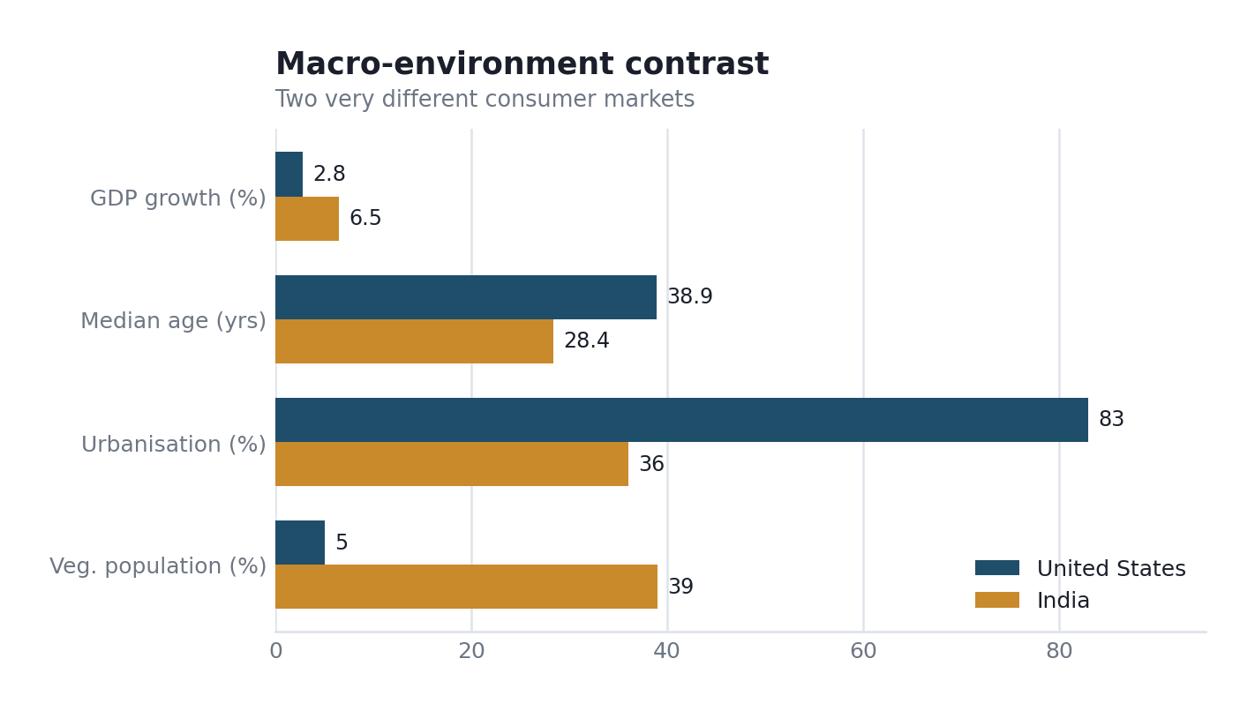
Figure 1: Macro-environment contrast between the two markets (author's compilation from World Bank and industry data, 2025–2026).
The scale of the decline in the home market merits emphasis. In 2015, Pizza Hut held a 16.9% share and led the category; by late 2025 its share had fallen to 12.1%. Over the same period, Domino's rose from 14.2% to 23.4% and assumed the lead in 2017 (Restaurant Dive, 2026). By early 2026, the brand had recorded its eighth consecutive quarter of same-store sales decline.
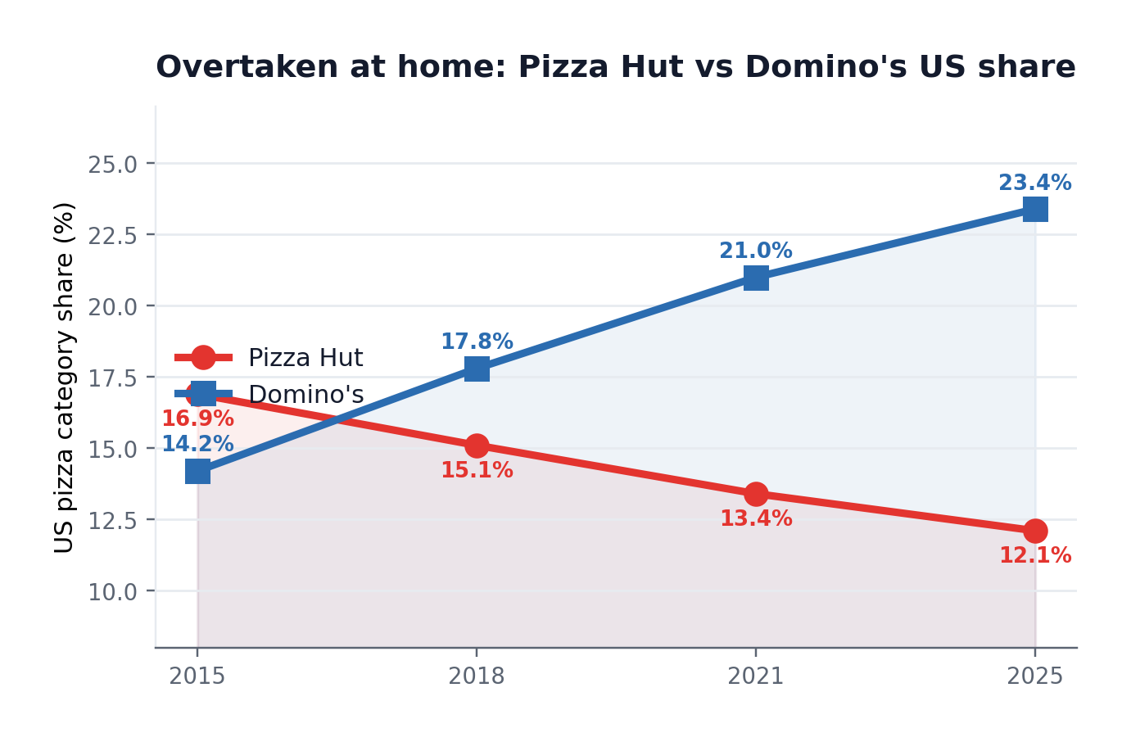
Figure 2: US pizza market share, Pizza Hut versus Domino's, 2015–2025 (Restaurant Dive, 2026).
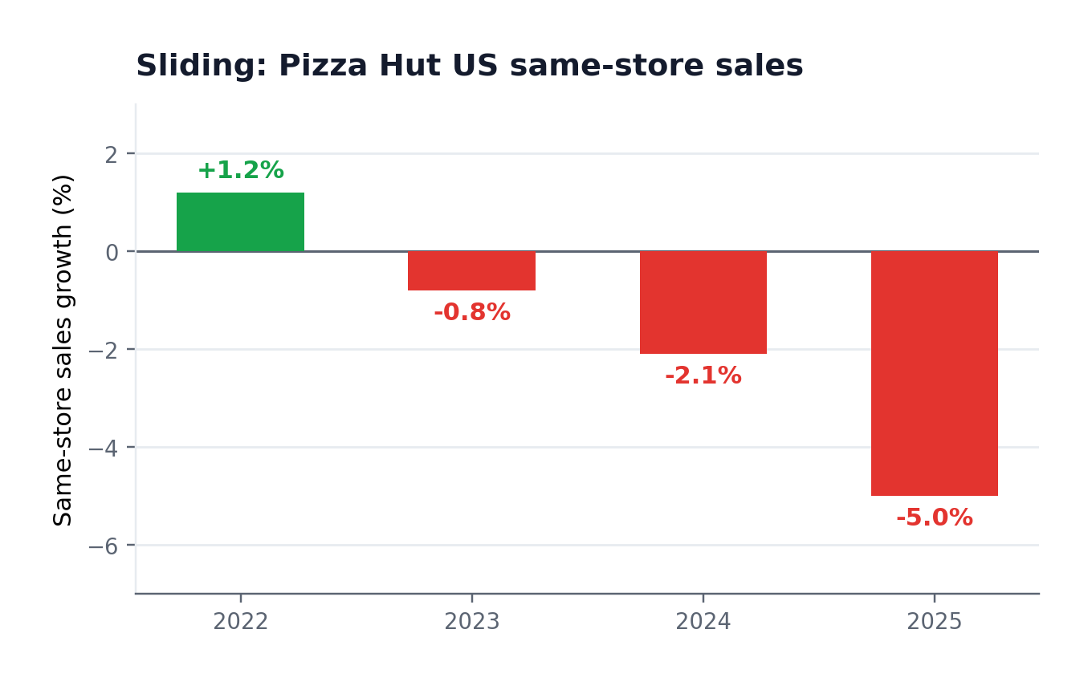
Figure 3: Pizza Hut US same-store sales growth, 2022–2025 (Restaurant Dive, 2026; Yahoo Finance, 2026).
Socio-cultural factors
Socially, the contrast is stark and is the factor that most reshapes the product. For the US, the individualist, convenience-oriented culture is favourable to Pizza Hut's single-serve, delivery-led model. For India, the social factor is mixed: the family-and-celebration dining culture is favourable to a sit-down brand, but the fact that around 39% of the population is vegetarian and most avoid beef and pork makes the standard American meat-heavy menu commercially unfavourable unless fundamentally adapted (Devyani International, 2023). This is the clearest example of a macro factor dictating a marketing-mix decision, which the 7Ps section revisits.
Similarities, differences and overall favourability
Read side by side, the two macro-environments share some features and diverge sharply on others. They are similar politically and technologically: both are stable, franchise-friendly economies with fast-developing digital ordering and delivery ecosystems, so neither political risk nor technology is a meaningful point of difference. They differ most on the economic and social dimensions, and it is these differences that drive almost every marketing-mix decision later in the report.
Figure 4a summarises the favourability of each PESTEL factor for Pizza Hut in each country. The pattern confirms the analysis above: India is the more attractive growth environment, strongly favourable economically, while the US is the more difficult, defensive one. The social factor reverses this, favouring the US convenience model but requiring costly adaptation in India, and legal factors are unfavourable in both. The clear conclusion is that Pizza Hut's difficulties in the growing, favourable Indian market carry particular strategic significance, since the environment cannot be blamed.
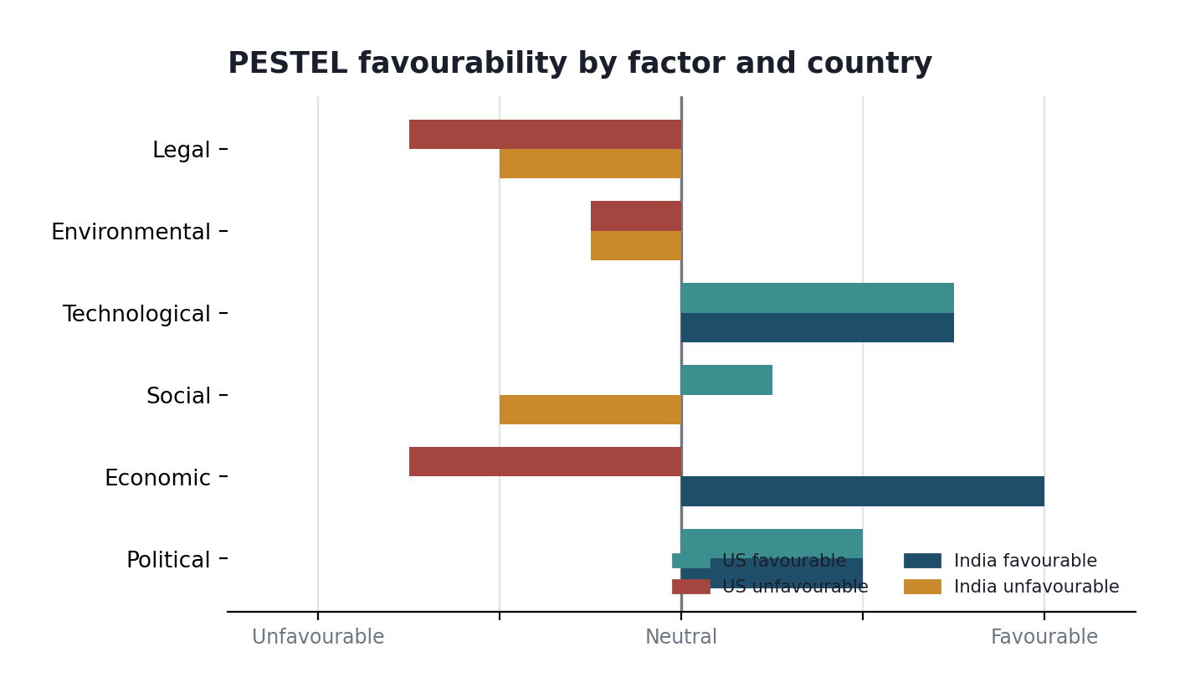
Figure 4a: PESTEL favourability by factor and country, showing where each environment helps or hinders Pizza Hut (author's assessment).
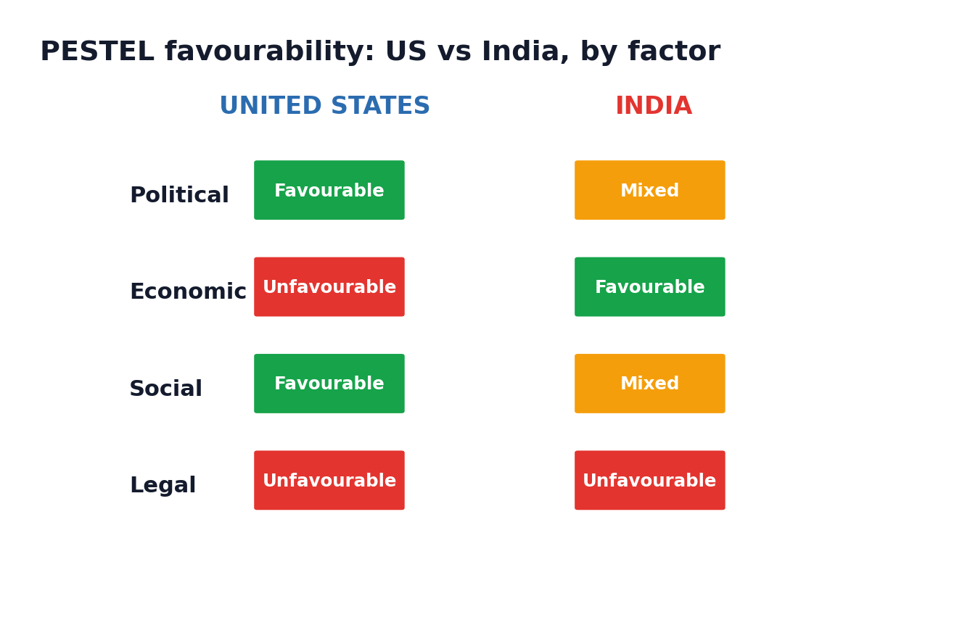
Figure 4b: PESTEL favourability by factor and country (author's construction).

1.3 Comparative Culture: Hofstede's Dimensions
The Hofstede model
Hofstede's (2011) framework turns the vague idea of cultural difference into six measurable dimensions: power distance, individualism, motivation towards success, uncertainty avoidance, long-term orientation and indulgence. Applied to the US and India, it explains why the same brand must speak differently in each market. The dimensions that carry the most marketing weight here are individualism, power distance and long-term orientation.
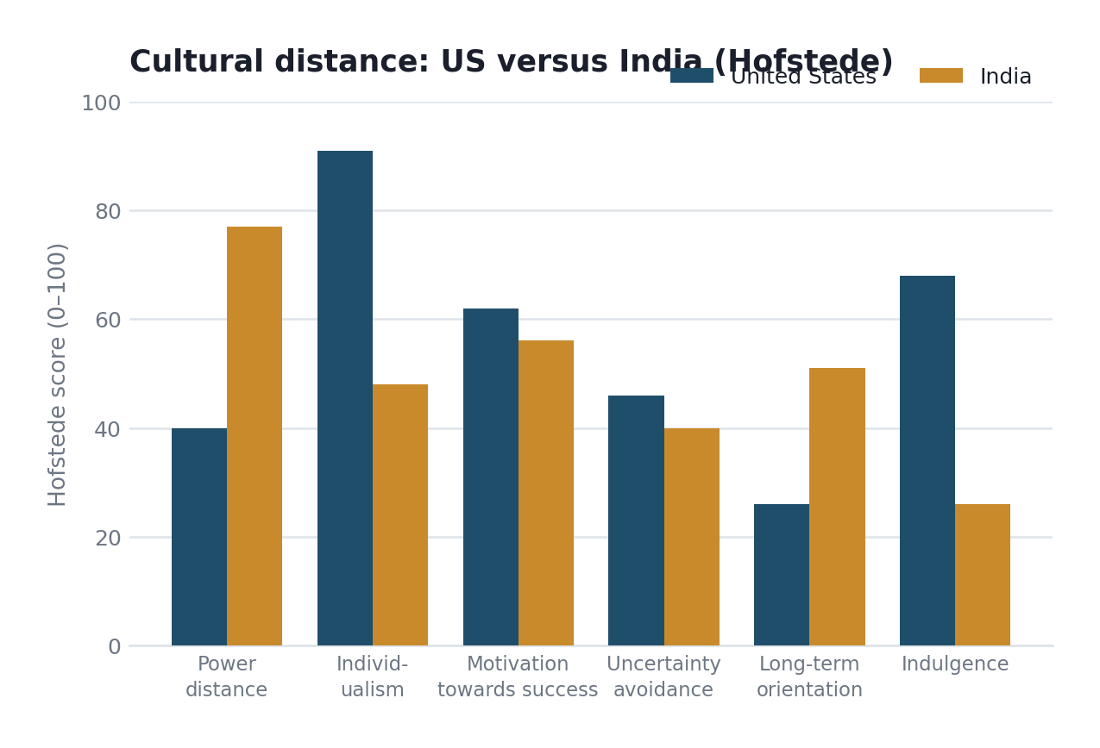
Figure 4: Cultural distance between the US and India on Hofstede's dimensions (Hofstede Insights, 2025).
Individualism exerts the greatest influence on marketing approach. The United States scores approximately 91 on this dimension, while India sits near 48 (Hofstede Insights, 2025). American campaigns can therefore address the individual consumer, through single-serve melts, personal pan pizzas and late-night solo delivery, whereas Indian campaigns must address the group, emphasising the family meal, the shared table and the celebratory occasion.
The remaining dimensions carry less explanatory weight. Uncertainty avoidance is moderate in both countries and accounts for little difference, while motivation towards success is moderately high in both and produces no material divergence. Indulgence is the exception: the US scores highly at approximately 68 against India's 26, consistent with a US market receptive to indulgent, treat-oriented food marketing and an Indian market in which more restrained, value-and-family framing proves more effective (Hofstede Insights, 2025). This explains why the indulgence-led promotion that is standard in the US would be less well received in India, a point that connects directly to the later ethical discussion.
Power distance and long-term orientation shape tone and positioning. India's high power distance (around 77 versus the US at 40) supports aspirational, status-aware positioning, part of why Pizza Hut could enter India as a premium dine-in experience rather than a cheap convenience option (Hofstede Insights, 2025). India's higher long-term orientation rewards brands that build patient relationships and value, while the lower US score rewards immediacy and novelty. As a first-order guide to why the same brand must speak differently in the two markets, the framework is genuinely useful.
Similarities, differences and overall favourability
Culturally, the two markets are similar only in that both are motivated, achievement-oriented societies where a branded meal can carry aspirational value. They differ sharply on individualism and power distance, and these differences are unfavourable to a standardised approach but favourable to a brand willing to adapt. For the US, the individualist, lower-power-distance culture favours Pizza Hut's convenience-led, single-serve model. For India, the collectivist, high-power-distance culture is favourable to an aspirational, family-oriented dine-in positioning but unfavourable to individualist Western messaging transferred unchanged. Overall, culture is a favourable factor for a brand that localises and an unfavourable one for a brand that does not.
Advantages and disadvantages of the Hofstede model
The framework's advantage is that it makes an abstract concept comparable and actionable, giving a structured, evidence-based basis for adapting marketing across borders. Its disadvantages are equally real: the scores are national averages that mask large regional, generational and urban-rural variation, which matters greatly in a country as diverse as India; the data is now dated; and the model can encourage stereotyping if applied too rigidly. It is therefore used here as a first-order guide to why adaptation is necessary, not as a precise predictor of consumer behaviour.

1.4 Comparative STP: Segmentation, Targeting and Positioning
This is where the abstract differences become concrete choices. Pizza Hut segments the markets differently.
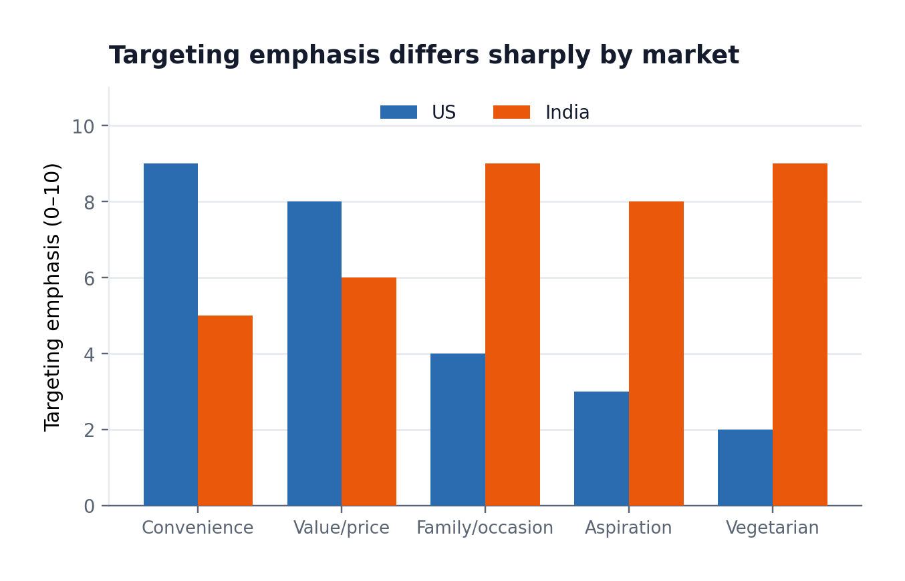
Figure 5: Targeting emphasis by market (author's assessment from company and industry sources).
Segmentation bases in detail
Segmentation is best read across the four standard bases. Demographically, the US target is busy working adults and families, median age around 39, whereas India is younger, median near 28, centred on aspirational middle-class families and students (Restaurant India, 2026). Geographically, the US spreads across roughly 6,300 suburban and roadside outlets, while India concentrates in metros and Tier-1 cities and pushes into Tier-2 and Tier-3 towns where fast-food spending rose 108% in two years (Devyani International, 2023).
Psychographically, US customers are convenience- and value-driven, treating pizza as an unremarkable weekday buy, while Indian customers are experience- and status-driven, valuing the sit-down occasion and the Western-brand pull. Behaviourally, US demand is high-frequency, delivery-led and promotion-sensitive, with people switching for a better deal; Indian demand is lower-frequency but occasion-led, tied to family celebrations and split hard by the vegetarian/non-vegetarian line. An identical segmentation model would misread India, where dietary identity and social occasion outrank the price and behavioural variables that dominate the US.
Targeting strategy: undifferentiated versus differentiated
On Kotler and Keller's (2016) spectrum, Pizza Hut uses a broadly differentiated approach in both countries but to different degrees. In the US it leans close to undifferentiated mass marketing, offering largely the same menu and value message to the whole pizza-buying public. In India it is more differentiated, tailoring product, price and messaging to an aspirational middle-class family segment while ceding the budget end to local players. The contrast reflects market maturity: a saturated US market rewards broad reach, whereas a developing Indian market rewards focus on the segment most able to pay a premium.
Positioning and the perceptual map
Positioning can be mapped against the two dimensions that matter most in the US pizza market: price and delivery-versus-dine-in orientation. Figure 5a plots the main players. Domino's occupies the commanding position, higher-priced yet strongly delivery-led and clearly differentiated, while Pizza Hut sits awkwardly near the centre, neither the cheapest nor the most convenient, carrying a lingering dine-in association the market has moved away from. The dashed arrow shows the gap Pizza Hut must close: it needs to move decisively towards the delivery-and-value quadrant Domino's owns rather than remaining in an undifferentiated middle. The map makes concrete the report's central argument that Pizza Hut's difficulty is blurred positioning and hesitant commitment.
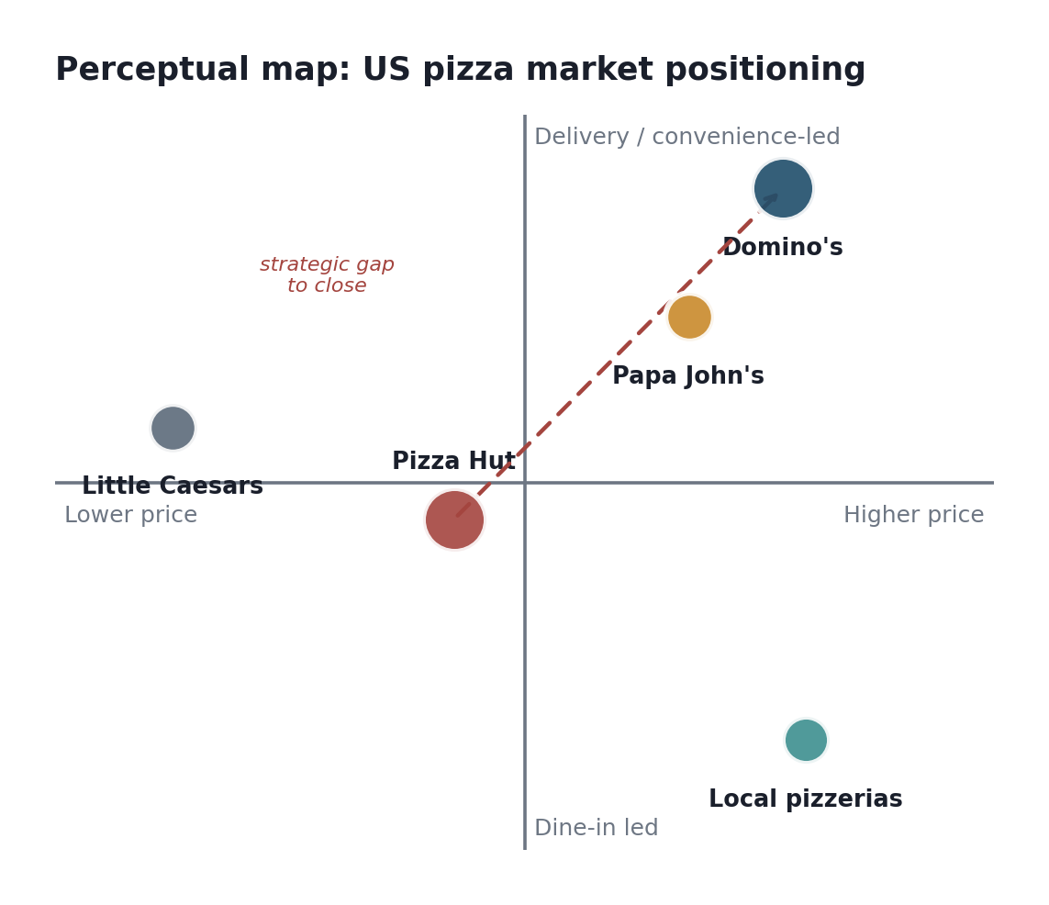
Figure 5a: Perceptual map of the US pizza market, showing Pizza Hut's positioning gap against Domino's (author's construction).
STP similarities and differences
Across the two markets, the STP approaches share one similarity: in both, Pizza Hut targets the branded, mid-market pizza occasion rather than the budget or ultra-premium extremes. Beyond that they differ at every stage. Segmentation shifts from age-and-convenience bases in the US to income, occasion and dietary bases in India. Targeting shifts from a broadly undifferentiated, mass-market approach in the US to a more differentiated, aspirational focus in India. Positioning shifts from convenient everyday value in the US to an aspirational, experience-led Western brand in India. The single thread holding them together is the mid-market pizza brand identity; almost everything else is adapted.

1.5 Comparative Marketing Mix: The 7Ps
The seven-element services marketing mix (Booms and Bitner, 1981) shows how much a single brand must bend to fit two markets. Figure 6 summarises the degree of local adaptation across the seven elements: India requires far more adaptation than the US, which is close to the brand's default. Table 2 sets out the detail; the paragraphs below draw out the elements where the contrast is most instructive.
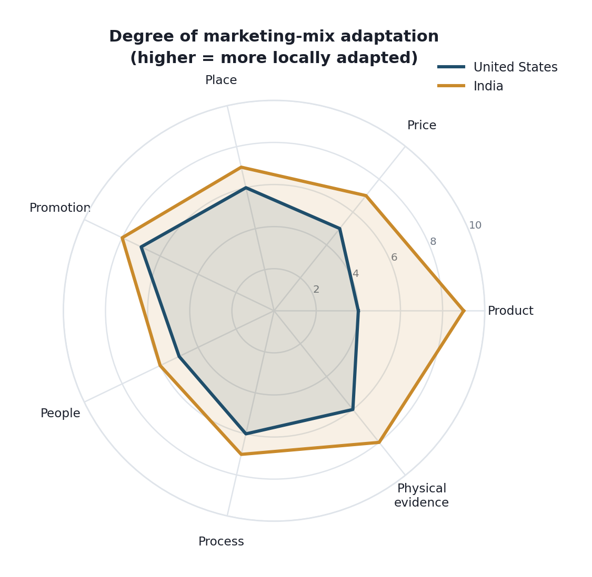
Figure 6: Degree of marketing-mix adaptation by market (author's assessment; higher = more locally adapted).
Element | United States | India
Product | Standard meat-heavy menu; pepperoni, stuffed crust, melts, wings. Minimal adaptation. | Heavily adapted: ~50%+ vegetarian menu, paneer and tandoori toppings, no beef/pork, spicier flavours, smaller portions. Maximum adaptation.
Price | Mid-market; promotion-led value deals to match Domino's. | Positioned above Domino's; premium dine-in pricing but value combos for young segment.
Place | ~6,300 outlets, delivery/carry-out led; ageing dine-in estate. | ~630+ outlets via Devyani and Sapphire; dine-in and mall focus, growing delivery via Zomato/Swiggy.
Promotion | Price-led national advertising, app deals, sports tie-ins. | Festival and family-occasion campaigns; vegetarian-forward messaging; cricket and Bollywood tie-ins.
People | Efficiency-focused service; high staff turnover. | Hospitality-led dine-in service fits high power-distance, family-occasion culture.
Process | Delivery-speed and digital-ordering focus, playing catch-up to Domino's. | Dine-in service process plus aggregator delivery; slower delivery execution than Domino's.
Physical evidence | Increasingly delivery-box branding; many dated dine-in interiors. | Fuller-service restaurant ambience; the red-roof dine-in experience as differentiator.

Product
Product is the element that adapts most, and it is dictated almost entirely by the cultural factors identified earlier. In India, over half the menu is vegetarian, beef and pork are absent, paneer and tandoori-spiced toppings feature prominently, and flavours are adjusted to local palates (Restaurant India, 2026). In the US the product is close to the global default. This is a textbook illustration of the adaptation-versus-standardisation debate: Pizza Hut standardises where it can, in the US, and localises heavily where it must, in India, which is exactly the transnational balance the theory recommends but which is expensive to sustain.
Product can also be read through depth and width. Product depth, the variety within a line, is greater in India, whose pizza range carries far more vegetarian and regionally spiced variants than the US line. Product width, the number of distinct lines, is broad in both markets, extending well beyond pizza through brand extension into sides, pasta, desserts and beverages. A clear brand-extension example is the localised paneer and tandoori range in India and the melts and Detroit-style lines in the US, each stretching the core brand into new product territory to capture more occasions.
Price
Pricing strategy diverges sharply between the two countries, driven by the economic and competitive contrasts. In the US, a mature, saturated market, Pizza Hut competes on value pricing and heavy promotional discounting, using bundles and coupons to defend share against Domino's, which compresses margins. In India, Pizza Hut uses a more premium, aspirational pricing approach for its dine-in experience, positioned above local quick-service options, while also deploying value entry points and combo meals to widen access in a price-sensitive market. The result is a psychological and value-based pricing mix in the US against a more premium-skewed, occasion-based pricing model in India, though intense competition from Domino's forces frequent discounting in both.
Place and distribution channels
Distribution follows the same direct-and-indirect pattern in both countries, but the balance differs. Figure 6a sets out the two routes. The direct channel runs from Pizza Hut's kitchens through company-owned outlets and its own app, giving control but limited reach. The indirect channel, dominant in both markets, runs through franchisees and third-party aggregators. In the US, delivery is app-led and speed-focused, still chasing Domino's tracking system; in India, dine-in is combined with aggregator delivery through Swiggy and Zomato, reflecting a market where the sit-down occasion retains value.
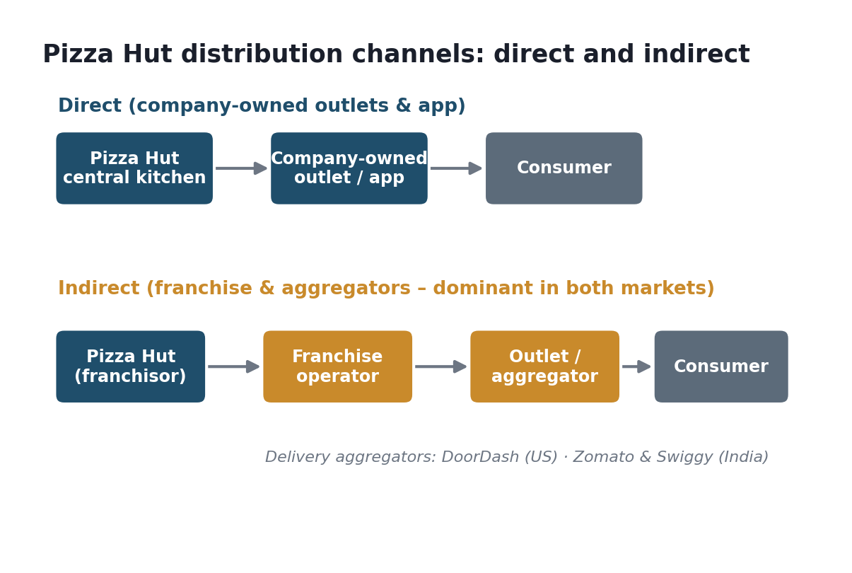
Figure 6a: Pizza Hut's direct and indirect distribution channels in both markets (author's construction).
Promotion and integrated marketing communications
Promotion is best understood through integrated marketing communications (IMC), the coordination of advertising, sales promotion, digital and in-store messaging into one brand voice (Kotler and Keller, 2016). Pizza Hut applies IMC differently in each market. In the US, the mix is dominated by price-led national advertising, app coupons, value bundles and sports sponsorships, built for habitual, deal-driven buyers. In India, the same tools are aimed at occasion and identity: festival and family campaigns, vegetarian-forward messaging, and cricket and entertainment tie-ins that carry a weight the US versions lack.
People
People matter disproportionately in food service because staff deliver the experience directly. Pizza Hut and its franchisees employ well over 300,000 people globally, with both the US and Indian estates staffed largely through franchise operators. In the US, high staff turnover and a delivery-and-carry-out focus mean training centres on speed and consistency. In India, the dine-in model makes attentive, hospitality-led service central, suiting the high-power-distance, family-occasion culture. The people element is therefore adapted from an efficiency focus in the US to a service-and-hospitality focus in India (Devyani International, 2026).
Process
Process covers how the service is delivered and how problems are fixed. Core steps (ordering, production, delivery, complaint handling) are increasingly digital in both markets. Customers complain through social media (public posts on X and Instagram create pressure), website and app forms, email or phone. US process is delivery-speed focused and app-driven, still chasing Domino's order-tracking system. India mixes dine-in service with aggregator delivery. Slower execution than Domino's has been a steady weakness. Efficient complaint recovery is a genuine differentiator. Handle a complaint well and you often keep the customer who was ready to leave.
Physical evidence
Physical evidence is the tangible signal: outlet interior, packaging, staff uniform and digital storefront. The traditional red-roof dine-in restaurant still works strongly in India, where the sit-down experience is part of the value, but in the US it has become a liability, with many interiors looking dated against a market that shifted to delivery. Staff uniforms keep the red-and-black identity in both markets, while the website and app now act as the main digital evidence, since customers judge the brand there before they buy.
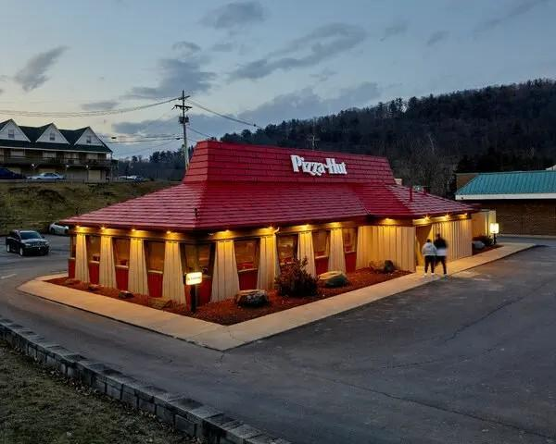  United States: red-roof dine-in outlet | 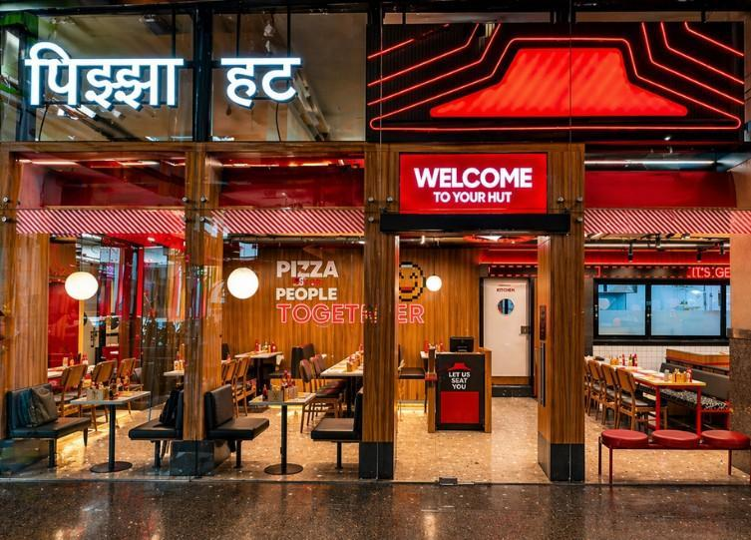  India: modern dine-in restaurant
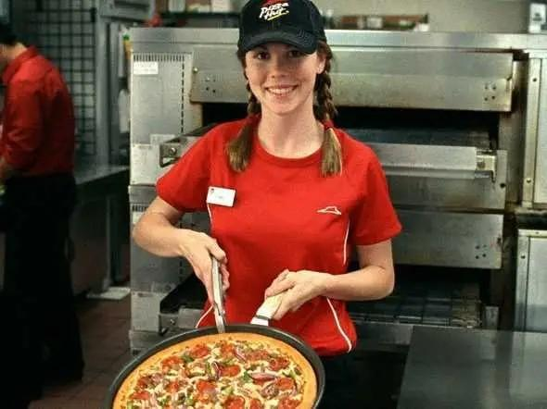
Staff uniform: red and black brand identity
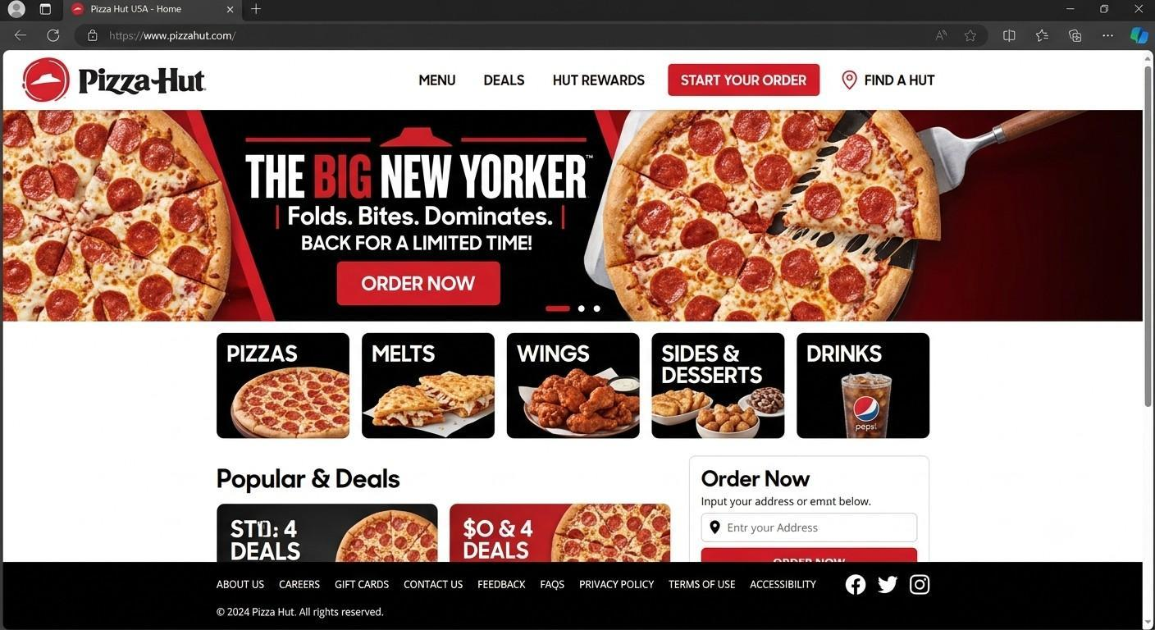  US website: delivery-first, deal-led | 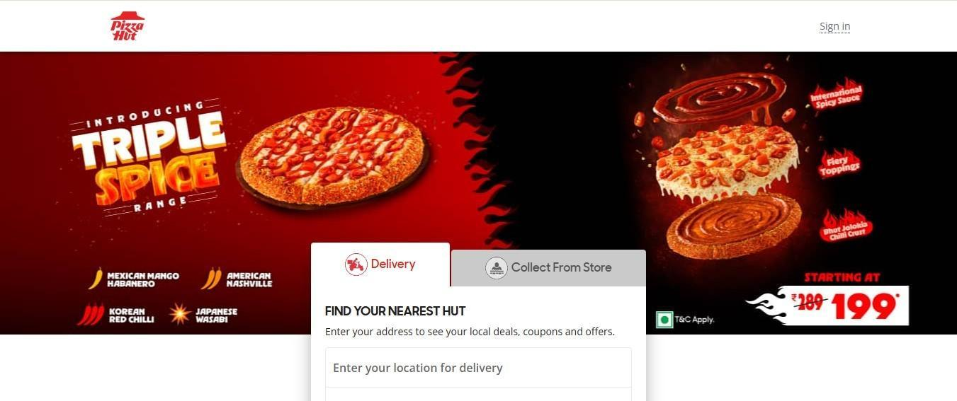  India website: veg/non-veg, family focus
Figure 6b: Comparative physical evidence, US and India (insert brand images from Pizza Hut's US and Indian websites, cited appropriately).

1.6 Market Entry Strategy: India
Pizza Hut's first Indian outlet opened in Bangalore in 1996, and the entry route was franchising, the model Yum! Brands uses in most markets. Yum! did not operate directly but worked through master-franchise arrangements and later large regional partners. Today, two listed operators, Devyani International and Sapphire Foods, run almost all of Pizza Hut India between them (Restaurant India, 2026). The approach was low-capital and locally embedded, with franchisees supplying the real estate, supply chain and cultural knowledge a foreign firm could not easily acquire, consistent with the internalisation logic Dunning (2000) set out for culturally distant markets.
The franchise mode was the correct structural choice, yet it carries a cost the figures expose. The same franchisees also operate KFC and other brands, and Pizza Hut has often sat lower in their priorities, so the strategic drift from dine-in to delivery partly reflects this divided attention (Devyani International, 2026). In January 2026, Devyani and Sapphire agreed a US$934m merger, creating a combined operator of more than 3,000 Yum outlets, which analysts expect to bring the scale and sharper decision-making the brand needs (MarketScreener, 2026). The entry mode was sound; the challenge has been the consistency of execution within it.
Advantages and disadvantages of franchising
Franchising, the mode used for Pizza Hut in India, has clear advantages that made it right for a culturally distant market: it needs low parent capital, transfers local knowledge, real estate and cultural adaptation to franchisees who understand the market, and allows rapid, lower-risk expansion, which is why Yum! used it to enter India. Its disadvantages are visible in Pizza Hut India today: the parent loses direct control over execution and consistency, franchisees running multiple brands may under-prioritise Pizza Hut, and profits are shared. The divided attention of operators running KFC alongside Pizza Hut is a textbook example of the control cost franchising carries.
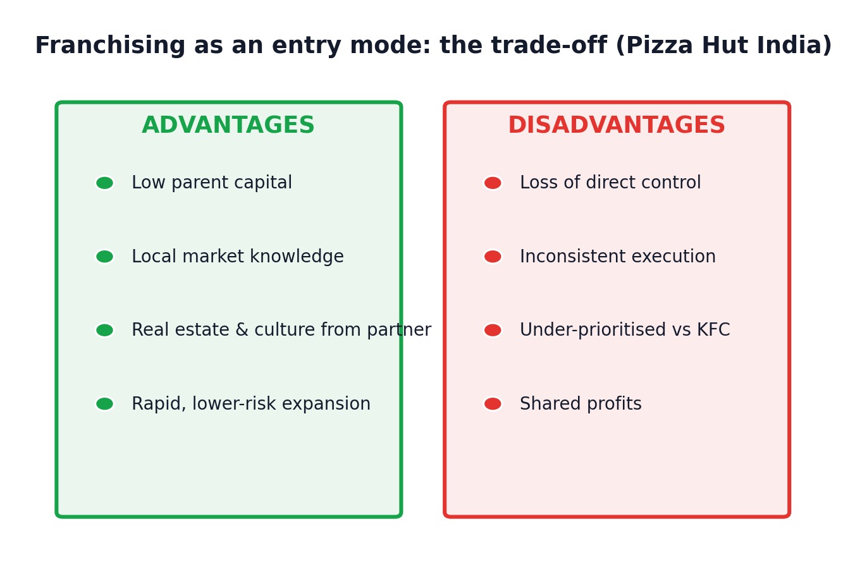
Figure 7a: Advantages and disadvantages of franchising as an entry mode (author's construction).
Theoretical framing clarifies this logic. On the standardisation-adaptation spectrum, franchising allowed Yum! to hold its brand system and core standards constant while delegating culturally sensitive decisions, including menu, service style and real estate, to partners with local knowledge. This represents the pragmatic middle path recommended for a culturally distant, high-uncertainty setting. Direct entry in 1996 would have been imprudent, whereas franchising was not. Nonetheless, a sound structure does not guarantee sound execution when a partner's attention is divided across several brands.
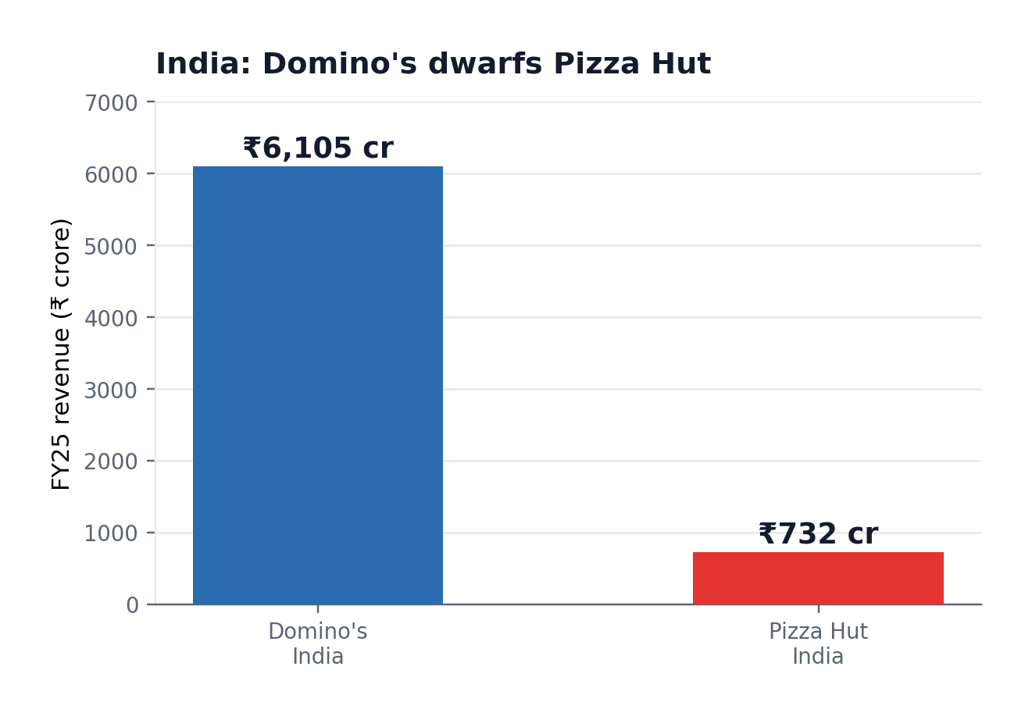
Figure 7: India pizza revenue, Domino's versus Pizza Hut, FY25 (Storyboard18, 2025).
The execution gap is substantial. In FY25, Domino's India generated approximately ₹6,105 crore in revenue against Pizza Hut's ₹732 crore, while daily sales per store stood at around ₹81,748 for Domino's compared with ₹34,000 for Pizza Hut (Storyboard18, 2025). Pizza Hut's brand-contribution margin collapsed from 7.2% to 2.7% within a single year (Storyboard18, 2025). The entry strategy succeeded in establishing the brand in a difficult market, which is a genuine achievement, but what followed lacked the operational intensity required to match a franchisee that had made delivery and value its sole focus.
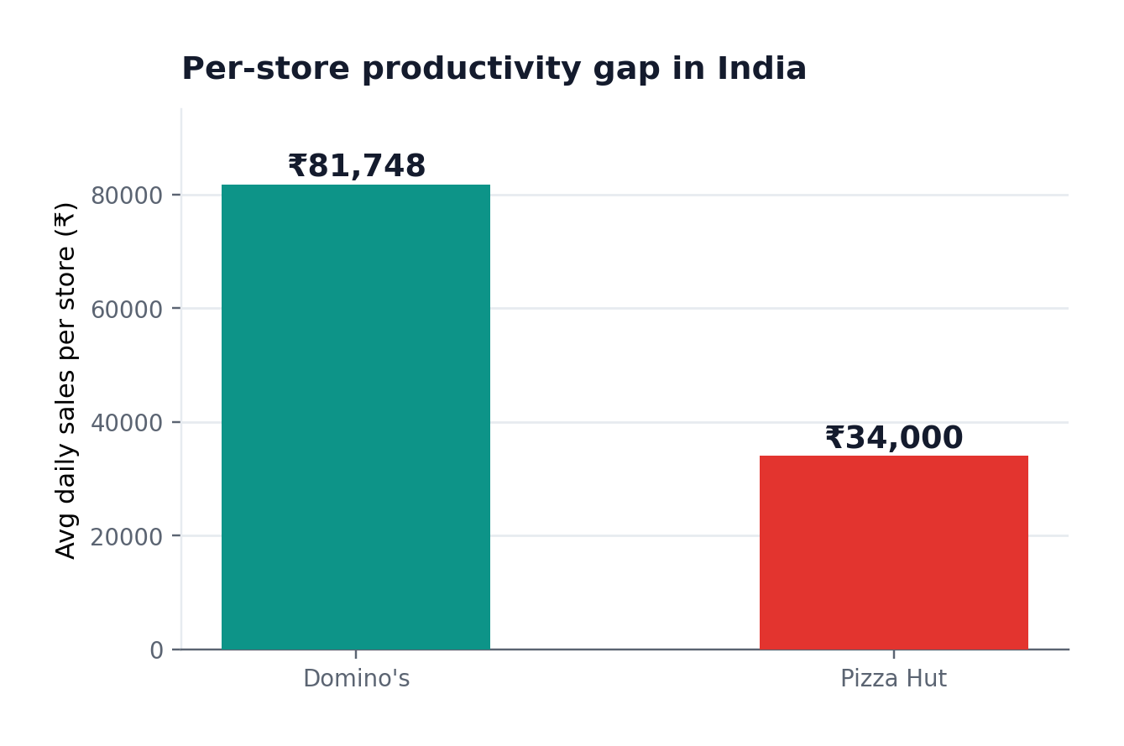
Figure 8: India average daily sales per store, Domino's versus Pizza Hut (Storyboard18, 2025).

1.7 Ethical Evaluation: HFSS Marketing in the United States
The clearest ethical issue concerns the promotion of high-fat, salt and sugar (HFSS) food, and it is most pronounced in the United States. The US strategy relies on indulgence: stuffed-crust pizzas, melts and calorie-dense sides, promoted through value bundles that encourage larger orders and advertising around sporting and family occasions with a reach that includes younger audiences. A single meal can exceed a thousand calories. As Figure 9 illustrates, the value-bundle mechanic that supports price competition also encourages customers towards larger, higher-calorie orders (Restaurant Dive, 2026).
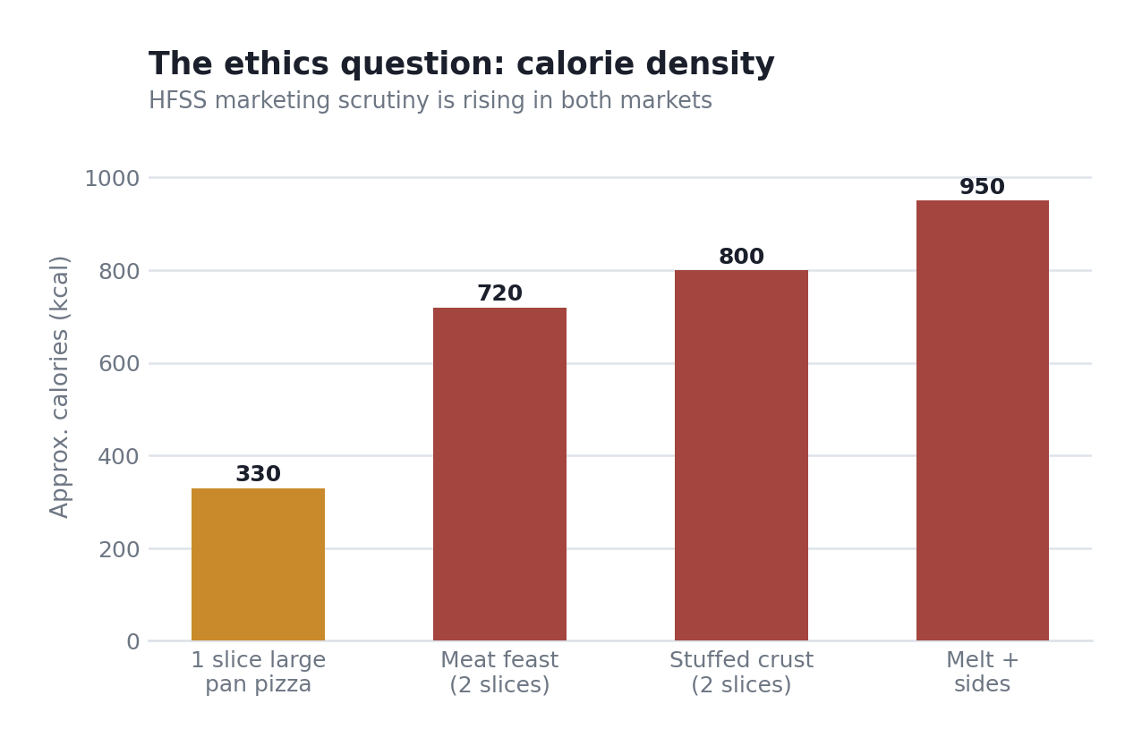
Figure 9: Calorie density and the HFSS ethics question (illustrative, from published nutritional data).
Whether this constitutes a genuine ethical breach is a legitimate and unresolved question. On one interpretation, the product is legal and sold to adults who choose for themselves, calorie information is available, and value promotions are standard competitive tools. On the other, the combination of calorie-dense products, price mechanics that reward over-ordering, and advertising that reaches younger groups generates real public-health costs, which is why many jurisdictions are tightening HFSS regulation. The strongest criticism is not that pizza itself is objectionable, but that this specific value-bundle-and-broad-reach model externalises a health cost onto society while the firm retains the profit.
A recognised ethical lens sharpens this. From a utilitarian standpoint the calculus is mixed: the marketing delivers pleasure and affordable calories to millions, but the aggregate public-health cost of promoting energy-dense food at scale falls on society rather than the firm. From a deontological standpoint, as long as information is truthful and choice genuine, marketing a legal product is defensible, though value-bundle mechanics that nudge larger orders sit uneasily with treating the customer as a fully rational chooser. Neither lens gives a clean verdict, which is the honest finding: the practice is not straightforwardly wrong, but it is ethically exposed as regulation shifts against it.
The comparison with India sharpens the point. Indian portions are smaller and the menu lighter on the heaviest US items, partly for cost and cultural reasons, but the effect is a marketing mix incidentally less exposed to the HFSS critique. The ethical issue is therefore not inherent to Pizza Hut but a feature of how it markets in the US specifically, a more precise conclusion than a blanket judgement.
Ethical and unethical practices compared
Balancing the picture means recognising that Pizza Hut's marketing mix contains genuinely ethical elements as well as questionable ones. Two practices stand out as ethical. First, its mandatory and prominent vegetarian and non-vegetarian labelling in India goes beyond a legal tick-box to respect deeply held religious and cultural dietary rules, giving customers honest, clear information on which to choose. Second, its provision of full calorie and allergen information in the US, in line with disclosure rules, supports informed choice and treats the customer as a capable decision-maker.
Two practices are more ethically exposed. The first is the HFSS value-bundle model, where price mechanics that reward larger, calorie-dense orders externalise a public-health cost while privatising the profit. The second is heavy advertising with reach into younger audiences, through sports tie-ins in the US and cricket and entertainment tie-ins in India, which sits uncomfortably with growing concern about marketing energy-dense food to children. Weighing these together, Pizza Hut is neither model citizen nor bad actor: its marketing is largely honest and informative, but its reliance on volume-maximising promotion of indulgent food is most exposed as regulation tightens.

1.8 Recommendations
Pizza Hut has been beaten in both markets by a rival that committed fully to delivery and value while it hesitated between dine-in and delivery, so the remedies centre on commitment and consistency rather than further adaptation. Figure 10 orders the shared priorities by impact against effort; the country-specific recommendations then follow.
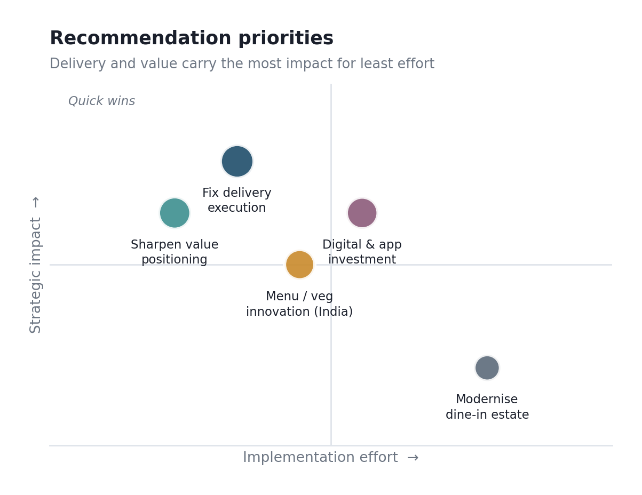
Figure 10: Recommendation priority matrix (author's assessment).
The overarching recommendation is uncomfortable but clear. Pizza Hut's international marketing has been competent at adaptation, the Indian menu is a genuine success of localisation, but weak at commitment. It has localised its product well and its strategy poorly. Going forward, the priority is not further clever adaptation but the discipline to choose a position in each market and execute it consistently, which is precisely the thing its more focused rivals have done and it has not.
Recommendations for the United States
In its home market Pizza Hut should stop straddling dine-in and delivery and commit decisively to the delivery-and-value position Domino's owns, since the perceptual map shows it cannot win from the undifferentiated middle. Concretely, it should invest in app and order-tracking technology to match Domino's digital benchmark, modernise or rationalise the dated dine-in estate rather than sustain it half-heartedly, and sharpen a clear value message instead of competing on scattered promotions. Under new private-equity ownership, disciplined, profitable smaller-scale operation may serve it better than chasing lost share in a structurally declining category.
Recommendations for India
In India the priority is different: protect and exploit the genuine points of difference that Domino's does not match, namely the premium family dine-in experience and the deep vegetarian menu. The coming Devyani-Sapphire merger should be used to invest behind these strengths and to fix the delivery-execution gap through better use of Zomato and Swiggy, rather than to cut costs indiscriminately. Sharper differentiated targeting of vegetarian, family and value-student segments, combined with faster delivery, would let Pizza Hut compete on its own terms rather than on Domino's.

Section 2: Reflective Account
This reflection uses Gibbs' (1988) six-stage cycle: description, feelings, evaluation, analysis, conclusion and action plan.

Description
I chose Pizza Hut in the United States and India because I wanted two markets that contrast on almost every dimension, and because Pizza Hut proved unusually topical: its parent agreed to sell it while I was researching. The work ran in three passes: first the parent's financial disclosures and news coverage, then the macro, cultural and competitor data for each country separately, and only then the frameworks, PESTEL, Hofstede, STP and the 7Ps, followed by entry, ethics and recommendations. Most reading I did in short bursts on weekday mornings before work, when I concentrate best, and I saved the framework writing for two longer stretches on consecutive Sundays at the university library.
On method, I worked from primary and reputable secondary sources outward rather than from opinion pieces inward. Yum! Brands' financial releases and Indian listed-operator disclosures gave the hard numbers, and I used industry and news reporting for the market context, cross-checking figures where sources disagreed. The company filings I reached through the SEC EDGAR database and the Indian operators’ investor pages directly, while Statista and the library’s Business Source database supplied the market-sizing figures I could not get first-hand.

Feelings
The moment that genuinely surprised me was discovering that Pizza Hut is losing in both markets, not just one. I had assumed a simple home-versus-host contrast, but finding it declining in the saturated US and shrinking in the growing Indian market forced me to rethink the framing: the problem was not the environment, since the environments are opposites, but the company itself. That realisation was uncomfortable, because it meant abandoning my neat comparison, but it sharpened the report. The second jolt was more literal: the parent company agreed to sell Pizza Hut for US$2.7 billion while I was writing about it, which made the exercise feel less like a textbook case and more like a moving target.

Evaluation
What went well was letting the data reshape the argument rather than forcing it to fit a template. My first plan was a straightforward compare-and-contrast, but the finding that Pizza Hut struggles in both markets gave me a genuine thesis, that the failure is executional rather than environmental, and the report improved once I organised it around that. What went less well was balancing breadth and depth across a demanding brief. My specific weakness showed in the sale news: I initially trusted a widely repeated revenue figure as fact, only to find on tracing it to the filing that it had been rounded and misreported across several outlets. I am too quick to trust a number that appears in several places at once.

Analysis
Two things from the module shaped how I worked. The first was the standardisation-versus-adaptation debate, the analytical spine of the report: seeing Pizza Hut's Indian menu as a textbook adaptation success while its strategy was an execution failure let me separate adapting a product well from competing well. The second was Hofstede, which did not fit as cleanly as the textbook implies. India's collectivism actually suits Pizza Hut's dine-in heritage better than US individualism does, the opposite of the simple story that Western brands must always localise, and that inversion was the most interesting thing I found. Reading Hofstede's own 2011 paper rather than the textbook summary made me more cautious about over-reading small score differences.
The assumption I had to abandon was that a strong home market position travels. I began assuming Pizza Hut's American scale would make it dominant wherever it went. The Indian data, where a much smaller, more focused Domino's operation outsells it many times over, forced me to see that scale and heritage count for little without consistent local execution. That changed my recommendations from clever-adaptation suggestions to a blunter argument about commitment and consistency.

Conclusion
The skill I improved most was building an argument from conflicting evidence rather than describing frameworks. Early drafts applied each framework dutifully and read like a checklist; the report only became good when I used the frameworks to support a single thesis. The weakness I still have to be honest about is that I read dense financial and market material slowly, which ate the time I should have spent polishing the later sections.
The comparison also changed how I think about the standardisation-adaptation debate itself. I had assumed adaptation is broadly good and standardisation broadly lazy. Pizza Hut complicated that: it adapted its Indian product beautifully and still lost, because its real problem in both markets was inconsistent execution that no amount of localisation would fix. The more useful question is not how much a firm adapts but whether it commits to a coherent strategy and delivers it.

Action Plan
Next time I would decide my central argument earlier rather than letting it emerge late, since the executional-versus-environmental thesis only crystallised after most of the research was done. I would also budget time per section against the marks each carries, so a multi-part brief does not leave the final sections rushed. As a concrete step, I will practise skim-reading three company annual reports before the next assignment, timing myself and noting only what answers a specific question, so dense financial documents stop being the bottleneck they were here.

References
Booms, B.H. and Bitner, M.J. (1981) 'Marketing strategies and organization structures for service firms', in Donnelly, J.H. and George, W.R. (eds.) Marketing of services. Chicago: American Marketing Association, pp. 47–51.
Devyani International (2023) Annual report FY23. Available at: https://girishnotes.substack.com/p/devyani-international-fy23-ar-notes (Accessed: 30 July 2026).
Devyani International (2026) 'Pizza Hut under pressure'. Available at: https://www.cbinsights.com/company/devyani-international (Accessed: 30 July 2026).
Dunning, J.H. (2000) 'The eclectic paradigm as an envelope for economic and business theories of MNE activity', International Business Review, 9(2), pp. 163–190.
Gibbs, G. (1988) Learning by doing: a guide to teaching and learning methods. Oxford: Further Education Unit, Oxford Polytechnic.
Hofstede, G. (2011) 'Dimensionalizing cultures: the Hofstede model in context', Online Readings in Psychology and Culture, 2(1).
Hofstede Insights (2025) Country comparison tool: United States and India. Available at: https://www.hofstede-insights.com/country-comparison (Accessed: 30 July 2026).
Kotler, P. and Keller, K.L. (2016) Marketing management. 15th edn. Harlow: Pearson.
MarketScreener (2026) 'Indian KFC, Pizza Hut operator Devyani rises on $934 million Sapphire merger'. Available at: https://uk.marketscreener.com/news/indian-kfc-pizza-hut-operator-devyani-rises-on-934-million-sapphire-merger-ce7e59d9d88ef027 (Accessed: 30 July 2026).
NACS (2025) 'Yum Brands explores sale of Pizza Hut'. Available at: https://www.convenience.org/Media/Daily/2025/November/5/3-Yum-Brands-Explores-Sale-of-Pizza-Hut_Finance (Accessed: 30 July 2026).
Restaurant Business (2026) 'What does a Pizza Hut-less Yum Brands look like?'. Available at: https://www.restaurantbusinessonline.com/financing/what-does-pizza-hut-less-yum-brands-look (Accessed: 30 July 2026).
Restaurant Dive (2026) 'Yum Brands sells Pizza Hut for $2.7B'. Available at: https://www.restaurantdive.com/news/yum-brands-sells-pizza-hut-27-billion/807829/ (Accessed: 30 July 2026).
Restaurant India (2026) '10 popular pizza chains in India by sales and locations'. Available at: https://www.restaurantindia.in/article/10-popular-pizza-chains-in-india-by-sales-locations.12998 (Accessed: 30 July 2026).
Storyboard18 (2025) "Domino's, Pizza Hut add hundreds of stores in FY25 as India pizza market heats up". Available at: https://www.storyboard18.com/brand-makers/dominos-pizza-hut-add-hundreds-of-stores-in-fy25-as-india-pizza-market-heats-up-73251.htm (Accessed: 30 July 2026).
Yahoo Finance (2026) 'Pizza Hut needs a bold change'. Available at: https://finance.yahoo.com/news/pizza-hut-needs-a-bold-change-and-a-sale-of-the-business-is-on-the-table-165826882.html (Accessed: 30 July 2026).
Yum! Brands (2026) Form 10-Q, second quarter 2025. Available at: https://www.sec.gov/Archives/edgar/data/1041061/000104106125000057/yum-20250630.htm (Accessed: 30 July 2026).

