BA Illustration Hons - Research in Practice (ADAD5004)
Proposal for Independent Project
Word count: 2,424
Lecturer: Delyth Lloyd-Evans

Proposed Question: In relation to Fairy Tales, how are illustrators able to use their art to convey meanings, stories, and emotions without the use of language?

Three key words: Synecdoche, Metaphor, Fairy Tale

In this proposal, I will be looking at the words synecdoche, metaphor, and Fairy Tale. My aim is to explore these words in detail in order to create a series of wordless illustrations, meaning I will be challenging myself to make the theme of the illustrations clear and readable without the use of any text. I have decided that I will be exploring both modern and traditional interpretations of Fairy Tales to do this and will be creating my own renditions of some of the stories. Through my research, I will be attempting to understand a number of aspects such as: what makes the Fairy Tales so recognisable? How are illustrators able to make the stories their own? And how much of a key role does language play into making a successful illustration? Among other things,In order to inform my own practice.

Synecdoche

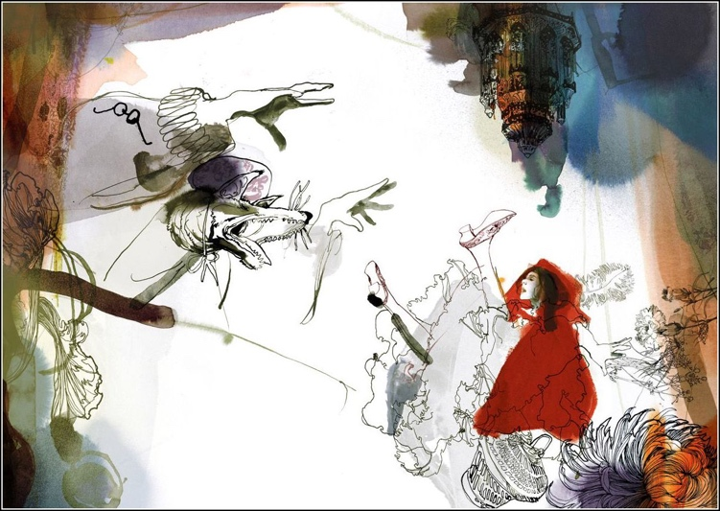
Literarydevices.net describes synecdoche as “a figure of speech in which a part of something is used to signify the whole, or vice-versa. In fact, it’s derived from the Greek word synekdoche: “simultaneous meaning.” (2022) And in the context of story telling and Fairy Tales “synecdoche allows for a smaller component of something to stand in for the larger whole, in a rhetorical manner.” (2022) Synecdoche is often used in Fairy Tales as a way to make characters both recognisable and iconic in both old and new iterations of the stories, for example, Red Riding Hood is always called as such, or always has the word ‘Red’ somewhere in her name, which is always paired with the iconic red colour somewhere in her design. This gives illustrators and authors complete freedom to change the stories, settings, and characters of the tale as much as they’d like while still having it be recognisable. A good example of this is Daniel Egnéus’s interpretation of Red Riding Hood, in which he completely reimagines the traditional tale with his own beautiful illustrations. In his retelling of the story, Red is shown with both a red cloak and a red dress, however because of the name given to the story and the iconic symbolism of the colours used, we are never unsure of who the main character is or what story we are reading.

Fig.1 Illustration from Daniel Egnéus’s Little Red Riding Hood

Synecdoche is also used in turn with metaphors to create compelling narratives centred heavily around symbolism. For instance, if we were to look outside of Fairy Tales and into the world of Greek Mythology, we would see that – particularly in Victorian times – the tale of Medusa become one that was consistently used as a symbol of conflict between men and women, and was even used by Freud in 1992 as a symbol of masculine castration anxiety, as discussed in his essay "Medusa's Head" ("Das Medusenhaupt"):

To decapitatelo (To castrate.) The terror of Medusa is thus a terror of castration that is linked to the sight of something. . .it occurs when
a boy... unwilling to believe the threat of castration, catches sight of the female genitals ...surrounded by hair... The hair upon Medusa's head is frequently represented in works of art. . .she becomes
the woman who is unapproachable and repels all sexual desires. (18: 273-74) (Freud,1992)

Medusa’s hair became a symbol for female empowerment and strength, the likes of which had never been seen before, and so was greatly disturbing to Victorians - so much so that she was the inspiration for the character of Madame Thérèse Defarge from Charles Dickens’s book A Tale Of Two Cities. Dickens seemed to be particularly disturbed by the aspect of equal rights for women, as shown in Michael Slater’s work Dickens and Women (1983), in which Dickens was quoted as saying:

“The rights of women to sit in Parliament represented the height of perverse female aspirations to participate in public life which were inevitably destructive to... the natural duties of their sex and a total overthrow of everything in them which was winning and lovable. A male female," he added, "is repulsive" (Slater 316).

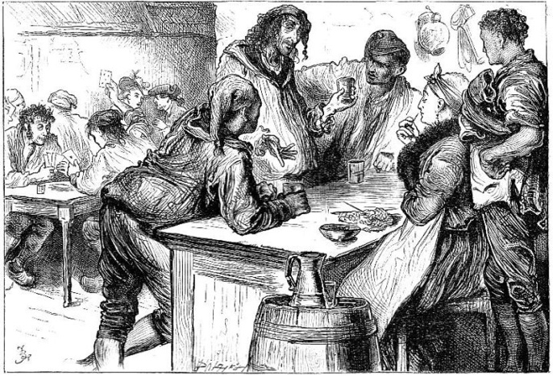

Fig.2 Madame Thérèse Defarge as shown in Charles Dickens’ A Tale Of Two Cities

Through these works and examples it is clear to see that synecdoche is a powerful tool for story telling, Fairy Tales and Illustration in general. In my own practice, I hope to use metaphor and synecdoche together to create a powerful piece of work. Although I am not completely sure what I would like the specific focus of my work to be, I know for sure that I would like to reimagine a fairy tale using research to inform what kind of underlying messages my illustrations will have. I hope that I can create something impactful while being beautiful at the same time, which will strike viewers and make them reconsider classic Fairy Tales in a way they never have before.

Metaphor

Fairy Tales and metaphor go hand in hand. Fairy tales have always been believed to be ways in which to teach children difficult topics in an easily digestible, friendly and safe way. Although it is true that Fairy Tales are deceptive, and at first might seem like nothing more than simple stories told to children, many of them are thought to have deeper meanings and lessons behind them when analysed in depth. For example, psychologist Jonathan Young believes that the Wizard Of Oz represents “compassion, courage, wisdom and a sense of home” (Suval, 2018). He also believes that the villains in the story such as the Wicked Witch or the flying monkeys are representative of our innermost fears, and that Fairy Tales that have scenes with forests represent dark, all-consuming places.
In his article, Young also mentions Fairy Tales such as Alice In Wonderland and The Princess And The Frog, stating that the first story represents the importance of creativity and fantasy, while the latter suggests the idea that most present-day relationships are based around disputes and disagreements. (Suval, 2018)

Like The Princess And The Frog, It seems that many of the classic Fairy Tales featuring Princesses contain many more darker themes and lessons than one would first expect from a children’s story. Elizabeth Danish believes that Fairy Tales which convey the idea of a ‘Hero’s Journey’, such as Sleeping Beauty or Snow White, are very encouraging for boys as it teaches them that they should grow to lead exciting, adventurous lives filled with countless rewards and new friendships. On the other hand, girls are taught that they should be nothing more than rewards for men, and only teaches them the traditional values of being protected by their parents until a man comes to ‘rescue’ them. This idea is reinforced by the fact that the dragons guarding the princesses in all of these stories are thought to represent protective parents who, back in the day, would make their daughters stay at home until a man who they deemed suitable enough to be her husband came along.

Danish theorises that although today women are far more empowered and are also expected to have their own independent lives and adventures, there is a chance that children who still read a large amount of fairy tales today could still be affected by the questionable gender roles they portray and, in return, could end up with this negative view for the rest of their lives. (Danish, 2011)
In her article, Danish also mentions that the portrayal of Princesses in general could be damaging for young girls’ self-esteem and mental health. This is because every Princess conforms to society’s expected beauty standards, meaning they are all slim and fit into a western standard of what is conventionally attractive, and although these Princesses are fictional, many young girls may feel like they want to be just like them, and as a result might develop feelings of inferiority when comparing themselves to these characters. Danish also notes that this could be an especially troubling problem for girls who do not fit into society’s standards of beauty, who might then in turn feel like they are not worthy of the Fairy Tale story they dream of due to their appearance. (Danish, 2011)

Although most of the Knights and Princes written about in these stories are also portrayed as very attractive, It is mentioned in the story more as an embellishment to add to the wonder of the world, whereas the Princesses in the stories always catch the hero’s attention and get rescued on the basis of her looks alone, meaning that although there is a possibility that these expectations could affect young boys too, it is far more unlikely as the heroes are still able to accomplish their goals regardless of what they look like. A great example of this is Shrek, in which the beautiful Princess Fiona is able to see through Shrek’s hideous appearance and accept and love him for who he is.
Another point that Danish brings up in the article is that children could develop a warped sense of real life, as Fairy Tales are such a far stretch from reality. She believes that it could cause young men and women to develop unrealistic expectations of finding a Knight or a Princess for their whole lives, only to discover that in reality no one is really like that. Another possible issue is that young boys might also feel unfulfilled with their futures after coming to the realisation that none of life’s daily tasks will ever be as exciting as the dragon-slaying adventures they were promised in their favourite Fairy Tales. Another point Danish makes is that the Fairy Tales that we know and love today are not the original versions of the stories, but are in fact based on tales written by The Brother’s Grimm, which are far more violent and dark. Her concern is that if children are exposed to these original versions of the stories, the effect they would have could be far more upsetting than the regular stories. (Danish, 2011)

Although Danish’s article makes Fairy Tales seem like stories that can only have a negative influence, at the end of the article she explains that it is more likely that children would only feel such real life effects from the stories if it was the only media that they were exposed to. In today’s society children’s media is much more progressive and teaches children many important values about life, so although it is possible, it is also very unlikely that Fairy Tales would have that much of a real life effect on them. One point that Danish makes about the positives of telling children Fairy Tales is that they teach them to be creative and imaginative, and that they are such a huge part of cultural storytelling around the world that it is important for children to know about them, regardless of the possible negative influences that they may have.

Despite what some people might say about the negative real life influences of Fairy Tales, it is clear that they are still being re-told and passed down today not only because they are so enjoyable, but because they do teach children important lessons and morals such as the importance of being kind to one another, staying safe, and working hard to achieve goals. The original, more gruesome versions of classic Fairy Tales such as Cinderella were also written as a way of teaching children lessons, but in a way that was much more cautionary in nature. Because of this it is safe to say that although the messages are delivered In different ways, the intended goals of Fairy Tales are the same today as they were when they were first created, and that metaphors and Fairy Tales are still as closely linked today as they were when they were first created.

In today’s society, many authors and artists have adopted the idea that Fairy Tales should not just be for children, and as a result of this many iconic Fairy Tales have been re-imagined to suit much more adult themes and have been transferred through to all forms of media. Some examples of this would be Telltale Game’s The Wolf Among Us, a game which involves the player taking the role of Detective Bigby Wolf, a humanised version of the Big Bad Wolf, and solving a murder case in the fictional world of Fabletown with the help of characters such as Snow White, Mr. Toad, and Sleeping Beauty, or My Mother She Killed Me, My Father He Ate me, an anthology book that re-imagines classic Fairy Tales and gives them much more modern, adult themes.
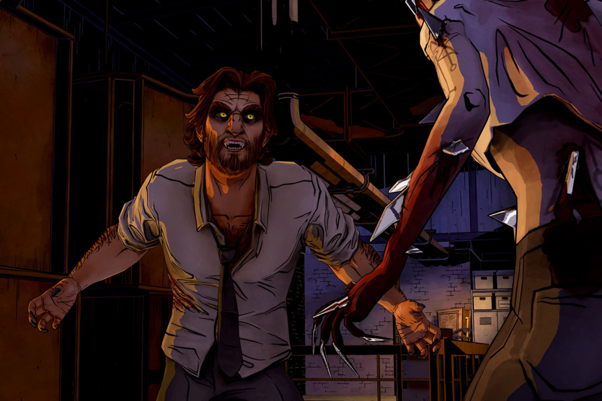
Fig.3 ‘Bigby Wolf’ as shown in Telltale game’s A Wolf Among Us

A particularly popular story that has been re-imagined countless times is Lewis Carroll’s’ Alice In Wonderland. The completely non-sensical themes and iconic characters make for an incredibly interesting story that can be twisted to show much darker themes, such as in American McGee’s games Alice: Madness Returns, and American McGee’s Alice, a series of horror games which uses the story of Alice In Wonderland as a metaphor for physical and mental abuse, where Alice finds herself in a mental institution and discovers that defeating the grotesque monsters that have polluted the Wonderland inside her head is the only way to save herself from succumbing to the institution and staying sane. It is clear to see that Fairy Tales can and have been used countless times as a way to express different metaphors and stories in very clever and creative ways, which is what I hope to do with my own work moving forward.

Fairy Tale

As clearly evidenced in this essay, Fairy Tales are so much more than simple stories. They are lessons for teaching, tools to inspire creativity, and classics to be retold over and over. Fairy Tales are simply timeless, and as artists no matter how many iterations of the same story we see we are always eager to create more, to try and make it our own, and to hopefully inspire others to do the same. I chose to focus my work on Fairy Tales as I myself am one of these people who are deeply inspired by them and have a great love for them. I think it’s is so amazing how people are able to take the same story and make something completely new, not just in illustration but even by way of creating video games, audiobooks, and interactive experiences. I am Incredibly excited to move on to the third year and create my own artworks that have been lovingly inspired by these timeless classics.

Bibliography

Young, J. (1997) How fairy tales shape our lives, Center for Story and Symbol. Folk story.com. Available at: https://folkstory.com/articles/onceupon.html (Accessed: April 20, 2023).
Danish, E. (2020) Influence of fairy tales on children, HealthGuidance.org | For Better Health. Available at: https://www.healthguidance.org/entry/15745/1/influence-of-fairy-tales-on-children.html (Accessed: April 20, 2023).
Slater, Michael. Dickens and Women. Stanford: Stanford UP, 1983.
Freud, Sigmund. "Medusa's Head." The Standard Edition of the Complete Psychological Works of Sigmund Freud. Trans, and ed. James Strachey, 24 vols. London: Hogarth, 1953-74. Vols. 18. 273-74, and 21.154.

OFEK, GALIA. “‘TIE HER UP BY THE HAIR’: DICKENS’S RETELLING OF THE MEDUSA AND RAPUNZEL MYTHS.” Dickens Quarterly, vol. 20, no. 3, 2003, pp. 184–99. JSTOR, http://www.jstor.org/stable/45291925. Accessed 20 Apr. 2023.

Fig.1 Egnéus, D. Little Red Riding Hood (Originally published 25th February 2011)

Fig.2 Dickens, C. A Tale Of Two Cities (originally published 26th November, 1859)

Fig. 3 TellTale Games A Wolf Among Us (Originally released 11th October 2013)

