Student Name: Guile Danielle Virginie Fohe
Student Number: 2128226
Programme: MSc Public Health and Social Care in Practice
Module Title: Population Health and Digital Health Promotion
Module Code:LCHS7009_BIRM
Assignment Title:2 Blogs
Lecturer: Dr Besty Jose

Blog Post 1 – The Impact of Headspace on Anxiety and Depression Management

Introduction
Mental health challenges like anxiety and depression are growing public health challenges that affect more than one in six adults in the United Kingdom (UK Government, 2018). Mental health challenges are exacerbated by the COVID-19 pandemic, which increases the demand for mental health services and exposes the challenges with accessing mental health services (World Health Organisation, 2022). As a result, digital health interventions emerged to complement traditional care models. In this case, the UK NHS approved and endorsed Headspace for mental health services, especially for its workforce (Headspace, 2025; NHS, no date). This blog critically evaluates the impact of headspace on the management of anxiety and depression, and its contribution to digital mental health promotion.
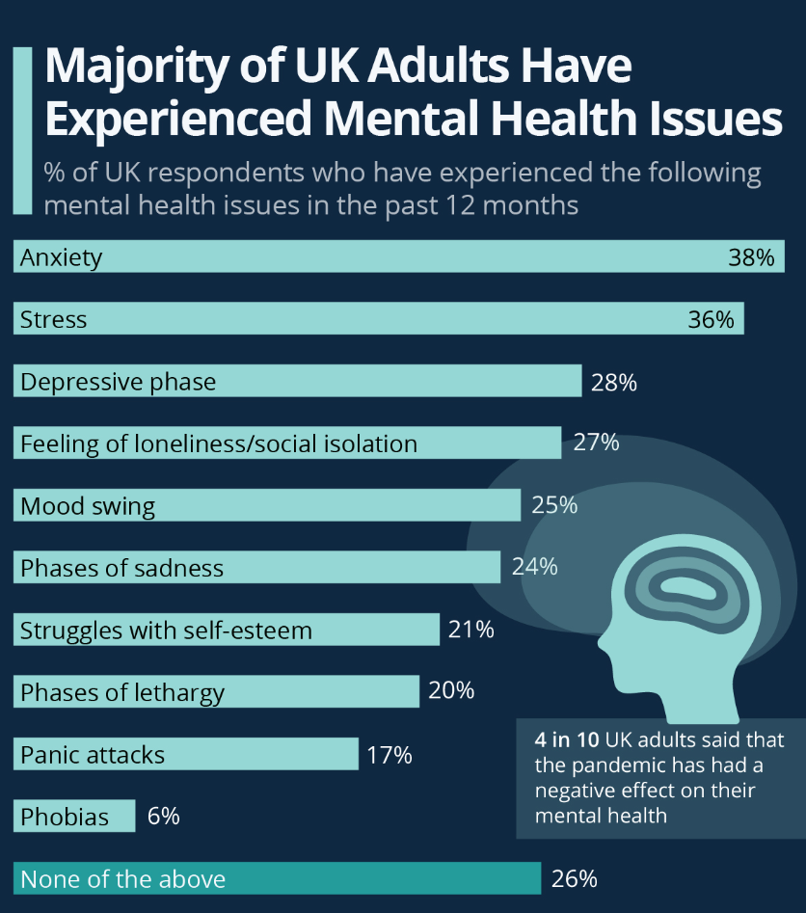
Mental Health Issues Experienced by Adults in the UK (Martin, 2021)

The Public Health Problem
Depression is said to be the leading cause of disability globally, affecting about 280 million people (World Health Organisation, 2025). The UK's NHS mental health service waiting lists exceed 1.9 million people (Sheena, 2023). Also, barriers like stigma, workforce shortages and limited access to in-person care prevent timely intervention (Schaffer et al., 2020). Digital technologies offer a solution by delivering mental health support to service users’ mobile phones directly and enabling anonymity and continuous self-management (Headspace, 2025).

An art illustrating mental health challenges (Sumbal, 2025)

Digital Technology Overview
Headspace is a digital mindfulness app that promotes mental health and well-being through meditation and stress management exercises. It is approved for use among the NHS workforce, and it supports the public goals of curbing the menace of anxiety and depression. Headspace empowers users to build self-awareness, regulate their emotions, reduce stigma and increase access to psychological support (Headspace, 2020; Headspace, 2025).
🔗 Explore Headspace: www.headspace-wellbeing.org
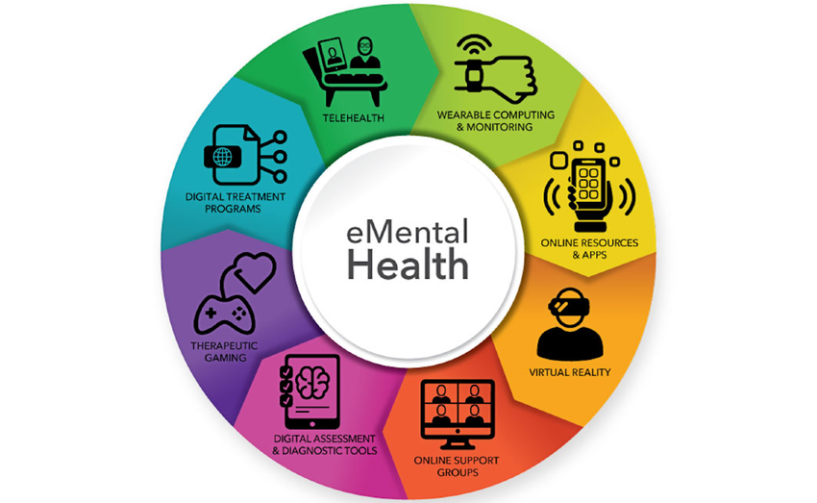
Digital tools for Mental Health Services (Elis et al., 2021)

Evidence of Impact
There is evidence that supports the efficacy of mobile mental health interventions. A randomised controlled trial (RCT) revealed that Headspace users demonstrated decreased stress and improved well-being across workplace and student populations (Headspace, 2020). Another RCT conducted by Taylor et al. (2022) among UK NHS health workers revealed that Headspace led to a significant reduction in stress, anxiety and depression.
Advantages and Disadvantages
The key advantage of Headspace is that it is easily accessible, confers anonymity on the users, and is affordable, making it ideal for mental health promotion, especially among workers and students. The app also promotes preventive care and reduces the stigma that are associated with mental health therapy.
However, the impact of Headspace is limited by low long-term engagement, digital exclusion and small clinical size effect. In addition, the dependence on data that are self-reported and possible privacy issues raises ethical concerns (Borghouts et al., 2021; Berardi et al., 2024).
The limitations that are associated with Headspace can be addressed by improving personalisation through the integration of AI to help in sustaining engagement. Expand the access of the app by making it multilingual and reducing exclusion through digital literacy training. Furthermore, there is a need for a large-scale evaluation to validate the outcomes of using Headspace.

References
- Berardi, C., Antonini, M., Jordan, Z., Wechtler, H., Paolucci, F. and Hinwood, M. (2024). Barriers and facilitators to the implementation of digital technologies in mental health systems: a qualitative systematic review to inform a policy framework. BMC Health Services Research, 24(1),p.243.
Available at: https://link.springer.com/content/pdf/10.1186/s12913-023-10536-1.pdf
(Accessed:25/10/2025).
- Borghouts, J., Eikey, E., Mark, G., De Leon, C., Schueller, S.M., Schneider, M., Stadnick, N., Zheng, K., Mukamel, D. and Sorkin, D.H. (2021). Barriers to and facilitators of user engagement with digital mental health interventions: systematic review. Journal of Medical Internet Research, 23(3),p.e24387.
Available at: https://www.jmir.org/2021/3/e24387/
(Accessed:24/10/2025).
- Ellis, L.A., Meulenbroeks, I., Churruca, K., Pomare, C., Hatem, S., Harrison, R., Zurynski, Y. and Braithwaite, J. (2021). The application of e-mental health in response to COVID-19: scoping review and bibliometric analysis. JMIR mental health, 8(12), p.e32948.
Available at: https://mental.jmir.org/2021/12/e32948
(Accessed:22/10/2025).
- Firth, J., Torous, J., Nicholas, J., Carney, R., Pratap, A., Rosenbaum, S. and Sarris, J. (2017). The efficacy of smartphone‐based mental health interventions for depressive symptoms: a meta‐analysis of randomised controlled trials. World psychiatry, 16(3), pp.287-298.
Available at: https://onlinelibrary.wiley.com/doi/pdf/10.1002/wps.20472
(Accessed:22/10/2025).
- Fitzpatrick, K.K., Darcy, A. and Vierhile, M. (2017). Delivering cognitive behavior therapy to young adults with symptoms of depression and anxiety using a fully automated conversational agent (Woebot): a randomised controlled trial. JMIR mental health, 4(2), p.e7785.
Available at: https://mental.jmir.org/2017/2/e19/Roboter
(Accessed:24/10/2025).
- Headspace. (2020). Amid Growing Global Health Crisis, NHS Partners With Headspace To Provide All Employees Free Subscriptions To Curb Rising Stress And Anxiety.
Available at: https://www.prnewswire.com/news-releases/amid-growing-global-health-crisis-nhs-partners-with-headspace-to-provide-all-employees-free-subscriptions-to-curb-rising-stress-and-anxiety
(Accessed:26/10/2025)
- Headspace. (2025). About Headspace.
Available at: https://www.headspace.com/about-us?
(Accessed:24/10/2025)
- Huberty, J., Green, J., Glissmann, C., Larkey, L., Puzia, M. and Lee, C. (2019). Efficacy of the mindfulness meditation mobile app “calm” to reduce stress among college students: Randomised controlled trial. JMIR mHealth and uHealth, 7(6), p.e14273.
Available at: https://mhealth.jmir.org/2019/6/e14273
(Accessed:26/10/2025)
- Löchner, J., Carlbring, P., Schuller, B., Torous, J. and Sander, L. (2025). Digital interventions in mental health: an overview and future perspectives. Internet Interventions, p.100824.
- Martin, A. (2021). The majority of UK Adults Have Experienced Mental Health Issues.
Available at: https://www.statista.com/chart/25645/uk-mental-health-issue-prevalence-gcs/
(Accessed:25/10/2025).
- NHS. (no date). Free wellbeing apps.
Available at: Free wellbeing apps:: Keeping Well
(Accessed:26/10/2025)
- Schaffer, C.T., Nakrani, P. and Pirraglia, P.A. (2020). Telemental health care: A review of efficacy and interventions. Telehealth and Medicine Today, 5(4).
- Available at:https://telehealthandmedicinetoday.com/index.php/journal/article/download/218/292
(Accessed:26/10/2025)
- Sheena, M. (2023). Call for Action on 'Overwhelmed' Mental Health Services.
Available at: Call for Action on 'Overwhelmed' Mental Health Services.
(Accessed:27/10/2025)
- Sumbal, J. (2025). Is Major Depressive Disorder a Disability?
Available at: Is Major Depressive Disorder a Disability?
(Accessed:25/10/2025).
- Taylor, H., Cavanagh, K., Field, A.P. and Strauss, C. (2022). Health care workers’ need for headspace: findings from a multisite definitive randomised controlled trial of an unguided digital mindfulness-based self-help app to reduce healthcare worker stress. JMIR mHealth and uHealth, 10(8), p.e31744.
Available at: https://mhealth.jmir.org/2022/8/e31744/1000
(Accessed:25/10/2025).
- UK Government. (2018). Health matters: reducing health inequalities in mental illness. Available at: Health matters: reducing health inequalities in mental illness - GOV.UK
(Accessed:26/10/2025).
- Woebot Health. (2025). About Us.
Available at: https:// woebothealth.com
(Accessed:25/10/2025).
- World Health Organisation. (2022). COVID-19 pandemic triggers 25% increase in prevalence of anxiety and depression worldwide.
Available at: COVID-19 pandemic triggers 25% increase in prevalence of anxiety and depression worldwide
(Accessed:27/10/2025).
- World Health Organisation. (2022). Mental disorders.
Available at: https://www.who.int/news-room/fact-sheets/detail/mental-disorders
(Accessed:27/10/2025).

Blog Post 2: Ease Your Mind – An AI–Powered Digital Tool for Promoting Mental Wellbeing

Introduction
This blog post critically discussed the impact of a proposed digital health technology for digital mental health promotion. Leveraging evidence from existing interventions like Headspace, this blog presents Ease Your Mind, a conceptual and AI-powered technology designed to promote mental well-being through personalised, culturally sensitive and behaviorally informed digital intervention.
Addressing the Public Health Problem
Depression and anxiety disorders affect the quality of life and human productivity, and they cost the UK economy more than £105 billion annually. The traditional mental health service is strained with high demands and long delays. Thus, there is a gap between the clinical need and service provision. Thus, digital health interventions offer accessible, low-cost and preventive care. Through the integration of artificial intelligence with behavioral science, Ease Your Mind aims to support people in managing their emotional distress themselves.
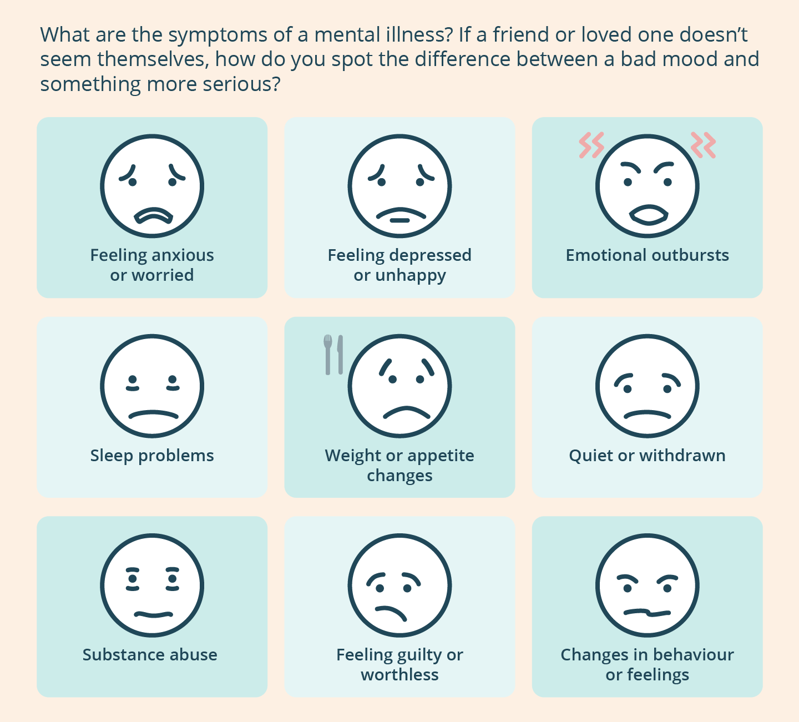
The nine signs of mental illness (Health Direct, 2023)

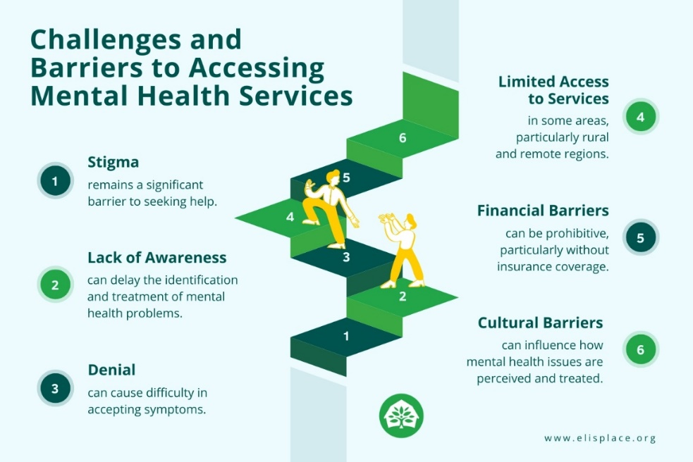
Challenges and barriers to accessing mental health services (Eli’s Place Communication Team, 2024)
Digital Technology Overview
Ease Your Mind will be a mobile and web-based platform that uses an adaptive AI chatbot. It will offer users cognitive behavioral therapy sessions (CBT), mindfulness exercises and track their mood. The system will process and interpret the inputs of user and provide real-time emotional support. It will identify stress patterns and recommend interventions such as guided relaxation or referring to medical services. This intervention will enhance care inclusiveness and will support multiple languages. The platform will also include a clinician dashboard to monitor users remotely.
🔗 Try Ease Your Mind Prototype: www.ease-your-mind.demo
Expected Impact
Leveraging behavioral change theories like Health Belief Model and Social Cognitive Theory, Ease Your Mind will promote self-efficacy, mental health awareness and coping strategies. Studies of similar digital interventions have shown that there is a reduction in anxiety and depression symptoms through CBT and mindfulness applications (Firth et al., 2019; Huberty et al., 2021). With the use of AI for personalisation, Ease Your Mind has the potential to increase the duration of engagement compared to a generic application. The linkage of digital care to professional care could also improve continuity and trust, while it reduces the strain and burden on the healthcare system.

Proposed Ease Your Mind Application Principles (Author, 2025)

Advantages and Disadvantages
This proposed system comes with advantages like offering personalised support, promoting user engagement, being culturally sensitive and promoting digital inclusiveness.
However, the platform may still experience ethical and data privacy issues that are known with AI-based tools. Over-reliance on automated dialogue could limit empathy when it comes to emotional care. In this case, continuous evaluation and using inputs from clinicians and service users will help to ensure reliability.

References
- Campion, J., Javed, A., Lund, C., Sartorius, N., Saxena, S., Marmot, M., Allan, J. and Udomratn, P. (2022). Public mental health: required actions to address implementation failure in the context of COVID-19. The Lancet Psychiatry, 9(2), pp.169-182.
Available at: https://www.thelancet.com/pdfs/journals/lanpsy/PIIS2215-0366(21)00199-1.pdf
(Accessed:27/10/2025)
- Johnson, S., Dalton‐Locke, C., Baker, J., Hanlon, C., Salisbury, T.T., Fossey, M., Newbigging, K., Carr, S.E., Hensel, J., Carrà, G. and Hepp, U. (2022). Acute psychiatric care: approaches to increasing the range of services and improving access and quality of care. World Psychiatry, 21(2), pp.220-236.
Available at: https://onlinelibrary.wiley.com/doi/pdf/10.1002/wps.20962
(Accessed:26/10/2025).
- UK Government. (2018). Health matters: reducing health inequalities in mental illness. Available at: Health matters: reducing health inequalities in mental illness - GOV.UK
(Accessed:27/10/2025).
  - Firth, J., Torous, J., Nicholas, J., Carney, R., Pratap, A., Rosenbaum, S. and Sarris, J. (2017). The efficacy of smartphone‐based mental health interventions for depressive symptoms: a meta‐analysis of randomised controlled trials. World psychiatry, 16(3), pp.287-298.
Available at: https://onlinelibrary.wiley.com/doi/pdf/10.1002/wps.20472
(Accessed:27/10/2025).

- Huberty, J., Green, J., Glissmann, C., Larkey, L., Puzia, M. and Lee, C. (2019). Efficacy of the mindfulness meditation mobile app “calm” to reduce stress among college students: Randomised controlled trial. JMIR mHealth and uHealth, 7(6), p.e14273.
Available at: https://mhealth.jmir.org/2019/6/e14273
(Accessed:27/10/2025).
- Health Direct. (2023). Nine signs of mental illness – infographic.
Available at: Nine signs of mental illness - infographic | health direct
(Accesse:27/10/2025)
- Eli’s Place Communication Team. (2024). Early Intervention for Mental Illness: Early Detection, Early Action.
Available at: https://Early Intervention for Mental Illness – Eli's Place
(Accessed:27 /10/2025).

