Curtis Stephens
1903184 University of Wales Trinity Saint David
ACCA5023 Network operating systems and services worksheet three

Table of Contents
No table of contents entries found.

1. Introduction
For this worksheet, it is required that the security of files and share permissions are set up correctly. This is to be done using NTFS permissions and using network shares.
As well as this, Group Policy Management will be used. This will be used to restrict what users can do – for example, stopping non admin users from accessing control panel, command prompt as well as restricting the use of removable storage and disabling software installations from the internet.
Next, a password policy will be set up which enforces users to have strong passwords via various criteria and ensures that users reset their passwords on a constant basis.
Finally, observational tasks will be completed relating to the work that has been completed in this worksheet.

2. NTFS and File Share Permissions
For this part of the assignment, NTFS and file sharing permissions will be det up. Firstly, NTFS permissions will be used to restrict the access of a folder to only one user for full control, and other network users will only have read access to the folder. This will lessen the chance of accidental or deliberate damage or destruction of the file.

2.1. Using NTFS Permissions
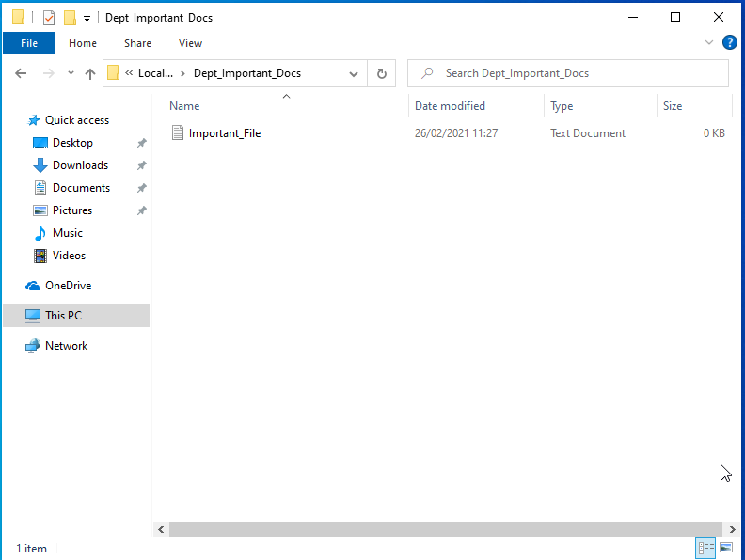
This file has been created for the purpose of restricting access – only one user will be able to have full control over the file, and all other users will have read-only access.

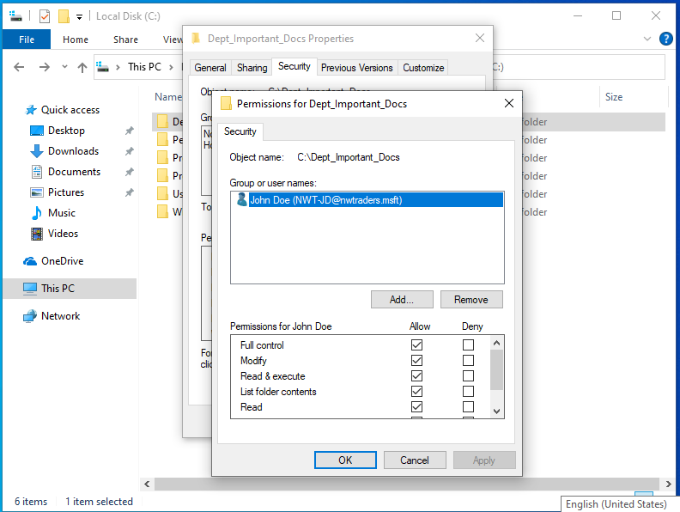
User John Doe has been given full control over the file. This means that the user can read, write, and modify the file, among a few other actions.

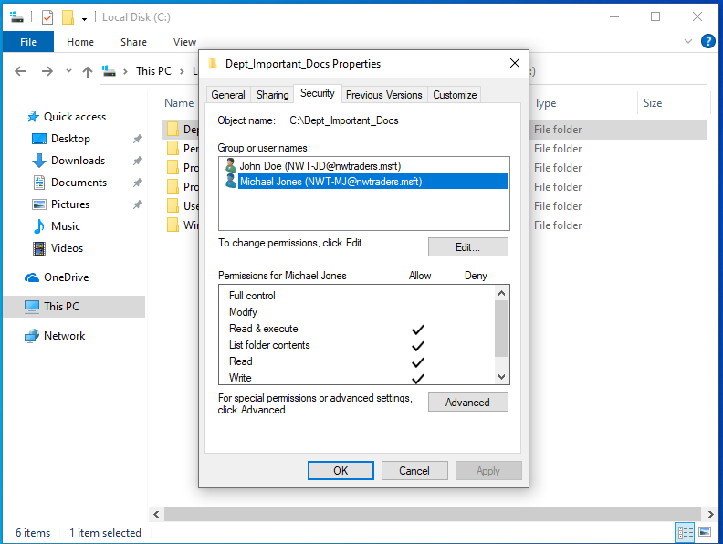
User Michael Jones has been granted full control over the folder, except for being able to modify the folder. This means that contents of the folder cannot be deleted, which means that an accidental deletion is a lot less likely.

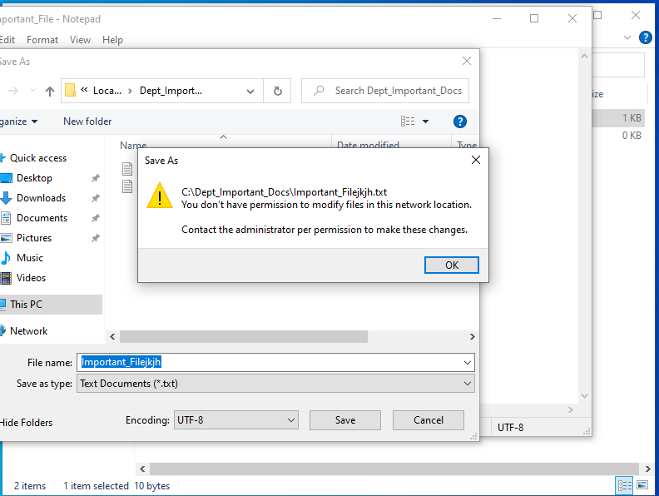
As can be seen here, attempting to change a file on Michael’s account is not allowed. This means that the NTFS permissions have been set up correctly.

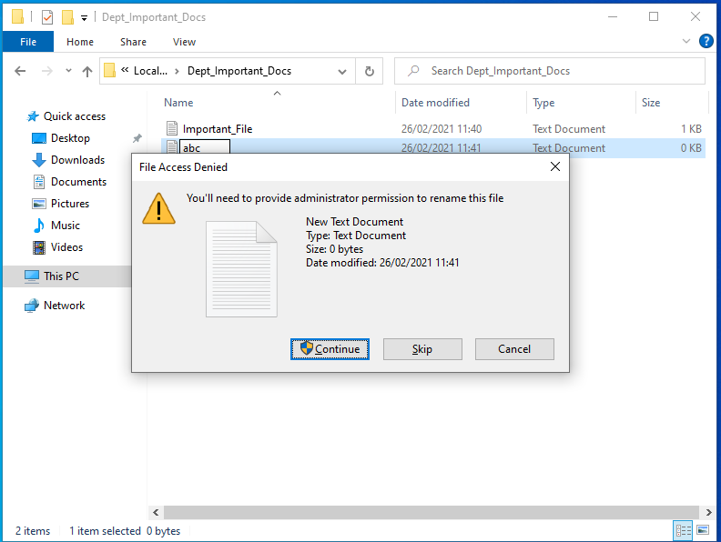

2.2. Share Permissions
Share permissions control the access of resources over a network environment. This allows files and drives to be shared over a network rather than locally, and access rights can also be set network-wide rather than locally.
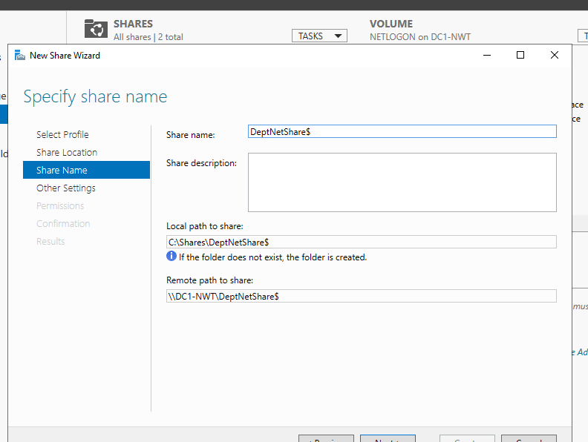
A file share has been created via Server Manager with the name DeptNetShare. This will be accessible to administrators as well as two other users on the network.

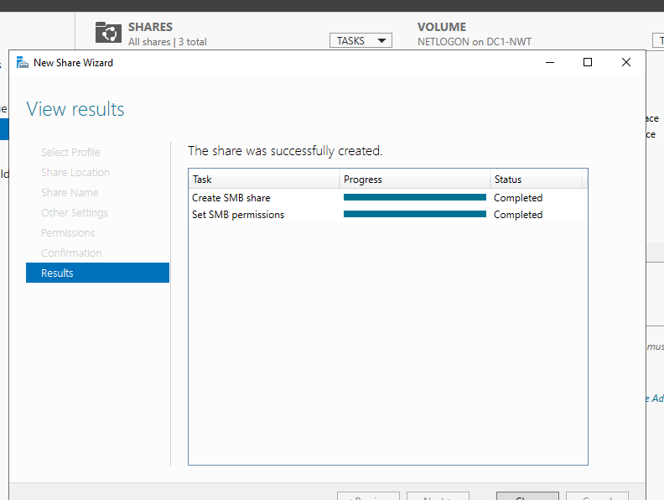
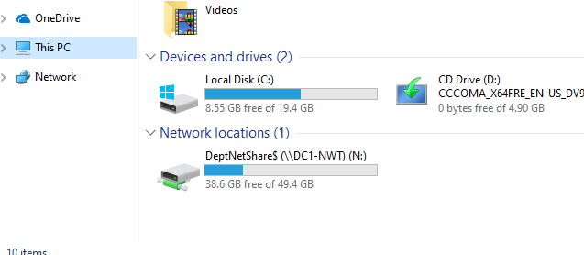
The drive has been lettered with the letter N:.

3. Using Group Policy Management
Group policy management is a built-in feature of Windows Server which allows system administrators to centrally manage domain joined computers and user accounts. Using group policy management automates the process of rolling out settings to the machines and users belonging to a domain. This allows security settings to be centrally managed which saves time as things do not have to be configured manually.
The following have been set up:
- Moderation of access to Control Panel
A control has been set up which restricts access to control panel so non-admin users cannot gain access. This ensures that important settings cannot be changed.
- Removal of access to Command Prompt
Access will be revoked for non-admin users as they may be able to use the command prompt to override system settings and give high-level access to users who may circumvent security policies that have been implemented.
- Restricting access to Removable Media Drives
These are one of the most common ways that viruses are transported, so it is very important that access to these is restricted until a network administrator scans the respective drive for viruses.
- Restricting software installs
These are another way in which viruses and malware can enter a system. If a user downloads a piece of software from an untrusted website, it could be a trojan horse, which is malware and viruses that come with a piece of genuine software.
- Enforcing password policy in the domain
Enforcing a password policy ensures accounts will be safer, as passwords will be required to be changed frequently, and there will also be complexity requirements enforced.
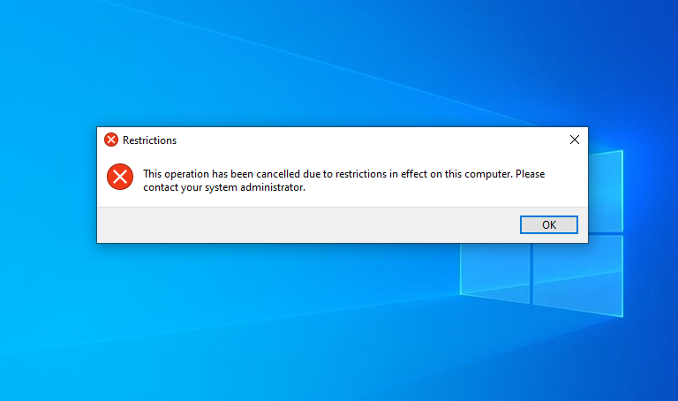
This error is displayed when a non-admin user attempts to open Control Panel. This stops administrative settings from potentially being changed.

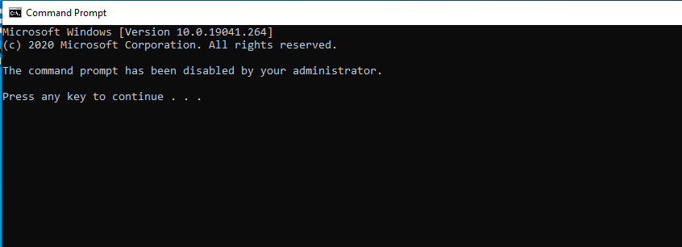
This error is displayed when a non-admin user attempts to access the command prompt. This stops policies from potentially being circumvented.

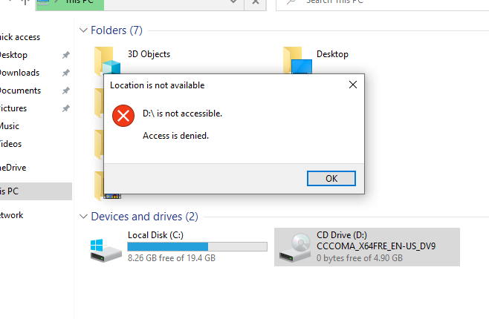
This error appears when a non-admin user attempts to access a removable drive.

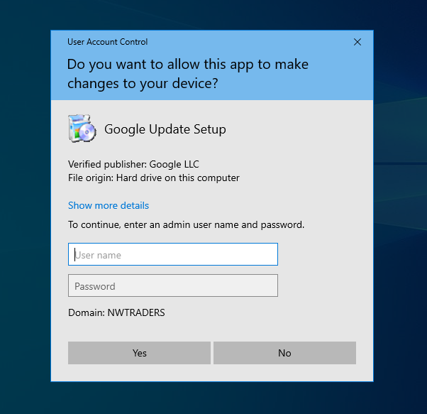
An admin-user login is required if a user wishes to install software from the internet.

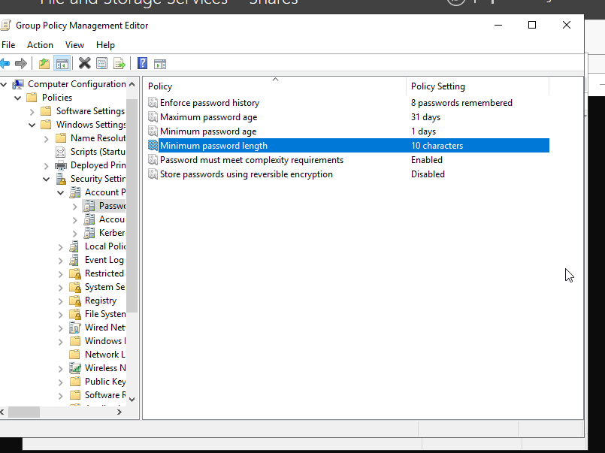
Finally, here are the new password settings.
This ensures the user changes their password every month, the password must be at least 10 characters long. The password must also contain a capital letter, a lowercase letter, a number, and a symbol. The user cannot use one of their eight previous passwords.

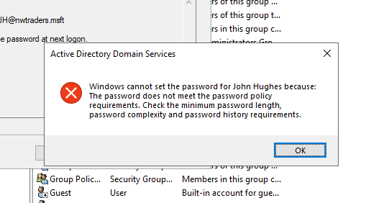
This is what happens if it is attempted to set a password which does not meet the requirements set out above.

4. Observational Tasks
These tasks will be related to the tasks completed in the worksheet. They will cover local permissions, file shares, Group Policy Management, and password principles.

4.1. Local NTFS Permissions and File Share
This part of the assignment will focus on the main differences between local permissions and file sharing on a network.
NTFS permissions affect both local users (users who have an account on a single workstation) and network users (users who have a network account and can log in from anywhere on the network). There are basic and advanced controls using NTFS, and they are controlled on an ‘allow’ or ‘deny’ basis. The basic controls are as follows:
- Full control
This allows users to add, modify and delete files and folders, and users with full control are also able to change permissions for files and subdirectories.
- Modify
Users can view and modify files and their properties, and can add or delete files from a directory, and file properties to or from a file.
- Read and execute
Users can read files, as well as run executable files such as scripts.
- Read
Users can view files, file properties and directories
- Write
Users can write to a file and add files to directories.
Share permissions manage access to folders which are shared over a network – they do not apply to users who are logged on locally. Share permissions apply to all files and folders in the share, and permissions can not be assigned individually to files and subfolders. The number of users able to access the shared folder at any time can also be specified.
There are three types of permissions when using file sharing. These are as follows:
- Read
Users can view file and subfolder names, read data in the files, and run programs. Everyone is assigned read permission by default.
- Change
Users are granted the permissions from the ‘read’ permission, and can also add files and subfolders, change data in the files, and delete files and subfolders.
- Full Control
With this permission, users can do everything allowed by the ‘read’ and ‘change’ permissions and can also change permissions for NTFS files and folders. The administrators’ group is assigned full control by default.
There are other key differences between NTFS and file share permissions. These are:
- NTFS permissions enable more ‘granular’ control of a folder and its contents. This means that users can be assigned access rights on a file-by-file basis when using NTFS.
- When both are used together, the most restrictive permission is always used. For example, if the shared folder permission is set to ‘Everyone can read’ and the NTFS permission is set to ‘Everyone can modify’, the share permission is used as it is most restrictive.
- Share permissions can be used when using FAT and FAT32 file systems, NTFS cannot be used.
- NTFS permissions apply to users logged on locally, share permissions do not.
- Share permissions can control how many users are using a folder at a time. (1)

4.2. Group Policy Management/Objects
A Group Policy Object (GPO) consists of settings that are created using the Microsoft Management Console Group Policy Editor. These objects can be assigned to single or several Active Directory containers, such as sites, domains, or organisational units. The console allows users to create objects which define policies, security settings and software installations, as well as the use of removable storage and certain programs on the computer. This is not an extensive list, however.
Group policy should be used as Windows is not that secure and has a lot of vulnerabilities. Using GPO can fix these vulnerabilities and therefore can secure a system or a network better.
For example, a GPO can be used to implement policies where the users of a network are only able to complete tasks that allow them to complete their jobs. For example, as seen above: -
- Disabling Control Panel and Command Prompt to stop users from being able to change settings on the computer that may make the computer or network more vulnerable to attacks.
- Stopping software downloads from internet sources, to stop viruses and malware from being able to enter the network.
- Disabling drives for removable storage, once again to stop malware and viruses from potentially entering the network through these methods.
- Implementing a password policy, such as minimum strength, and users having to change their password after a period of time.
In a networking environment, Group Policy Management (GPM) allows a networking manager to apply updates to policies remotely. This means that they do not have to assign the policies to users manually, one-by-one. Instead, they can assign them to a group of users based on ranks within a company, for example. This ensures that policies are kept as up to date as possible.
Also, on a network a password policy can be used to make user accounts as secure as possible. As can be seen above, passwords can have a maximum age set, meaning they expire and need to be changed after a period of time has elapsed. Passwords can also have complexity requirements set, such as the number of upper/lowercase letters, symbols and numbers used. (2)

4.3. Password Principles
According to the National Institute of Standards and Technology (NIST), sound password principles are as follows: -
- Passwords should not include dictionary words, repetitive or sequential characters (e.g., ‘aaaaaa’ or ‘1234’)
- Passwords should be at least eight characters in length. NIST encourages users to use passwords which are up to 64 characters in length, including spaces.
- Passwords should include a variety of symbols, such as at least one number, uppercase and lowercase letters, as well as special characters (e.g., ‘!”£$%^&*()@#’).
- Previous guidelines published by NIST recommended passwords are changed every 90 days, however, changing passwords irritates users and usually makes them reuse passwords, or use simple patterns such as adding a letter to their current password. Therefore, the current guidance states that businesses should only make their employees change passwords if there is a potential threat or unauthorised access.
- Users should also avoid using things such as their name, the name of a family member or pet, usernames, dates of birth, licence plates, or their address.
There are many steps that administrators can carry out to ensure that the password policy in their network is implemented. These are: -
- Configuring and enforcing a minimum password length.
- Enforcing a password history with a minimum of ten passwords remembered – this means users cannot use any of their previous ten passwords when changing their password.
- Enforcing a minimum password age of three days, so users cannot change their password less than three days apart.
- Enabling complexity requirements, as mentioned above.
- For admin accounts, stronger passwords should be enforced.
- Track all password changes.
- Ensure users do not store their passwords in plain text anywhere whether on the computer or written down, and they also must not share passwords.
- Use multi-factor authentication to mitigate the risk of passwords being stolen or mishandled.
- Delete accounts or change passwords when employees leave the company. (3) (4)

References
1. Melnick, Jeff. Differences Between Share and NTFS Permissions. Netwrix Blog. [Online] 3 March 2020. [Cited: 16 April 2021.] https://blog.netwrix.com/2018/05/03/differences-between-share-and-ntfs-permissions/.
2. Coggins, Jason. What is Group Policy (GPO) and What Role Does It Play in Data Security. Lepide. [Online] 26 March 2021. [Cited: 26 April 2021.] https://www.lepide.com/blog/what-is-group-policy-gpo-and-what-role-does-it-play-in-data-security/.
3. Netwrix. Password Policy Best Practices for Strong Security in AD. Netwrix. [Online] [Cited: 26 April 2021.] https://www.netwrix.com/password_best_practice.html.
4. Grassi, Paul A., et al. NIST Special Publication 800-63B. Digital Identity Guidelines - Authentication and Lifecycle Management. 2017.

