Professional Graduate Certificate in Education (PCET):
Managing Behaviour and Supporting Learner Engagement
(ECPT6005)

Reflective report

By
Ffion Griffiths
(1810276)

Part 1
When teaching, it is essential to know how to manage behaviours in the classroom environment as this is how the teacher and student learn how to react and respond to each other (Soheili et al. 2015). When first mentioned the term ‘behaviour management’ has a negative connotation linked to stopping a particular behaviour, for example, talking out of turn (Reinke et al. 2018). However, behaviour management has a significant positive role in teaching and learning (Welsh Government, 2012). A teacher must encourage a student to contribute to discussions and have specific strategies to facilitate this (Lebor, 2017).

In order to maintain good behaviours, learner engagement is essential to the teaching and learning process and one does not happen without the other (Kahu, 2013). Students who are engaged in their learning tend to have good behaviours in the learning environment (Schnitzler et al. 2021). A student who is not engaged will often be the one that is disruptive and difficult to manage (Schnitzler et al. 2021). Behaviour management and student engagement are perhaps part of the same continuum. Behaviour management that sets up and establishes positive learning routines can in turn lead to better student engagement (Schnitzler et al. 2021).

Currently, there is specific legislation in Wales that is targeted towards post-compulsory education settings the ‘Higher Education (Wales) Act 2015’, however, it is not primarily focused on engagement and management. The Act ensures that there is a system of accountability for universities and uses the Higher Education Funding Council for Wales (HEFCW) to implement aspects of this. HEFCW provides a wealth of resources to the HE sectors to encourage student engagement and behaviour management (HEFCW, 2020 and Welsh Government, 2019). Advance HE (2011) has established the UK Professional Standards Teaching Framework which by developing teaching skills also facilitate better learning and engagement of students (Wearing, 2019).

Behaviour management is more closely associated with teaching compulsory education (Welsh Government, 2012). For example, it is more common for secondary school teachers to deal with students who are disruptive and poorly behaved. Having said that, teachers in post-compulsory settings will also encounter badly behaved students. In this setting, however, learner engagement is generally the focus that is used to lead to better learning outcomes (Schnitzler et al. 2021). If students are not bored or lacking motivation and have clearly explained tasks and learning outcomes, they will perform better and get more out of the lessons, thus helping with their engagement and learning (Schnitzler et al. 2021). There are challenges that comes with teaching at all education levels, but these challenges in post-compulsory vary due to factors such as age and life experience (Graham, 2015). One of the key factors that governs student engagement is the level of maturity and development within an individual learner (Bowden et al. 2021). In general, students in post-compulsory education have a higher degree of self-regulation and self-motivation that not always present in younger students due to their age and developmental levels (Bowden et al. 2021).

Within post-compulsory education, HEFCW highlighted how student retention is a key focus area (HEFCW, 2020). This is in response to the high dropout rate amongst students and patterns that were noted within this. Student retention is a key factor because students have the freedom to opt in and out of learning and may sometimes do this without understanding the implications (Elliott and Healy, 2001). As a result, to improve retention, universities must review recruitment methods to ensure that students are properly informed of course content, demands and expectations (Elliott and Healy, 2001). A student will disengage with their learning quickly if the course seems to be irrelevant and this may be due to lack of appropriate information (Elliott and Healy, 2001).

There are different types of challenges that students in post-compulsory education face. Mature students when they return to education report that they had a challenging time at school (Graham, 2015). Mature students can therefore find it difficult to re-engage with learning and may find that there are certain aspects of education that have negative associations for them that impact their confidence and motivation (MacKeracher et al. 2006).
Equally, the time gap between leaving school and restarting education can prove difficult as they have got ‘out of the habit’ of learning in the formal sense (Cullity, 2006). Tasks such as research and essay writing may be particularly difficult (Murphy and Fleming, 2000 & MacKeracher et al. 2006).
The age gap, whist it brings many benefits due to maturity, can also bring other commitments that mean that focus on education may be difficult. Older students, for example, may have work commitments, or family members who are dependent on them for care (Hagedorn, 2005). This contrasts with a compulsory school setting where education is the student’s focus. It is important that education providers in the post-compulsory sector recognise these demands on a student’s time and energy (Mercer, 2007).
However, it is often a difficult situation for the education provider to negotiate how to respond to a student who is unable to complete work due to other commitments (van Rhijn et al. 2016). The student still needs to be aware of their need to complete work and to engage with learning (Marshall, 2020). This is where the educator in the post-compulsory sector must develop inclusive practices alongside student engagement strategies so that the educator and student are working towards the same goal and the student is aware of their responsibilities as well and knows how to fulfil them (Conduit, 2016). Wearing (2019) indicates how the promotion of inclusive learning environments connects to behaviour management, engagement and professional standards. This is especially so with attendance, where it is the student’s choice to attend, it is not compulsory. However, regardless of whether it is compulsory to attend, attendance has a key impact on learning (Gerber et al. 2013). Students need to attend in order to learn and attain, attendance is a key indicator of student engagement (Gerber et al. 2013).

Within all areas of education communication is a key component and helps combat challenges. For the post-compulsory sector, it is important that the communication includes ensuring that the students have a clear understanding of the course (Robinson, 2019). Older students who are opting in to learning need to be able to know and understand what they are learning and why; the course objectives and learning criteria are a way of ensuring that this is communicated (Akin-Little et al. 2004). Equally students need to feel able to ask questions and to clarify the objectives and criteria so that they can feel secure in the learning environment (Angelo, 1993). If a student is unclear about what and why they are learning they are likely to disengage (Schnitzler et al. 2021). In this scenario the educator needs to ensure that behaviour management is used to develop an open learning environment where learners can raise questions and not feel embarrassed or nervous (Angelo, 1993).

In response to this the teacher needs to monitor learning through assessment for learning and ensure that students have understood the lesson rather than carrying on regardless (Bell, 2013 and Gerber et al. 2013). In order to develop learner engagement and confidence the teacher needs to be aware of where there are gaps in learning and to address these as they arise rather than ignoring them or assuming that the student will catch up (Polson, 1993 & Marshall, 2020). Lessons might have to be adapted or paused so that material can be covered again (Polson, 1993 & Marshall, 2020). Post-compulsory education is therefore often flexible to account for the different levels of student experience and knowledge (Conduit, 2016).
Learner engagement is related to the level of student interest and challenge. The content must provide students with appropriate challenge so that the student has a clear sense of development (Newton et al. 2001 & Lebor, 2017). The student has chosen to learn and so needs to have clear evidence of what and how they are learning (Newton et al. 2001 & Lebor, 2017). It means that students need to have opportunities to measure and reflect on their achievements and progress at regular intervals (Newton et al. 2001 & Lebor, 2017). Within post-compulsory education it is important that students can feedback to the teachers so that student voice is heard and acted upon (Young and Jerome, 2020). In terms of ongoing assessment, the feedback from students enables the teacher to monitor learning and understanding to ensure that the summative assessments are achievable (Newton et al. 2001 & Lebor, 2017).

Student engagement plays a key role, and the levels of engagement are in turn linked to the ways in which behaviour management has been used to support and nurture this engagement.

Part 2
Observation 1 was for a Level 2 BSL (British Sign Language) class practicing for the conversation assessment. Students had expressed their concerns about the assessment and their confidence in their signing ability. The teacher reassured them of their signing abilities and gave them a practice opportunity alongside their mock assessment. The teacher then explained the assessment procedure and made sure that the students understood what is expected of them. They were given an opportunity to go through the assessment marking criteria form.
For practice, the teacher wrote up a list of topics for the students to choose and did one-to-one practice with the students individually. During the one-to-one conversation practice, the teacher gave out pointers of their strengths and their weaknesses. The teacher explained how to improve signing form, handshapes, BSL structure and additional marking requirements. The students were also given an opportunity to go through the assessment marking form of their conversation practice with the pointers. Other students who had finished or not yet had one-to-one, practised their conversation skills with peers in the class.

From observing the class, I can understand that assessments are considered as one of the difficult times for students as they are prone to getting anxious during this period. Therefore, the teacher would have to be encouraging but strict as the signer would need to be concise and clear in their signing along with correct signing form and structure in order to pass the assessment. As part of the technique involved in behaviour management and learner’s engagement, students need to understand the assessment procedure and the assessment marking criteria. Through understanding these aspects of the course, the students should develop greater awareness of the tasks that they need to do and develop in their confidence to do them because they have a clear understanding of what is required of them.
The use of a mock assessment helps the students to put their awareness of the assessment criteria into practice and to develop confidence in their signing abilities. The mock assessment enables the student to see in practice how the assessment works and so develops their levels of confidence and engagement. This in turn helps with behaviour management as the students know what is expected of them and can do it.

For my second observation in a Level 3 BSL class the session consisted of the uses of descriptive skills in BSL. This session started with news discussion where students would discuss international news stories and that of the United Kingdom and were encouraged to use BSL. Here, students could also express their views about the news which then developed into a debate. After this, the teacher led a discussion on sign language poetry and the use of it in deaf community and showed few videos of the signer using visual poetry. The students expressed their awe at the detailed expressive description of visual poetry. The teacher then assigned a task where students were required to write their own poetry linked to their descriptive uses of BSL. For example, one had to pretend to be a gorilla and uses expressive and descriptive vocabulary to describe themselves as a gorilla (including appearance) in a poetic style. Many of the students seemed to enjoy the activity.
Afterwards, the teacher had shown the book of ‘Red Riding Hood’ and students were required to translate the English version into BSL and acted out the story with the uses of BSL. Many of the students find it challenging as they had to translate a book from English to sign language.

From observing the class, I can see the importance of activities in encouraging learner’s engagement as it requires the learner to participate into the class and using the language which is the main objective of this class. I can see how confidence building is essential as there were two levels of engagement in the observed lesson. The students needed to trust and engage with the teacher in order to complete the activity. They also needed to trust and engage with other students in the class as they were demonstrating their work to each other without having previous preparation time. This meant that the examples that the students were showing each other did contain mistakes and as the observer I could see how this could be a potentially vulnerable situation for students is there was not enough trust and engagement present.
The common theme shown in my two observations is the way in which the teacher acted as a facilitator through their development of a trusting and encouraging learning environment. This meant that the students were able to engage with the tasks and that learning took place: without the high levels of trust and good relationships the high levels of learning would not have happened.
One particular episode that represents an example of behaviour management is where I teach BSL to medical students on every Friday evenings for a six-week period. In this scenario, the students had signed up to attend the course on sign language that would be useful to know in a medical setting in order to improve communication between staff and deaf patients. The course was an optional extra to other parts of their university-based teaching and had been arranged by Swansea Centre for Deaf People in conjunction with the university. The university paid for the course; the students just had to attend. I designed the course specifically for this cohort and planned for a six-week duration.
Initially, all the students attended, and this developed a good learning environment where the students were able to get to know each other and the teacher. However, by week three there was a distinct decline in attendance and several students failed to attend which created a difficulty for the class and the teacher. The course had been designed to last six weeks and so missing even one session would mean that a student would become significantly behind the rest of the group. The short length of the course also meant that there was not enough time to allow for extended re-cap sessions. As the group were medical students the course was designed around their learning needs and working environment, this was to ensure that the students were engaged in the learning.
The poor attendance continued to be a problem despite efforts to encourage students and emphasising the delays to learning that missing a lesson would cause. Several students missed several lessons in a row which for a six-week course represented missing half of the course. It was decided that part of the reason behind this was the lack of commitment on behalf of the students. This was related to there not being either a financial or exam obligation for the students. After discussion with the university, it was decided that if a student missed three or more sessions, then they would have to be responsible for paying the course deposit. This helped in several ways. The students could see that they were being monitored and needed to engage. Also, it means that the university got clear feedback from the teacher about the students’ progress. Furthermore, better attendance meant that student engagement improved alongside student learning. It also helped with behaviour management because the improved attendance created a better working relationship within the classroom that meant the students were more willing to use and practice sign language.
References
Advance HE. (2011) ‘UK Professional Standards Framework’.
Available at: https://www.advance-he.ac.uk/knowledge-hub/uk-professional-standards-framework-ukpsf
(Accessed date: 06/05/2022)

Akin‐Little, K.A. Little, S.G. Delligatti, N. (2004). ‘A preventative model of school consultation: Incorporating perspectives from positive psychology.’ Psychology in the Schools, 41(1), pp.155-162.
DOI: https://doi.org/10.1002/pits.10147
(Accessed date: 28/05/2022)

Angelo, T.A. (1993). ‘A "teacher's dozen": Fourteen general, research-based principles for improving higher learning in our classroom.’ AAHE Bulletin, 45(8), pp.3-7.
(Accessed date: 23/05/2022)

Bell, M.J. (2013). ‘Define academic performance.’
(Accessed date: 27/05/2022)

Bowden, J.L.H. Tickle, L. Naumann, K. (2021). ‘The four pillars of tertiary student engagement and success: a holistic measurement approach.’ Studies in Higher Education, 46(6), pp.1207-1224.
DOI: https://doi.org/10.1080/03075079.2019.1672647
(Accessed date: 26/05/2022)

Conduit, J. Karpen, I.O. Farrelly, F. (2016). ‘Student engagement: A multiple layer phenomenon.’ In Making a difference through marketing (pp. 229-245). Springer, Singapore.
DOI: 10.1007/978-981-10-0464-3_17
(Accessed date: 26/05/2022)

Cullity, M. (2006). ‘Challenges in understanding and assisting mature-age students who participate in alternative entry programs.’ Australian Journal of Adult Learning, 46(2), pp.175-201.
(Accessed date: 26/05/2022)

Elliott, K.M. Healy, M.A. (2001). ‘Key factors influencing student satisfaction related to recruitment and retention.’ Journal of marketing for higher education, 10(4), pp.1-11.
DOI: https://doi.org/10.1300/J050v10n04_01
(Accessed date: 16/05/2022)

Gerber, C. Mans-Kemp, N. Schlechter, A. (2013). ‘Investigating the moderating effect of student engagement on academic performance.’ Acta Academica, 45(4), pp.256-274.
(Accessed date: 27/05/2022)

Graham, H. (2015). ‘Re-engaging with education as an older mature student: their challenges, their achievements, their stories’ Unpublished Masters Dissertation. Ireland: Department of Social Sciences, Dublin Institute of Technology.
Available at: https://web.archive.org/web/20200320032525id_/https://arrow.tudublin.ie/cgi/viewcontent.cgi?article=1078&context=aaschssldis
(Accessed date: 29/05/2022)

Hagedorn, L. S. (2005). ‘Square pegs: Adult students and their “fit” in postsecondary institutions.’ Change, 37(1), 22–29.
(Accessed date: 15/05/2022)

Higher Education Funding Council for Wales. (2020). ‘Annual report and accounts.’
Available at: https://senedd.wales/media/4esnolep/agr-ld14630-e.pdf
(Accessed date: 11/05/2022)

Kahu, E.R. (2013). ‘Framing student engagement in higher education.’ Studies in higher education, 38(5), pp.758-773.
DOI: https://doi.org/10.1080/03075079.2011.598505
(Accessed date: 18/05/2022)

MacKeracher, D. Suart, T. Potter, J. (2006). ‘State of the field report: Barriers to participation in adult learning.’ Canadian Council on Learning.
Available at: https://www.voced.edu.au/content/ngv%3A9279
(Accessed date: 23/05/2022)

Marshall, S. (2020) ‘A handbook for teaching and learning in higher education; enhancing academic practice.’ Fifth Edition. Routledge, Abingdon, Oxon ; New York :; Abingdon, Oxon ; New York.

Lebor, M. (2017). ‘Testing Times: What Is the Role of Assessment?.’ In Classroom Behaviour Management in the Post-School Sector (pp. 89-106). Palgrave Macmillan, Cham.
DOI: https://doi.org/10.1007/978-3-319-57051-8_5
(Accessed date: 28/05/2022)

Mercer, J. (2007). ‘Re‐negotiating the self through educational development: mature students’ experiences.’ Research in Post‐Compulsory Education, 12(1), pp.19-32.
DOI: 10.1080/13596740601155314
(Accessed date: 26/05/2022)

Murphy, M. Fleming, T. (2000). ‘Between common and college knowledge: Exploring the boundaries between adult and higher education.’ Studies in Continuing Education, 22(1), pp.77-93.
DOI: https://doi.org/10.1080/713695718
(Accessed date: 29/05/2022)

Newton, J. Ginsburg, J. Rehner, J. Rogers, P. Sbrizzi, S. Spencer, J. (2001). ‘Voices from the Classroom: Reflections on Teaching and Learning in Higher Education.’ University of Toronto Press.
(Accessed date: 29/05/2022)

Polson, C.J. (1993). ‘Teaching Adult Students.’ IDEA Paper No. 29.
Available at: https://eric.ed.gov/?id=ED395136
(Accessed date: 03/05/2022)

Reinke, W.M. Herman, K.C. Dong, N. (2018). ‘The incredible years teacher classroom management program: Outcomes from a group randomized trial.’ Prevention Science, 19(8), pp.1043-1054.
DOI: https://doi.org/10.1007/s11121-018-0932-3
(Accessed date: 03/05/2022)

Robinson, D. (2019). ’Classroom Behaviour Management in Further, Adult and Vocational Education. Moving Beyond Control?’ Bloomsbury Academic, London.

Schnitzler, K. Holzberger, D. Seidel, T. (2021). ‘All better than being disengaged: Student engagement patterns and their relations to academic self-concept and achievement.’ European Journal of Psychology of Education, 36(3), pp.627-652.
DOI: https://doi.org/10.1007/s10212-020-00500-6
(Accessed date: 28/05/2022)

Soheili, F. Alizadeh, H. Murphy, J.M. Bajestani, H.S. Ferguson, E.D. (2015). ‘Teachers as leaders: The impact of Adler-Dreikurs classroom management techniques on students' perceptions of the classroom environment and on academic achievement.’ The Journal of Individual Psychology, 71(4), pp.440-461.
DOI: 10.1353/jip.2015.0037
(Accessed date: 03/05/2022)

UK Government. (2015). Higher Education (Wales) Act 2015
https://www.legislation.gov.uk/anaw/2015/1/contents/enacted
(Accessed date: 03/05/2022)

van Rhijn, T.M. Lero, D.S. Bridge, K. Fritz, V.A. (2016). ‘Unmet needs: Challenges to success from the perspectives of mature university students.’ Canadian Journal for the Study of Adult Education, 28(1), pp.29-47.
Available at: https://cjsae.library.dal.ca/index.php/cjsae/article/view/4704
(Accessed date: 27/05/2022)

Wearing, J. (2019). ‘The Use of Professional Standards for Teachers and Trainers in Promoting Positive Behaviour’, in Robinson, D. (ed) Classroom Behaviour Management in Further, Adult and Vocational Education. Moving Beyond Control?’. Bloomsbury Academic, London.

Welsh Government. (2012). ‘Practical approaches to behaviour management in the classroom. A handbook for classroom teachers in primary schools.’
Available at: https://gov.wales/sites/default/files/publications/2018-12/practical-approaches-to-behaviour-management-in-the-classroom-a-handbook-for-classroom-teachers-in-primary-schools.pdf
(Accessed date: 11/05/2022)

Welsh Government. (2019). ‘Guidance for applicants seeking to be designated as institutions for the purpose of the Higher Education (Wales) Act 2015’
Available at: https://gov.wales/sites/default/files/publications/2019-03/guidance-for-applicants-seeking-to-be-designated-as-institutions-for-the-purpose-of-the-higher-education-wales-act-2015-v2019.pdf
(Accessed date: 11/05/2022)

Young, H. Jerome, L. (2020). ‘Student voice in higher education: Opening the loop.’ British Educational Research Journal, 46(3), pp.688-705.
DOI: https://doi.org/10.1002/berj.3603
(Accessed date: 25/05/2022)

Appendices
Appendix A: Teacher 1 Observation Form
(Created on 18/05/2022)

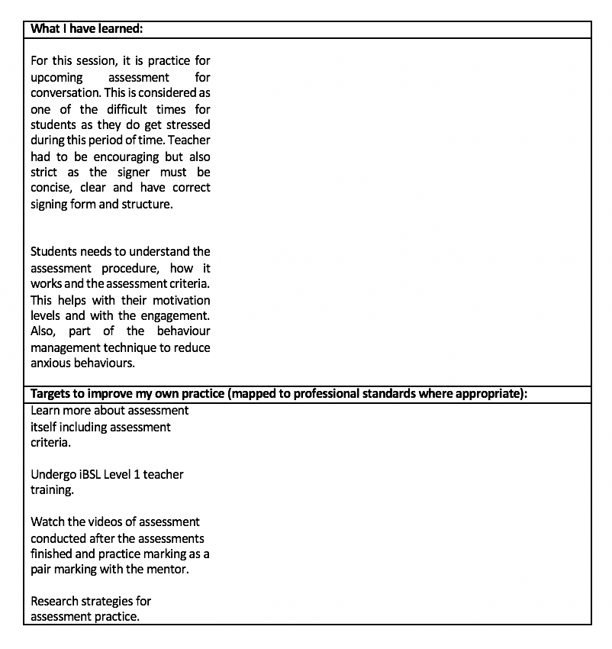

Appendix B: Teacher 2 Observation Form
(Created 24/05/2022)

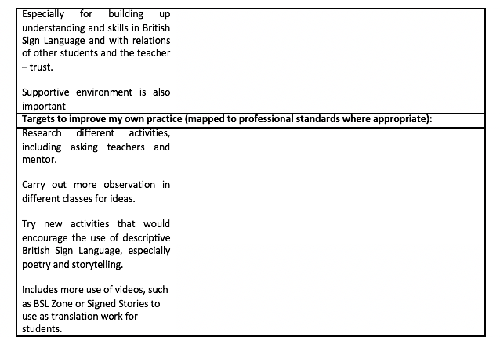

Appendix C: Lesson plan of own teaching session
(Created 25/03/2022)
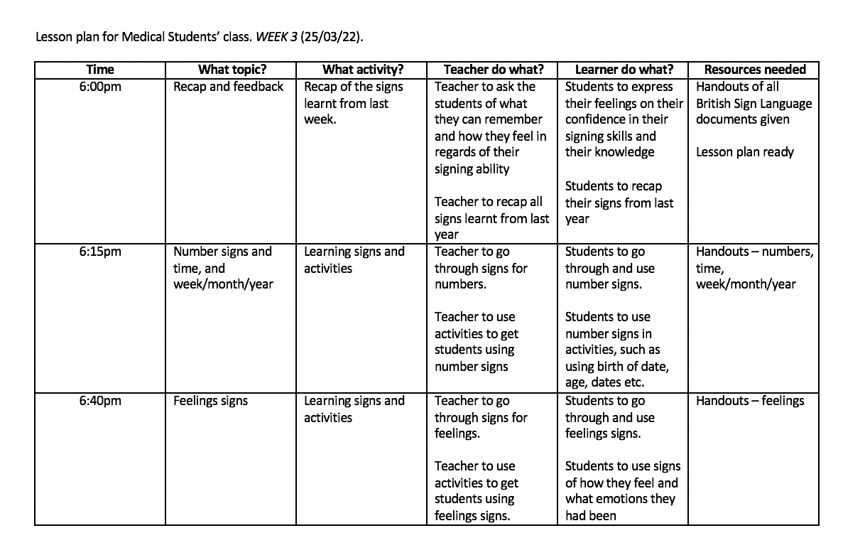
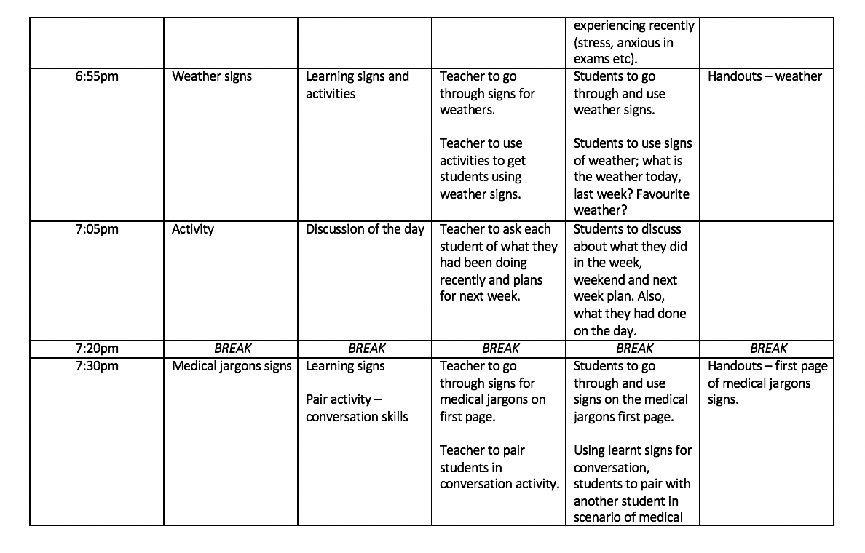
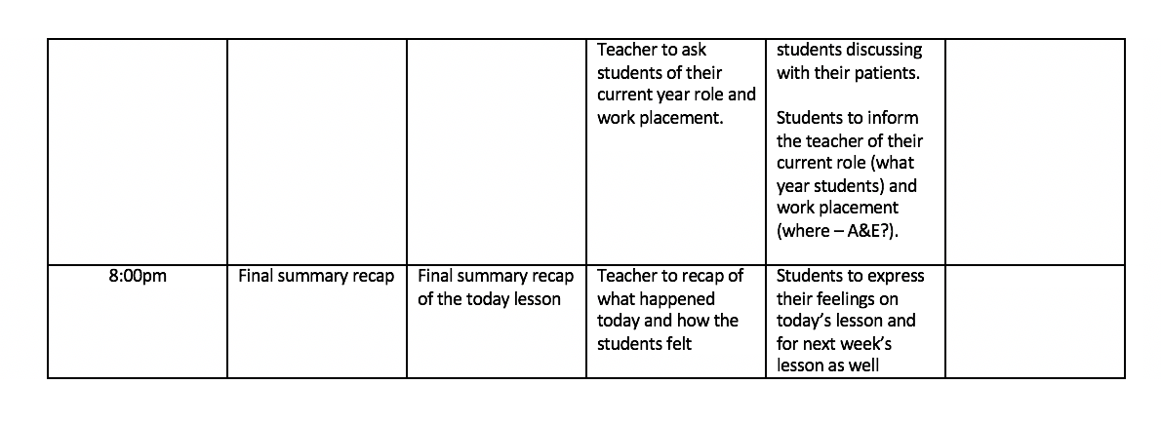

Appendix D: Action Plan for Professional Development
(Created 27/05/2022)


