Commentary on Tintern Abbey

- Ground plan of Tintern Abbey

Tintern Abbey is an abbey founded in 1131 on the borders of Wales and England, which was the first of the Cistercian order to be built in Wales and only the second in Britain. It was known as a daughter house of L’Aumone which itself was a daughter house of Citeaux France, the first Cistercian monastery to be built. Twenty monks were sent to Wales at the invitation of Walter Fitz Richard de Clare, a second-generation Norman settler, and settled near to his castle in Chepstow. The monastery survived for four hundred years but was abandoned in 1536 following the the dissolution of the monasteries by Henry VIII and is now an extremely picturesque ruin looked after by Cadw, sitting on the banks of the River Wye within its deep valley, covered with thick woodland, much how the Cistercians wanted all their monasteries to be situated. The Exordium Cistercii, a twelfth century summary of events leading to the establishment of the Cistercian Order, describes the original monastery in Citeaux as ‘a place of horror, a vast solitude.’ Tintern was secluded rather than remote, and was like the earliest monks and hermits, situated away from human habitation but close enough to transport links, which the Wye provided.

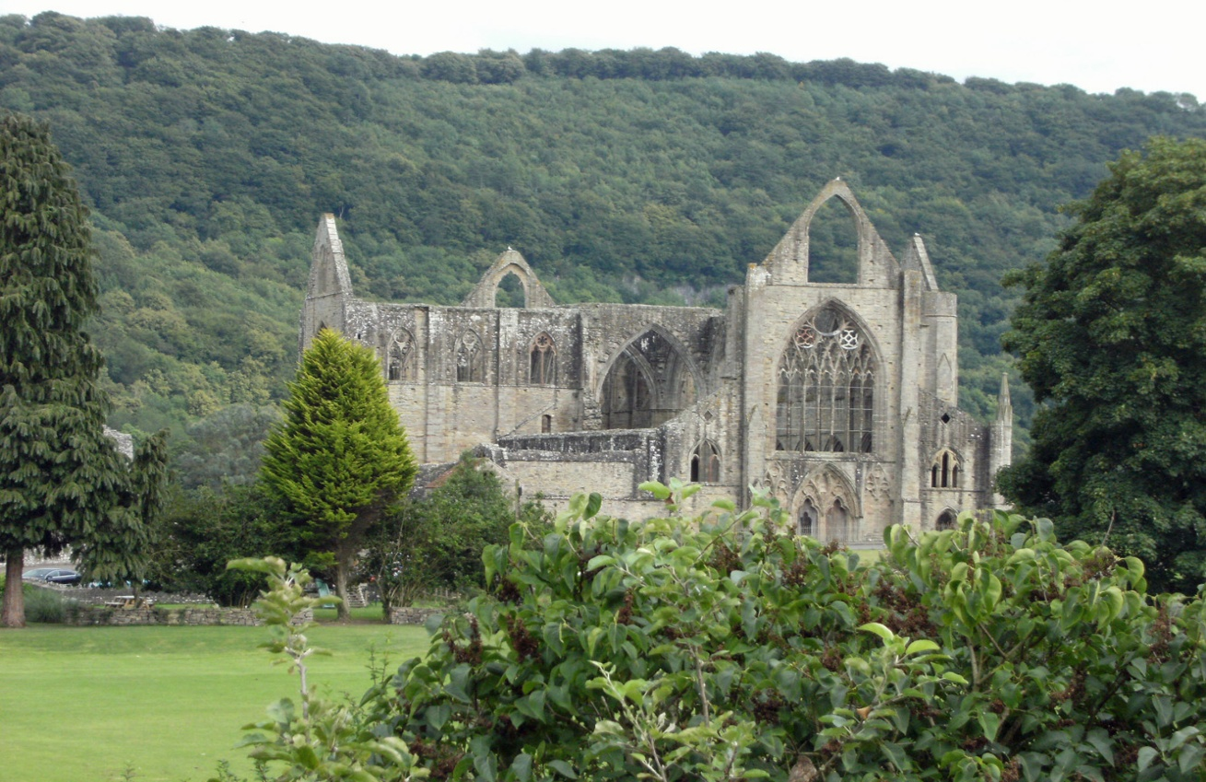

Tintern nestled within the forested valley hills of the River Wye

The Cistercian Order was founded by monks who wanted to return to the old values of the Rule of Benedict, which had been heavily adapted as illustrated by the monks of the Cluniac Order. It was formed by Abbot Robert of Mosleme and other monks in 1098 in Citeaux as described in the Exordium Parvum and Exordium Cistercii. These monks had been dissatisfied with the laxity of standards of discipline and devotion and wanted a new monastery to continue their devotion using the original ideals of St Benedict.

With the large uptake of their ideas, the order was formed with the endorsement of people such as Bernard of Clairvaux and William of Malmesbury who wrote, ‘the Cistercians at the present day are a model for all monks, a mirror for the diligent, a spur to the indolent.’
They embraced poverty, thus allowing no luxury or wealth, manual labour which was used to promote self-sufficiency, isolation, no ornamentation to their church and property to concentrate on worship to God and observance of the Rule. The monks wore distinctive but ‘simple and inexpensive white robes,’ although this was condemned by Orderic Vitalis, ‘Now however, as if to make a show of righteousness, the men of our time reject black.’ Under the jurisdiction of the Cistercian ruling body namely the General Chapter, each monastery followed a constitutional and legislative framework called the Cartae Caritatis et Capitula which gave instruction on every aspect of monastic life. Standards were maintained by the annual meeting of all abbots at the General Chapter in Citeaux and through visitations between mother and daughter houses. David Robinson states that Europe witnessed a ‘monastic renaissance, correcting abuses and re- living purity and poverty.’

This image of the plan of Tintern is similar to that found in the back of a publication called Tintern Abbey, sponsored by the Welsh Government. It presents what is known of the ruins, illustrating the known buildings that were part of Tintern, using different colours to represent the times these buildings were constructed and their use. This allows us to see the adaptations to the precinct over the years as it grew larger and it illustrates the position of the monastic buildings in relation to the church and the cloister. Robinson states that the cloister was fundamental to the planning of the monastery as the monks were cut off from the outside world spiritually and physically therefore needed a haven of tranquillity.

Tintern is slightly unusual as the church, usually located to the North of a monastery complex has been built to the South so that the monks were able to take advantage of the sunlight in the cloisters which were used for reading, studying and meditation. It was also so that living quarters were near to the River Wye which could provide water and accommodate drainage of the latrines.

Although uniformity of the precincts was part of the Cistercian legislation, many monasteries made alterations to the general design depending on the topography of the area. In a study by Bernadette Brady and others, it was noticed that Tintern church, which normally should have its axis from east to west to take advantage of the rising and setting of the sun, was in fact shifted to southeast to northwest to be able to best catch the sunlight over the surrounding hills.

According to the Cartae Caritatis, all monasteries, including Tintern had to be developed and essential buildings constructed, prior to the twelve monks and abbot arriving to take ownership, so that observance of The Rule could start immediately. This meant that there had to be an oratory in which to pray, dormitory to sleep, refectory to eat and a guest house for visitors so that they did not intrude on the monks. These would most likely have been built either by the patron or by lay brothers who were illiterate manual workers, living in the same monasterial complex, and despite having taken monastic vows, lived and prayed completely separately to the choir monks. They were necessary to fulfil the monastery’s economic needs, by providing the manual labour while working on agricultural land known as granges, found near or away from the monastery, thus preserving the condition of self-sufficiency. The lay brothers had their own dormitory and refectory to the west of the monastery, separate from the monks with less austere rules and living conditions and had their own set of monastic rules. They also worshipped separately, with the lay brothers in the Nave and the choir monks in the presbytery, separated by the Pulpitum screen an unusually decorative piece of architecture that should have been contrary to the Cistercian idea of austerity.

The colour coding on the plan illustrates how the complex was systematically added to over the four hundred years with the initial structures(of which nothing is shown) built from wood taken from the nearby forests, later being replaced and added to using locally quarried sandstone. The church was rebuilt on a much grander scale beginning in 1269 and finishing in 1301 most likely due to Roger Bigod’s patronage. It was possibly built as a shell around the original wooded church so that the monks could continue their worship. The church has large gothic style windows which required less stone thus were a more efficient form of building.

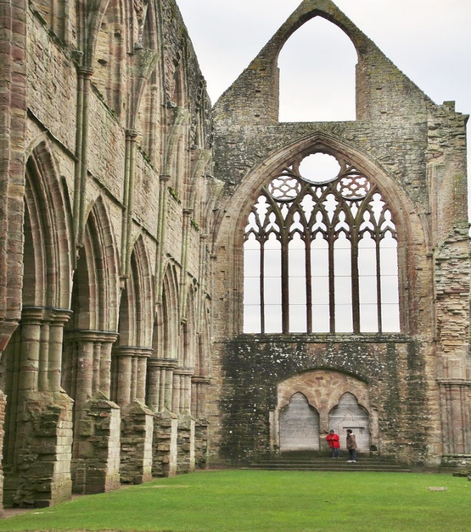
This Photo by Unknown Author is licensed under CC BY-NC-ND
Gothic style west window of Tintern church.

The monks’ quarters to the north of the cloister, had their own refectory, day room and chapter house where they gathered for daily meetings. At Tintern they also had a warming house which contained the only fire apart from the kitchen and infirmary. Their dormitory would have been above the refectory with stairs leading directly to the church to allow easy access, again allowing no contact with the lay brothers.

To the west of the complex is the abbot’s quarters. In the twelfth century, he would have shared a dormitory with the brothers, but from the thirteenth century he had separate accommodation which also would have housed any visiting abbots. As the years progressed and with his probable increased status, accommodation was made more comfortable – even housing Henry II when he visited in 1326.

The infirmary was found to the northeast and appears to have been built in a later phase of building. It housed the sick and infirm monks and had better heating, bedding and food it also had its own cloister. Although inmates were physically removed from the rest of the choir monks, they were still linked by a passage to the church.

The plan of Tintern Abbey gives a comprehensive view on how it was constructed, adapted and utilised during its time as a monastery. It gives an insight into its development plus the social and working life of a Cistercian monk, making it a fascinating and beneficial tool for tourists and scholars.

Bibliography

- Brady, Bernadette, Guneburg, Darrelyn, Silva, Fabio, The Citation Of Cistercian Churches In Wales: A Cultural Astronomy Case Study,2016, https://www.academia.edu/40449073/THE ORIENTATION_OF_CISTERCIAN_CHURCHES_IN_WALES_A_CULTURAL_ASTRONOMY_CASE_ STUDY [accessed 20 N0vember 2025].

- Burton, Janet, Monastic And religious Orders In Britain 1000-1300, (Cambridge: Cambridge University Press,1994).

- Burton Janet and Kerr Julie, The Cistercians In The Middle Ages, (Woodbridge: The Boydell Press, 2016).
- Exordium Cistercii, Summa Carte Caritatis and Capitula, Cistercian Sources 1, Moodle: From Desert Myths To Sheep Tales, The Cistercians In The Middle Ages, < https://moodle.uwtsd.ac.uk/course/section.php?id=144133>.
- Exordium Parvum, Cistercian Sources 1, Moodle: From Desert Myths To Sheep Tales, The Cistercians In The Middle Ages, < https://moodle.uwtsd.ac.uk/course/section.php?id=144133>.

- Lawrence, C.H. Medieval Monasticism 2nd Edn (New York: Longman,1989).

- Phillips, Rachel, Regionalisation Of Cistercian Monasteries In Wales. The Effects Of Local Politico-Cultural Environments On Material Culture, https://www.academia.edu/3376084/Regionalism_of_Cistercian_Monasteries_In_Wales_The_effects_of_local_politico_cultural_environments_on_material_culture [accessed 20 November 2025].

- Robinson, David R. ‘Cistercian Cloisters In England And Wales’, Journal of the British Archaeological Association,159 (2006), pp.131- 207. https://doi.org/10.1179/174767006X147460 .

- Robinson, David M., Tintern Abbey, 5th ed, (Cardiff: Cadw, 2011).

- William of Malmesbury, ‘History Of The Cistercian Order’, Cistercian Source 2,Moodle: From Desert Myths To Sheep Tales, The Cistercians In The Middle Ages, < https://moodle.uwtsd.ac.uk/course/section.php?id=144133>.

- Vitalis, Orderic, ‘The Ecclesiastical History Of Orderic Vitalis’, Cistercian Source 2, Moodle: From Desert Myths To Sheep Tales, The Cistercians In The Middle Ages, < https://moodle.uwtsd.ac.uk/course/section.php?id=144133>.

        - Photographs

- Unknown Photographer. West Window Tintern, https://live.staticflickr.com/7899/45583896365-73c30f8d59_b.jpg [accessed 20 November 2025].

- Unknown photographer, Tintern Abbey, https://2bp.blogspot.com/-L7ugZ16_H-c/TKQb1mvacl/AAAAAAAAEG8/TEDMslmMiF0/s1600/050811_Tintern_abbey.jpg [accessed 20 November 2025].

Janet Burton and Julie Kemp, The Cistercians In The Middle Ages, (Woodbridge: The Boydell Press,2011) p.10.
Exordium Cistercii, Chapter 1, Cistercian Sources 1, Moodle: From Desert Myths To Sheep Tales, The Cistercians In The Middle Ages, < https://moodle.uwtsd.ac.uk/course/section.php?id=144133>
Burton and Kemp, The Cistercians, p. 16.
Unknown photographer, Tintern Abbey, https://2bp.blogspot.com/-L7ugZ16_H-c/TKQb1mvacl/AAAAAAAAEG8/TEDMslmMiF0/s1600/050811_Tintern_abbey.jpg
Exordium Parvum, Cistercian Sources 1, Moodle.
William of Malmesbury, ‘History Of The Cistercian Order’, Cistercian Sources 2, Moodle
Summa Carte Caritatis et Capitula, XI, Cistercian Sources 1, Moodle.
Orderic Vitalis, ‘The Ecclesiastical History Of Orderic Vitalis’, Cistercian Source 2, Moodle.
Summa Cartae Caritatis et Capitula, Cistercian Sources 1. Moodle.
David M. Robinson, Tintern Abbey, 5th ed, (Cardiff: Cadw, 2011), p.7.
Ibid, p.65.
David, M. Robinson, ‘Cistercian Cloisters In England And Wales’, Journal of Archaeological Association, 159, (2006),pp.131-207, p.133, https://doi.org/10.1179/174767006X147460 [accessed10 November 2025]
Janet Burton, Monastic and Religious Orders in Britain 1000-1300 ,(Cambridge: Cambridge University Press, 1995) p141.
Robinson, Cistercian Cloisters, p.134.
Bernadette Brady, Darrelyn Guneburg, Fabio Silva, The Citation Of Cistercian Churches In Wales: A Cultural Astronomy Case Study,2016, https://www.academia.edu/40449073/THE_ORIENTATION_OF_CISTERCIAN_CHURCHES_IN_WALES_A_CULTURAL_ASTRONOMY_CASE_STUDY [accessed 20 N0vember 2025]
Summa Cartae Caritatis et Capitula, IX, Cistercian Sources 1. Moodle.
Robinson, Tintern Abbey, p.8.
Rachel Philips, Regionalisation Of Cistercian Monasteries In Wales. The Effects Of Local Politico-Cultural Environments On Material Culture, https://www.academia.edu/3376084/Regionalism_of_Cistercian_Monasteries_In_Wales_The_effects_of_local_politico_cultural_environments_on_material_culture [accessed 20 November 2025].
Robinson, Tintern Abbey, p.32.
Janet Burton and Julie Kerr, The Cistercians In The Middle Ages, (Woodbridge: the Boydell Press, 2016), p.78.
Unknown Photographer. https://live.staticflickr.com/7899/45583896365-73c30f8d59_b.jpg [accessed 20 November 2025].
Robinson, Tintern Abbey, p.47.
Ibid, p.63.

