Student Name: Kiara Owen
P Number: 2000525
Programme of Study: Photography in the Arts
Module: ADAD4018
Ways of Thinking Lecturer’s Name: Ryan Moule

Tasks in the order I received them:
Task 1: Observational Writing = 467 words
Task 2: Manifesto Writing = 736 words
Task 3: Practice-based Writing = 524 words
Observational Writing:
In this text I will be talking about semiotics, then deconstructing an image of my choice. But what is semiotics? Who created semiotics? What does ‘deconstruct an image’ mean? The founder of semiotics is “In the development of the modern semiotic history, there are two pioneers from western countries who have made big contributions towards the respected field, namely Ferdinand de Saussure (1857-1913), a linguist from Switzerland and Charles Sanders Peirce (1839-1914), a philosopher from America.” Semiotics means “Semiotics (also called semiotic studies) is the study of sign process (semiosis), which is any form of activity, conduct, or any process that involves signs, including the production of meaning. A sign is anything that communicates a meaning, that is not the sign itself, to the interpreter of the sign.”

Semiotics is usually divided into three branches, which include: Semantics: Relation between signs and the things to which they refer; their denotata or meaning. (reference) Syntactics: Relations among signs in formal structures. (reference) Pragmatics: Relation between signs and the effects they have on the people who use them. (reference). How to deconstruct an image “choose a visual artifact that has meaning, purpose, or intrigue; research the artifact to understand its context; evaluate the rhetorical devices the artifact uses to affect an audience; examine the design principles the artifact employs,”
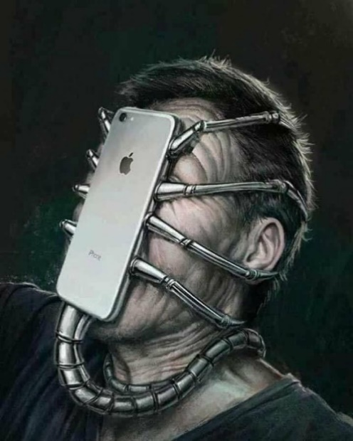
I chose to deconstruct this Image because I think it’s an image with a lot of meaning. You can see the phone which is the signifier, and the man which is being signified. As a viewer this image is shocking to me, and possibly to other viewers as it’s quite grotesque, in the meaning that it’s essentially “sucking him in”. However, I would argue that technology and social media definitely “sucks you in” they do certain things, advertise in certain ways to make you want to buy the new technology, to buy something advertised, or even with images of celebrities etc. Another reason I picked this image is because I think it shows the impact that technology is having on people because technology is improving through the years, and is allowing people to do more things on the technology which is disassociating them from reality. People are becoming affected daily and are on their technology more than actually socialising-although this has proven to be useful in lockdown. However, studies show that people are becoming addicted to technology which can affect brain activity. Also, this image is quite dark because it’s like there are chains around his face, keeping the phone attached showing that it’s hard to get away from technology. Another thing I notice in this image is the use of grey tones, which creates a melancholy mood and a feeling of ominous. I think this was done to attract the viewers attention, and to create the sense of darkness.
Bibliography.
(© 2014 The Authors. Published by Elsevier Ltd. This is an open access article under the CC BY-NC-ND license (http://creativecommons.org/licenses/by-nc-nd/3.0/). Peer-review under responsibility of School of Multimedia Technology & Communication, Universiti Utara Malaysia.)
En.m.wikipedia.org. n.d. Semiotics. [online] Available at: <https://en.m.wikipedia.org/wiki/Semiotics> [Accessed 2 January 2021].

Manifesto Writing:
8-Point Manifesto.
- As a photographer I prefer to use handheld cameras because I can position it however I want to, instead of it being on a tripod etc and it being stuck in one position and not being able to change the position easily. Unless working with shutter speed.
- As a photographer I like to use colour as I think there is more to experiment with, and it is easier to manipulate. Also, I like colour because it can tell a story more than black and white in my opinion.
- As a photographer I like to use black and white to create certain moods and atmospheres. I think black and white enhances details in certain ways to fit topics and it works better than colour.
- I took an interest in photography at a young age when I got my very first phone, the images were shocking, and the quality was abysmal. However, it definitely showed me that I wanted to explore photography more.
- The reason I am continuing my studies for photography is because I have had trouble with poor mental health and a lot of family issues over the past couple of years and the only way I would be able to deal with it all is by picking up a camera. It would relieve my stress just for that little while. Then editing would occupy my mind as well.
- My main reason and my answer when people ask me “Why I do photography?” is that the images I take are the stories I fail to put into words. It’s my way of expressing myself without having to fully explain.
- Another reason I do photography is because I put a lot of thought into my work, so my art comes from my heart. It’s heartfelt and meaningful and the work I complete is what I truly believe is fitting for the brief etc.
- Sometimes my style of work changes based on how I feel, or how I’m influenced.
Emotional Response: You don’t need previous knowledge to look at art.
I personally think you can have many different emotional responses to art, whether you understand the piece of art or not. For example, you can have a happy, excited, angry, upset response to an image, and your response could be different to another person’s response. “One central feature of aesthetic experiences is their ability to arouse emotions in perceivers. It feels natural to experience joy, pleasure shivers down the spine, awe in sight of grandiose artworks, or sometimes even negative emotions of fear, anger or disgust in front of visually challenging stimuli.”
Easy Understanding: Some people want to be able to look at a piece of art and know what’s going on. However, sometimes that’s not possible and you have to look to understand.
In my work I’d like people to be able to look at it and understand what’s going on if I wanted. But, on other times I might want the viewer to have to concentrate and think about what is going on. The 3 steps I do whilst producing my work is I ‘look’ at it, and look at what is there in front of me. Then, I ‘see’ it, and I go further into depth at what I’m seeing. Finally, I try to understand what is happening by thinking, and taking in everything in the piece of art. ‘Here’s a simple three-step method I use, adapted from an old technique by the art historian Erwin Panofsky: 1) Look 2) See 3) Think. ‘
Reality VS Social Media:
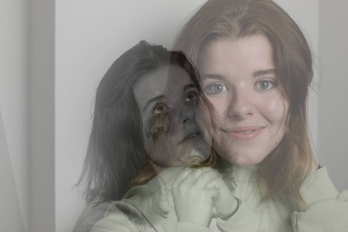
One of the main issues I struggle with within art, not just mine but generally. I see a lot of images, and I can tell they have been edited to an extent where you can’t tell what’s real or not. Then, when you see the original there’s barely any similarities. But, as a young girl seeing those images online, it ruins self esteem etc. ‘The pressure to be thin can have serious consequences. Research has linked the exposure of images of underweight air-brushed female bodies to unhealthy eating habits and decreased self-esteem.’ That’s why in some of my work I address this factor; for example, this is an image I made to show how someone could be living. They could seem happy online, but behind the screen in real life they could be very sad and depressed.

Bibliography.
Aesthetics.univie.ac.at. n.d. Art & Emotion. [online] Available at: <https://aesthetics.univie.ac.at/research/art-emotion/#:~:text=Art%20and%20Emotion,front%20of%20visually%20challenging%20stimuli> [Accessed 2 January 2021].
The Conversation. n.d. Three Simple Steps To Understand Art: Look, See, Think. [online] Available at: <https://theconversation.com/three-simple-steps-to-understand-art-look-see-think-33020> [Accessed 2 January 2021].
Morin, A., 2020. Help Prevent The Media From Damaging Your Teen's Body Image. [online] Verywell Family. Available at: <https://www.verywellfamily.com/media-and-teens-body-image-2611245> [Accessed 3 January 2021].

Practise-based writing:
An exhibition is a public event at which pictures, sculptures, or other objects of interest are displayed, for example at a museum or art gallery, an exhibition is for anyone who is interested, such as artists, students, or just anyone interested in the art. Due to the pandemic, I haven’t been to an exhibition this year, and I have studied a virtual exhibition. However, when I have been previously, the feeling of an exhibition was quite overwhelming because there’s so many pieces of work, so many places to look but it’s truly amazing to see all the hard work that has been put into the work and the exhibition itself. The exhibition I am looking at is Andy Warhol in the Tate Modern, London. The Andy Warhol exhibition was a temporary exhibition between 12th March 2020 – 15th November 2020. It’s a contemporary show which is indoors by a solo artist, he has created this exhibition to walk through his life/career and show you various aspects of it. This exhibition is trying to tell a story which is in fact Andy Warhol’s life story. After looking at the exhibition which is an online exhibition due to the current pandemic; I think it is a lot harder to see things, acknowledge the hard work that went into the exhibition and I think it’s holding back the potential for the exhibition. The work in the exhibition is in a certain order, he goes through the different stages in his life and career. He shows his first serious art film which was called ‘Sleep’ then he shows how his art has developed over the years. He shows his pop artwork and goes onto ‘The Factory’ which was a studio space where his career really blossomed. He has 12 different spaces for the exhibition, in each room there is a different title and a different experience. In ‘The Factory’ room you will see how his factory looked, in another room it’s called ‘Exploding Plastic Inevitable’ which you experience that he combined film with performance and music to create cinema. From what I can see, it looks like the images are hung at different heights throughout the rooms, I think this could be to create effect or to catch the attention of the audience/ If their hung at different heights, your eyes wander, they look at each image and really focus, rather than if they were in a straight line. Due to it being a virtual gallery experience, I definitely think the experience was dulled slightly because you can’t get the full view of the room properly, you just have snippets; but also, you can’t feel the atmosphere as well as if you were actually there. However, I think the curatorial decisions which were made by Andy Warhol were made very well, he knew how he wanted his exhibition to flow and how he wanted the work placed he did this to create the sense of a timeline. I think that due to this, his exhibition was better to view than if he just placed any type of pictures where he wanted rather than doing a different room per ‘topic’,
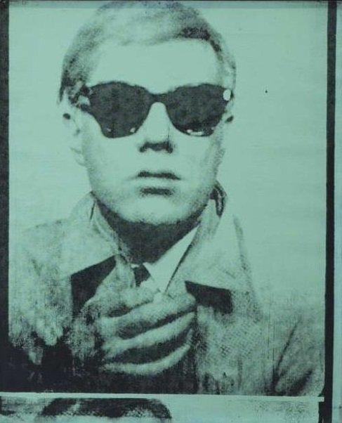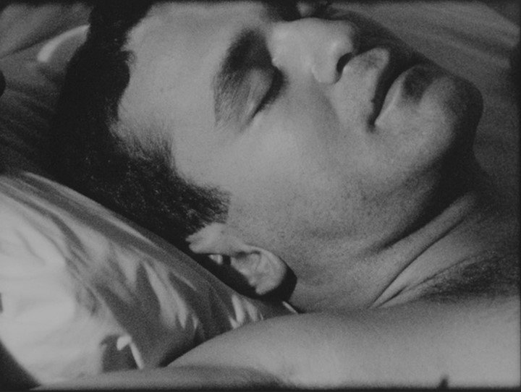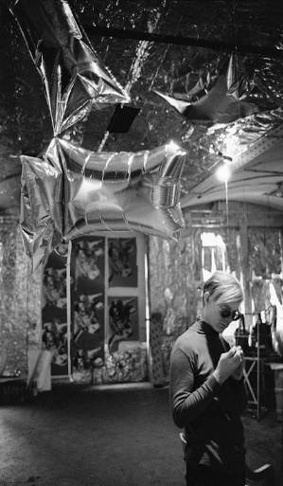
Bibliography.
Andy Warhol – Exhibition Guide | Tate
Video Link: https://youtu.be/ZjgAd6Z-dd0

