Electrical and Electronic Principles
Resonance

Robert Webb
2308625

Embedded Electronics Degree Apprentice Course

L4 – Electrical and Electronic Principles
ACDA4006

Table of Contents
Table of Figures 2
Abstract 3
1.0. Introduction 3
1.1. Parallel inductor Circuits: 3
1.2. AC Theory 4
1.3. Reactance: 4
1.4. Impedance: 4
1.5. Resonance 4
2.0. RLC Circuit Test Set-up 5
2.1. Simulated Circuit 1 5
2.2. Circuit 2 (Real world using Bread board) 6
3.0. Results 7
3.1. Simulated Circuit Results 8
3.2. Real World Circuit Results 8
3.3.Q-factor from Proteus Simulation and practical Experiment 9
4.0. Discussion 9
4.1. Result Differences 9
5.0. Conclusion 10
6.0. References 10

Table of Figures
Figure 1: Parallel Inductor Circuit. Source: https://www.electronics-tutorials.ws/inductor/parallel-inductors.html 4
Figure 2: Proteus Simulation Setup 5
Figure 3: Lab Circuit Setup 6
Figure 4: Lab Experiment Oscilloscope 7
Figure 5: Simulated Circuit Graph 8
Figure 6: Lab Circuit Graph 8
Figure 7: Proteus Simulation Q-Factor 9
Figure 8: Lab Experiment Q-Factor 9

Abstract
The following report will be looking at the operation and behaviours of an RLC which is known as a resistor, inductor and capacitor. This circuit was simulated via a computer simulation software and conducted within a lab in a real-world environment. The circuit’s that are being tested during this report are LC circuits with this the data being collected is to find the resonant frequency and Q-factor. This then continues on to show the differences in the data through the two different environments, the simulation and the lab. The simulated circuit ended up having a more precise and accurate results compared to the lab results. The author calculated the Q factor and the resonant frequency and compared the reasons for different values and why this happens.

Introduction

For this assignment, the author was tasked to simulate a LC tank circuit via proteus software and in the lab to then investigate the differences between the results and why this happened. Both circuits are simulated using the same values and components for the best results as well as to minimise errors within the results.
LC circuits comprise of two key components, capacitors (C) and inductors (L), these components are used due to their unique characteristics of being able to resonate and oscillate as well as being able to exchange and store energy between an capacitors electric field and a inductors magnetic field. [1]

1.1. Parallel inductor Circuits:

Parallel inductor circuits are made when both of the connections of an inductor are connected to another inductor, in parallel, this makes the configuration of this circuit can then be understood as ‘inductors in parallel’. Using a circuit with the inductor in this configuration allows the voltage changes to be the same across all of the inductors that are in the same series [2]. Whilst they may allow the voltage to be the same across the conductors the inductors do not share the same total current. In a parallel inductor circuit, the total of the current is calculated by the sum of each current and when the current flowing through an inductor is constant this means that there is no overall change to the currently in the whole circuit. When the potential changes in a circuit across an inductor there is an opposing force present that counter the change in current.
The calculation of the total inductance when the inductors are in parallel is based off of Kirchoff’s current Law, the equation is $\frac{I}{LT}=\frac{I}{L1}+\frac{I}{L2}+\frac{I}{L3}……+\frac{1}{LN}$ [2].
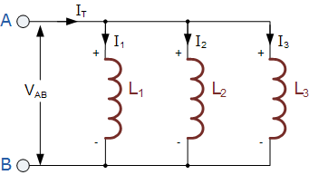
Figure 1: Parallel Inductor Circuit. Source: https://www.electronics-tutorials.ws/inductor/parallel-inductors.html

1.2. AC Theory
AC theory is based on the mathematical analysis of the electrical circuits’ behaviour where the voltage and the current changes over a period of time [3]. AC power is much more useful in electronics than DC power due to the ability of AC being able to step or step down whenever needed. AC power allows the ability to manufacture things like electric generators, power distribution systems, motors etc due to them being much more efficient than those of DC [4]

1.3. Reactance:
Reactance is known as a measure of the opposing forces that are provided by individual components such as capacitors and inductors through capacitance and inductance. [5] The reactance is the opposition from alternating current through capacitance and inductance. The reactance can be used to calculate the amplitude and the phase changes of the AC. With this there is inductive reactance which relates to positive values and capacitive reactance which relates to negative values, the greater the reactance allows a smaller current for a constant voltage. [6]
Reactance inductive equation: $XL=2π fL$ where ‘XL’ is the inductive reactance, ‘L’ is the inductance measured in Henrys and ‘f’ is the AC current frequency in Hz.
Reactance Capacitive Equation: $XC=\frac{1}{2πfC}$ where XC is the capacitive reactance in Ohms, ‘f’ is the frequency and ‘C’ is the capacitance in farads. [7]

1.4. Impedance:
Impedance is known as the measure of the total opposition that a circuit presents so supplied electrical current. The impedance of a circuit includes both reactance and resistance, the reactance is the opposition to the flow of electric charge that happens when the electric and magnetic fields change when oscillating in AC (Alternating Current). The resistance comes from the collisions between the charged particles and the conductor. [8] The magnitude of impedance can be shown as ‘Z’, this is equal to the potential difference’s maximum value divided by the total value of current ‘I’, this means the equation for impedance is $Z=\frac{V}{I}$. For the value of impedance, the unit is ohm ‘Ω’. [8]

1.5. Resonance
Resonance takes place in a circuit at a resonant frequency when the admittances or impedances cancel out. Resonance in a circuit that involves inductors and capacitors happens due to the magnetic field of an inductor collapses which generates an electric charge (Current). This current is generated in the windings which then charge the capacitor, visa versa when discharging a capacitor. It provides an electrical current which generates a magnetic field within the inductor which happens continuously, this can be seen as a simple harmonic oscillator. [9]

In the remainder of the report, the author will conduct experiments to find the differences between a simulated and a real-world LC/Resonant circuit. This will be done by collecting data from both experiments and comparing them using graphs. The author will explain about the experiment setups and how they conducted the experiments and what the differences where between the simulation and the lab experiment. The results will then be compared and differences between them explained with reasoning behind why the results are the way they are.

2.0. RLC Circuit Test Set-up

2.1. Simulated Circuit 1
This simulated circuit practical was conducted using proteus software, the software can simulate circuits in the most ideal conditions meaning that the results will be much more precise then experiments in real life.
In this setup the author copied the circuit from the assignment brief into proteus, after doing this the author used a signal generator to produce an output of 2 Vpk-pk, this peak-to-peak voltage was kept the same throughout the simulation as well as the lab simulation. The author then started at 100 Hz frequency using the signal generator, during the simulation the author would then take the measurements at a range of frequencies rising in increments up to a maximum of 20 kHz. The results shown on the oscilloscope in the simulation were the written up into an excel document to be calculated for attenuation and the dB attenuation.
Component list for practical:
- Capacitor (1µF)
- Resistor (1 kΩ)
- Inductor (1mH)
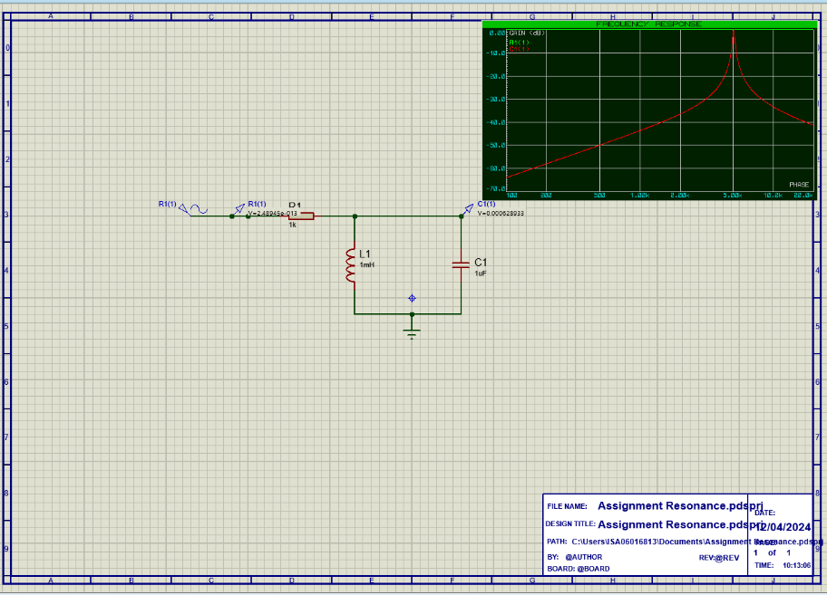
Figure 2: Proteus Simulation Setup

As shown in Figure 2 there is a graph that was generated by the proteus software of the dB Attenuation. The software did this after the author defined boundaries to the results logging, these boundaries were that the starting frequency was 100 Hz and to finish at 20 kHz. For this simulation, the author used decades as the interval with a no. steps being 1000 to get a good spread of data.
To calculate the dB attenuation the author used the equation $20 x log⁡(\frac{Vout}{Vin})$. This formula allowed the author to calculate the dB attenuation across the circuit. As stated, this data was then put into an Excel sheet to generate the graph. This equation converts the VL/Vin to dB VL where Vin is the voltage in. The data after the calculation the axis were plotted as X being the Frequency and the Y being Attenuation.

2.2. Circuit 2 (Real world using Bread board)
After simulating the circuit on proteus the author used a breadboard with the same components (as listed below) to simulate the circuit in a lab environment. The process was pretty much the same as the simulation circuit in terms of collecting results and the signal generator frequencies, the same frequencies were tested to ensure that the test was the same and to reduce error in the results.
Once the breadboard has had its components put in the author then connected the oscilloscope and signal generator to the circuit using some crocodile clips, shown in figure 3.
Component list
- Resistor (1kΩ)
- Inductor (1mH)
- Capacitor (1µF)
- Breadboard
- 2 Wires

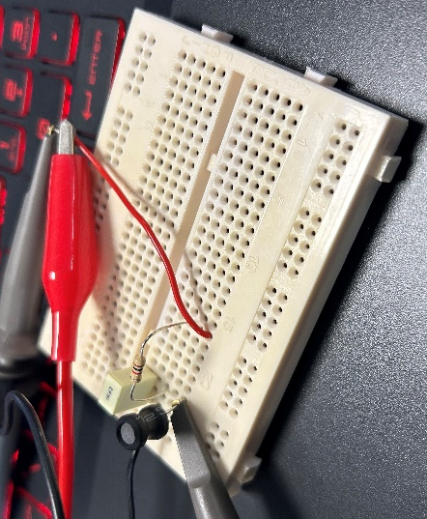
Figure 3: Lab Circuit Setup
During the test, the author would use a signal generator to input different frequencies and then take the values that were shown on the oscilloscope and add them to an excel document. The breadboard consisted of 3 components and 2 power cables which allowed the data to be collected just like in the simulation. The oscilloscope was connected via a leg of the capacitor and the Vin wire, this allowed the signals to be shown on the oscilloscope for collecting. With this the grounds were all connected to the other wire that was connected to the signal generator. The signal generator was then turned on and set to 100 Hz minimum and just like the simulation circuit was put up in increments to 20 kHz. Measurements were taken at the same increments as the simulation to make the test fair and as close to the same as possible.
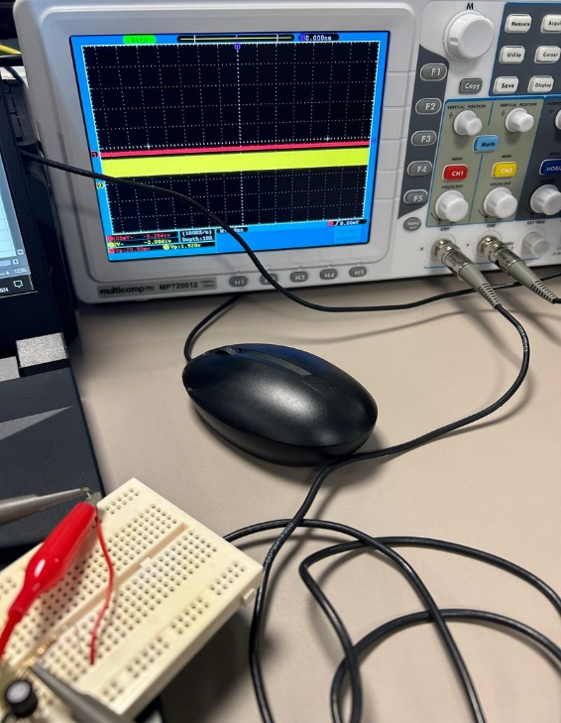
Figure 4: Lab Experiment Oscilloscope

3.0. Results
Q factor also known at the Quality factor which is used to measure the efficiency of the conversion of AC (Alternating Current) power to DC power (Direct Current). This rating of efficiency is a way of showing how easily a component will resonate at a set frequency or frequencies. The Q-factor is a parameter which is dimensionless therefore meaning it has no unit. [10] The Q factor of an inductor is infinite if put in an ideal environment while in a non-ideal environment the Q factor is much lower. Q factor can be calculated using the equation $Q= \sqrt{\frac{R^{2}C}{L}-\frac{1}{4}}$, where ‘R’ is the resistance, ‘C’ is the capacitance and ‘L’ is the inductance.

3.1. Simulated Circuit Results

Figure 5: Simulated Circuit Graph
Figure 5 shows the results of the circuit, which was tested using the simulation software, Proteus. The results being shown are the results of Frequency (f) against the Db Attenuation. This was worked out be using the attenuation results and using the equation $20 x log⁡(attenuation)$. This equation then gave the results which were plotted onto a scatter graph as shown.

3.2. Real World Circuit Results

Figure 6: Lab Circuit Graph
Figure 6 shows the results obtained from the lab experiment using a breadboard circuit. The results were obtained in the same way as the simulation results and then using the $20 x\log\left(Attenuation\right)$ equation. As shown in the graph the results were significantly different to the results obtained in the simulation circuit.
The common aspect between the two is that the peak of the graph which is known as the resonant frequency happens at the same frequency considering the conditions between the two. The difference is that the graph has a lower dB attenuation which shows a lower accuracy and efficiency within the circuit compared to the simulation.

3.3.Q-factor from Proteus Simulation and practical Experiment
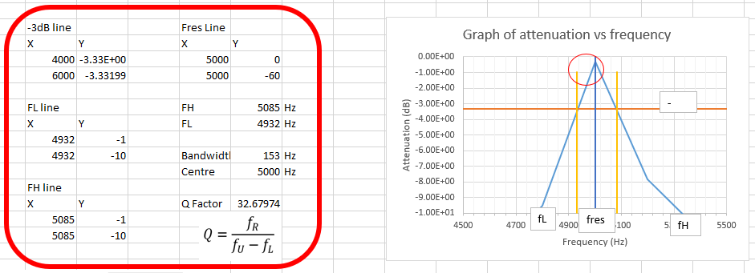
Figure 7: Proteus Simulation Q-Factor
The Q factor was calculated using $Q= \frac{f_{R}}{f_{U-f_{L}}}$ via an excel document which uses the bandwidth to calculate it. This document allowed the author to input data and worth out the Q factor for them. [11]
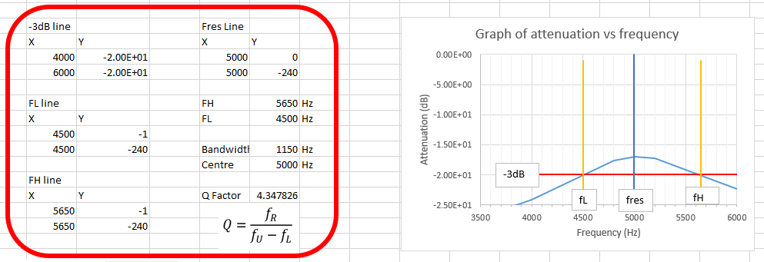
Figure 8: Lab Experiment Q-Factor

4.0. Discussion
Above showed the graphs from the two experiments that were conducted by the author. The graph was the best way to show the data due to the ability to precisely work out the q-factor from them and being able to easily show the differences between the results.

4.1. Result Differences
These results show a clear difference in data between a simulation test and a real-world test. The reason for this is due to the fact that the simulation can provide an ideal environment for the components. An ideal environment for testing circuits is when there is no resistance in any wires within the circuit and that the efficiency of the components are 100%, not only this but their tolerances are minimal meaning that they are for example, resisting exactly 10 Ω instead of 9.5 Ω. This is why the results for the simulation circuit are very precise with a steep graph. Comparing the simulation to the lab results it can be seen that the graph is much lower and less sharp; this is due to the environment in which the lab experiment experiences. This is that the wires connecting the components together will have some resistance which will affect the results in the circuit, not only this but due to the real world not being an ideal environment the components won’t be 100% efficient and higher tolerances. These factors overall cause the differences in the results between the two circuit’s which have been displayed in graphs to visually see the differences which helps to see just how large it is. The Q-factor for the lab circuit was 4.347 whereas the simulation Q-factor was up to 32.679 simply displaying that the simulation is much more accurate.
The resonant frequency (fr) of the simulation graph was 5032.92 Hz whereas the lab experiment resonant frequency was around 5000, to work this out the author used the equation $1/2×π×\sqrt{L ×C}$ [12]. This equation uses the capacitance and inductance of the circuit to fine the resonant. The lab experiment graph was calculated using the graph as said above. This point is when the frequency reaches its maximum degree of oscillation, this means that the resonant is the frequency at which the transfer function meets is max value.

5.0. Conclusion

In this experiment, it has been determined that the changes shown in the results is due to the environments being very different to each other when carrying out the experiments. The differences between the ideal environment in proteus and the conditions of a lab in the real world have shown that the components are much more efficient and have lower tolerances within the simulation, factors such as resistance are zero compared to real world.
In doing these experiments the author has found that:
- Real world conditions and component efficiencies are much lower than simulations.
- The resonant frequency is nearly the same for both circuits, only the ideal environment makes the resonant frequency be different to the simulation value.
- The Q factor is significantly different between the two circuits due to the environments not being ideal and that as above the tolerances and efficiency affect the results.
If the author was to repeate this again they would test each component individually for their tolerances, this way it will enable the author to make a more accurate circuit that will better represent the simulations, however this still won’t be as perfect as the simulations but closer than the completed lab circuit results.

6.0. References

[1] | Electricity - Magnetism , “LC Circuits,” Electricity - Magnetism , 2024. [Online]. Available: https://www.electricity-magnetism.org/lc-circuits/. [Accessed 24 April 2024].
[2] | ALLIED COMPONENTS INTERNATIONAL, “Inductors Connected in Parallel: What to expect,” Allied Components International, 29 March 2022. [Online]. Available: https://www.alliedcomponents.com/blog/inductors-in-parallel#:~:text=When%20both%20terminals%20of%20an,share%20the%20same%20magnetic%20field.. [Accessed 28 04 2024].
[3] | A. &. H.M.Howarth, “Althernating Current Theory,” Springer Link, 1991. [Online]. Available: https://link.springer.com/chapter/10.1007/978-94-011-3142-1_4#:~:text=Alternating%20current%2C%20or%20ac%2C%20theory,voltages%20vary%20periodically%20with%20time.. [Accessed 01 May 2024].
[4] | ElectronX Lab, “Chapter 1: Basic AC Theory,” ElectronX Lab, 2022. [Online]. Available: https://www.electronx.ca/education/ac-circuits/ac-chapter-1/. [Accessed 01 May 2024].
[5] | Testbook, “Reactance and Impedance: Explained with difference and importance,” Testbook, 03 May 2024. [Online]. Available: https://testbook.com/physics/reactance-and-impedance#:~:text=Reactance%20is%20the%20opposing%20force,down%20into%20resistance%20and%20reactance.. [Accessed 25 April 2024].
[6] | Wikipedia, “Electrical Reactance,” Wikipedia, 29 March 2024. [Online]. Available: https://en.wikipedia.org/wiki/Electrical_reactance. [Accessed 02 May 2024].
[7] | A.Bhatia, “Electrical Fundamentals - Reactane and Impedance,” 2020. [Online]. Available: https://pdhonline.com/courses/e239/CT-15-07-Content-Reactance.pdf. [Accessed 02 May 2024].
[8] | The Editors of Encyclopaedia Britannica, “Electrical Impedance,” Britannica, 01 March 2024. [Online]. Available: https://www.britannica.com/science/electrical-impedance. [Accessed 01 May 2024].
[9] | Wikipedia, “Electrical Resonance,” Wikipedia, 29 October 2023. [Online]. Available: https://en.wikipedia.org/wiki/Electrical_resonance#:~:text=LC%20circuits,-Main%20articles%3A%20LC&text=Resonance%20of%20a%20circuit%20involving,magnetic%20field%20in%20the%20inductor.. [Accessed 30 April 2024].
[10] | Testbook , “Quality Factor of LCR Circuit: Learn formula, Derivation and circuits,” Testbook , 26 May 2024. [Online]. Available: https://testbook.com/physics/quality-factor-of-lcr-circuit#:~:text=The%20quality%20factor%20of%20an,be%20linked%20series%20or%20parallel.. [Accessed 30 April 2024].
[11] | S. Mosey, “Parallel RLC Circuit Q Factor Example,” [Online]. Available: https://moodle.uwtsd.ac.uk/mod/resource/view.php?id=497010. [Accessed 24 April 2024].
[12] | Cadence PCB Solutions, “What is Resonant Frequency,” Cadence, [Online]. Available: https://resources.pcb.cadence.com/blog/2021-what-is-resonant-frequency. [Accessed 01 May 2024].

