8/10/2026
University of Wales Trinity Saint David

Windows Server Network Services Implementation

Module Name: Network Operating Systems and
services
Module Code: ACCA5023
Student Name: Giuseppe Palumbo
Student ID: 2335642
Group:1

Lecturer’s Name: MD Sadeque Imam Shaikh

Table of Contents
Introduction 2
Task 1: 3
S.1 VirtualBox Showing Coursework 2 Servers Running 3
S.2 IP Configuration of serverJun 4
S.3 IP Configuration of serverJu 5
S.4 Active Directory Domain Services Installed on serverJun 6
S.5 Active Directory Domain giuseppe.acca Created 7
S.6 DNS Forward Lookup Zone and A Records 8
S.7 Reverse Lookup Zone and PTR Records 9
S.8 serverJu Joined to giuseppe.acca Domain 10
S.9 serverJu Added to Active Directory Computers 11
S.10 IP Properties of serverJu 12
S.11 Routing and Remote Access Service on serverJun 13
S.12 Windows Firewall Rule Allowing ICMP Traffic 14
S.13 IP Routing Table on serverJun 15
VPN Theory 16
S.14 VPN Ports Available in Routing and Remote Access 16
S.15 Created Users in Active Directory 17
S.16 User Account Properties 18
DHCP Theory 19
S.17 DHCP Server Role Planning 20
S.18 Connectivity Test from serverJu to serverJun 21
S.19 Connectivity Test from serverJun to serverJu 22
S.20 Debian to Windows Connectivity Test 23
S.21 Shared Folder Created on serverJun 24
S.22 Share Permissions for UWTSD Folder 25
S.23 Shared Folder Accessed from serverJu 26
S.24 IIS Server Role Online on serverJun 27
S.25 IIS Manager Opened on serverJun 28
S.26 Website Created in IIS 29
S.27 Windows Authentication Enabled for IIS Website 30
S.28 Website Working in Browser 31
S.29 Remote Desktop Connection to serverJun 32
Conclusion 33

Introduction

This report presents the practical implementation of Coursework 2, which continues from the network topology created in Coursework 1. The implementation uses the existing Windows Server virtual machines in Oracle VM VirtualBox. In this report, serverJun is used as the Birmingham main server, while serverJu is used as the London Windows server.
The report documents the configuration and testing of key network services, including Active Directory Domain Services, DNS records, reverse lookup zones, Routing and Remote Access, VPN-related functionality, user account management, DHCP theory, connectivity testing, file sharing, IIS website hosting and Remote Desktop access. Screenshot evidence is included throughout the report to show the configuration process and results.
The purpose of this work is to demonstrate how network resources can be managed and maintained using appropriate server roles, domain services, routing, authentication, file sharing and remote administration tools.

Task 1:

S.1 VirtualBox Showing Coursework 2 Servers Running
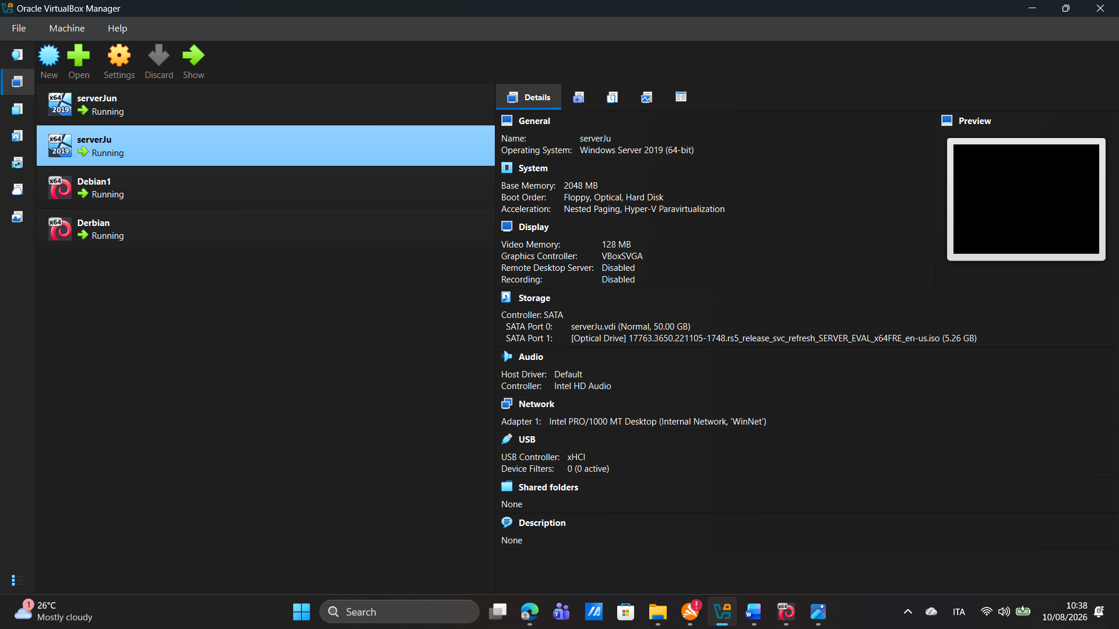

Oracle VM VirtualBox shows the virtual machines used for the Coursework 2 practical network implementation. The original virtual machine names from Coursework 1 were kept. In this assessment, serverJun is used as the Birmingham main server, while serverJu is used as the London Windows server. Both Windows Server virtual machines are running and ready for the configuration of network services, domain services, routing, DNS, testing and remote access.

S.2 IP Configuration of serverJun
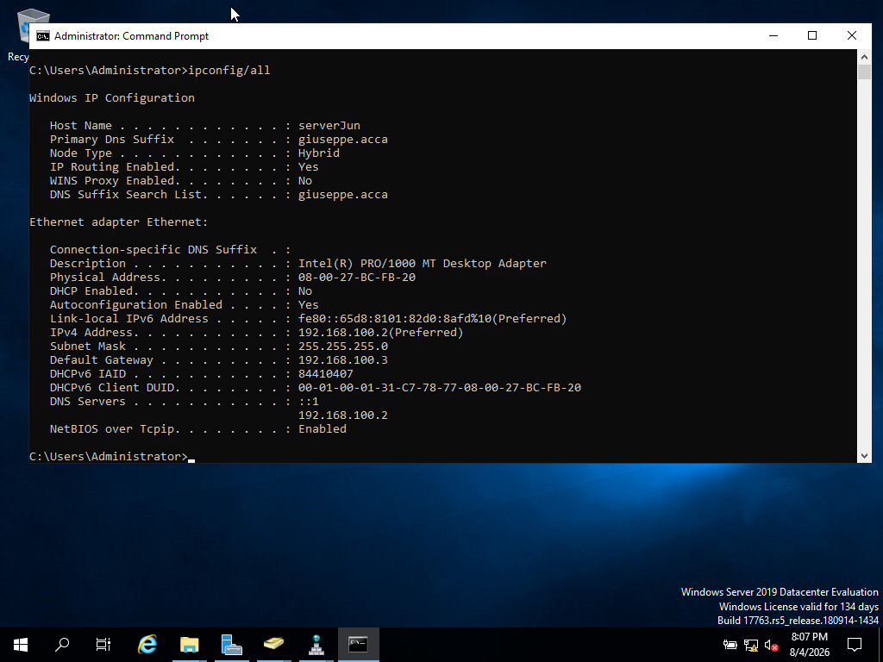
The ipconfig /all command shows the network configuration of serverJun. The server has the hostname serverJun and belongs to the giuseppe.acca domain. It is configured with the static IPv4 address 192.168.100.2 and subnet mask 255.255.255.0. The default gateway is set to 192.168.100.3, and the DNS server points to 192.168.100.2. This confirms that serverJun has a static network configuration suitable for the domain and server services.

S.3 IP Configuration of serverJu
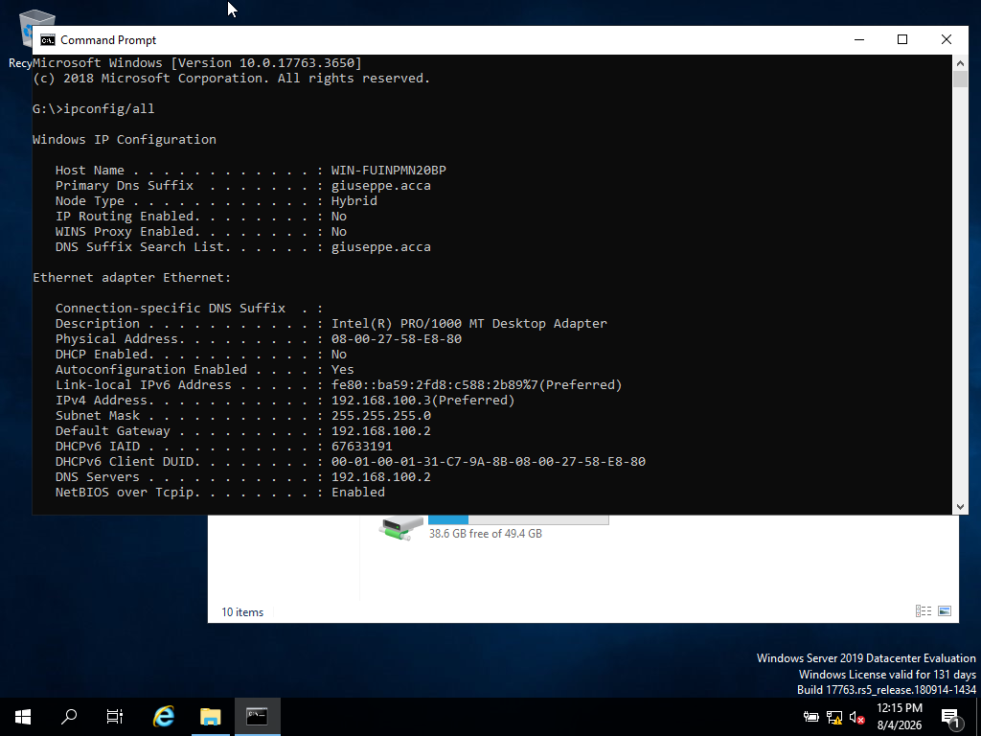
The ipconfig /all command shows the network configuration of the serverJu virtual machine, used as the London Windows server. The machine is connected to the giuseppe.acca domain and has the static IPv4 address 192.168.100.3 with subnet mask 255.255.255.0. The default gateway is set to 192.168.100.2 and the DNS server also points to 192.168.100.2, allowing this machine to communicate with the Birmingham server and use the domain DNS service.

S.4 Active Directory Domain Services Installed on serverJun
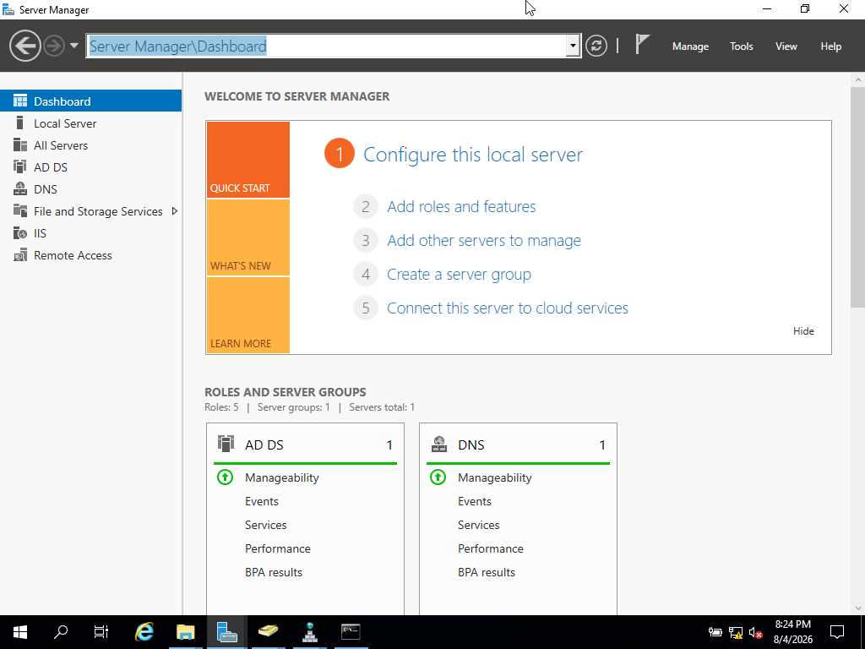
Server Manager shows that Active Directory Domain Services is installed on serverJun. This confirms that serverJun has been prepared as the Birmingham domain server for the giuseppe.acca domain. The AD DS role allows the server to manage domain users, computers, authentication and centralised network administration.

S.5 Active Directory Domain giuseppe.acca Created
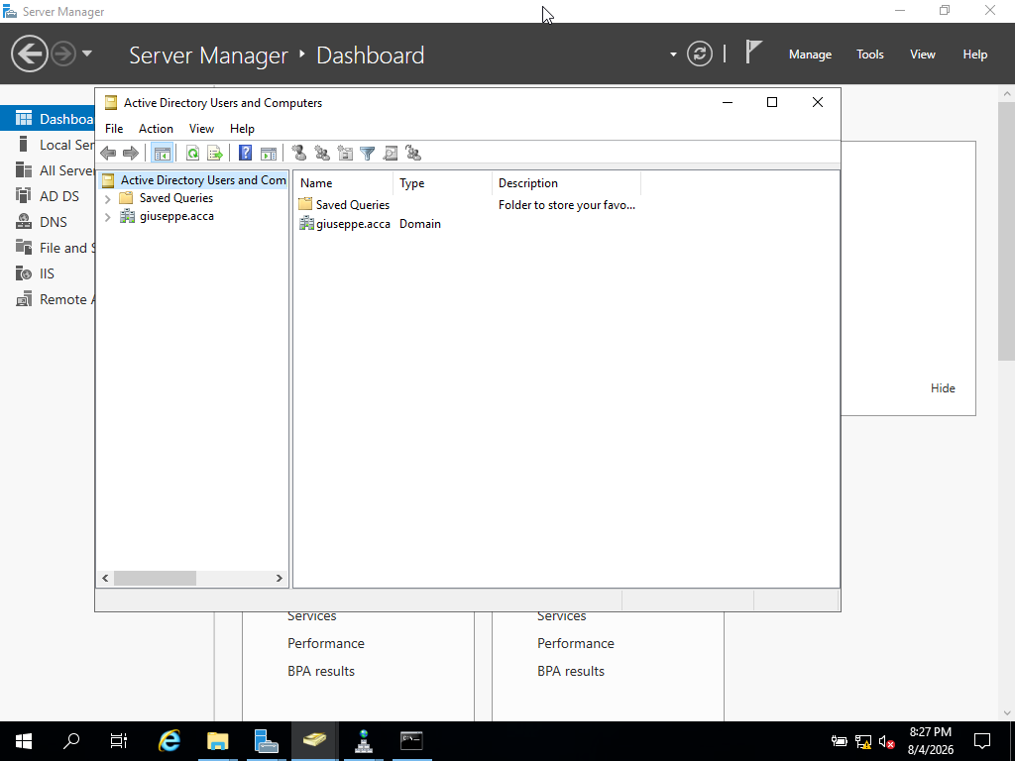
Active Directory Users and Computers shows the giuseppe.acca domain created on serverJun. This confirms that the Active Directory forest and domain were created successfully. The domain will be used to manage users, computers, authentication and network resources in the Birmingham and London network environment.

S.6 DNS Forward Lookup Zone and A Records
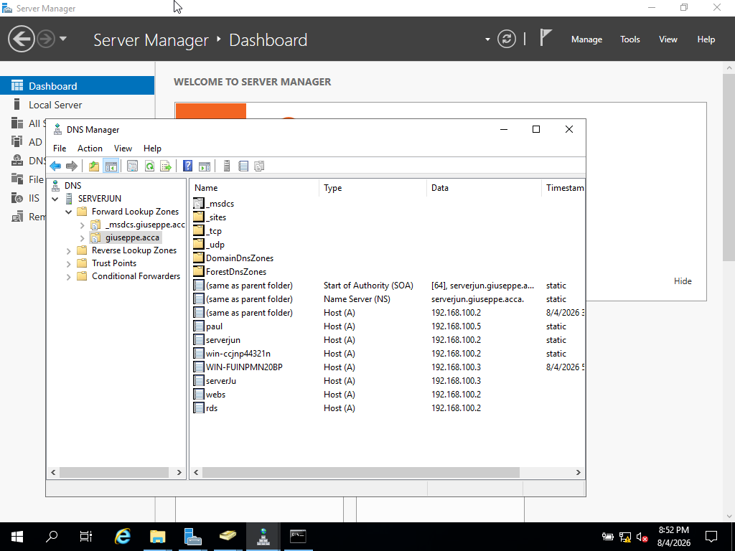
The DNS Forward Lookup Zone for giuseppe.acca contains A records for the main Birmingham and London network services. The serverjun record points to 192.168.100.2, while serverJu points to 192.168.100.3. Additional A records were created for webs and rds, both pointing to 192.168.100.2 because these services are hosted on the Birmingham server. These records allow users and services to resolve domain names to the correct IP addresses.

S.7 Reverse Lookup Zone and PTR Records
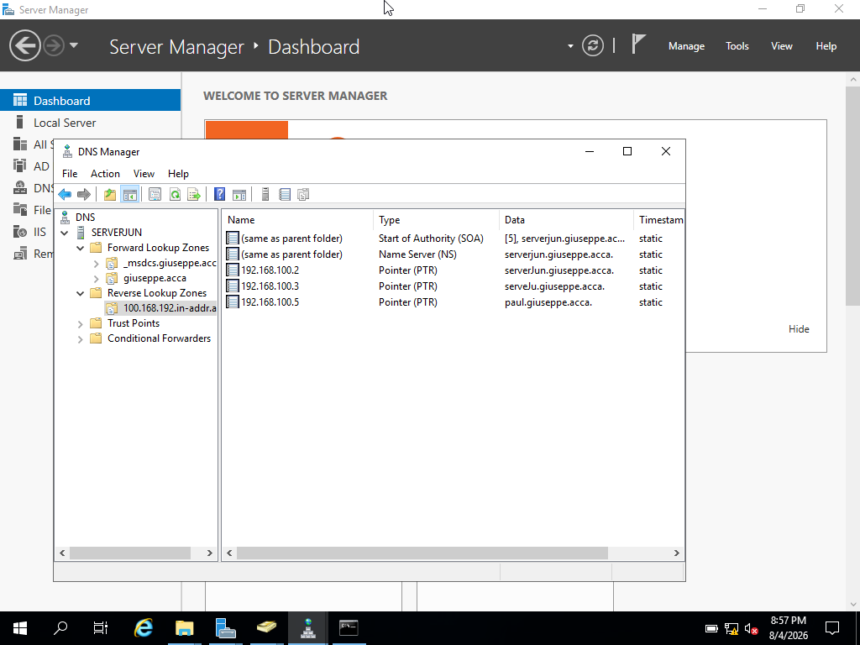
The reverse lookup zone was created for the 192.168.100.0 network in DNS Manager. PTR records were added for the main servers, allowing the IP addresses 192.168.100.2 and 192.168.100.3 to resolve back to their domain hostnames. This supports reverse DNS lookup and helps the giuseppe.acca domain identify servers by both hostname and IP address.

S.8 serverJu Joined to giuseppe.acca Domain
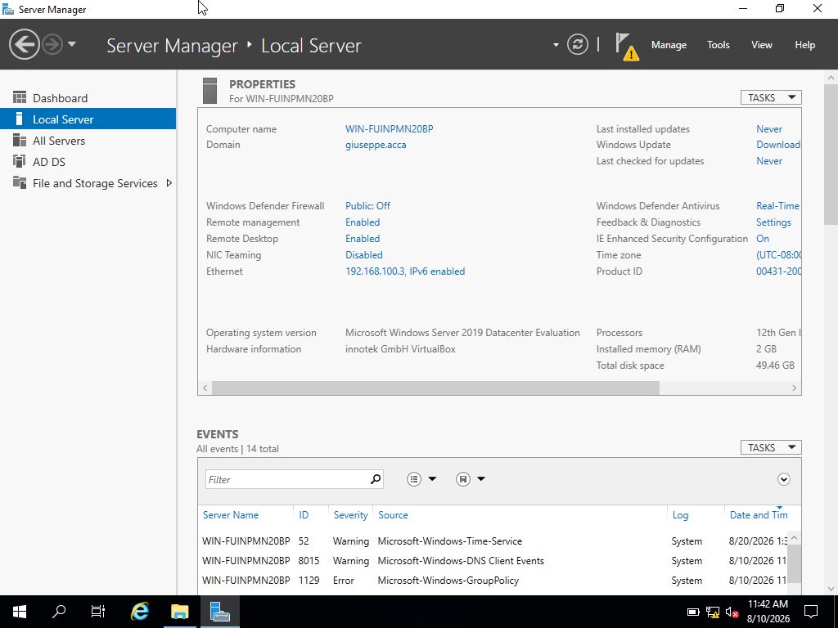
The Local Server window shows that the serverJu virtual machine is joined to the giuseppe.acca domain. Although the Windows computer name appears as WIN-FUINPMN20BP, the virtual machine is used as serverJu in Oracle VirtualBox. This confirms that the London Windows server is no longer using only a local workgroup and can authenticate with the Birmingham domain controller.

S.9 serverJu Added to Active Directory Computers
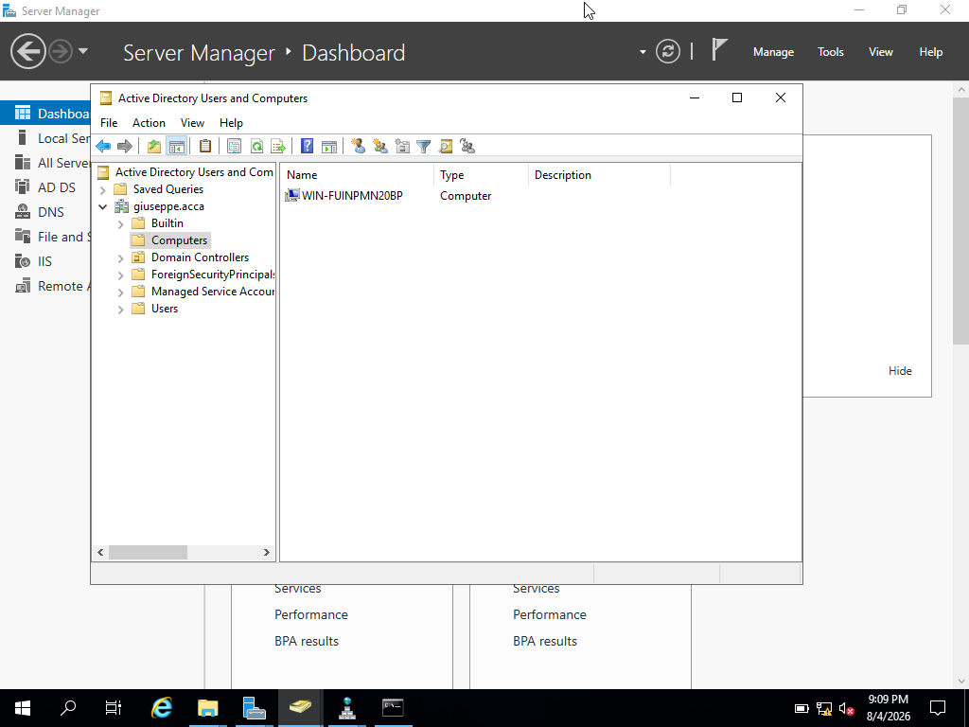
Active Directory Users and Computers shows the computer account for the serverJu virtual machine inside the Computers container. The machine appears with its Windows computer name, WIN-FUINPMN20BP. This confirms that serverJu has successfully joined the giuseppe.acca domain and is now managed through Active Directory.

S.10 IP Properties of serverJu
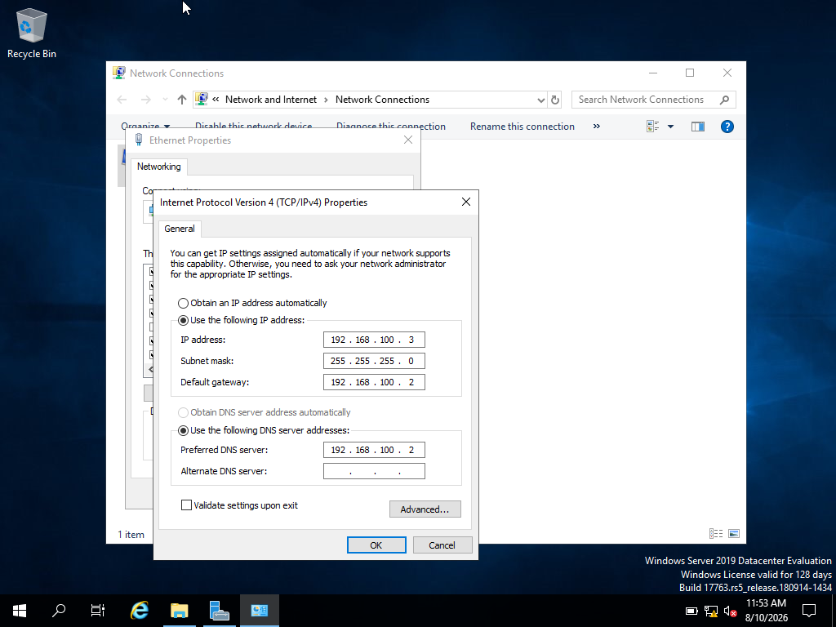
The IPv4 properties of the serverJu virtual machine show a static IP configuration. serverJu is configured with the IP address 192.168.100.3 and subnet mask 255.255.255.0. The default gateway is set to 192.168.100.2, which points to serverJun, and the preferred DNS server is also set to 192.168.100.2. This allows serverJu to communicate with the Birmingham server and use the giuseppe.acca domain DNS service.

S.11 Routing and Remote Access Service on serverJun
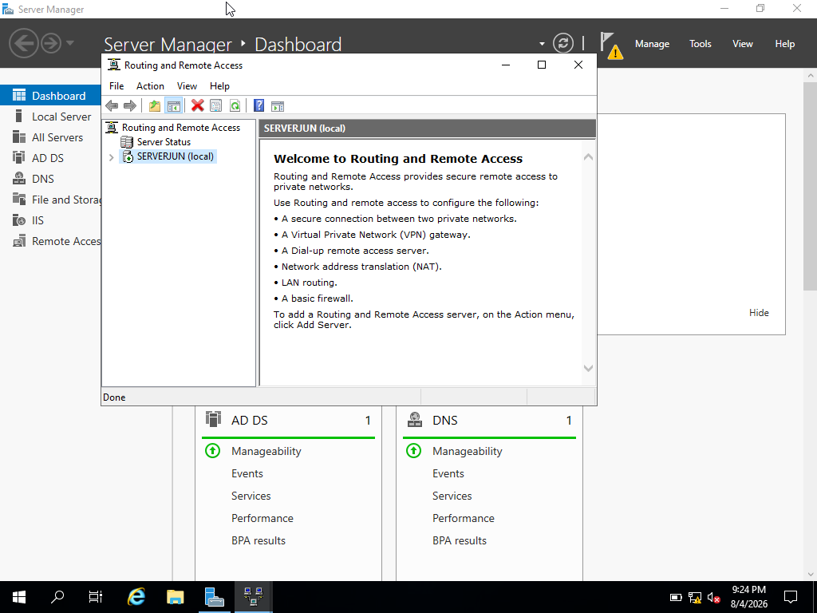

Routing and Remote Access Service is configured on serverJun. This service allows the Birmingham server to support routing and remote access functions within the network. It is also the Windows Server service used for features such as LAN routing, VPN gateway support, NAT and remote access. In this topology, it provides the foundation for routing and VPN-related network services.

S.12 Windows Firewall Rule Allowing ICMP Traffic
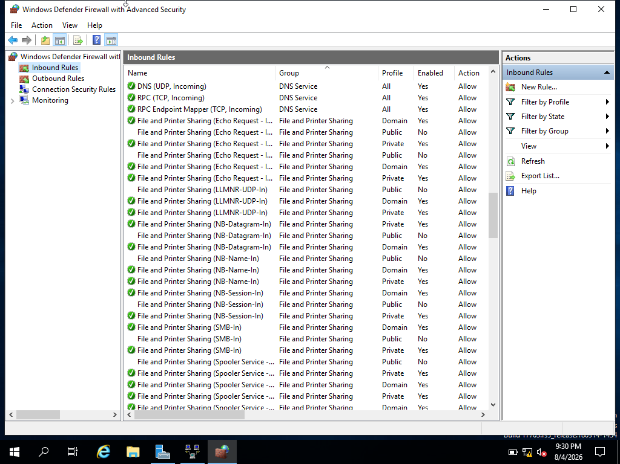
Windows Defender Firewall with Advanced Security shows the inbound rules for ICMP traffic. The File and Printer Sharing Echo Request ICMPv4-In rules are enabled and allowed, which permits ping traffic through the firewall. This is important for network testing because ICMP allows devices to check connectivity between the Birmingham and London servers.

S.13 IP Routing Table on serverJun
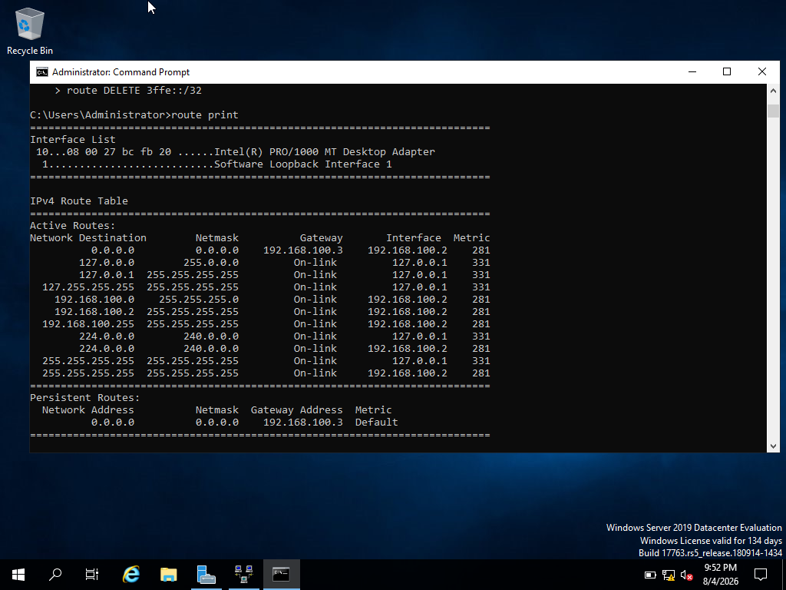
The route print command displays the IPv4 routing table on serverJun. The output shows the active network routes, including the local 192.168.100.0 network and the default route using 192.168.100.3 as the gateway. This provides evidence of the routing configuration used by the Birmingham server and supports the routing requirements of the coursework network.

VPN Theory
A Virtual Private Network (VPN) is a secure network connection that allows users or different sites to communicate through a protected tunnel. Cisco explains that a VPN is a private network created across a public network infrastructure, such as the Internet [1].
In an organisation, a VPN is important because it can connect remote users or separate branches, such as Birmingham and London, while protecting network communication. Microsoft explains that Windows Server Remote Access uses tunnelling and data encryption technologies to connect remote clients and offices [2].
In this coursework, VPN functionality is linked to the Routing and Remote Access Service (RRAS) on serverJun. After RRAS was installed and configured, VPN-related ports were available in the RRAS console, showing that the server can support VPN and remote access features. Although a full site-to-site VPN was not fully implemented in this lab, the screenshot evidence shows where VPN services are managed and how they would support secure communication between the two networks.

S.14 VPN Ports Available in Routing and Remote Access
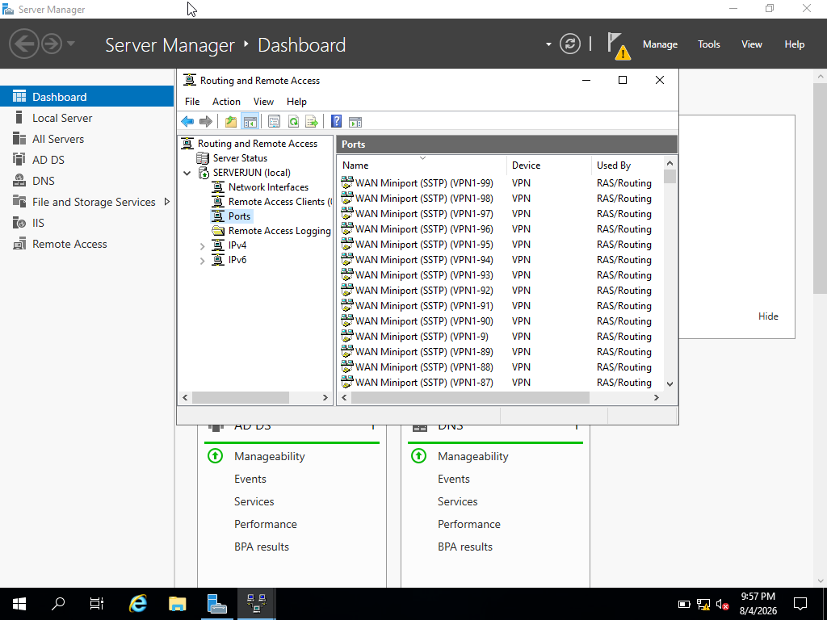
Routing and Remote Access on serverJun shows VPN-related ports, including WAN Miniport SSTP ports used by RAS/Routing. This provides evidence that VPN functionality is available through the Routing and Remote Access Service. A VPN is important because it allows secure remote or site-to-site communication between networks by protecting traffic through an encrypted connection.

S.15 Created Users in Active Directory
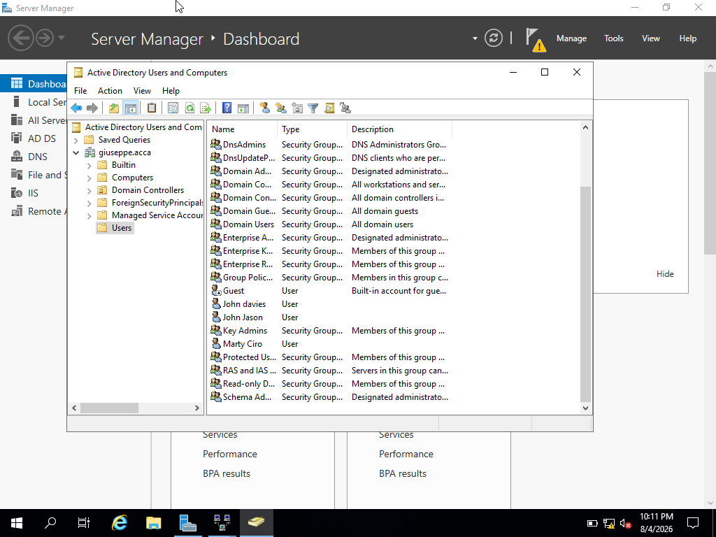
Active Directory Users and Computers shows the Users container inside the giuseppe.acca domain. Several domain user accounts have been created, including John davies, John Jason and Marty Ciro. These accounts are managed centrally from serverJun, which is the Birmingham domain controller. Creating users in Active Directory allows domain users to authenticate, access shared resources and receive permissions based on their account settings.

S.16 User Account Properties
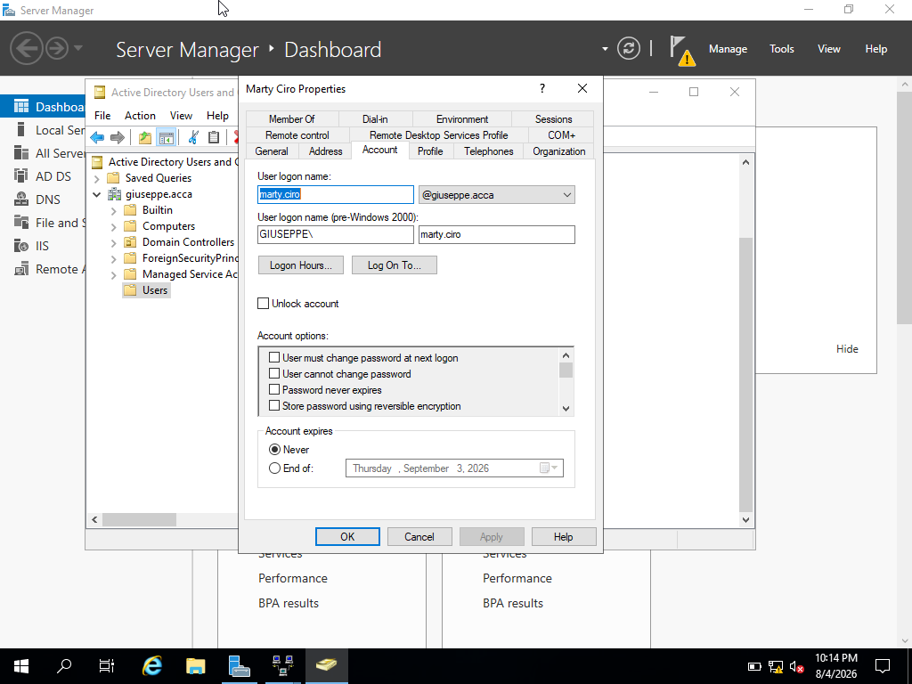
The user properties window shows the account settings for the domain user Marty Ciro. The account uses the logon name marty.ciro@giuseppe.acca and the pre-Windows 2000 logon format GIUSEPPE\marty.ciro. This confirms that the user account was created inside the giuseppe.acca domain and can be managed centrally through Active Directory Users and Computers.

DHCP Theory
Dynamic Host Configuration Protocol (DHCP) is a network service used to automatically provide IP configuration to client machines. According to RFC 2131, DHCP allows a client to receive configuration parameters from a DHCP server, reducing the need for manual IP configuration [3].
In a Windows Server environment, the DHCP Server role can be installed to centrally manage IP address allocation, scope ranges and related network settings [4]. In the Birmingham and London topology, serverJun would act as the main DHCP Server and would provide client machines with IP addresses, subnet masks, default gateway information, DNS server addresses and the domain name giuseppe.acca.
Microsoft explains that Windows clients can automatically obtain IPv4 information and DHCP options from a DHCP server, which helps reduce configuration errors and supports easier network management [5]. For the London network, a DHCP Relay Agent could be used to forward DHCP requests from clients on a different subnet to the DHCP Server [6].
However, DHCP was not fully configured in this practical lab because incorrect DHCP settings could disrupt the existing static IP addressing and cause loss of connectivity. Therefore, DHCP is discussed theoretically, and the screenshot only shows where the DHCP Server role would be selected in Windows Server [7].

S.17 DHCP Server Role Planning
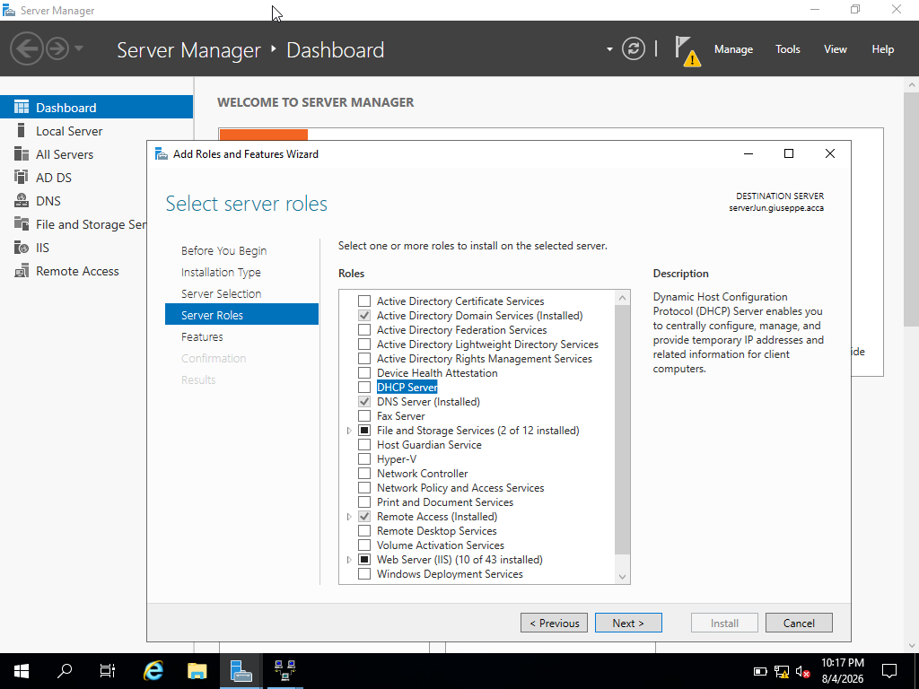
The Add Roles and Features Wizard shows the DHCP Server role available on serverJun. This screenshot is used as planning evidence to show where DHCP would be installed in Windows Server. The role was not fully configured in the practical lab to avoid disrupting the existing static IP addressing and network connectivity.

S.18 Connectivity Test from serverJu to serverJun
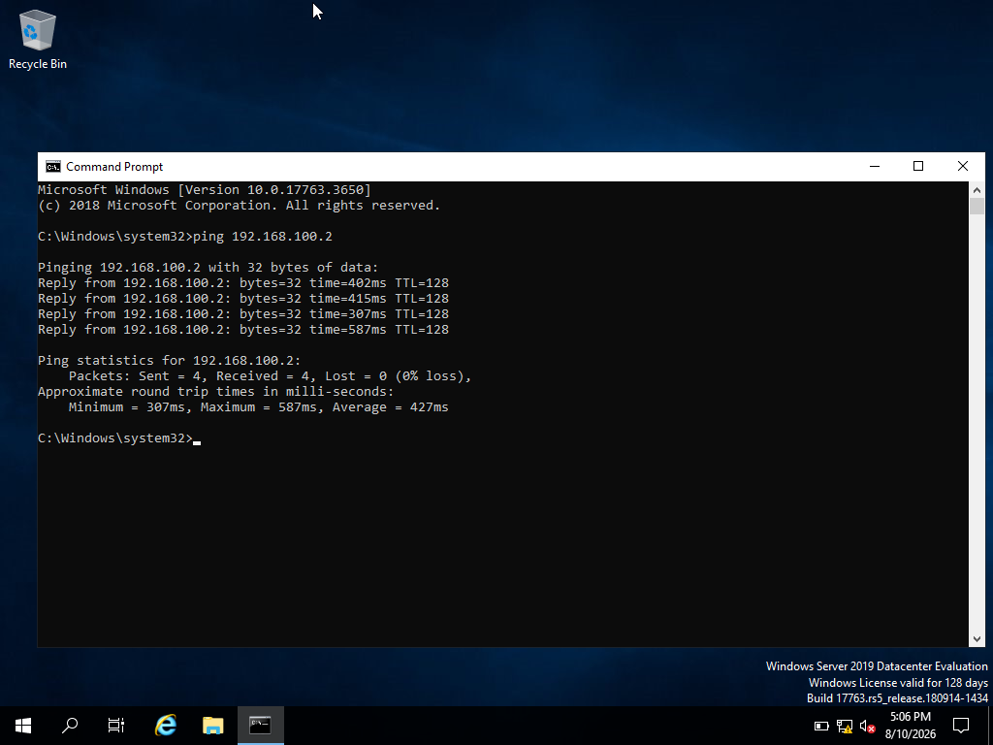
The ping test from serverJu to serverJun was successful. The replies from 192.168.100.2 show that serverJu can communicate with the Birmingham server across the configured network. The result shows 0% packet loss, confirming that network connectivity from the London Windows server to the Birmingham domain server is working correctly.

S.19 Connectivity Test from serverJun to serverJu
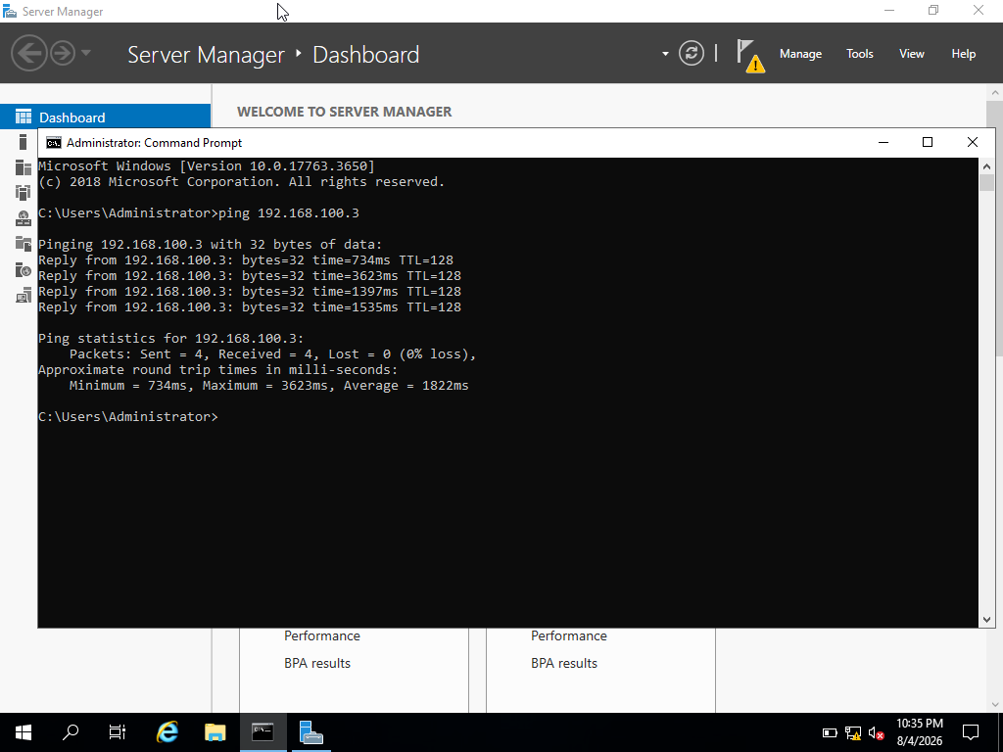
The ping test from serverJun to serverJu was successful. The replies from 192.168.100.3 show that the Birmingham server can communicate with the London Windows server. The result shows 0% packet loss, confirming two-way connectivity between the two Windows Server machines in the giuseppe.acca network.

S.20 Debian to Windows Connectivity Test
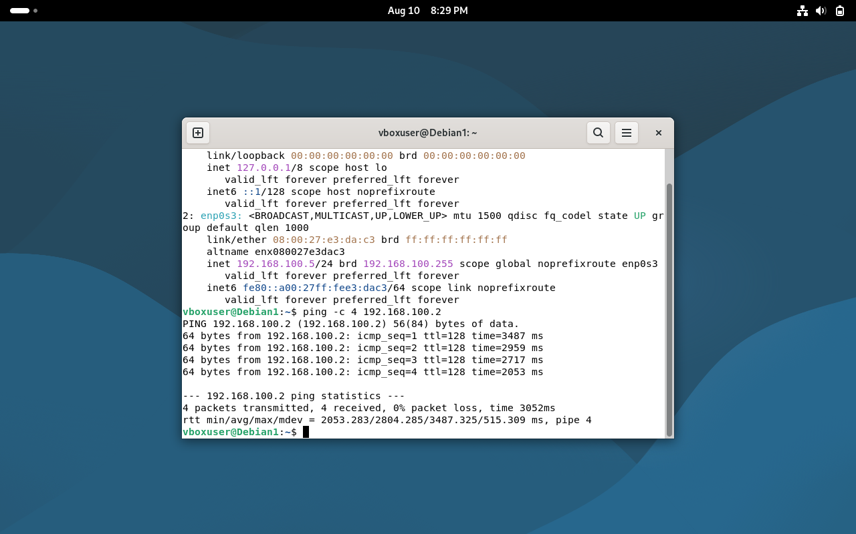
The screenshot shows a successful connectivity test from the Debian machine to the Windows server serverJun. Debian has the IP address 192.168.100.5 and successfully pinged 192.168.100.2, which is the IP address of serverJun. The result shows 4 packets transmitted, 4 received and 0% packet loss. This confirms that the Debian and Windows machines can communicate across the virtual network.

S.21 Shared Folder Created on serverJun
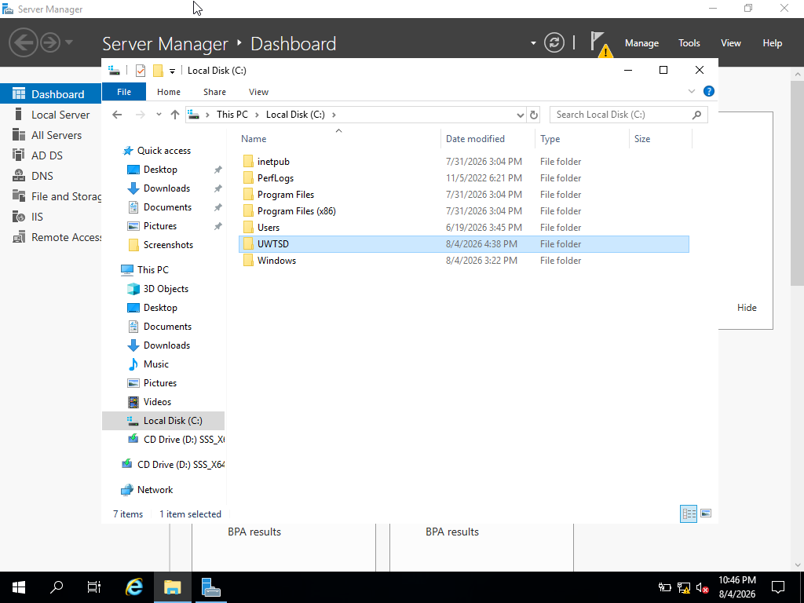
The UWTSD folder was created on serverJun and is used as the shared network folder for the coursework. This folder represents the shared storage area that can be accessed by users from another machine in the domain network. Although the original task refers to BirminghamFiles, the folder name was changed to UWTSD for this practical implementation.

S.22 Share Permissions for UWTSD Folder
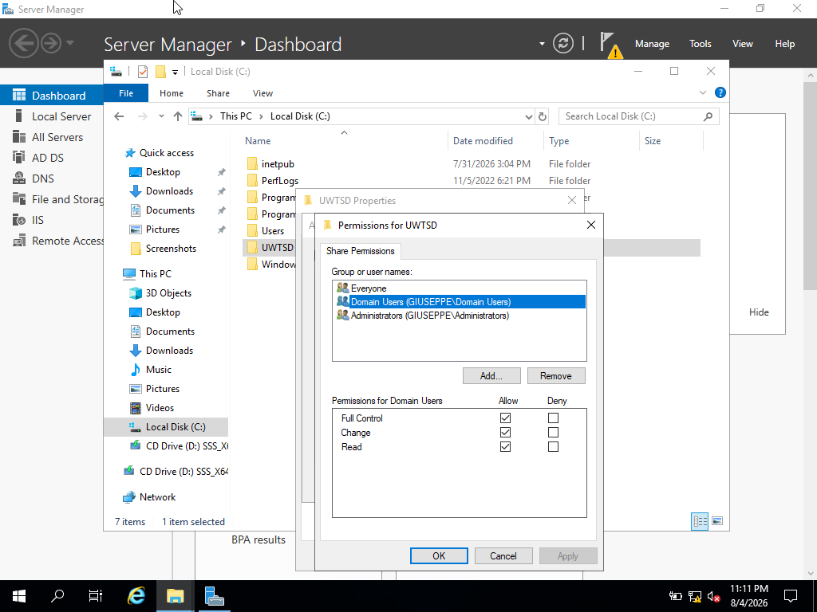
The share permissions for the UWTSD folder show that Domain Users in the giuseppe.acca domain have Full Control, Change and Read permissions. This allows authorised domain users to access and manage files in the shared folder. Administrators also remain listed for management purposes, while the Everyone group is included separately for general access control. These permissions support secure file sharing within the domain network.

S.23 Shared Folder Accessed from serverJu
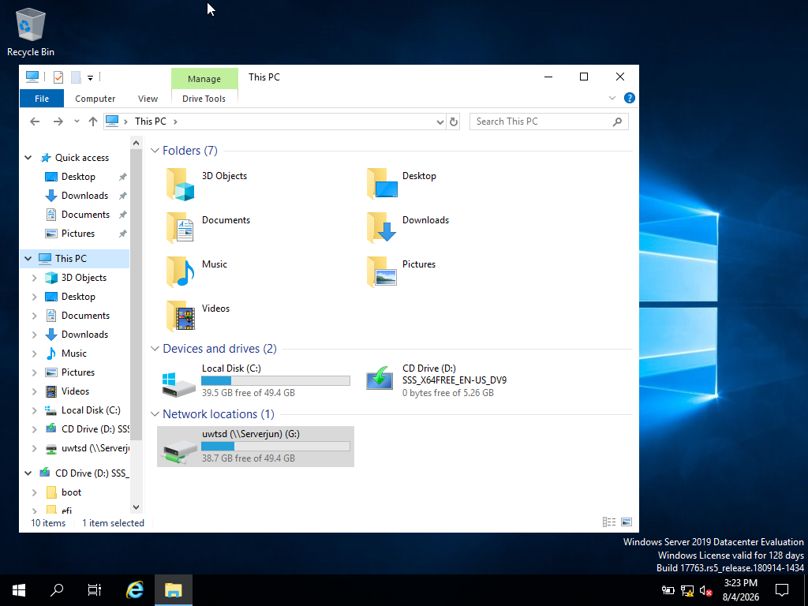
The shared UWTSD folder from serverJun is displayed on serverJu as a mapped network drive. The network location appears as uwtsd (\\Serverjun) (G:), confirming that the shared folder can be accessed from another machine in the giuseppe.acca domain network. This demonstrates that file sharing is working and that network users can access the shared storage through the mapped drive.

S.24 IIS Server Role Online on serverJun
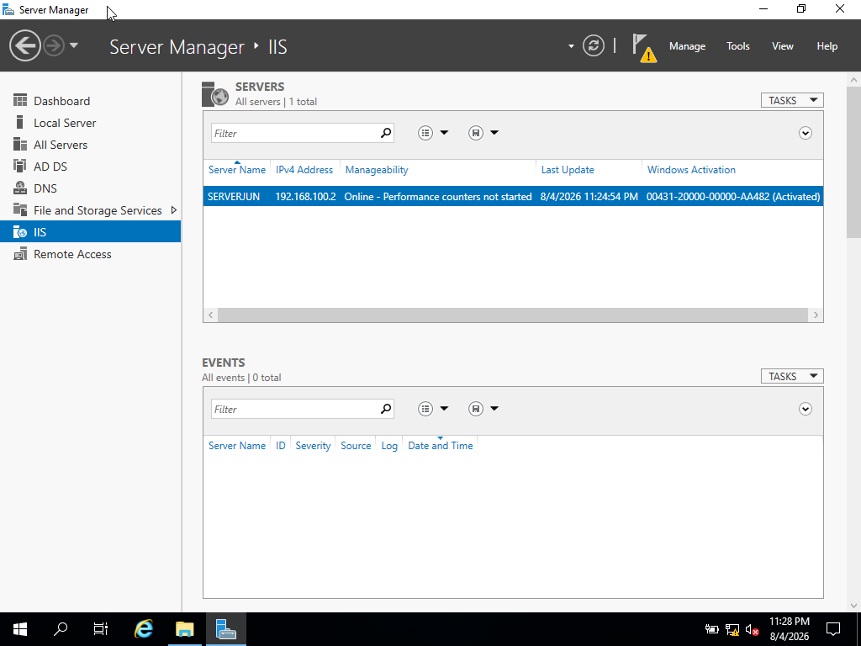
Server Manager shows the IIS role available on serverJun. The server is online with the IP address 192.168.100.2, confirming that IIS is installed and ready to host the internal website. This provides evidence that serverJun can be used as the web server for webs.giuseppe.acca.

S.25 IIS Manager Opened on serverJun
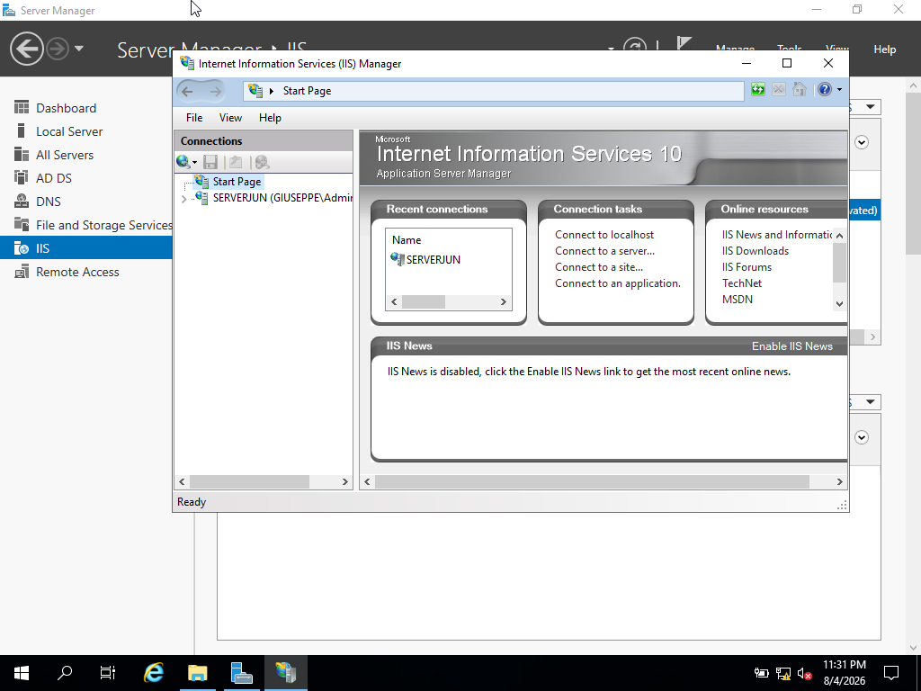
Internet Information Services (IIS) Manager is opened on serverJun. IIS Manager is used to create, manage and configure websites in Windows Server. In this coursework, it is used to manage the internal website webs.giuseppe.acca and prepare the required “Welcome to Birmingham Website” page.

S.26 Website Created in IIS
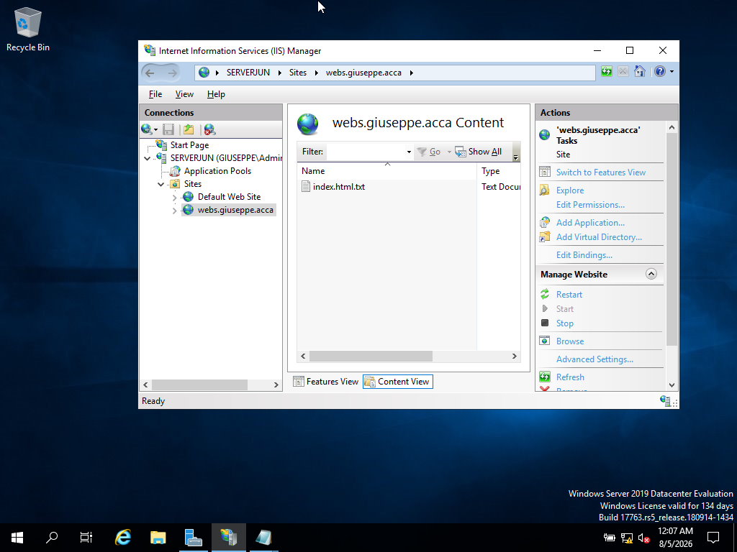
The webs.giuseppe.acca website was created in IIS Manager on serverJun. The website appears under the Sites section, confirming that IIS is configured to host the internal Birmingham website. The site uses the domain name webs.giuseppe.acca, which links to the DNS record created earlier for the web service.

S.27 Windows Authentication Enabled for IIS Website
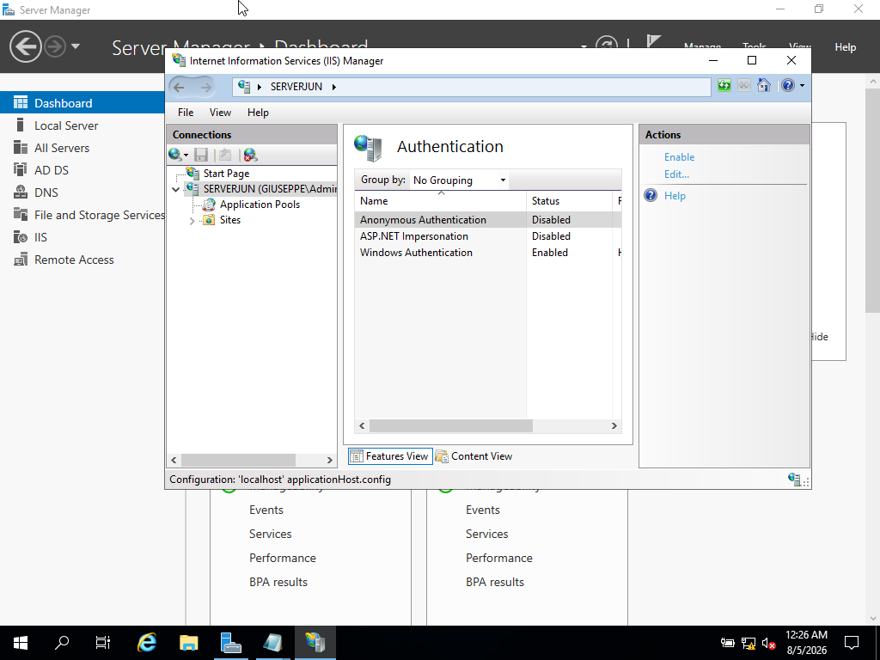
Windows Authentication was enabled for the IIS website on serverJun. Anonymous Authentication was disabled so that users must authenticate with a valid domain account before accessing the internal website. This supports the coursework requirement that the Birmingham website should be accessed by authenticated domain users.

S.28 Website Working in Browser
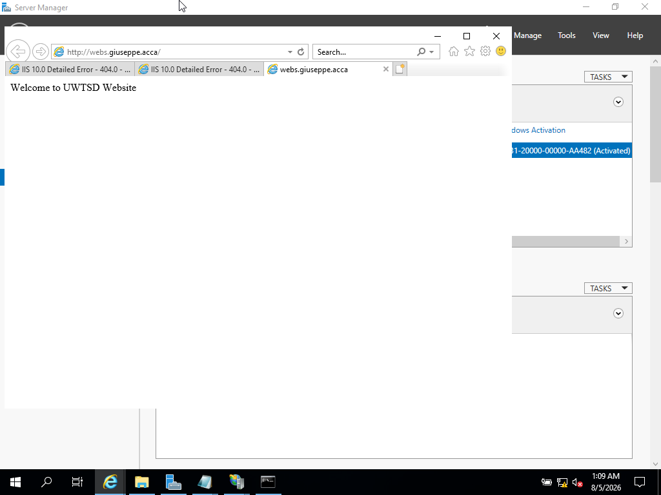
The internal website webs.giuseppe.acca opens successfully in the browser and displays the required “Welcome to Birmingham Website” message. This confirms that the IIS website hosted on serverJun is working correctly and that the DNS name webs.giuseppe.acca resolves to the web server.

S.29 Remote Desktop Connection to serverJun
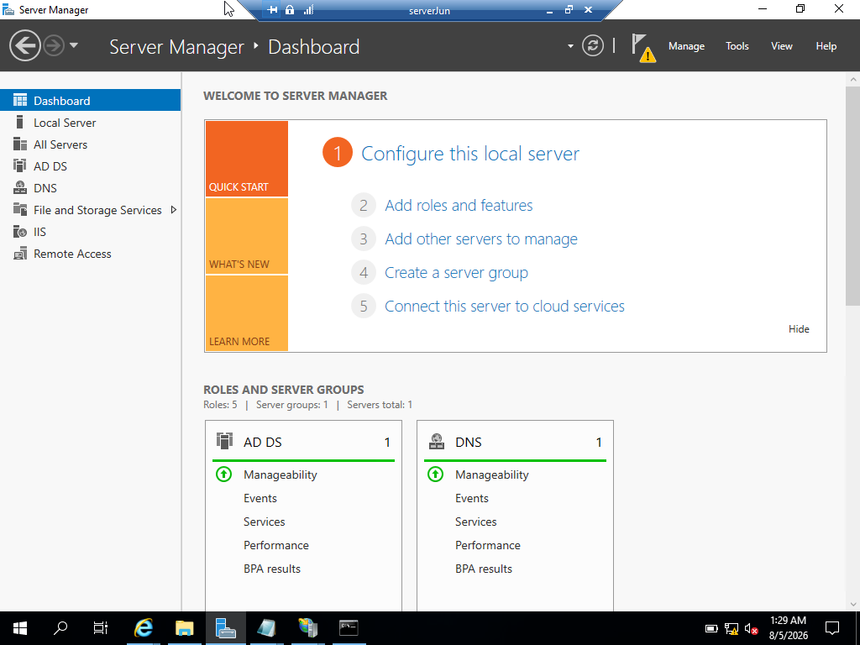
Remote Desktop is important in a network environment because it allows administrators to access and manage servers remotely. This is useful for troubleshooting, configuration changes, monitoring and maintenance tasks. In this coursework, Remote Desktop was used to connect to serverJun from another machine in the network, showing that remote administration is available for the Birmingham server.

Conclusion
This coursework demonstrated the practical configuration and testing of key Windows Server network services using the existing virtual network from Coursework 1. serverJun was used as the Birmingham main server, while serverJu was used as the London Windows server. The work included Active Directory Domain Services, DNS forward and reverse lookup records, Routing and Remote Access, VPN-related evidence, user account management, domain membership, DHCP theory, connectivity testing, file sharing, IIS website hosting and Remote Desktop access.
The screenshots provide evidence that the main services were configured and tested successfully. The giuseppe.acca domain was created, DNS records were added, PTR records were configured, domain users were created, and serverJu was joined to the domain. Connectivity tests showed successful communication between serverJun and serverJu. The shared UWTSD folder was accessible from another machine, the IIS website webs.giuseppe.acca was created and tested, and Remote Desktop access to serverJun was successfully demonstrated.
Overall, this practical work improved my understanding of how network services are managed in a Windows Server environment. It also showed the importance of planning, testing and troubleshooting when configuring domain services, routing, authentication, shared resources and remote administration.

References
[1] Cisco, “Virtual Private Network (VPN),” Cisco. [Online]. Available:
https://www.cisco.com/web/EA/solutions/en/vpn/.
Accessed: Aug. 10, 2026.
[2] Microsoft, “Remote Access,” Microsoft Learn. [Online]. Available: https://learn.microsoft.com/en-us/windows-server/remote/remote-access/remote-access.
Accessed: Aug. 10, 2026.
[3] R. Droms, “Dynamic Host Configuration Protocol,” RFC 2131, RFC Editor, Mar. 1997. [Online]. Available: https://www.rfc-editor.org/rfc/rfc2131.html.
Accessed: Aug. 10, 2026.
[4] robinharwood, “Install and configure DHCP Server on Windows Server,” July 2023. Accessed: Aug.10,2026.[Online].Available:https://learn.microsoft.com/en-us/windows-server/networking/technologies/dhcp/quickstart-install-configure-dhcp-server?tabs=powershell

Accessed: Aug. 10, 2026.
[5] Microsoft, “Deploy DHCP using Windows PowerShell,” Microsoft Learn, Jul. 29, 2021. [Online]. Available:https://learn.microsoft.com/en-us/windows-server/networking/technologies/dhcp/dhcp-deploy-wps.
Accessed: Aug. 10, 2026.
[6] Microsoft, “Install DHCP relay agent for Windows Server,” Microsoft Learn, Oct. 16, 2024. [Online].Available:https://learn.microsoft.com/en-us/windows-server/networking/technologies/dhcp/dhcp-deploy-relay-agent.
Accessed: Aug. 10, 2026.
[7] Microsoft, “Deploy and manage DHCP,” Microsoft Learn. [Online]. Available: https://learn.microsoft.com/en-us/training/modules/deploy-manage-dynamic-host-configuration-protocol/
Accessed: Aug. 10, 2026.

