What Makes A Great Leader
university of wales trinity saint david

Jorna Ali (1706149)
2019
Contents
Introduction 2
Task one 3
The life of Benazir Bhutto 3
Task Two 5
Leadership Theories and Models. 5
Managerial Model 5
John Adair’s Action Centred Leadership Model 6
Tannenbaum and Schmidt – Leadership Styles Continuum 7
Kurt Lewin – Styles of Leadership 8
French and Raven – Leadership and Power 9
Benazir Bhutto 9
Task Three 11
Positives of Benazir Bhutto 11
Negatives of Benazir Bhutto 11
Leadership and Motivation 13
Task Five 14
Self – reflection 14
Task Six 15
How I would bring change. 15
Appendices 17
Appendix 1- Tannenbaum and Schmidt - Leadership styles continuum 17
Appendix 2 – Kurt Lewin- Styles of leadership 17
Appendix 3 18
Appendix 4 20
Bibliography 23

Introduction
In order to evaluate what makes a great leader, the following case study will be based on the political leader, Benazir Bhutto. As a way of establishing her leadership style, the case study will critically analyse her leadership qualities and traits. task 1 will look at the life of Benazir Bhutto. Task 2 will identify the traits and styles of Bhutto using leadership model and theories. Task 3 will critically evaluate how Bhutto planned for change. In Task 5 and 6 the author identifies her leadership style and evaluates her personal ability to fulfil the key leadership responsibilities and manage change in the role of class representative for level 6 BA Leadership and Management and also in her roles within her family.

Task one

The life of Benazir Bhutto
According to Drucker (1974, p.10) “leadership is lifting a person’s vision to high sights. The raising of a person’s performance to a higher standard. The building of a personality beyond its normal limitation”. Burns’s (1978) defined leadership as:
the reciprocal process of mobilising by persons with certain motives and values, various economic, political, and other resources, in a context of competition and conflict, in order to realise goals independently or mutually held by both leaders and followers.
Leadership is no longer associated with commands and control but with inspiration, support and getting people to follow of their own accord. (Sharma and Jain, 2013).
Benazir Bhutto (also known as Pinkie to her family) was born on 21st of June 1953, in Karachi Pakistan (Doherty, 1990). The first child of Nusrat Ispahani and Zulfikar Ali Bhutto, who was one of Pakistan’s wealthiest landowning families and an Oxford graduated lawyer. Benazir was born into a life of privilege and wealth, her father being a barrister and politician who became the 9th Prime Minister of Pakistan in 1973 (Doherty and Doherty, 1990). Bhutto went to study at Harvard University and then University of Oxford, where she was made President of the Oxford Union. Her course of study included government and law, through which she investigated women’s rights and developed her skills for democratic principles and liberation (Shaikh, 2000).
Benazir’s parents provided her with the best education available from an early age. She was a shy but happy child. Often Benazir’s parents used to be away, and Benazir was given the responsibility of keeping the household money from the age of eight (NowThis World, 2018) from this young age Benazir began to develop management and leadership traits. For instance, when one of her professors, Michael Walzer, criticised Pakistan and its military policies for its role in the civil war in East Pakistan, Benazir stood up in class at school and refuted his statements (Bhutto, 1988). Her impassioned defence of her country at such a young age was the first indication of what a moving and powerful public speaker she would become. Zulfikar Ali Bhutto would include Benazir in his political travels whenever he could, taking her on visits to foreign countries and discussing foreign policy with her. Consciously or subconsciously, he was in fact preparing her to follow in his footsteps (Doherty and Doherty, 1990).
In 1977, Bhutto returned to her native Pakistan, only to be placed under immediate house arrest. Her family’s leadership had been overthrown by a military coup – led by General Zia ul Haq – and the following year her father was executed after being convicted for authorising a murder. Benazir then became the leader of the Pakistan People’s Party (PPP), but moved to the United Kingdom in 1984, where she became party’s joint leader in exile (Allen, 2016). On her return to Pakistan in 1986, she began her election campaign, and in November 1988 her party won a majority of seats in the National assembly (Sekine, 1992).
Following her marriage to Asif Ali Zardari in 1987, she then went to become the first woman (and, at the age of only 35, the youngest person) in the role of leading the government of Muslim minority state (Bhutto, 1988).
In 1990, her government was dismissed due to corruption charges, and following the elections in the Autumn of that year, Nawaz Sharif was voted into power. Benazir Bhutto then served as the leader of the opposition for the following three years, until her party was re-elected to power in October 1993, allowing her to continue with her reform proposals. However, yet again, she was dismissed from power upon corruption charges by the President of the time, Farooq Leghari (Bhutto, 1988).
Whilst in power, Benazir faced many controversies, including the assassination of her brother during a failed coup in 1995 and accusations of bribery against herself and her husband, leading again to the dismissal of her government. Following the election defeat of the PPP in 1997, Bhutto placed herself in exile in Dubai and was later convicted of corruption by Swiss court in 2003. Benazir returned to politics, following America’s support in negotiations Pervez Musharraf, and found herself in great opposition to rising Islamic violence. Following several attempts on her life, Benazir Bhutto was finally assassinated during a political rally on the 27th of December 2007 (Shaikh, 2000).
Opinion remains that Bhutto was a very controversial leader. Her time in power was littered with accusations of bribery and corruption, and criticism for being so politically in-experienced. Her lack of popularity amongst Pakistani’s Islamic extremists was perhaps centred upon the fact that she was a woman, and also for her attempts to modernise the political agenda of the country. Even so, her early years in power were supported by many in her country, and she also attracted the support of countries in the West who were in support of her desire to promote democracy (Bhutto, 1988). After her death, she also became an iconic figurehead for the cause of women’s rights and was seen to have mostly succeeded in the role of a woman in power in a totally male dominated society.
Benazir was bold and fearless; her life is a symbol of courage and untiring struggle. In the New Guinness Book of Record 1996, Bhutto was mentioned as the world’s most popular politician (Hassan, 2016), also the Australian Magazine and The Times listed Benazir Bhutto as one of the 100 most powerful women in the world.

Task Two

Leadership Theories and Models.
According to Cambridge University (2016), Leadership in the modern world has to take place by accounting for current trends in civil society and global pressures. Specific theories exist to help guide leaders to do their job effectively.
Modern management style needs to meet objectives and complete the job properly. In the nineteen eighties, command and control styles seemed normal, but later, collaborative and coaching styles became recognised to be more effective.
Currently, there is more focus upon management style and the way leaders, and the managers treat their employees.’ Leadership’ style has been replaced by the term ‘management’ style in the workplace. (CMI, 2015).
Leaders are not born to many but created. Nevertheless, in order to be a good leader, it is generally recognised that one must have the experience, expertise, dedication, endurance and, most importantly, the ability to negotiate and cooperate with others to achieve goals. Good leadership is built through an endless process of self-study, learning practise and the accumulation of relevant experience (Bass & Bass, 2008).
We can understand leadership models as guides recommending specific behaviours of leadership to be used in a particular environment or circumstances. Graphical representation is used to illustrate the appropriate leadership behaviour. (Amanchukwu et al, 2015).
The following literature provides an overview of several different styles of leadership theories and models, starting with the Managerial Model, as devised by Don Clark (Ajami and Goddard, 2018).

Managerial Model
This specific theory model can be set out comprising the following factors:
A Managerial Grid which focuses upon a leader's concern for the task and concern for people to predict leadership outcomes (Ajami and Goddard, 2018). This model requires strong leadership which is integrated within management, suggesting that management and leadership cannot be segregated. It also dictates that a manager organises, directs, and controls activities of an enterprise towards a specific end whilst inspiring confidence and trust in other staff members. The Managerial model has been evaluated within studies and concentrates on concern for people and concern for tasks. Within this, 2 studies have broken it down further, and they are
  - (Ohio) Consideration (concern for people) and Initiating structure (concern for tasks)
  - (Michigan) Employee Orientation (concern for people) and Production Orientation (Concern for tasks.
It is possible however, that a leader can be strong in one of these behaviours but weaker in the other, but still be part of the same continuum, according to Michigan. However, Ohio considers these 2 behaviours to be independent. Ultimately a leader needs to be good with both, but this is not always the case.
It could be suggested this model is too simplistic as it is based on two types of leadership styles and in real life it is not that simple. There are leaders who are both task and people oriented who are excluded from this model. In addition, this model does not consider cultural differences and modern-day globalisation. In many cultures’ men are held higher esteem than women so even if the leader was people orientated culturally, he would more in favour of male colleagues. A prime example is Benazir Bhutto.

John Adair’s Action Centred Leadership Model
The second model that will be looked at is John Adair’s Action Centred Leadership Model (Adair, 2007). All of the following three elements are part of this theory:
Task, Team and Individual.
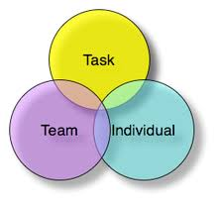
(Wikipedia, 2019)
A leader should be able to use each element according to the situation, needing to keep the right balance, to get results, and build morale.
These three elements are represented by overlapping circles (integrated within each other). To achieve the task, Adair advises that we need to connect the team to the task:
- Inspire team with a compelling vision
- Unite the team with common purpose
- Equipped the team with shared values
This creates the passion, the belief and the culture for success.
Need to equip the Individual for the task through:
- One on one coaching.
- Delegation of task that will grow the individuals.
- Creating a culture of visible empowerment that demonstrate trust and belief in each person.
Accelerate the team development with
- Create clarity around team roles.
- Provide interpersonal skills training for each member
- Encourage the team member to share responsibilities both for successes and any problem along the way.
Core functions of leadership vital to the action centred leadership model are:
  - Planning
  - Initiating
  - Controlling
  - Supporting
  - Informing
  - Evaluating
The leader who seeks to integrate the three elements of task, team and individual is likely to succeed (Adair, 1979).
It could be considered that the potential failing of this model is the fact that each element relies on the other elements. If one fails it all fails. In addition, supporting this model is time consuming and modern-day business, time is money and therefore leaders would need to have a good HR team and allow enough time not only to implement this model but continually review it.

Tannenbaum and Schmidt – Leadership Styles Continuum
Some business leaders are autocratic, they prefer to tell their team exactly what to do. Other business leaders prefer a much more democratic, participative approach. They join with employees in decision making, they make them feel and actually are part of the decision-making process. Of course, there are lots of other business leaders whose style might be in-between, telling employees what to do and joining them. That’s the idea of Tannenbaum and Schmidt Continuum. It was developed in 1958 by two contingency theorist called Robert Tannenbaum and Warren Schmidt, who suggested that there is a ‘continuum’ of leadership behaviour. Continuum measures the extent to which a manager is given authority to make decisions and the area of freedom available to non-managers (Tannenbaum and Schmidt, 2009). Continuum identifies four main styles of leadership; tells, sells, consults, and joins. (Definitions in appendix 1).
Therefore, the key thing about the Continuum is that there are four main styles of leadership, namely Tells, Sells, Consults and Joins.
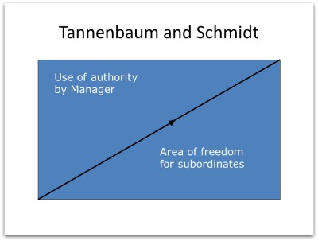
(Practical management skills, 2014)
On the left-hand side of the Continuum is the ‘Tell’ part of the continuum, which it is suggested is a very autocratic way of leading and on the right-hand side is the ‘Joining’ employees, participating and decision making with them and effectively empowering them to find the solution for themselves, which is a very democratic approach to leadership.
This model unlike the Managerial Grid considers of baring leadership styles and therefore includes the mixed method leaders, that Managerial Grid excluded. This model is now over 60 years old but still highly relevant in modern day business.

Kurt Lewin – Styles of Leadership
In 1939, Psychologist Kurt Lewin led a study that identified three core styles of leadership and outlined the effect that each style had upon the team members. His finding has influenced many of today’s leadership theories and approaches (Komarov and Aloyan, 2017).
Three core leadership styles identified were:
- Authoritarian (autocratic) leadership
- Participative (democratic) leadership
- Delegative (laissez-faire) leadership
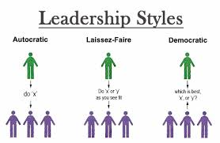
(Big Hugeo, 2017)
Authoritarian (Autocratic) leadership is when leaders, lead in an authoritarian way, making decisions without consulting the team members. They tell, rather than ask. This can cause disengagement in the team, even causing people to be aggressive and hostile; and it can lead to high absenteeism and increase staff turnover.
Participative (democratic) leaders have the final say on decisions, but they involve team members in the decision-making process. The downside of participative leadership is that it can slow the decision-making process which can lead to missed opportunities.
Delegative (Laissez-faire) leadership is very much hands-off. It allows the team members to set their own goals and deadlines. This kind of leadership is most effective when team members are highly motivated and highly skilled.
Similarly, to Tannenbaum and Schmidt model (Tannenbaum and Schmidt, 2009), this model included leadership style which were excluded but the Managerial Grid model. With the use of this model a leader can analyse their leadership style and if requires modify it.
An example of an Authoritarian leader is Alan Sugar because he rules by fear, (Behan, 2007). One of his many famous quotes are “Fair? The only fair you’re gonna get is your bloody train fare home”. An example of a participative leader is Richard Branson, he treats his employees like a family, with respect and as equals. He say’s “no one can be successful alone, and you cannot be a great leader without great people to lead” Chris, (2015). Whereas an example of a laisses-fair leader would be Queen Victoria (Future of working, 2019) as people in the United Kingdom worked hard using their talent and skills and she would stay out of their business unless it was necessary remarking that “Heaven helps those who help themselves”.

French and Raven – Leadership and Power
Two social psychologist, John R. P. French and Bertram Raven identified five types of power in 1959 (Blois and Hopkinson, 2013). The five types of power:
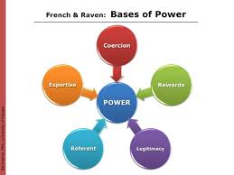
(Cheryl Stanley, 2019)
- Coercive power – comes from one’s ability to punish someone else for noncompliance. For example, this can be through fear of losing job.
- 2.Reward power – comes from one’s ability to issue rewards. For example, through bonus or to have time off in lieu.
- Legitimate power – comes from a person’s formal rights to issue directives or commands because of their position in the organisation, for example the CEO has the right to dictate the strategy.
- Expert power -comes from one’s experience or specialist knowledge. For example, a senior surgeon will display the expert knowledge to trust them.
- Referent power – comes from being trusted or respected, for example this is when someone refers to you as a role model.
The five bases of power are split between two categories of power
- Formal power = position
- Personal power = followers. (Appendix 2).
It could be considered that this model is most inclusive of all the models mentioned in this paper. As it identifies and categories the power. It allows for an in-depth leadership style and analyses that is holistic can be broken down in small section allowing for certain leadership traits to be improved upon and modified.

Benazir Bhutto
Benazir Bhutto was a democratic leader on many occasions (but not all) but if she had applied the above models and theories such as John Adair’s (2007) approach to the three centred leadership style, there would have been an emphasis on leadership which utilises the three elements (see above) which include ‘team’, ‘task’ and ‘individual’ on any situation. In Adair’s view, these elements combined to achieve balance and good team morale. For example, team values, vision and purpose in Adair’s model are enhanced when the three elements are kept in harmony.
However, this theory has been criticised as all the elements are interdependent and one when fails this has been known to collapse the system. It is unlikely that Benazir Bhutto used this type of leadership approach as her style was closer at times to the ‘autocratic’ style of leadership we find in Lewin’s (1959) threefold description of leaders as either 1. authoritarian (autocratic) leadership, 2. participative (democratic) leadership or 3 delegative (laissez-faire) leadership. Despite this, it is possible to see that there was also a democratic element in her style of leadership which was closer to the second type of leadership style described by Lewin (1959) and therefore there is evidence of a ‘continuum’ between the two styles (autocratic and democratic) which is described by Tannenbaum and Schmidt, (2009) in their management theories which were developed in the late 1950s.

Task Three
According to Northouse (2018), great leaders will have faith in their beliefs, they will put the wellbeing of others first. They earn respect, they would have to know the team working beside them. Leaders need to understand people, are the centre of everything. A good leader has strong and positive character traits which includes honesty, humility and integrity, they help people to reach their goals. Ambition is important, not for themselves but for the people. Typically, they are able to motivate people and not force them and prefer to lead by example.
Benazir Bhutto was a courageous leader and exhibited many of the core leadership styles we are familiar with today and which appear in the management literature. For example, she demonstrated visionary leadership traits particularly in her pursuit of democracy in her home country (Bhutto, 1988). She wanted to improve the country politically and economically. The fact that she was the first woman to govern her country was a key part of her leadership, and she states
“As a woman leader, I thought I brought a different kind of leadership. I was interested in women’s issues, in bringing down the population growth rate … as a woman, I entered politics with an additional dimension- that of a mother “(BBC world service, 2019).
This was not carried out as she found it difficult to manage all of the responsibilities of government because of her commitment to her family. She was trying to live her father’s dream, governing the country the way her father governed it. As a female she had the responsibility of being a wife and mother and she became Prime Minister a few months after giving birth to her child.

Positives of Benazir Bhutto
Benazir was renowned for being charismatic and for having a keen eye for detail and was a great pragmatist. She was also regarded as a strong leader, although she was not always successful at healing the divisions within Pakistani culture. Looking back upon her time in power, we can see that she was a very positive role model for millions of Pakistani girls and women (Allen, 2016). She had determination, and persevered with the problems that faced her, against all odds. In Pakistan, the idea that being a woman does not mean that you cannot achieve anything, is rooted in Benazir’s political career (Shah, 2014).

Negatives of Benazir Bhutto
The tragedy of her father’s death was inextricably linked to the political path of the country that she was trying to govern. As a result of this, perhaps her personal history stood as a barrier to her overcoming the problems that faced her; she was also a bit constrained by her responsibilities to her family. Her attempts at being progressive were faced with having to deal with “two diametrically opposed positions, one addressed competitive democratic process, the other remained heavily autocratic.” (Ziring, 1991). This situation made it difficult to reconcile these opposing forces, and Benazir failed in creating a deal between her political opposition in Karachi, Punjab and the provinces of the frontier; this weakness led to her needing to gather a loyal band of followers around her. It also meant that she did not have the power to actually change the fundamentalist laws that were degrading to women, and she could do little to help the poor. Brooke (2016, cited in Bhatia, 2008) states that “at no time in her years in power did Bhutto, westernized though she was, feel comfortable in seriously challenging Pakistan's Islamists”. Islamic fundamentalists were in fact unhappy with having a woman in power at all. The economy of Pakistan suffered because the education system was also a mess, so her government was seen as being chaotic and weak and not as having the power to make effective change. This meant that investment was also poor and led to Pakistan not being able to compete with its neighbours in East and Southeast Asia. Bhutto continued to support the nuclear programme, as her father had also done, and told the USA that she was only interested in the nuclear programme for peaceful means. It perhaps went against her politically that she had such a strong relationship with the army, but not one with many of the politicians that were part of Pakistan’s political scene (Manegold and Vine, 1990).
Imran Khan stated, “Visionary leaders do not make popular decision, they make right decision” (Trends Pak, 2017). Both leaders share great charisma, and Benazir Bhutto had viewpoints in common with Khan. For example, she wanted to change the country’s leadership, but she did not succeed because the other parties would not allow her to. Bhutto had far more opposition to her leadership because she was a woman, whereas Khan continues to be a popular leader. Both graduated from Oxford University, but of the two, Khan perhaps has greater people skills, enabling him to communicate well with people. (Taseer, 2019).
Benazir Bhutto’s leadership can be directly related to the managerial leadership style. Her role demanded strong leadership and firm management, but she did not always fulfil these demands. As a woman she was not respected, and she faced the pressures of her gender in a non-equal society where men are considered dominant to women. “Islamic fundamentalists …were openly uncomfortable with a woman at the helm of state affairs” (Ziring, 1991) as a result of this she was not able to lead her country successfully because her peers would not listen to her political stance based on her gender. The managerial style dictates that a leader must “organise, direct and control activities of an enterprise towards a specific end” (Ajami and Goddard, 2018) but if her political stance was considered weak because of her gender then this would mean she was not able to successfully control the decisions or activities being made to any specific end. It can be argued also that she was unable to make strong political alliances; Ziring (1991) describes political confrontation with Nawaz Sharif and his decision not to “yield to a woman” (Ziring, 1991). This can be challenged however as her inability to embrace all types of politicians and political stances may have been a personality problem instead. “Benazir would have been a far more successful prime minister had she embraced the variety of politicians that make up the Pakistani scene” (Ziring, 1991) Her strong relationship with the army has been cited by Ziring as affecting this also.
Benazir was born into a family of strong leaders and her father trained her to follow in his footsteps, but she could not master the power politics of Pakistan. At the age of eighteen Benazir’s father was quizzing her about a Pakistan hearing at the United Nations and to her surprise her father said to her “you may be a good student of international law Pinkie, and I hesitate to disagree with Harvard undergraduate but you don’t know anything about power politics.” (Bhutto, 1988, p-49). Despite the fact that she had her family name to establish her as a strong leader this could also have acted against her. The responsibility to live up to her father’s name and strength within this role arguably made it difficult for her to find her own managerial style, whilst living in her father’s footsteps.
Benazir’s personal skills set her up to be a great leader according to the managerial style. She was a pragmatist with a keen eye for detail, determined and persevered even when she was removed from power, claiming she would fight her way back (Manegold, 1990). She had a Harvard degree and as such was not “bound by the chronic capitulations of backroom politics” (Manegold, 1990) able to instead understand policies and see areas for change. She had desire to initiate structure and organise the political system in Pakistan however her weak management skills proved to be her downfall, and this arguably could have been because of her overwhelming concern for others in addition to her family responsibilities. Managerial style dictates that a leader must be strong in concern for people and tasks (Ajami and Goddard) and it could be argued that her concern for people removed her ability to be an effective leader. She failed to manage the opposing political forces in Pakistan during her time as leader, resulting in failure to manage internal politics very well. Benazir could not reconcile the opposing political forces within Karachi and Punjab because her management was not strong enough. She did not have the power to change the fundamentalist law and also did little to help the poor (Brook 2016, cited in Bahtia, 2008). Pakistan economy was affected because of the poor education system in the country and Benazir’s government was seen as weak and chaotic and not having the power to make a better change.

Leadership and Motivation
Dwight Eisenhower quoted, ‘Motivation is the art of getting people to do what you want them to do because they want to do it’. (Berman, et al, 2009). Motivation improves performance, it builds positive attitude and it reduces employee turnover. Leaders motivates by a clear persuasive vision, value, appeal to their motion and giving people reason for doing what they want them to do (Charisma on command, 2016).
There are two types of motivation:
- Extrinsic motivation is where an individual is encouraged to reach a goal or target by reward or sanction.
- Intrinsic motivation is the motivation to succeed in something, or to pursue something purely because it is interesting, that comes from within (Sansone and Harackiewics, 2000).
According to Raymondson (2016), there are three elements that seem to drive motivation. They are:
- Intensity – how hard a person tries
- Direction – towards beneficial goal
- Persistence – how long a person tries.

However, Benazir Bhutto was able to inspire and motivate through her communications skills and charismatic speeches and oration and many of these skills were acquired from watching her father. These skills and ability to inspire and motivate are found in motivational theories first discussed in Maslow (2016) and which are found in the management theories and motivational concepts of Northouse (2018) and others. There are two motivational theories which may apply to her leadership style, these are ‘Extrinsic’ and ‘Intrinsic’ set out in Sansone and Harackiewics, (2000) and of the two, Benazir Bhutto is perhaps linked more closely to the ‘intrinsic’ type of motivation where motivation comes from within – such as her love of country and her desire to improve her country (Bhutto 1988). Additionally, other forms of motivation highlighted in Raymondson (2016) which describes motivation as being three elements or ‘intensity’, ‘direction’ and ‘persistence’ it is clear that Benazir Bhutto demonstrated ‘persistence’ because she tried to her last breath (even up to the assassination) to organise her opposition party and with ‘intensity’ and ‘direction’ toward achieving her political goals.
Yet, perhaps the most important leadership quality she possessed was that of ‘referent power’ or the power to act and be a good role model – someone who people looked up to (for example, the girls and women in Pakistan at that time) which is described in the management theories of French and Raven (1959).

Task Five

Self – reflection
For this part of the report, I will be discussing my own leadership style and traits, with reference to Northouse (2017) Leadership Styles questionnaire (see Appendix 3). The results, once I had completed it, showed that I display Democratic Leadership traits, which surprised some of my friends, who tend to describe me more as an Authoritarian Leader. However, those closest to me know me as someone who takes people’s opinions and feelings into consideration before making any kind of judgement or decision. The Conceptualization of the Leadership questionnaire (Sage, 2019) indicated that I define and view leadership by placing emphasis upon the character traits, skills and behaviour of a leader (see Appendix 4). For the development of my own leadership skills, I realise that I firstly need to practice discipline, as I see this to be an important skill. I already implement this approach within my family, by insisting my children are disciplined in their everyday life.
I feel that I personally come from a very disciplined family and that this has had a positive effect on me, teaching right from wrong and how to behave with respect and dignity. This also taught me to help others, and in this role, I do a lot of charity work in the community, taking people to hospital appointments etc. I would like to think that this sort of action might inspire others to be good ‘leaders’ as I view it as an essential skill within my leadership style or ‘referent power’ (French & Raven 1959).
I also feel that I always worked well within my team at university, and many times I have successfully taken up the leading roles. As the eldest child in my family, I was always included in the decision-making process, which has taught me how to make good decisions. This also required me to be democratic which is the leadership style I have been most associated with. Listening to the views of others especially within my family I have always placed emphasis on character and behaviour of a person. I have also learned, through organising five large family weddings for my siblings, that I could organise functions, involving taking the lead and ensuring that it was all successful.
These skills all contributed to me being chosen as the Student Ambassador for the University of Wales Trinity St David, during the summer of 2018. This involved promoting the university and trying to encourage adult learners to return to study in Higher Education.
I am assertive, but sometimes feel my emotion takes over and I make decisions with my heart, not my head. As a leader, I need to become stronger and more confident with my decisions to combat my emotions taking over.

Task Six

How I would bring change.
In order to describe how I would bring about change, it is important to first define change. Change is “to make the form, nature, content, future course, etc., of (something) different from what it is or from what it would be if left alone…/ to become altered or modified” (Dictionary.com, 2019). With regards to a business or organisation, change becomes a method for dealing with new situations and developing to meet new markets (Cambridge dictionary, 2019).
In combining these definitions and applying them to my own personal situation, change becomes the ability to read a situation and make the necessary adaptations to ensure the situation is handled correctly; it is being flexible and adaptable to the conditions you are presented with and working out what the best strategy is for dealing with this. When dealing with change at work or home I would firstly try to listen to the situation and to the problem presented until I fully understand what has happened, as Covey (2004) described “reflecting what a person feels and says in your own words to their satisfaction so they feel listened to and understood”, I then look to ways of solving the issues. To be able to solve the problem I would use the information that I have gained through listening and try to work out the best solution for all parties based on an understanding of the situation. I would show empathy and compassion with members of my family and in the community but not so much in the workplace. Communication is essential for both work and family, and this can be done through listening, talking, reading another person’s behaviour and/ or writing. It “Brings the gap between individuals and group through the flow of information and understanding between them” (Vikram, 2009). To be able to effect change, communication is essential; I need to be able to communicate a solution to the issue once the person has communicated the problem to me.
As Class Rep I am responsible for communicating any issues that students may be having to the higher level within the university to effect change for them. An example I have recently dealt with was students having their study support changed during the third year of their course when they were experiencing high levels of stress anyway. I dealt with this by listening to the individual students as they spoke about their issues and described to me how they were not adjusting well to new support and were finding it was increasing their anxiety. “This is crucial to maintaining productive relationships, and sometimes the only way to establish communication” (Wolvin, 2011). I was empathic during this session with them and made sure I showed a compassionate nature as I understand how damaging it can be to not get the support you require. I made notes on the situation and then attended a course rep meeting whereby I communicated this issue to the relevant people: course leader, lecturers etc. In this situation this was the way to effect change as the issue could not be resolved by myself and needed to be passed to a higher level of management. I spoke candidly to the student however and ensured that I motivated them to speak to the Learning Support Manager (Student Services) about the issue which gave them a focus to leave with so they felt more able to deal with the situation or as Vroom’s expectancy theory believes “having the right skills to do the job” (Borkowski, 2009). In this situation, I was supporting peers, however, in a formal working environment where there may be decisions to be made, my leadership approach may be different.
How I tackle change at work and home

Understanding and listening
- Listening to the situation and to the problem presented until I fully understand what has happened. Then I problem solve…
Problem solving
- Using the information, I have gained through listening you try to work out the best solution for all parties based on your understanding of the situation
Empathy and compassion
- This is for family/ community situation but not work as much- must show some compassion if bereavement or family problem.
Communication
- Essential for both work and family
- Must discuss the problem or situation in order to understand it and be able to problem solve it and find the best solution
- Listening, talking, behaviour, written (reading)
Motivation- focus them to see the positives not the negatives
Flexible and adaptable
- In order to deal with change and make the best amendments to problem solve successfully
Make alternative arrangements where necessary

Appendices

Appendix 1- Tannenbaum and Schmidt - Leadership styles continuum
- Tells – leader identifies problem, makes decisions and announces to everybody in particular the subordinates what the decision is, and this should lead to implementation, no discussions. Donald Trump leadership method.
- Sells - leaders still in charge of the decision-making process but tempts to overcome any resistance or uncertainty through an element of discussion and persuasion.
- Consults – leaders identifying the problem, presenting the problem or the issue to the group and then listening as a leader to what the group believe might be the appropriate approach. What advice and suggestion they have and taking those into account before making the decision.
- Joins – leader would join if they firstly define the problem and then passed on, solving and resolution of that decision or problem to a group.

Appendix 2 – Kurt Lewin- Styles of leadership
Formal power sources:
Coercive power is based on threats, it only works when you have visibility of what people are doing and can be useful if people are persistently underperforming.
Reward power is based on rewards to achieve compliance with your wishes, the expectation of reward is the key to using this type power. It is advisable to use praise and thanks frequently.
Legitimate power based on title and also determine by situation. It does not work well when there is no clear chain of commands.
Personal Power Sources
Expert power is used
- When use experience in particular area and past history of demonstrating solid judgement in that area to achieve compliance with your wishes. Past experience will guide you to make the right decisions.
- It is based on perception of expertise.
- Can tend to diminish over time
Referent power is used
- You use this power when you use your status as trusted and respected role model to achieve compliance with your wishes.
- Gained power by modelling behaviour and effective use of delegation.
- Only works if you have low employee turnover.

Appendix 3
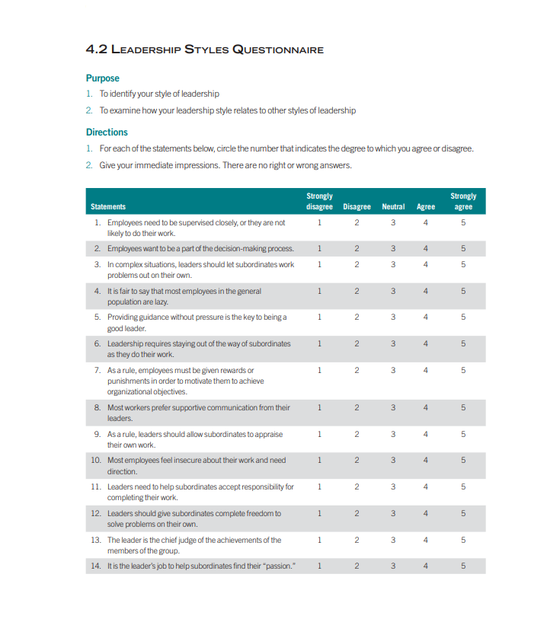

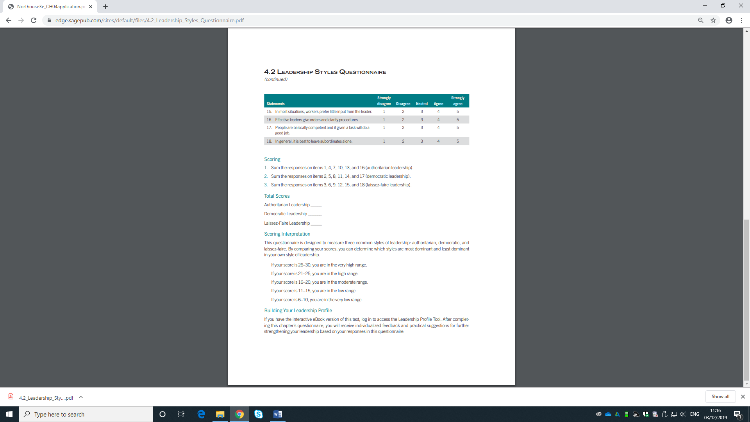

Appendix 4
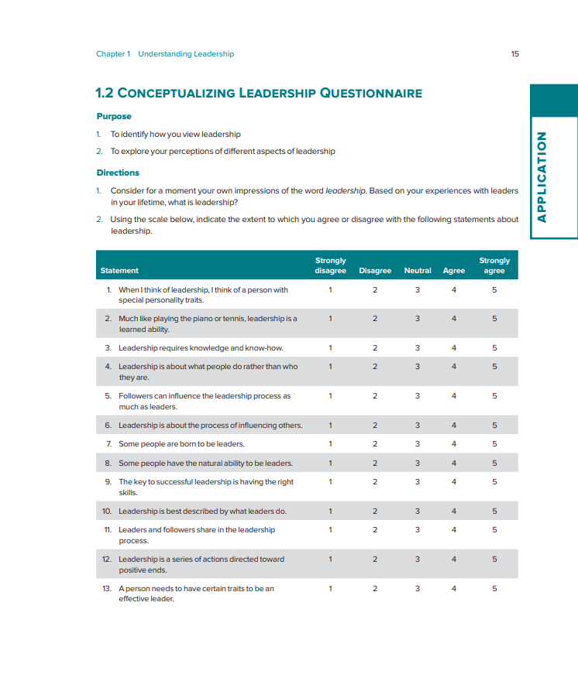

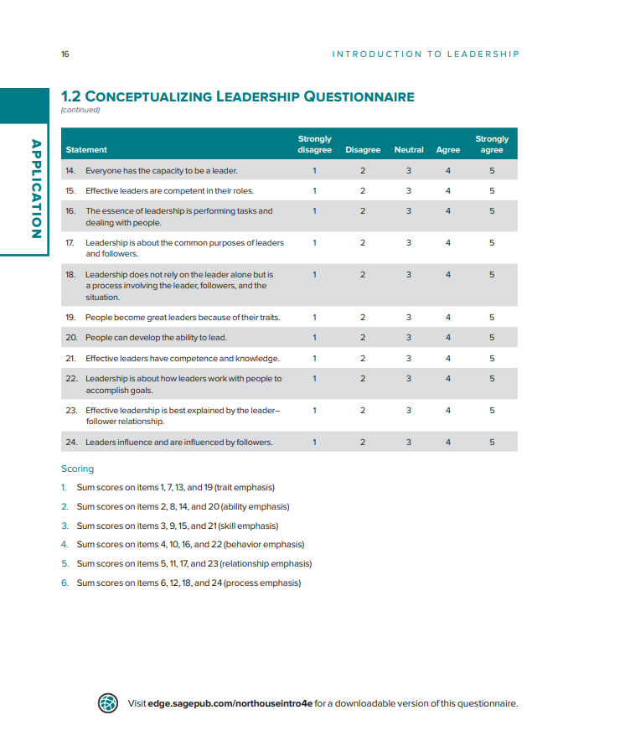

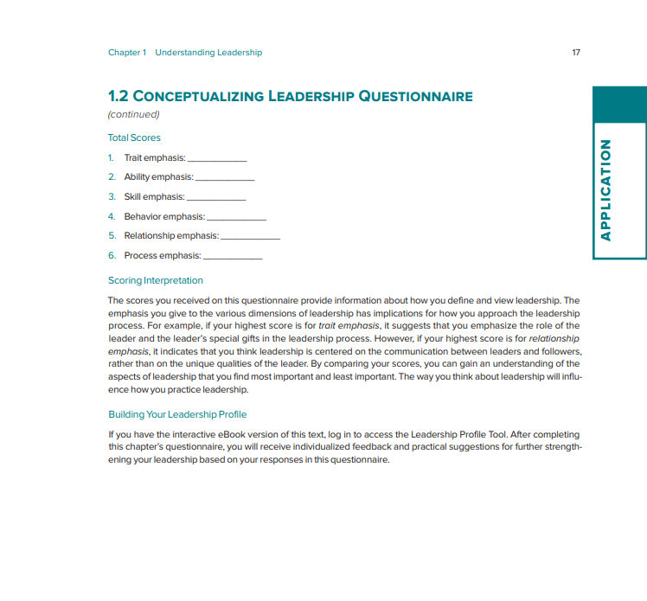

Bibliography

Adair. E. J. (2007). Develop your leadership skills, Great Britain: Kogan Page Publishers.
Adair. J. (1979). Action centred leadership. London: Gower.
Ajami, A.R. and Goddard, J. G (2018) Global Business: Competitiveness and Sustainability. Abingdon: Routledge.
Allen. B. (2016). Benazir Bhutto: Favoured Daughter. New York: Amazon Publishing.
Amanchukwu, N. R., Stanely, G. J. and Ololube, P. N. (2015). A Review of Leadership Theories, Principles and Styles and Their Relevance to Educational Management. Management, 5(1). [Online]. Available at: https://pdfs.semanticscholar.org/2307/c61b175cb5ba9bdb614907bdb46cd242c1d6.pdf [Accessed on 12 November 2019].
Avolio, B. J., Walumbwa, F. O., & Weber, T. J. (2009). Leadership: Current Theories, Research, and Future Directions. Annual Review of Psychology 60 (2009), pp.421-449. doi: 10.11146/annurev.psych.60.110707.163621.
BBC World service. (2019). Women in power: reveal what it takes, [Online]. Available at: http://www.bbc.co.uk/worldservice/people/features/wiwp/statcon/bhutto_quote.shtml, [Accessed on 29 October 2019].
Behan, R. (2007). Why on earth would anyone want to work for Sir Alan Sugar?, [Online]. Available at: https://www.dailymail.co.uk/news/article-461607/Why-earth-want-work-Sir-Alan-Sugar.html , [Accessed on: 11 November 2019].
Berman, M. E. et al. (2009) Human recourse management in public service: paradoxes, processes and problems. 3ed. London: SAGE publications.
Bhatia. S. (2008) Goodbye Shazadi: A Political Biography of Benazir Bhutto. United Kingdom: Lotus Roli Books.
Bhutto. B. (1988) Benazir Bhutto: Daughter of the East. London: Penguin Group.
Big Hugeo. (2017), Leadership – Kurt Lewin, [Video]. Available at: https://www.youtube.com/watch?v=LGiiV6nGpUU, [Accessed 11 November 2019].
Blois, K. and Hopkinson, G. C. (2013) ‘The use and abuse of French and Raven in the channels literature’, Journal of Marketing Management, 29(9–10),[online]. Available at: https://web-b-ebscohost-com.ezproxy.uwtsd.ac.uk/ehost/pdfviewer/pdfviewer?vid=1&sid=90335f76-feed-4582-b352-3e60ab2ba546%40sessionmgr102, [Accessed on 01 November 2019].
Borkowski, N. (2009). Organisational behaviour in health care. 2nd ed, London: Jones and Barlett publishers
Burns, J. M. (1978). Leadership. New York, NY: Plenum.
Cambridge Dictionary. (2019). ‘Organisational change’, [online]. Available at: https://dictionary.cambridge.org/dictionary/english/organizational-change, (Accessed on 14 November 2019).
Cambridge University (2016) Global Definitions of Leadership and Theories of Leadership Development. Available at: https://www.britishcouncil.org/sites/default/files/final_leadership_composite_report_with_references_26-06-17.pdf. [Accessed: 01 November 2019].
Charisma on command. (2016) Steve Jobs Leadership Skills Breakdown - How To Motivate People [video]. Available at: https://moodle.uwtsd.ac.uk/pluginfile.php/312927/mod_resource/content/1/Harvard-eng_v.1.2.pdf, [Accessed: 11 November 2019].
Chartered Management Institute (2015) Understanding and Management Leadership Style. Available at: https://www.managers.org.uk/~/media/Files/PDF/Checklists/CHK-256-Understanding-management-and-leadership-styles.pdf [Accessed: 01 November 2019].

Chris, J. (2015). Richard Branson leadership styles commandments, [Online]. Available at: https://www.josephchris.com/richard-branson-leadership-style-commandments, [Accessed on: 09 November 2019].

Covey, R. S. (2004). The 7 habits of highly effective people personal workbook, New York: Simon and Schuster, Inc.

Cummings, G. T. and Worley, G. C. (2009) Organisational development and change, 9ed, United Kingdom: Cengage learning publishers

Dictionary. Com. (2019). ‘Change’, [online]. Available at: https://www.dictionary.com/browse/change, (Accessed 14 November 2019).

Doherty, M. K., and Doherty, A. C. (1990). Benazir Bhutto. New York: NY: Franklin Watts.

Drucker, F. P (1974). Management: Tasks, Responsibilities, Practices. Abingdon: Routledge.
Future of working. (2019). 5 Famous Laissez Faire Leaders, [Online]. Available at: https://futureofworking.com/5-famous-laissez-faire-leaders/, [Accessed on, 11 November 2019]
Hassan, A. (2016). ‘Not forgotten’, The New York Times, 21st June. Available at: https://www.nytimes.com/interactive/projects/cp/obituaries/archives/benazir-bhutto, [Accessed: 02, December, 2019.
Komarov, V, F. and Aloygan, G. N. (2017). A study of Kurt Lewin’s styles of leadership by business games method, 17 (2). [online]. Available: https://doaj.org/article/a1d342ae33b44cd8a09d2066d78b93c4, [Accessed on, 01 November 2019].
Manegold, C.S and Le Vine. S (1990) ‘Benazir Bhutto’s decline and Fall’, Newsweek, 116(8), p.47
Maslow, H. A. (2016) A theory of human motivation. United States of America: Midwest Journal Press.
Northouse, P, G. (2018) Leadership. 8th edn. United Kingdom: sage.
NowThis World (2018) The Rise and Fall of Pakistan’s Benazir Bhutto, 21 January. Available at: https://www.youtube.com/watch?v=yFwx6-ovdEs (Accessed 16 October 2019).
Practical management skills. (2014). Leadership theories – what do they mean?, Available at: http://www.practical-management-skills.com/leadership-theories.html, [Accessed 11 November 2019].
Raymondson, H. A. (2016) An introduction to organisational leadership and management: leading innovation and change. United Kingdom: Ultimate learning recourses.
Sansone, C. and Harackiewics, M. J. (2000). Intrinsic and Extrinsic Motivation: The Search for Optimal Motivation and Performance, London: Academic Press.
Sekine. K (1992) Benazir Bhutto: her political struggle in Pakistan, Masters Thesis, University of Massachusetts.
Shaikh, A.M (2000) Benazir Bhutto: A political Biography. Michigan: Orient Book.
Shah. B (2014) ‘The Legacy of Benazir Bhutto’, The New York Times, 26th Dec. Available at: https://www.nytimes.com/2014/12/27/opinion/the-legacy-of-benazir-bhutto.html (Accessed: 23rd October, 2019).
Sharma, K. M. and Jain, S. (2013). ‘Leadership management: principles, models and theories’, Global journal of management and business studies, 3(3). Available at: https://www.ripublication.com/gjmbs_spl/gjmbsv3n3spl_14.pdf (Accessed: 24 October 2019).
Stanley, C. (2019), ‘Discover ideas about Raven’, [Online]. Available at: https://www.pinterest.co.uk/pin/193373377727187574/, (Accessed 11 November 2019)
Taseer, A. (2019). He Is Trying to Play a Very Difficult Game”: The Once and Future Imran Khan, Vanity Fair – Hive. [online]. Available at: https://www.vanityfair.com/news/2019/09/the-once-and-future-imran-khan, (accessed on: 15 November 2019).
Tannenbaum, R. and Schmidt. H. W. (2009). How to choose a leadership pattern. United State of America: Harvard Business Review Press.
Trends Pak. (2017). Imran Khan talks about the leadership with PTI members in Dubai. [Video]. Available at: https://www.youtube.com/watch?v=tV48-aHFU-s&feature=emb_title, (accessed on 07 November 2019).
Vikram. B. P. (2009). Business communication. London: New age international https://books.google.co.uk/books?id=v1u3OhgV8MYC&source=gbs_navlinks_s
Wikipedia. (2019). Functional leadership model, Available at: https://en.wikipedia.org/wiki/Functional_leadership_model, [Accessed 11 November 2019].
Wolinski, S. (2010). Leadership Theories. Retrieved June 14, 2014, from http://managementhelp.org/blogs/leadership/2010/04/21/leadership-theories/.
Wolvin, D. A. (2011). Listening and Human Communication in the 21st Century. United Kingdom: Wiley- Blackwell publishing.
Ziring, L. (1991) ‘Benazir Bhutto: A political portrait’, Asian Affairs: An American Review, 18(3), p.178.

