Network Programability
Peter Siow - 2104217

Table of Contents
Introduction 2
GET Request 2
Conclusion 5

Introduction
The purpose of this report is to display the running code of a python application which holds a RESTful web service, and I will be documenting if any errors within the code or even problems with implanting any HTTP request such as GET, POST and PUT etc.

GET Request
The API which I will be using to create a python application for is http://makeup-api.herokuapp.com/api/v1/products.json this API holds data of makeup from many brands I will organise the data, so when I run the application in Python it will display each brand name as well as the product of the brand with a price of the product.
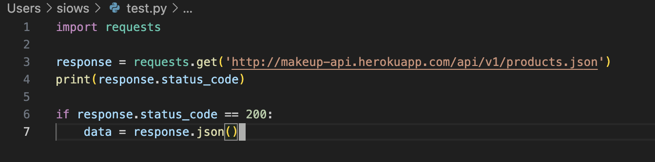

Firstly, the code above I wanted to make sure that the API which I chose to use for my Python application worked and wanted to see if I was able to connect to the API, so the variable ‘response’ holds the API and fetches the URL and if the it was successful the ‘response.status.code’ will display 200. So, when I run the code in Python it should print out ‘200’
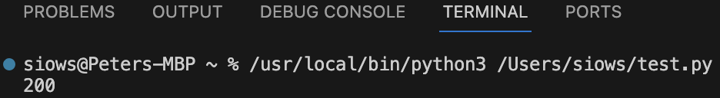

Now that the connectivity is present, I am able to fetch data from the API and now with the code below, I wanted to print out the brand names of the makeup, in which worked but when the code was printed it was untidy and would show duplicates of the brands due to the brands have multiple of products under the same brand name in which I didn’t have any idea how to overcome this problem as I had to become creative to overcome this.

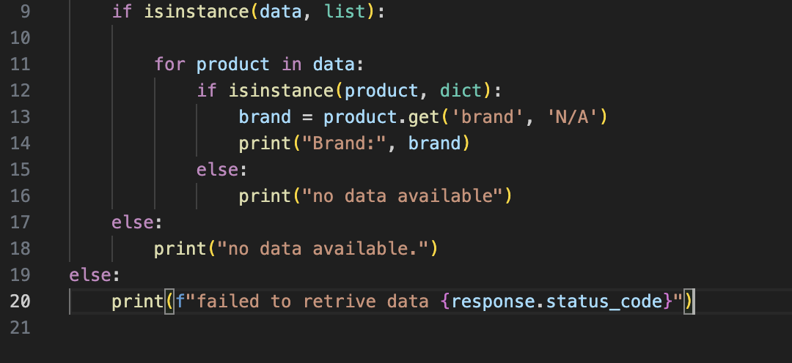

To make the code more presentable when I would run it implemented in which would also print out the products and the price of each product, as brands are able to have multiple of products, so it made sense to implement the product as well the price of the product.
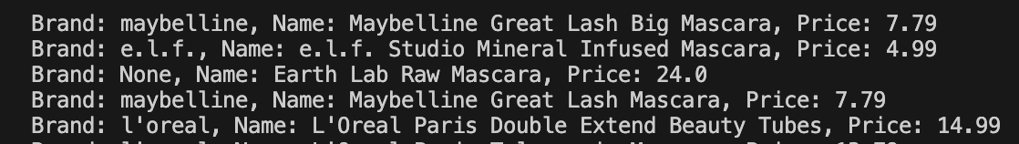
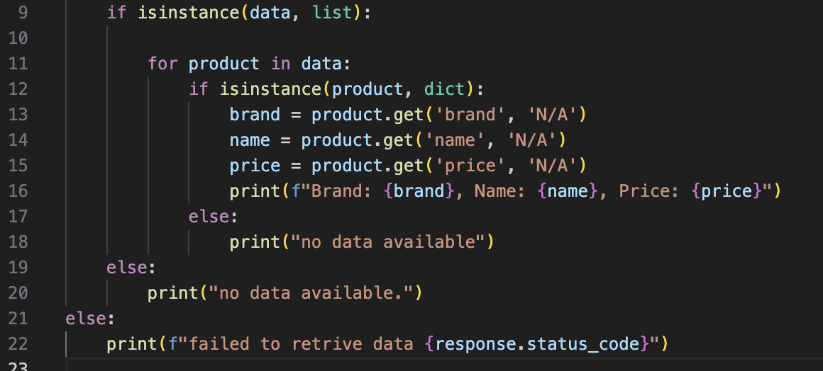

Although I was content with the outcome when the code was run I was still a bit unhappy with how that each product wasn’t spaced out which gave the appearance of it look cluttered together, so I wanted to space out each product to make it easier to read for the user when the code was being run and I did this by adding ‘\n’ which made a new line after each brand and the outcome look like this. As I thought this was important to implement as my scope for this is to allow customers to easily search for products they’re wanting to purchase.

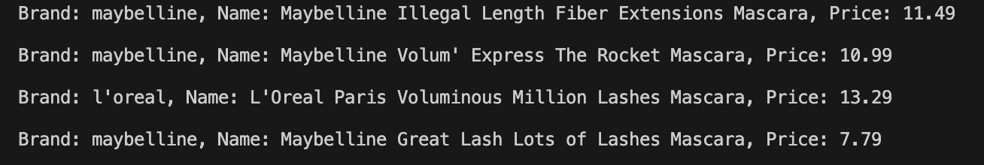

As well the thought of the code showing all the products, I wanted to implement code so it shows the products which are less than a certain price as customers might be working with a budget and gives them an easier way to filter out the products they want to view. So the code which I implemented to achieve this result was to use the parameter from the API website which was ‘price_less_than’ and this would allow me to freely choose a number I could put into my code and it would only show those products and ‘params’ is the variable which I would need to call to the API to fetch the data.

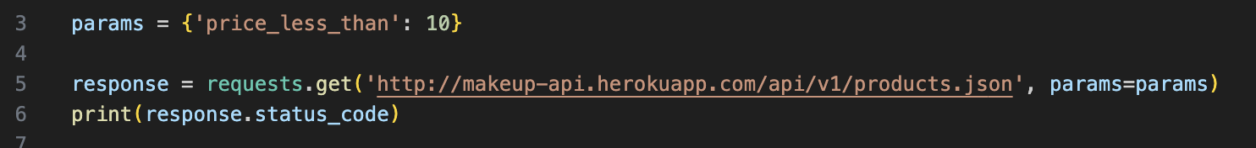

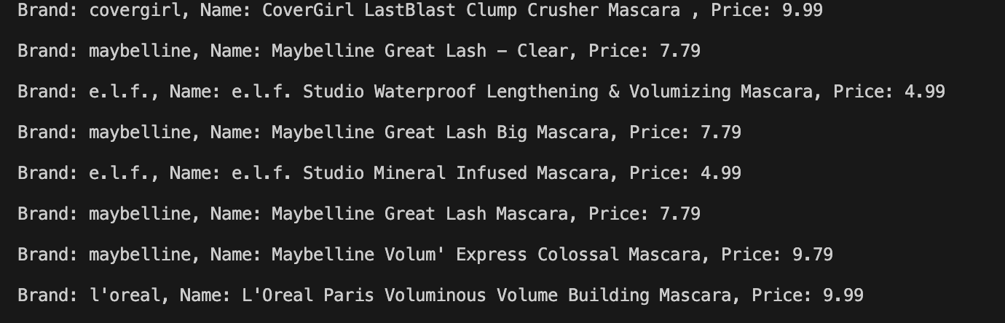

As well I wanted to have it so the user can view the prices greater than a certain amount and from the API website the parameter I could use was ‘price_greater_than’ and the value which I wanted to view the products over the price of 10 and when running the code, it displayed all the products which were priced greater than 10.

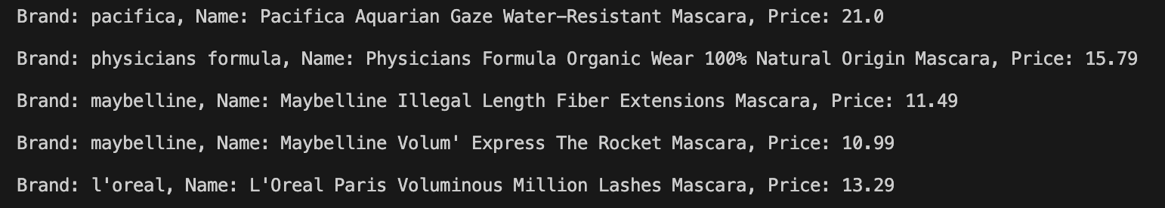

Even though I was content with the code and what it produced, I wanted the product type to display so users can know what product type they’re looking for and this can be helpful for users as it specifies the search even more than before.

As seen from the code it fetches the product type from the API and from each product and when the program is running it prints out the correct product type according to the product.
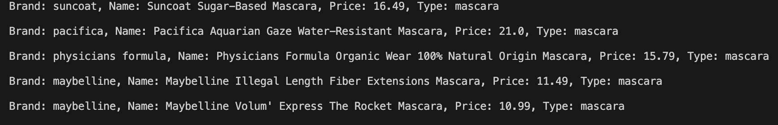

Conclusion
To conclude this documentation, I was wanting to enhance my knowledge with using a RESTful web service in my python application and have learnt a lot by doing this and I do hope in the future that I am to further that. As the API I chose was only able to do GET requests I couldn’t do POST requests and, but I tried to find different open APIs which could accommodate the existing I was using, such as a cash calculator which calculates the price of the product. Overall I have enhanced my knowledge about APIs and how they work.

