

UNIVERSITY OF WALES TRINITY SAINT DAVID - BIRMINGHAM
Prepared by:

Student Name: Akaur Rahman
Student ID: 2505136
The program: CERTHE Computing Skills for the Workplace
Module Name: Analysing & Solving Problems
Module Code: ACCA4019
Lecturer’s Name: Abida Perveen
Date: 26/03/2026

1. Problem Deconstruction and System Analysis

The scenario shows a local college having trouble putting classes into rooms. Some rooms are overcrowded while others are underused altogether. That caused timetable clashes and wasted time as students and staff move between different rooms. Lessons may start late and the learning experience can be negatively affected.

There are several techniques to solve a problem more effectively. These include abstract thinking, decomposition, and requirement analysis. These techniques assist in breaking down the problem into parts to ensure a structured solution can be achieved.

Abstract thoughts help to simplify a situation by focusing only on the important aspects of the problem. An analysis can be conducted using fewer concepts in this case, but not with the name of each class, or by using the name of each course. Instead, there can be such concepts like class size, room capacity, available classrooms, and timetable slots. This form of simplification of complex problems is a critical concept in computational thinking and problem solving [1].

Dividing problems into smaller components. Decomposition refers to breaking a complex problem into smaller and more manageable tasks. The classroom allocation issue may be broken down into steps. The system must first identify the classes requiring classrooms. The next step is to identify the existing classrooms and their capacity. The system should then check whether the classroom is not booked for that time. The system assigns each class a suitable classroom at last. Decomposition is a key technique in computational thinking that breaks down problems [2].

2. Input–Process–Output (IPO)

Input | Process | Output
Class size | Compare class size with room capacity | Classroom allocation schedule
Available classrooms | Check room availability at time slot | Assigned classroom for each class
Room capacity | Select appropriate classroom | Efficient classroom usage
Timetable slot | Allocate classroom to class | Reduced timetable clashes

The IPO model helps describe how information enters the system, how it is processed, and what output is produced.

3. MoSCoW Requirements Analysis

The MoSCoW method is used to prioritise system requirements according to importance.
Priority | Requirement | Explanation
Must Have | Each class must be assigned a classroom | Ensures all classes can take place
Must Have | Room capacity must not be exceeded | Prevents overcrowding
Must Have | Timetable clashes must be avoided | One room cannot be used by two classes at the same time
Must Have | Allocation must use the correct time slot | Ensures rooms are checked at the right time
Should Have | Reduce travel time between classrooms | Improves efficiency for students and staff
Should Have | Improve classroom utilisation | Prevents unused classrooms
Could Have | Lecturer preference for rooms | Teachers may prefer certain classrooms
Could Have | Special equipment matching classes | Some classes require equipment
Won’t Have | Real-time room changes | Not included in current system
Won’t Have | Student room preferences | Students cannot choose rooms

The MoSCoW method helps focus on the most important requirements first.

4. Variables Used in the System

After identifying the system requirements, it is necessary to identify the variables used in the classroom allocation system. Variables store the information required for the classroom allocation process.

Variable Name | Description | Example
ClassID | Identifies each class | 7A
ClassSize | Number of students in the class | 25
ClassName | | Name of the class or subject | Maths
RoomID | Identification of each classroom | R101
RoomName | Name or label of the room | Lab 1
RoomCapacity | Maximum number of students the room can hold | 30
TimeSlot | Scheduled time of the class | Wednesday 14:00
RoomAvailable | Indicates if the room is available | TRUE
AllocatedRoom | Classroom assigned to the class | R201
AllocationStatus | | Shows whether the allocation was successful | Allocated
TravelTime | Estimated movement time between rooms | 5 minutes
ClashStatus | Shows whether a timetable clash exists | No Clash

These variables allow the system to compare values such as class size and room capacity when assigning classrooms.

5. Proposed Solution

A structured algorithm can be developed to solve the classroom allocation problem. This is achieved by efficiently allocating classrooms while at the same time ensuring that the capacity of each room is adequate and that there is no clash in the timetable.

The system begins by collecting input data such as class sizes, room capacities, available classrooms, and time slots. This is necessary before the allocation can take place.

The system selects a class from the timetable. It then checks the availability of the rooms. It checks each room to ensure that it has enough capacity to accommodate the class. If it does not, it checks the next room.

Once it has identified a room that has enough capacity, it checks if the room is available at the time slot. If it is not, it checks the next room.
Once a room meets these conditions, it is classified accordingly. The room is then marked as unavailable for the given time slot.

This process continues until all classes have been assigned a classroom. The final output will be a classroom allocation plan that indicates the classroom assigned to each class.
The use of logical algorithms and step-by-step processes in designing solutions is an essential aspect of computational thinking [3].

6. Pseudocode

START
Step 1: Input class information
DISPLAY "Enter Class ID:"
INPUT ClassID

DISPLAY "Enter Class Name:"
INPUT ClassName

DISPLAY "Enter class size:"
INPUT ClassSize

DISPLAY "Enter time slot:"
INPUT TimeSlot

Step 2: Input classroom information
DISPLAY "Enter Room ID:"
INPUT RoomID

DISPLAY "Enter Room Name:"
INPUT RoomName
DISPLAY "Enter room capacity:"
INPUT RoomCapacity

DISPLAY "Is the room available? (Yes/No)"
INPUT RoomAvailable

DISPLAY "Enter travel time to this room:"
INPUT TravelTime

Step 3: Check for classroom suitability
IF RoomCapacity >= ClassSize AND RoomAvailable = "Yes" THEN

Step 4: Allocate the room
SET AllocatedRoom = RoomID
SET AllocationStatus = "Allocated"
SET ClashStatus = "No Clash"

Step 5: Display successful result
DISPLAY "Class ID:"
DISPLAY ClassID
DISPLAY "Class Name:"
DISPLAY ClassName
DISPLAY "Allocated Room:"
DISPLAY AllocatedRoom
DISPLAY "Allocation Status:"
DISPLAY AllocationStatus

ELSE

Step 6: Allocation unsuccessful
SET AllocationStatus = "Not Allocated"
SET ClashStatus = "Possible Clash"

DISPLAY "Room cannot be allocated for this class"
DISPLAY "Allocation Status:"
DISPLAY AllocationStatus
ENDIF
END

7. Trace Table

Step | ClassID | ClassName | ClassSize | RoomID | RoomCapacity | RoomAvailable | AllocatedRoom | AllocationStatus | ClashStatus
1 | 7A | Maths | 26 | Room A | 30 | Yes | Room A | Allocated | No Clash
2 | 7B | IT | 35 | Room A | 30 | No | Reject
3 | 7B | IT | 40 | Room B | 50 | Yes | Room B Allocated | Allocated | No Clash

Trace tables are useful for testing algorithms and ensuring that the logic works correctly [4].

8. Flowchart

You can visualise the algorithm with a flowchart, which makes it easier to understand the logical steps and decision points in the system.

The flowchart begins with the start of the program and the inputting of information about the classroom and the timetable. The system then checks if the classroom capacity is enough for the class. If the capacity is small, then another classroom is checked.

If the room fits the size, the system then verifies whether it's available during the needed time slot. If it's already booked, it searches for another option.

When the classroom is selected, then the classroom is assigned to the class and so on until all the classes have been assigned.

Figure 1: Flowchart for Classroom Allocation Process
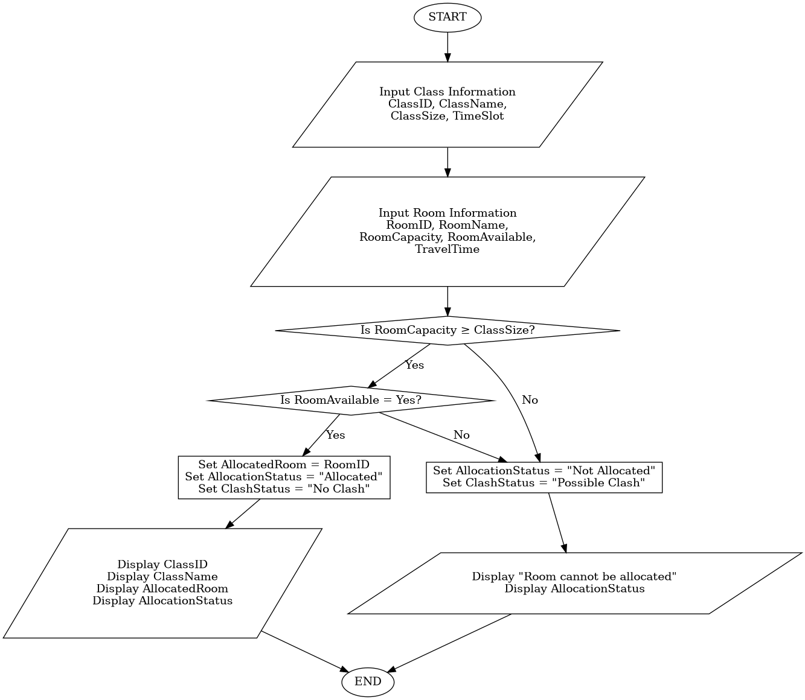

9. Reflection

In this assignment, we have attempted the classroom allocation problem using various techniques of problem-solving and arrived at a well-structured solution.

Abstract thinking helped in simplifying the problem by focusing only on the essential factors of the problem, like the size of the class and the capacity of the room [1]. Decomposition helped in breaking the problem into smaller parts, which were easier to analyse and organise [2].

The use of pseudocode and flowcharts has helped to clearly illustrate the solution. The pseudocode indicates the steps that the algorithm takes to arrive at the solution, while the flowchart shows a visual representation of the process.

Even though the suggested solution enhances classroom allocation, there are still some drawbacks. The system relies on the accuracy of classroom data and timetable information. Any unexpected issues, such as the cancellation of a class or maintenance of a classroom, may occur.

Despite these limitations, the structured approach adopted for this assignment has helped to improve classroom and minimise scheduling conflicts.

References (IEEE)

[1] S. Maharani, M. N. Kholid, L. N. Pradana and T. Nusantara, “Problem Solving in the Context of Computational Thinking,” Infinity (Bandung), vol. 8, no. 2, pp. 109-116, 2019.

[2] L. Dall’Acqua, Computational Thinking for Problem Solving and Managerial Mindset Training. Hershey, PA: IGI Global, 2021.

[3] P. J. Denning and M. Tedre, “Computational Thinking: A Disciplinary Perspective,” Informatics in Education, vol. 20, no. 3, pp. 361-390, 2021.

[4] T. Palts and M. Pedaste, “A Model for Developing Computational Thinking Skills,” Informatics in Education, vol. 19, no. 1, pp. 113-128, 2020.

