
Assignment Title: Component 2 – Individual Report
Module Name & Code (Problem Solving & Decision Making – LCLM4004)

Table of Contents
1. Introduction 4
2. Problem Identification 4
3. Two Alternative Solutions 5
Solution A: Website redesign along with development of a digital marketing strategy 5
Solution B: Subscription model and loyalty programme 6
4. Evaluation Using Decision Tool 6
5. Justification of Final Selected Solution 6
6. Risk Analysis of Chosen Solution 7
7. Implementation Action Plan 8
8. Measurement of Success 9
9. Conclusion 10
10. Reference List 11
11. Appendices 13
Appendix A: Grid Analysis 13
Appendix B: Risk Matrix Table 14
Appendix C: Action Plan Table 15

List of figures:
Figure 1: Fishbone structure of Green Haven Florists 4
Figure 2: Risk analysis guide 7
Figure 3: key performance metrics ( KPIs ) 9

Executive Summary
The analysis first examined the primary issue facing Green Haven Florists, which is the 30% decline in physical sales, while the online platform is deteriorating. As a result, two solutions were created for the business, and solution 1 was ultimately chosen after the grid analysis was used to evaluate each solution's efficacy. Additionally, a risk analysis was conducted for solution 1 while considering every factor that could cause the majority of the plan to fail. A plan of action has also been created based on the predictable risk. Nonetheless, it can be said that the study's answer for the business has been well designed.

1. Introduction
From the component 1 discussion, it has been identified that due to the change in the customer's behaviors and the backdated online service, there has in a reduction in the sales of the Green Haven Florist. Sales are reduced to 30% and customers are preferring the large online visible store for the flowers. Even due to the increase in market demands, the profit margin is also reducing in this case, as they are mostly focused on sustainable development. This report is mainly aiming to develop action plans for the Green Haven Florist and how the risks can be mitigated in the process of implementation will also be discussed here.

2. Problem Identification
Root cause analysis theory is the most appropriate means of analysing the core problem, which is fundamental in terms of the declining cause, and it is essential for problem-solving methods that will ultimately give a permanent solution. It is mainly focused on analysing the problem from a deeper point of view and then eliminating the core cause of the problem to not happen in the future. This method mainly uses Pareto analysis, five whys, fishbone diagram, and fault tree analysis to evaluate the cause of the root (Toolshero, 2025). For this analysis, where problems have to be solved, root cause analysis will be an accurate means of measurement to be applied.
In the case of the Green Haven Florist, there is a reduction in physical sales, and there are strong competitors who are competing with the Green Haven Florist. They are also having weak online vigilance, along with the bad reviews given by the customers. In this online era online strong vigilance is mandatory for the growth of any brand, and a negative impact on the online medium can degrade the quality and brand reputation. People mostly prefer the store that has the best reviews and recommendations (Falcon, 2025).
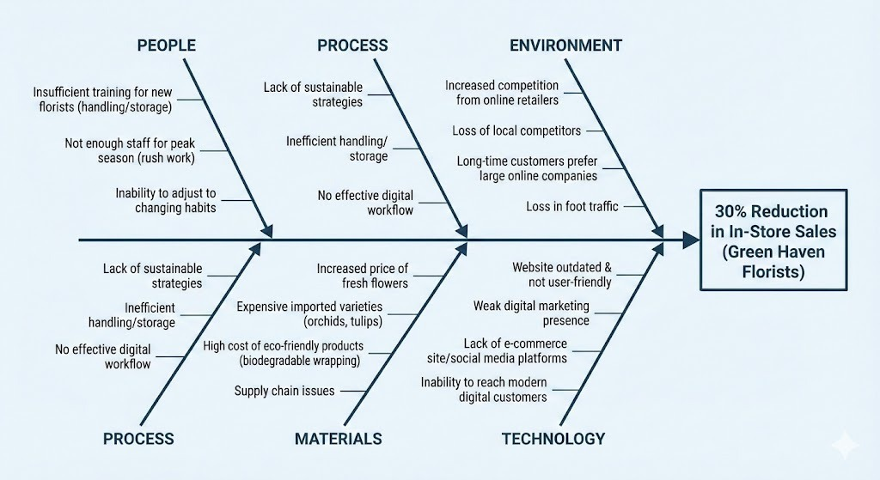

Figure 1: Fishbone structure of Green Haven Florists
Source: (autogenerated)
The fishbone diagram illustrates reasons that have caused a 30% decrease in the in-store sales of Green Haven Florists. There are problems with people, process, materials, technology, and environment: there are training cracks, poor management, increasing prices, an old-fashioned web page, poor digital marketing, online stores taking over the market, and changing customer behaviour, shrinking the number of people coming to physical stores.

3. Two Alternative Solutions

Solution A: Website redesign along with development of a digital marketing strategy
The primary focus of the Green Haven Florist should be on the development of the website, where they can redesign the website through the improvement of an easy-to-use feature where the customer can order the flowers with one click, and through the online platform, people can get their flowers with a flexible delivery process. To promote their website, they can also incorporate social media promotion through influencer marketing. To promote their online order, they can also think of the offers that will be available on the website only.

Solution B: Subscription model and loyalty programme
In this section, all the loyal customers will receive the loyalty bonus from the brand for the regular subscription. The individuals who will take the subscription facilities will get the cashback offer after one month of subscription; this cashback can be used on the next subscription. The individuals who will take the subscription will have the premium delivery section, where they will be prioritised before the ordinary order, and the order will be delivered to them without any delay within the first hours of the service.

4. Evaluation Using Decision Tool
Grid analysis is mainly designed for spatial analysis, decision-making, and qualitative research. Its decision matrix is the best option for choosing the best option from the various choices. It mainly puts the option in the row and factors that are associated with it in the column and then measures the weightage of each section. Among the options highest score wins (KnowledgeCity, 2024). Here, for solutions 1 and 2 Grid analysis table is developed, and scores are analysed using different parameters. Where solution 1 gets the score of 110 and solution 2 gets the score of 82, which are mentioned in Appendix A. Therefore, solution 1 is appropriate for the implementation of the degradation of the sales scenario.
Solution 1 was focused on the redesign of the website and improvement of the digital marketing strategy. In this scenario, the cost of the implementation is effective as it can gain long-term profit. As the solution is based on long-term goals, it can be effective for revenue generation and securing the competitive edge. It is also directly connected with the customers feedback from the development procedure can also be developed. And it is less risky in terms of finance.

5. Justification of Final Selected Solution
This selected solution is effective as the website is the primary score of the interaction with the customers, so it is required to be improved. In the recent era, digital advancement and development are more acceptable to customers. Websites create positive experiences for the customers, whereas SEO can also enhance the website engagement for the customers. Website vigilance is essential for various reasons, which mainly include CRO, user experience, development of the brand image and credibility, and for the better collection of the data for analysis.
Through this approach, sales volume can also be improved due to the CRO and SEO implementation. Through social media presence, digital marketing strategy, and advertising on online platforms can be beneficial to reach a broad audience. Customer retention can also be developed further due to the personalised experience and website-based offerings. Through the adaptive business model, long-term sustainability can be created (Pfoertsch, 2024).

6. Risk Analysis of Chosen Solution
There are several risks associated with the resigning strategy, which can be modified and managed through risk analysis. The first significant risk is spending too much on website development, since if more technological abilities are needed, the project can go over budget. According to Appendix B, this risk has a medium chance and a high impact rating. Green Haven should settle on a fixed-price agreement with the developer of the website and specify the scope of work up front in order to lessen this. This achieves necessary functionality while guaranteeing financial protection.
Limited knowledge of digital marketing poses a second concern, which could lower customer understanding of the new online offerings. This threat has a high probability and a medium impact. It can be managed by first hiring a freelancer to handle posting and campaign management, or by undergoing fundamental social media branding training. This approach makes sense since it encourages early internet interaction while enabling owners to develop long-term competencies. A third risk is that the opening and recuperation of revenue may be delayed if website updates are not completed on time. The project should adhere to weekly progress check-ins and milestone checkpoints to lower this risk. This method enhances responsibility and facilitates the timely completion of projects. All things considered, the solution can be implemented successfully and with limited risk exposure.
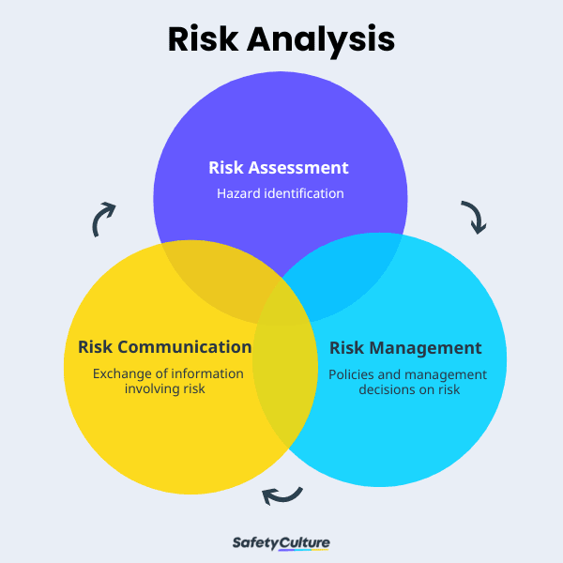

Figure 2: Risk analysis guide
Source: (Safetyculture, 2025)

7. Implementation Action Plan
To guarantee defined roles, deadlines, and quantifiable results, the digital modernization strategy will be implemented using a structured action plan based on the SMART objectives approach. In ten weeks, the main goal is to rebuild the Green Haven webpage with a combined ordering and delivery planning system. Recruiting an independent web developer, redesigning the website, adding updated product photos, incorporating safe online payment methods and shipment slot functionality, and starting a focused social media marketing campaign to advertise the new platform are all important responsibilities. The hired developer will share accountability, with an advertising fund to boost awareness. Appendix C provides precise deadlines and resource allocation, facilitating effective cooperation and responsibility. The plan's anticipated result is a fully operational, user-friendly website that boosts online sales and consumer accessibility, setting the company up for sustained success and digital competitiveness. To turn the goal into reality, the implementation plan has to be aligned with the budget and target of the company (Asana, 2025).
- Month 1: SEO setup and website rebuilding
- Months 2-3: Collaborations and marketing initiatives
- Month 4: Add new services or provide a subscription model
- Months 5 and 6: Evaluate results and improve

8. Measurement of Success
A set of key performance metrics ( KPIs ) will be used to gauge the success of the digital modernization strategy, and performance tracking will be used on a regular schedule. It is an effective metric for the measurement of the company’s effectiveness on the strategic objectives (GeeksforGeeks, 2025). The main KPIs include a 40% increase in website traffic within six months, a 20% improvement in online conversion rates, and an increase in customer retention through recurrent online purchases. Additionally, regular online sales revenue will be compared to marketing and operating expenses in order to assess financial effectiveness. Sales reports, social media insights, and website analytics dashboards will be used to gather data so that evidence-based changes can be implemented as needed. This guarantees ongoing development and promotes long-term corporate viability.
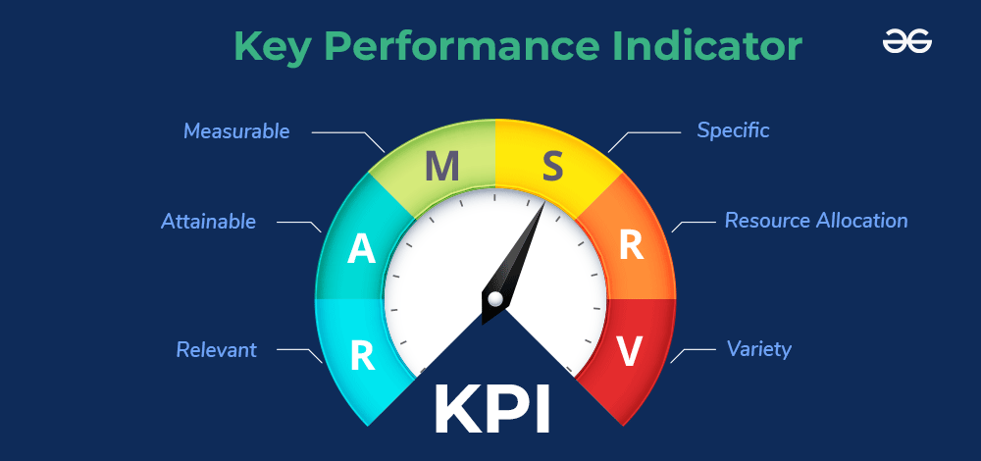

Figure 3: key performance metrics ( KPIs )
Source: (GeeksforGeeks, 2025)

9. Conclusion
Initially, the report analysed the core problem of the Green Haven Florists in terms of the reduction of the physical sales by up to 30% side by side degradation of the online platform. Hence, two solutions were prepared for the company, and based on the grid analysis, the effectiveness of both solutions was analysed, and then, finally, solution 1 was selected. Moreover, for solution 1, risk analysis was done while keeping in mind all the parameters where most of the plan can fail. Depending on the predictable risk action plan has also been made. However, it can be concluded that the study has successfully planned the solution for the company.

10. Reference List
Asana, (2025) What is an implementation plan? 6 steps to create one [2025] • asana, Asana. Available at: https://asana.com/resources/implementation-plan#:~:text=An%20implementation%20plan%20is%20a,of%20gaps%20in%20your%20strategy (Accessed: 06 December 2025).
Falcon, L. (2025) Top retail review sites to boost online visibility and foot traffic for local retailers, Local Falcon. Available at: https://www.localfalcon.com/blog/top-retail-review-sites-to-boost-online-visibility-and-foot-traffic-for-local-retailers#:~:text=Instead%2C%20local%20retailers%20are%20reviewed%20and%20discovered,search%20engines%2C%20mobile%20apps%2C%20and%20mapping%20tools (Accessed: 06 December 2025). KnowledgeCity, (2024) Grid analysis to make tough business decisions, KnowledgeCity. Available at: https://www.knowledgecity.com/blog/grid-analysis-easy-way-make-tough-business-decisions/#:~:text=Grid%20analysis%20is%20a%20tool%20that%20can,How%20to%20rate%20and%20choose%20a%20supplier (Accessed: 06 December 2025).
GeeksforGeeks, (2025) What is a KPI (key performance indicator)?, GeeksforGeeks. Available at: https://www.geeksforgeeks.org/data-science/what-is-a-kpi-key-performance-indicator/ (Accessed: 06 December 2025).
Pfoertsch, W. (2024) ‘revolutionizing marketing: Unveiling the power of the 5E framework in the Digital age’, LinkedIn. Available at: https://www.linkedin.com/pulse/revolutionizing-marketing-unveiling-power-5e-digital-age-pfoertsch-gm1tf/ (Accessed: 06 December 2025).
Safetyculture, (2025) A guide to risk analysis: Example & methods, SafetyCulture. Available at: https://safetyculture.com/topics/risk-analysis (Accessed: 06 December 2025).
Toolshero, (2025) Root cause analysis: Definition, process, and Tools (2025) Toolshero. Available at: https://www.toolshero.com/problem-solving/root-cause-analysis-rca/#:~:text=What%20is%20a%20Root%20Cause,this%20problem%20from%20happening%20again (Accessed: 06 December 2025).

11. Appendices

Appendix A: Grid Analysis
Criteria | Weight (1-5) | Solution 1 | Weighted score for solution 1 | Solution 2 | Weighted score for solution 2
Implementation cost | 4 | 4 | 16 | 2 | 8
Impact on the customers | 5 | 5 | 25 | 4 | 20
Operational risk | 4 | 3 | 12 | 2 | 8
Time required | 3 | 4 | 12 | 2 | 6
Financial development | 5 | 4 | 20 | 5 | 25
Competitive edge | 5 | 5 | 25 | 3 | 15
Total score | - | - | 110 | - | 82

Appendix B: Risk Matrix Table
Description | Likelihood | Impact | Risk level | Mitigation strategy
Excess spending on the development of the website | Medium | High | High | The fixed budget and plan should be maintained.
Adaptation scenario of customers | Medium | Medium | Medium | Providing launch offers and training on social media.
Work loads on owners enhancement | Medium | Medium | Medium | Responsibilities should be divided into parts.
Time gap in implementation | Medium | Medium | Medium | Milestone development should be encouraged.
Technical glitch | Low | High | Medium | More testing is required at initiation.
Limitations of technical skills | High | Medium | High | Basic training on digital

Appendix C: Action Plan Table
Activity | Description | Start date | End date | Required resources | Outcomes
Recruitment of a website developer | For the redesign of the website | Jan, 2026 | Jan, 2026 | 2,000 pounds as a budget | Professional outlook of the website.
Recruitment of a website developer | Improvement of the navigation, modernised layout, and development of the product category. | Jan, 2026 | Feb, 2026 | Content and website | Enhancement of the customer's preference
Visual update of the products | Inclusion of the high-quality images | Feb, 2026 | Mar, 2026 | Photographic requirements | Better online appearance
Social media campaign | Promotion and offers update on social media | Mar, 2026 | Will continue | Around 150 | Enhancement of the brand value
Development of the online order | Fast delivery slot booking and enhancement of the online orders | Mar, 2026 | Arp, 2026 | Payment gateway | Convenience online platform
Launching announcement | Promotion of new websites through discount showcasing and advertising. | Arp, 2026 | May, 2026 | Budget for marketing | Attraction of customers and retention of the old customers.
Checking development | Assessment of the website foot traffic and evaluating customer feedback | May, 2026 | Will be continue | An analytical dashboard from Google. | Evaluation of the effectiveness.

