Networks and operating systems
WORKSHEET 2
Student Name: Katie Rees
Student Number: 1903413
Date: 27th April 2022

Contents
1/ Task 1: Managing and Maintaining Network Resources Using Network Policy and Security Practices 2
1.1/ File Share 2
1.2/ Group Policy Objects (GBO) 10
2/Task 2: Routing and Packet Filtering within Core TCP/IP Services and Critical Failover/Redundancy Practices 18
2.1/ FTP 19
2.2/ Install and Configure Routing and Remote Access 27
2.3/ Filter 3: Only Allow Specific Hosts in PrivateNet1 to Access the FTPService Running on Server 2 38
3/ Task 3: Observational Task 41
3.1/ Sound Passwords 41
3.2/ High Availability and Failover Clusters 41
3.3/ 43
3.3.1/ Network Topology 43
3.3.2/ Network Team 43
3.3.3/ Password Policy 43
3.3.4/ Security Policy 44
3.3.5/ Risk Assessment 44
3.3.6/ Network Management Software 44
3.3.7/ Mitigations in the Event of Violations 44

1/ Task 1: Managing and Maintaining Network Resources Using Network Policy and Security Practices

1.1/ File Share
Sign into client 1 using an administrator account and create a folder called Share_Files_NOSS which holds a text document renamed ‘Important_File’.
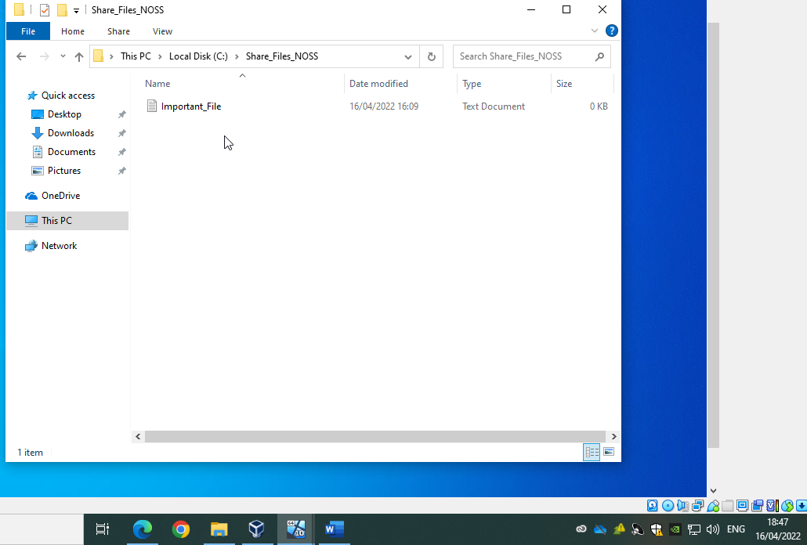

Next, remove inherited permissions to ensure only correct users have access to folder: -
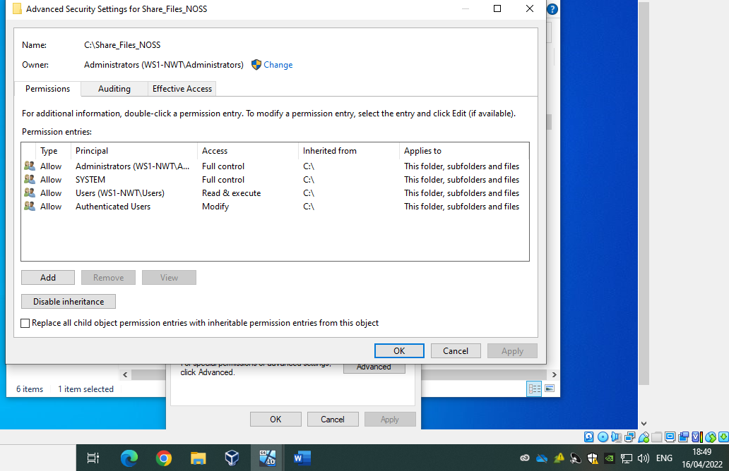

Confirm access for inherited permissions has been removed: -
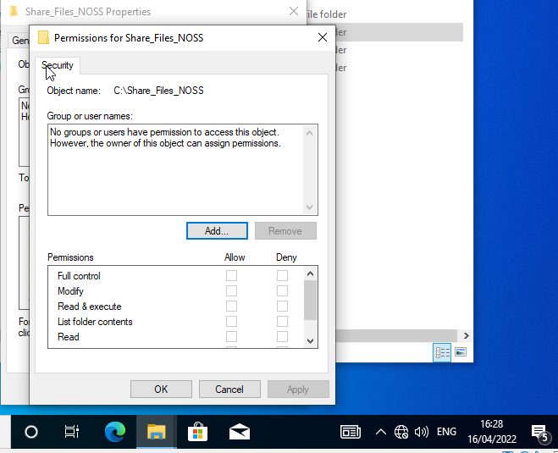

Assign the current account which has administrator privileges full control: -

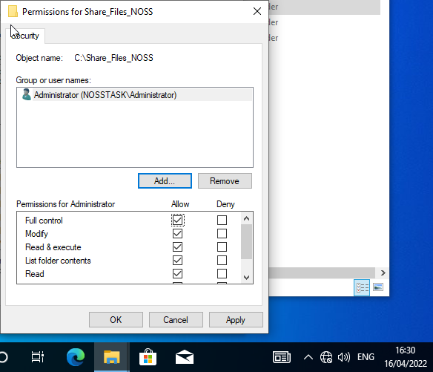
Assign a second account that does not have to be an administrator account, with read-only access: -
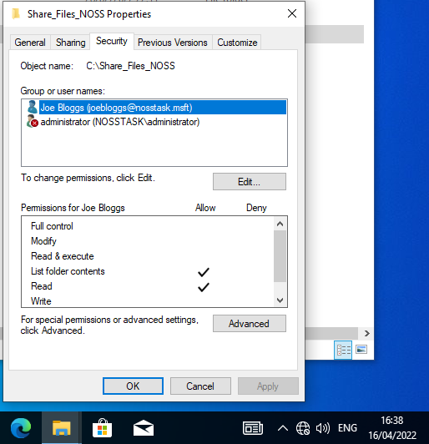

As the administrator has full control access, they should be able to update and save the file whereas the second account with read-only access should not. Below demonstrates the ability to save file whilst logged in as administrator: -
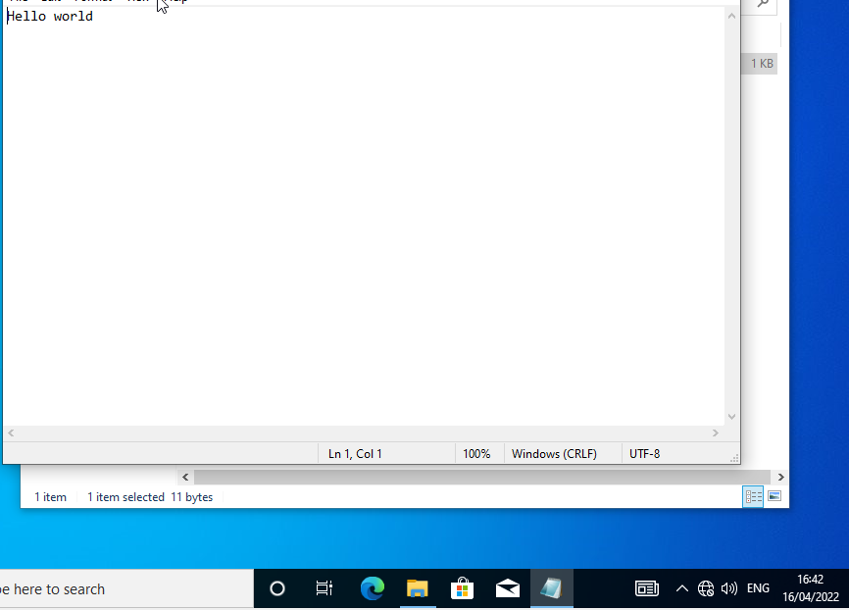

Below demonstrates being unable to save as a non admin user (joebloggs): -
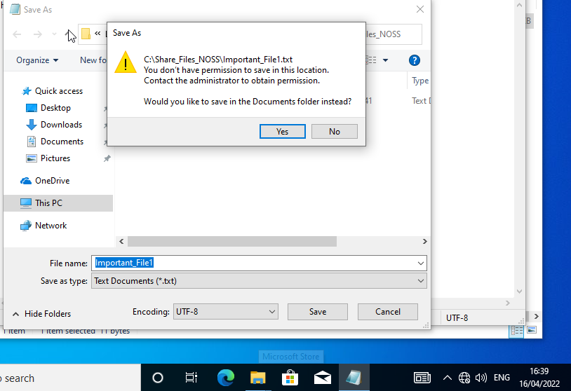
A new share should now be created to allow both server 1 and client 1 access to the folder: -
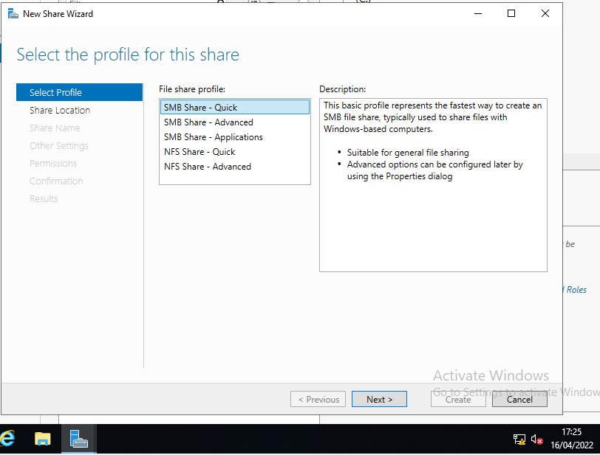
Ensure the correct local path is selected: -

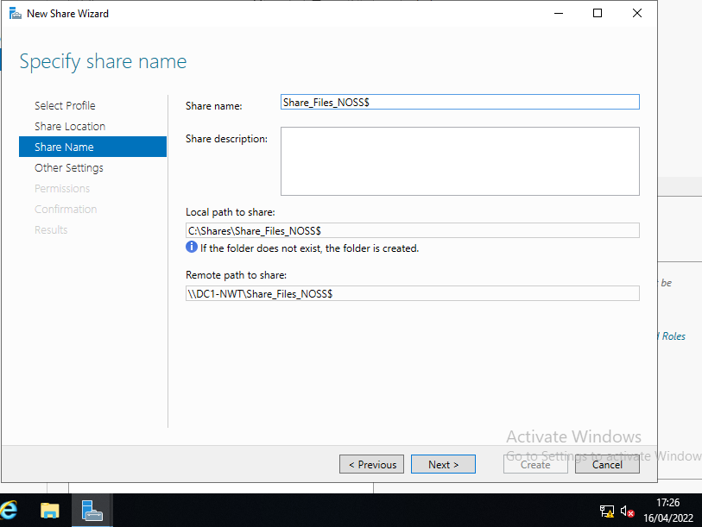
Overview of share permissions: -
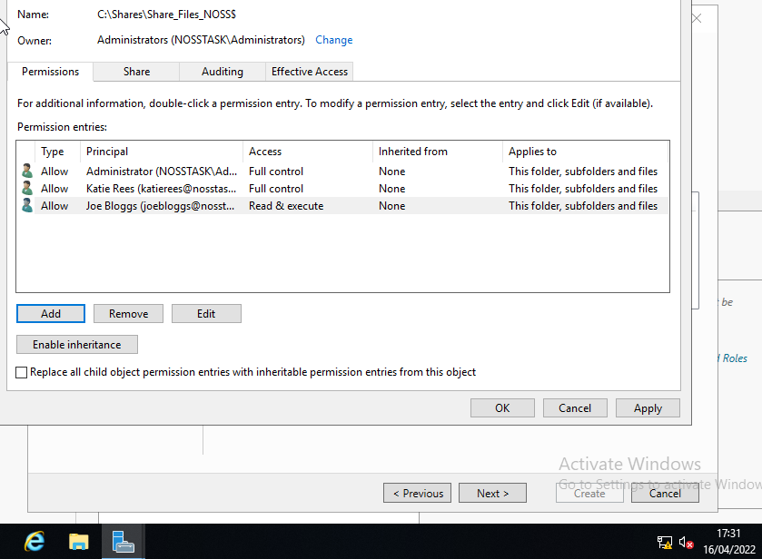

Demonstrate the ability to access the file share on client 1: -
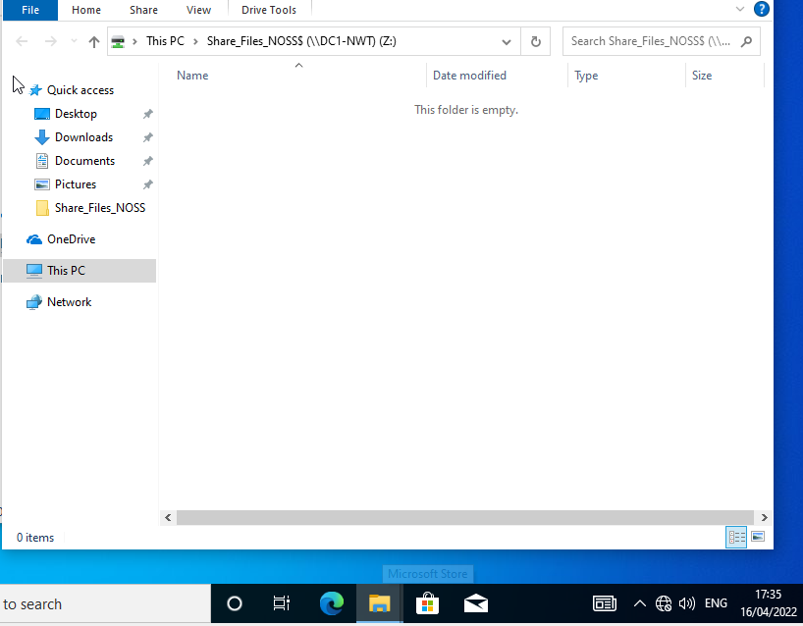

1.2/ Group Policy Objects (GBO)

1.2.1/ GBO 1
Create new folder of non admin users: -

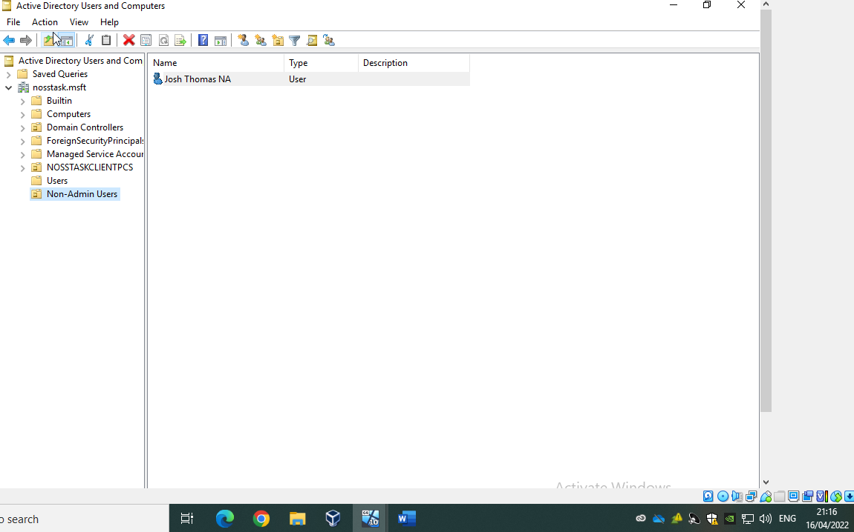
Create group policy object to restrict control panel access:-
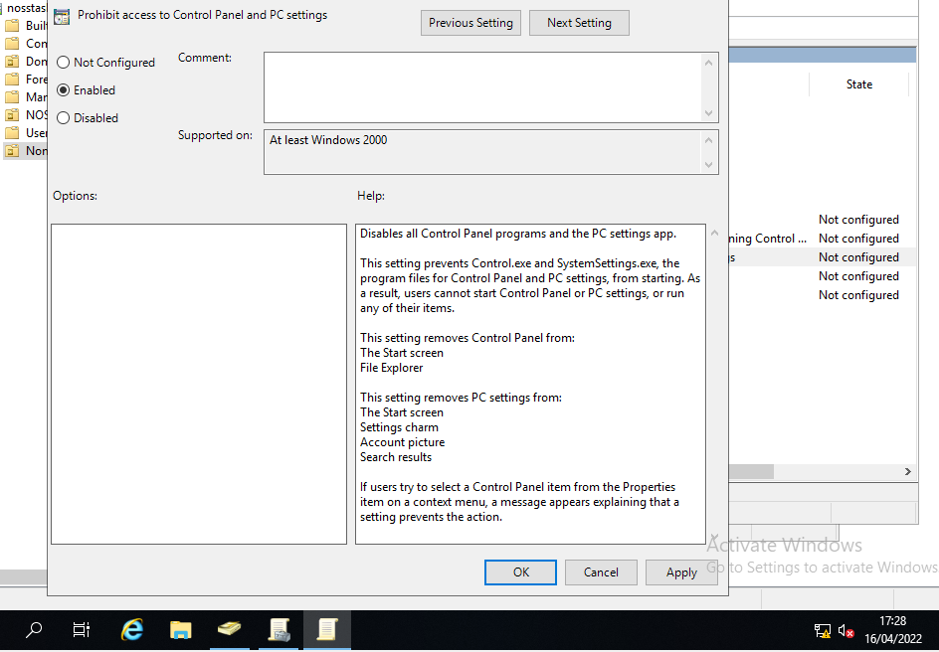
Force settings update via command prompt: -
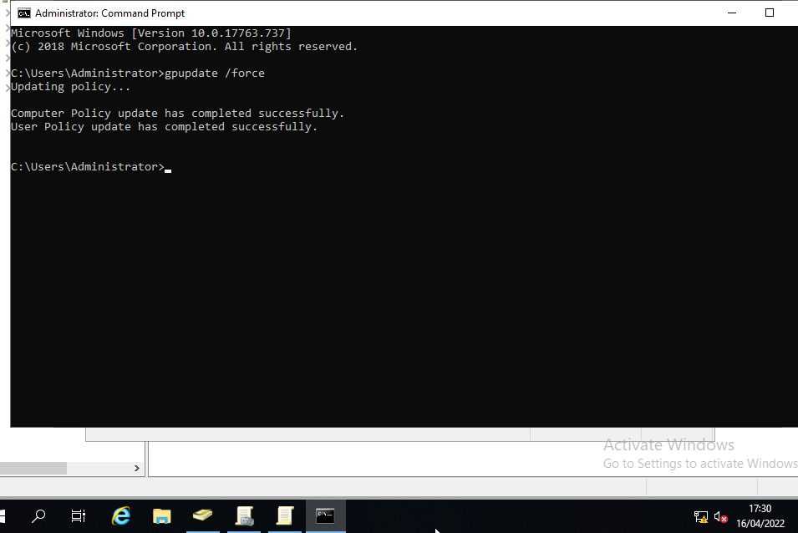
Unable to access control panel on client 1 when logged in as non-admin user:-
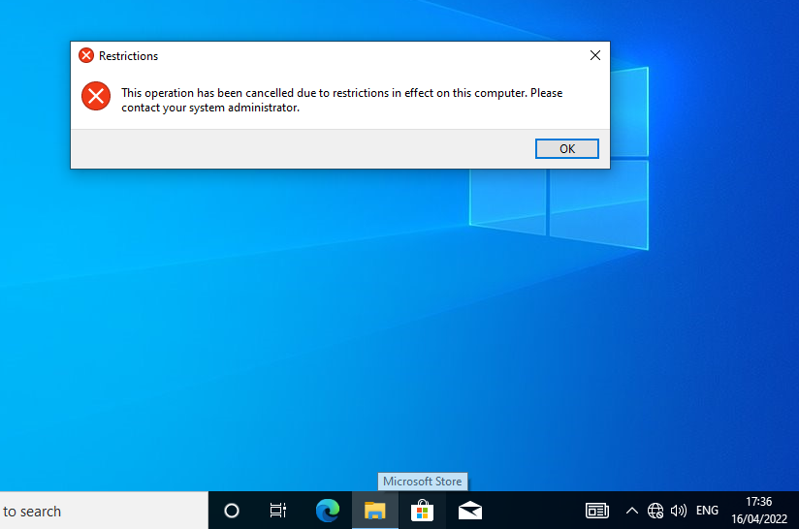

1.2.2/ GPO 2
Next, prevent access to command prompt using GPO: -
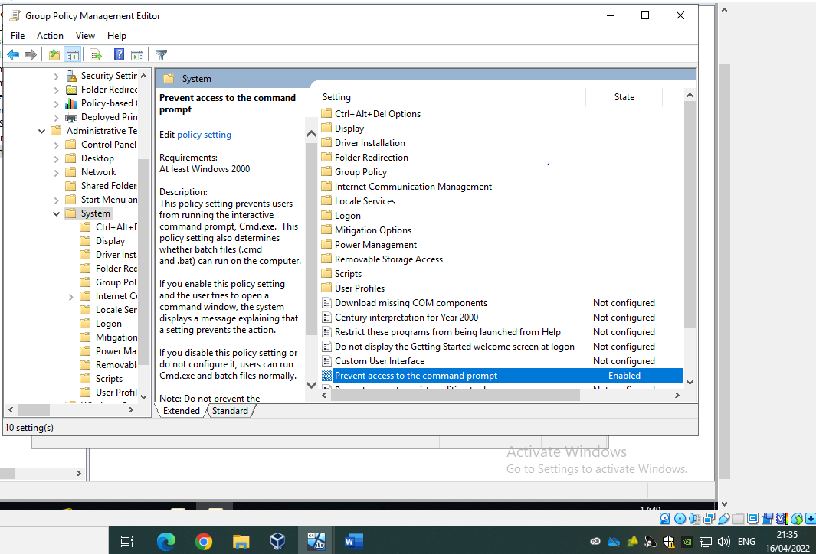
Force update of settings: -
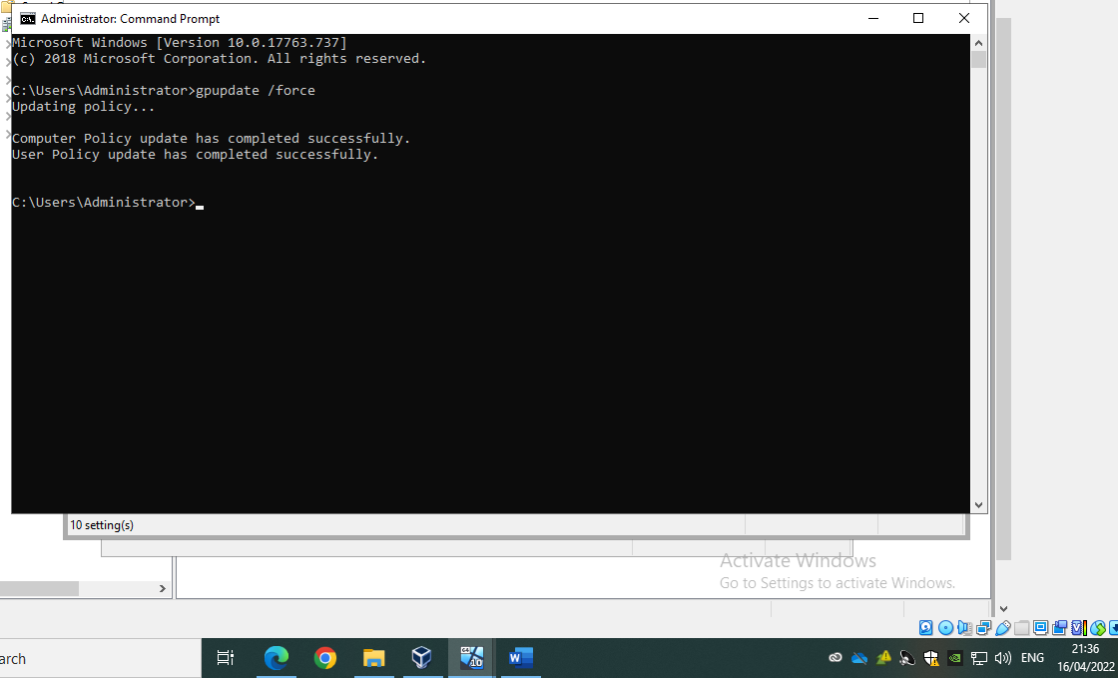
Unable to access command prompt following GPO on client 1: -
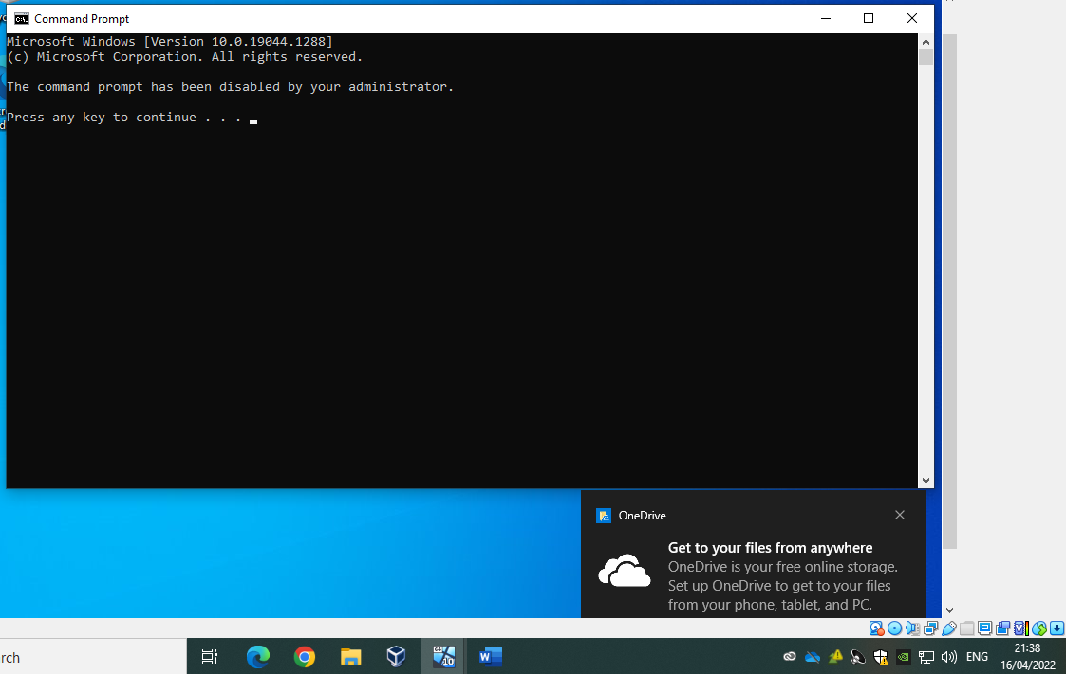

1.2.3/ GPO 3
Add new GPO to deny access to removable storage access: -
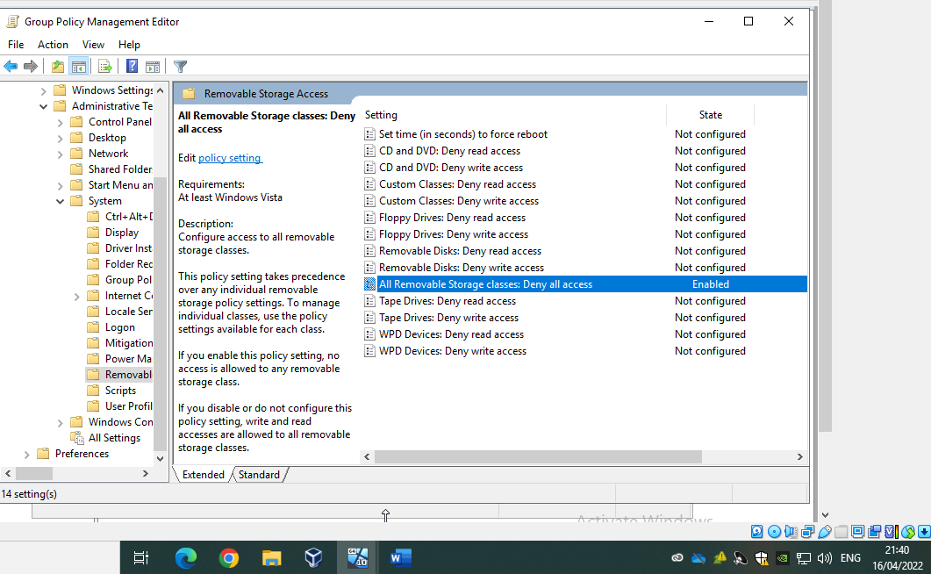

1.2.4/ GPO 4
Create new organizational unit called NWClient Computers and more the computer object for the client into this OU: -
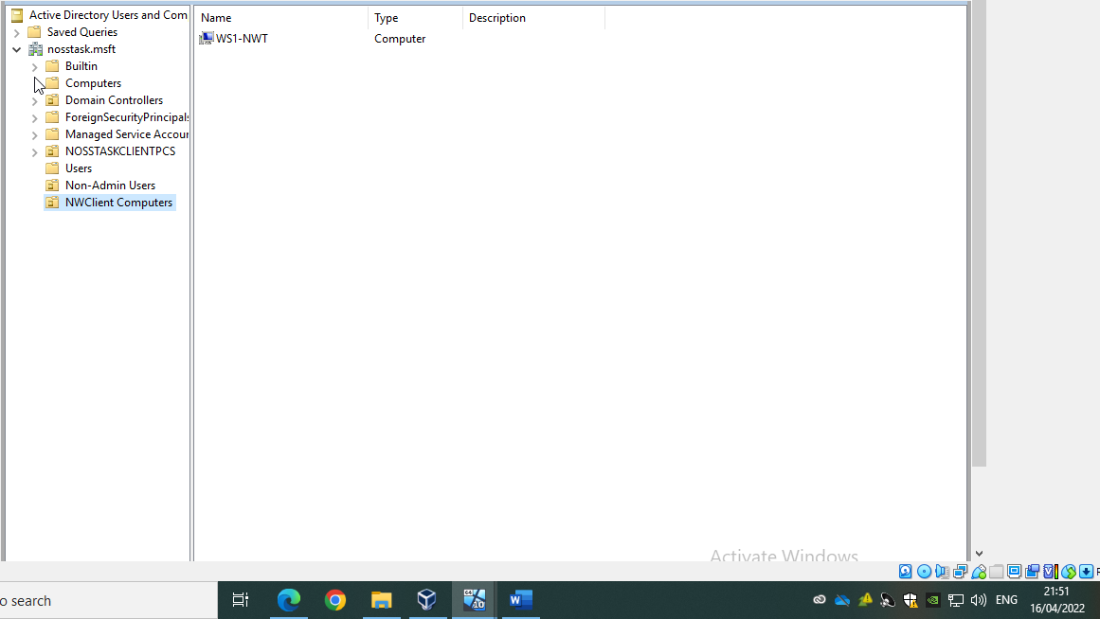
Enable ‘prohibit user install’ policy: -
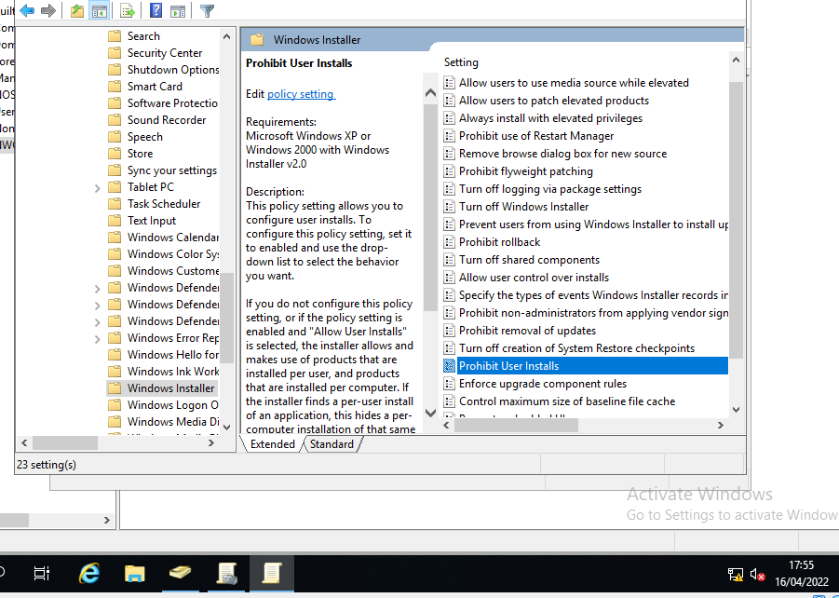
Force update of group policies settings: -
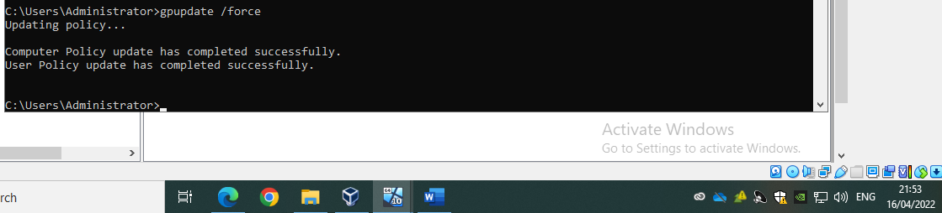

For testing purposes, allow access to internet on client 1: -
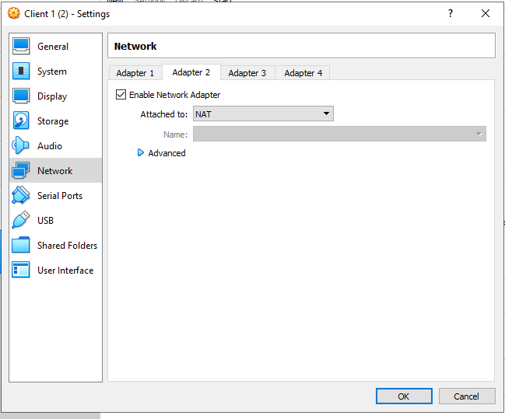
Attempt to download 7-zip: -
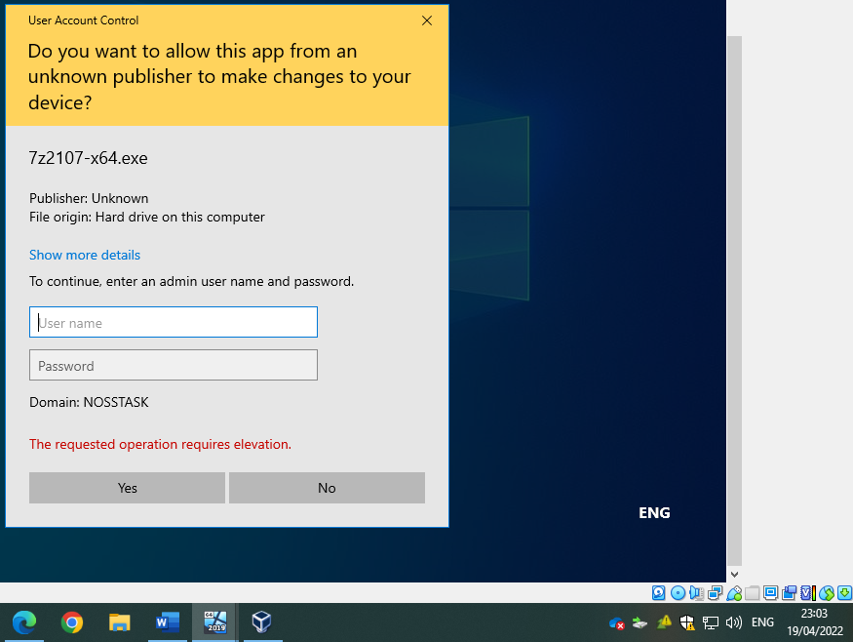
Note the error ‘The requested operation requires elevation’ confirming the success of the GPO.

1.2.5/ GPO 5
Update predefined settings for password policies: -
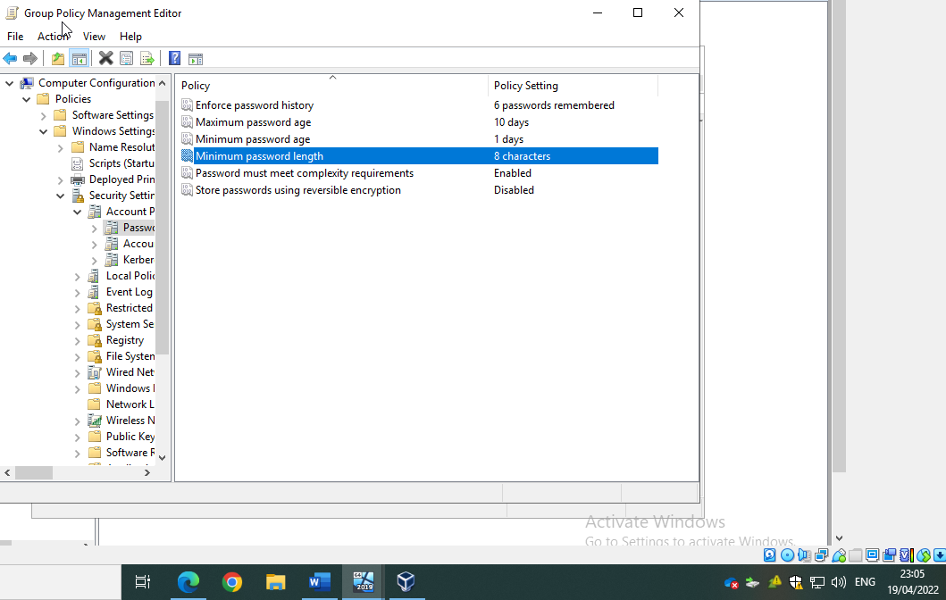
Force update of GPO settings: -
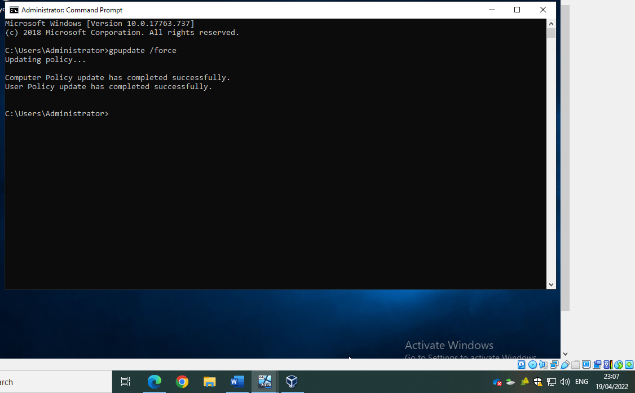
Attempting to set up a password less than 8 characters for new user: -
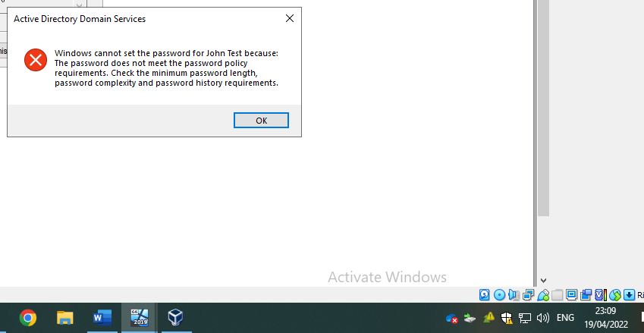

2/Task 2: Routing and Packet Filtering within Core TCP/IP Services and Critical Failover/Redundancy Practices

2.1/ FTP

To start, install FTP on server 2: -
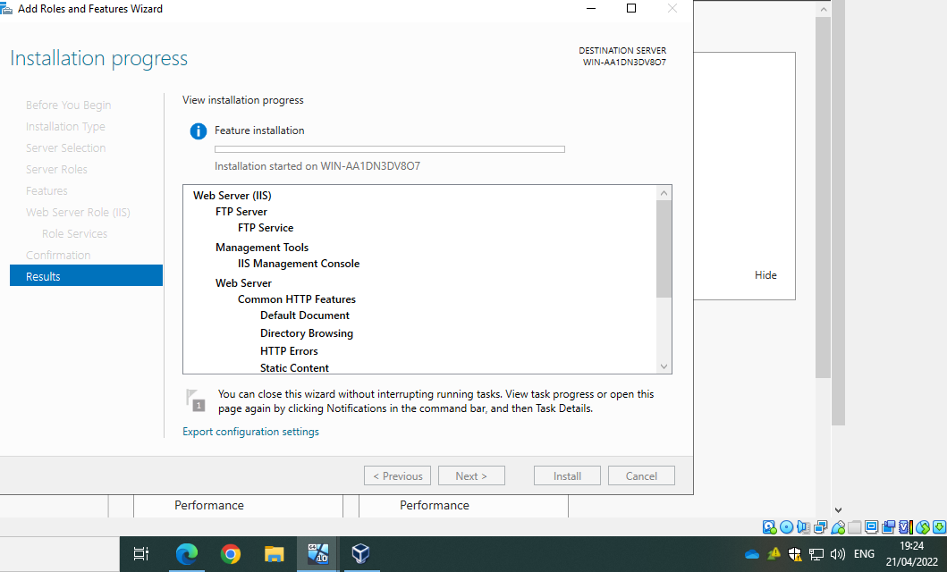
Create a new user in computer management: -
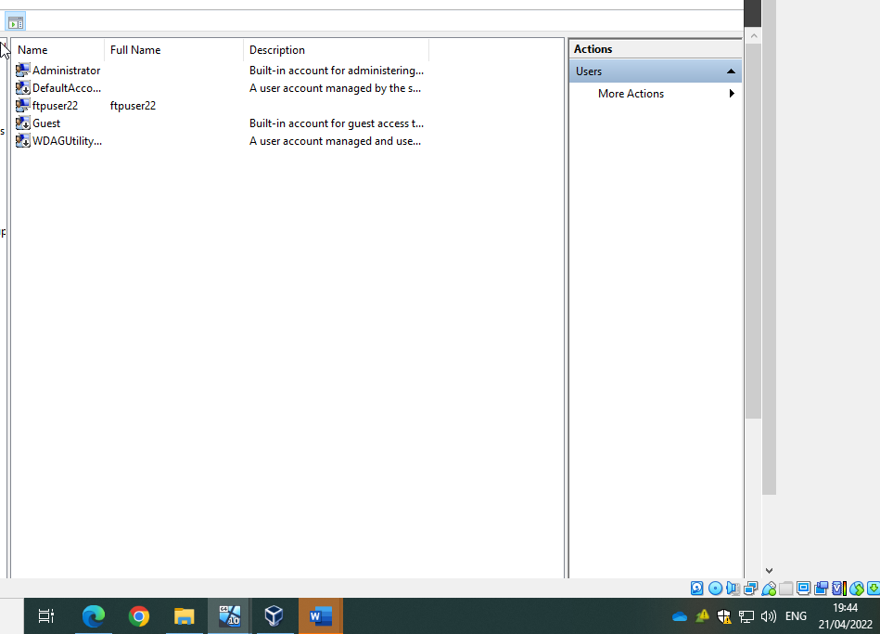
After creating new user account set up FTP site: -
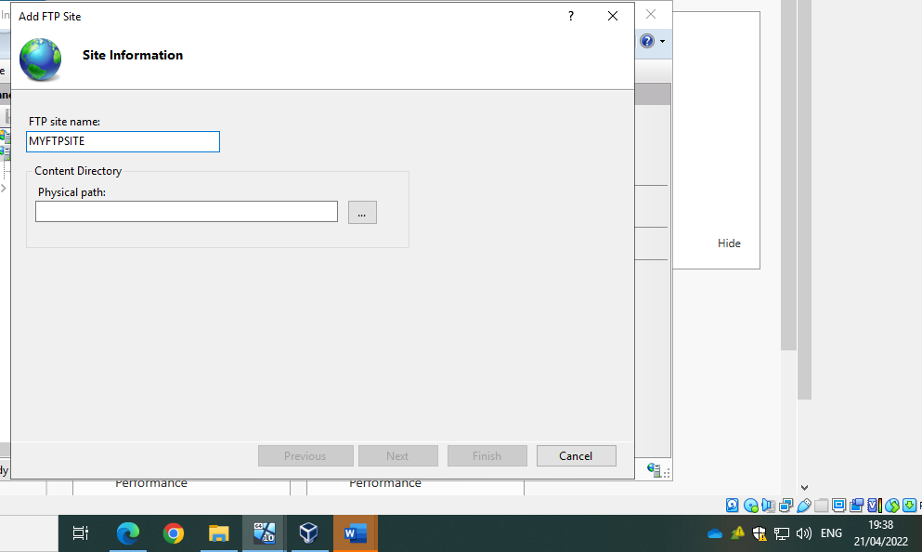
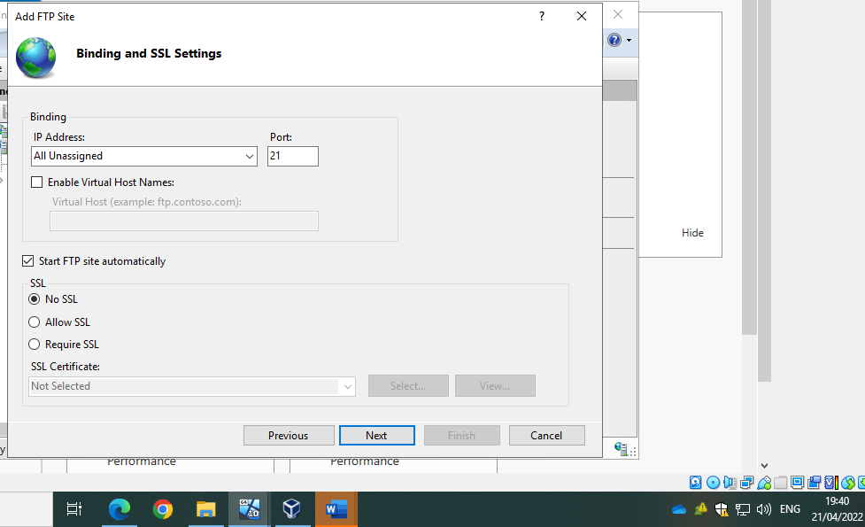
Confirm FTP has been successfully created: -
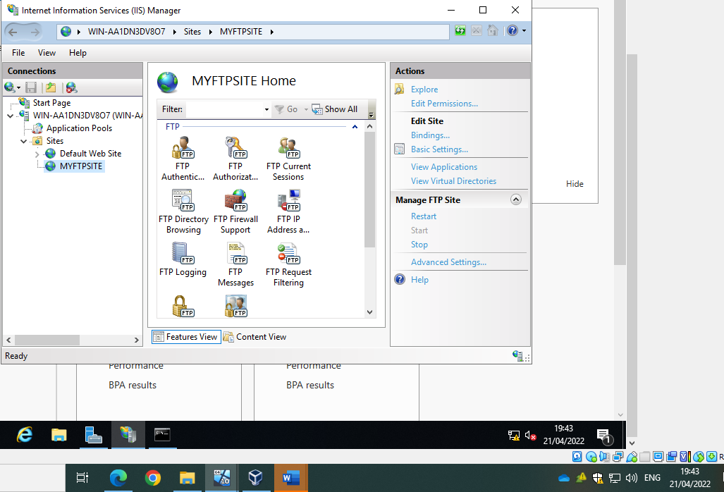
Add banners to your FTP site to so that users can easily identify what FTP site they have accessed: -
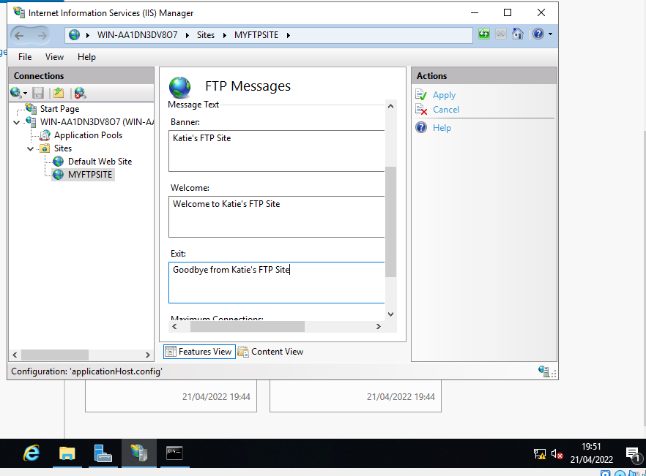
Add user to FTP service: -
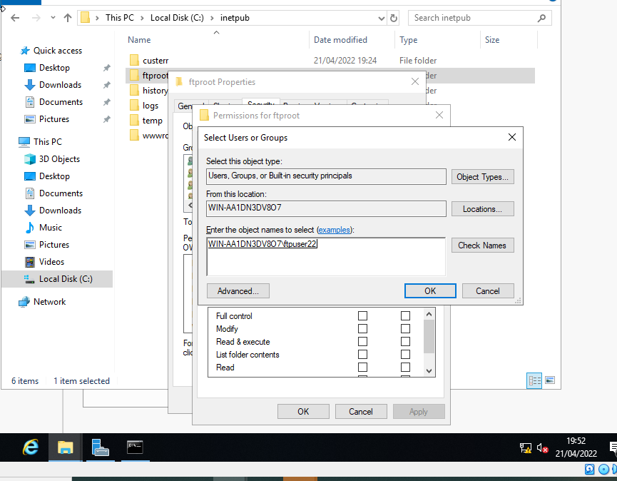
Create a folder named MyFTPUploads on server 2: -
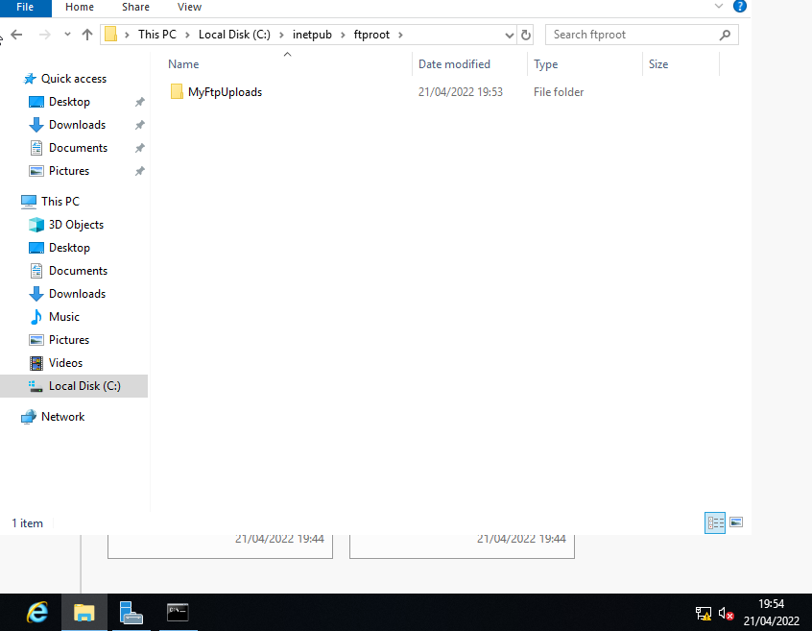
Turn the firewall off on server 2 to allow access from client 2: -
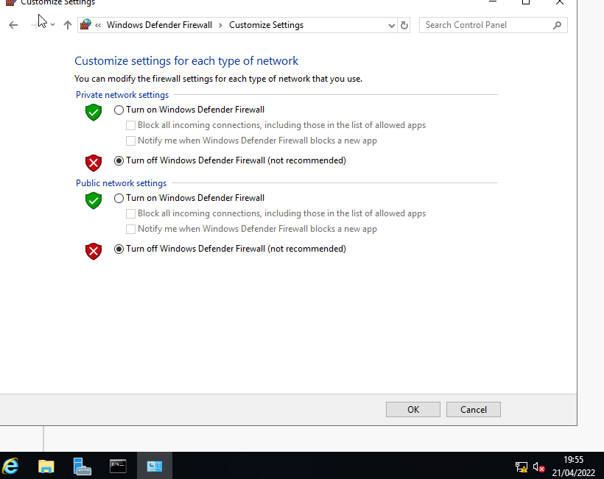

Access FTP site on client 2: -
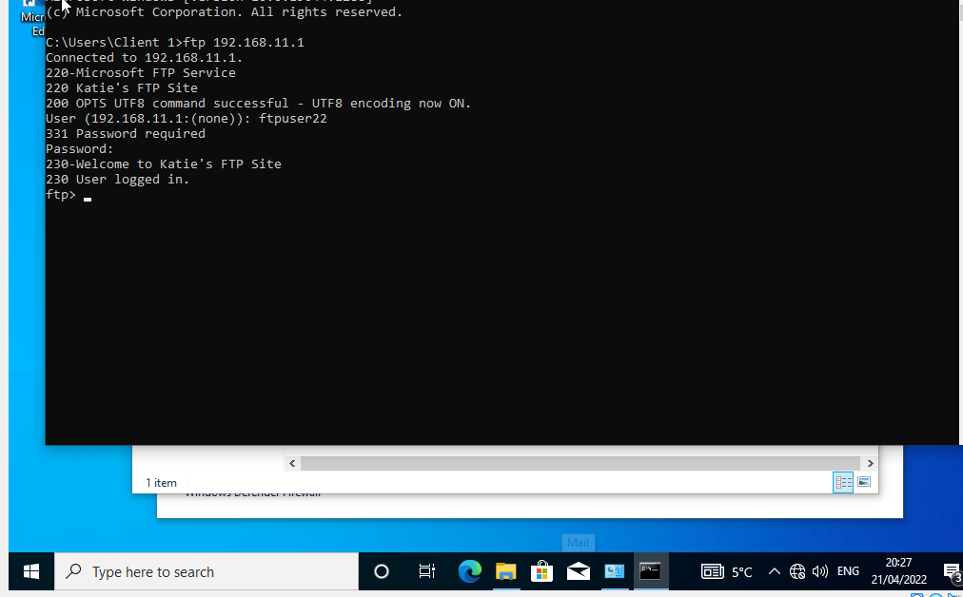
Identify what is held in the FTP file: -
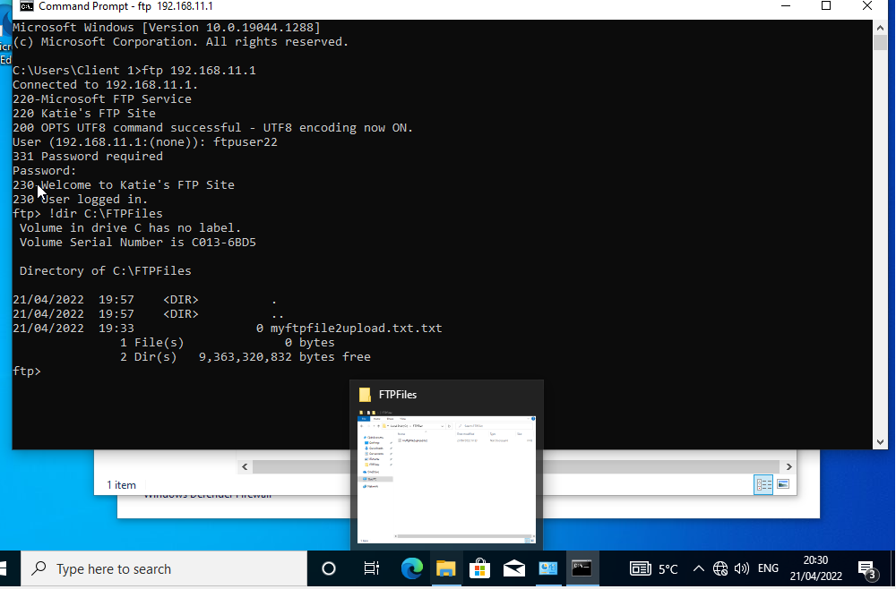
Access myftpuploads folder on command prompt: -
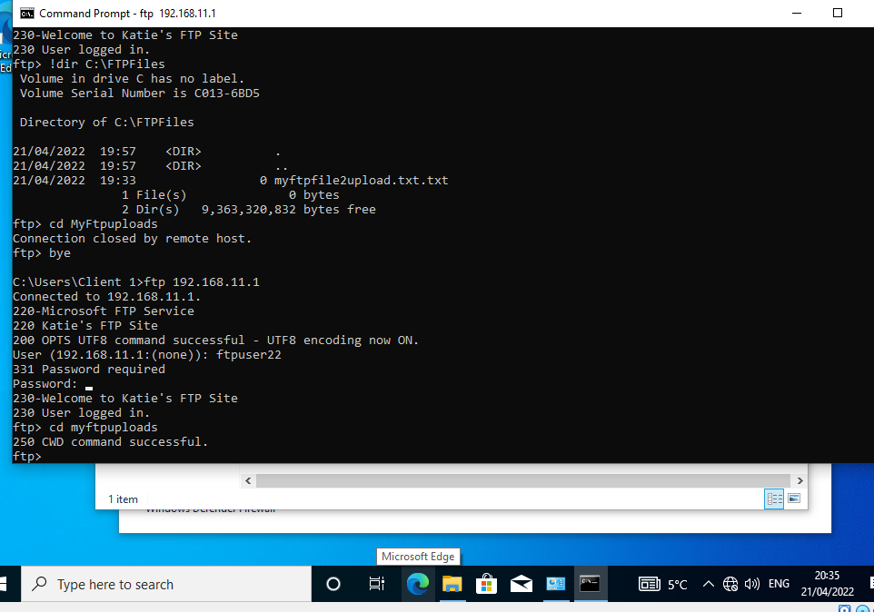
Transfer of ftp file: -
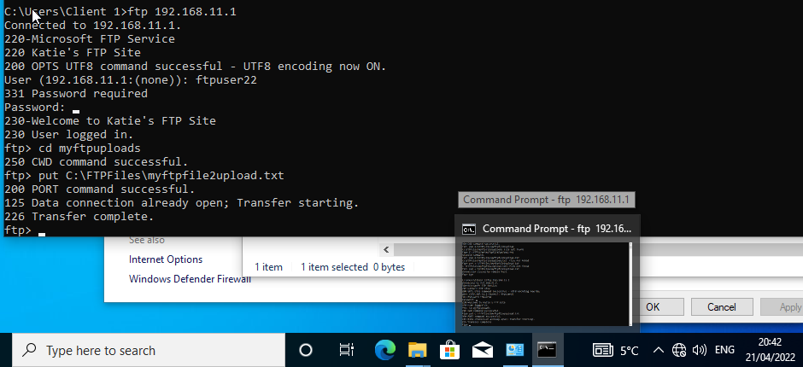
Confirmation that file has transferred: -
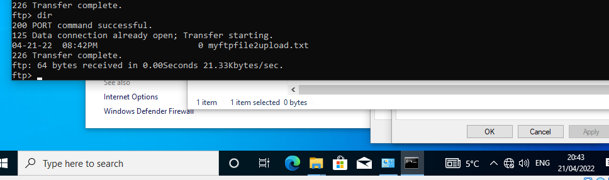
File on server 2: -
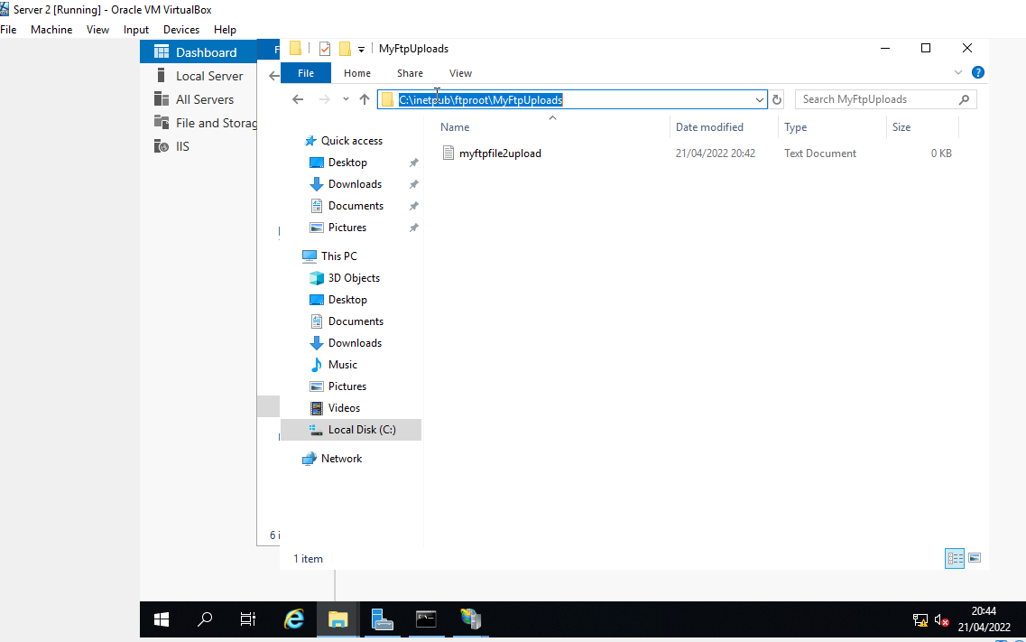

2.2/ Install and Configure Routing and Remote Access
Add routing to server 1: -
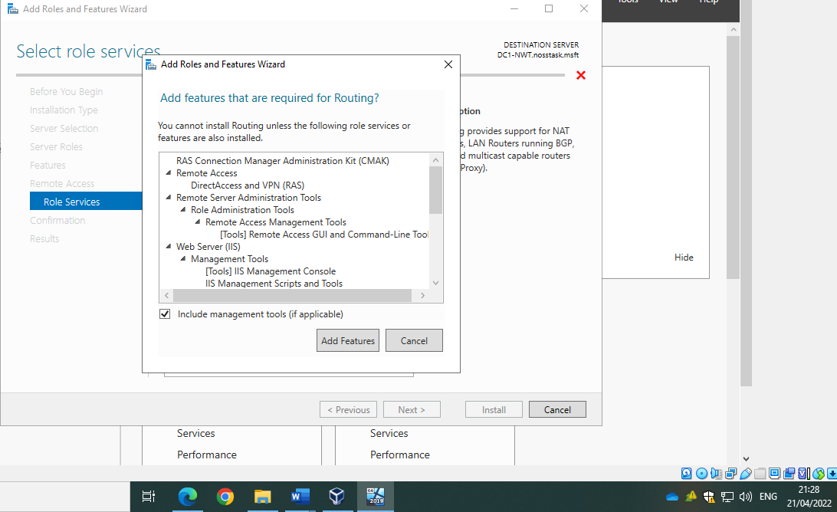
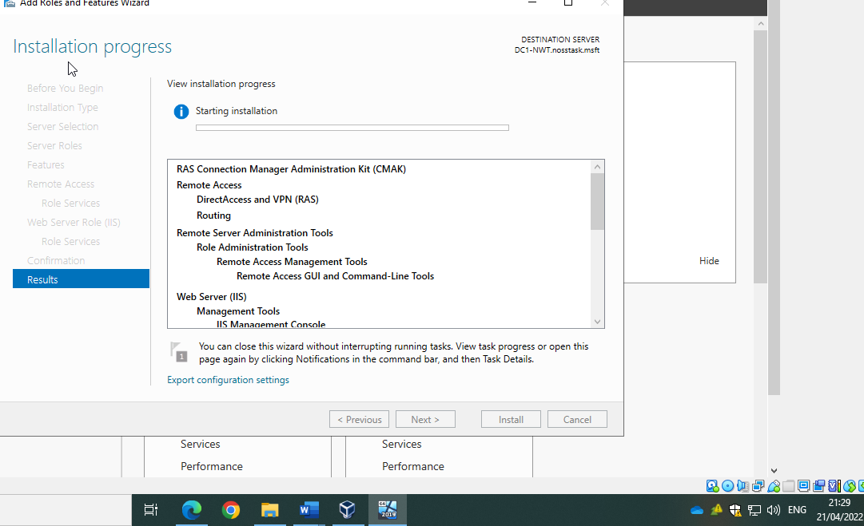
Add default gateway to client 2: -
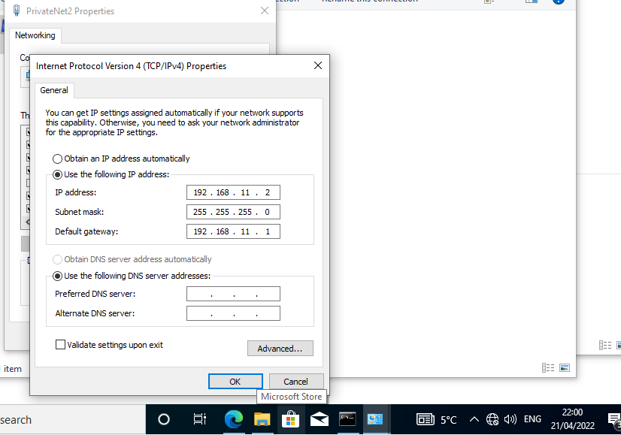

Complete the routing and remote access server setup wizard on server 1 and select ‘Start Service’: -
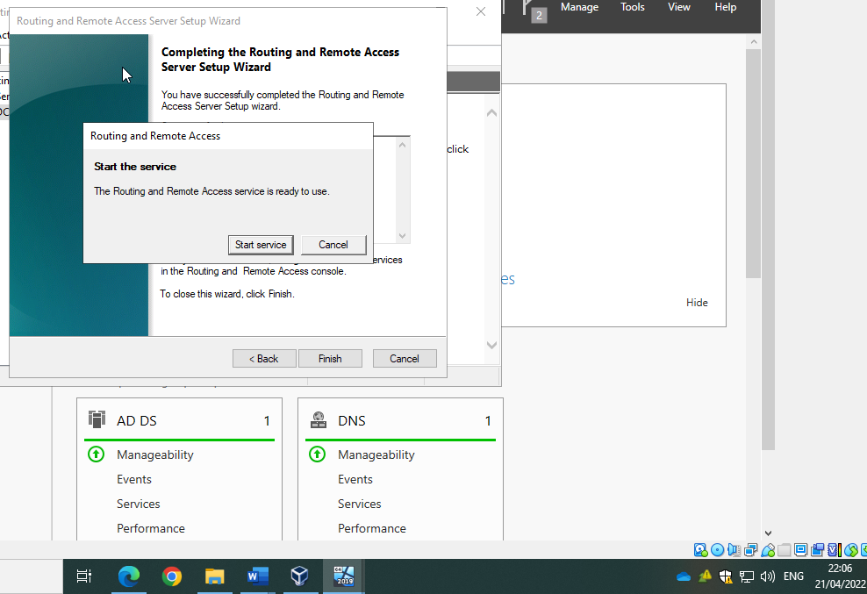
Confirm the service is now running: -
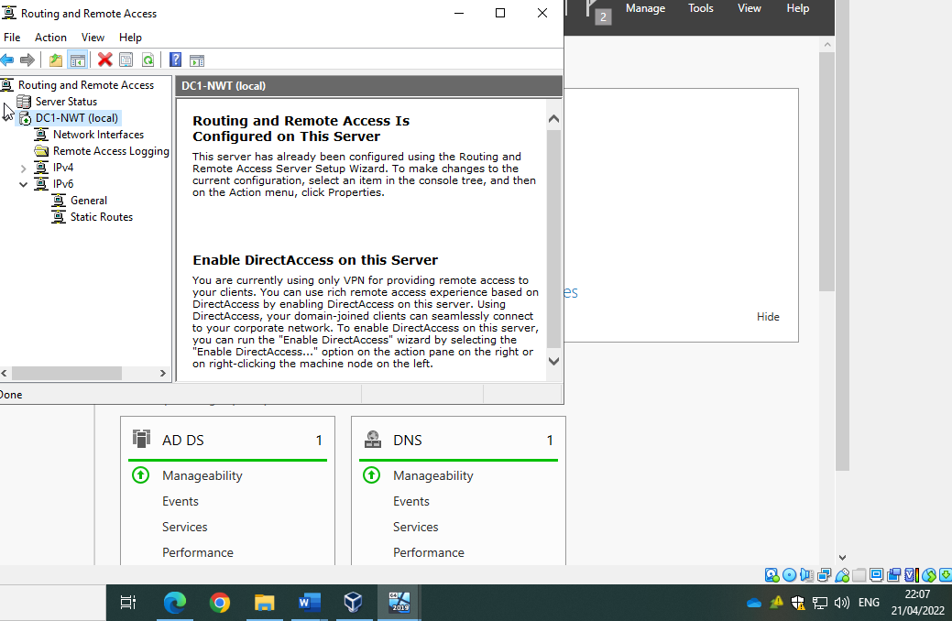
Add RIP version 2 into protocol: -
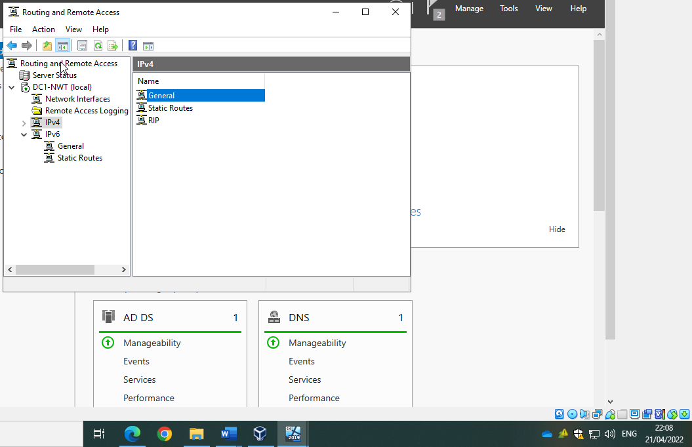

Add interfaces publicnet and privatenet1: -
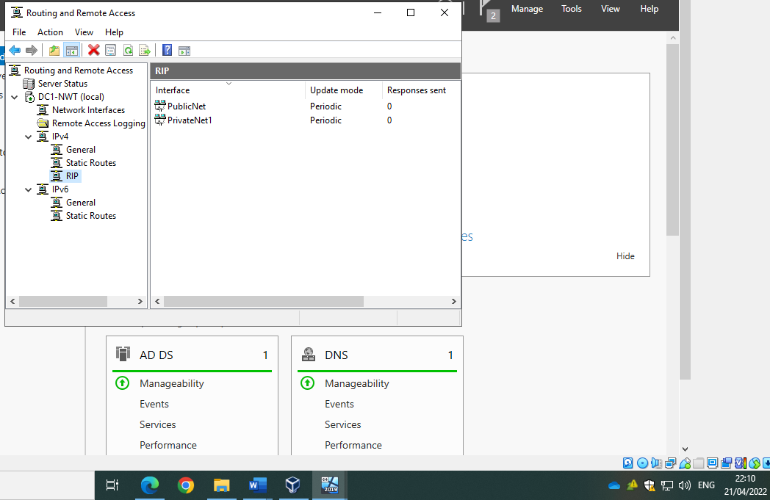
Repeating installation on server 2: -
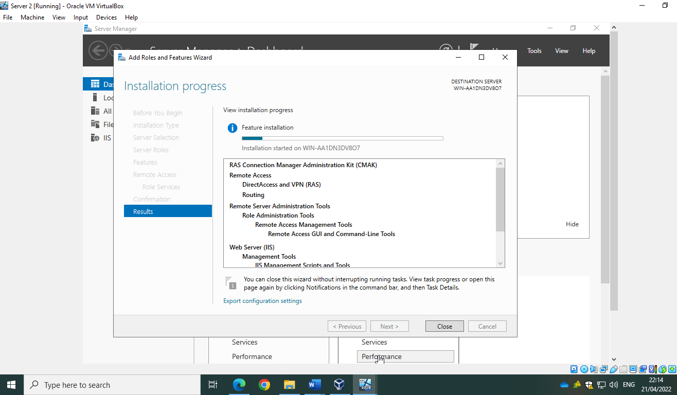
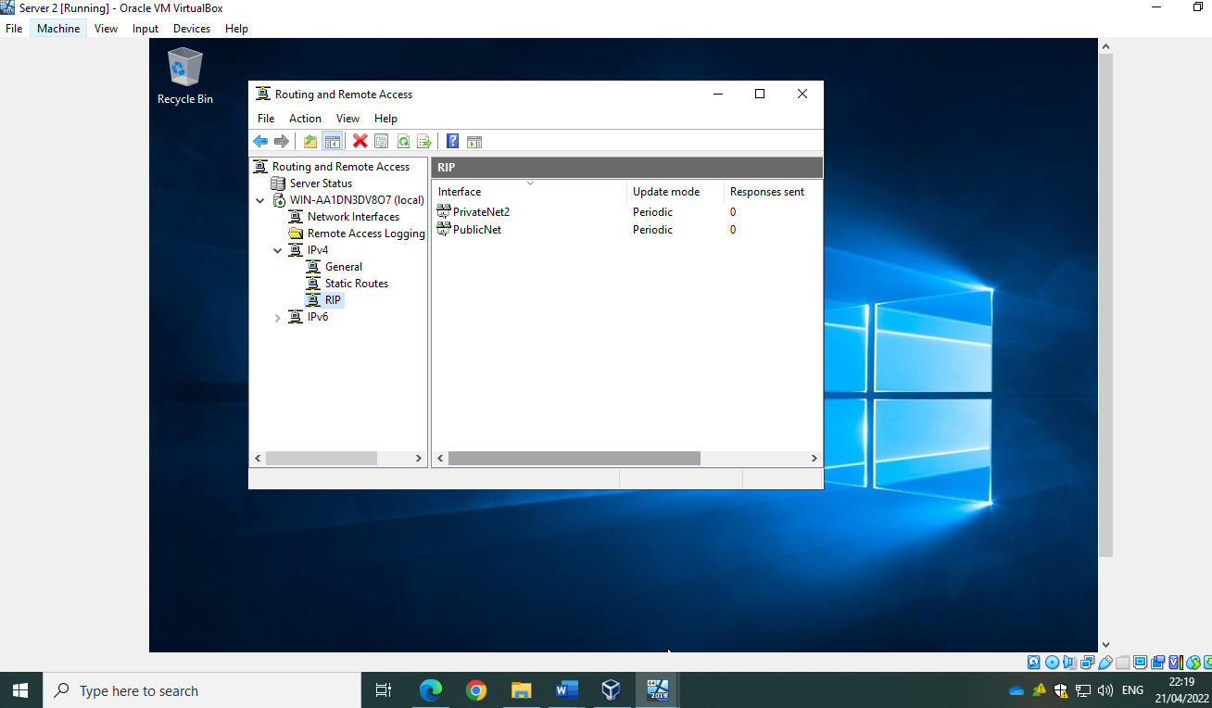
Ping publicnet address from server 2: -
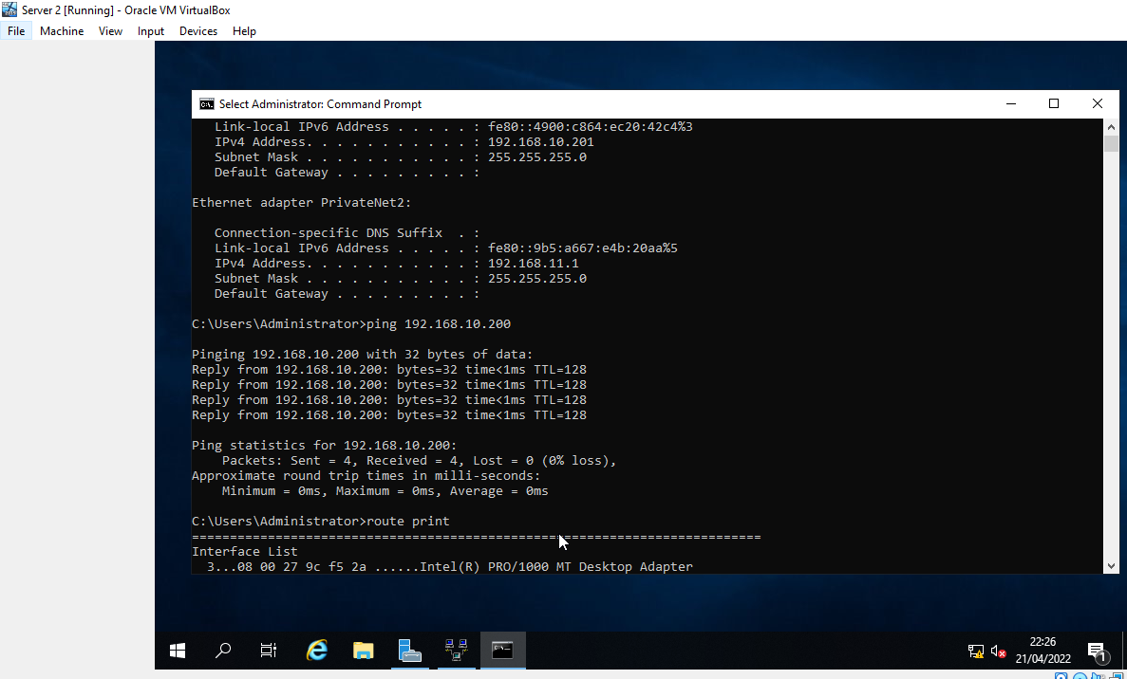

Setting default gateway on client 1:-
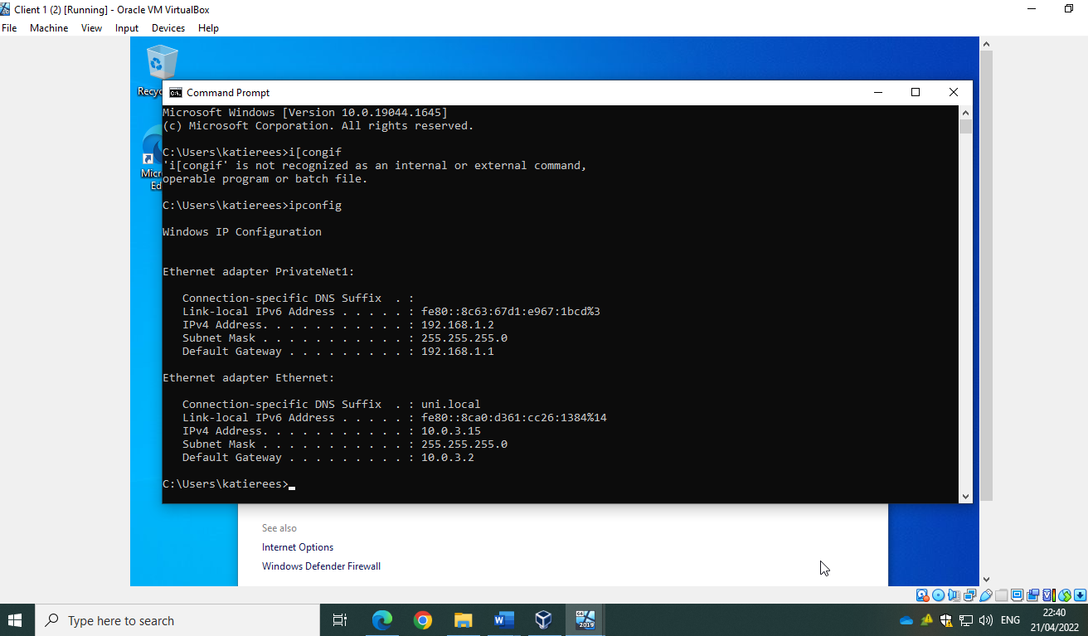

Ping public net from client 1:-
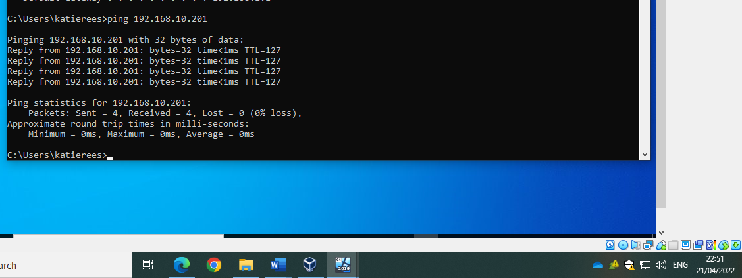
Ping client 2 on its privatenet2 ip address from client 1: -
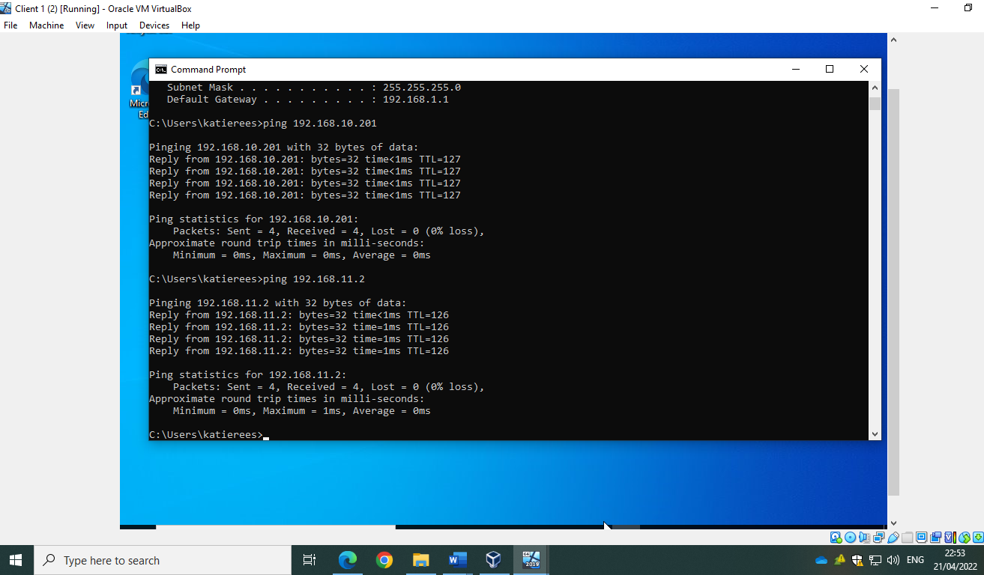
Set up IP and routing so that client 1 is unable to pint privatenet1: -
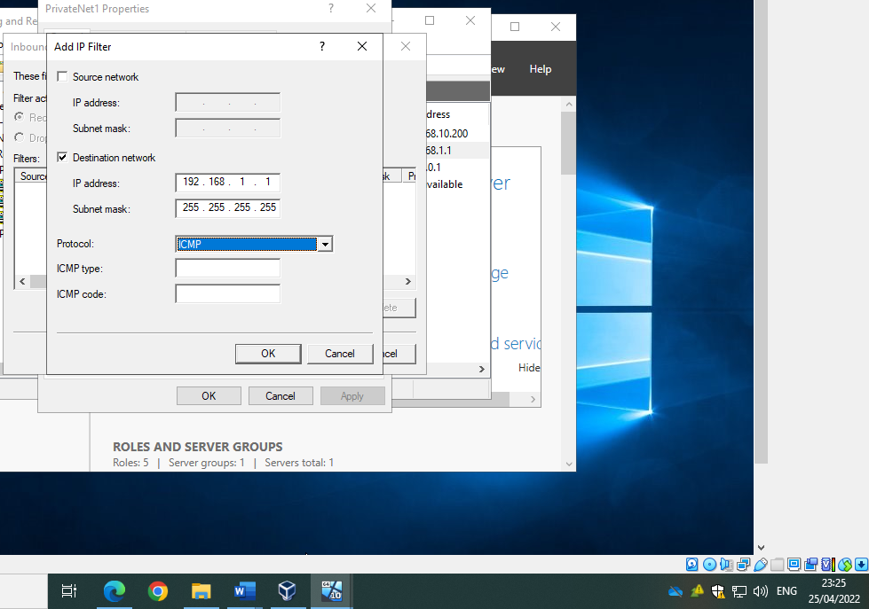
Unable to ping privatenet1 on client 1 but able to ping publicnet as specific destination has been selected: -
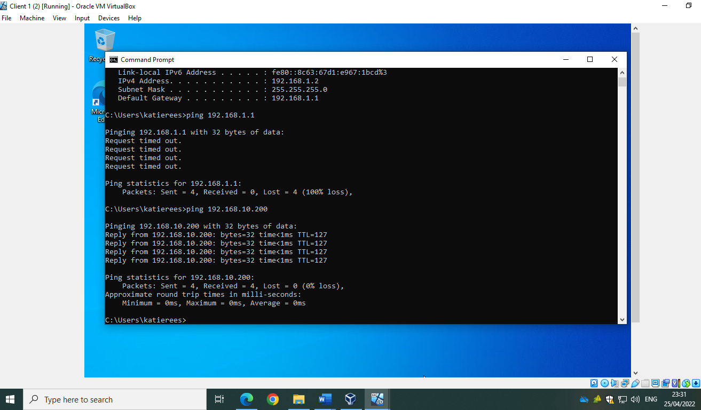

To test, add source destination 192.168.1.2 to privatenet1 and update from ‘receive all packets except those that meet the criteria below’ to ‘drop all packets except those that meet the criteria below’.
Now able to ping 192.168.1.1 on client 1:-
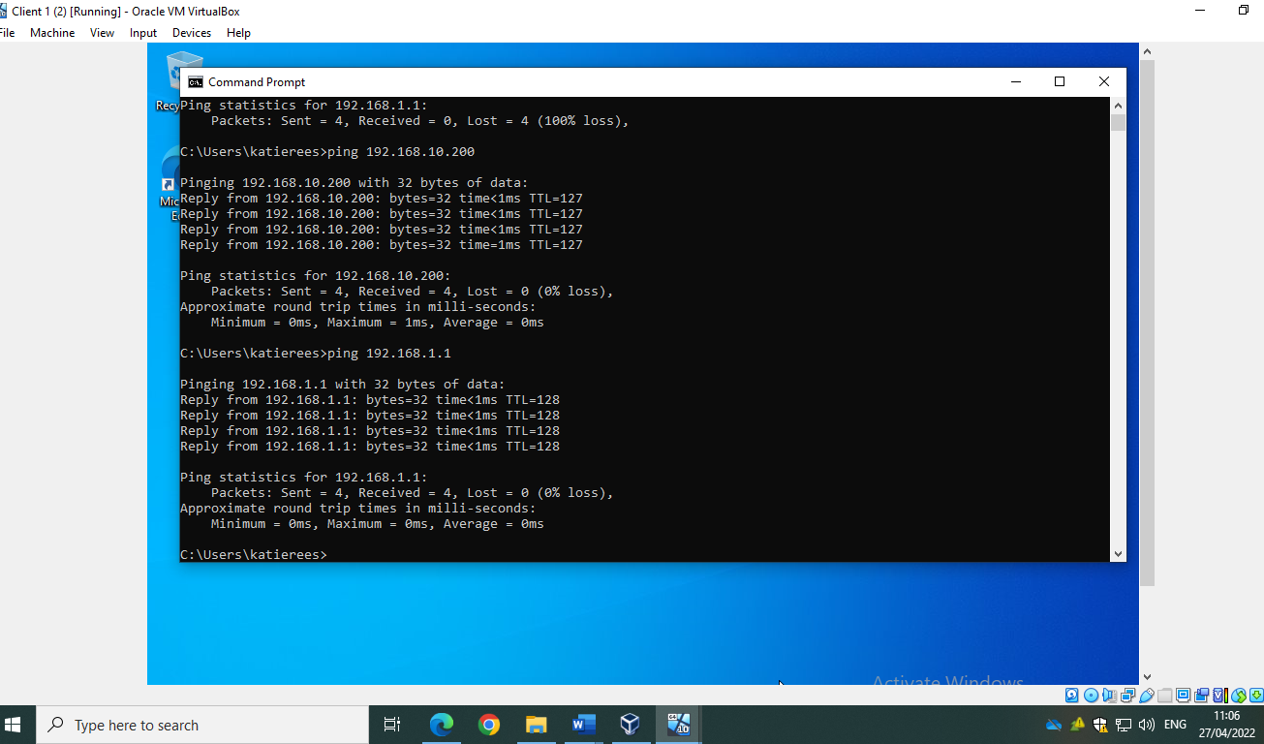
To allow client 1 to be unable to ping server 1 at all, update filter back to receive all packets and remove source destination. Remove destination address so that anyone on privatenet1 is unable to ping server 1: -
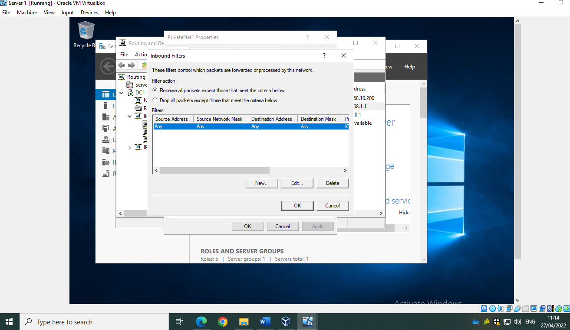
On client 1 unable to ping 192.168.1.1 or 192.168.10.200: -
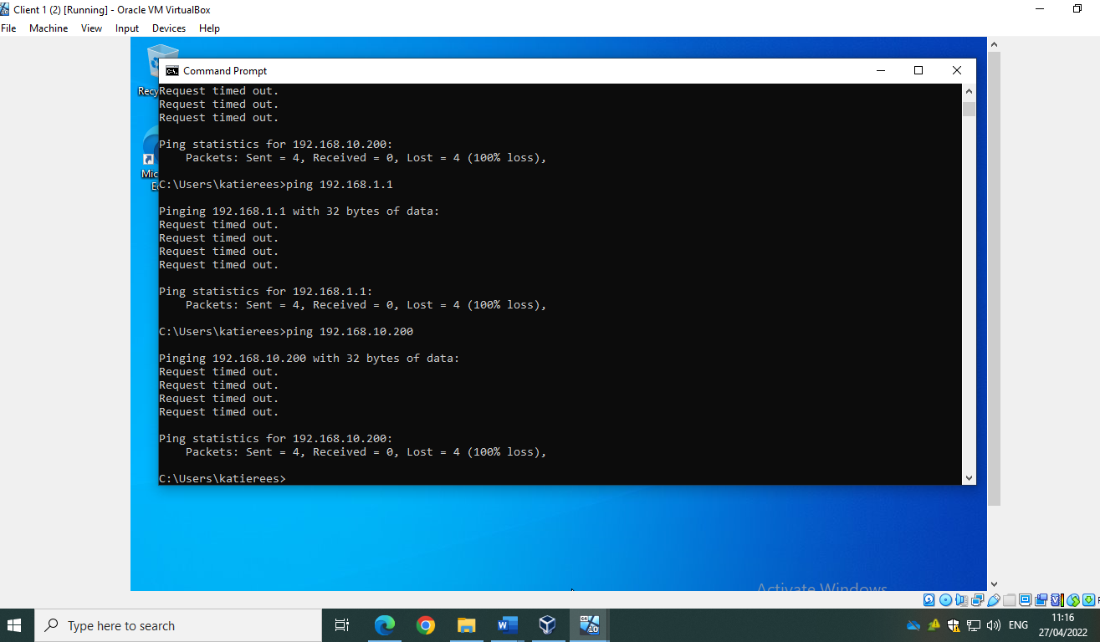
Remove inbound filter rule on server 1 to ensure that this does not impact any further testing: -
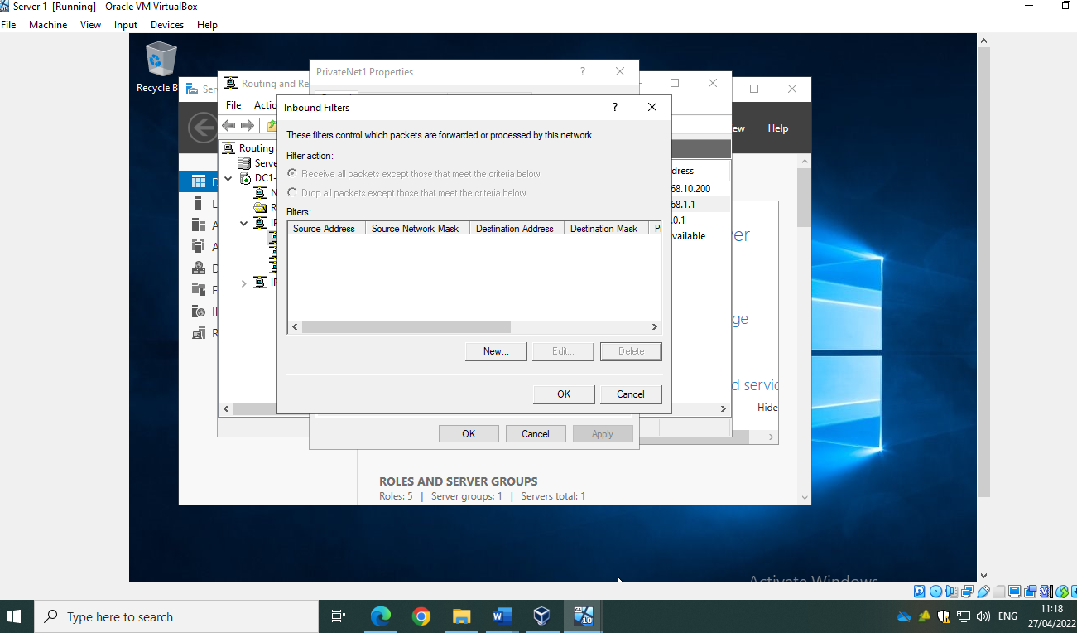

Add outbound filter on server 1: -
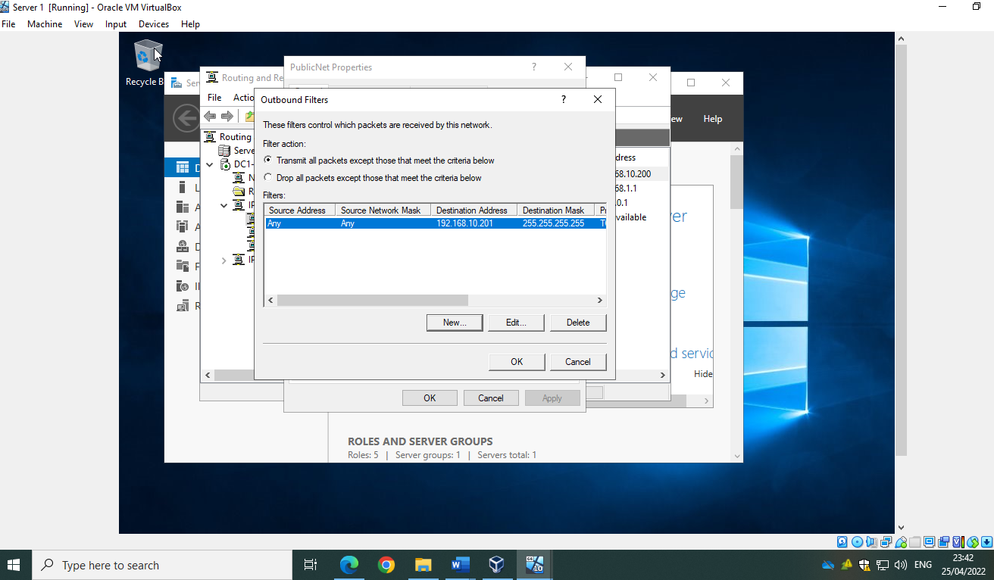
Able to access FTP via 192.168.11.1 but not 192.168.10.201 as the exact destination has been specified: -
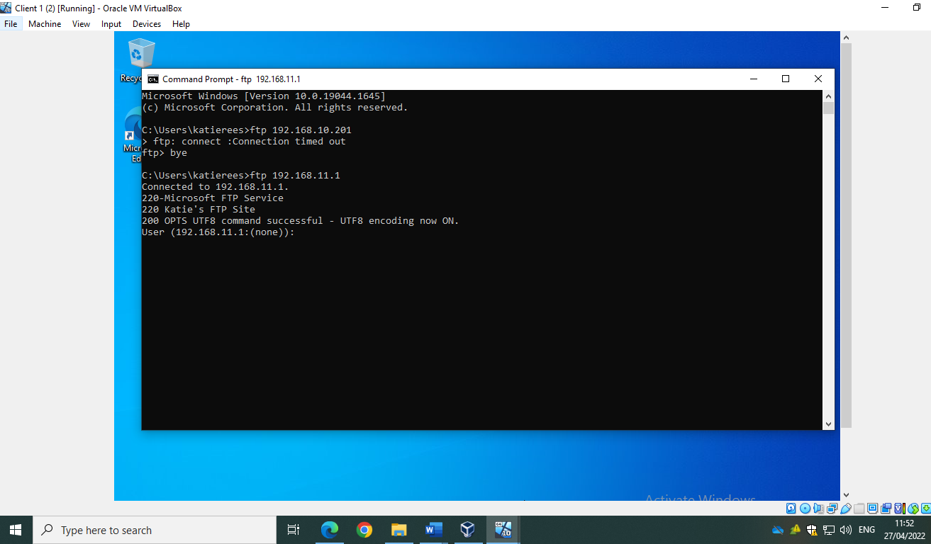
Add another rule to restrict access via 192.168.11.1 also: -
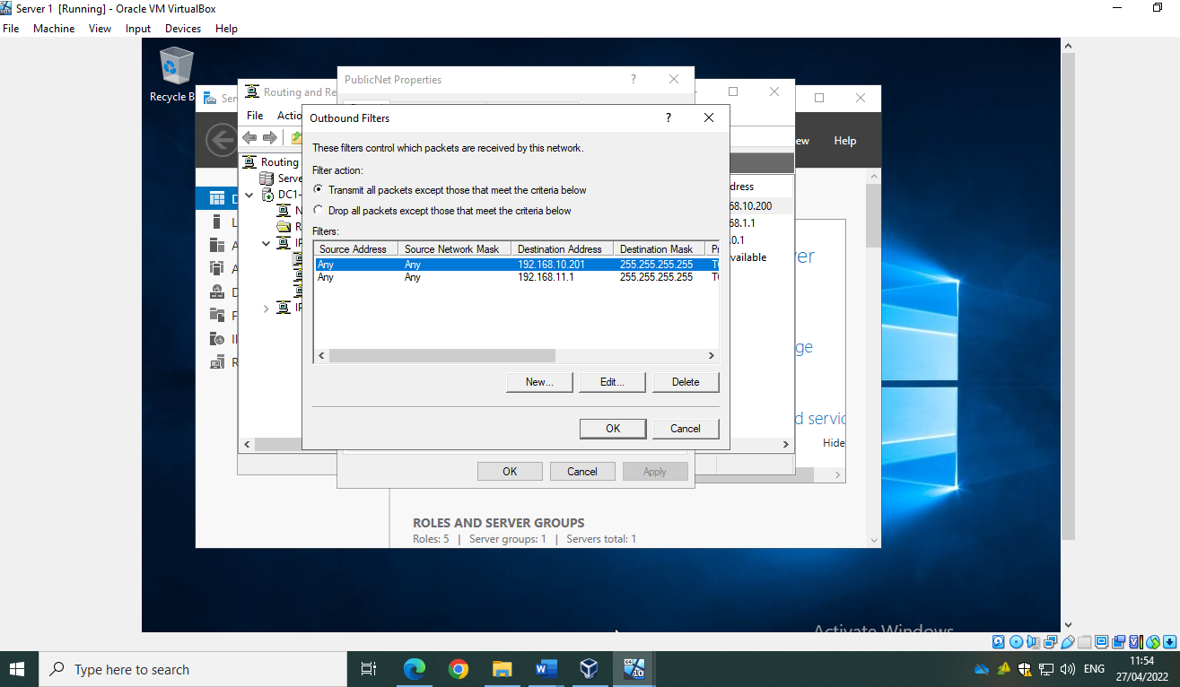
Now unable to access FTP service via 192.168.10.201 or 192.168.11.1 on client 1.
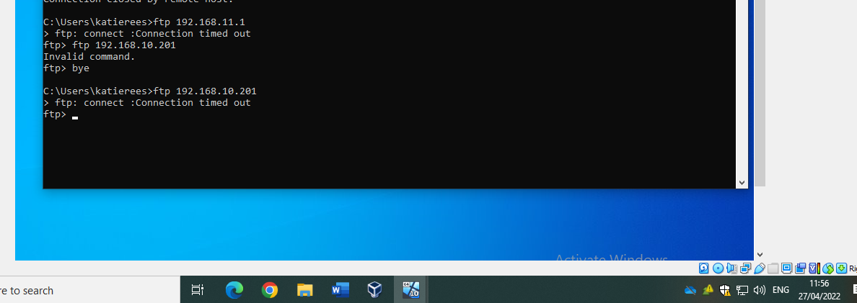
Pinging 192.168.11.1 should still work as rule has been set up to TCP only: -
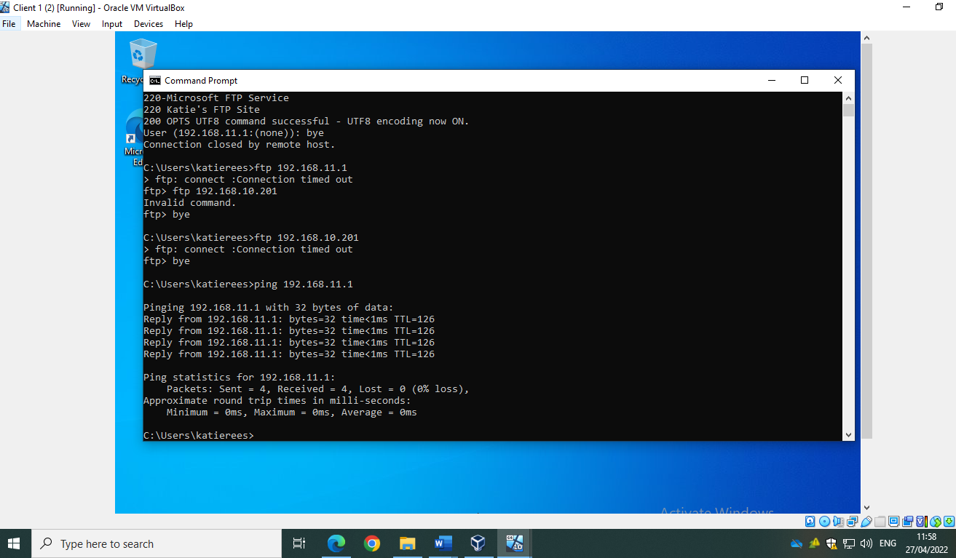

2.3/ Filter 3: Only Allow Specific Hosts in PrivateNet1 to Access the FTPService Running on Server 2
First, select ‘drop all packets except those that meet criteria below’ and add source address as client 1 privatenet1 IP and destination address as server 2 privatenet2 and publicnet IP addresses.
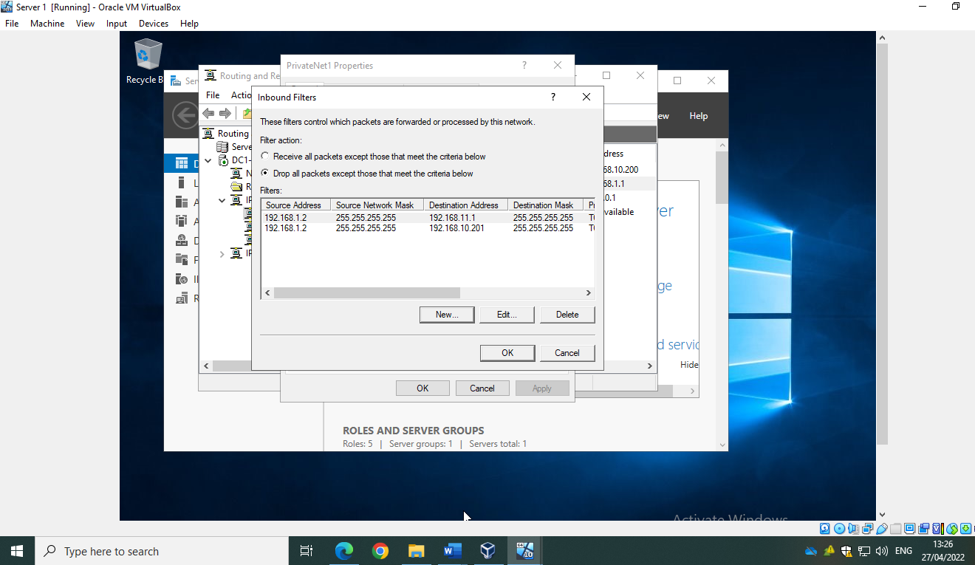

Able to access ftp on client 1: -
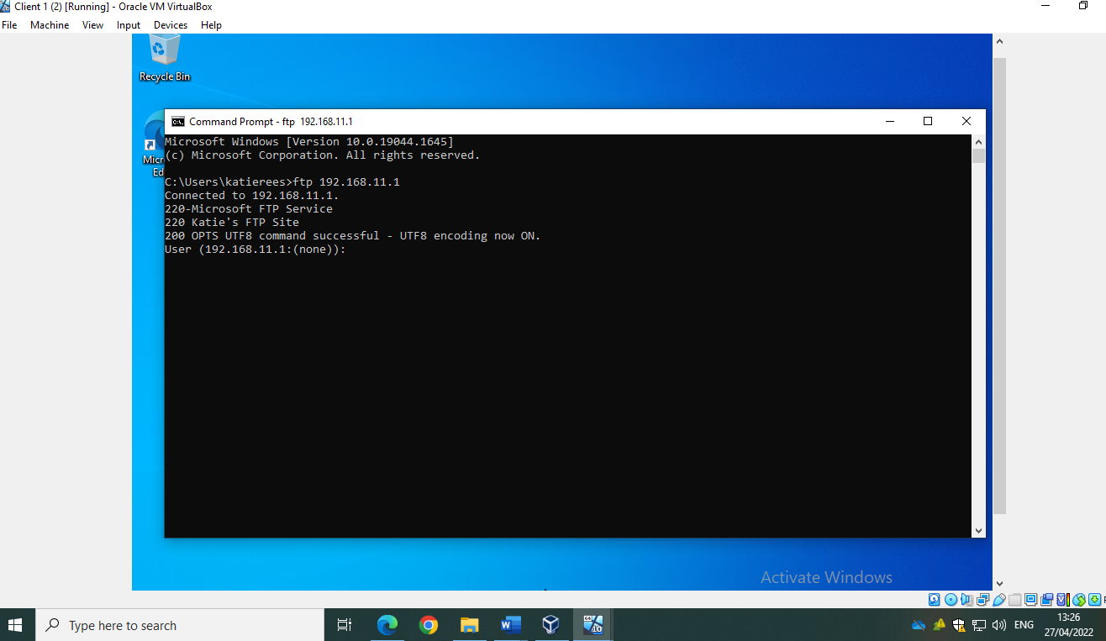
To test, swap from ‘drop all packets’ to ‘receive all packets’: -
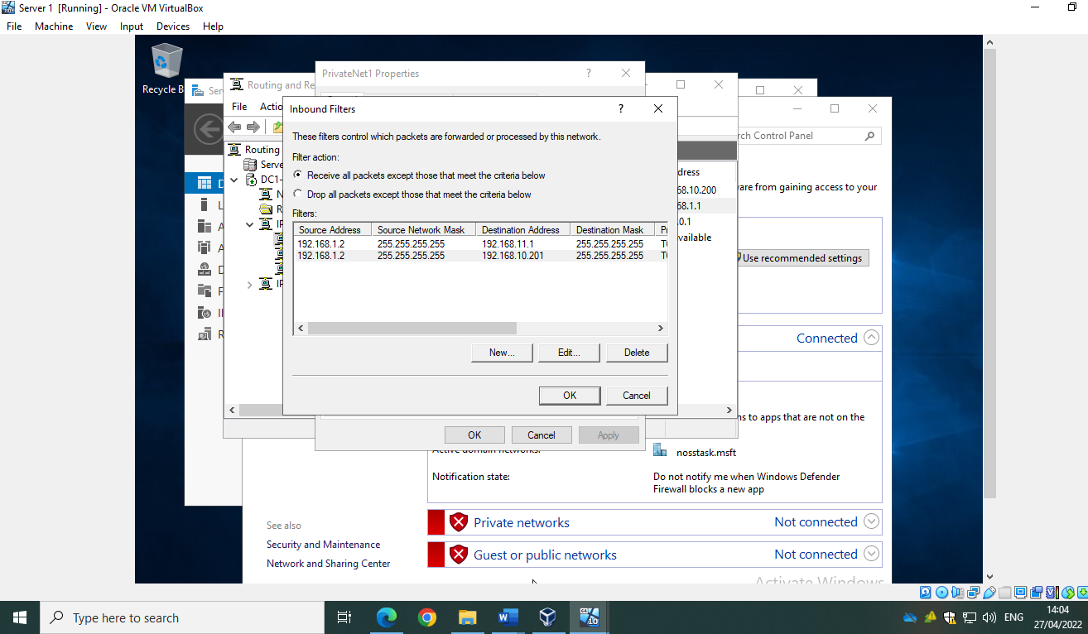
Confirm unable to access ftp on client 1: -
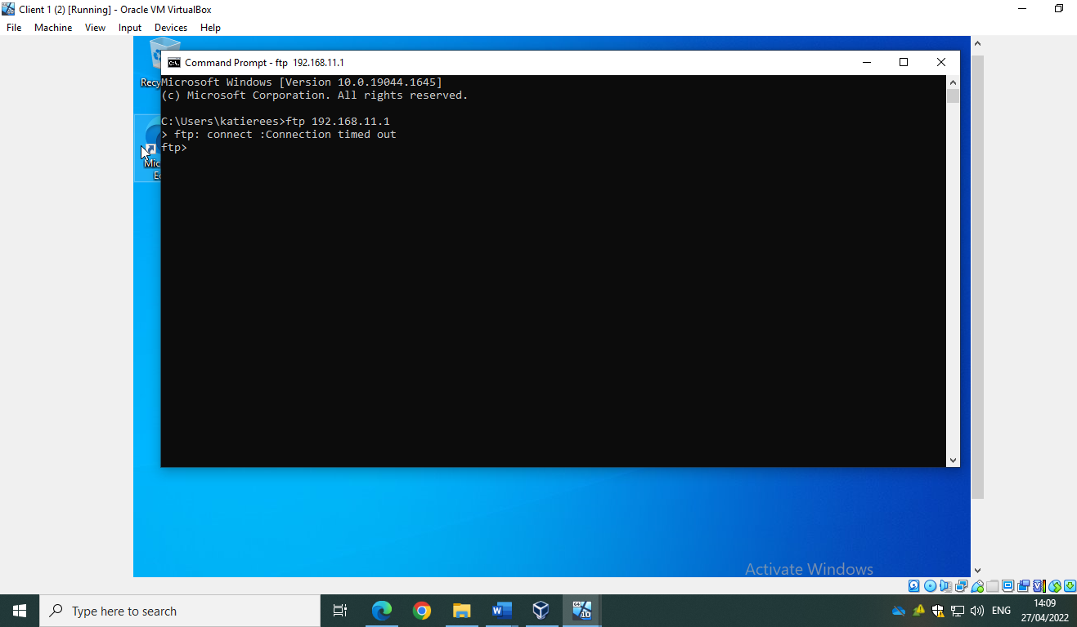

3/ Task 3: Observational Task

3.1/ Sound Passwords
Strong passwords are of paramount importance as they act as a defense mechanism against unauthorized access within a network. Weak passwords can put Organisations at risk of data breaches and cyberattacks. There are numerous ways in which a password can increase its strength such as the use of passphrases. As explained by Froehlich [1] passphrases can be up to 100 characters containing a string of words that form a sentence. They can be easy to remember however difficult to ‘crack’. Another password principle could be Multifactor Authentication (MFA). According to Microsoft [2] MFA adds an extra level(s) of protection on top of a password, such as receiving a code to a personal device, or scanning a fingerprint/face recognition.

3.2/ High Availability and Failover Clusters
High Availability (HA) is defined by Heidi [3] as a quality of a system which offers a high level of performance over a defined timeframe. High availability aims to eliminate a single point of failure within a network and is therefore vital for industries such as the NHS where it is imperative for computer systems to remain available. Whilst high availability can be advantageous due to protecting companies from the loss of data, revenue, and outages, it can also be costly to implement due to the more complex infrastructure. High availability systems require constant management and a high level of planning and testing before implementation can take place. [4]
There are multiple modern network enterprise services which would benefit from using high availability such as e-mail (with a major focus on corporate emails) and internet access. Databases, such as an electronic health record within the NHS, would also require HA so that there is consistent access to systems which are dependent on providing a good and safe service to the public.
HA can be combined with Continuous Availability (CA) if required. Whilst HA removes a single point of failure within an agreed time, CA offers continuous operation where a system would have no outages/downtime or interruptions to users. Within CA, redundancy is vital and each component within a system requires at least one back up to ensure users always have access even if the primary component fails. [5]
Within the Windows OS Server, Windows Service Failover Clustering (WSFC) can provide high availability of services by allowing more than one computer (or virtual machine) to host a service. If one of those computers fails, then the other computers are set up to take over the hosting automatically. Within WSFC clusters are created by combining two or more servers (also known as nodes). [6]
There are several things to consider before implementing a failover cluster. First would be determining whether a failover cluster is the best solution for your system. Considerations would include: -
- Is the system critical enough for high availability to be cost effective? It could be that solutions such as load balancers alone that could point to a cluster of servers could be more cost-effective, however if a load balancer goes down then the users would be impacted.
- Is CA required alongside HA? If using physical servers, then the location should be spread out so that if one node is damaged, for example, flooding or overheating, then it could failover to a node in a different location.
- Ensure that you have more than one node and that all those nodes a running on the same version of Windows Service. Not only that all nodes must be on the same Active Directory (AD) domain. The user setting up the cluster nodes must have administrator rights on all servers that are required as a cluster node. At least one cluster node should be identified as domain controller however it is advantageous to have multiple domain controllers identified so that a backup is available for fault tolerance.
- For management purposes, it is suggested that an Organisational Unit (OU) is created which would contain all computers of the servers you would like to add to as a cluster node. OU’s can help prevent accidental deletions of objects within a cluster node and can contribute to easier control of group policy settings such as restricting access to control panel. [7]
Once considerations are complete, to implement a failover cluster, navigate to the first node within the cluster and log in with administrator privileges. Next, install failover clustering via roles and features on server manager. This should be repeated on each node within the cluster. Once the nodes have then been restarted after the install, within server manager, confirm the failover cluster manager displays under the tools tab. Next, open failover cluster manager and validate configuration by selecting all the nodes within the desired failover cluster. Here, tests will be run to confirm all nodes within the cluster meet the requirements. For example, it will confirm there are no IP address conflicts and there is enough storage. Once the tests are complete, the cluster needs to be created. Server names should be identified for the nodes required in the cluster. Storage disks should then be added to the cluster from the other available nodes. At the point, the cluster will be created in active directory. [8]
Once complete, services such as SQL Server Always On can be downloaded onto the nodes to ease HA deployment and management. This would allow a failover cluster instance (FCI) which would mean databases can automatically failover to a designated node if a server within the cluster fails. As only one node in the cluster can host the FCI at a time, the database on the failover node would start. [9]
As previously discussed, high availability is critical dependent on the service that Organisations require. For example, Organisations such as the NHS would require HA and CA on certain systems to provide a continuous high level of care. Other Organisations however, such a small startup may decide that the cost of implementation of high availability would not be cost effective.

3.3/ Network Policy for Katie’s Technologies

3.3.1/ Network Topology
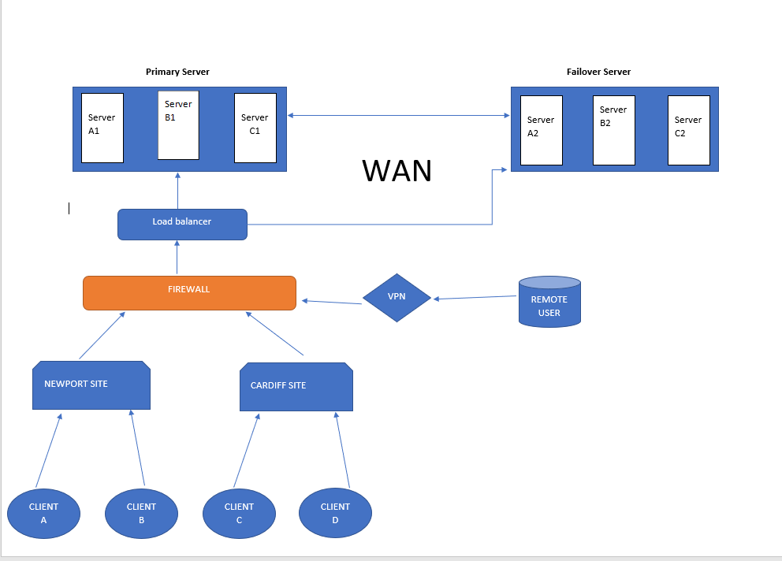
Fig 1.
Figure 1 is a brief diagram of the networks topology which includes a primary and failover server. Katie’s Technologies require high availability and therefore cluster nodes are demonstrated. The topology includes remote users accessing via virtual private network (VPN) as well as local client’s access from branch locations.

3.3.2/ Network Team
The network team is made up of network architects, engineers, and specialists within hardware. Teams such as the infrastructure, architecture and security teams should support the networking team to ensure the best network architecture is provided for Katie’s Technologies. [10]

3.3.3/ Password Policy
All users have an expectation to be aware of the password policy as outlined below: -
- Passwords must be more than 8 characters long.
- You must not re-use old passwords.
- You must not use personal information.
- It is encouraged to use passphrases where possible. [11]
- Never share your password with anyone.
- Never write your password down.

3.3.4/ Security Policy
Several security policies should be in place to work towards mitigating vulnerabilities. This includes the following: -
- Multifactor Authentication (MFA): this will be in place to offer extra security measures on top of a strong password to avoid unauthorised access. This would include things like face recognition or fingerprint technology and sending security codes to designated personal devices. [2]
- Group Policies: Group policy is a security measure which should be implemented to allow higher privileges or restrict access to certain users. This is vital in ensuring users pose as minimum-security risk to the company as possible and to avoid data breaches.
Group policy measures will be in place to ensure the following: -
- Password policy is adhered to.
- Control panel can only be accessed via identified users.
- Ensure removable drives such as DVDs and USBs are not allowed.
- Restrict software installations.
- Control access to command prompt. [11]

3.3.5/ Risk Assessment
There are many potential threats within a network such as viruses, ransomware attacks and malware. One of the main potential security threats within a network is human error. Katie’s Technologies should ensure that all employees have a thorough understanding and awareness of security risks such as phishing emails, and they should be aware of what steps should be carried out if they suspect any suspicious activity. For example, Outlook 365 offers a ‘Report Phish’ button which allows users to notify the network team quickly and easily when they suspect suspicious activity. Anti-virus software should be installed on all devices within the network. The security team will carry out continuous penetration testing and audits to ensure software is as secure as possible. [12]

3.3.6/ Network Management Software
Another way to mitigate risk within a network is to ensure network management software is available. Vulnerability scanners can automatically scan the devices within the network to assess the security vulnerabilities and will help identify any security weaknesses. [14] Management Software such as Ganglia would be advantageous as it is a monitoring system for networks containing cluster nodes with very low overheads. This is a well trusted monitoring system used in thousands of clusters around the world. [13]

3.3.7/ Mitigations in the Event of Violations
Katie’s Technologies is a high availability network and therefore includes cluster nodes to allow a failover if the primary server encounters an unplanned incident. A disaster recovery plan should be in place to ensure employees are aware of their roles and responsibilities to restore to the failover server in the event of an unplanned incident. [14] The disaster recovery plan should outline the primary and failover servers, any pre-requisites and the steps required to failover. The disaster recovery plan should also outline any tests that should be carried out to confirm the failover has been successful.

References

[1] | A. Froehlich, “What is a passphrase?,” Tech Target, [Online]. Available: https://www.techtarget.com/searchsecurity/definition/passphrase#:~:text=A%20passphrase%20is%20a%20sentencelike,to%20100%20characters%20or%20more.. [Accessed 4 April 2022].
[2] | “What is multifactor authentication (MFA)?,” Microsoft, [Online]. Available: https://www.microsoft.com/en-gb/security/business/identity-access-management/mfa-multi-factor-authentication. [Accessed 4 April 2022].
[3] | E. Heidi, “What is High Availability?,” Digital Ocean, 17 May 2021. [Online]. Available: https://www.digitalocean.com/community/tutorials/what-is-high-availability. [Accessed April 20 2022].
[4] | B. Lutkevich, “high availability (HA),” Tech Target, [Online]. Available: https://www.techtarget.com/searchdatacenter/definition/high-availability#:~:text=High%20availability%20(HA)%20is%20the,agreed%2Dupon%20operational%20performance%20level.. [Accessed 20 April 2022].
[5] | G. Wiesen, “What Is Continuous Availability?,” 21 March 2022. [Online]. Available: https://www.easytechjunkie.com/what-is-continuous-availability.htm. [Accessed 10 April 2022].
[6] | “Windows Server Failover Clustering (WSFC),” Tech Target, [Online]. Available: https://www.techtarget.com/searchwindowsserver/definition/Windows-Server-failover-clustering#:~:text=Windows%20Server%20Failover%20Clustering%20(WSFC)%20%2D%2D%20a%20feature%20of%20Microsoft,over%20the%20hosting%20of%20the. [Accessed 12 April 2022].
[7] | “Create a failover cluster,” Microsoft, 11 February 2022. [Online]. Available: https://docs.microsoft.com/en-us/windows-server/failover-clustering/create-failover-cluster. [Accessed 19 April 2022].
[8] | Kindson, “How to Configure Failover Cluster in Windows Server 2019 - Step by Step,” Youtube, 6 October 2020. [Online]. Available: https://www.youtube.com/watch?v=AsCWgIva1xo. [Accessed 20 April 2022].
[9] | “Always On Failover Cluster Instances (SQL Server),” Microsoft, 12 April 2022. [Online]. Available: https://docs.microsoft.com/en-us/sql/sql-server/failover-clusters/windows/always-on-failover-cluster-instances-sql-server?view=sql-server-ver15. [Accessed 28 April 2022].
[10] | “Who makes up an IT team?,” Aha!, [Online]. Available: https://www.aha.io/roadmapping/guide/information-technology/it-team. [Accessed 22 April 2022].
[11] | “Password policy recommendations,” 2 March 2022. [Online]. Available: https://docs.microsoft.com/en-us/microsoft-365/admin/misc/password-policy-recommendations?view=o365-worldwide. [Accessed 27 April 2022].
[12] | D. Murphy, “Top 10 Most Important Group Policy Settings for Preventing Security Breaches,” Lepide, 10 July 2021. [Online]. Available: https://www.lepide.com/blog/top-10-most-important-group-policy-settings-for-preventing-security-breaches/. [Accessed 22 April 2022].
[13] | C. D. Vos, “Top 12 (Must Know) Network Security Threats & Vulnerabilities,” Resolute, 5 June 2020. [Online]. Available: https://www.resolutets.com/network-security-threats-and-vulnerabilities/. [Accessed 23 April 2022].
[14] | “Vulnerability scanning: what is it, and how does it work?,” itgovernance, [Online]. Available: https://www.itgovernance.co.uk/vulnerability-scanning. [Accessed 27 April 2022].
[15] | “What is Ganglia?,” Ganglia Monitoring System, [Online]. Available: http://ganglia.sourceforge.net/. [Accessed 26 April 2022].
[16] | “What is a disaster recovery (DR) plan?,” IBM, [Online]. Available: https://www.ibm.com/uk-en/services/business-continuity/disaster-recovery-plan. [Accessed 24 April 2022].

