

Computer Forensics

Synthesize a solution to a potential real-life scenario

Dylan Bell - 2417050

Table of contents
Task 1: introduction – Page 3
Task 1: Comparative analysis table – Page 4
Task 1: Evaluation of Tools – Page 5-7
Task 2: Case Study Introduction – Page 8
Task 2: ACPO Principles/CHFI Methodology – Page 9-10
Task 2: Investigation Plan – Page 11-12
Task 2: Forensics Report – Page 13-17
Task 2: Professional Invoice – Page 18
References – Page 19

Task 1 – Research
Introduction
Computer forensics is one of the main fields of study in cybersecurity, which deals with the identification, preservation, analysis and presentation of digital evidence [1]. It is critical to both crime and corporate investigations, especially when a digital system is involved in a case like data breaches, insider threats, and intellectual property theft. Digital evidence integrity is very essential because it should be treated in a manner that will avoid it being inadmissible during legal or disciplinary hearings.
Despite stable core principles like chain of custody, evidence integrity, and structured investigative methods, digital forensics tools and techniques continue to evolve at a fast pace. This has been contributed by the continuous technological advancements such as cloud computing, mobile devices, encryption technologies and the growing use of anti-forensic methods to conceal or destroy evidence [2].
This leads to the fact that no one forensic tool can be used in every investigation. Rather forensic practitioners choose the tools depending on the needs of the case, the nature of evidence, and the investigation phase. This methodology is complemented by systematic models like the CHFI (Computer Hacking Forensic Investigator) model which breaks down investigations into steps that include acquisition, analysis and reporting.
There are four contemporary forensic tools that are being critically analysed and compared in this report: FTK Imager, Magnet AXIOM, Autopsy, and Cellebrite UFED. Their applicability at various phases of the forensic process, such as imaging, analysis, mobile forensics, and cloud-based investigations are analysed.
Beyond technical aspects, digital forensics has important legal and organisational implications. Not only does the evidence recovered from an investigation need to be accurate, it also needs to be admissible in a court of law, so there are specific processes that need to be followed. It is essential that investigators can accurately explain the actions they have taken, the tools they have used and the processes they have followed so that the results are defensible in court [1].
In addition, the growing use of digital systems within organisations has resulted in a growing number of insider attacks, where trusted insiders abuse systems for their own benefit. Such attacks are especially challenging to identify, as they often involve legitimate user credentials and knowledge of the organisation's IT systems. Consequently, digital forensic investigations need to be comprehensive and systematic, employing a range of tools and techniques to ensure that all possible sources of evidence are investigated [2].
Tool Name | Type | Cost | Key Features | Supported File Systems | Evidence Types | Reporting Capabilities | Best CHFI Phase
FTK Imager | Imaging Tool | Free | Hash Verification, Disk Imaging, Preview Files, Memory Capture | NTFS, FAT, exFAT, EXT | Disk Images, RAM | Basic reporting, Hash logs | Imaging and Preservation
Magnet AXIOM | Commercial Suite | Paid (High Cost) | Timeline Analysis, Advanced artefact analysis, Cloud acquisition, AI features | NTFS, EXT, FAT, APFS | Disk, Mobile, Cloud, IoT | Advanced Reporting, Customisable reports | Analysis and Examination
Autopsy | Open-Source Suite | Free | Keyword Search, Plug-in support, File Craving, Timeline | NTFS, EXT, FAT | Disk Images, Limited mobile | Basic to moderate reporting | Analysis
Cellebrite UFED | Mobile Forensics | Paid (Very High Cost) | App Data Recovery, Encrypted data handling, Mobile extraction | Mobile OS (e.g. IOS/Android) | Mobile Devices, SIM data, app artefacts. | Detailed Legal reports | Mobile Forensics
Comparative Analysis Table

Evaluation of Tools
FTK Imager
FTK Imager is a light but efficient forensic imaging tool that is greatly utilised during the first steps of digital investigations. It enables investigators to make verbatim copies (forensic images) of storage devices without altering the data integrity with cryptographic hashing [4].
The major advantage of FTK Imager is that it is simple and reliable. It accepts various image formats that include E01 and raw (dd) and allows investigators to have a preview of files prior to obtaining them. It is also useful especially in live forensic investigations, where there is risk of losing data during system shut down due to volatile memory (RAM).
However, FTK Imager has its limitations. It does not support more sophisticated analysis features like artefact parsing, timeline analysis or automated evidence correlation. Its reporting capabilities are also limited with the emphasis being made on hash verification and acquisition logs.
Critically, FTK Imager can be considered extremely effective when it is employed in combination with more sophisticated tools. It is not aimed at conducting full forensic investigations, but to make sure that evidence is obtained in a forensically sound way.
Suitability:
FTK Imager is best suited for the identification, preservation, and collection phases of the CHFI process.

Magnet AXIOM
Magnet AXIOM is a full-scale commercial digital forensic platform that can be applied to a broad spectrum of digital investigations. It is especially famous for its ability to recycle and analyse artefacts across the various sources, such as computers, smartphones, cloud services, and IoT devices [5].
A great benefit of Magnet AXIOM is the artefact-based focus. The tool does not need the investigator to manually sift through raw data; it is capable of automatically extracting the relevant artefacts that include:
- Chat messages (e.g., WhatsApp, Facebook Messenger)
- Browser history
- Email communications
- Cloud storage data
Additionally, Magnet AXIOM also has the following sophisticated capabilities such as, timeline analysis, which enables investigators to recreate user activity in a chronological order, and AI-based categorisation, which makes it easier to find the evidence that is relevant to the case.
However, despite the tools many advantages, it has some significant disadvantages. It is very expensive and might be prohibitive to smaller organisations or academic institutions. Moreover, it consumes a lot of system resources, which can affect performance with the analysis of large datasets.
From a critical standpoint, Magnet AXIOM is a state-of-the-art forensic solution, and its success is related to the expertise of the investigator and the available infrastructure.
Suitability:
Magnet AXIOM is best suited for the examination, analysis, and reporting phases, particularly in complex, multi-source investigations.

Autopsy
Autopsy is a free digital forensic platform, which is based on The Sleuth Kit. It is popular in educational institutions and other low-end organisations because it is free and scalable.
Autopsy provides a range of core forensic features, including:
- Keyword searching
- File system analysis
- Timeline creation
- File carving and recovery
Its architecture is modular, which enables its users to add extensions and extend its functionality. This makes it a flexible tool for customised investigations [6].
However, Autopsy has several drawbacks in comparison to commercial alternatives. It also has a less intuitive user interface and does not provide built-in support to support advanced features like cloud forensics and AI-driven analysis. Processing large datasets can also be slower, which may impact efficiency in time-sensitive investigations.
More importantly, although effective, Autopsy demands higher technical proficiency to achieve results equivalent to commercial tools, reflecting its role as a foundational forensic platform rather than a comprehensive solution.
Suitability:
Autopsy is most appropriate for the examination and analysis phases, especially in disk-based investigations and educational settings.

Cellebrite UFED
Cellebrite UFED is a mobile device forensic tool, which is most commonly utilised by the law enforcement agencies. It specialises in data extraction in smartphones, both logical and physical.
One of the strongest features of Cellebrite UFED is that it supports locked and encrypted devices, which appear to be increasingly typical in contemporary investigations. It works with multiple mobile operating systems and can salvage data in applications like:
- Messaging apps (WhatsApp, Telegram)
- Social media platforms
- Call logs and contacts
- GPS and location data
The tool also generates detailed, court-admissible reports, making it highly suitable for legal proceedings.
However, it is very expensive and specialised making it unavailable and not versatile. It is not intended to be used in traditional disk forensics or cloud analysis, so it should be used in conjunction with other tools.
In a critical viewpoint, Cellebrite UFED cannot be dispensed when it comes to mobile devices and still requires the use of larger forensic platforms.
Suitability:
Cellebrite UFED is ideal for the collection, examination, and analysis of mobile evidence.

Case Study Introduction
The case being investigated is an instance of insider sabotage and intellectual property theft within Cyfusion Mobile Manufacturing Company (CMMC), a London-based organisation that specialises in designing mobile phone interfaces and graphical user interfaces (GUIs) to large manufacturers. The company has managed to carve a market niche as a market leader in a relatively short time, much of which can be attributed to its innovative designs and its proprietary development processes.
The suspect, Rich Daley, was a major employee that worked on designing a new GUI of the Samsung Galaxy Z Flip 6. This project was a major investment in research and development and was aimed at giving a competitive edge over competing products including a future device by a competing manufacturer. After he resigned, it was found that his workstation issued by the company did not have several important design files. Since the work was highly confidential, there were no backups of these files and only the suspect had been allowed to access them.
This was further raised after it was discovered that the suspect had possibly communicated with a rival organisation unauthorised and likely tried to sell proprietary designs. It is also believed that the suspect intentionally deleted files with a file-wiping utility and copied data to a personal Google Drive account before leaving the company. Such activities indicate sabotage and possible data exfiltration.
The primary evidence in this case is a desktop of the suspect running Windows 11 and encrypted with BitLocker full-disk encryption technology. Encryption and potential anti-forensic actions add a new dimension, and it must be dealt with carefully to preserve and analyse the evidence according to the available forensic principles.
For this I will conduct a forensic investigation of the suspect's workstation to recover deleted data, identify any anti-forensic activity, and determine if company information was stolen and leaked outside of the company. This investigation will produce evidence in a professional and coherent way that can be presented in a court of law and possibly used by CMMC management in disciplinary proceedings.

ACPO Principles
The investigation will be carried out in line with the principles of the Association of Chief Police Officers (ACPO), which offers a guideline of how to handle digital evidence in a way that would make it intact and admissible in court [3].
The first principle is that no action must be done to modify data that can be later used in court. This is particularly important in digital investigations, where even minor changes to a system can compromise the integrity of evidence. To deal with this, any acquisition processes were done through forensically sound tools and techniques that would not alter the original data.
The second principle is that, in cases where the original data is needed, the person carrying out the investigation should be competent and capable of justifying the relevance and implications of their actions. In this case, all the steps were performed with the help of known forensic tools and methodologies, so that the process could be justified in case it was necessary.
The third principle focuses on the need to have a clear audit trail. Every action undertaken in the investigation was recorded, such as the tools used, activities carried out, and findings. This ensures that the investigation is transparent and reproducible.
The fourth principle is that the individual leading the investigation must make sure that these principles are adhered to. The forensic investigator in this case is responsible for the integrity of the evidence and validity of the conclusions made.

CHFI Methodology
Alongside the ACPO principles, my investigation will adhere to the Computer Hacking Forensic Investigator (CHFI) model, which breaks down the forensic process into five basic steps: identification, acquisition, preservation, analysis and reporting.
The identification phase is the process of identifying potential sources of digital evidence. In this scenario, the suspect's computer was identified as the main source of evidence, given that it was used to create, store, and possibly delete the design files involved in this case.
The acquisition phase involves obtaining a forensic image of the system. This allows the original evidence to be preserved and a copy to be used for analysis. Due to BitLocker encryption, some extra processes were needed to ensure that the data was available in an unencrypted format.
The preservation phase guarantees that the evidence collected is not altered during the investigation. This involves the use of hashing to ensure the integrity of the data and secure storage processes.
The analysis phase is the process of analysing the forensic image to locate artefacts, recover deleted information and provide a reconstruction of activities. This is the most challenging part of the process, involving the use of forensic software.
The last phase is the reporting phase, where the results are documented in a professional and organised way, so that the outcomes are well communicated and justified.

Investigation Plan
The case started with the collection of digital evidence from the suspect’s computer, the main evidence source. The system was secured with BitLocker full-disk encryption, which presents a challenge when trying to access information stored on the system. In a live case, if the system is still running at the time of acquisition, live acquisition will be favoured to obtain the information held in volatile memory and potentially the BitLocker keys. This would enable the contents of the drive to be accessed in its unencrypted form. If a live acquisition approach cannot be used, other avenues may be explored such as recovery keys.
Once the data has been accessed, a forensic image would be taken of the storage media device using FTK Imager. This software allows for a bit-stream copy of the original disk to be made, capturing all information, including information that is hidden or deleted, for forensic analysis. Acquiring the image will result in the generation of cryptographic hashes (such as MD5 and SHA1) to ensure the integrity of the image [2]. This guarantees that the forensic image is identical to the original evidence and has not been tampered with during the imaging process. It is critical to use a validated imaging tool to comply with forensic guidelines and to ensure the evidence is acceptable to a court of law.
Once the forensic image has been acquired, it's important to preserve the image for analysis. This involves securely storing and restricting access to the image and ensuring its integrity by hashing. Write-protecting tools are used when obtaining the image to ensure that it isn't altered. Documentation of all actions taken is important to allow for transparency and repeatability of the investigation.
During the analysis phase, we look for evidence of anti-forensic techniques, recover files that have been deleted and reconstruct events. In this instance, it's believed the suspect used a file-wiping tool, so the PC would be searched for traces of these tools. This involves looking for artefacts such as installed software, Windows registry keys, prefetch files and logs. These are particularly useful as they show what programs have been executed on a Windows computer. If there are entries for these types of tools, this would indicate they had been executed. This is significant as it suggests an attempt to obliterate information to conceal it during forensic analysis.
Computer forensic tools, such as Autopsy and Magnet AXIOM, would be employed to assist in this process. These contain advanced capabilities for system artefact and user activity analysis. They are ideal for the analysis of data relating to the registry, applications and processes - making them a great tool to detect anti-forensic activity.
In addition to identifying indications of data deletion, attempts would be made to recover any deleted files associated with the Autodesk Maya design project. Unallocated space would also be searched for file signatures to aid file carving. This is essential in cases where files have been deleted but not overwritten. Autopsy is an excellent tool for this type of analysis as it can search the unallocated space and carve files using their signatures. Although the use of file-wiping software will reduce the likelihood of recovering entire files, it is possible to recover file fragments which can still provide useful information such as file names, file metadata and some of the file content.
A further key part of the investigation relates to examining browser artefacts for potential data theft using cloud storage. The individual under investigation is suspected of having used a web browser to access a personal Google Drive account to transfer sensitive information. Consequently, analysing the browser history, cache, cookies and session data would be used to discern evidence of such activity. The use of Magnet AXIOM to acquire and process these artefacts would be recommended as it has enhanced features to reconstruct user activity and interactions with cloud services.
Visits to Google Drive URLs, login activity and file transfers would provide corroborating evidence that data was transferred. Similarly, temporary internet and cached files may provide some evidence of the files that were accessed or transferred. By combining this data with system timestamps, a timeline can be created that emphasises the actions taken by the user prior to the resignation.
Overall, this approach provides a thorough, systematic and forensically sound investigation. Through forensic imaging, artefact analysis, file recovery and cloud activity investigation, it is possible to reconstruct the suspect's actions and establish if the data was deliberately deleted and exfiltrated.
It is crucial to acknowledge the potential limitations that can be encountered during forensic investigations, especially in relation to encryption and anti-forensic techniques. Encryption using BitLocker and file deletion through file-wiping programs can limit the amount of data that can be recovered, making it difficult to acquire all necessary evidence. This means that they need to rely on circumstantial evidence and residual data.
However, by employing forensic processes and tools, a valid investigation can be performed. Using a variety of techniques, such as imaging, artefact analysis and timeline reconstruction, these challenges are addressed to allow a thorough understanding of the incident.

Forensics Report

Executive Summary
This report presents the findings of a computer forensic examination of a Windows 11-based computer previously owned by Mr. Rich Daley from Cyfusion Mobile Manufacturing Company (CMMC). A forensic investigation was conducted as a result of the loss of critical design files for a valuable mobile phone user interface development project from the suspect's computer following his resignation from the organisation. These data files contained key intellectual property and were vital to the organisation's market position.
The key concerns included the possibility that the suspect may have intentionally deleted confidential data, used anti-forensic techniques to hide his tracks, and potentially transferred proprietary data to an external cloud-based service prior to resigning from the company. The lack of system backups and the sensitivity of the data indicated that this incident could have a serious impact on the organisation, both financially and reputation-wise.
FTK Imager was used to create a forensic image of the suspect system to acquire a forensically accurate copy of the media. This allowed the original evidence to be maintained in its original form. The image was then analysed with Autopsy and Magnet AXIOM to analyse system artefacts, recover deleted data and user activity.
The forensic investigation discovered traces of file deletion, indications of file wiping activity, recovery of deleted Autodesk Maya files, and web browsing activity related to accessing Google Drive. This evidence suggests that the suspect had deliberately deleted important corporate data and may have attempted to exfiltrate this data before resigning from the organisation.

Investigation steps
The forensic investigation was conducted using accepted practices based on ACPO guidelines and CHFI methodology.
The workstation belonging to the suspect was the key piece of evidence. BitLocker full-disk encryption was in place, meaning forensic acquisition needed to be undertaken with caution to gain access to the decrypted data. The system was imaged using FTK Imager. This allowed a bit-by-bit copy of the original media to be obtained without modification to the original evidence. Integrity hashing (MD5 and SHA1) was performed during the process.
Once the forensic copy was acquired, it was securely stored and all analysis was performed on the forensic copy to ensure integrity. During the analysis phase, artefacts on the system were analysed, including the registry, installed applications, prefetch files and event logs, to determine user activity.
The computer was searched for signs of anti-forensic measures, such as file wiping utilities. Artefacts relating to software installation and execution were examined to see if data wiping applications, such as Eraser, were used.
Methods of recovering deleted files were then employed to reveal traces of Autodesk Maya project files. File carving techniques were used to search for known file signatures for design files in unallocated disk space. Incomplete file recovery was obtained, suggesting the files were once present on the machine.
Investigators also examined browser artefacts to probe for possible data exfiltration to the cloud. The analysis involved a review of browser artefacts including history, cache and session data, using Magnet AXIOM. This revealed activity involving Google Drive through a web browser, as well as actions indicative of file uploads.
A sequence of user actions was then generated, revealing a pattern of file deletion followed by cloud account access, just before the suspect resigned. This is indicative of deliberate deletion and transfer.

Findings
The forensic investigation revealed multiple categories of evidence relevant to the case.
The forensic analysis revealed several types of evidence useful in this investigation. The program execution artefacts were examined to detect traces of software installation and use. This can be used to detect the presence and execution of file-wiping software. Here's an example of program execution artefacts used to detect software activity in Autopsy: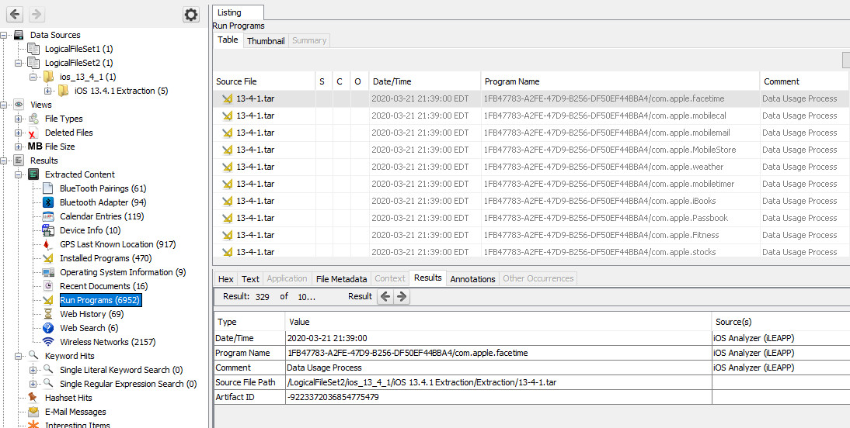
[7] This type of artefact is crucial to forensic investigations, as it offers indirect but reliable evidence of software use, even if the program is no longer present on the system.
Additional investigation of the media included file carving to recover deleted data from unused space on the disk. Several fragments and reconstructed items were recovered from the unallocated region which showed that deleted data can be recovered. This technique is important in the investigation of the removal of Autodesk Maya project files, as it enables the recovery of partial files and verify that the files have been deleted. Here is an example of files carved from unallocated space in Autopsy:
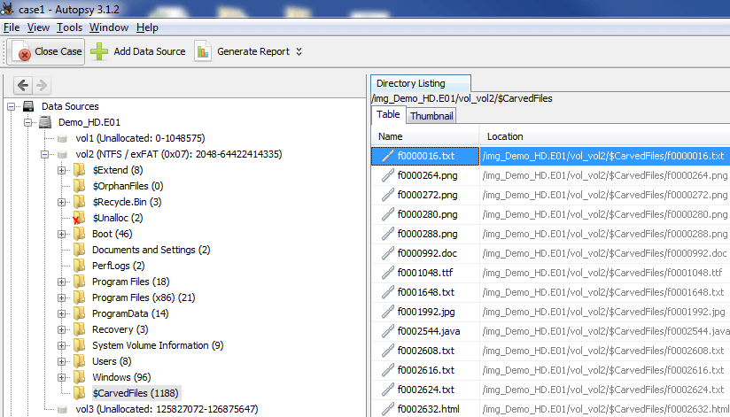

[8] Carved files highlight the fact that data remains on storage media until it is overwritten, making file carving an essential process for recovering data deliberately deleted by a user.
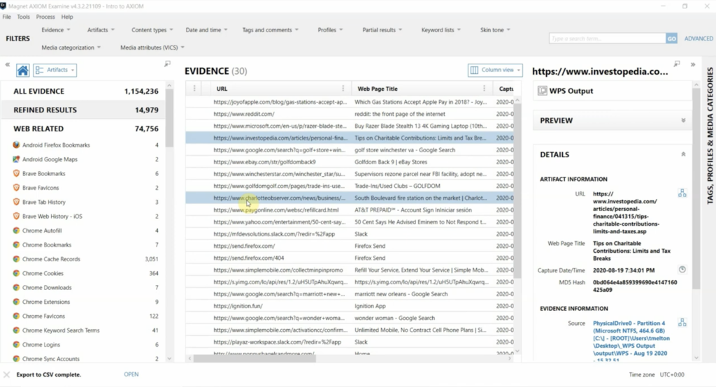
Web artefacts were examined to determine interaction with online services. This involved analysis of history, cache and session information. These artefacts can show access to cloud drives, such as Google Drive, and potential data sharing. Here's an example of browser artefact analysis showing user Internet activity and URLs visited in Magnet AXIOM:

[9] Browser artefacts are particularly useful for cloud computing investigations, as they can provide evidence of user intent, access and data transfer.
Beyond the specific artefacts discovered, the presence of these artefacts together offers a broader perspective on the suspect's activities. In digital forensic analysis, it is not uncommon to rely on the combination of evidence artefacts, rather than a single "smoking gun". Here, the combination of traces of program execution, fragments of deleted files and traces of web browsing provide greater confidence in the overall findings.
This is especially crucial in cases where anti-forensic measures have been taken to deliberately obscure direct evidence. By examining indirect artefacts, such as residual traces, it is still possible to reconstruct events and establish patterns of activity. Multiple forensic tools also aid this process, as they provide different features and insights into the data.
Therefore, the results of this forensic investigation are not only backed up by individual artefacts, but also by the consistency and correlation between a range of evidence sources. This increases the certainty in the findings and highlights the usefulness of the forensic approach employed.
Conclusion
This analysis has exposed evidence of unauthorised and intentional activity by Mr. Rich Daley in the deletion and potential exfiltration of valuable data. The presence of program execution artefacts relating to file-wiping software indicates deliberate action to permanently delete files and make recovery difficult. Similarly, the recovery of fragments of files from the unallocated space on the hard drive also suggests that critical Autodesk Maya design files were present on the system and subsequently deleted. While it was not possible to recover the files in their entirety, these fragments establish that valuable proprietary information was stored and then deleted. Also, an analysis of web browser artefacts revealed activity consistent with the use of a cloud-based service. Although it cannot be definitively determined that files were successfully shared, the timing of this activity in conjunction with the file deletion suggests that data may have been accessed and potentially exfiltrated to a cloud computing service before the suspect left the organisation.
The temporal relationship of these observations within a comprehensive timeline emphasises a pattern of action consistent with pre-planning. The application of anti-forensic measures, followed by cloud access, suggests that there was an attempt to delete and potentially steal proprietary company data.
At a corporate level, this incident underlines the need for more robust internal controls, such as data backups, user activity monitoring and controls around data transfer. This lack of controls in this case amplified the effect of the incident.
To conclude, the evidence paints a picture of deliberate behaviour on the part of Mr. Daley that is a serious violation of organisational trust and security. The results of this investigation could inform legal advice and may be used to support further disciplinary action or legal action.

Forensics Invoice

Troy Simpson Forensics Bill to:
Digital Forensic Investigation Cyfusion Mobile Manufacturing Company
London, United Kingdom

Invoice Number: INV-001
Date: 05/04/2026

Services Provided:
Description | Hours | Rate | Total
Analysis | 20 | £100/hr | £2000
Evidence Acquisition | 8 | £100/hr | £800
File Recovery and Carving | 5 | £100/hr | £500
Reporting | 12 | £100/hr | £1200
Expert testimony preparation. | 6 | £100/hr | £600
Total |  |  | £5100

Payment Terms
Payment due within 14 days of invoice date.

Thank you for your Business.
To ensure we correctly match your payment, always reference invoice numbers when making a payment.

References
[1] E. Casey, Computer crime and Digital evidence. Available: https://www.sciencedirect.com
[2] National Institute of Standards and Technology (NIST), Guide to Integrating Forensic Techniques into Incident Response. Available: https://csrc.nist.gov/pubs/sp/800/86/final
[3] Association of Chief Police Officers (ACPO), Good Practice Guide for Digital Evidence. Available: https://www.digital-detective.net/digital-forensics-documents/ACPO_Good_Practice_Guide_for_Digital_Evidence_v5.pdf
[4] Exterro, “FTK Imager.”
Available: https://www.exterro.com/digital-forensics-software/ftk-imager
[5] Magnet Forensics, “Magnet AXIOM.”
Available: https://www.magnetforensics.com/products/magnet-axiom/
[6] Sleuth Kit, “Autopsy.”
Available: https://www.sleuthkit.org/autopsy/
[7] Google Images, “Autopsy User Documentation,”. Available: https://www.google.com. [Accessed: April 10, 2026].
[8] Google Images, “Using Autopsy to Recover Deleted Files,”. Available: https://www.google.com. [Accessed: April 10, 2026].
[9] Google Images, “Using the magnet web page saver,”. Available: https://www.google.com. [Accessed: April 10, 2026].

