MARKETING MANAGEMENT

ASSESSMENT 1
UNILEVER

Table of Contents
Introduction 3
About Unilever 3
Business Strategy 4
Critical analysis 4
Sustainable and Innovative manufacturing process 4
Factors for exploring customer experience value identified by Unilever 5
Digital Marketing and Distribution Channel 5
Personal Development 5
Goals of Unilever to explore brand touch points 6
Challenges that requires troubleshoot with the touchpoints 6
Impacts of adopting effective marketing strategies of Unilever 6
Marketing Mix on Unilever 8
Impact of digitalization 10
Customer aspect and reaction 11
Theoretical approach to judge the potential to enable customer satisfaction by Unilever 11
Application of value proposition model 13
Conclusion 15
Recommendation 16
Reference list 17
Case study 17
Maechler, N., Neher, K., & Park, R. (2016). From touchpoints to journeys: Seeing the world as customers do. McKinsey & Company, 1-10. 17
External 17

Introduction
The following report analysis helps to provide the best-case scenarios that would highlight the key understanding of the statement, ‘to maximize customer satisfaction, companies have long emphasized touchpoints. But doing so can divert attention from the more important issue: the customer’s end-to-end journey (Neher et al, March 2016). The initial discussion of this specific set of statement focuses on the ideal key findings that would allow a brand to match up to the requirements of the customers. In order to stage a perfect or rather a near to perfect marketing strategies to hold on to the current customers as well as to generate or attract more new potential customers as per Kurdi et al (2020). It is not easy for any brand, be it an existing one or a new one to stay in the competition, as it is an uphill task for a brand like the selected one for this context, Unilever to perform enormous decision-making aspects (Dam and Dam, 2021). This is based on challenges like rise of digital dependency, reputation management by following ethical means and maintaining a standard by following constant changes of demands or requirements by the customers. Hence, with the application of few of the most strategic theoretical applications and models of marketing, a thorough analysis would enlighten the vital challenges and the steps to rectify those in the given report analysis.

About Unilever
Unilever is a multinational British company featured with consumer goods having its headquarters at London. Founded in the late 19th century, Unilever has grown to become a global powerhouse with extensive products, portfolios, and services that cater to the needs of customers around the world as per Tien (2019). Owning outlets in more than 190 countries and 3.4 billion customers, Unilever runs a worldwide business and is considered one of oldest companies in Europe. In 2022, the level of turnover was so high with an amount of 60 billion euro with 59% emerging markets according to Iglesias et al (2023). The purpose shared by Unilever is ‘to make sustainable living commonplace’ which emphasizes on providing consumer goods on a sustainable basis. The approach of Unilever is food and a healthy way of life that includes food, condiments, ice cream, energy drinks, beauty products, and personal care as opined by Chandra and Jatmika (2022, March).

Business Strategy
Mission: The mission of Unilever is offering daily usable products to consumers with the purpose of making a quality life for the consumer thus enabling it to create a positive effect on quality of life. In this section, the cost limit and quality requirements depend on the specification of products as per Lieu et al (2021).
Vision: The vision statement of Unilever is leading business with a sustainable action that promotes growth of business and maintains superior business performance, for that reason generic strategy and intensive growth requirement is must as opined by Baragiola and Mauri (2022).
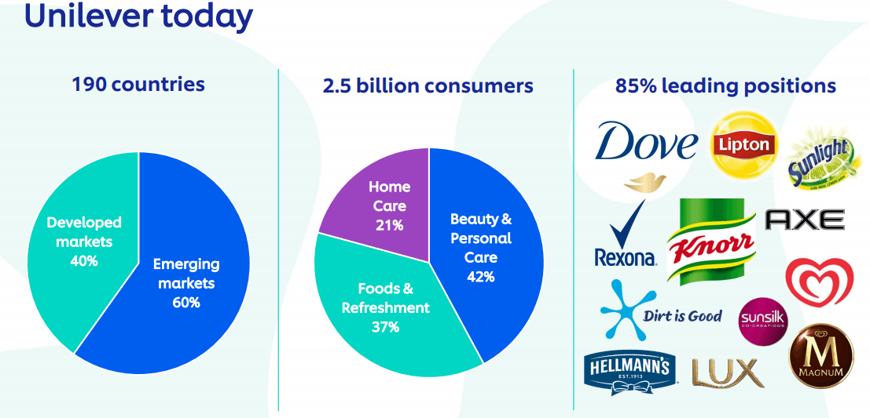
Pie chart 1: Unilever service
(Source: Lieu et al 2021)

Critical analysis

Sustainable and Innovative manufacturing process
Unilever makes use of technology and digital transformation processes in its consumer goods. The inevitable process of digital transformation aids the rise of the digital economy. Digital transformation is a part of an innovative manufacturing where initially production was done by human power and now the process is upgraded as per Prado Perez (2020). This upgrade includes AI and IoT system application and this system enables synchronisation of all feedback and information for processing and analysing according to Prado Perez (2020).
One part that is more important is manufacturing and distribution of consumer goods under environmental protection. It became a solution for carbon reduction by controlling carbon emission and saving additional waste of water or energy during the process of manufacturing. For instance, Unilever uses Robotics for packaging and transportation purposes according to Reza (2020).

Factors for exploring customer experience value identified by Unilever
- Overview customer journey by analysing the key determinants from the factors based on the perspective led by the customer themselves while purchasing the products as per Neher et al (March 2016)
- Monitoring the progress of the customer based on the key points under the given needs and requirements of the individual customer of Unilever
- Underlying the crc8ila pointers to overview the main points and to prioritise those by knowing what steps would work and what steps would not (Neher et al, March 2016)
- Crucial for the company to find out the root cause analysis of the issues based on the challenges faced in customer centric aspects

Digital Marketing and Distribution Channel
Digital marketing plays an important role in operation. In its Data-driven marketing mission at Unilever uses digital technologies to take advantage of consumer trends. For example, Unilever uses PowerBI app, using this tool Unilever, employees are able to get access to any data according to their need. Unilever introduced a new marketing model, to be focused on targeting customers based on consumer data, which includes personalised messages, or by direct communication, surveys as per Jevtić and Milovanović (2023).
For instance, Unilever Vietnam launched OrderUNow app to bring about 170000 retails and grocery stores into 1 place. Unilever also follows this model UShop ecommerce system, in order to sell the Unilever products (Mañosca et al 2022).

Personal Development
In its mission of Data-driven technology, Unilever pays careful attention to building data driven activities within its business by equipping workers having data management skills, which would be open to create an opportunity for 10000 people to prepare for making data-driven decisions (Mañosca et al 2022). Thus, the digitization process requires the business to invest in research and development with an aim of enhancing the standard of economy on a digital level.

Goals of Unilever to explore brand touch points
A goal point is now essential for every branding business using various touchpoints, both physical and digital. Likewise, Unilever shares the three main touchpoints to focus on customer experience.
- The primary objective of Unilever is to convey the brand narrative. Most important is the brand story to make a clear view of understanding of brand values, value proposition and positioning. Thus in turn, empowers and directs them in their collaborative efforts towards co-creation and co-branding. An active Customer involvement is key to hold this significant influence as opined by Amin (2022).
- Secondly, the responsible area is to make them understand the best provided offers based on customer needs. In terms of needs, the benefits of products are specifically linked with offers by making the products more sellable as per Amin (2022).
- Last, keeps maintaining transparency in terms of providing information regarding the brand that allows it to differentiate between competitor and Unilever.
- For instance, Nestle, Pepsi-co are competitors of Unilever, but in the case of product quality Unilever comes on rank 1st.

Challenges that requires troubleshoot with the touch points
The issue experienced by Unilever Company is distant more than any other set of companies with a similar approach as it concedes and is regularly troublesome to spot. It is more about-facing the issues that would ideally provide utmost benefit conveyance and the insular societies, behaviours, forms, and arrangements that thrive interior the utilitarian bunches that companies depend on to plan and convey their administrations in order to deal with the mentioned touchpoints as per Neher et al (March 2016).

Impacts of adopting effective marketing strategies of Unilever
A brand takes years to establish but to preserve its image and raise its value over time, correct marketing methods must be used. Unilever is one of the world’s most recognizable brands and its success is due to largely effective marketing strategies as per Widyastuti et al (2019). Here it is being described how marketing strategies affected Unilever’s brand image over the years.
Skilled employee’s engagement: The value of product, its guiding principles, and perception are the foundation of marketing strategy. For this reason, Unilever believed to employ qualified workers in order to sustain this because it is thought that motivated staff are more likely to stick with marketing strategies by giving higher performance and achieving higher revenues as opined by Widyastuti et al (2019).
Increased sales quality: The marketing strategy of Unilever is intended to effectively involve customers and establish a sense of loyalty. With effective campaigns and promotions, it is able to create a strong customer base that is loyal to the brand. This loyalty proves as an invaluable part as it ensures greater purchase of consumers over the unfamiliar one with increased sales quality and profitability as per Jose (2021).
Increased CLV: CLV stands for ‘Customer Lifetime Value’, this concept refers to the total amount of revenue that a customer is expected to generate for a business over the course of their relationship. Effective marketing strategies help to increase the Customer lifetime value of Unilever’s products. Unilever has been able to gain more exposure for their products by implementing marketing tactics that create a stronger customer base by engaging with customers as opined by MagaganandNgugi (2021). This positive experience given by Unilever to its customers may increase the probability of customers purchasing different products within the same product line.
Advantages of Pricing: With so many consumer goods companies operating in the same place, Unilever’s effective marketing strategies helped to build a strong reputation in the marketplace. The strong reputation makes the ability to sell Unilever goods at a higher price point as it elicits a robust emotional bond with its consumers as opined by MagaganandNgugi (2021).
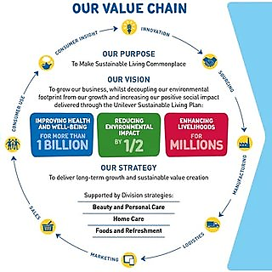
Figure 1: Unilever sustainability channel aspect
(Source: Widyastuti et al 2019)
Less volatile market positioning: During economic downturn, despite the potential for reduced financial performance, companies like Unilever that prioritize effective brand value are more prepared to deal with challenges. This phenomenon is attributed with the fact that consumers may exhibit a strong customer loyalty towards products of Unilever that have established an ideal and solid connection, even in the unfavourable economic condition as opined by Asawawibul and Wanarat (2023).

Marketing Mix on Unilever
Products: Unilever products classified into three categories - Food and Refreshment, Personal care, and Home care. The company’s portfolio includes more than 400 products that serve the daily needs of customers across all three of those mentioned categories. In food categories, it includes Ice cream, Mayonnaise, peanut butter, sandwich spreads, in home care some of the products are comfort, surf, Wheel detergent, in the personal care section it has found Dove, Lakme, toothpaste, Tony and Guy shampoo, Body spray etc. as per Reza (2020). Companies frequently use utilization of these brands because it can provide immunity from the chain effect. Indeed, certain brands have gained such widespread popularity that a number of people are sometimes aware of using them, yet unaware of their connection with Unilever (Reza 2020). Some of the recognised names are Hellmann’s, Lynx, and Lipton, Magnum, Dove and more.
Pricing: The global market for fast moving consumer goods is featured by high levels of competition. Hence, it is imperative for any brand operating in this industry to take into account the action of its rivals. It has been argued by many analysts Unilever set its pricing strategy that reflects the strategy of competitors. By following, this aids the organization in establishing pricing strategy of its merchandise according to its rivals according to Wichmann et al (2022).
Due to the diverse consumer segment, Unilever set its pricing strategy accordingly. Therefore, some of the products are maintained at high price due to their supreme quality and some of them at a lower rate. In this case, Unilever has implemented a strategic pricing approach below the market price in order to satisfy the lower income customer needs as opined by Wichmann et al (2022). Southeast Asia, Africa, Latin America is one of those countries that target lower income people.
Place: Unilever products gained at global reach, spreading across 190 countries. The distribution strategy of Unlived has observed and products distributed through hypermarkets, supermarkets, wholesale, e-commerce platforms, and others. Each of these places has the significance of delivering products to its consumers (Wichmann et al 2022). Unilever has found innovative in terms of its distribution. For instance, Unilever in India, Hindustan Unilever Limited introduced a programme where local rural women must train to sell Unilever products door to door.
Promotion: Unilever utilizes a diverse range of promotional and advertising strategies. Based on Guttman's report (2020), Unilever’s expenditure on promotional activities is 7 billion Euros annually. For instance, Unilever spent 168 million US dollars on the advertisement of Dove alone (Mir-Bernal and Sadaba, 2022). This event proved Unilever’s advertising endeavours are extensive, though coupled with significant costs. In Social media like Facebook, Instagram the presence of Unilever products are massive. Nevertheless, the number of its followers on Instagram amounts to 107 thousands, a significantly lesser figure compared to that of Facebook as per Mir-Bernal and Sadaba (2022).
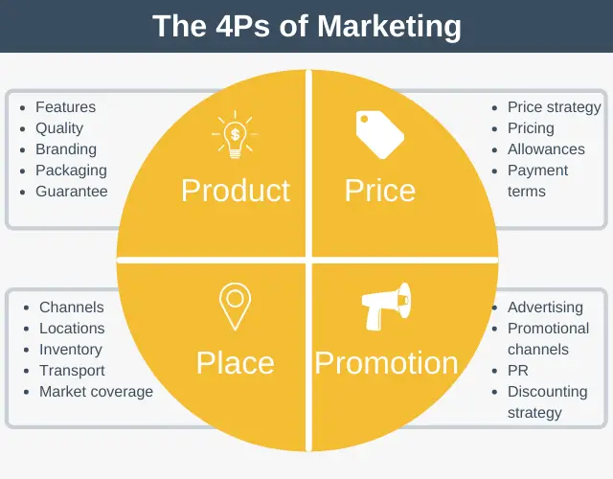
Figure 2: 4P marketing mix
(Source: Mir-Bernal and Sadaba, 2022)

Impact of digitalization
Digitalisation helps a business like Unilever to grow to its full potential by helping the brand to identify the loopholes or goals that could only fulfilled with the help of digital access. This contributes to the improvement of the operation of Unilever as a whole by making it possible for the selected brand to play a crucial role in the market to address certain aspects by helping to decline the cost reduction aspect or any kind of errors made by human during the offline process as per Durand and Zijlstra (2020). Unilever applied digitalisation aspect in its business model to upscale its business and transfer it to a much more customer friendly framework by reconfiguring the business mode of landscape of the mentioned brand and transferring the analog form of the company to a digital one. Unilever with its online platform was able to utilise the advantages of cloud computing that enabled the company to access more storage capacity or inventories to carry forward with much more crucial set of information according to Durand and Zijlstra (2020). This provides a healthy as well as a strong competitive advantage in the current market scenario. Cloud base database helped the company to gather and upscale the overall growth base performance, provide utmost insurance of data privacy and data mode of backups.

Customer aspect and reaction
More than 77% of an increase displayed in the online growth while marketing or sleeting products in the Unilever section. The sudden outbreak of pandemic made this even more crucial for the customers to purchase, literally everything online and that developed enough advantage for the mentioned company to sustain even in this dire consequences as opined by Durand and Zijlstra (2020). The overall competition or comparison made by the customers in terms of accessing other products offline from that of online service made by Unilever, clearly indicated that the company was able to move through the challenges of adapting digitalization in its business model with flying colours as a great marketingstrategy.

Theoretical approach to judge the potential to enable customer satisfaction by Unilever
- Dissonance theory: Unilever was successful in terms of managing this crucial stage to maintain the customer centric theory where a customer finds it difficult to manage or rather select from more than one product. As that individual falls in between the beliefs or values of one and receiving something just the opposite from his or her favourite brand as per Vaidis et al (2019). The promise made by any brand which is later on not fulfilled, creates a sublime formation of dishonesty that hampers the beliefs of the customers who fell for the misconducts or misleading terms and conditions led by the brand. Unilever maintains utmost transparency with its marketing strategies and hence, no such incidence that could potentially point towards any of the products categorised in the offline or online segment of mentioned brand found as misleading as opined by Vaidis et al (2019). The after sell service or rather the customer service is the one of the most strongest points of the mentioned brand that helped to mitigate through this issue of cognitive dissonance.
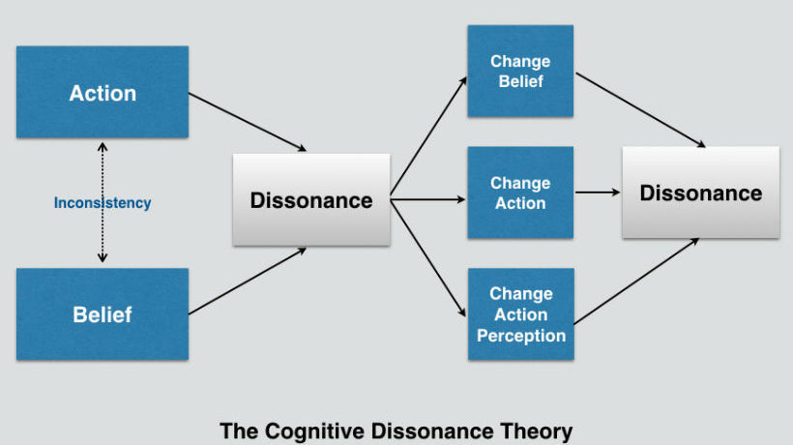
Figure 3: Concept of dissonance theory
(Source: Vaidis et al 2019)
- Contrast theory: This particular theory focuses on the negative aspects a brand creates or develops in the mind of a customer with the low-grade quality of the products or services provided to the customers as per Lleras et al (2020). Unilever with their careful approach of eliminating any kind of mishaps within the supply chain management of the goods produced, staged Ai or Artificial Intelligence base program to check the overall progress of the warehouse systems and to get regular updates of the inventories (Lleras et al 2020). This helped the company to avoid any negative experience from the customer point of view based on this specific theory of managing employee satisfaction.
- Value percept theory: This particular aspect deals with the ultimate set of proposition that helps to determine the ideal case scenarios of analysing the perception elements of a customer based on two specific set of factors, actual value with that of ideal value as opined by Asha et al (2023). Actual value is generally based on the concept of quality and the related performance that is directly perceived by the customer segments. Ideal value refers to that of the same scenario of quality and performance but perceived by the customer before buying the products or services. This often changes the perception towards a brand if the customer is not fully satisfied (Asha et al 2023). However, Unilever with its active performance in both the sector in terms of delivering actual value with that of ideal value, around 97% of the customers found utmost satisfaction in terms of trusting the products displayed by the mentioned brand according to Asha et al (2023). Customers do not want to change the brand they prefer to get products from mainly for the services offered by Unilever.
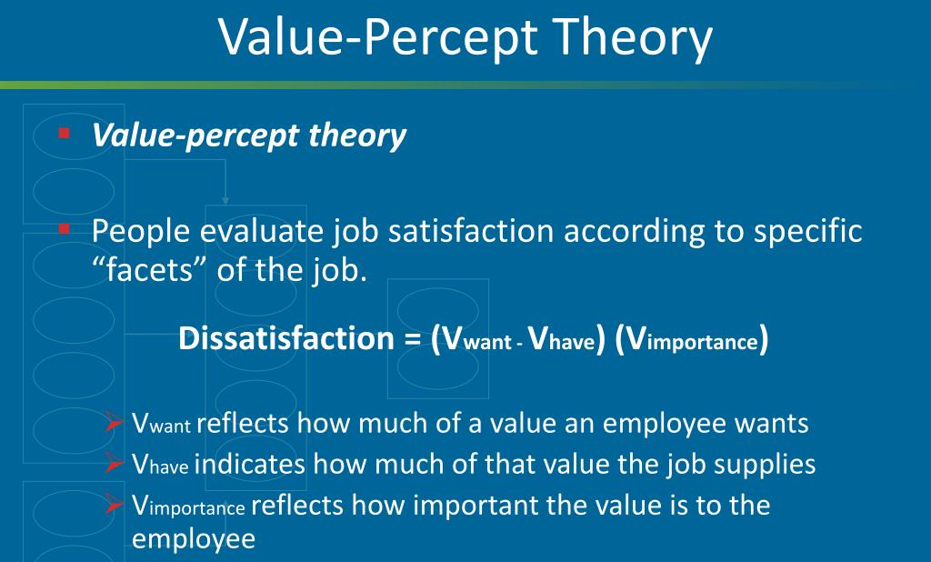
Figure 4: value percept theory
(Source: Asha et al 2023)

Application of value proposition model
The ideal target audience of such type of value proposition model to determine the customer oriented set of satisfaction are the end users. The ideal goal for any business model like Unilever to achieve success in the segments of the satisfying the customers to a deeper level, more than just from selling point of view. The main scenario of the mentioned company is to achieve success in the mind of the customers by generating superior value through delivering the best mode of service.
Emotional benefits: Unilever products provide the best sort of benefits to its customers from the emotional point of view more than just selling the products to its customers. The utmost service of honesty followed by integrity duly followed by the mentioned brand as per Mohd Satar et al (2019). That gives enough transparency in the customer segmented to generate respect of the customer rights and developing a strong bond with the branding of Unilever. Unilever promotes utmost level of data secrecy of the user base data while managing the online business of the products of the customers.
Product features: The products displayed by the mentioned brand encourage superior value to the customer needs and are well within the safety level as well. The ideal value of the products sold by the mentioned brand followed with a true concept of making or rather following a sustainable growth in the life of public. This heavily reflects upon the products sold by the company as per Mohd Satar et al (2019).
Consumer insights: The mentioned company maintains utmost honesty while displaying the possible challenges. High-risk promoting can too bring tall rewards, not as it were in making an attention-grabbing duplicate, but moreover in boosting the foot line according to Mohd Satar et al (2019). Receiving a self-deprecating fashion too lets buyers known brands are tuning in to them, by applying the basic set of understanding and utilising the bits of knowledge.
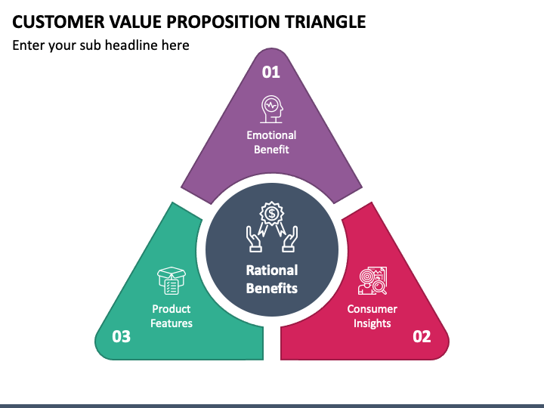

Figure 5: Value proposition model
(Source: Mohd Satar et al 2019)

Conclusion
Based on the above set of consideration of the customer set of satisfaction, the mentioned brand followed rigorous attempts to maintain absolute transparency that helped the company to go through all the challenges to maintain the highest level of marketing aspect. The following certain aspects of theory and models in the marketing concepts highlighted the crucial changes in the business model by implementing and focusing on digital advances, by enabling the customer service development across various sectors and by improving transparency across all the level of products in terms of maintaining utmost sustainability.

Recommendation
The first as well as the foremost thing, which the management of Unilever must try to stay, connected all the time with the customers by adopting the best marketing strategies. One of the most effective marketing strategies that the mentioned company must adopt over the ways is towards providing the necessary information for the customers where the people the customers of the company found fully aware by fostering the sales of the company indicating success for the business. Along with the same point of time, the mentioned in the report also explored the determined point of considerations with creating the best as well as the necessary consequences in order to accomplish the long-term set of goals for the goals for the company while creating the best marketing strategies.
It is essential for Unilever Company to upscale the business by implementing strategies based on digitalisation that would allow the company to have a headspace to work freely and to acquire more brand awareness among potential new customer base on a global scale. For this to happen, Unilever Company need to reinforce their Research and Development structure to identify the key strategic decision making requirements that would help to form the foundation towards digitalised company. Surviving with an orthodox mind set is difficult, that will act as barrier for the company, and hence, including AI and machine-learning aspect would guide the company to a better position.

Reference list

Case study

Maechler, N., Neher, K., & Park, R. (2016). From touchpoints to journeys: Seeing the world as customers do. McKinsey & Company, 1-10.

External
Amin, F. (2022). Measuring the Effectiveness of Recruitment: The Case of Safe Water Advisor Project.Measuring the Effectiveness of Recruitment: The Case of Safe Water Advisor Project
Asawawibul, S., and Wanarat, S. (2023). FACTORS INFLUENCING THE ADOPTION OF CORPORATE SOCIAL RESPONSIBILITY ACTIVITIES OF SMALL AND MEDIAUM ENTERPRISES. Economic and Social Development: Book of Proceedings, 209-218.
Asha, A. A., Dulal, M., and Habib, A. (2023). The Influence of Sustainable Supply Chain Management, Technology Orientation, and Organizational Culture on the Delivery Product Quality-Customer Satisfaction Nexus. Cleaner Logistics and Supply Chain, 100107.The influence of sustainable supply chain management, technology orientation, and organizational culture on the delivery product quality-customer satisfaction nexus - ScienceDirect
Baragiola, G., and Mauri, M. (2022). SDGs and the private sector: Unilever and PandG case studies.
Chandra, R., and Jatmika, S. (2022, March). Unilever Unilever Surabaya Corporate Social Responsibility (Csr) Policy in Maintaining Environmental Sustainability in Surabaya in 2014-2020. In International Conference on Public Organization (ICONPO 2021) (pp. 444-452). Atlantis Press.Unilever Unilever Surabaya Corporate Social Responsibility (Csr) Policy in Maintaining Environmental Sustainability in Surabaya in 2014-2020 | Atlantis Press (atlantis-press.com)
Dam, S. M., and Dam, T. C. (2021). Relationships between service quality, brand image, customer satisfaction, and customer loyalty. The Journal of Asian Finance, Economics and Business, 8(3), 585-593.
Durand, A., and Zijlstra, T. (2020). The impact of digitalisation on the access to transport services: a literature review. Netherlands Institute of Transport Policy Analysis, Den Haag, the Netherlands.
Iglesias, O., Mingione, M., Ind, N., and Markovic, S. (2023). How to build a conscientious corporate brand together with business partners: A case study of Unilever. Industrial Marketing Management, 109, 1-13.How to build a conscientious corporate brand together with business partners: A case study of Unilever - ScienceDirect
Jevtić, A., and Milovanović, G. (2023). Impact of digital marketing on sustainable business: Case of the Unilever company. Economics of Sustainable Development, 7(1), 15-28.2560-421X2301015J.pdf (ceon.rs)
Jose, J. (2021). Analyzing the necessity and impacts of organizational culture on the performance of Unilever UK Ltd (Doctoral dissertation, Dublin, National College of Ireland).jerinjose.pdf (ncirl.ie)
Kurdi, B., Alshurideh, M., and Alnaser, A. (2020). The impact of employee satisfaction on customer satisfaction: Theoretical and empirical underpinning. Management Science Letters, 10(15), 3561-3570.The impact of employee satisfaction on customer satisfaction: Theoretical and empirical underpinning » Growing Science
Lieu, P. T. H., Arunjit, N., Buapradabkul, S., and Nathaniel, D. (2021). Unilever Company Strategic Business Analysis.M0870434109139.pdf (fcu.edu.tw)
Lleras, A., Wang, Z., Ng, G. J. P., Ballew, K., Xu, J., and Buetti, S. (2020). A target contrast signal theory of parallel processing in goal-directed search. Attention, Perception, and Psychophysics, 82, 394-425.A target contrast signal theory of parallel processing in goal-directed search | SpringerLink
Magagan, K. C., and Ngugi, L. (2021). Influence of project management practices on performnace of projects in Unilever Kenya Ltd. International Academic Journal of Information Sciences and Project Management, 3(6), 2.iajispm_v3_i6_392_418.pdf (iajournals.org)
Mañosca, M. K., Poyaoan, A. K., and Vitug, J. (2022). Impact of Content Marketing on the Brand Image of Selected Unilever's Personal Care Brands through the Social Media. Journal of Business and Management Studies, 4(1), 107-114.View of Impact of Content Marketing on the Brand Image of Selected Unilever's Personal Care Brands through the Social Media (al-kindipublisher.com)
Mir-Bernal, P., and Sadaba, T. (2022). The ultimate theory of the marketing mix: A proposal for marketers and managers. International Journal of Entrepreneurship, 28, 1-22.THE-ULTIMATE-THEORY-OF-THE-MARKETING-MIX-A-PROPOSAL-FOR-MARKETERS-AND-MANAGERS.pdf (researchgate.net)
Mohd Satar, N. S., Dastane, D. O., and Ma’arif, M. Y. (2019). Customer value proposition for E-Commerce: A case study approach. International Journal of Advanced Computer Science and Applications (IJACSA), 10(2), 454-458.Customer Value Proposition for E-Commerce: A Case Study Approach by Nurhizam Safie Mohd Satar, Dr Omkar Dastane, Muhamad Yusnorizam Ma’arif :: SSRN
Prado Perez, S. (2020). Sustainability Discourse in the Fast-Moving Consumer Goods Sector–A comparison between Procter and Gamble and Unilever.Sustainability Discourse in the Fast-Moving Consumer Goods Sector – A comparison between Procter and Gamble and Unilever (diva-portal.org)
Reza, M. H. (2020). Marketing Strategy and Sustainable Plan of Unilever.Marketing Strategy and Sustainable Plan of Unilever (researchgate.net)
Tien, N. H. (2019). Comparative Analysis of Multidomestic Strategy of PandG and Unilever Corporation. International journal of foreign trade and international business, 1(1), 5-8.1-2-2-49920200528-90060-1r51f7w-libre.pdf (d1wqtxts1xzle7.cloudfront.net)
Vaidis, D. C., and Bran, A. (2019). Respectable challenges to respectable theory: Cognitive dissonance theory requires conceptualization clarification and operational tools. Frontiers in psychology, 10, 1189.Frontiers | Respectable Challenges to Respectable Theory: Cognitive Dissonance Theory Requires Conceptualization Clarification and Operational Tools (frontiersin.org)
Wichmann, J. R., Uppal, A., Sharma, A., and Dekimpe, M. G. (2022). A global perspective on the marketing mix across time and space. International Journal of Research in Marketing, 39(2), 502-521.A global perspective on the marketing mix across time and space - ScienceDirect
Widyastuti, S., Said, M., Siswono, S., and Firmansyah, D. A. (2019). Customer trust through green corporate image, green marketing strategy, and social responsibility: A case study.OAR@UM: Customer trust through green corporate image, green marketing strategy, and social responsibility : a case study

Appendix
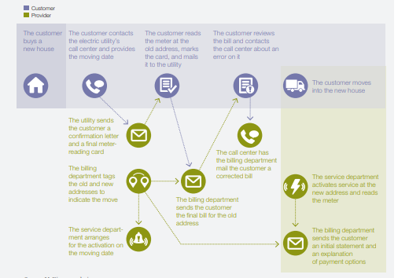
Figure 1: Customer Experience Journey (Exhibit 1)
(Source: Neher et al, March 2016)

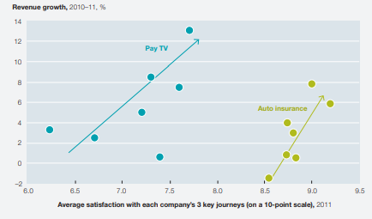
Figure 2: Higher Satisfaction leads to revenue growth (Exhibit 2)
(Source: Neher et al, March 2016)

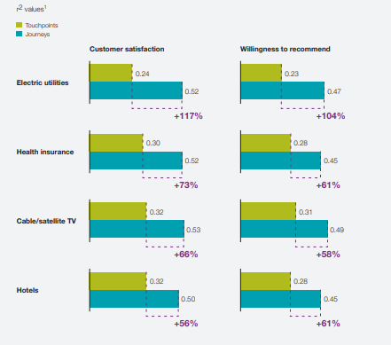
Figure 3: Journey strongly correlated with the overall outcomes as compared with touch points (Exhibit 3)
(Source: Source: Neher et al, March 2016)

