Chimera around us
1.Introduction
2.Chimera in fairy tales
2.1Dangerous demon
2.2Chimera's tragic death
2.3Chimera later influence
3.Chimera in Science
3.1Human chimera
3.2Research on chimera
3.3Outbreak after silence
3.4The significance of this research
4.summary
5.reference

1.Introduction
As a long-standing cultural symbol, chimera has appeared in all kinds of art works, such as animation, film, novel and so on. Under the background of the current information explosion, "chimera", a cultural symbol, also shows its special cultural significance of this era under the dual role of the development of culture and science and technology.
Chimera is often remembered as a monster with lion's head, goat's body, Python's tail and wings. However, in modern times, the word "chimera" has more additional meanings. In genetics, it refers to individuals with chimeric or mixed expression of different genetic traits. In most people's cognition, such chimera is far from our life, but in fact, chimera may affect our daily life in the near future.

2.Chimera in fairy tales
Chimera is a monster in ancient Greek mythology. Its original meaning is "female goat" in Greek. It first appeared in Homer's epic.
Nowadays, the word "chimera" can refer to any hybrid or synthetic animal, or to "impossible ideas", "unrealistic dreams" or anything we can imagine but can't achieve.
2.1Dangerous demon
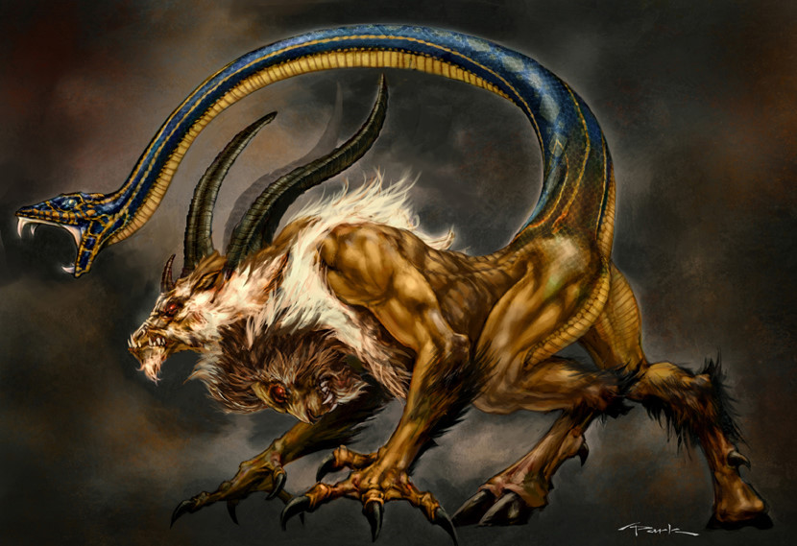
When it was a cub, it was the pet of the king of Kalia in the southwest of Karia minor in Turkey. But soon its violent personality revealed that it was no longer content to be a domestic pet, but fled to neighboring Libya, where it would be desolate. It devoured both animals and humans, and its fire burned villages, which no one could stop Its footsteps. Figure1:chimera

2.2Chimera's tragic death
The handsome Bellerophon was instructed by his father Proteus to visit the king in Lycia. Somehow, when the king of Lycia opened the letter of introduction written by the sea god, he found that the content of the letter was to kill Bellerophon. The king was unwilling to do so, so he appointed him to kill the monster chimera. He felt that the young man would die in the sea On the battlefield.
Bellerophon accepted the challenge. He flew to the place where chimera had disappeared. But it was not easy to kill it. The flame emitted by it made Bellerophon and his horse unable to get close, so they had to wait in the nearby Bay, and the bow and arrow could not really hurt chimera. So he came up with a way: smear graphite on a spear, and then Let the Pegasus get as close to chimera as possible, and then quickly throw the spear into chimera's mouth.
The spear coated with fireproof paint pierced chimera's throat and it was killed.

2.3Chimera later influence
Many Roman and Greek writers have described the legendary story of Bellerophon killing chimera. In the middle ages, it became a symbol of evil, so witch catchers Heinrich Kramer and sprig compared chimera, a monster composed of python, goat and lion, with women, and believed that they had such commonalities: "They all look beautiful, difficult to comfort and impossible to tame."

3.Chimera in Science
Nowadays, the word "chimera" can refer to any hybrid animal or synthetic animal, as well as "impossible idea", "unrealistic dream" or anything we can imagine but can't achieve. 1, "many inherent words have increased or changed their meaning in the development of the network, which is a common phenomenon of network culture today." (p55 Z 2012)
Synthetic monsters similar to chimera are common in myths of various countries, such as the Dragon worshipped by the Chinese and the feather snake god in the hearts of the Maya. The mythical world is a legendary country full of fantastic ideas, but in the real world, even among humans, chimera, a rare and strange human, also exists in the world. 2, "Chimera is more often synonymous with all kinds of bio mechanical chimeras in the current network culture, and is no longer a simple fierce beast of European culture." (P39 l 2017)
Chimera refers to organisms composed of cells of different genotypes. In 1907, German botanist and geneticist h. Winkler compared chimera to chimera with lion head, sheep body and snake tail in Greek mythology, which is also the origin of chimera in vitro. For more than 100 years, the development path of chimera technology has been bumpy and difficult, and even disappeared from the public for a time Eyes.

3.1Human chimera
In recent years, the more famous "chimera event" The protagonist of is Taylor Moore, a model from California. There is a unique birthmark on one side of her torso, which is not only the different pigmentation of her skin, but also an external sign that she carries two sets of DNA. In a rare inheritance event, she and her twin brothers and sisters fused in her mother's womb. Therefore, she has two Set of DNA: one is her own, and the other is her twin brothers and sisters. This situation is called "chimerism".Many similar things happened earlier.
Lydia's pending case: this news is quoted from MAIL ON SUNDAY. As early as 2002, Lydia, an American mother of two, conducted a DNA paternity test in order to apply for social assistance. But the test results surprised her - DNA tests showed that Lydia was not the biological mother of two children, but confirmed that her male partner was indeed the father of the children.
Lydia thought the DNA test was wrong, so she and her two children had three more DNA tests, but the results were still the same. Unable to prove that Lydia was the child's mother, she was accused of using other people's children to defraud benefits. Local judicial prosecutors then demanded that Lydia be deprived of custody of the two children and that the two children be sent to an orphanage.
For example, to prove that she is the child's mother, Lydia asked to give birth to her third child under the supervision of an official witness, and then do a DNA paternity test to prove the error of the test results. The third child just born and Lydia were tested again. The results are still realistic. Delia is not the child's mother.
Lydia, who nearly lost her child, was finally cleared. The court admitted that there was a mistake in the DNA evidence, and finally ruled that Lydia's three children were her own. Finally, Lydia's legal team finally found out the cause of the DNA identification error. It turned out that Lydia had two sets of DNA - one dominant, and the other only appeared in some organs, but this set of DNA happened to be passed on to the children. When samples were taken from her hair and skin cells, the results were the same as before, but when samples were taken from her ovaries, her DNA matched exactly the children's.
Is this news true? When the reporter called MAIL ON SUNDAY in the UK, Susan hope, the manager of the close-up department, helped the reporter find the article from the Manuscript Library and told the reporter that their newspaper did not hang all the articles on the Internet. "This is not a fake news. Lydia is real, and channel 5, a local commercial radio station in Britain, broadcast a documentary about her in the column of Extraordinary People on March 6." Susan said. Then, the reporter got the same answer from the staff of channel 5: This is not a fake news, but a real thing that happened in Britain recently. 3. "With the continuous development of science and technology, chimeras are constantly found and studied in newborns. Medical workers have obtained a large number of research data in such research objects. The acquisition of such data has also played a certain role in promoting the development of biological research." (P11 B 2016)

3.2Research on chimera
There are some examples of human chimerism in real life, which are mainly divided into three categories: fraternal twins, bone marrow transplantation and fetal micro chimerism. In essence, chimera is an organism composed of two or more "individuals". It contains two sets of DNA, and its code constitutes two different organisms. When the concept of chimera is enlarged to all organisms, the use of chimera can also produce various values. Human animal chimera is a research field full of possibilities. By allowing animals to grow human organs, scientists can open up new ways of organ transplantation for patients; At the same time, it can also be used in some experiments that can only study the human body by allowing animals to have a part of the human system.
Both human chimera and human animal chimera have broken our conventional definition of "human". When chimerism occurs in the brain and heart, should we think of ourselves as ourselves or absorbed "brothers and sisters"? When animals grow human hearts or brains, what should they be? Facing the challenge of ethics, people's fear mostly comes from the crisis that science may bring. 4 "the development of science and technology has a great impact on morality and philosophy. In the process of the development of science and technology, it is difficult and important to re-establish moral standards." (P4 C 2010)
Although the existing technical means have been used to measure, many people's concerns about human animal chimerism are groundless. But is this another human play of God? The debate over the human animal chimera is being focused on. Returning the scientific issue to science is the final way out for everything
Transgenic is nothing new in plants and animals. The earliest sheep "Dolly" is the exploration of human beings towards the image of "chimera"
As early as 1646, Italian horticulturist Ferrarius first reported the naturally occurring citrus chimera: in 1860, German beekeeper Auygues found the chimera in bees. This chimerism also occurs in humans.
Since this chimerism phenomenon will occur in natural conditions, can this phenomenon be artificially controlled under artificial conditions?
In 1875, C.R. Darwin called plants in the middle state produced by scions and stocks of different species as vegetative hybrids; In 1910, German geneticist E. Bauer proved that the so-called nutritional hybrid is actually a grafted chimera. Thus, the "desire" to interfere with plant chimerism has long been completed, and scientists naturally shifted the goal of chimerism to animals. But compared with plants, this research is also much more difficult.

Obviously, it is impossible for the adults of animals to fuse together, so scientists thought of the embryonic development stage of animals. In the embryo, there is a universal cell - embryonic stem cell, which has a kind of totipotency and can differentiate into various tissues. Take us as human beings. All cells in our body organs are differentiated from embryonic stem cells. Therefore, as long as the embryonic stem cells from two blastocysts are mixed together, it is possible to produce chimera "chimera".
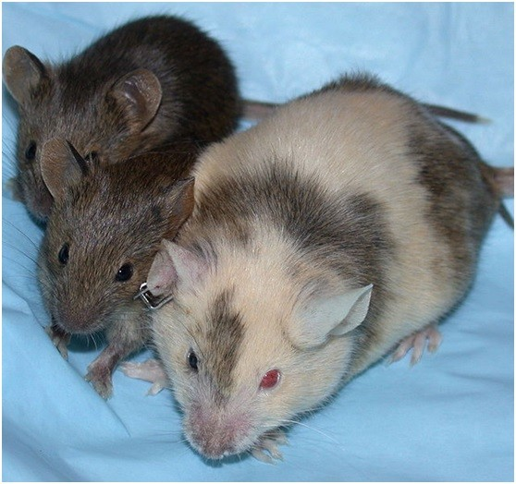
In 1968, Gardner, a physiologist at Cambridge University, stuffed the cell mass containing embryonic stem cells in the blastocyst of black haired mice into the blastocyst of a white haired mice. The cell clusters of the two mice fused and finally gave birth to a black-and-white mouse. This is the first time to prove the possibility of artificial chimera.
Figure2: chimerice mice
In 1981, biologists Sir Martin Evans and Matthew Kaufman of Cambridge University and Professor Gail Martin of the University of California invented the in vitro cultivation technology of mouse embryonic stem cells almost at the same time. This technology can inhibit the differentiation of embryonic stem cells and keep them in the state of embryonic stem cells forever. In this way, these embryonic stem cells with differentiation function can be effectively applied in science, not just a "flash in the pan" in embryos.
Since then, the progress of chimerism has been very smooth. Embryonic stem cells from sheep, pigs, cattle and various livestock have been cultured in vitro and produced chimeras. However, it has been found that primate embryonic stem cells, including humans, can no longer be cultured in vitro, let alone chimeric.
In 1997, James Thomson, a professor at The University of Wisconsin System cultured four macaque embryonic stem cell lines in vitro successfully , and established a human embryonic stem cell line in the world using human embryos in 1998. However, it is disappointing that these embryonic stem cells are completely unable to participate in the formation of primate chimeras.

3.3Outbreak after silence
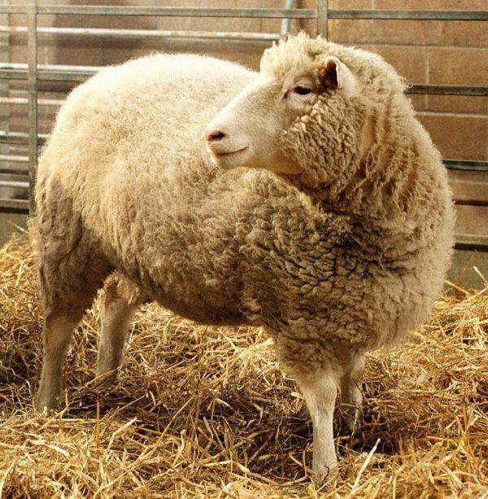
In 1997, the birth of Dolly, a cloned sheep, had a great impact on primate chimerism. With cloning technology, people can create complete animals in one step. On the contrary, chimeras are always just hybrids. If chimeric technology has no practical application and can serve human beings, what is the significance of this technology?
Figure3:Cloned sheep Dolly
Then, in the ten years after the emergence of Dolly sheep, cloning technology has a rising trend, while chimera is gradually silent.
However, a similar history has emerged, and the rapid development of cloning technology is also stuck in primate cloning. At this time, the scientific community finally decided to re-examine the possibility of primate chimerism technology.
Finally, referring to the experience of making the first chimeric mice, the scientists transplanted one inner cell mass directly into the blastocyst of another. The successful achievement is the Kazakh American scientist
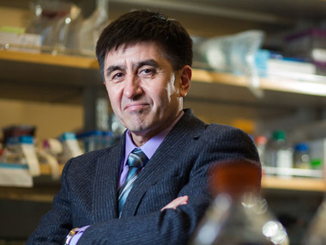
Shoukhrat Mitalipov. In 2007, he made a great breakthrough in chimerism research by directly bonding three macaque embryos that were still in the four cell stage. Later, mitalipov also found that embryonic stem cells can be divided into two forms: primitive state and initial state. Primitive embryonic stem cells have better differentiation and development ability in vivo, which is similar to the blastomeres of early embryos before blastocysts. When injected into early embryos, they can participate in the development and differentiation of embryos and produce chimeric animals, while primitive embryonic stem cells do not have this function.
Figure4：Shoukhrat Mitalipov
Mitalipov's research led the research on chimerism to the right path. After that, chimerism research quickly entered the right track and showed explosive growth. In just a few years, research that can transform primate embryonic stem cells into primitive state has sprung up. Their work has completed the most difficult step on the road of primate chimerism, which has brought new dawn to chimerism research. 5, "the acquisition of any scientific achievement is not a simple personal behavior, but can be achieved only through the theoretical and technical research and falsification of generations of scientific researchers." (p155 n 2019)
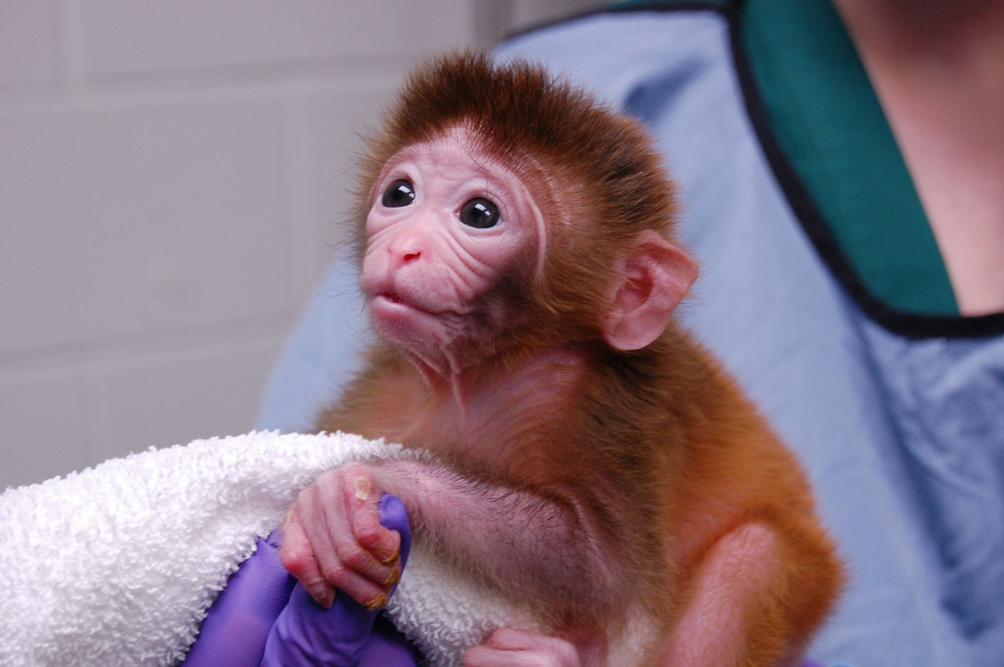
Nowadays, primate chimera has become a reality, and chimeric monkey has been born in the world. How will the research on human animal chimera continue?

Figure5:Chimeric monkey
3.4The significance of this research
In the history of mankind, there are many major diseases that have been plaguing human survival, such as AIDS and hepatitis, and these viruses can not be transmitted to other animals. So far, no animal models have been established. If animal chimera is established, the virus can be replicated in animal experiments, which will speed up the research on the treatment of diseases.
Similarly, regenerative organs are also of great significance for us to study human animal chimera. Nowadays, almost all organs can be transplanted, but the most important source of organs is always a huge difficulty. The imbalance between supply and demand can not meet the needs of transplant waiters. Human animal chimerism may be a good way to solve this problem, because if human embryonic stem cells are transplanted into the organ where animal embryos want to grow in the future, human organs can grow in animals and be provided to organ transplant demanders.
However, ethical and moral issues are always inseparable from the human animal chimera. Perhaps compared with the technical difficulties, ethical issues are the key to the development of this research.

4.Summary
Nowadays, chimera has begun to try to enter our life. We can't know what impact this technology will bring to our daily life, but we can look forward to the future. Maybe one day, the research on chimera will change our life.

- Reference
Research on network culture, Zhu Ziming, February 2012 1st, Beijing Forestry University
Game design theory Luo Xin March 2017 1st Changsha Central South University
Strange talk on science and technology Bai Hao September 2016 1st Beijing houlang Publishing House
Morality and philosophy, Cheng Lingyu, April 2010 1st, Chongqing University Press
General knowledge of bioinformatics Ning Lingling March 2019 1st Hangzhou Zhejiang University

