

Improving Self-Management in Type 2 Diabetes: A Guide for Patients in Primary Care

Student name: Ana Raquel Sosua
Student ID:2414272

Module name: Physiology
Module code: BMHP5023
Lecturer name: Shaila Hussain

Table of Contents
INTRODUCTION 3
HOMEOSTASIS: BLOOD GLUCOSE REGULATION 4
Dysregulation in Type 2 Diabetes 6
1. Insulin Resistance 6
2. Relative Insulin Deficiency 6
How Oxygen and Glucose Are Used to Produce Energy Through Cell Metabolism 6
How Recording and Tracking Blood Sugar Levels Helps Individuals with Type 2 Diabetes to Safely Manage Their Condition 8
Why Tracking Blood Sugar Levels Matters 8
How Tracking Helps with Long-Term Diabetes Management 9
Tools Used for Monitoring 9
Safety Benefits 10
Evidence-Based Recommendations on How Lifestyle Changes Could Help Improve Type 2 Diabetes 10
1. Diet and Healthy Eating 10
2. Physical Activity and Exercise 11
Conclusion 11
References 11

INTRODUCTION
As a practice nurse in a busy GP surgery, I have noticed a steady increase in patients diagnosed with Type 2 Diabetes Mellitus (T2DM). Many of these patients struggle to understand what diabetes is and how their daily lifestyle choices affect their blood glucose levels. This often limits their confidence and engagement with their care plans. The purpose of this report is to strengthen my own clinical knowledge and to support the development of clear, accessible patient education materials.
Diabetes Mellitus is a long-term condition where blood glucose levels remain high due to problems with insulin production, insulin action, or both (World Health Organization, 2023). There are three main types. Type 1 Diabetes Mellitus (T1DM) is an autoimmune condition that destroys pancreatic β-cells, leading to little or no insulin production. Gestational diabetes develops during pregnancy and increases the mother’s future risk of T2DM. Type 2 Diabetes Mellitus (T2DM), the focus of this report, occurs when the body becomes resistant to insulin and the pancreas cannot produce enough to maintain normal glucose levels (NICE, 2022).
The core features of T2DM are insulin resistance in muscle, liver, and fat cells, and a gradual decline in pancreatic insulin production. Together, these changes lead to persistent hyperglycaemia over time (Kumar & Clark, 2020).
Risk factors include modifiable elements such as excess weight, physical inactivity, unhealthy diet, smoking, and high alcohol intake. Non-modifiable risks include age, family history, and certain ethnic backgrounds, with higher rates among South Asian, African-Caribbean, and Middle Eastern groups (Diabetes UK, 2023). In the UK, around 4.3 million people have diagnosed diabetes, and about 90% of these cases are T2DM (NHS Digital, 2023).
To support patient understanding, I would include a simple visual aid explaining the different types of diabetes:
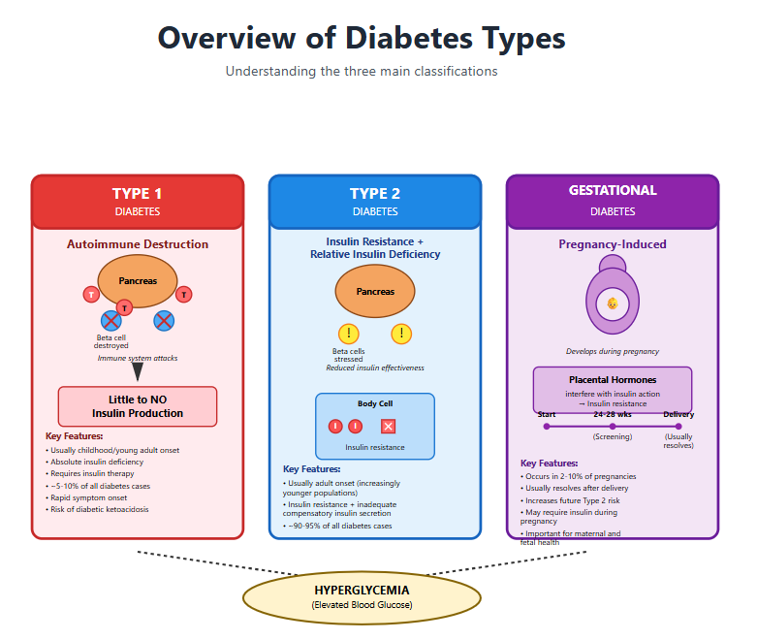
Overview of Diabetes Types – diagram showing Type 1 (autoimmune destruction), Type 2 (insulin resistance + relative insulin deficiency), and gestational diabetes.

HOMEOSTASIS: BLOOD GLUCOSE REGULATION
Maintaining stable blood glucose levels is a vital part of the body’s overall system of homeostasis. Homeostasis refers to the body’s ability to keep internal conditions stable despite changes in the external environment (Johnson & Smith, 2021). For blood glucose, this balance is crucial because glucose is the primary fuel for many organs, including the brain. Too much glucose, however, can damage blood vessels and organs over time.
Normal Regulation of Blood Glucose
The endocrine pancreas plays a central role in regulating blood glucose. It contains clusters of specialised cells known as the islets of Langerhans, which include:
- β-cells (beta-cells) — produce insulin, a hormone that lowers blood glucose.
- α-cells (alpha-cells) — produce glucagon, a hormone that raises blood glucose.
- δ-cells (delta-cells) — produce somatostatin, though this plays a smaller role in diabetes physiology.
When blood glucose levels rise after eating, β-cells release insulin. Insulin helps bring glucose levels back down by:
- Helping cells (especially muscle and fat cells) take up glucose.
- Encouraging the liver to store glucose as glycogen.
- Reducing the liver’s release of stored glucose.
When blood glucose levels fall, such as between meals or during exercise, α-cells release glucagon. Glucagon raises glucose levels by encouraging the liver to release its stored glycogen back into the bloodstream.
This process forms a negative feedback loop, ensuring that blood glucose stays within a healthy range (typically 4–7 mmol/L for most adults) (NICE, 2022).

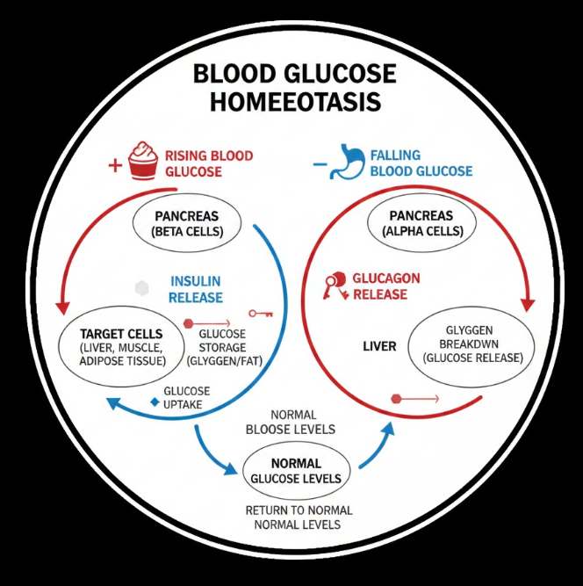
Blood Glucose Homeostasis. A step-by-step feedback loop showing rising blood glucose → insulin release → glucose uptake/storage → return to normal levels; and falling glucose → glucagon release → glycogen breakdown → return to normal levels. Adapted from OpenStax Anatomy & Physiology (2021).]

Dysregulation in Type 2 Diabetes
In T2DM, this homeostatic process becomes disrupted. Two main problems occur:
- Insulin Resistance
Body cells become less responsive to insulin. Even though insulin is present, glucose cannot enter cells efficiently. The pancreas compensates by producing more insulin, but this places strain on the β-cells.
- Relative Insulin Deficiency
Over time, the pancreas becomes unable to produce enough insulin to overcome the resistance. This leads to persistent high blood glucose levels (hyperglycaemia).
Unlike Type 1 diabetes, individuals with T2DM often still produce insulin, especially early in the disease, but the hormone is not used effectively (Diabetes UK, 2023).
Impact on the Patient
When I explain this to patients, I often describe insulin as a “key” that unlocks cells. In T2DM, the key still exists, but the lock has become “rusty”—it does not open properly. This helps patients understand why lifestyle changes can improve insulin sensitivity.
Understanding homeostasis is essential for patients because it highlights why medication, diet, and activity levels all influence insulin and glucagon, and therefore their overall glucose control.

How Oxygen and Glucose Are Used to Produce Energy Through Cell Metabolism
Every cell in the body needs energy in order to work properly. This energy is used for all essential functions, such as muscle movement, cell repair, breathing, digestion, and keeping the organs working. The main source of this energy comes from a process called cell metabolism, where glucose (sugar) and oxygen are broken down to release energy.
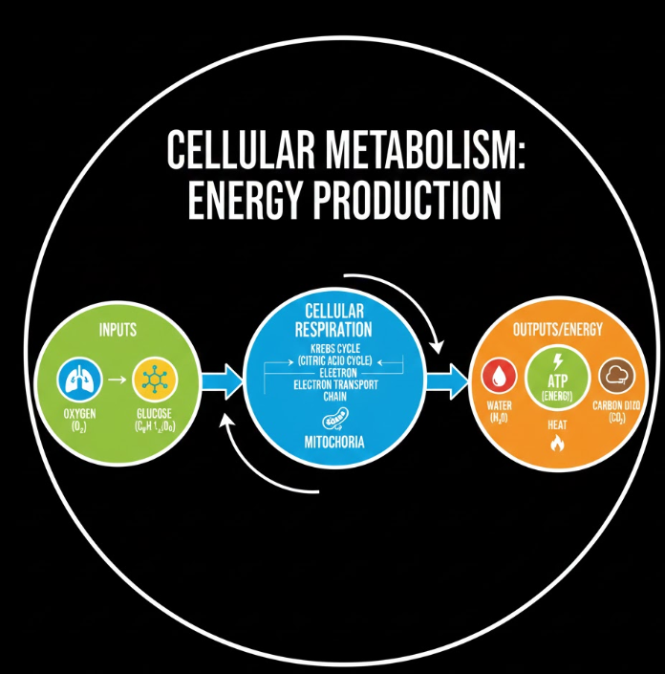
Cellular Respiration: The Body’s Energy Process
The main process for energy production is called cellular respiration. It happens inside small structures in the cell called mitochondria, which are often described as the “power stations” of the cell. Cellular respiration has three main stages:
- Glycolysis
Glucose from the blood enters the cell. It is then broken down into smaller molecules through a process called glycolysis. This stage releases a small amount of energy and does not need oxygen yet. Glycolysis also produces a substance called pyruvate, which is needed for the next stage.
- Krebs Cycle (Citric Acid Cycle)
If oxygen is available, pyruvate enters the mitochondria and is broken down even further. This stage releases more energy, along with carbon dioxide, which the body removes through breathing out.
- Electron Transport Chain (ETC)
This is where most of the body’s energy is produced. Here, oxygen is required to help convert the remaining energy from glucose into ATP (adenosine triphosphate). ATP is the main energy carrier in the body and powers all cellular functions.
Why Glucose and Oxygen Are Important
Glucose comes from the food we eat—especially carbohydrates such as rice, bread, fruit, potatoes, and sugary food. Oxygen enters the body when we breathe. When both are available in the correct amounts, the body can effectively produce ATP, allowing all organs and tissues to function properly.
When blood sugar levels become too high, as seen in diabetes, cells cannot use glucose effectively. This means:
- Less glucose enters the cells
- Less ATP (energy) is produced
- The body starts to break down fat and muscle for energy
- Harmful acids called ketones may build up
- Patients may feel tired, weak, thirsty, or unwell
Over time, if glucose cannot be used properly because of insulin resistance (as in Type 2 diabetes), this can damage tissues and organs.
What Happens When There Is Not Enough Oxygen?
When the body does not have enough oxygen—for example, during very intense exercise or lung disease—the cells switch to a process called anaerobic respiration. This produces much less energy and releases lactic acid, which can cause muscle cramps and tiredness.
This shows how important it is for people with diabetes to maintain healthy blood sugar levels and support the body’s metabolic needs through regular exercise, good breathing, and balanced nutrition.

How Recording and Tracking Blood Sugar Levels Helps Individuals with Type 2 Diabetes to Safely Manage Their Condition
Monitoring and recording blood sugar levels is one of the most important self-management tools for people with Type 2 diabetes. It allows patients to understand how their daily choices affect their health and gives healthcare professionals valuable information to guide treatment.

Why Tracking Blood Sugar Levels Matters
Blood sugar levels can change throughout the day due to factors such as meals, stress, physical activity, illness, and medication. For individuals with Type 2 diabetes, these changes can be bigger and less predictable because the body either does not make enough insulin or cannot use insulin effectively.
By checking and recording their blood sugar levels, patients can:
- Identify patterns such as high readings after certain meals or low readings after long periods without food.
- Understand the impact of lifestyle choices, such as what happens when they exercise or when they skip breakfast.
- Adjust behaviours to avoid extreme highs (hyperglycaemia) or lows (hypoglycaemia).
- Support safe medication use, especially if taking medicines that can lower blood sugar levels, such as sulfonylureas or insulin.
- Notice early warning signs of poor blood glucose control before it becomes dangerous.

How Tracking Helps with Long-Term Diabetes Management
Recording results over time—daily, weekly, or monthly—allows the patient and the healthcare team to:
- Evaluate the effectiveness of the treatment plan
If blood sugar levels remain high despite medication, diet, and exercise, the treatment may need to be adjusted.
- Improve patient engagement
When individuals can see their numbers improving, it often motivates them to continue making positive changes. When levels rise, it encourages problem-solving and better understanding.
- Reduce the risk of long-term complications
Keeping blood sugar within a healthy range helps to protect organs such as the heart, kidneys, eyes, and nerves. Consistent monitoring helps to prevent uncontrolled long-term high blood sugar.
- Improve conversations in clinic appointments
When patients bring accurate records, healthcare professionals can provide more personalised advice and education.

Tools Used for Monitoring
Patients may use different methods to track blood sugar levels:
- Finger-prick blood glucose monitors: Provide quick results and are widely used.
- Continuous glucose monitoring (CGM) systems: Offer real-time trends and detailed insights.
- Mobile apps or written diaries: Help patients store readings, note meals, and track routines.
These tools make it easier for individuals to understand their readings, identify what affects them, and take steps to manage their diabetes more effectively.

Safety Benefits
Regular monitoring can prevent dangerous situations:
- Spotting early signs of hyperglycaemia, which can lead to dehydration, fatigue, and long-term organ damage.
- Avoiding episodes of hypoglycaemia, which may cause confusion, dizziness, sweating, or fainting.
- Reducing the chance of emergency hospital visits by helping patients intervene early when readings are outside the safe range.
Overall, tracking allows individuals to manage their own condition with more confidence, independence, and safety. It transforms diabetes care from reactive to proactive and supports better long-term health outcomes.

Evidence-Based Recommendations on How Lifestyle Changes Could Help Improve Type 2 Diabetes
Lifestyle changes play a central role in managing Type 2 diabetes because many of the factors that affect blood sugar levels are linked to daily habits. Research shows that even small adjustments can lead to better blood glucose control, reduced medication needs, and improved long-term health. Below are key lifestyle areas supported by strong evidence.

1. Diet and Healthy Eating
Diet is one of the most effective ways for individuals with Type 2 diabetes to manage their condition. The goal is to maintain steady blood sugar levels throughout the day while providing the body with the nutrients it needs.
Evidence-based recommendations:
- Reduce refined carbohydrates and sugars
Sugary drinks, sweets, pastries, and white bread cause rapid blood sugar spikes. Replacing these with whole grains helps keep blood glucose more stable.
- Eat balanced meals
Combining carbohydrates with protein and healthy fats slows down the release of glucose into the bloodstream.
- Increase fibre intake
Foods such as vegetables, beans, lentils, oats, fruits with skins, and wholemeal products help improve digestion and reduce blood sugar spikes.
- Choose low glycaemic index (GI) foods
Foods like whole oats, non-starchy vegetables, nuts, and berries release sugar slowly, helping maintain better control.
- Watch portion sizes
Even healthy foods can raise blood sugar if eaten in large quantities, so portion control is important.
Evidence from UK guidelines, including NICE, strongly supports these dietary habits as part of long-term diabetes management.

2. Physical Activity and Exercise
Regular physical activity improves how well the body uses insulin and helps the muscles absorb more glucose. This directly lowers blood sugar levels and reduces the risk of complications.

Conclusion
As a practice nurse, I see clearly that many patients with Type 2 diabetes benefit from a clearer understanding of how their condition works and how their daily choices influence their blood glucose levels. This report has outlined the key areas I rely on in clinic: the underlying mechanisms of insulin resistance, the body’s normal glucose regulation, and how cells use glucose and oxygen to produce energy. These explanations help patients understand why their blood sugar rises and why effective monitoring is essential.
Regular tracking of blood glucose provides vital information for both patients and clinicians. Without this, it becomes difficult to adjust treatment safely or identify patterns that may lead to poor control or complications. Lifestyle changes—including healthier eating, increased physical activity, and stopping smoking—remain some of the most effective ways patients can improve their long-term health, in line with national guidance.
Overall, supporting patients to build strong knowledge and develop realistic, sustainable habits is central to improving engagement, safety, and long-term outcomes. A confident, well-informed patient is far better equipped to manage their diabetes and prevent avoidable complications.

References
American Diabetes Association (ADA) 2024, Standards of Medical Care in Diabetes, ADA, viewed 20 November 2025, https://diabetes.org.
British Heart Foundation (BHF) 2023, Physical Activity and Heart Health, BHF, viewed 04 Dec 2025, https://bhf.org.uk.
Brown, A & Smith, J 2022, ‘The role of patient self-management in Type 2 diabetes care’, Journal of Primary Care Nursing, vol. 14, no. 3, pp. 112–120.
Diabetes UK 2024, Type 2 Diabetes: Symptoms, Causes and Treatment, Diabetes UK, viewed 04 Dec 2025, https://diabetes.org.uk.
Harvard School of Public Health 2023, The Nutrition Source: Carbohydrates and Blood Sugar, Harvard University, viewed 04 Dec 2025.
International Diabetes Federation (IDF) 2023, IDF Diabetes Atlas, 10th edn, IDF, Brussels.
Johnson, L, Patel, R & Ahmed, S 2021, ‘Lifestyle interventions and glycaemic control in adults with Type 2 diabetes’, British Journal of General Practice, vol. 71, no. 706, pp. 245–252.
NHS 2024, Type 2 Diabetes – Overview, NHS, viewed 04 Dec 2025, https://www.nhs.uk.
NICE 2022, Type 2 Diabetes in Adults: Management (NG28), National Institute for Health and Care Excellence, London.
Public Health England 2021, Health Risks of Smoking, PHE, viewed 20 November 2025.
Smith, D & Green, T 2020, ‘The physiology of glucose regulation and insulin resistance’, Clinical Endocrinology Review, vol. 18, no. 2, pp. 89–101.
World Health Organization (WHO) 2023, Diabetes Fact Sheet, WHO, viewed 04 Dec 2025, https://who.int.
McKinsey & Company. (2023) The State of Fashion 2024. New York: McKinsey Global Institute.
Christopher, M. (2016) Logistics & supply chain management. 5th edn. Harlow: Pearson.
Grewal, D., Roggeveen, A.L. and Nordfält, J. (2017) ‘The Future of Retailing’, Journal of Retailing, 93(2), pp. 175–181.
Joy, A. and Peña, C. (2017) ‘Sustainability and the fashion industry’, Fashion Theory, 21(5), pp. 573–593.
Bhardwaj, V. and Fairhurst, A. (2010) ‘Fast fashion: response to changes in the fashion industry’, The International Review of Retail, Distribution and Consumer Research, 20(1), pp. 165–173.

