Business Plan and Reflection
Module Name – BMSW4011 Student: Cosmin Vasar
Managing Enterprise Student number: 2421847
Module Lead: Melanie Squire

Business Concept & Story
1. Concept:
Bark&Wash is a self-service dog-wash station designed for parks, trails, and high-footfall nature areas where dog owners frequently walk their pets. The business provides a convenient, low-cost, and stress-free washing solution for muddy dogs, eliminating the hassle of cleaning pets at home or transporting into cars and make a mess. The aim is to launch one fully operational wash station within a popular dog-walking park and then scale through partnerships and multi-site expansion. The focus is on convenience, affordability, cleanliness, and seamless customer experience.

2.Story
Bark&Wash was created to solve a common problem among dog owners: after a muddy walk, owners often struggle to clean their pets quickly before they headed home. Traditional groomers are expensive, require appointments, and are not always accessible immediately. Bark&Wash stations offer an easy, walk-in solution where owners can rinse and clean their pets using professional equipment without the mess at home or into the owners car.
The idea came from my own experience walking my dog. I often had to travel 20–30 minutes from home just so he could run freely and play in a proper park or dog-friendly area. But every time it was time to go home, I faced the same problem: my dog was muddy, and I had nowhere nearby to wash or clean him before putting him back in the car. I didn’t want the mess, and I knew other dog owners must feel the same way.
That’s when I realised that if this problem could be solved for me, it could be solved for every dog owner. This inspired me to create the Bark&Wash self-wash dog station.

Mission, Aims & SMART Objectives
1.Mission Statement:
To simplify dog ownership by providing clean, convenient, and accessible wash points across popular walking locations, ensuring every walk ends with a clean dog and a happy owner.

2. SMART Objectives:
S- Specific: Launch and operate a fully functional self-wash dog station in the most popular dog-walking park.
M- Measurable: Achieve a minimum of 150 customers/wash sessions per month within six months.
A- Achievable: The high-traffic environment guarantees consistent dog owner presence.
R- Relevant: Owners need wash facilities immediately after muddy walks.
T- Time-Bound:
• Month 1: Install station and launch marketing.
• Month 3: Reach 100 monthly washes and gather online reviews.
• Month 6: Reach 150 monthly washes, build loyal customers.
• Month 12: Achieve £1000+ net profit and over 200 customers.

Legal Structure & HR Strategy
1.The business will operate as a Limited Company (LTD).
Pros:
- Limited liability protection for personal assets.
- Tax-efficient at higher income levels.
- Enhanced credibility when negotiating with councils or authorities.
- Easier expansion for multiple stations.
- Attractive for investors.
Cons:
- More paperwork and accounting obligations.
- Financial accounts must be filed publicly.
- Increased regulation and director responsibilities.

2.HR Strategy:
No additional human resources are required, as the station operates as a fully self-service, walk-in dog wash. The facility can remain open 24/7, and all operational needs: including maintenance, restocking, and supervision. Can be managed directly by the owner. This ensures efficient operation while keeping staffing costs at a minimum for the first year.

3. SWOT Analysis
Strengths: Unique, convenient service offering.
Weaknesses: Weather-dependent customer flow.
Opportunities: -Partnerships with vets, pet shops, cafes, and caravan parks.
-Rising dog ownership in the UK.
Threats: - Vandalism and equipment damage.

4. PESTLE Analysis
Political: Requirements for permissions from councils or park authorities.
Economic: Low-cost operating model with increased pet-care spending.
Social: Rise in dog ownership and emphasis on pet well-being.
Technological: Self-pay and automated washing systems.
Legal: Compliance with animal-care and safety regulations.
Environmental: Encourages cleaner public spaces.

Market Research
There is a gap between the rising number of dog owners and the lack of public wash facilities near popular walking routes. Many owners face challenges cleaning muddy dogs after outdoor activities, confirming demand for a convenient self-service wash station.
1. Location Strategy
Locations will be placed near countryside trails, dog parks, caravan sites, and nature reserves.

Benefits:
- Natural user flow after walks.
- Enhanced community integration.
- High visibility and convenience.
2. Local Marketing Strategy
- Flyers and posters in dog parks, vets, cafes, and community boards.
- QR-coded loyalty cards.
- Instagram reels and social media presence.
- Google Business listing.

3. Partnership Strategy
Partners such as vets, pet shops, dog trainers, and cafes will:
- Display promotional materials.
- Share discount vouchers.
- Cross-promote on social media.

12-Month Marketing Plan
Months 0–2:
- Build website and Google profile.
- Launch “First Wash Discount.”
Establish partnerships and distribute flyers.

Months 3–6:
- Introduce loyalty program.
- Host “Dog Wash Day.”
- Attend markets and dog events.

Months 7–12:
- Launch 10-wash yearly bundles.
- Increase social media advertising.
- Prepare expansion strategy.

Marketing Examples
- Quick demo videos.
- Before/after wash photos.
- Pet-care tips.
- Opening promo: £5 first wash + treats.
-Feedback (QR-code)

1. 2.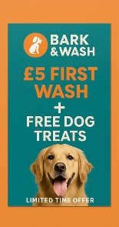

Financial resources:
The full £7,000 will be funded by myself through personal savings. This eliminates the need for loans, reduces financial risk, and ensures the business begins with no debt. This approach is highly realistic, especially given the low start-up cost and minimal ongoing expenses.
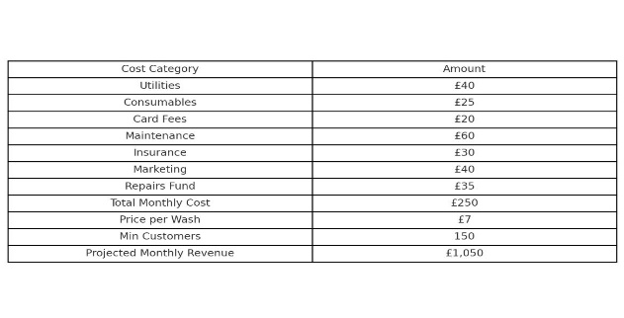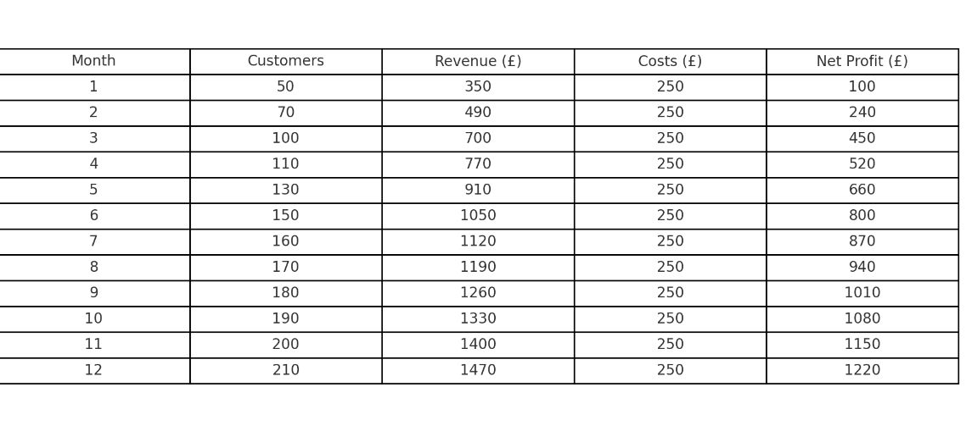

Branding
- Clean, bright colours such as blue and green.
- Simple, memorable logo
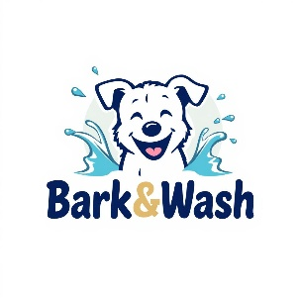
-Create flyers with QR-codes for customers to give suggestions and how I can improve my service.

Elevator Pitch
Dog owners struggle with messy home washing, and groomers are often expensive or fully booked. With rising pet ownership, Bark&Wash provides a fast, affordable, walk-in solution with professional equipment and no mess. It is a scalable, high-demand business ideal for expansion.
Bark&Wash will offer a complete self-service dog wash for £7 per wash, which includes shampoo, conditioner, and access to a built-in dryer. The station will provide warm water for a comfortable and thorough cleaning experience. In addition, customers will be able to purchase disposable capes and gloves to help keep themselves clean while washing their dogs.

Reference
1.Animal Friends Pet Insurance (2017) Hygiene habits of British pet owners revealed! Available at: https://www.animalfriends.co.uk/dog/dog-blog/hygiene-habits-of-british-pet-owners-revealed/
2.Attract more customers with convenience (2025) Facebook, 5 September. Available at: https://www.facebook.com/thedogwashcompanyuk/posts/attract-more-customers-with-convenience-in-the-competitive-uk-pet-care-market-of/122196376046309956/
3.Boost revenue & customer loyalty with a self-service dog wash (2025) The Dog Wash Company UK [online]. Available at: https://thedogwashcompany.co.uk/diy-self-service-dog-wash-near-me/
4.Bathing your dog (n.d.) Petplan [online]. Available at: www.petplan.co.uk
5.Grand View Research (2024) UK pet grooming services market size & outlook, 2025-2030. Available at: https://www.grandviewresearch.com/horizon/outlook/pet-grooming-services-market/uk
6.Grand View Research (2024) UK pet services market size & outlook, 2023-2030. Available at: https://www.grandviewresearch.com/horizon/outlook/pet-services-market/uk
7.Johnsons Veterinary Products (2022) PFMA 2022 data report [PDF] Available at: https://johnsons-vet.com/wp-content/uploads/2023/08/PFMA-2022-Data-Report.pdf
8.K9000 Dog Wash Units (n.d.) Business opportunity UK. Available at: https://www.k9dogwash.co.uk/
9.Mintel (2025) UK Household Care Habits of Pet Owners Consumer Report 2025. Available at: https://store.mintel.com/report/uk-household-care-habits-of-pet-owners-market-report
10.Nova One Advisor (2024) UK Pet Grooming Products Market Size, Share | Companies. Available at: https://www.novaoneadvisor.com/report/uk-pet-grooming-products-market
11.Starting a dog grooming business UK (2023) Pet Business Insurance [online]. Available at: https://www.petbusinessinsurance.co.uk/news/starting-a-dog-grooming-business/
12.The Dog Wash Company UK (2024) Dog wash investment smart business move – UK site. Available at: https://thedogwashcompany.co.uk/dog-wash-investment-smart-business-move/
13.The Dog Wash Company UK (2025) How a self-service dog wash can generate passive income and... [online]. Available at: https://thedogwashcompany.co.uk/self-service-dog-wash-passive-income-uk/
14.The Dog Wash Company UK (2024) Self-service dog wash for sale. Available at: thedogwashcompany.co.uk.
15.Yahoo Finance UK (2025) Growth trends in the pet grooming services industry, 2025-2030. Available at: https://uk.finance.yahoo.com/news/growth-trends-pet-grooming-services-112600050.html.

Reflection

During the lectures and while working on my assessments, I learned and developed many new business and entrepreneurial skills. Before this module, I did not fully understand how to plan a business idea in a professional way. Now, I feel more confident about analysing a market, understanding customer needs, and preparing a full business plan. One of the first skills I developed was learning how to use tools like SWOT and PESTLE. These helped me look at my business idea from different angles and understand what can affect it, such as political rules, social trends, and economic changes. Understanding these factors made me think more carefully about how my business can grow and what risks I need to consider.
I also learned more about market research. I practised looking for information about customers, identifying what they need, and checking if my idea solves a real problem. By researching dog owners, parks, and similar services, I realised that there is a real demand for a self-wash dog station. This helped me feel more confident that my idea can work. I also learned about the importance of competitors and how to make my business different from others.
Another important skill I developed is creating financial plans. At the beginning, I found budgeting and forecasting difficult, but by doing the tasks step by step, I learned how to calculate start-up costs, monthly running costs, and future revenue. Building a 12-month financial plan helped me understand how money flows in a business and how profit is made. This was completely new for me, but now I feel more comfortable working with numbers.
I also improved my marketing skills. I learned how to design a simple marketing strategy, plan promotions, and think about branding. Creating flyers, social media ideas, and a marketing plan showed me how important it is to attract customers and keep them coming back. This creative part of the module was very enjoyable for me.
One entrepreneurial trait I realised I need to develop is more confidence when making decisions. Sometimes I think too much or worry if my idea is good enough, and this stops me from moving forward quickly. To improve this, I plan to practise making decisions without overthinking, ask for feedback from people with more experience, and try small business tasks to gain real-life confidence. I also want to learn more about how successful entrepreneurs deal with risk and challenges.
Reflecting on my business idea, I believe it is realistic and achievable. My idea solves a real problem that dog owners face every day, including me. The start-up cost is low, the
monthly costs are small, and the business can run 24/7 without staff. My financial forecast shows that the business can break even in the first six months and make profit by the end of the year. With the growing number of dogs in the UK, I am confident that my service will be useful and in demand.
Overall, this module helped me understand how to turn a simple idea into a real business plan, and it gave me many skills that I will use in the future.

