CILT(UK) Level 6 Advanced Diploma in Logistics and Transport

Unit 5
Research Methods

Assignment Title
Reverse Supply Chain
In the British Army.

TABLE OF CONTENTS

Para Subject
- Introduction
  - Background
  - Research Question
  - Scope
  - Methodology
  - Planning
- Literature Review – not included
- Methodology – not included
- Analysis – not included
- Conclusions – not included
6 References

1 – INTRODUCTION

  - Background.
Supply chain consists of all parties involved, directly or indirectly, in fulfilling a customer request. The supply chain includes not only the manufacturer and suppliers, but also transporters, warehouses, retailers, and even customers themselves. Within each organization, such as a manufacturer, the supply chain includes all functions involved in receiving and filling a customer request. These functions include, but are not limited to, new product development, marketing, operations, distribution, finance, and customer service.

Over the past years, reverse supply or items that are being returned in the Bristish Army has gone wrong as kits are either damaged, lost In transit and many of these returned kits does not get to its destination within its pipeline time. Millions of pounds worth of kits were either missing In transit or did not get back to the UK in time during OP TELIC and Op HERRICK and these included Vehicles, weapons, specialist equipment’s and many others. According to National Audit Office 2008, some £155 million worth of BOWMAN assets reported in the accounts could not be fully accounted for, although the MOD estimates that a significant proportion of these are under repair.

Same issues has been noticed In the Supply Regiments here in the UK as kits are lost in transit or doesn’t get to the right place at the right time

Reverse Supply Chain is defined as:
The process of managing products past the manufacturing stage. This flow of returned materials from consumer to retailer, retailer to distributor, or distributor to manufacturer, is also known as the reverse logistics. Antil P (2001). The materials’ post-return activity can include repair, warranty recovery, redistribution, remarketing, end-of-life recycling, or any combination of these activities.
The ultimate goals of establishing a formal reverse logistics process are to recover remaining value from returned materials that would otherwise be lost in product disposal, improve efficiency in the reverse supply chain, and minimize waste – all of which can translate into additional revenue for a company’s bottom line.

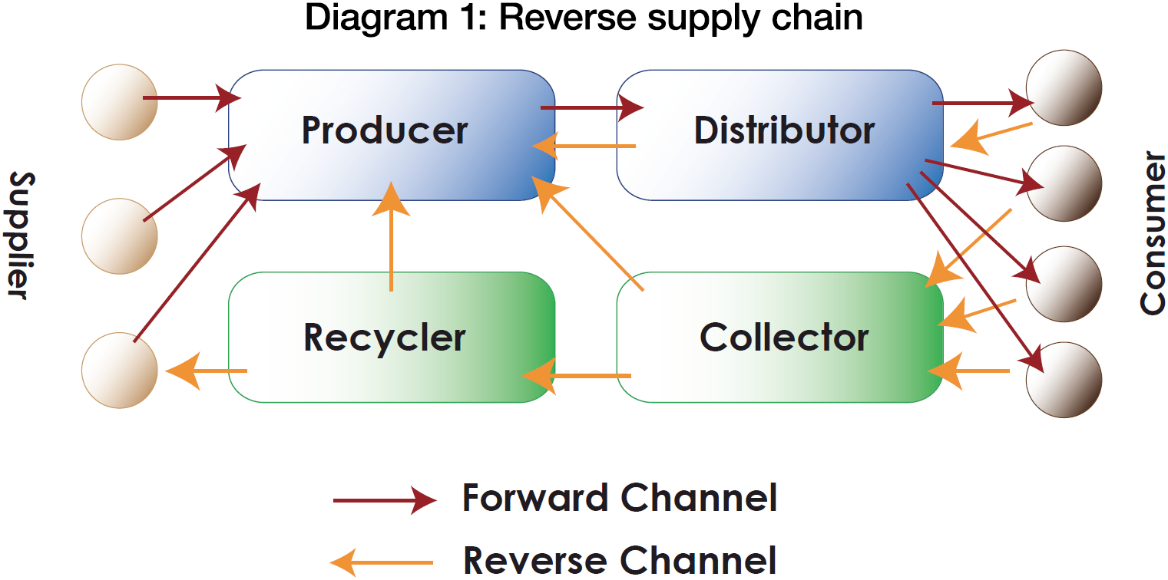
Reverse Supply Chain
Source: Treasurytoday.com

Ministry Of Defence (2011) defines Reverse Supply Chain as:

The means by which surplus, repairable, damaged or waste materiel is returned for reallocation, repair or disposal. It is an integral part of the JSC. The process begins when a Return item is identified and ends when that item is receipted on to the account from which retention, reallocation, repair or disposal takes place.

1.2 Research Question
Ho Reverse Supply Chain in the Army is ineffective?
Ha. Reverse Supply Chain in the Army is effective?
1.3 Scope
This will be based on 9 Regiment RLC Mat Troop and 6 Close Battalion REME Store Section. The Materiel troop in 9 regiment backload all their stock that are obsolete, nearing its shelf life and items that are not being used within 24 months. The 6 Battalion REME also backload kits and sends back repairable items like BOWMAN and Engine to depot to be repaired. This reverse supply packages will be either required or not required by depot.
1.4 Research Methodology
1.4.1 The research design will be based on both the Materiel troop in 9 regiment RLC because they have stores that are called “problem packages”, Items nearing its shelf life and stores with no usage within 24 months. These packages are returned back to depot or the consignor. More so Stores troop at 6 Battalion REME will be used as all P class stores requires its old stock back to be repaired when demanded. I will be using the Delphi technique to refine the research idea of these two departments from beginning with briefing the members of the group about the area of research all the way through to reaching a consensus.
A full set of cases from which a sample is taken is called Population (Saunders et al 2000). The research population will be the line managers, section commanders and the private soldiers in both the Provisioning Control and the Accounts (PC &A) and Receipt and Issues cell.
To meet the research objectives , this essay will use surveys which is a measure of opinions or experiences of a group of people through the asking of questions and semi structure interviews which is a qualitative method of inquiry that combines a pre-determined set of open questions (questions that prompt discussion) with the opportunity for the interviewer to explore particular themes or responses further.
Will also use the dispatch and receipt data of some of the P class items in these units taking into consideration the Supply Chain Pipeline Times (SCPT) and whether they are met. Sources of theory and literature will include JSP 886 , Defence Logistics Framework (DLF) and Technical Operation Procedures (TOPs)
More so this work will touch on the reverse supply chain applicable to civilians which can be returning items bought that they are not satisfied with or items that were damaged in transit. These customers raise complaints and customers service arrange for the product or item to be picked up.

1.5 Planning
Planning is a timescale which will assist with time management.
The following is an outline of timings for the dissertation:
Ser | Date | Task to be achieved
01 | 01.10.2017-30.12.2017 | Literature Review
02 | 01.01.2018-28.02.2018 | Survey and Semi structured interview
03 | 01.03.2018-31.03.2018 | Analysis
04 | 01.04.2018-30.05.2018 | Production of Dissertation

6. References:
Antill, P. (2001) Focused Logistics, retrieved from http://www.historyofwar.org/articles/concepts_focused_logistics.html on 9th September 2017

Dyckhoff K et al, (2004) Supply Chain Management and Reverse Logistics.

Ministry of Defence, 2011. Reverse Supply Chain, JSP886 Defence Logistic Support Chain Manual, Volume 3, Part 13 retrieved on 12th September 2017.

National Audit Office. The use of information to manage Logistic supply chain. Session 2010-2011

Saunders,M.N.K, P Lewis and A Thornhill (2000) Research Methods for Business Students.

