
University of Wales Trinity Saint David

Module Name: Management Economics
Module Code: LCBB5003
Student Name: Diana Roabis
Student ID: 2028044
Module Lecturer: Taye Osadiya

Management Economics - Apple Smart Watch

Table of Contents
1. Introduction and product description 3
2. Demand and market equilibrium of Apple smart watch 3
3. Discussion on the factors that influence the price elasticity and demand for the Apple smartwatch 7
Conclusion 10
Reference List: 11

1. Introduction and product description
The business chosen for this study is Apple, Inc (UK). Apple Inc. is a technology company that designs and manufactures smartphones, tablets, personal computers (both laptop and desktop), and other portable devices. The company also deals with in-built software, services, accessories, applications, and digital content. Its product portfolio of Apple includes a vast range of products ranging from iPhone, iPod, iPad, Apple Watch, and Apple TV. Software applications include iOS, macOS, iPadOS, watchOS, iCloud, Apple Pay and AppleCare. Apart from that, digital applications, and content such as Apple News+, Apple fitness+, Apple Music, Apple card, and Apple Arcade are also sold by Apple through the Apple store. The significant and prominent products and services offered by the tech giant Apple include Mac,iPhone, iPad, Apple Watch, Airpods, AirTag, Apple TV 4K, and HomePod Mini.
Founded in 1976 in California, United States, by Steve Jobs and Steve Wozniak, Apple Inc is a multinational company that creates iPhones, smart watches, personal computers and software. Apple’s product line is iPhones, watches, iPad and Mac computers (apple.com, 2022).
The chosen product is the Apple Smart Watch, a wearable smartwatch that allows users to bring up various tasks, including messaging, phone calls, reading, and tracking fitness. In other words, the Apple smartwatch is called a small wearable computer on the wrist (apple.com, 2022). Apple's target market is mainly based on its interest in achieving profitability. The wellness segment is the dominant market for Apple, especially for smartwatches. Apple operates in such a business environment where despite specific barriers, the growth of the Apple smartwatch tends to remain upward since they do not compromise the quality of their products.

2. Demand and market equilibrium of Apple smartwatch
Price of the substitutes
The primary substitute for the Apple smartwatch is the Fitbit Varsa 4, which is a significant alternative considering the overall features of the Apple smartwatch. The price of the Fitbit Versa 4 is cheaper than Apple and maintains a similar quality of features as the Apple smartwatch. The cost of the Apple smartwatch starts from a high price and the Fitbit Versa 4 maintains a reasonable price to enhance their sale. The difference in pricing between the two products affects the demand for the product in the market (Strik et al., 2021).
Moreover, the price of Fitbit Versa, the substitute for the Apple Smartwatch, is experiencing an ongoing pricing strategy that is increasing and decreasing, therefore enhancing the customer base for the product. On the other hand, it impacts the Apple smartwatch's market, as it maintains high technological features at a lower price than the Apple smartwatch. People with active, maintained lifestyles and low budgets can easily afford the Fitbit Versa 4. The increasing pricing rate of Apple smartwatches in every series and model is the reason for the decreasing demand in its market (Haghayegh et al., 2019). However, the Fitbit Versa 4, with low price and quality features, increases its market demand daily, negatively impacting the Apple smartwatch's marketing.
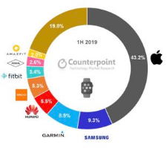
Figure 1: figure showing the percentage of smartwatch production by several companies.
(Source: Strik et al., 2021)
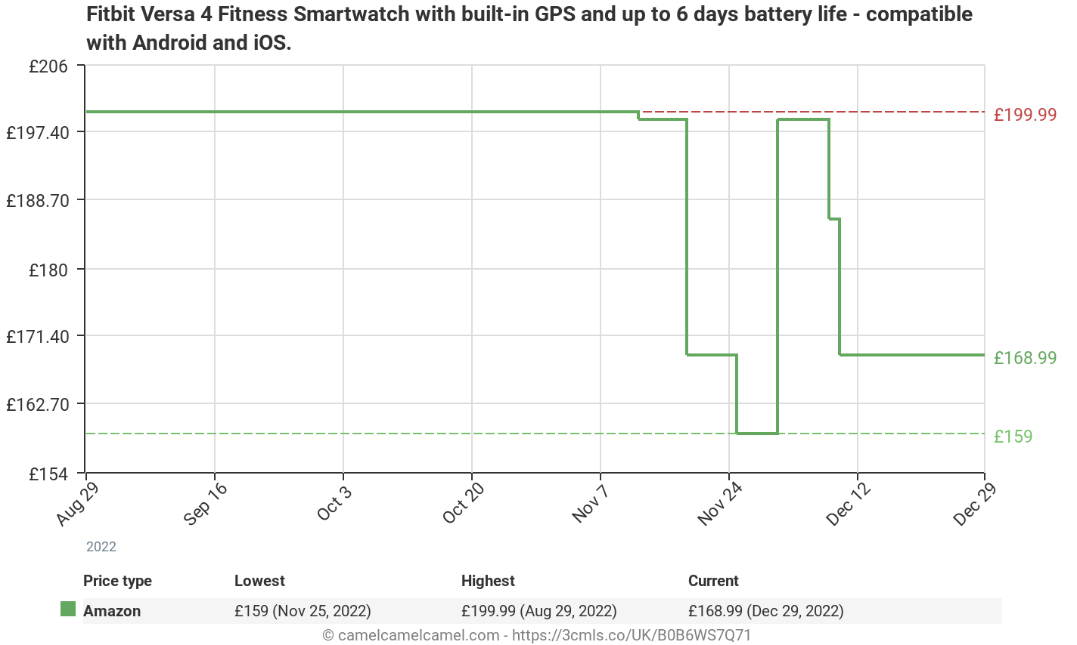
Figure 2: Figure showing Fitbit Varsa 4 smartwatch compatible with Android and iOS
(Source: Haghayegh et al., 2019)

Price of compliments
Apple Watch operating system produced for the Apple watch, a wearable device with many developed features, can take advantage of the smaller screen and location of the device for the users. Apple Watch operating system is based on Apple's iOS operating system for Apple's iPhones and iPads which can share the same capabilities. On the Apple Watch screen, there are some icons through which users can access the features of the Apple watch. The watch icons such as Friends, Glances, and Time Travel. Apple watches operating system also includes some features from iOS for Force Touch Capability, which allow the users to measure the pressure when they touch the screen. On the other hand, Apple watches operating system also offers many customization options for its users. Users can take personal, time-lapse photos of their watch face (Hernando et al, 2018).
The price of the Apple Watch operating system is high due to super-developed technology. With the help of the Watch OS Apple can produce their Smartwatches with ultra-modern technology and can enhance the market demand (Roelle et al, 2020). As users are attracted by the unique features of the Apple Smartwatch, the cost of the products could only sometimes create barriers to the marketing of the Apple Smartwatch.
Consumer income
According to the survey of the Office of National Statistics, a department of the UK Government, in 2021 the average UK salary for a full-time role was £38,131 and £13,549 for a part-time role. In the year 2020, the average UK salary for a full-time role was £38,552; for a part-time role, it was £13,819. ONS collects information on the nation's economy and helps identify the main factors related to the nation's economic trends. The gross domestic product per capita income in the UK for 2020 was 29,687 GBP and for 2021 was 31,793 GBP. During the pandemic, the earnings per capita and total earnings of every nation were affected; for this reason, the economic growth of the nations showed a downward trend in earnings (McCann, 2020).
The capital growth or economic growth of every country depends on the total earnings and the gross domestic product per capita income. During the time of covid, the downward trends of earnings per capita and total earnings negatively impacted the marketing of the Apple Smartwatch (Perez et al, 2019).
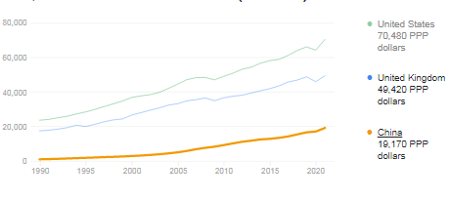
Figure 3: Figure showing average earning trends of the UK.
(Source: McCann, 2020)
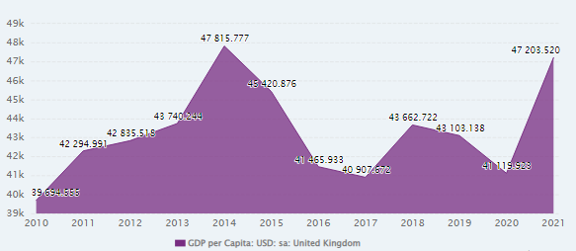
Figure 4 shows Gross domestic product per capita income in the UK.
(Source: statista.com)

Consumer tastes and preferences
Consumers' preferences relate to the customers' likes, dislikes, motivations, and satisfaction after purchasing a specific product. Social status, and active lifestyle, are also the reason for producing the Apple smartwatch. Changing tastes and demands of the people push Apple to make a super technological wearable product like the Apple smartwatch (Ramasundaram et al., 2022). The communication and frequency factors affect the marketing of the Apple smartwatch. Apple customers who like the promotions such as special offers, special rewards, and some other objects, Apple allows them to increase their attraction towards the product. On the other hand, the consumers who prefer good communication through email, Apple also meet their demand to get the desired customer satisfaction (Nam and Kannan, 2020). Aligning with the customer's tastes and preferences, the company always produced its product, and the demand for Apple Smartwatch is growing.
Consumer expectation of price on products
The reason behind the increasing cost of Apple smartwatches is the capability of tracking fitness, Accessibility of several apps, power of location tracking, durability, and its focus on the ecosystem. The cost of the Apple smartwatch is truly high, and the product price could not create a severe issue of its regular market. People with a highly active lifestyle and with a high budget for this type of product are not affected by the price of the Apple smartwatch. The fitness tracking capacity of the Apple smartwatch can enhance the customer's attraction. Moreover, the capacity to access several apps is also essential to enhance the demand for the Apple watch. Apple products can work better with each other, this is the main advantage of the Apple ecosystem (cashify.in, 2022). It also creates issues at the time of transferring data from the Apple device to another device, which is outside the Apple ecosystem. As the service of the Apple smartwatch is truly appreciable, the demand for the Apple smartwatch can keep the desired growth.
Demographics
The number of consumers of Apple smartwatches worldwide from 2015 to 2022 is 10 million, 18 million, 32 million, 50 million, 72 million, and 702 million. The increasing number of customers can inflict that the Apple smartwatch meets the customers' demand and get a huge response in customer satisfaction. On the other hand, with the help of this watch, users can stay connected with the desired factors like calls, music, taxes, and many other objectives. Moreover, this device also helps to express the individual self and also helps to increase the technological sense relating to the device (OReilly et al., 2022). As Apple watches meet and fulfil the customers' demand, and their supply management is truly appreciable, the demand for Apple watches is at a high level.

3. Discussion on the factors that influence the price elasticity and demand for the Apple smartwatch
Price of the substitutes
The price of the Fitbit Versa 4 is cheaper than the Apple smartwatch. Fitbit Versa 4 maintains a similar quality of features to the Apple smartwatch. The cost of Apple smartwatch starts at a high price and the Fitbit Versa 4 maintains a reasonable price to enhance their sale. According to Strike (2021), the difference in pricing between the two products affects the demand for the product in the market. The increasing price of Apple smartwatches, however, still consumers tend to buy them. Hence, it can be proved to be elastic.
Price of compliments
The increasing product price and demand for complimentary goods will fall. Complimentary goods have a negative cross-elasticity of demand. Cross elasticity of demand implies that the percentage change in the quantity for the first goods is divided by the percentage change in the price of the complimentary product. The cross elasticity of complimentary goods shows a negative demand because when the cost of one Apple smartwatch is increased, the associated products, such as Apple Watch Operating System will decrease because there will be a chance to decrease the demand for the main product. However, in the case of the Apple Smartwatch, the increasing price only affects a little on demand for the product. The increasing price of the Apple Smartwatch's complementary product is inelastic (Dekel et al., 2022).
Consumer income
The effect of income on the UK people dose has a small impact on the Apple smartwatch. The income elasticity of demand describes the relationship between the changes in consumer income and the number of goods the customer demands. As Apple serves its products according to the needs or demand of the customers, the changes in income can create a good impact on its market. When the product meets the need of the customer and they are satisfied after using the product, there will be a chance to get the desired profitability from the product. The customers' income factor influences the elasticity of demand, which is inelastic for the demand for the Apple smartwatch (Wilkinson, 2022).
Consumer tastes and preferences
The changing taste and preferences can be one of the most important for to influence the price elasticity of demand. Customers' needs are the changing factors, for this company has to improve its technological objects and also focus on its marketing. Apple Smartwatch always tries to focus on the changing taste and preferences of the customers. The super-developed technology and moderate features allow the consumers to buy the product (Siyao, 2021). on the other hand, As Apple made the smartwatches according to the preferences of their customers, here the changing preferences are also inelastic for the demand for the Apple Smartwatch.
Consumer expectation of price on products
The expectation of the consumers according to their lifestyle, and social status influences the elasticity of demand. Apple smartwatches introduced the whole world with their unique features in a wearable device. The device can meet many customer demands, such as the location tracking feature, fitness tracking feature, durability, and ability to handle a lot of apps with efficiency (Dehghani et al, 2020). Apple smartwatches always serve products beyond the expectations of consumers. It also proved an inelasticity in demand for the Apple smartwatch.
Demographics
The increasing numbers of buyers of the Apple Smartwatch proved their efficiency towards the product quality and strong marketing. This factor is getting strong due to the satisfaction of the customers. New and innovative features always attract consumers to the Apple Smartwatch. The customers are satisfied with the measurement of health-related features in the smartwatch. These new and ultra-modern features are constantly seeking the attention of the people, at a high cost. Apple smartwatch proves its inelasticity of demand (Siegmann and Anderljung, 2022).
The proportion of Total Expenditure
It relates to a crucial element affecting the price elasticity of demand. For instance, the demand for a particular Apple product (in this case, an Apple smartwatch) would be elastic if a consumer spent a significant portion of his or her money to purchase it. Apple smartwatches, on the other hand, would have an inelastic demand because they are only purchased with a small fraction of the consumer's money.
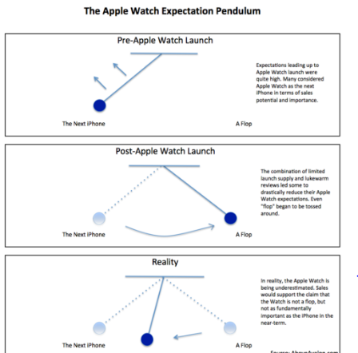
Figure 5: Figure showing Apple Watch expectation Pendulum
(Source: Dehghani et al, 2020)

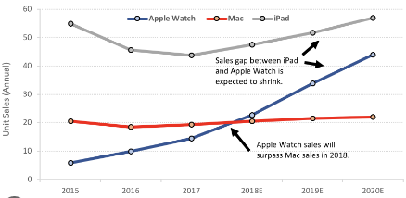
Figure 6: Figure showing the Apple watch is the bridge to the future.
(Source: Ioannidis et al, 2019

Conclusion
In this paper, various aspects of the Apple smartwatch are addressed in accordance with the module named 'Management Economics. the business chosen is Apple Inc and Apple Smart Watch is considered for the study. The paper depicted detailed insights into the demand and market equilibrium along with the factors that influence Demand for the specified product. It is deduced that the substitute for Apple Smart Watch is the Fitbit Varsa 4, which is deemed as a significant alternative with the overall features of the Apple smartwatch. The price of the Fitbit Versa 4 is less costly than Apple and it maintains almost similar features as the Apple smartwatch. The cost of the Apple smartwatch starts from a high price whereas the Fitbit Versa 4 maintains an affordable price comparatively. Along with this, the price of compliments and consumer income, taste, and preferences have been incorporated in this study. Factors including nature of products, availability and substitute, income distribution, level of price in terms of the mentioned product, time factor and proportion of total expenditure have been explained to draw a conclusion reflecting that despite certain barriers, the growth of the e remains as upwards as before since they do not compromise with the quality of their products.

Reference List:
Dehghani, M., Abubakar, A.M. and Pashna, M., 2020. Market-driven management of start-ups: The case of wearable technology. Applied computing and informatics.
Dekel, I., Cummings, R., Heffetz, O. and Ligett, K., 2022. The Privacy Elasticity of Behavior: Conceptualization and Application (No. w30215). National Bureau of Economic Research.
Haghayegh, S., Khoshnevis, S., Smolensky, M.H., Diller, K.R. and Castriotta, R.J., 2019. Accuracy of wristband Fitbit models in assessing sleep: systematic review and meta-analysis. Journal of medical Internet research, 21(11), p.e16273.
Hernando, D., Roca, S., Sancho, J., Alesanco, Á. and Bailón, R., 2018. Validation of the apple watch for heart rate variability measurements during relax and mental stress in healthy subjects. Sensors, 18(8), p.2619.
Inc, A. (2022) Apple, Apple (United Kingdom). Available at: https://www.apple.com/uk/ (Accessed: December 29, 2022).Apple (United Kingdom)www.apple.com
Ioannidis, D.C., Kapasouri, E.M. and Vassiliou, V.S., 2019. Wearable devices: monitoring the future?. Oxford Medical Case Reports, 2019(12), pp.492-494.
McCann, P., 2020. Perceptions of regional inequality and the geography of discontent: Insights from the UK. Regional Studies, 54(2), pp.256-267.
Nam, H. and Kannan, P.K., 2020. Digital environment in global markets: Cross-cultural implications for evolving customer journeys. Journal of International Marketing, 28(1), pp.28-47.
OReilly, M., Shapiro, I., Stein, J. and MacRae, C., 2022. Pulse Oximetry Values from 33,080 Participants in the Apple Heart & Movement Study.
Perez, M.V., Mahaffey, K.W., Hedlin, H., Rumsfeld, J.S., Garcia, A., Ferris, T., Balasubramanian, V., Russo, A.M., Rajmane, A., Cheung, L. and Hung, G., 2019. Large-scale assessment of a smartwatch to identify atrial fibrillation. New England Journal of Medicine, 381(20), pp.1909-1917.
Published by D. Clark and 16, N. (2022) GDP per capita UK 2021, Statista. Available at: https://www.statista.com/statistics/970672/gdp-per-capita-in-the-uk/ (Accessed: December 29, 2022).
Ramasundaram, A., Pandey, N., Shukla, Y., Alavi, S. and Wirtz, J., 2023. Fluidity and the customer experience in digital platform ecosystems. International Journal of Information Management, 69, p.102599.
Roelle, L., Dalal, A.S., Miller, N., Orr, W.B., Van Hare, G. and Silva, J.N.A., 2020. The impact of direct-to-consumer wearables in pediatric electrophysiology telehealth clinics: A real-world case series. Cardiovascular Digital Health Journal, 1(3), p.169.
Siegmann, C. and Anderljung, M., 2022. The Brussels Effect and Artificial Intelligence.
Siyao, L., 2021, June. Analysis of Luxury Brand and Consumer Psychology. In 2021 International Conference on Enterprise Management and Economic Development (ICEMED 2021) (pp. 44-47). Atlantis Press.
Strik, M., Ploux, S., Ramirez, F.D., Abu-Alrub, S., Jaîs, P., Haïssaguerre, M. and Bordachar, P., 2021. Smartwatch-based detection of cardiac arrhythmias: Beyond the differentiation between sinus rhythm and atrial fibrillation. Heart Rhythm, 18(9), pp.1524-1532.
Tech GeekExplore More >I am geek your friends warned you about. Total nerd (2022) 5 reasons why Apple Watch is so expensive: Cashify Blog, Cashify. Available at: https://www.cashify.in/why-apple-watch-is-so-expensive (Accessed: December 29, 2022).
Wilkinson, H., 2022. Market harms and market benefits. Philosophy & Public Affairs, 50(2), pp.202-238.

