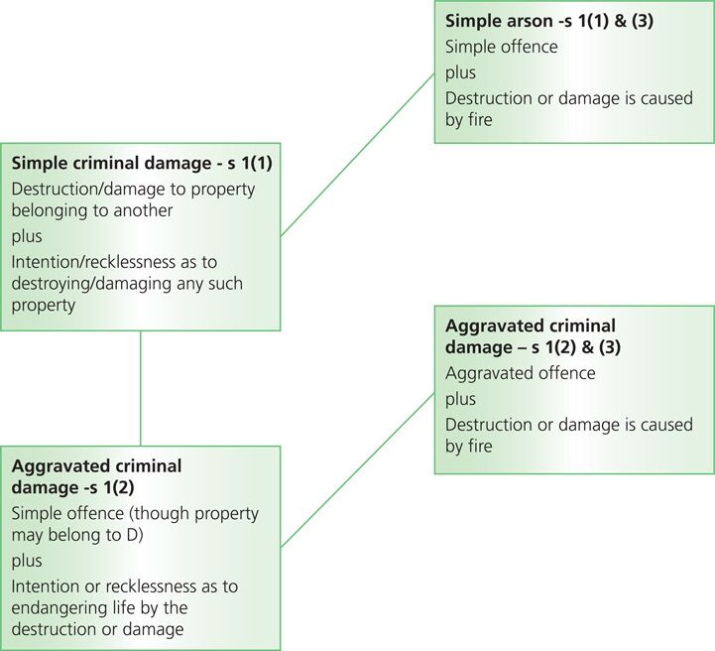
Figure 12.1 Criminal damage offences

Criminal Damage Act 1971 | Actus reus | Comment/case | Mens rea | Comment/case
s 1(1) Simple criminal damage | Destroy or damage property belonging to another. | Damage need not be permanent (Roe v Kingerlee (1986)).  Effort/expense to remove it or impairment of value/usefulness indicates it is ‘damage’ (A (a Juvenile) (1978)).  Any tangible property including land can be damaged.  Having a possession/control or a proprietary right/interest. | Intending or being reckless as to destruction or damage. | Normal principles of intentionj apply.  Subjective ‘Cunningham recklessness’ applies (G and another (2003)).
S 1(2) Endangering life | Basic offence and intending or being reckless as to whether life was endangered. | D must intend to endanger life by the destruction/damage (Steer (1987);  Webster and Warwick (1995)). Can commit offence by damaging own property. | Mens rea for basic offence plus intention or recklessness as to whether life would be endangered. | Intention and recklessness have the same meaning as for the basic offence (Castle (2004)).
s 1(3) Arson | Simple offence committed by fire. Aggravated offence committed by fire. | Can be committed by omission (Miller (1983)). | Must intend or be reckless as to destruction or damage by fire. | -

