Business plan

Excited explorers



Learning through exploration

Word count: 3293

Contents page

- Ideas behind Excited explorers
- The service
- Pricing
- Tuff trays in the early years
- Challenges and barriers
- Research (Part 2)
- Reference list

Ideas behind excited explorers
After spending the last 6 years working in different schools as a level 4 teaching assistant, I began to notice how nearly every class I worked in had a Tuff tray regardless of the ages of the children. A tuff tray is a large heavy-duty plastic tray about a meter in diameter, octagonal shaped and has raised sides that are perfect for messy play (Edwards 2015). Although it may not look like much at first glance, when they are set up the opportunities and activities you can achieve with children through them are endless. The way a Tuff tray is used can be adapted from person to person and can be used for a wide range of activities in nurseries, schools at home and at sensory play groups. Although most people assume Tuff trays to be for young children due to their accessibility for children and babies to sit in them whilst exploring, they can also be used right through to year six simply by placing the tray on to stands and them allowing them to access real world science or experiments through them. They are perfect for looking closely at mini beast or creating science explosions in them at a safe distance for staff although they are more commonly used for babies and young children. It was during my time working in different schools that I realised that not everyone saw the potential a Tuff tray could bring to a class room to enhance the child’s learning and some even saw it as a hindrance in the class as it was often in the way or they were unable to think of ideas on what to do with it. This is why I have created Excited explorers, as a company I will offer schools and nurseries the opportunity to hire items and resources off me for their tuff trays so all they have to is open the box and put the resources in the tray. Through my personal experience I noticed that teachers often have so many things going on in a class and things to plan for, the idea of planning what should go in their tuff tray that week is often at the bottom of their to do pile. Hopefully by providing settings with boxes of resources for any theme or topic we will be enhancing the learning experience for children in south Wales but also helping to motivate and inspire teachers and school staff were unsure on how to use their tuff tray.

The service
Excited explores will be offered to schools and nurseries in the local Swansea and Neath area with the hope of progressing further to cover the whole of south Wales in future years. If schools and nurseries would like to opt into the excited explorers service, they would pay for a 6 month or 1 year fee similar to other subscription services used by schools. As part of our standard package I will then provide 3 boxes to the setting every month for them to use and rotate around classes before collecting them back in and then exchanging them for 3 new boxes. These boxes will be put together based on what the setting requires in regard to pupil ages, topic etc. Below is an example of what the 3 boxes would contain for a setting who has requested farmyard themed equipment for a reception class. The boxes will each contain all of the items needed for that tuff tray, meaning staff will simply have to put it in the tray for the pupils. A laminate will be included with a breakdown of items to ensure all of the items are accounted for before packing the box back up aswell as photos and a breakdown sheet explain what to use each item for. As part of the schools subscription package I will offer to come into the setting on an inset day and hold a workshop for half a day showing the benefits of Tuff trays within education and how they can be adapted aswell as having a practical session with staff where they can experience a variety of trays. Photos’ for illustration purposes only from Happy Learners (2017).
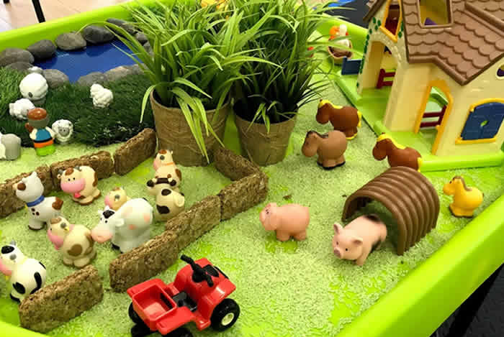
Box 1 Small world- A base mat to line the tray with a printed image on that will set the scene for children to play or where appropriate natural items will be used as the base. Toys and objects related to the topic where children can learn through play and explore with toys. (Toy animals, barn, famer characters, plants, coloured rice, pebbles, artificial grass).

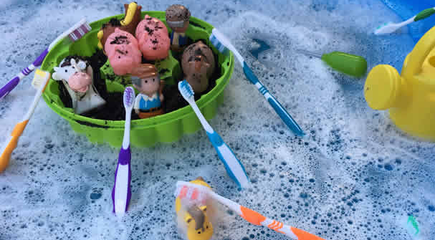

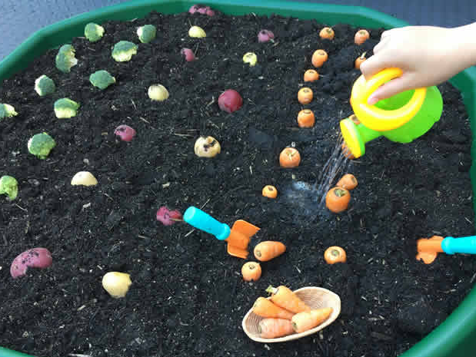
Box 3 Subject based- This box will enable children to explore or even for teachers to teach subjects through the tray. This could be literacy, numeracy or even science. The use of numbers or letters can be used with in the tray for pupils to discover however for the farm tray we would include miniature plastic vegetables where pupils an experience planting and caring for growing things. Information sheets within the box will also suggest other ideas for example staff could give pupils seeds to play with in the soil during the day and then remove the seeds at the end of the day and replace with plants or fresh vegetables.

Package 1
- 3 themed boxes a month for 6 or 12 months (All boxes based on one age range, Reception or KS2 etc.)
- Introduction session for staff
- Tailored boxes specifically designed for what the setting requires in regard to topic, and accessibility.
- Stands for the sensory trays included
- Email or telephone consultation to decide what themed boxes are required on change over day.
6 months = £800 12 months = £1,500
Pricing

Package 2
- 6 themed boxes a month for 6 or 12 months (For 2 different departments- 3x reception and 3x KS2 )
- Introduction session for staff
- Tailored boxes specifically designed for what the setting requires in regard to topic, and accessibility.
- Stands for the sensory trays included
- Email or telephone consultation to decide what themed boxes are required on change over day.
= 6 months = £1,300 12 months = £2,500

Extras
- Hire 3 trays for 6 or 12 months = £35 or £70
- Hire 6 trays for 6 or 12 months = £65 or £135
- 3 extra boxes for 6 or 12 months = £110 or £120

Many early years settings are now using Tuff trays because they are so adaptable and durable. Kelly (2016) explains that Tuff trays can be used for many different activities. The tray is the perfect shape for a group of children to engage in shared play, developing their social skills as well as the communication and language skills. Allowing the pupils to learn from other children, the interaction with staff and the resources can all be associated with Vygotsky’s theory of the more knowledgeable other. Vygotsky (Teaching time, no date) points to the role of a More Knowledgeable Other in demonstrating ideas, values, strategies, speech patterns and so on that a child internalises and learns from it. In early stages of development, this is likely to be a parent, teacher, peers, or a technology. Having the trays in a classroom enforces what has been taught to the child and they are then allowed to go away and solidify what they have learnt by experimenting through play and sensory equipment. The ability of the child can be easily catered for with different activities and made more educational rather than obviously play based as they develop. Allowing children to research and experiment for themselves after being taught a concept can be associated with Montessori’s (Gottesman, no date) 3 stages of teaching, Learning, process and knowing. During the process stage the tuff trays would be perfect resources to have with in the classroom as they allow children to develop and explore the topic themselves through the use of play and come up with their own research, questions and ideas. Stewart (2016) believes that ordinary play can often start out looking haphazard or chaotic but when given time to freely explore through ordinary play, remarkable growth and development is always taking place, this supports Albert Einstein’s (Good reads) theory that ‘Play is the highest form of research.
Tuff trays in the Early years
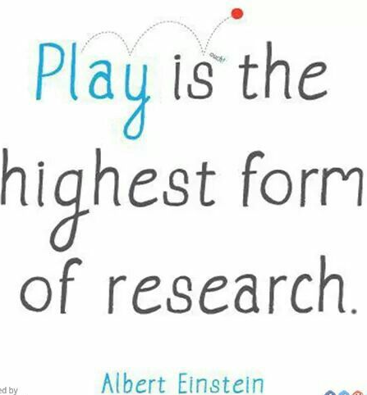

(Source: Pinterest, no date)
Creating a new concept or idea and trying to get your company name into establishments is a challenging time for all new business however I feel that the service I am providing is unique and not like any other already in use. As this is an innovative idea it will work well within nursery and reception classes who are following the foundation phase and the use of learning through play, Therefor I am hoping that the fact there is no one else like us already in business will give us the upper hand in securing subscriptions with schools. Below are two of the biggest challenges and barriers I feel I may incur during my process and how I aim to over come them.
Challenges and barriers

- School budget cuts.
Ratcliffe (2017) informed that in a report by the National audit office has identified that the education services grant, worth £600m, is going to be cut during 2019-20, which means there will be less money for local authorities or academies to provide services such as school improvement. Although there are cuts being made, I am confident that the positive benefits our service offers will benefit the stakeholders dramatically. I have tried to bare the cuts in mind when pricing our service so by having relatively cheap prices for a high-quality services I am hoping that we will still be able to secure some contracts before the cuts take hold. Should the funding cuts become an issue and preventing schools from buying in to Excited explorers then we will approach private nurseries and play groups.

- Staff making their own trays.
In many schools staff are preparing their own tray resources which is fantastic for the children but not all staff in all schools are lucky enough to high volumes of support staff that they can delegate the job of planning and creating the tray to, and therefor as much as they want to create a fun learning through play experience for children the restraints on being a teacher just will not allow the time to let this happen. As I am currently only just starting up this business venture it would be impossible to cater for all of the schools at the same time so by pitching at different schools I will be able to identify what schools are already happy with the provision they provide through the use of Tuff trays and those who feel they would like assistance.

Research paper

The educational provisions we provide for children in schools should be structured around a holistic approach. The foundation phase identifies that it is about practitioners understanding, inspiring and challenging children’s potential for learning (Curriculum for Wales: Foundation phase framework). This is why the concept of Excited explorers was created. It gives practitioners the opportunity to inspire children to develop and practice their knowledge and development in the classroom in a fun and exciting way that appeals to them. The Welsh Government (2019) describes the foundation phase as being build upon the principle of learning through play. Play is essential to the educational development of all children and evidence shows that learning through play is a powerful tool which can help children to develop and extend their language and communication skills. This way of learning through play supports the view of Albert Einstein (no date) who believed that play is the highest form of research. This way of working with children is now widely used in schools and early years setting thanks to the foundation phase framework 2015. Excited explorers wanted to see if there was a way of enhancing the provision of independent learning through play within schools to take the pressure of finding extra resources off teachers. It is common knowledge within schools that teachers are struggling to keep up with the high depends and never-ending list of high priority jobs that come with a teaching job, for example, individual educational plan writing (IEP’s), assessments, reporting concerns, attending reviews and meetings, dealing with issues and planning. This view is supported by Thompson (2019) who has reported that for various reasons, teachers everywhere are now busier than ever. They are trying to get through the day frantically trying to find a balance between school responsibilities, home life, and the enjoyment of a career in education should bring. However with all of these other factors piling up it can often be to time consuming to teachers to find extra resources to use with in classrooms to enhance the children’s learning. Teachers may not have the time to set up additional learning areas in classrooms so may delegate these jobs to their support staff to create and erect. Most foundation phases classrooms are split up into clear areas similarly to the set up of a Montessori classroom. The Montessori classroom (Echo Montessori) is a well-organised, structured learning environment that includes many distinct learning areas. With in classrooms there is usually a construction area, role play area, extended learning area and a sensory area. All of these areas require planning and time to decided what is going to put into each area and how it is going to be set up. After observing this situation firsthand the concept for excited explorers was created as I discovered a solution to the problem. By providing an easy to use service where teachers simply choose the topic of boxes, they would like us to provide and excited explorers does the rest by proving them with 3 large boxes full of different resources and sensory equipment to use within their sensory areas. Schools with out tuff trays will have the option to hire these for additional charges but the main concept of this business to provide schools with ready made resources that requires no preparation from the class staff. So should they wish to use them in sensory bins etc. then they can do so. After carrying out extensive research there appears to be no other company like this available anywhere. There are several tuff tray sensory play groups who allow children to attended but this is a preschool service. Research in to potential opposition companies releveled that there are companies available online that allow you to print resources like information cards or bases mats but these website require subscriptions to access them and then take up valuable time off the staff who have to print, cut and laminate the resource cards as well as having to find different ideas and toys or sensory equipment to put in the trays to support the print outs. This process will then have to be repeated termly as the topic changes as well as updating the role play and construction areas.
After discovering that there were no similar companies operating it proved obvious that now would be the perfect time to set up this company so that it is fully operational by the time the new framework comes into force in 2022. The Welsh Government 2019 describes the new approach to progression, and how the curriculum must be inclusive for all learners. With this in mind it would be an ideal time to approach schools and explain to them the benefits of having tuff trays in their classrooms and how they will effectively link into the new curriculum. The four new purposes of the curriculum which have been set out in the Successful futures document have guided the whole design and development for Wales 2022, Welsh Government (2019). The evidence that was gathered from the Successful futures review identified important strengths within Wales. Some of these included the commitment to equality and inclusion and the attention given to supporting children and young people with special needs through the routes for learning and the foundation phase, Successful futures, 2015. By allowing children with additional needs to access the new curriculum through the use of sensory play then it will enable teachers in mainstream schools to cater for children with additional learning needs in their classes whilst also creating a fun and enjoyable area for other pupils to participate with. Ensuring that children in mainstream settings understand and show tolerance towards children with additional needs is essential for future life, this is supported by Wang (2004) who believes that mainstream schools are capable of accommodating every student regardless of their disabilities, making it certain to other children that all pupils belong to the same single community. Whilst this statement may not be supported by all educational professions the concept that some with children with additional needs, (depending on their needs) should be able to cope within a mainstream class if the provisions are correct. Therefore opening up more place for children with severe needs within the specialised teaching facilities (FTS) or special needs schools.
As well as the link to the new curriculum, the next few months would be the perfect time to set up and develop excited explorers because during the pitches to the schools the emphasis on sustainability can be brought in. Global footprint (2009) has revealed that children rely on toys for imaginative play, but it doesn’t mean that parents and teachers should buy the most expensive toys that they see on the store shelf. Very often children like to play with different things, such as plastic bottles, cardboard boxes, coffee tins, etc. Children use these items to create props for various games and such activity helps develop creativity, logical thinking and ability to concentrate. This supports the vision of Excited explorers because where possible the majority of boxes we provided will have natural, or recycled equipment in them. In the boxes that this is not possible and toys are used schools will still be doing their bit for the environment as these toys will be play with and then cleaned before being sent to another school, resulting in schools buying less toys in that will then sit in the cupboard until next time a similar topic appears which by then the toys will have been broken and will then need to be binned.
Excited explorers would require a business loan or possible business grant to get the company started as it will provide costly to initially go out and purchase in all of the equipment needed such as boxes, toys, equipment, figures as well as things like business issuance. This will be discussed further with business Wales (no date) who are a Welsh Government Initiative that give potential business information and advice to get new business to allow them to get started aswell as providing a personal mentor who will assist new businesses through the application process. Costing for a local storage unit will also be needed where Excited explorers will be able to store all of the equipment which also provided enough space to clean and re package the boxes before storing them or getting them ready for the next school. In future months/ years if the business proves to be successful then additional staff maybe required to assist in the cleaning, preparing, and delivering of boxes.
Taken all of the ideas and suggestions for Excited explores on board we are hoping to create a successful and thriving business that will hopefully be fully effective by May 2021 in preparation for the proposed start for the new curriculum in 2022.

Business Wales. (No date) ‘Welcome to business Wales’ https://businesswales.gov.wales/ [Accessed: 11th May 2019].
Department for children, Education, Curriculum for Wales: Foundation phase framework. Cardiff: Welsh Government.
Department of education. (2019) ‘A guide to curriculum for Wales 2022’. Cardiff: Welsh Govement.
Donaldson, G. (2015) Successful futures: Independent review of curriculum and assessments in Wales. https://gov.wales/sites/default/files/publications/2018-03/successful-futures.pdf [Accessed: 14th May 2019].
Echo Montessori. (No date) ‘areas of a classroom’ http://www.echomontessori.com/program/montessori-approach/areas-of-a-classroom [Accessed: May 5th 2019].
Edwards, E. (2015) ‘Tuff spot tray’ http://adventuresandplay.com/tuff-spot-tray-where-to-buy/ [Accessed 25th April 2019].
Global footprint. (2009) ‘Toys’ https://www.globalfootprints.org/toys/ [Accessed: 15th May 2019].
Good reads. (2016) ‘Albert Einstein’ https://www.goodreads.com/quotes/286612-play-is-the-highest-form-of-research [Accessed: 27th April 2019].
Gottesman, S. (No date) ‘Theories of early childhood’ https://sites.google.com/site/tourosgottesman/theories-of-early-childhood [Accessed: 27th April 2019].
Hounslow Toy Library. (No date) ‘What is a toy library’ http://www.hounslowtoylibrary.co.uk/page2.htm [Accessed: 11th May 2019].
Kelly. (2016) ’10 tuff spot activities for toddlers’ Early years careers, April. [On-line]. Available at: http://www.earlyyearscareers.com/eyc/enabling-environment/10-tuff-spot-activities-toddlers/ [Accessed: 27th April 2019].
Morelli, Z. (2017) ‘Happy learners’ https://www.happylearners.co.uk/ [Accessed 25th April 2019].
Neath Port Talbot council. (No date) ‘Toy Library’ https://www.npt.gov.uk/1230 [Accessed: 11th May 2019].
Pinterest. (no date) ‘Albert Einstein quote’ https://i.pinimg.com/originals/8d/e1/71/8de171377b6a50471f1757751dc34c59.jpg [Accessed 27th April 2019].
Ratcliffe, R. (2017) ‘Cuts, cuts, cuts’, The guardian, 17 January: pp.1. [On-line]. Available at: https://www.theguardian.com/education/2017/jan/17/cuts-headteachers-schools-funding-crisis [Accessed: 27th April 2019.]
Stewart, D. (2016) ‘Teach preschool’ https://teachpreschool.org/in-the-classroom-2/classroom-set-up/ [Accessed 27th April 2019].
Teaching time. (No date) ‘Vygotsky lives’ https://www.teachingtimes.com/kb/71/vygotsky-lives.htm [Accessed: 27th April 2019].
Thompson, J. (2019) ‘You are probably too busy to read this’ http://teaching.monster.com/benefits/articles/6472-you-are-probably-too-busy-to-read-this [Accessed: 5th May 2019].
Turner, D. (2016) ‘Messy play is ideal for SEN learners’, Pentagon, 5, January, PP.1. [On-line]. Available at https://www.pentagonplay.co.uk/news-and-info/messy-play-for-children-with-special-educational-needs# [Accessed: 11th May 2019].
Welsh Government. (2019) ‘Nursery education for 3 and 4 years olds in Wales, Foundation phase nursery: A guide for parents and carers, [On-line]. Available at: https://gov.wales/sites/default/files/publications/2019-03/foundation-phase-nursery-guide-for-parents-and-carers.pdf
Victoria play park. (2018) ‘Messy play is good for child development’, Victoria play park, 20, November, PP.1. [On-line] Available at: https://www.victoriaplaypark.com/news-events/messy-play-is-good-for-child-development/ [Accessed: 11th May 2019].
Wang, H, L. (2009) ‘Should all students with special educational needs be included in mainstream provision?’, International education studies, Volume 2, Issue 4, November. [On-line]. Available at: https://files.eric.ed.gov/fulltext/EJ1065757.pdf [Accessed: 15th May 2019].

